19-07-2017
WiFiMon Scalability and Performance Tests

Table of Contents
1 Introduction 3
2 Testing Environment 4
3 Testing Results 6
Annex A: Virtual Machines Specifications 10
vm11: 62.217.125.88 (WiFiMon Agent) 10
vm30: 62.217.127.133 (JSON Data Generator) 10
vm16: 62.217.125.172 (JSON Data Generator) 10
vima-3: 62.217.124.241 (JSON Data Generator) 10
Annex B: JSON Data Generator Files 11
Simulation Configuration (wifimonSimConfig.json) 11
Workflow (wifimonWorkflow.json) 11

Introduction
On the 13th and 14th of July 2017, the WiFiMon team initiated a series of tests in order to:
- examine the scalability of the WiFiMon agent when it receives a large amount of measurements, and
- examine the performance of WiFiMon GUI as the measurements in the two databases used in WiFiMon increases.
To this direction, the WiFiMon team generated a real-time stream of JSON data using the JSON Data Generator.

Testing Environment
The JSON Data Generator was configured accordingly and started running in the 3 virtual machines (VM) shown below. The specifications of all VMs can be found in Annex A: Virtual Machines Specifications.
- vm30: 62.217.127.133
- vm16: 62.217.125.172
- vima-3: 62.217.124.241
The JSON Data Generator was configured to perform a sequence of 10 measurements (about 1 per 250 ms), then paused for about 1 sec before repeating a new sequence of measurements. Table 1 presents the values that the configuration properties were set to and explains their meaning.

Table 1. Configuration properties
Property | Type | Description | Value
eventFrequency | integer | The time in milliseconds events between steps should be output at | 250
varyEventFrequency | boolean | If true, a random amount (between 0 and half the eventFrequency) of time will be added/subtracted to the eventFrequency | true
repeatWorkflow | boolean | If true, the workflow will repeat after it finishes | true
timeBetweenRepeat | integer | The time in milliseconds to wait before the Workflow is restarted | 1000
varyRepeatFrequency | boolean | If true, a random amount (between 0 and half the eventFrequency) of time will be added/subtracted to the timeBewteenRepeat | true
stepRunMode | string | Possible values: sequential, random, random-pick-one. Default is sequential | sequential
steps | Array | A list of Workflow Steps to be run in this Workflow | See Annex B

With the configurations above, a graph of two sequences of measurements generated from one VM is depicted in Figure 1.
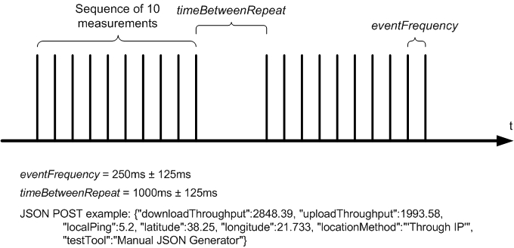
Figure 1. Graph of two sequences of measurements according to the configuration

These settings generated about 150-200 JSON requests/measurements per minute per VM. The measurements from all VMs were posted in the same WiFiMon agent (https://vm11-gn3-sa2t5.vm.grnet.gr:8443/wifimon/add/), i.e. the agent was receiving about 450-600 measurements per minute. The measurements we also correlated with Radius logs to increase the complexity. Manual Radius logs were inserted to the PostgreSQL to this direction.

Testing Results
The simulation lasted for 24 hours. Every 30 minutes, the WiFiMon team noted down the count of measurements and the used disk space of the WiFiMon agent VM. In addition, we measured the time required to load two pages of the WiFiMon GUI. The results are presented in Table 2 and Table 3 respectively, while a screenshot from the Grafana interface is presented in Figure 2.

Table 2. Performance results
Date and Time  (UTC) | Measurements  count | No of measurements | Used Disk Space  (KB) | Disk Space Increase (KB)
2017-07-13 09:27 | 133243 | - | 7100736 | -
2017-07-13 09:57 | 147923 | 14680 (~489/min) | 7117496 | 16760
2017-07-13 10:27 | 162531 | 14608 (~487/min) | 7134332 | 16836
2017-07-13 10:57 | 176436 | 13905 (~464/min) | 7150924 | 16592
2017-07-13 11:27 | 190721 | 14285 (~476/min) | 7167344 | 16420
2017-07-13 11:57 | 204671 | 13950 (~465/min) | 7183128 | 15784
2017-07-13 12:27 | 220666 | 15995 (~533/min) | 7200784 | 17656
2017-07-13 12:57 | 234900 | 14234 (~474/min) | 7217344 | 16560
... | ... | ... | ... | ...
2017-07-14 06:27 | 845744 | 610844 (~582/min) | 7338968 | 121624
2017-07-14 06:57 | 860199 | 14455 (~482/min) | 7355920 | 16952
2017-07-14 07:27 | 877140 | 16941 (~565/min) | 7372984 | 17064
2017-07-14 07:57 | 894873 | 17733 (~591/min) | 7394308 | 21324
2017-07-14 08:27 | 912327 | 17454 (~582/min) | 7411852 | 17544
2017-07-14 08:57 | 930476 | 18149 (~605/min) | 7430844 | 18992
2017-07-14 09:27 | 948469 | 17993 (~600/min) | 7448964 | 18120

Table 3. WiFiMon GUI load time
Date and Time (UTC) | Measurements page (sec) | Grafana page (sec)
2017-07-13 09:27 | 1.12 | 2.30
2017-07-13 09:57 | 1.24 | 1.86
2017-07-13 10:27 | 1.13 | 2.17
2017-07-13 10:57 | 1.01 | 2.26
2017-07-13 11:27 | 1.26 | 1.99
2017-07-13 11:57 | 1.57 | 2.22
2017-07-13 12:27 | 1.23 | 1.98
2017-07-13 12:57 | 1.07 | 1.95
... | ... | ...
2017-07-14 06:27 | 1.85 | 2.01
2017-07-14 06:57 | 2.11 | 2.33
2017-07-14 07:27 | 1.78 | 2.08
2017-07-14 07:57 | 2.16 | 1.98
2017-07-14 08:27 | 2.18 | 2.16
2017-07-14 08:57 | 2.25 | 2.33
2017-07-14 09:27 | 1.92 | 2.20

It is worth mentioning that before the testing procedure there were about 6000 (real) measurements stored in our database. With the JSON Data Generator we simulated more than 942000 measurements, while we started measuring the performance metrics when the measurement count was 133243.

Even for this large (and dense) amount of measurements, the smooth performance of the WiFiMon GUI and WiFiMon agent was not affected as shown in the two tables above.

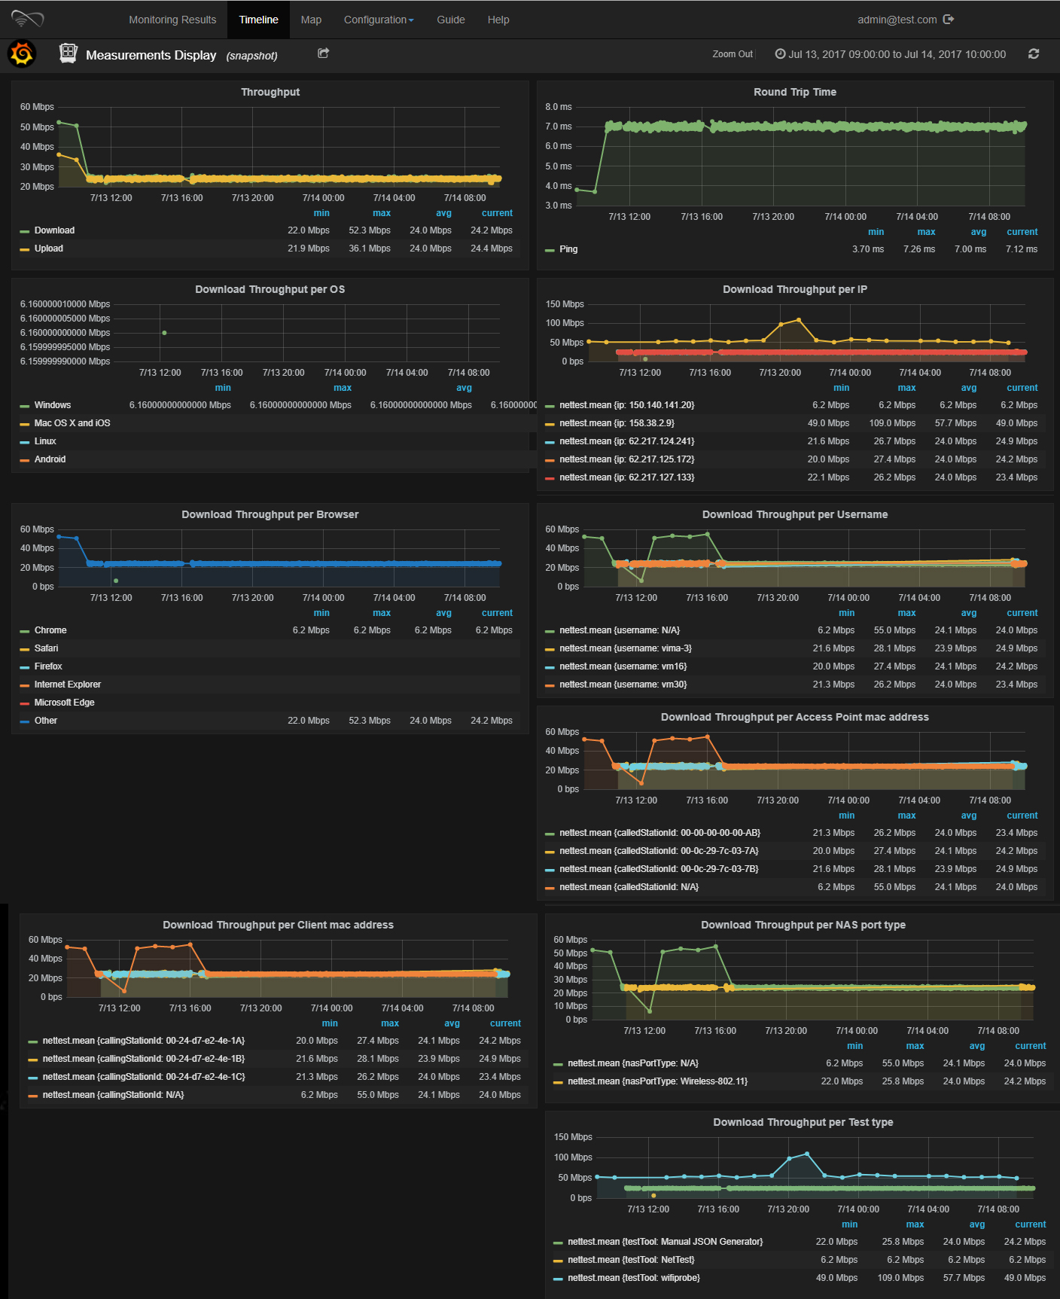
Figure 2. Screenshot from the Grafana interface for the time period Jul 13, 2017 09:00:00 to Jul 14, 2017 10:00:00

Assuming that a realistic amount of measurements would be about 100-1000 measurements per hour (from all access points and including hardware probes and end-users measurements) and by taking into account that our database has already stored more than 948000 measurements without affecting the WiFiMon performance, we can conclude to the following table. The table shows the guaranteed time of WiFiMon smooth performance assuming that it runs on a machine with specifications similar to the specifications of the VM that hosts the WiFiMon agent. The limits presented in Table 4 have been extracted from the simulations, which however did not fully stress the WiFiMon application and may be too conservative.
The 3rd column in Table 4 is a configuration setting that has not been implemented yet. Depending on the expected number of measurements per hour, we could provide this configuration option to the WiFiMon GUI admin, enabling the automatic deletion of entries (only from the PostgreSQL database) which are older than a predefined number of months. Thus, the measurements count would always be kept inside the limits proven by this simulation.
Table 4. Guaranteed time of WiFiMon smooth performance
Number of measurements per hour | Guaranteed time  (days) | Suggested measurements lifetime in PostgreSQL database  (months)
100 | >395 | 12
250 | >158 | 5
500 | >79 | 2
750 | >53 | 1
1000 | >39 | 1

Annex A: Virtual Machines Specifications
vm11: 62.217.125.88 (WiFiMon Agent)
- 2GB RAM
- 1 CPU
- 9.8 GB HD
- debian-squeeze
vm30: 62.217.127.133 (JSON Data Generator)
- 2GB RAM
- 1 CPU
- 9.8 GB HD
- Ubuntu (12.04)
vm16: 62.217.125.172 (JSON Data Generator)
- 2GB RAM
- 1 CPU
- 9.8 GB HD
- Ubuntu-trusty (14.04)
vima-3: 62.217.124.241 (JSON Data Generator)
- 2GB RAM
- 1 CPU
- 9.8 GB HD
- debian-squeeze

Annex B: JSON Data Generator Files
Simulation Configuration (wifimonSimConfig.json)
{
"workflows": [{
"workflowName": "wifimon-test",
"workflowFilename": "wifimonWorkflow.json"
}],
"producers": [{
"type":"http-post",
"url": "https://vm11-gn3-sa2t5.vm.grnet.gr:8443/wifimon/add/"
}]
}
Workflow (wifimonWorkflow.json)
{
"eventFrequency": 250,
"varyEventFrequency": true,
"repeatWorkflow": true,
"timeBetweenRepeat": 1000,
"varyRepeatFrequency": true,
"steps": [{
"config": [{
"downloadThroughput": "double(1000.0,5000.0)",
"uploadThroughput": "double(1000.0,5000.0)",
"localPing": "double(4.0,10.0)",
"latitude": 38.25,
"longitude": 21.733,
"locationMethod": "'Through IP'",
"testTool": "Manual JSON Generator"
}],
"duration": 0
},{
"config": [{
"downloadThroughput": "double(1000.0,5000.0)",
"uploadThroughput": "double(1000.0,5000.0)",
"localPing": "double(4.0,10.0)",
"latitude": 38.25,
"longitude": 21.733,
"locationMethod": "'Through IP'",
"testTool": "Manual JSON Generator"
}],
"duration": 0
},{
"config": [{
"downloadThroughput": "double(1000.0,5000.0)",
"uploadThroughput": "double(1000.0,5000.0)",
"localPing": "double(4.0,10.0)",
"latitude": 38.25,
"longitude": 21.733,
"locationMethod": "'Through IP'",
"testTool": "Manual JSON Generator"
}],
"duration": 0
},{
"config": [{
"downloadThroughput": "double(1000.0,5000.0)",
"uploadThroughput": "double(1000.0,5000.0)",
"localPing": "double(4.0,10.0)",
"latitude": 38.25,
"longitude": 21.733,
"locationMethod": "'Through IP'",
"testTool": "Manual JSON Generator"
}],
"duration": 0
},{
"config": [{
"downloadThroughput": "double(1000.0,5000.0)",
"uploadThroughput": "double(1000.0,5000.0)",
"localPing": "double(4.0,10.0)",
"latitude": 38.25,
"longitude": 21.733,
"locationMethod": "'Through IP'",
"testTool": "Manual JSON Generator"
}],
"duration": 0
},{
"config": [{
"downloadThroughput": "double(1000.0,5000.0)",
"uploadThroughput": "double(1000.0,5000.0)",
"localPing": "double(4.0,10.0)",
"latitude": 38.25,
"longitude": 21.733,
"locationMethod": "'Through IP'",
"testTool": "Manual JSON Generator"
}],
"duration": 0
},{
"config": [{
"downloadThroughput": "double(1000.0,5000.0)",
"uploadThroughput": "double(1000.0,5000.0)",
"localPing": "double(4.0,10.0)",
"latitude": 38.25,
"longitude": 21.733,
"locationMethod": "'Through IP'",
"testTool": "Manual JSON Generator"
}],
"duration": 0
},{
"config": [{
"downloadThroughput": "double(1000.0,5000.0)",
"uploadThroughput": "double(1000.0,5000.0)",
"localPing": "double(4.0,10.0)",
"latitude": 38.25,
"longitude": 21.733,
"locationMethod": "'Through IP'",
"testTool": "Manual JSON Generator"
}],
"duration": 0
},{
"config": [{
"downloadThroughput": "double(1000.0,5000.0)",
"uploadThroughput": "double(1000.0,5000.0)",
"localPing": "double(4.0,10.0)",
"latitude": 38.25,
"longitude": 21.733,
"locationMethod": "'Through IP'",
"testTool": "Manual JSON Generator"
}],
"duration": 0
},{
"config": [{
"downloadThroughput": "double(1000.0,5000.0)",
"uploadThroughput": "double(1000.0,5000.0)",
"localPing": "double(4.0,10.0)",
"latitude": 38.25,
"longitude": 21.733,
"locationMethod": "'Through IP'",
"testTool": "Manual JSON Generator"
}],
"duration": 0
}]
}

JSON Data Generator: https://github.com/acesinc/json-data-generator
The simulation configuration and the detailed workflow are presented in Annex B: JSON Data Generator Files

