**Battery storage system with smaller battery capacity and larger variance of wind power inflow has more peaks of energy storage level with larger expected value of the system operation per day.**

**Scenario A - Small storage capacity (Rj=300 kwh) with small variance of wind power to battery storage N(900,100) under a Beta (α,β) process unmet commitment (:**

**Achieve three energy storage peaks under a smaller storage level, and small value of commitment decisions per day. The energy storage peaks are morning, afternoon and midnight of each day.**

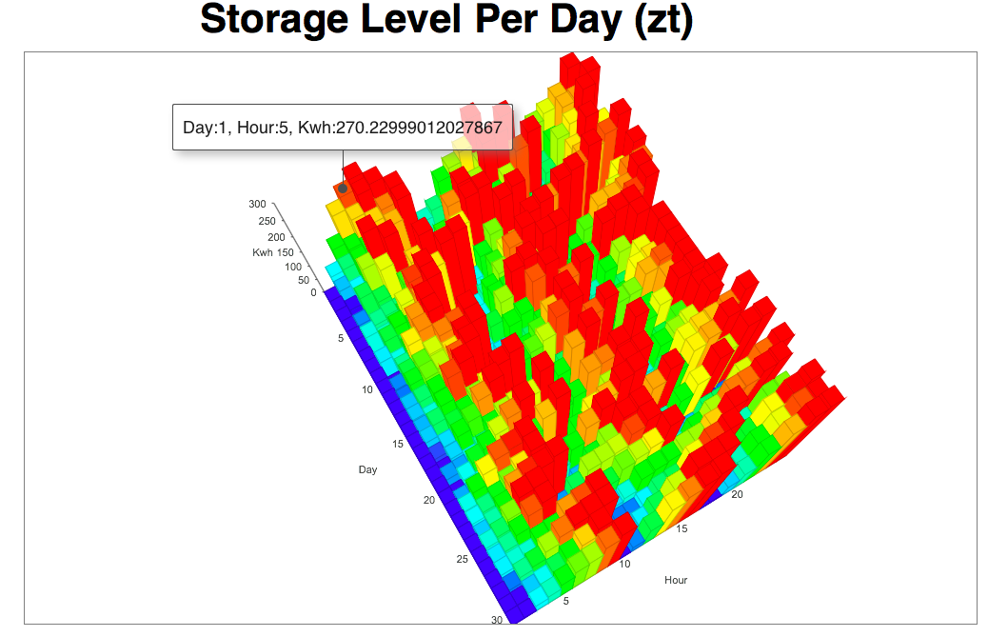

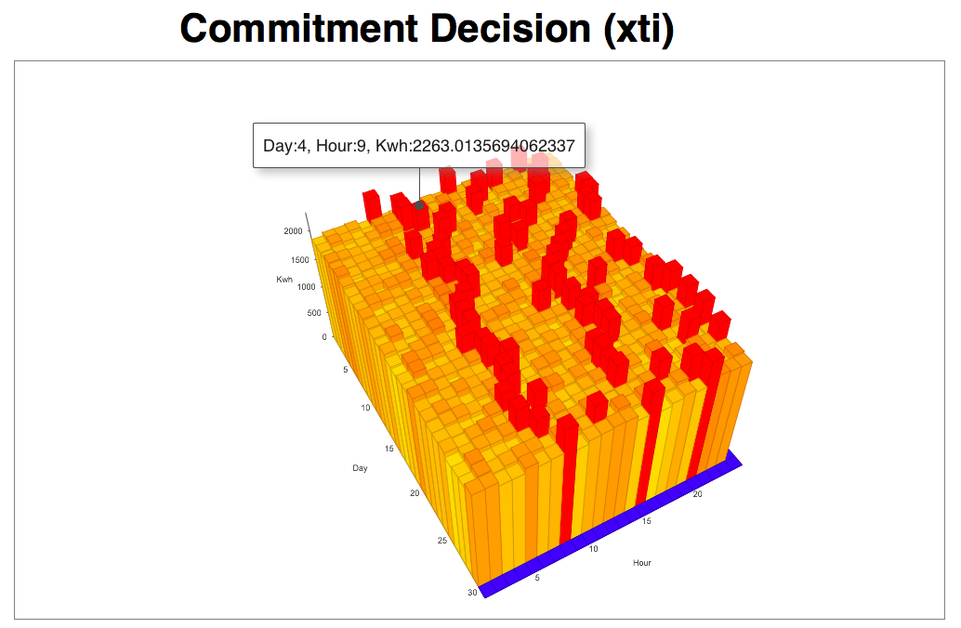

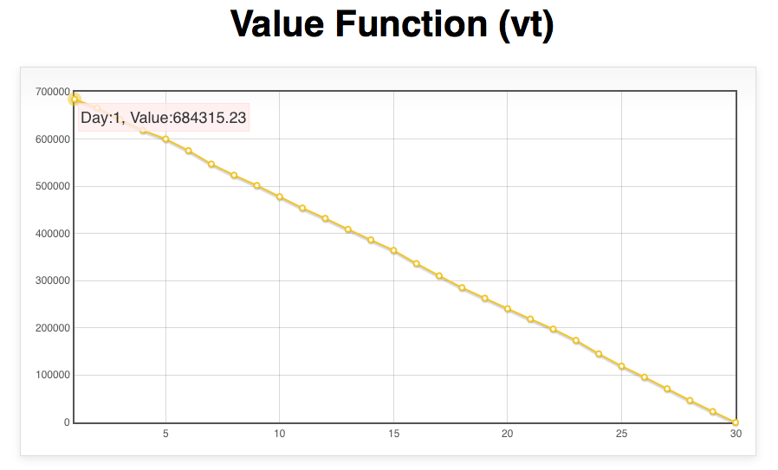

**Scenario B- Medium storage capacity (Rj=600 kwh) with small variance of wind power to battery storage N(900,100) under a Beta(α,β) process unmet commitment (:**

**Achieve two energy storage peaks under medium storage level, and medium value of commitment decisions per day. The energy storage peaks are noon and midnight of each day.**

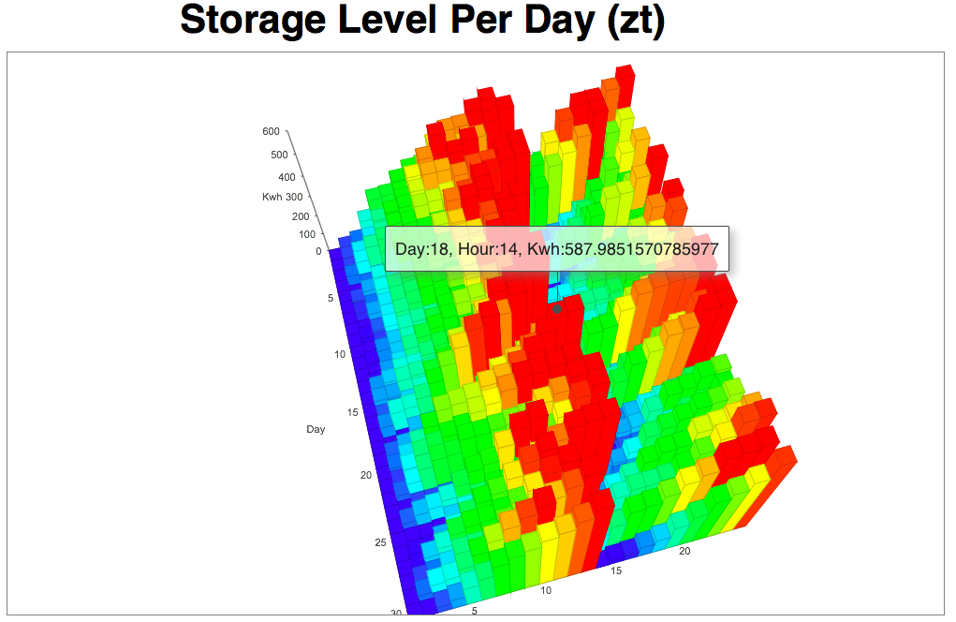

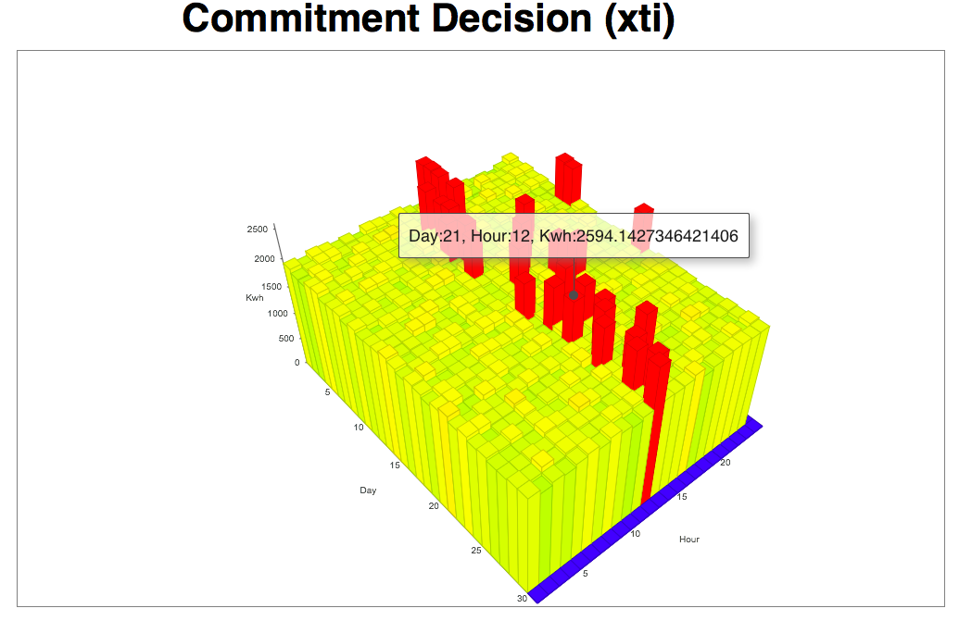

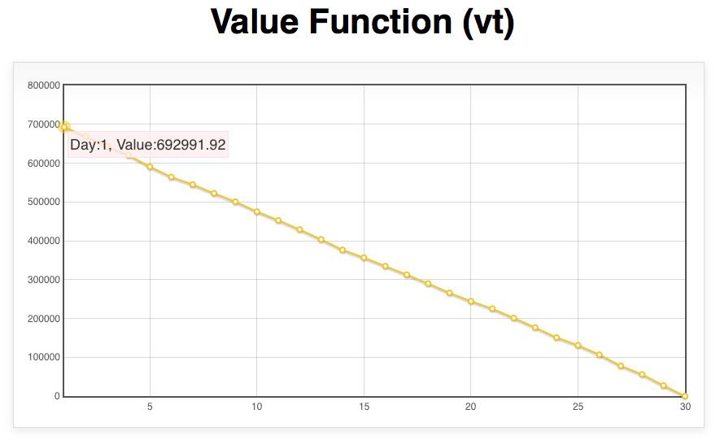

**Scenario C- Large storage capacity (Rj=900 kwh) with small variance of wind power to battery storage N(900,100) under a Beta (α,β) process unmet commitment (:**

**Achieve one energy storage peak under a smaller storage level, and larger value of commitment decisions per day. The energy storage peak is midnight of each day.**

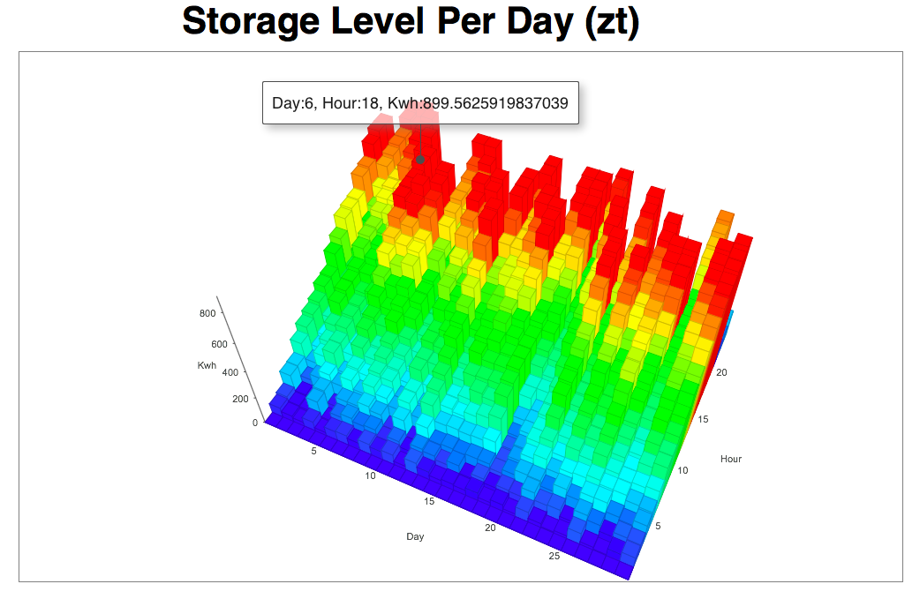

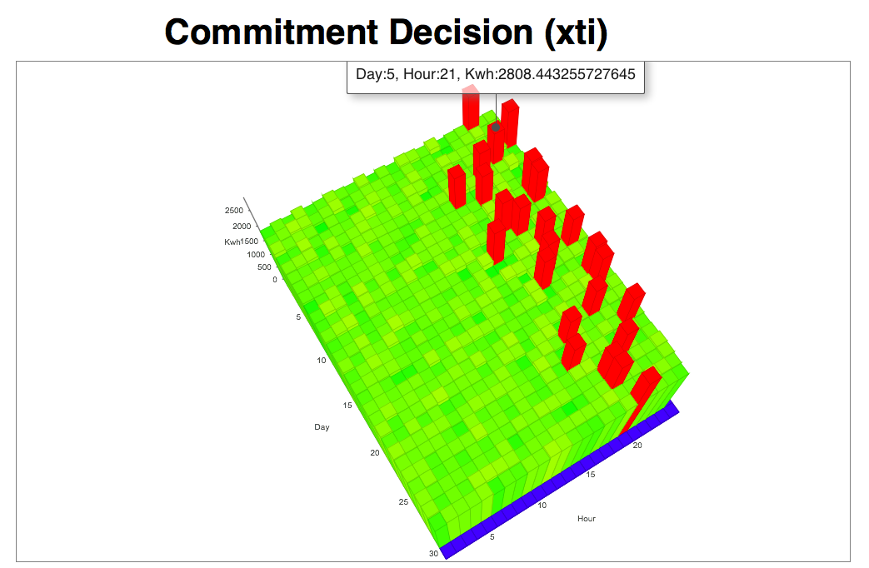

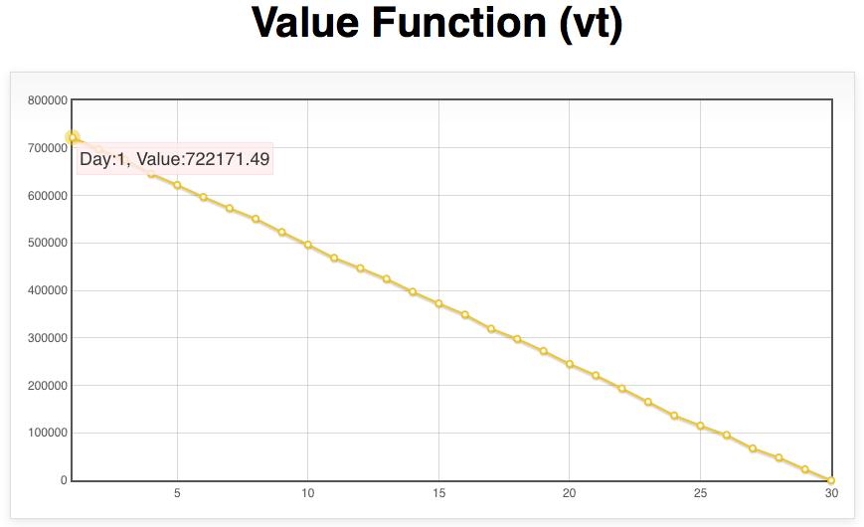

**Scenario D- Small storage capacity (Rj=300 kwh) with large variance of wind power to battery storage N(900,500) under a Beta (α,β) process unmet commitment (:**

**Almost achieve maximum storage level, and smaller value of commitment decision every day. The larger variance of wind power to battery storage produces a greater and more harmonious value of commitment decisions and operating value per day.**

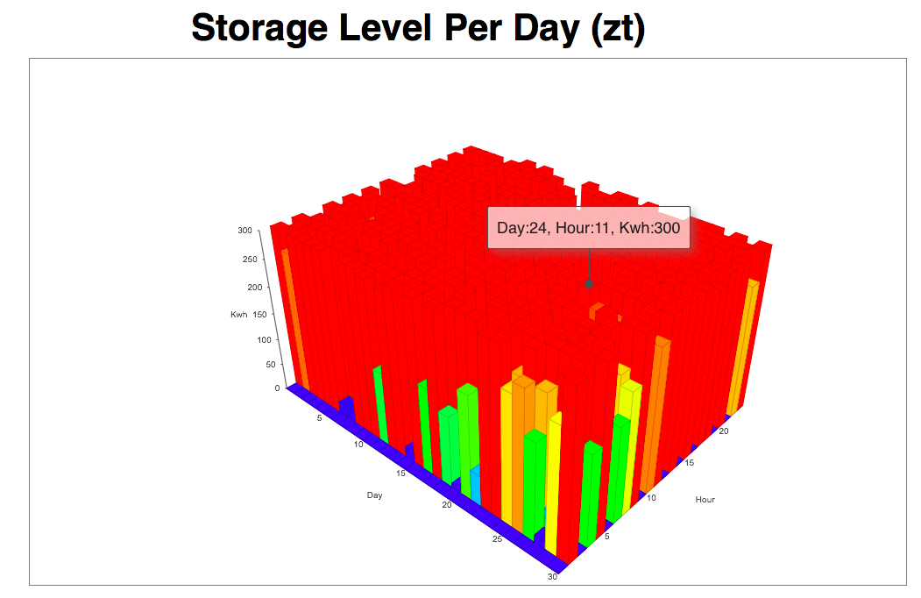

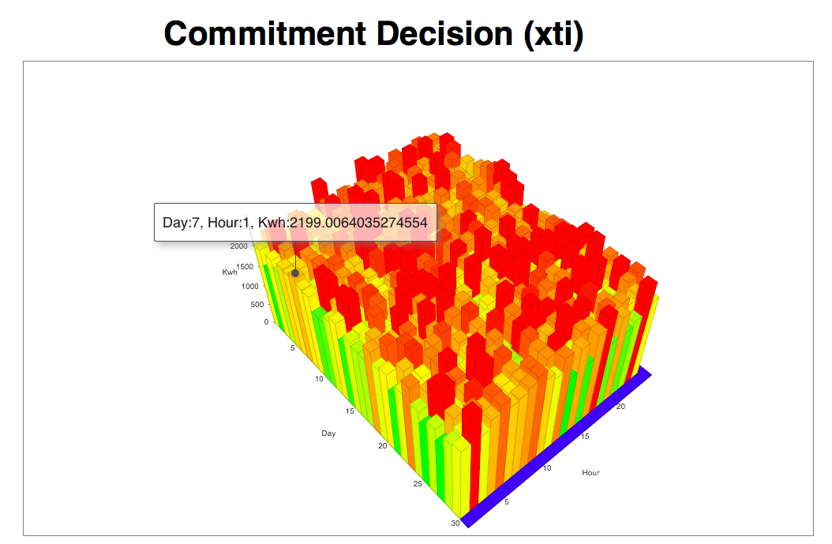

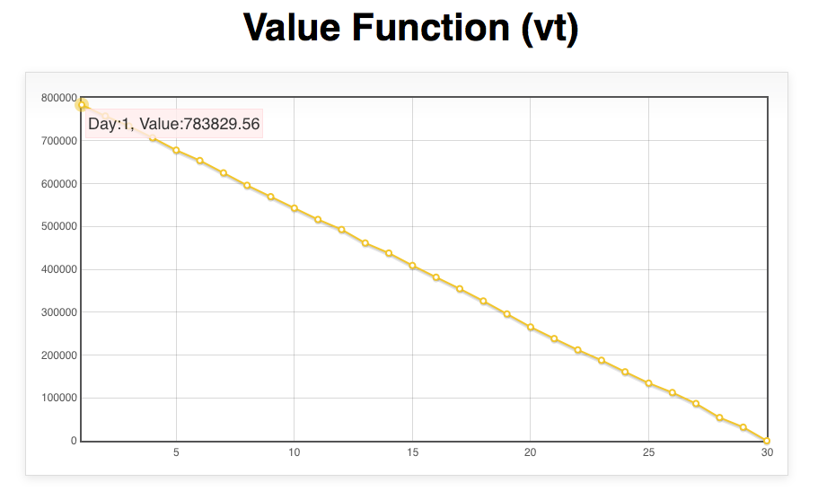

**Scenario E- Medium storage capacity (Rj=600 kwh) with large variance of wind power to battery storage N(900,500) under a Beta (α,β) process unmet commitment (:**

**Almost but sparsely achieve maximum storage level, and smaller value of commitment decision every day. The larger variance of wind power to battery storage produces a greater and more harmonious value of commitment decisions and operating value per day.**

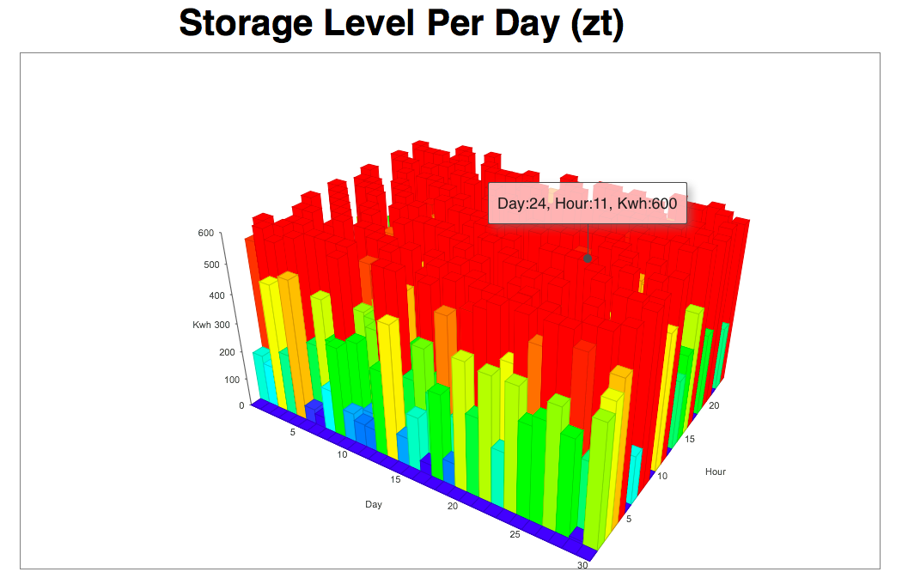

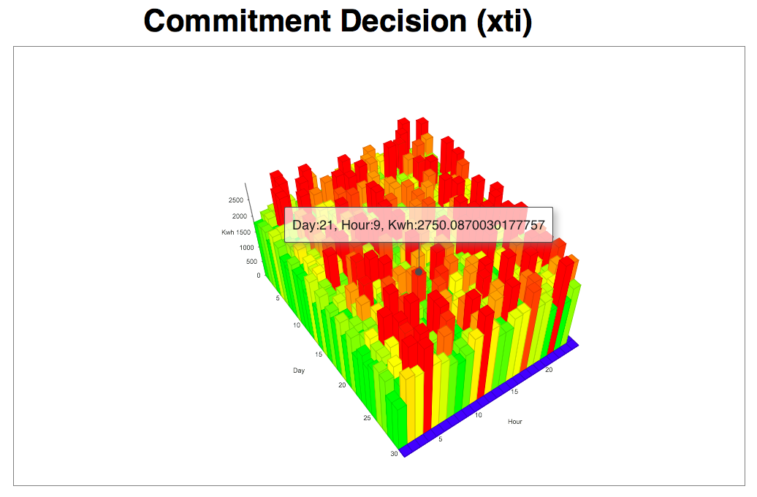

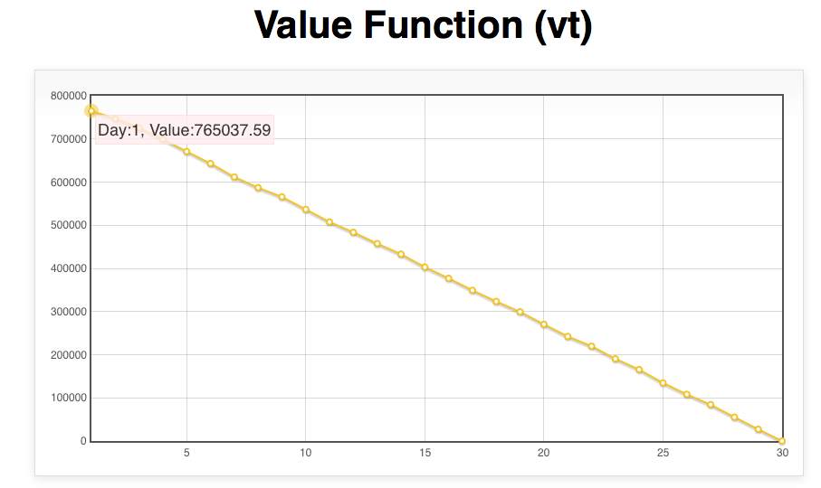

**Scenario F**

**Large storage capacity (Rj=900 kwh) with large variance of wind power to battery storage N(900,500) under a Beta (α,β) process unmet commitment (:**

**Almost but even more sparsely achieve maximum storage level, and smaller value of commitment decisions every day. The larger variance of wind power to battery storage produces a greater and more harmonious value of commitment decisions and operating value per day.**

