# LAB REPORT

# Lab 3: Control Design Using the Root Locus

# Lab Date: Monday November 18, 2019

# Submission Date:

# Prelab: 1 marks

# Lab Report: 4 marks

# Lab Work: 5 marks

|  |  |
| --- | --- |
| Name | Student Number |
| Bingran Li | 1004191910 |
| Omar ElZaria | 1004095739 |
|  |  |

## 4.1 Identification of model parameters

(0.25 mark) Estimated parameters are: a = 1.576 b = 11

## 4.2.1 Controller design using Matlab, Part1

(0.25 mark) Root locus plot when TI = 1.

Using the plot, prove that there doesn’t exist K>0 such that the closed-loop system has two poles on the real axis with real part<-20.

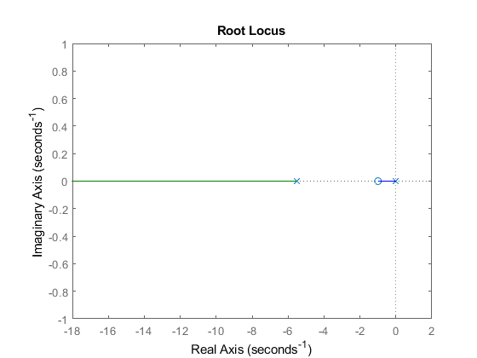

(0.25 mark) Value of TI and K for which the closed-loop system has two poles at S = -20,

TI = 0.0725 K = 18.4

(0.25 mark) Root locus plot for the value of TI you just found.

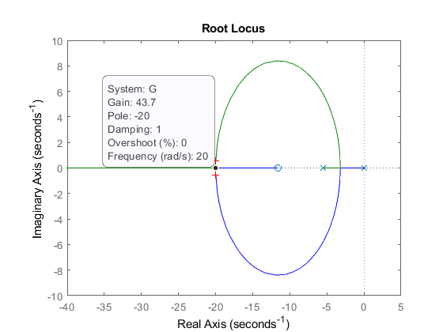

## 4.2.2 Controller design using Matlab, Part2

(0.25 mark) Plot showing one period of the simulation output (with proper labels).

What is the estimated value of the settling time: Ts = 0.18s

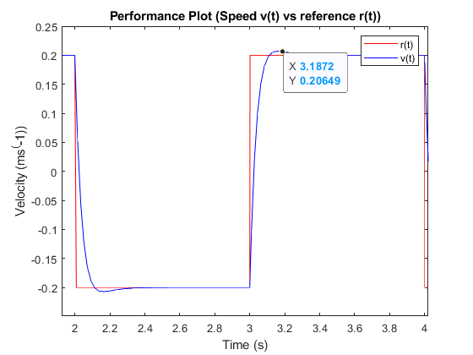

(0.25 mark) Plot showing the control input voltage Vm(t) (with proper labels).

What is the peak value of Vm(t) ? 5.82V

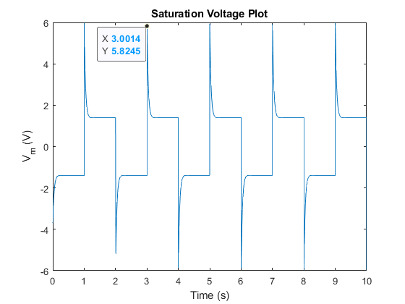

## 4.2.3 Controller design using Matlab, Part3

(0.25 mark) Value of TI and K for the more aggressive controller (S = -30)

TI = 0.0544 K = 31.1

(0.25 mark) Plot showing one period of the simulation output (with proper labels).

What is the estimated value of the settling time: Ts = 0.15s

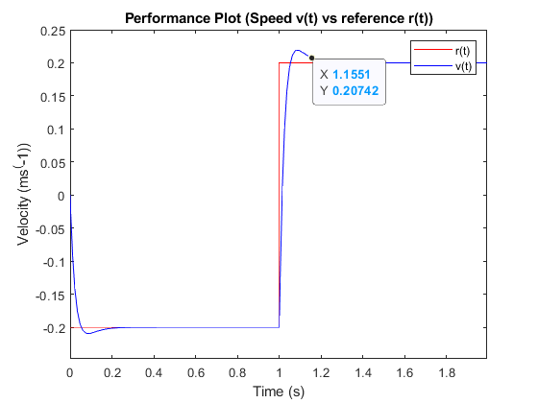

(0.25 mark) Plot showing the control input voltage Vm(t) (with proper labels).

What is the peak value of Vm(t) ? 11.01V

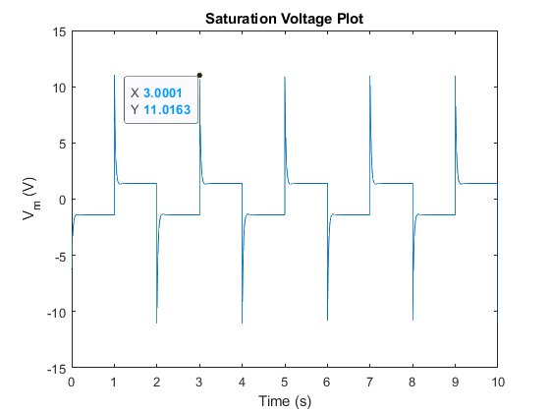

(0.75 mark) Compare the performance of the two controller you designed earlier.

How do settling time and overshoots compare? How about maximum value of Vm(t)?

Which controller is best suited to meet the specifications?

What is the cause of the differences between the two controllers?

## 4.3 Controller Implementation

(0.5 mark) Normal controller, with no disturbance:

Plot showing actual cart speed V(t) and reference r(t) (with proper labels).

What is the estimated value of the settling time: Ts = 0.26s

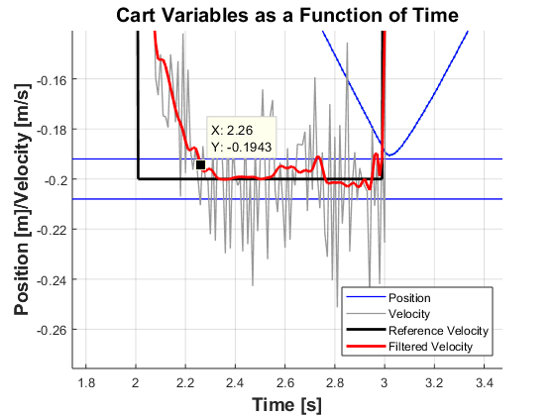

(0.5 mark) Normal controller, when cart is tilted:

Plot showing actual cart speed V(t) and reference r(t) (with proper labels).

What is the estimated value of the settling time: Ts = 0.26s

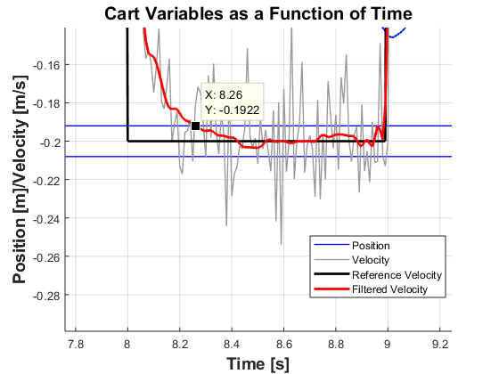

(0.5 mark) Aggressive controller, with no disturbance:

Plot showing actual cart speed V(t) and reference r(t) (with proper labels).

What is the estimated value of the settling time: Ts = 0.17s

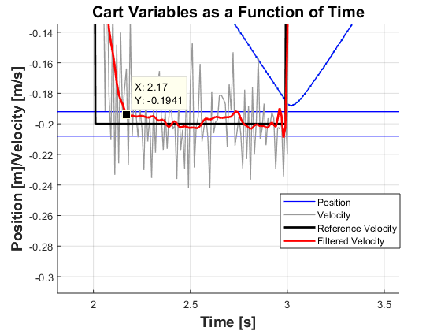

(0.5 mark) Aggressive controller, when cart is tilted:

Plot showing actual cart speed V(t) and reference r(t) (with proper labels).

What is the estimated value of the settling time: Ts = 0.17s

