1. Based on the provided dataset good approach here is using collaborative filtering. Collaborative filtering methods leverage user-item interactions (in this case, user book ratings) to make personalized recommendations. User-Item Collaborative Filtering: Recommend books to users based on the preferences of users with similar “rating scores”. We can calculate similarity scores (e.g., cosine similarity) between users and recommend books that similar users have rated highly.
2. For the future update of the dataset let’s assume that we have big data. To handle a problem of a large amount of data we should implement some form of scaling like alternating least squares (ALS). ALS is a matrix factorization algorithm commonly used for collaborative filtering in recommendation systems. ALS works by factorizing the user-item interaction matrix into two lower-dimensional matrices: one representing users' latent factors and the other representing items' latent factors. These latent factors capture underlying patterns and preferences in the data.
3. Using PySpark for collaborative filtering is a good idea when dealing with large datasets, as it allows for distributed computing and can handle big data efficiently. PySpark provides a library called pyspark.ml that includes collaborative filtering algorithms such as Alternating Least Squares (ALS) for recommendation tasks.
4. Also if we would like to get a product from our machine-learning model we have to use a more structured approach. In my opinion, we can use Azure Databricks as a platform for our project.
5. This recommendation book model could be implemented on a website. This website could be on JavaScript.

There are two parts to developing a JavaScript website.

1. Front-End Development:

* ***UI/UX Design:*** Design the user interface of your website. This includes creating user profiles, allowing users to rate books, and displaying book recommendations.
* ***User Registration/Login:*** Implement user registration and login functionality to track user preferences and interactions.
* ***User Interaction:*** Create user interfaces for users to rate books, provide feedback, and request recommendations.
* ***Display Recommendations:*** Design a section of your website to display recommended books to users.

2. Back-End Development:

* ***Server:*** Set up a server using a JavaScript runtime environment like Node.js.
* ***Database:*** AWS S3 to store user data, book data, and user interactions (e.g., book ratings). Azure Databricks provides seamless integration with AWS S3, allowing you to read data from and write data to S3 buckets. This is especially useful when you have data stored in AWS S3 that you want to process or analyze within the Azure Databricks environment.
* ***APIs:*** Develop RESTful APIs to handle user registration, login, book ratings, and recommendation requests. We can create an API endpoint in Python within Azure Databricks using web frameworks like Flask or FastAPI. This endpoint can serve as an interface for our JavaScript-based website to communicate with the machine learning model.
* ***Authentication:*** Implement user authentication and authorization mechanisms to ensure secure access to user data.
* ***Recommendation Logic:*** Build the recommendation engine on the server side. In our case, it would be collaborative filtering on PySpark in Azure Databricks.
* ***Data Preprocessing:*** Preprocess and clean the data to make it suitable for recommendation algorithms.

1. For the future improvement of our machine learning model, we could use a hybrid model. Combine collaborative and content-based filtering for more accurate recommendations. For instance, we can use collaborative filtering to identify users with similar “rating scores” and then use content-based filtering to recommend books within that genre or style. For example, if the user likes fantasy novels with epic quests, recommend books with similar attributes.

Based on the provided dataset here is my planning workflow:

1. Set up PySpark environment: ensure we have a Spark cluster available for distributed processing.
2. Load User and Book Ratings data into PySpark DataFrames.

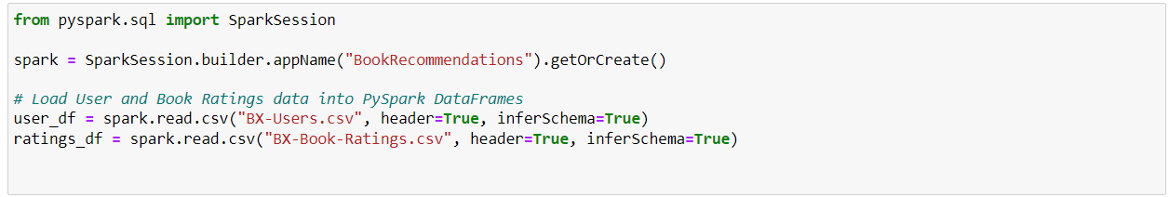

1. Use the ALS algorithm from pyspark.ml to build a collaborative filtering model.

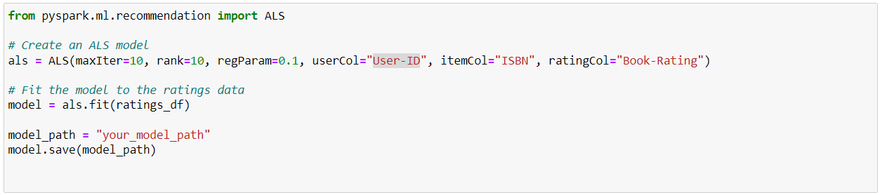

We can configure an ALS model by specifying parameters such as maxIter (maximum number of iterations), rank (dimensionality of the latent factors), and regParam (regularization parameter). These parameters control the model's training process and regularization.

Once we have a trained ALS model, we can generate book recommendations for a target user. Provide the user's ID, and the model will predict their ratings for unrated books.

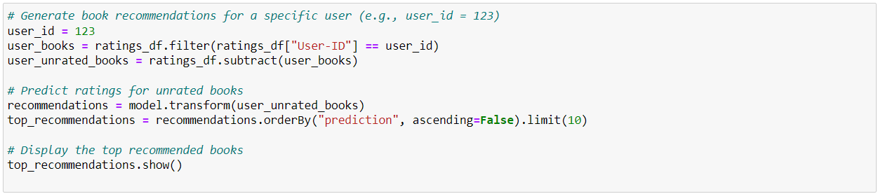

1. The next step is creating a RESTful API using Flask to serve recommendations. In terms of Azure Databrick.

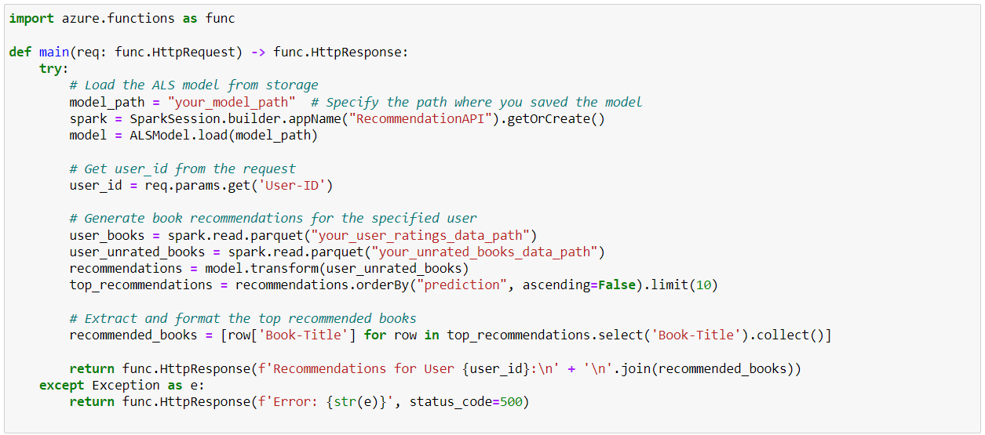

1. It creates an Azure Function that loads the saved ALS model and generates book recommendations.
2. Then, deploy the Azure Function to our Azure subscription.
3. The next step is creating an Azure API Management Service for our model.
4. Inside your Azure API Management service, create a new API. Define the API, including the base URL and version.
5. Define the operations (endpoints) for our API. In our case, we would have a single operation that corresponds to the Azure Function serving book recommendations. Configure the operation to accept the required parameters, such as the “User-ID”.
6. Depending on our Azure Function's complexity, we can import the API schema automatically from your Azure Function or manually define the request and response schema for the operation.
7. In Azure API Management, we can configure policies to apply to our API operations. For example, we can implement rate limiting, authentication, or request/response transformation policies as needed. That would increase the security of our system.
8. After defining the API and configuring operations and policies, we can publish the API in Azure API Management. After that, the API becomes accessible via the API Management's base URL.
9. When in JavaScript we can handle this API request for example

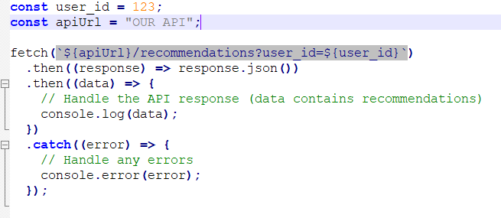

Azure API Management acts as a gateway, managing API traffic, security, and policies, making it easy for our website to consume the API.