MEDIArchive

An application designed by Tyler Hogg, Cole Neville, Julie Perrier, and Brennan Brown.

# Description

MEDIArchive is an application that we want to create to keep track of various media and your progress made through them. For example, a series of movies or books. In today's society, we have a lot of media we can take in. Too much, even. It becomes difficult to remember what exactly you've seen and read or listened to. This application will be a much needed way of ensuring that you don't lose track of all of this.

The application will use APIs of many kinds to track your media intake on many sites, such as Netflix or Youtube. The planned media types include: movies, songs, books, magazines, radio, TV shows, internet browsing, comics, manga, games, images, art.

We expect the system to be used by teens and young adults looking for help keeping tabs on all of their media usage. They would open the site, create an account, and link their account to other websites and databases. For example, if they watched half of a movie on Netflix, their account on MEDIArchive would understand this and add the movie to their list of played movies as well as keep track of the timestamp of where they were at in the movie.

The context they would use it would be a website. They can log on at home or at work. Server-side we would keep track of all of the information and databases, so that it would sync anywhere they used their account.

Lastly, the application would be able to keep track of user statistics. This would enable the application to collect data and make suggestions based on the user’s preferences.

# Stakeholders and Users

The main stakeholder for this application will be the user. The user will invest time into setting up their account to automatically keep track of all of their media so that they can look at it later.

Alternatively, other stakeholders could make use of the data we gather on our user-base. For example, the information regarding what demographics watch certain shows or read certain books, and the relations between the information. In a further example, if a popular romance movie came out, and users who watched this movie also began watching romantic TV shows and listening to romantic music, an advertising company would be able to target these infatuated users with other types of romantic media.

Our primary user target is teens and young adults. Particularly English speaking individuals using services available to Canada. Below are some personas we have crafted using our interviews and demographic research.

## Personas



Manny Smith [1]

* Avid Brony
* No strong male role model in life
* Adores Reddit
* Anime and Manga fan
* Owns a fake katana
* Low-fame Let’s Player
* Still makes rage comics in this year of 2017
* Hates outdoors
* Plays World of Warcraft
* Plays League of Legends
* Fan-fiction writer
* Owns fedora and trench coat
* Lives with parents
* Has no job and isn’t in school
* Uses memes in real life
* Thinks he’s good at technology

Media desired to be stored include League champions statistic charts, fan-art, Youtube videos (his own and others), fan-fiction, memes, anime and manga lists, video games, comics, web comics.



Chloe Yung [2]

* Not very confident in their decision making
* Knows how to drive
* Lives in a small apartment with several roommates
* Lives off cheap food
* Hates doing household chores
* Always tired
* Has a job at a retail/fast food/grocery store
* In post-secondary
* In a relationship more serious than dating when they were a teen
* Questions their choices in life
* Always stressed
* Self-depreciating
* Doesn’t have much time to sort their media intake
* A little bit more patient because life requires it

Media desired to be stored include movies, TV series sorted by casual watching and binge watching, Youtube videos, books, images, schedules, webcomics.



Karl Cheng

* Cares about appearances
* Keeps up on new trends
* Wants to impress friends
* Copies other’s homework
* Has a designated clique
* Claims to hate school
* Still tries their best in class
* Needs to be woken up every morning
* Likes to procrastinate
* Likes short videos to watch when getting things done
* Has several accounts on different social media
* Draws or keeps a collection of friend’s drawings
* Impatient
* Wants to hang out with friends often
* Has been in 0-2 serious relationships

Media desired to be stored include short videos, music and music videos, drawings, camera taken pictures, webcomics, video games, books, wants separation/distinction in storing between friends/things done with friends and own media.

# Research Methods

## Interviews:

Questions:

1. What kind of UI do you prefer? A minimalistic and flat design, that is simple. Or a realistic and detailed design?
2. What kind of details do you want to remember about your media?
3. What kinds of media would you like to track?
4. How do you find new media?
5. What options would you like to sort and search your media?
6. Would you like to schedule or plan out your media?

Person 1

1. Realistic
2. Graphics/Aesthetics
3. Internet movies/video music
4. Internet browsing
5. What is most viewed
6. Date, time

Person 2

1. Realistic and detailed
2. Everything
3. Movies, music and TV shows
4. Word of mouth, radio for songs and browsing the internet
5. New releases and whatever is available
6. Nothing in the morning and a little on the weekend

Person 3

1. Does not know
2. Color, expression and mood
3. TV and music
4. Online/google, Spotify or word of mount
5. Instrument/genre?
6. Spontaneous/non-scheduled

## Demographic Research

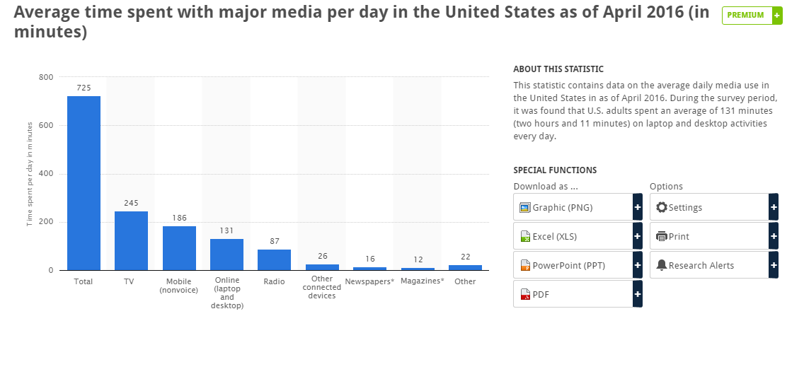

## Conclusions

The conclusions we drew from this information was that our target audience has a preference for realistic (or skeuomorphic) UI designs. We also discovered a number of unconsidered genres and mediums that we hadn’t thought of, so we added those into our design.

# TASK DESCRIPTIONS

1. **Create an account**

MEDIArchive allows a user to create an account to access their portion of our server and the database of their selected media varieties. An account is private to a user and can be accessed by them at any place they have internet.

1. **Make a search for their desired type of media**

MEDIArchive gives the user an option to select a type of media from a large range spanning from essentially anything the user can think of. They can search for their specific type of media whether it be a book, game, or even if they want to keep track of progress in something of their own creation, a layout is available for each different type depending on what attributes they would have.

1. **Store information of where they are in a media**

Our system can take in all records a user wants to fill in regards to their use of the media they want to keep track of. They only need to fill in the details they would desire to have saved, or pieces that contribute to calculations they would like to view.

1. **Schedule time to devote to said media**

Another aspect MEDIArchive can track is a schedule where a user can store plans to engage in each selection of media. They can categorize their media and remember to keep up on some, such as readings they’d have to do for classes. This way, a busy user don’t have to concern about keeping up to date on their life requirements and leisure.

1. **Access statistics and records of each piece of media they have stored**

Depending on the input values the user enters on their media entries, they can access a whole lot more than simply what they’ve put in. Calculations on their process by percentage and how many hours per day/week should be spent on a piece of media to complete it by a certain deadline are available for the user who plans ahead, as well as plenty of other functions.

1. **Find new popular/related media to explore at their leisure**

MEDIArchive is able to use data from a user’s interests to suggest other pieces of media they may also be interested in. A user may explore from a list of what is popular, and also relevant to their own interests. With this, a user is free to view more media varieties they could find themselves enjoying.

# Proof



Table - A chart displaying media usage per day in 2016 [4]

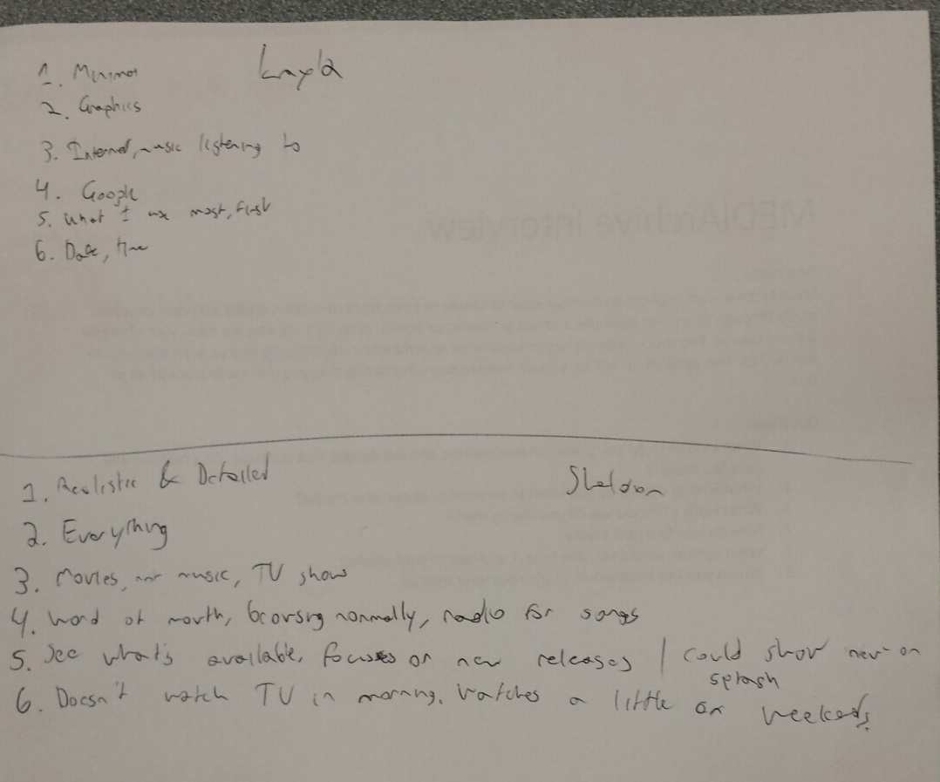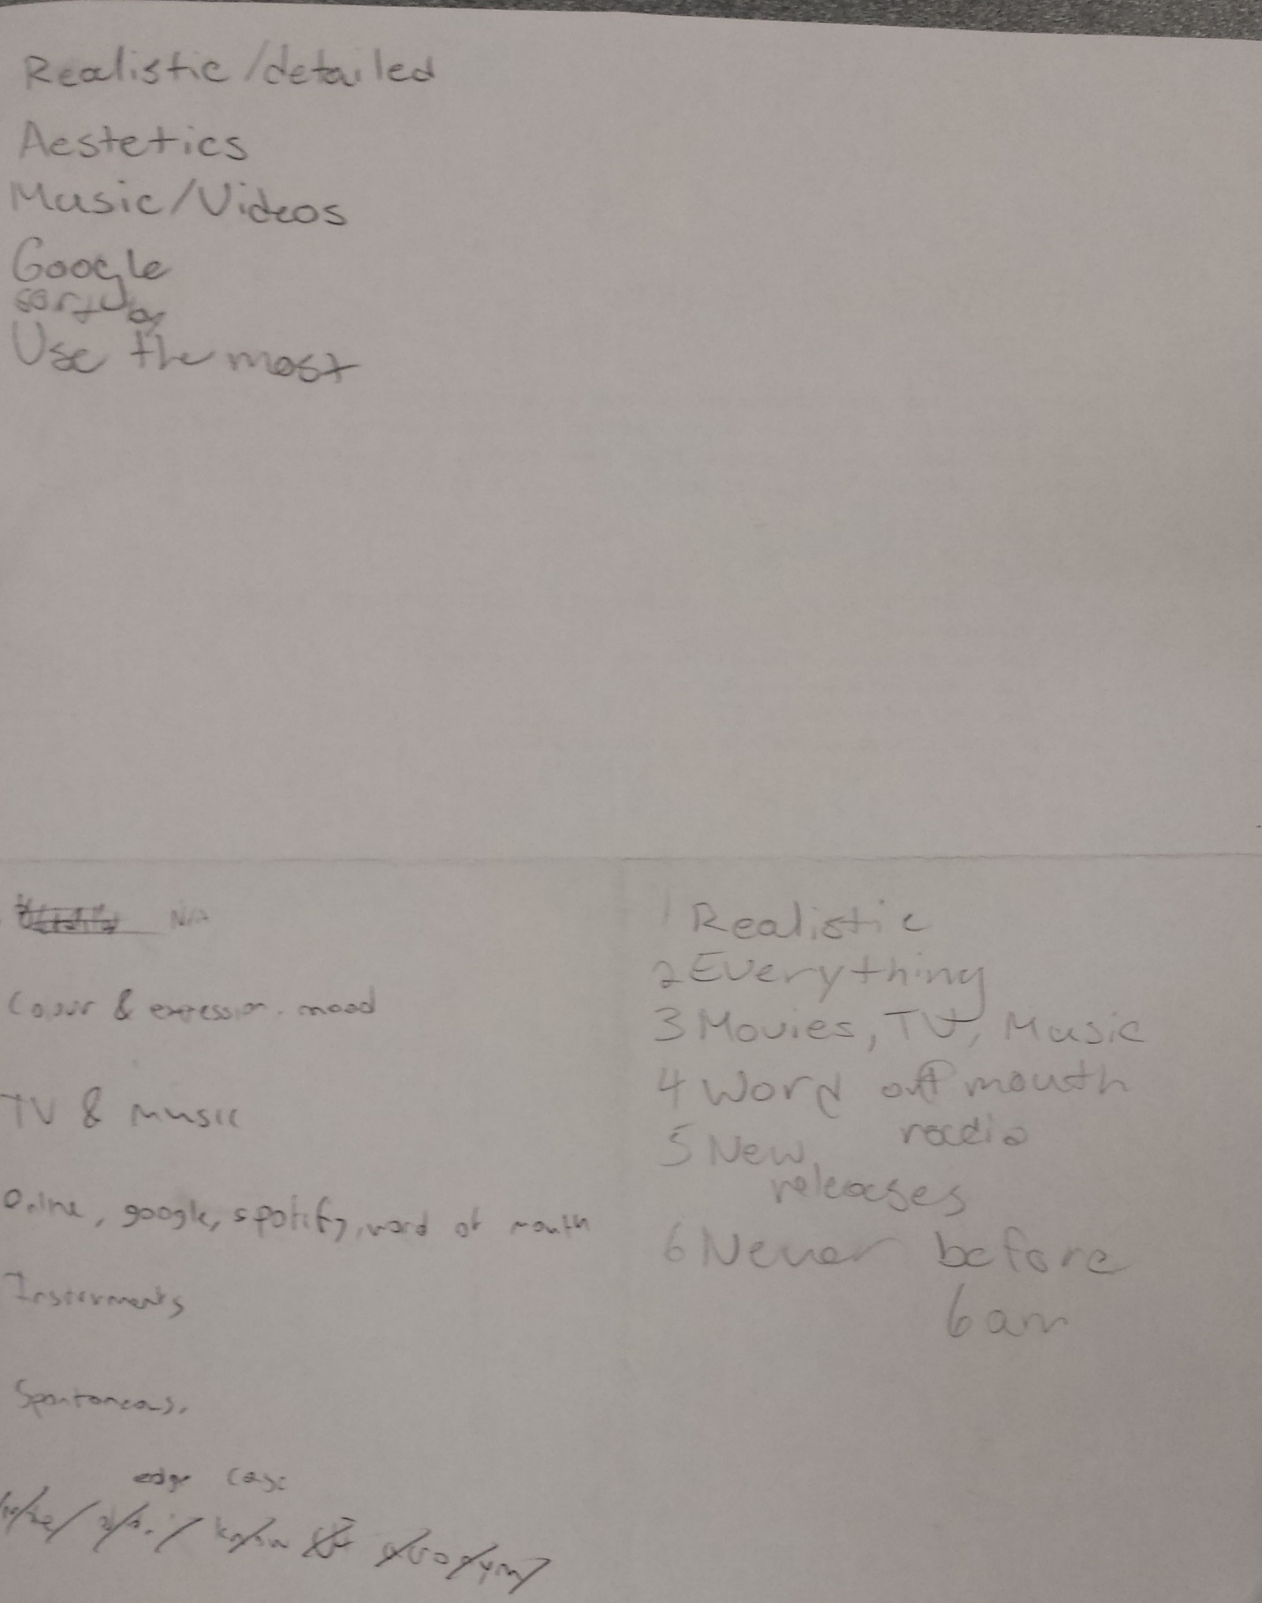

# Bibliography

1. Tom, "(not) embracing adulthood," in *Daniel Tosh in a Baby Chair*, 2011. [Online]. Available: https://tomgilchrist.wordpress.com/tag/man-child/. Accessed: Feb. 16, 2017.
2. "EPIC young adult program - work2future foundation youth program," in *W2FF*, work2future Foundation Youth Program, 2017. [Online]. Available: http://w2ff.org/epic-young-adult-program/. Accessed: Feb. 16, 2017
3. Administrator, "Stop saying ‘That’s so gay!’: 6 types of Microaggressions that harm LGBTQ people," Psychology Benefits Society, 2014. [Online]. Available: https://psychologybenefits.org/2014/02/07/anti-lgbt-microaggressions/comment-page-2/. Accessed: Feb. 16, 2017.
4. "Media use in the U.S. 2016 | statistic," Statista, 2016. [Online]. Available: https://www.statista.com/statistics/276683/media-use-in-the-us/. Accessed: Feb. 16, 2017.