

**School of Computer Science and Engineering**

DBMS Course Project Report

on

**Image Caption Generator**

Submitted by

**Mr. Abbasali Jamadar 01FE20BCS414**

**Ms. Neha Kardant 01FE20BCS422**

**Mr. Nihal Fernandis 01FE19BCS237**

**Table of Contents**

Content Page No.

1. Introduction 3
2. Proposal Phase
   1. Problem Statement 4
   2. Proposed Method of Solving 4
   3. Image Caption Generator Model 4
   4. Explanation on each modules 5
3. Design Phase
   1. Dataset being used 6
4. Implementation Phase
   1. Importing all the necessary packages 7
   2. Getting and performing data cleaning 8
   3. Extracting feature vector from all images 11
   4. Loading dataset for training the model 12
   5. Tokenizing the vocabulary 14
   6. Create Data Generator 15
   7. Defining the CNN-RNN model 16
   8. Training the model 17
   9. Testing the model 17
   10. Results 19
5. References 20

1. User manual/Readme 20

**Introduction:**

**What?**

Image caption generator is a task that involves computer vision and natural language processing concepts to recognize the context of an image and describe them in a natural language like English.

**Why?**

You saw an image and your brain can easily tell what the image is about, but can a computer tell what the image is representing? Computer vision researchers worked on this a lot and they considered it impossible until now! With the advancement in Deep learning techniques, availability of huge datasets and computer power, we can build models that can generate captions for an image. With the availability of such techniques there are software’s that are developed that use these techniques to improve their quality of service and provide better user experience while using the software some such software’s are Photoshop, Blender, Unity 3D, Movie maker etc

**How?**

The objective of our project is to learn the concepts of a CNN and LSTM model and build a working model of Image caption generator by implementing CNN with LSTM. In this Python project, we will be implementing the caption generator using [***CNN (Convolutional Neural Networks)***](https://data-flair.training/blogs/convolutional-neural-networks-tutorial/)and LSTM (Long short term memory). The image features will be extracted from Xception which is a CNN model trained on the imagenet dataset and then we feed the features into the LSTM model which will be responsible for generating the image captions.

**Problem Statement:**

Humans can see an image and can easily tell what the image is about, but can a computer tell what the image is representing? Computer vision researchers worked on this a lot and they considered it impossible until now! With the advancement in Deep learning techniques, availability of huge datasets and computer power, we can build models that can generate captions for an image.

**Proposed method of solving:**

In this Python project, we will be implementing the caption generator using ***CNN (Convolutional Neural Networks)***and LSTM (Long short term memory). The image features will be extracted from Xception which is a CNN model trained on the images dataset and then we feed the features into the LSTM model which will be responsible for generating the image captions.

**Pre-requisites:**

Pip**,** keras**,** tqdm**,** numpy**,** jupyterlab

**Image Caption Generator Model:**

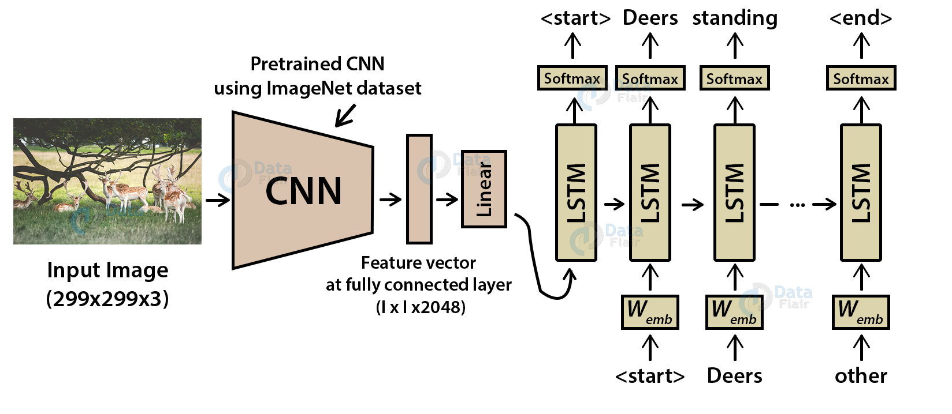

CNN is used for extracting features from the image. We will use the pre-trained model Xception. LSTM will use the information from CNN to help generate a description of the image. It is also called a CNN-RNN model.

**Explanation on each of the modules in the methodology:**

**Convolutional Neural networks (CNN):**

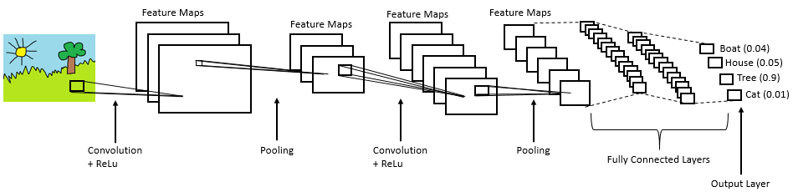

Convolutional Neural networks are specialized deep neural networks which can process the data that has input shape like a 2D matrix. Images are easily represented as a 2D matrix and CNN is very useful in working with images.

**Long short term memory (LSTM):**

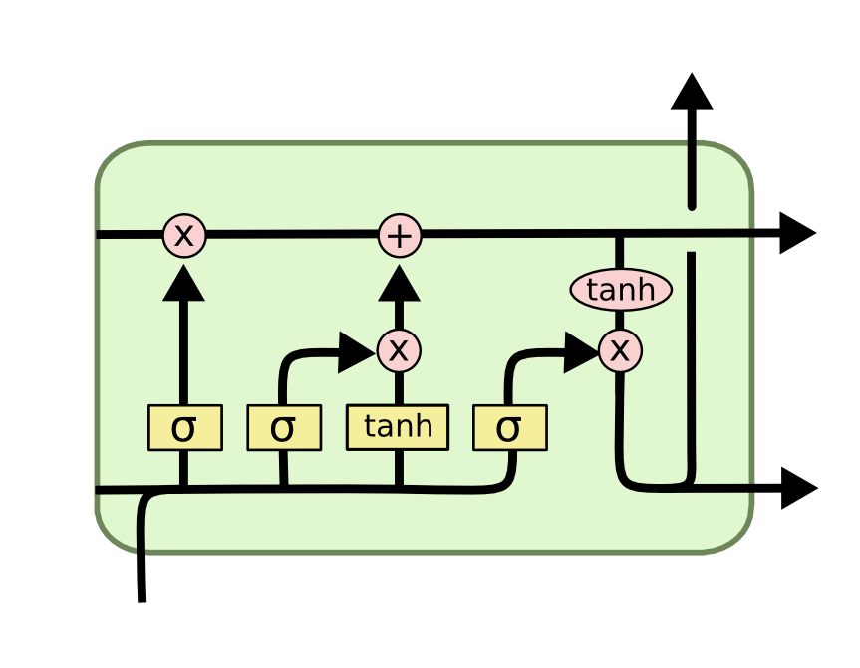

LSTM stands for Long short term memory is a RNN (recurrent neural network) which is well suited for sequence prediction problems. Based on the previous text, we can predict what the next word will be. It has proven itself effective from the traditional RNN by overcoming the limitations of RNN which had short term memory. LSTM can carry out relevant information throughout the processing of inputs and with a forget gate, it discards non-relevant information.

**Dataset being used details:**

**Snapshots:**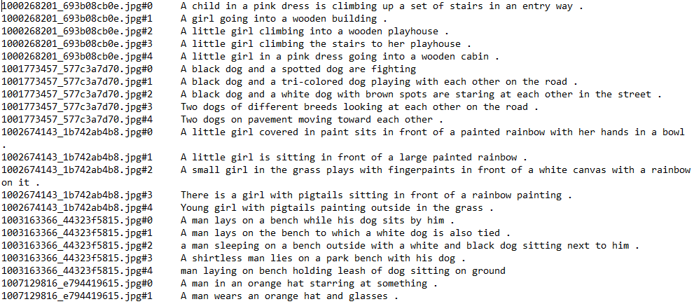

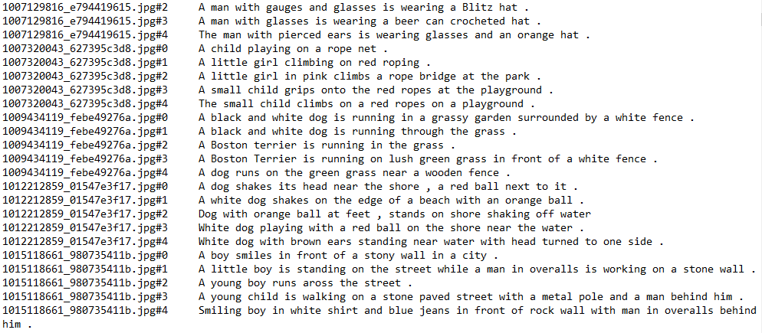

**Building the Python based Project**

We start by initializing the jupyter notebook server by typing jupyter lab in the console of your project folder. It will open up the interactive Python notebook.

Creating a Python3 notebook and naming it **training_caption_generator.ipynb**

1. **First, we import all the necessary packages**

**Code:**

import string

import numpy as np

from PIL import Image

import os

from pickle import dump, load

import numpy as np

from keras.applications.xception import Xception, preprocess_input

from keras.preprocessing.image import load_img, img_to_array

from keras.preprocessing.text import Tokenizer

from keras.preprocessing.sequence import pad_sequences

from keras.utils import to_categorical

from keras.layers.merge import add

from keras.models import Model, load_model

from keras.layers import Input, Dense, LSTM, Embedding, Dropout

# small library for seeing the progress of loops.

from tqdm import tqdm_notebook as tqdm

tqdm().pandas()

1. **Getting and performing data cleaning**

The main text file which contains all image captions is **Flickr8k.token** in our **Flickr_8k_text** folder.

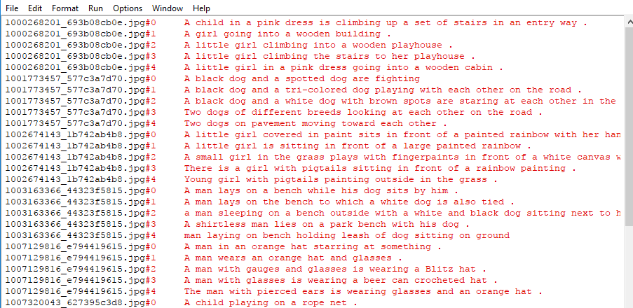

The format of our file is image and caption separated by a new line (“\n”).

Each image has 5 captions and we can see that #(0 to 5)number is assigned for each caption.

We will define 5 functions:

* **load_doc( filename ) –** For loading the document file and reading the contents inside the file into a string.
* **all_img_captions( filename ) –** This function will create a **descriptions** dictionary that maps images with a list of 5 captions. The descriptions dictionary will look something like this:

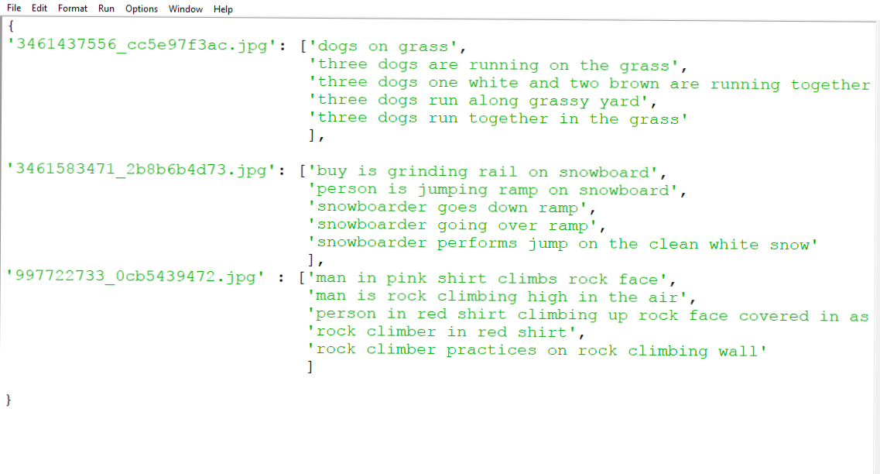

* **cleaning_text( descriptions) –** This function takes all descriptions and performs data cleaning. This is an important step when we work with textual data, according to our goal, we decide what type of cleaning we want to perform on the text. In our case, we will be removing punctuations, converting all text to lowercase and removing words that contain numbers.  
  So, a caption like “A man riding on a three-wheeled wheelchair” will be transformed into “man riding on three wheeled wheelchair”
* **text_vocabulary( descriptions ) –** This is a simple function that will separate all the unique words and create the vocabulary from all the descriptions.
* **save_descriptions( descriptions, filename ) –** This function will create a list of all the descriptions that have been preprocessed and store them into a file. We will create a descriptions.txt file to store all the captions. It will look something like this:

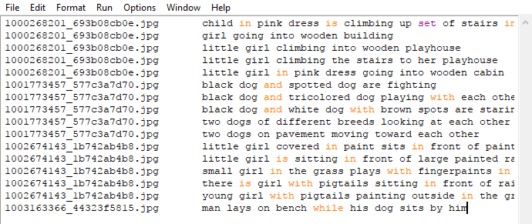

**Code :**

# Loading a text file into memory

**def** load_doc(filename):

# Opening the file as read only

file = open(filename, 'r')

text = file.read()

file.close()

**return** text

# get all imgs with their captions

**def** all_img_captions(filename):

file = load_doc(filename)

captions = file.split('\n')

descriptions ={}

**for** caption **in** captions[:-1]:

img, caption = caption.split('\t')

**if** img[:-2] not **in** descriptions:

descriptions[img[:-2]] = [ caption ]

**else**:

descriptions[img[:-2]].append(caption)

**return** descriptions

#Data cleaning- lower casing, removing puntuations and words containing numbers

**def** cleaning_text(captions):

table = str.maketrans('','',string.punctuation)

**for** img,caps **in** captions.items():

**for** i,img_caption **in** enumerate(caps):

img_caption.replace("-"," ")

desc = img_caption.split()

#converts to lowercase

desc = [word.lower() **for** word **in** desc]

#remove punctuation from each token

desc = [word.translate(table) **for** word **in** desc]

#remove hanging 's and a

desc = [word **for** word **in** desc **if**(len(word)>1)]

#remove tokens with numbers in them

desc = [word **for** word **in** desc **if**(word.isalpha())]

#convert back to string

img_caption = ' '.join(desc)

captions[img][i]= img_caption

**return** captions

**def** text_vocabulary(descriptions):

# build vocabulary of all unique words

vocab = set()

**for** key **in** descriptions.keys():

[vocab.update(d.split()) **for** d **in** descriptions[key]]

**return** vocab

#All descriptions in one file

**def** save_descriptions(descriptions, filename):

lines = list()

**for** key, desc_list **in** descriptions.items():

**for** desc **in** desc_list:

lines.append(key + '\t' + desc )

data = "\n".join(lines)

file = open(filename,"w")

file.write(data)

file.close()

# Set these path according to project folder in you system

dataset_text = "D:\WickedG0d\ Image Caption Generator\Flickr_8k_text"

dataset_images = "D:\ WickedG0d\Image Caption Generator\Flicker8k_Dataset"

#we prepare our text data

filename = dataset_text + "/" + "Flickr8k.token.txt"

#loading the file that contains all data

#mapping them into descriptions dictionary img to 5 captions

descriptions = all_img_captions(filename)

print("Length of descriptions =" ,len(descriptions))

#cleaning the descriptions

clean_descriptions = cleaning_text(descriptions)

#building vocabulary

vocabulary = text_vocabulary(clean_descriptions)

print("Length of vocabulary = ", len(vocabulary))

#saving each description to file

save_descriptions(clean_descriptions, "descriptions.txt")

1. **Extracting the feature vector from all images**

This technique is also called transfer learning, we don’t have to do everything on our own, we use the pre-trained model that have been already trained on large datasets and extract the features from these models and use them for our tasks. We are using the Xception model which has been trained on imagenet dataset that had 1000 different classes to classify. We can directly import this model from the keras.applications . Make sure you are connected to the internet as the weights get automatically downloaded. Since the Xception model was originally built for imagenet, we will do little changes for integrating with our model. One thing to notice is that the Xception model takes 299*299*3 image size as input. We will remove the last classification layer and get the 2048 feature vector.

model = Xception( include_top=False, pooling=’avg’ )

The function **extract_features()** will extract features for all images and we will map image names with their respective feature array. Then we will dump the features dictionary into a “features.p” pickle file.

**Code:**

def extract_features(directory):

model = Xception( include_top=**False**, pooling='avg' )

features = {}

**for** img **in** tqdm(os.listdir(directory)):

filename = directory + "/" + img

image = Image.open(filename)

image = image.resize((299,299))

image = np.expand_dims(image, axis=0)

#image = preprocess_input(image)

image = image/127.5

image = image - 1.0

feature = model.predict(image)

features[img] = feature

**return** features

#2048 feature vector

features = extract_features(dataset_images)

dump(features, open("features.p","wb"))

This process can take a lot of time depending on your system. I am using an Nvidia 1050 GPU for training purpose so it took me around 7 minutes for performing this task. However, if you are using CPU then this process might take 1-2 hours.

1. **Loading dataset for Training the model**

In our **Flickr_8k_test** folder, we have **Flickr_8k.trainImages.txt** file that contains a list of 6000 image names that we will use for training.

For loading the training dataset, we need more functions:

* **load_photos( filename ) –** This will load the text file in a string and will return the list of image names.
* **load_clean_descriptions( filename, photos ) –** This function will create a dictionary that contains captions for each photo from the list of photos. We also append the <start> and <end> identifier for each caption. We need this so that our LSTM model can identify the starting and ending of the caption.
* **load_features(photos) –** This function will give us the dictionary for image names and their feature vector which we have previously extracted from the Xception model.

**Code :**

#load the data

**def** load_photos(filename):

file = load_doc(filename)

photos = file.split("\n")[:-1]

**return** photos

**def** load_clean_descriptions(filename, photos):

#loading clean_descriptions

file = load_doc(filename)

descriptions = {}

**for** line **in** file.split("\n"):

words = line.split()

**if** len(words)<1 :

continue

image, image_caption = words[0], words[1:]

**if** image **in** photos:

**if** image not **in** descriptions:

descriptions[image] = []

desc = '<start> ' + " ".join(image_caption) + ' <end>'

descriptions[image].append(desc)

**return** descriptions

**def** load_features(photos):

#loading all features

all_features = load(open("features.p","rb"))

#selecting only needed features

features = {k:all_features[k] **for** k **in** photos}

**return** features

filename = dataset_text + "/" + "Flickr_8k.trainImages.txt"

#train = loading_data(filename)

train_imgs = load_photos(filename)

train_descriptions = load_clean_descriptions("descriptions.txt", train_imgs)

train_features = load_features(train_imgs)

1. **Tokenizing the vocabulary**

Computers don’t understand English words, for computers, we will have to represent them with numbers. So, we will map each word of the vocabulary with a unique index value. Keras library provides us with the tokenizer function that we will use to create tokens from our vocabulary and save them to a **“tokenizer.p”** pickle file.

**Code:**

#converting dictionary to clean list of descriptions

**def** dict_to_list(descriptions):

all_desc = []

**for** key **in** descriptions.keys():

[all_desc.append(d) **for** d **in** descriptions[key]]

**return** all_desc

#creating tokenizer class

#this will vectorise text corpus

#each integer will represent token in dictionary

from keras.preprocessing.text import Tokenizer

**def** create_tokenizer(descriptions):

desc_list = dict_to_list(descriptions)

tokenizer = Tokenizer()

tokenizer.fit_on_texts(desc_list)

**return** tokenizer

# give each word an index, and store that into tokenizer.p pickle file

tokenizer = create_tokenizer(train_descriptions)

dump(tokenizer, open('tokenizer.p', 'wb'))

vocab_size = len(tokenizer.word_index) + 1

vocab_size

Our vocabulary contains 7577 words.

We calculate the maximum length of the descriptions. This is important for deciding the model structure parameters. Max_length of description is 32.

#calculate maximum length of descriptions

**def** max_length(descriptions):

desc_list = dict_to_list(descriptions)

**return** max(len(d.split()) **for** d **in** desc_list)

max_length = max_length(descriptions)

max_length

1. **Create Data generator**

Let us first see how the input and output of our model will look like. To make this task into a supervised learning task, we have to provide input and output to the model for training. We have to train our model on 6000 images and each image will contain 2048 length feature vector and caption is also represented as numbers. This amount of data for 6000 images is not possible to hold into memory so we will be using a generator method that will yield batches.

**Code:**

#create input-output sequence pairs from the image description.

#data generator, used by model.fit_generator()

**def** data_generator(descriptions, features, tokenizer, max_length):

**while** 1:

**for** key, description_list **in** descriptions.items():

#retrieve photo features

feature = features[key][0]

input_image, input_sequence, output_word = create_sequences(tokenizer, max_length, description_list, feature)

yield [[input_image, input_sequence], output_word]

**def** create_sequences(tokenizer, max_length, desc_list, feature):

X1, X2, y = list(), list(), list()

# walk through each description for the image

**for** desc **in** desc_list:

# encode the sequence

seq = tokenizer.texts_to_sequences([desc])[0]

# split one sequence into multiple X,y pairs

**for** i **in** range(1, len(seq)):

# split into input and output pair

in_seq, out_seq = seq[:i], seq[i]

# pad input sequence

in_seq = pad_sequences([in_seq], maxlen=max_length)[0]

# encode output sequence

out_seq = to_categorical([out_seq], num_classes=vocab_size)[0]

# store

X1.append(feature)

X2.append(in_seq)

y.append(out_seq)

**return** np.array(X1), np.array(X2), np.array(y)

#You can check the shape of the input and output for your model

[a,b],c = next(data_generator(train_descriptions, features, tokenizer, max_length))

a.shape, b.shape, c.shape

#((47, 2048), (47, 32), (47, 7577))

1. **Defining the CNN-RNN model**

To define the structure of the model, we will be using the Keras Model from Functional API. It will consist of three major parts:

* **Feature Extractor –** The feature extracted from the image has a size of 2048, with a dense layer, we will reduce the dimensions to 256 nodes.
* **Sequence Processor –** An embedding layer will handle the textual input, followed by the LSTM layer.
* **Decoder –** By merging the output from the above two layers, we will process by the dense layer to make the final prediction. The final layer will contain the number of nodes equal to our vocabulary size.

**Code:**

from keras.utils import plot_model

# define the captioning model

**def** define_model(vocab_size, max_length):

# features from the CNN model squeezed from 2048 to 256 nodesinputs1 = Input(shape=(2048,))

fe1 = Dropout(0.5)(inputs1)

fe2 = Dense(256, activation='relu')(fe1)

# LSTM sequence model

inputs2 = Input(shape=(max_length,))

se1 = Embedding(vocab_size, 256, mask_zero=**True**)(inputs2)

se2 = Dropout(0.5)(se1)

se3 = LSTM(256)(se2)

# Merging both models

decoder1 = add([fe2, se3])

decoder2 = Dense(256, activation='relu')(decoder1)

outputs = Dense(vocab_size, activation='softmax')(decoder2)

# tie it together [image, seq] [word]

model = Model(inputs=[inputs1, inputs2], outputs=outputs)

model.compile(loss='categorical_crossentropy', optimizer='adam')

# summarize model

print(model.summary())

plot_model(model, to_file='model.png', show_shapes=**True**)

**return** model

1. **Training the model**

To train the model, we will be using the 6000 training images by generating the input and output sequences in batches and fitting them to the model using model.fit_generator() method. We also save the model to our models folder. This will take some time depending on your system capability.

**Code:**

# train our model

print('Dataset: ', len(train_imgs))

print('Descriptions: train=', len(train_descriptions))

print('Photos: train=', len(train_features))

print('Vocabulary Size:', vocab_size)

print('Description Length: ', max_length)

model = define_model(vocab_size, max_length)

epochs = 10

steps = len(train_descriptions)

# making a directory models to save our models

os.mkdir("models")

**for** i **in** range(epochs):

generator = data_generator(train_descriptions, train_features, tokenizer, max_length)

model.fit_generator(generator, epochs=1, steps_per_epoch= steps, verbose=1)

model.save("models/model_" + str(i) + ".h5")

1. **Testing the model**

The model has been trained, now, we will make a separate file testing_caption_generator.py which will load the model and generate predictions. The predictions contain the max length of index values so we will use the same tokenizer.p pickle file to get the words from their index values.

**Code:**

import numpy as np

from PIL import Image

import matplotlib.pyplot as plt

import argparse

ap = argparse.ArgumentParser()

ap.add_argument('-i', '--image', required=**True**, help="Image Path")

args = vars(ap.parse_args())

img_path = args['image']

**def** extract_features(filename, model):

**try**:

image = Image.open(filename)

**except**:

print("ERROR: Couldn't open image! Make sure the image path and extension is correct")

image = image.resize((299,299))

image = np.array(image)

# for images that has 4 channels, we convert them into 3 channels

**if** image.shape[2] == 4:

image = image[..., :3]

image = np.expand_dims(image, axis=0)

image = image/127.5

image = image - 1.0

feature = model.predict(image)

**return** feature

**def** word_for_id(integer, tokenizer):

**for** word, index **in** tokenizer.word_index.items():

**if** index == integer:

**return** word

**return** None

**def** generate_desc(model, tokenizer, photo, max_length):

in_text = 'start'

**for** i **in** range(max_length):

sequence = tokenizer.texts_to_sequences([in_text])[0]

sequence = pad_sequences([sequence], maxlen=max_length)

pred = model.predict([photo,sequence], verbose=0)

pred = np.argmax(pred)

word = word_for_id(pred, tokenizer)

**if** word is None:

break

in_text += ' ' + word

**if** word == 'end':

break

**return** in_text

#path = 'Flicker8k_Dataset/111537222_07e56d5a30.jpg'

max_length = 32

tokenizer = load(open("tokenizer.p","rb"))

model = load_model('models/model_9.h5')

xception_model = Xception(include_top=**False**, pooling="avg")

photo = extract_features(img_path, xception_model)

img = Image.open(img_path)

description = generate_desc(model, tokenizer, photo, max_length)

print("\n\n")

print(description)

plt.imshow(img)

**Results:**

|  |  |
| --- | --- |
| **6** | **7** |
| **C:\Users\WickedG0d\Desktop\KLE Tech\SEM 4\DBMS Project\8.jpg** | **C:\Users\WickedG0d\Desktop\KLE Tech\SEM 4\DBMS Project\9.PNG** |
| **C:\Users\WickedG0d\Desktop\KLE Tech\SEM 4\DBMS Project\10.jpg** | **C:\Users\WickedG0d\Desktop\KLE Tech\SEM 4\DBMS Project\11.PNG** |

**References:**

* **Flicker8k_Dataset: https://www.kaggle.com/ming666/flicker8k-dataset**
* **Flciker_8k_text: https://www.kaggle.com/ming666/flicker8k-dataset**
* **CNN: https://data-flair.training/blogs/convolutional-neural-networks-tutorial/**
* **For some ideas, went through Github and other websites.**

**User Manual/Readme:**

* **Install python version 3.7**
* **Install tensorflow version 2.3.0 using the “pip install tensorflow” command**
* **Install all the other requirements using the pip command i.e, keras, tqdm,numpy,jupyterlab**
* **To use the Image Caption Generator download the files provided in the zip file.**
* **Check where python is working by opening cmd and type “python” if you get Python 3.7 and “>>>” in the cmd then python is working fine.**
* **Now type the following command “ python testing_caption_generator.py –i <filename.jpg> ”**

**In the above command testing_caption_generator.py is the name of our python file, -i is used to command used to include the image file and filename is the name of the image followed by the .jpg extension.**

* **Now you should be able to see the results between the “start” and “end” which is fixed.**