Proposal Phase Report
Team ID: 4D16
Category: Explorative Project

Title: Image Caption Generator

List of Team Members: Abbasali A Jamadar (USN: 01FE20BCS414 Roll No: 466)
Neha Kardant (USN: 01FE20BCS422 Roll No: 469)
Nihal Fernandis (USN: 01FE19BCS237 Roll No: 437)

Team Leader: Abbasali A Jamadar

Responsibilities:
Abbasali A Jamadar: Working on CNN, LSTM, CV, NLP, tensorflow, Datasets
Neha Kardant: Working on CNN, LSTM, CV, NLP, Datasets
Nihal Fernandis: Working on CNN, LSTM, CV, NLP, Datasets
Note: Study of libraries in the above given responsibilities is specifically related to our course project only.

Problem Description:
Humans can see an image and can easily tell what the image is about, but can a computer tell what the image is representing? Computer vision researchers worked on this a lot and they considered it impossible until now! With the advancement in Deep learning techniques, availability of huge datasets and computer power, we can build models that can generate captions for an image.

Introduction:

Image caption generator is a task that involves computer vision and natural language processing concepts to recognize the context of an image and describe them in a natural language like English. For the image caption generator, we will be using the Flickr_8K dataset.

Proposed Method:

In this Python project, we will be implementing the caption generator using CNN (Convolutional Neural Networks) and LSTM (Long short term memory). The image features will be extracted from Xception which is a CNN model trained on the images dataset and then we feed the features into the LSTM model which will be responsible for generating the image captions.

Pre-requisites:
- pip
- keras
- tqdm
- numpy
- jupyterlab

Functionality:

In this Python project, we will be implementing the caption generator using CNN (Convolutional Neural Networks) and LSTM (Long short term memory). The image features will be extracted from Xception which is a CNN model trained on the imageNet dataset and then we feed the features into the LSTM model which will be responsible for generating the image captions.

Convolutional Neural networks (CNN):

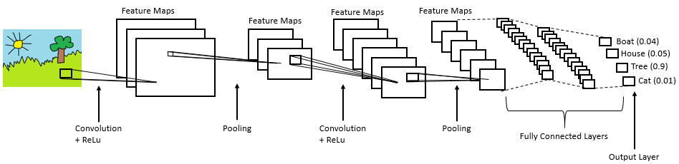

Convolutional Neural networks are specialized deep neural networks which can process the data that has input shape like a 2D matrix. Images are easily represented as a 2D matrix and CNN is very useful in working with images.

Long short term memory (LSTM):
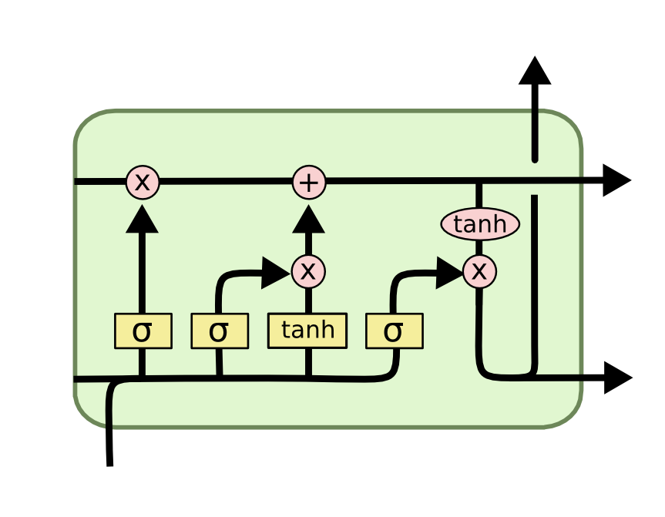
LSTM stands for Long short term memory is a RNN (recurrent neural network) which is well suited for sequence prediction problems. Based on the previous text, we can predict what the next word will be. It has proven itself effective from the traditional RNN by overcoming the limitations of RNN which had short term memory. LSTM can carry out relevant information throughout the processing of inputs and with a forget gate, it discards non-relevant information.

Image Caption Generator Model:
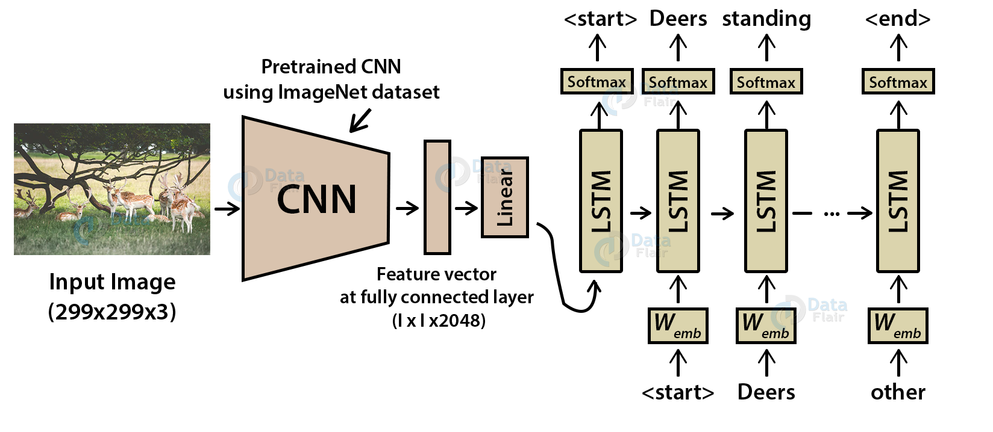
CNN is used for extracting features from the image. We will use the pre-trained model Xception. LSTM will use the information from CNN to help generate a description of the image. It is also called a CNN-RNN model.

References:
- Flicker8k_Dataset: https://www.kaggle.com/ming666/flicker8k-dataset
- Flciker_8k_text: https://www.kaggle.com/ming666/flicker8k-dataset
- CNN: https://data-flair.training/blogs/convolutional-neural-networks-tutorial/
- For some ideas, went through Github and other websites.

Submission Date: 19/04/2021

