**mDrill安装文档**

本文档针对的安装包只在64位CentOS 7操作系统测试通过！

说明：

vi 详解：

http://wenku.baidu.com/link?url=lwNWeoLEG0UnzoMhdw7X2Vek0sNkIqAaRVk0Uh7CkB51yAbXXD8ZarQuIZjuKfGRtEoRXBwn5Yq5zF74EcA7SHIVs84ocI57Vpnid7ruFQ7

说明：

所有软件以及环境依据此文档为准，并且需要用root超级用户来完成，另外需要关闭防火墙。不保证其他环境能成功

软件准备：

下载 JDK：http://www.oracle.com/technetwork/java/javase/downloads/index.html

下载 zeromq：<http://download.zeromq.org/zeromq-3.2.5.tar.gz>

下载 zookeeper 3.4.6：http://zookeeper.apache.org/

下载 Hadoop 2.5.1：http://hadoop.apache.org/

**1. 配置操作系统**

1.1 # vi /etc/sysconfig/network

修改HOSTNAME=master.chinaj.com（例子）

1.2 # vi /etc/hosts

增加192.168.1.8 master.chinaj.com（例子）

1.3 # vi /etc/selinux/config

修改SELINUX=disabled

1.4 设置无密码登录

# ssh-keygen -t rsa 注：Passphrase为空，直接Enter

# mv /root/.ssh/id_rsa.pub /root/.ssh/authorized_keys

# ssh master.chinaj.com uptime 注：测试配置是否正确，建议一定要执行，如果不提示输入密码，说明执行成功了。

1.5 安装java

chmod +x jdk-6u45-linux-x64.bin

./jdk-6u45-linux-x64.bin

mv jdk1.6.0_45 /usr/local/java

1.6 增加环境变量

# vi /root/.bashrc

alias grep="grep --color=always"

export HADOOP_HOME=/usr/local/hadoop

export HADOOP_CONF_DIR=$HADOOP_HOME/conf

export JAVA_HOME=/usr/local/java

export PATH=$PATH:$HADOOP_HOME/bin:$JAVA_HOME/bin:/usr/local/mdrill-0.20.9/bin

# source /root/.bashrc 注：使用环境变量生效

1.7 安装zeromq、jzmq、mysql

先安装以下依赖项

yum install make gcc gcc-c++ git libtool -y

tar xzvf zeromq-4.0.5.tar.gz

cd zeromq-4.0.5/

./configure --with-pgm

make

make install

安装jzmp

git clone https://github.com/zeromq/jzmq.git

cd jzmq/

注意：configure.in修改成configure.ac

./autogen.sh

./ configure

make

make install

echo /usr/local/lib > /etc/ld.so.conf.d/local.conf

ldconfig

echo CLASSPATH=/usr/local/share/java/zmq.jar:. >> /etc/environment

echo export LD_LIBRARY_PATH=/usr/local/lib > /etc/profile.d/ldlibrarypath.sh

数据库准备

# wget <http://dev.mysql.com/get/mysql-community-release-el7-5.noarch.rpm>

# rpm -ivh mysql-community-release-el7-5.noarch.rpm

# yum install mysql-community-server

成功安装之后重启mysql服务

# service mysqld restart

初次安装mysql是root账户是没有密码的

# mysql -uroot -p

用户名为myuser，密码为空，需要创建

grant all on *.* to 'myuser'@'%' identified by 'bjtest1234';

grant all on *.* to 'myuser'@'localhost' identified by 'bjtest1234';

flush privileges;

1.9 重启服务器

# reboot

**2. 配置支撑软件**

2.1安装配置

tar xzvf zookeeper-3.4.6.tar.gz

mv zookeeper-3.4.6 /usr/local/zookeeper

配置zookeeper

# vi /usr/local/zookeeper/conf/zoo.cfg # 下方两个参数，可以根据自己的情况进行定制

dataDir=/tmp/zookeeper

server.1=master.chinaj.com:2888:3888

# mkdir -p /tpm/zookeeper

# cd /usr/local/zookeeper/bin/

# ./zkServer.sh start

# ./zkServer.sh status

注：以下是正常情况下的显示

JMX enabled by default

Using config: /usr/local/bin/../conf/zoo.cfg

Mode: standalone

2.2 配置hadoop

tar xzvf hadoop-2.5.1.tar.gz

mv hadoop-2.5.1 /usr/local/Hadoop

环境变量

vi ~/.bashrc

export JAVA_HOME=/usr/local/java

export JRE_HOME=/usr/local/java/jre

export MYSQL_HOME=/usr/local/mysql

export HADOOP_HOME=/usr/local/hadoop

export HADOOP_CONF_DIR=$HADOOP_HOME/etc/hadoop

export ZOOKEEPER_HOME=/usr/local/zookeeper

export CLASSPATH=.:$JAVA_HOME/lib:$JRE_HOME/lib:$CLASSPATH

export PATH=$JAVA_HOME/bin:$JRE_HOME/bin:$MYSQL_HOME/bin:$ZOOKEEPER_HOME/bin:$HADOOP_HOME/bin:$PATH

source ~/.bashrc

修改配置文档

cd /usr/local/hadoop/etc/hadoop

vi hadoop-env.sh

添加JAVA路径



Vi yarn-env.sh



注：以下几个配置文件内容很简单，需要改的内容只有目录和域名

# vi /usr/local/hadoop/etc/hadoop/core-site.xml

<configuration>

<property>

<name>fs.default.name</name>

<value>hdfs://localhost:9000</value>

</property>

<property>

<name>dfs.replication</name>

<value>false</value>

</property>

<property>

<name>hadoop.tmp.dir</name>

<value>/usr/local/hadoop/tmp</value>

</property>

</configuration>

# vi /usr/local/hadoop/etc/hadoop/hdfs-site.xml

<configuration>

<property>

<name>dfs.namenode.name.dir</name>

<value>file:/usr/local/hadoop/dfs/name</value>

</property>

<property>

<name>dfs.name.data.dir</name>

<value>file:/usr/local/hadoop/dfs/data</value>

</property>

<property>

<name>dfs.replication</name>

<value>1</value>

</property>

</configuration>

# vi /usr/local/hadoop/etc/hadoop/mapred-site.xml

<configuration>

<property>

<name>mapred.job.tracker</name>

<value>localhost:9001</value>

</property>

<property>

<name>mapreduce.framework.name</name>

</value>yarn</value>

</property>

</configuration>

# vi /usr/local/hadoop/etc/hadoop/yarn-site.xml

<configuration>

<!-- Site specific YARN configuration properties -->

<property>

<name>yarn.nodemanager.aux-services</name>

<value>mapreduce_shuffle</value>

</property>

</configuration>

# hadoop namenode -format

# cd /usr/local/hadoop/sbin

# ./start-all.sh

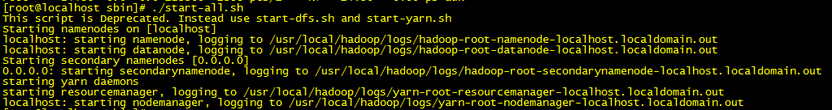



启动成功

2.3 配置mdrill

# cd /usr/local/

# git clone https://github.com/alibaba/mdrill.git

# vi /usr/local/mdrill/trunk/adhoc-core/conf/storm.yaml

将文件中的adhocbak.kgb.cm6替换成localhost

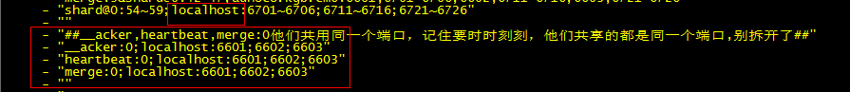

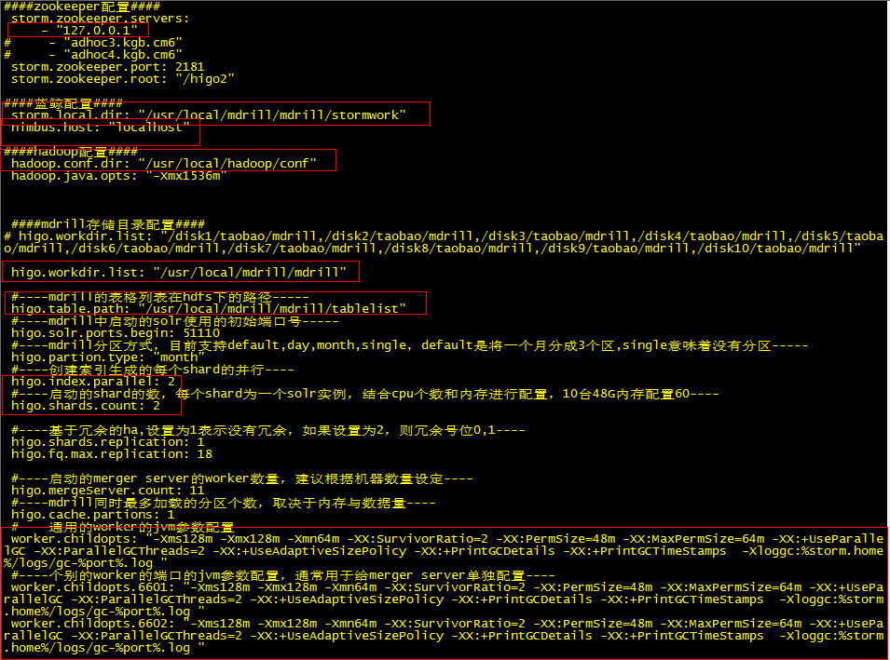

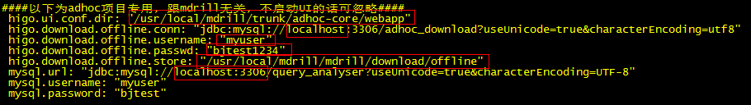

tar xzvf alimama-adhoc.tar.gz（注意：alimama-adhoc.tar.gz是从Mdrill技术群里下载的。QQ群：（171465049））

cp -a /root/alimama/adhoc-core/lib/ /usr/local/mdrill/trunk/adhoc-core/lib

cd /usr/local/mdrill/trunk/adhoc-core/bin

# ./bluewhale nimbus &

#./bluewhale supervisor &

#./bluewhale mdrillui 1107 ../lib/adhoc-web-0.18-beta.war ./ui &

启动完之后，查看/usr/local/mdrill/trunk/adhoc-core/logs/里面的日志，检查是否有报错。

启动后，可以通过浏览器打开mdrill的1107端口，看是否能正常打开即可，可看到下图

