Widad Khalid Alkibsi

DAR – 1707382

Project 3

**Concept Application & Algorithmic Part**

**Concept Application**: **(BST)**

Given the binary tree shown below, determine what gets printed when the method **methodA**(root) is called.

Assume that root is a variable reference of type intBSTnode and pointing to the node containing 20 in the tree below.

**Place your answers in the boxes provided.**

public void methodA(intBSTnode p){

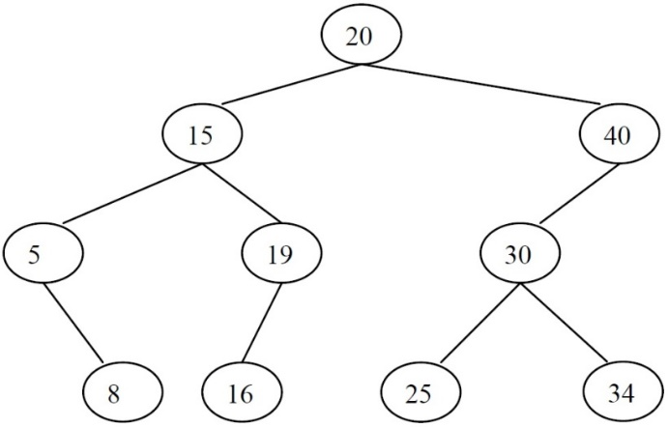if (p != null){

p

System.out.print(p.data * 2);

System.out.print(“ ”);

methodB(p.left, 20);

methodB(p.right, 40);

}

}

public void methodB(intBSTnode p, int key){

if (p != null) {

methodA(p.left);

System.out.print(key + p.data);

System.out.print(“ ”);

methodA(p.right);

**Answer:**

|  |  |  |  |  |  |  |  |  |  |
| --- | --- | --- | --- | --- | --- | --- | --- | --- | --- |
| **40** | **10** | **48** | **35** | **38** | **36** | **60** | **45** | **74** | **80** |

**Algorithm/Pseudocode Write-up**: **(BST)**

Write a pseudocode for changing the binary search tree into its mirror image.

**Algorithm:**

1. Checks if tree is empty by seeing if there a root or not
2. Call mirror for the subtree in the left
3. Call mirror for the right subtree
4. Swap left with the right subtrees

**Input:**

Binary Tree nodes

**Output:**

Mirrored Binary Tree

**Method:**

public void mirror(BSTnode p) {

if (p != null) {

BSTnode temp;

mirror(p.getLeft());

mirror(p.getRight());

//SWAP

temp = p.getLeft();

p.setLeft(p.getRight());

p.setRight(temp);

}

}