**Body measurement system by human**

**pose estimation**

This project is for human body measurement from mobile/web camera image for any human.

Input is front/ back human body image such as the following:

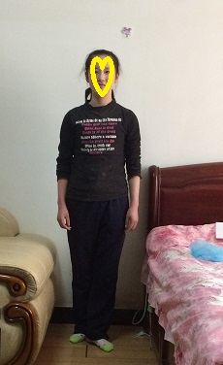 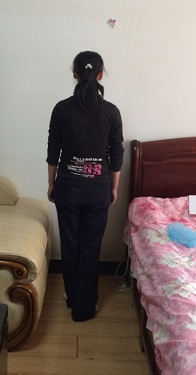

Front image Back image

Our app will use either front or back image, or our app can use both of them.(perhaps if we use both of front and back images, accuracy will be higher than we use only either one image.)

I introduce human body measurement system in the below in detail.

Our system has three parts.

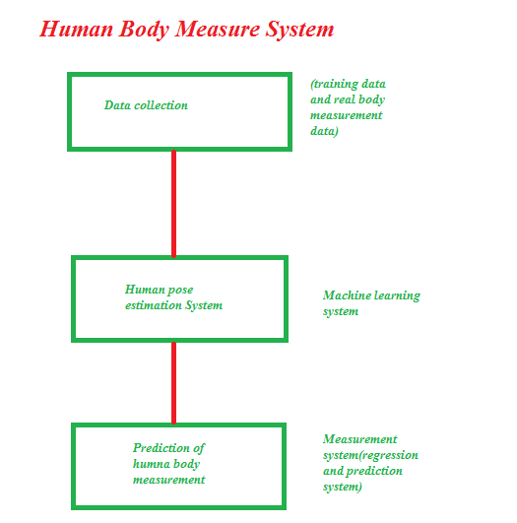

1. **Data preparing**

First is data collection.

In this part, we need training data and real human body measurement data.

We already collected 21 men and 50 women real measurement data.

And as training data, we got already a few thousands of labelled images.

The training data with label will be used in human pose estimation system.

For training data we know the real human pose points for front / back images.

This data is based on human biological structure.

As the testing data, we can use real human front/back image.

1. **Human posing estimation system**

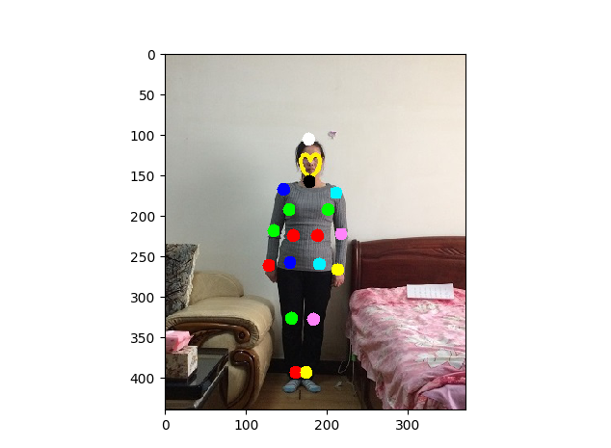

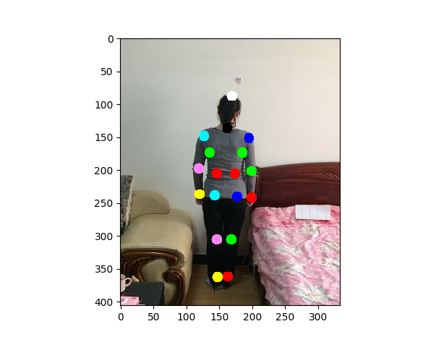

This part is the main part in this project. All human body measurement from any image or video is starting to get human pose points.

In this part, the labelled training data will be used.

For this part, we have already implemented by my old project. I used tensorflow for deep learning.

The main algorithm is CNN algorithm by tensorflow.

Now we have pretrained model for machine learning system.

So we can use it now.

The result of training data is same as the above images.

If user input image, our machine learning system will estimate the human pose points as the above results.

For both of front and back image of one human, we can get full human pose points by the current machine learning system.

1. **Measurement system.**

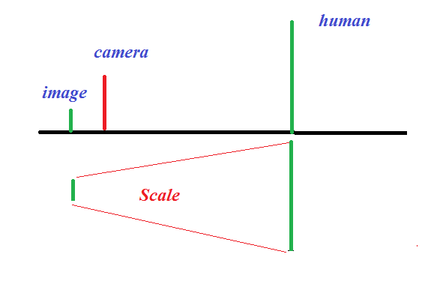

This part is final project.

In this part, we will use mathematical algorithm for real human body measurements.

First we need to scale between pixel and real cm measurement.

I think we can solve this scale value in front end.

For that purpose, we can use short video as Mtailor video.

Next we need to predict human pixel measurement based on human pose estimation results.

I think regression and some predict machine algorithm such as ANN/ RF/ SVM can be used in this part.

From testing result, we can select one regression/ prediction algorithm which gives us the best result.

If we use both of front and back images, then accuracy can be improved.