# 实训报告

|  |  |  |  |  |  |  |
| --- | --- | --- | --- | --- | --- | --- |
| **作业名称** | Part 1: Observing and Experimenting with GridWorld | | | | | |
| **院系** | 软件学院 |  | **班级** | 教务2班 | **姓名** | 李明宽 |
| **学号** | 11331173 |  | **完成日期** | 2013年07月02日 | | |
| **QQ** | 736459905 |  | **E-mail** | limkuan@mail2.sysu.edu.cn | | |

### Running the Demo

Once the code is installed, simply compile and run the BugRunner.java application supplied with the case study. The GridWorld GUI will show a grid containing two actors, a "bug" and a "rock."Clicking on the Step button runs one step, making each actor act once. Clicking on the Run button carries out a series of steps until the Stop button is clicked. The delay between steps during a run can be adjusted with the slider. Try it!]

Do You Know?

1. Does the bug always move to a new location? Explain.

Answer: Of courses not. When bug meets a rock or another bug in the direction it heads, it will turn around and doesn’t move to a new location. Or just if rocks are all around the bug like the picture below, the bug can’t move to anywhere.

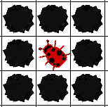

1. In which direction does the bug move?

Answer: It moves to the direction which its head points to and it moves to the next grid. If the next grid have something, except flowers, and it will turn its head 45°clockwise.

1. What does the bug do if it does not move?

Answer: If it can’t move to next grid, it will turn it’s head 45°clockwise.

1. What does a bug leave behind when it moves?

Answer: It leaves a flower which color is same with the bug when it moves.

1. What happens when the bug is at an edge of the grid? (Consider whether the bug is facing the edge as well as whether the bug is facing some other direction when answering this question.)

Answer: It has two conditions:

Firstly, when a bug is at an edge of the grid and it is facing the edge, it can’t move, so the bug will trun 45 degree clockwise and judge again, if it also can’t move to next grid, it turns again, until it can move to next grid.

Secondly, when the bug isn’t facing other diection, if the next grid is avaliable, it moves to it, or the grid is not avaliable, it turn is direction.

1. What happens when a bug has a rock in the location immediately in front of it?

Answer: Obviously, it turns its head for 45 degrees clockwise.

1. Does a flower move?

Answer: The flower can’t move, but it can change its color.

1. What behavior does a flower have?

Answer: The flower can act and make itself color deeper.

1. Does a rock move or have any other behavior?

Answer: In the gridWorld, the rock can only stick the bug. It can’t move and rotate. But if you use the function moveTo() or setDirection(), it can force.

1. Can more than one actor (bug, flower, rock) be in the same location in the grid at the same time?

Answer: Only one actor can be in the same location at the same time. You can test it by use function moveTo() force change an actor’s location, move it to a location which it alreadly have an actor, then move it away, we can see that the location is empty and the actor which in the grid before is gone. So only one actor can be in the same position.

### Exploring Actor State and Behavior

When you click on a cell containing an actor (bug, flower, or rock), a drop-down menu displays the methods that you can invoke on the actor. The methods that appear above the separator line are specified by the class that defines this actor; those that appear below the line are the methods inherited from the Actor class.

Exercises

By clicking on a cell containing a bug, flower, or rock, do the following.

1. Test the setDirection method with the following inputs and complete the table, giving the compass direction each input represents.

|  |  |
| --- | --- |
| 0 | North |
| 45 | NorthEast |
| 90 | East |
| 135 | Southeast |
| 180 | South |
| 225 | Southwest |
| 270 | West |
| 315 | Northwest |
| 360 | North |

1. Move a bug to a different location using the moveTo method. In which directions can you move it? How far can you move it? What happens if you try to move the bug outside the grid?

Answer: It can move to any directions. The max distance is 9 grid(?), it can move to anywhere in the grid, but when you try to move the bug ouside the grid, it will make an illegal argumeng exception like the picture below.

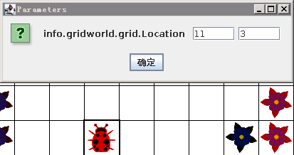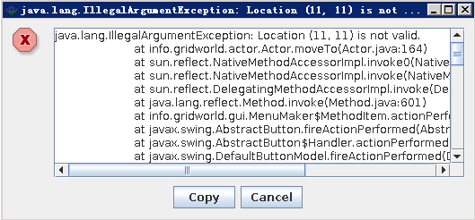

1. Change the color of a bug, a flower, and a rock. Which method did you use?

Answer: I can use the setColor() method to change the color of an actor.

1. Move a rock on top of a bug and then move the rock again. What happened to the bug?

Answer: Because only one actor can be in the same position, When we move a rock on the top of a bug and move the rock again, the bug is gone.