**HELLOW DEAR, TODAY WE NEED TO INSTRUCT YOU HOW TO DOWNLOAD FLO PERIOD & OVULATION TRACKER,**

**FLO PERIOD & OVULATION TRACKER**,, is an Online Application which gives you access to Create Personal Account as well as registering yourself for daily conversation about your menstruation cycle, tracking your menstruation cycle (including safe days as well as dangerous days),

Also through this application you get access to conversant with specialist according to your demand, For example, How to avoid unexpected pregnant, How to control your emotions during dangerous days and how to deal with abnormal menstruation.

**HOW TO DOWNLOAD FLO PERIOD & OVULATION TRACKER**.

By using your smartphone, with access to internet, open Search Engine Forexample Google chrome or Play store, then search “Flo Period & Ovulation tracker”, then click to download and install.

After installing the application in your smartphone, click to open it, after opening it, at the left corner of your smartphone you will find a doll (Mwanasesere), then click it, after clicking you will find instructions for creating your personal account and other personal registration concerning with your Menstruation cycle.

**THAT`S HOW YOU CAN DOWNLOAD AN ONLINE APPLICATION FOR PERIOD AND OVULATION TRACKING.**

**CONTACT.**

**IN ANY PROBLEM, DURING INSTALLATION OF FLO PERIOD AND OVULATION TRACKER, PLEAS CONTACT US VIA, what’s up number 0678547358 or email us via** [**singumariam@gmail.com/**](mailto:singumariam@gmail.com/)[**groupnumber4@gmail.com**](mailto:groupnumber4@gmail.com)

**THE FOLLOWING ARE PICTURES WHICH SHOWS THE FLO PERIOD & OVULATION TRACKER ONLINE APPLICATION AFTER INSTALLING IT IN YOUR SMARTPHONE.**

**PICTURE NUMBER 01; BEFORE OPPENING IT.**

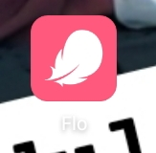

**J**

**PICTURE NUMBER 02; AFTER OPPENNING IT,**

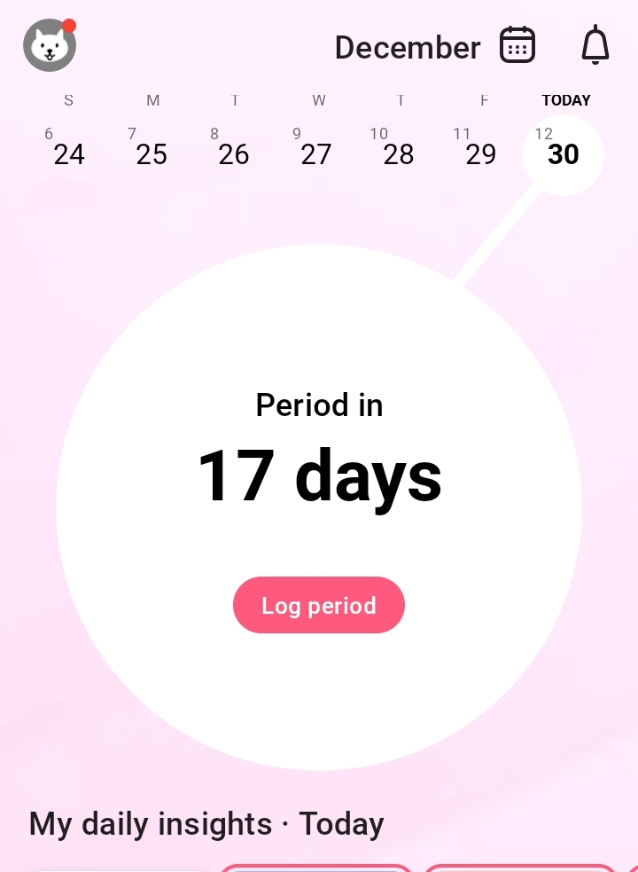

**PICTURE NUMBER 3; AFTER CLICKING THE DOLL (MWANASESERE)**