Beit Jala Pharmaceutical Co.
Engineering & Maintenance Department

Software Requirements Specification (SRS)
Computerized Maintenance Management System (CMMS)
Graduation Project — Industrial Engineering

Field | Details
Document Version | 1.0
Status | Draft — for graduation project
Prepared For | Beit Jala Pharmaceutical Co. — Maintenance Department
Prepared By | [Student Name]
Supervisor | [Academic / Industrial Supervisor Name]
Date | [Date]
Reference Document | Maintenance Management Procedure — Doc. No. MAIN-00-0052-13, Eff. 18/3/2023

1. Introduction

1.1 Purpose
This Software Requirements Specification (SRS) defines the functional requirements of the Computerized Maintenance Management System (CMMS) to be developed as a graduation project for the Engineering & Maintenance Department at Beit Jala Pharmaceutical Co. The system digitizes the machine maintenance records, checklists, requests, and plans that are currently maintained on paper, while keeping the underlying maintenance workflow unchanged.

1.2 Scope
The system covers four core areas, matching exactly what was requested for this phase of the project:
- User accounts and role-based access for maintenance staff and other departments.
- A Machines module covering the company's ~200 pieces of equipment, each with an Equipment Information Record, a Preventive Maintenance record, and a Corrective Maintenance record/request workflow.
- A Maintenance Plans module (Annual Plan and Monthly Plan).
- A Spare Parts module (part catalogue with stock in/out).

1.3 Definitions and Abbreviations
Term | Definition
CMMS | Computerized Maintenance Management System
PM | Preventive Maintenance
CM | Corrective (breakdown) Maintenance
Admin | System administrator — manages user accounts and permissions
Maintenance Supervisor | Owns the PM checklists and the maintenance plans
Maintenance Technician | Executes and records PM/CM activities
Requesting Department | Any department (e.g., Production) that submits a corrective maintenance request
QA Supervisor | Reviews and approves a maintenance request (with signature) before it reaches the Engineering/Maintenance department
Checklist Point | A single inspection item within a PM record (e.g., "Check motor bearings")

1.4 References
- Beit Jala Pharmaceutical Co. — Maintenance Management Procedure, Doc. No. MAIN-00-0052-13, Effective Date 18/3/2023.
- Company forms referenced in this document: Equipment Information Record (FORM-10-0118), Maintenance Request & Corrective Maintenance Report (FORM-10-0975), Preventive Maintenance Plan for Year (FORM-10-1025), Monthly Preventive Maintenance Program (FORM-10-0117).

2. Overall Description

2.1 Product Perspective
The CMMS is a standalone, database-backed web application that replaces the paper forms currently kept in each machine's physical file. It does not change who does what in the maintenance process (per the company procedure) — it only changes the medium from paper to a shared electronic system.

2.2 User Classes and Characteristics
Role | Description | Typical Permissions
Admin | Manages the system and its users | Create/edit/deactivate user accounts; assign roles; full access to all modules
Maintenance Supervisor | Owns PM checklists and maintenance plans | Prepare Annual/Monthly plans; review PM/CM records; add/edit/remove PM checklist points (near-Admin level access, see FR-5.4–FR-5.6); all permissions remain individually adjustable by the Admin (FR-1.8)
Maintenance Technician | Executes maintenance work | Fill PM checklist results; perform CM work and fill CM records; view all machines
Department Employee (e.g., Production) | Reports equipment failures | Submit a corrective maintenance request; view the status of their own requests only
QA Supervisor | Approves maintenance requests before Engineering review | Review and approve/reject submitted maintenance requests (signature); view request status; no access to PM/CM records or Administration

2.3 Operating Environment
- Web-based application, accessible and fully usable from both desktop/laptop computers and mobile phones (a clear, responsive layout on both), on the company network.
- Central relational database storing machines, checklists, records, plans, and spare parts.

2.4 Design Constraints
- Every screen that represents an official company form (Equipment Information Record, PM record, CM record, Monthly Plan, etc.) must preserve the same fields as the paper form; the underlying workflow described in the Maintenance Management Procedure must not be altered.
- The number of checklist points (rows) in a PM record differs per machine (from about 10 up to 20+) — the data model must not assume a fixed number of checklist items.
- Historical PM/CM entries are never overwritten or deleted; each maintenance activity adds a new record/column.

2.5 Assumptions and Dependencies
- The list of ~200 machines and their basic identification data will be available for initial data migration/entry.
- Each machine is assigned one PM frequency (e.g., every 1, 2, 3, or 6 months), used when generating the Annual and Monthly Plans (Section 3.7).

3. System Features (Functional Requirements)

3.1 User Accounts, Roles and Permissions
The system must support creating an account for every employee (maintenance technicians, maintenance supervisor/admin, and employees from other departments such as Production), with each role seeing a different set of screens and actions.
ID | Requirement | Priority
FR-1.1 | The system shall require a username and password to log in. | High
FR-1.2 | The system shall support at least the following roles: Admin, Maintenance Supervisor, Maintenance Technician, Department Employee. | High
FR-1.3 | The Admin shall be able to create, edit, and deactivate user accounts and assign a role to each account. | High
FR-1.4 | The system shall show/hide modules and actions (buttons, edit rights) according to the logged-in user's role. | High
FR-1.5 | Department Employees shall only be able to create maintenance requests and track the status of the requests they submitted — they shall not access machine maintenance records. | High
FR-1.6 | Maintenance Technicians shall be able to view all machines and fill in PM/CM records but shall not be able to add or edit PM checklist points. | High
FR-1.7 | Only the Maintenance Supervisor (or Admin) shall be able to create or edit the checklist points of a PM record. | High
FR-1.8 | In addition to assigning a role, the Admin shall be able to independently grant or revoke specific module/action-level permissions for each individual user account, so that users of the same role are not necessarily granted the exact same permissions. | High
FR-1.9 | The system may provide additional named preset roles beyond the four base roles in FR-1.2 (e.g., Engineering Manager, QA Supervisor), each with a pre-configured permission set that is close to, but not necessarily identical to, the Admin's; regardless of the role assigned, the Admin retains full ability to view and change any individual user's permissions at any time (per FR-1.8). | Medium

3.2 Dashboard (Home Screen)
After logging in, the user is presented with the Dashboard: a main menu giving access to the modules covered by this SRS, plus a set of live widgets summarizing maintenance activity so the user does not have to open every module to know what needs attention.

3.2.1 Main Menu
- Machines
- Maintenance Requests (Corrective Maintenance)
- Maintenance Plans (Annual / Monthly)
- Spare Parts
ID | Requirement | Priority
FR-2.1 | The system shall display a main menu with buttons for: Machines, Maintenance Requests, Maintenance Plans, and Spare Parts. | High
FR-2.2 | Each button shall only be visible/enabled according to the permissions of the logged-in user's role. | Medium

3.2.2 "This Week's Preventive Maintenance" Widget
Shows which machines have a preventive maintenance activity planned during the current calendar week, pulled directly from the Monthly Plan (Section 3.7) so the list is always consistent with the official monthly form.
ID | Requirement | Priority
FR-2.3 | The Dashboard shall display a list of machines whose planned PM date range (Planned Date — From/To, from the current month's Monthly Plan) overlaps the current calendar week (Saturday–Friday, or the company's defined work week); no single fixed day is required. | High
FR-2.4 | Each entry in this widget shall show at least: machine name/number, planned date range (From – To), and current status (Due / Completed / Overdue), and shall link to that machine's Preventive Maintenance Record. | Medium

3.2.3 Maintenance Requests Counters
Two simple KPI numbers giving a quick view of the corrective maintenance workload.
ID | Requirement | Priority
FR-2.5 | The Dashboard shall display the total number of maintenance requests submitted (all statuses). | High
FR-2.6 | The Dashboard shall display the number of maintenance requests that have been completed/closed. | High
FR-2.7 | Both counters shall update automatically whenever a request is created, accepted, rejected, or completed. | Medium

3.2.4 Notifications Panel
A dedicated area on the Dashboard that alerts the Engineering/Maintenance department to events requiring attention.
ID | Requirement | Priority
FR-2.8 | The system shall generate a notification, visible to the Engineering/Maintenance department, whenever a new maintenance request is submitted by any department. | High
FR-2.9 | The system shall generate a notification whenever a scheduled preventive maintenance activity's planned date has passed without being carried out (i.e., it becomes Overdue). | High
FR-2.10 | The Notifications panel shall list notifications with the machine/request concerned and a link that opens the related record directly.ء | Medium

3.2.5 Monthly PM Completion Chart
A donut/pie chart giving an at-a-glance view of how the current month's preventive maintenance plan is progressing.
ID | Requirement | Priority
FR-2.11 | The Dashboard shall display a donut/pie chart showing the total number of machines scheduled for preventive maintenance in the current month, based on the Monthly Plan. | High
FR-2.12 | The chart shall break this total down into: machines whose PM has been Completed, and machines whose PM is still Overdue/not yet carried out. | High
FR-2.13 | Selecting a segment of the chart shall show the corresponding list of machines (Completed list or Overdue list). | Medium
Note: All Dashboard widgets are read-only views computed from existing data (Monthly Plan, PM records, and Maintenance Requests) — they do not introduce new data entry and are not tied to a specific paper form, unlike the modules in Appendix A.

3.2.6 Role-Based Dashboard Visibility
The Dashboard is not the same for everyone: each user sees only the menu items and widgets relevant to their role. For example, a Production supervisor's account is only granted the ability to submit a maintenance request — they do not see PM widgets, request counters for other departments, or the Engineering notifications feed.
Role |  | Dashboard Content Shown
Admin / Maintenance Supervisor |  | Full Dashboard: main menu, This Week's PM widget, request counters (all departments), Notifications panel, Monthly PM Completion chart.
Maintenance Technician |  | Main menu (Machines, Maintenance Requests), This Week's PM widget, Notifications relevant to assigned work. No access to Spare Parts stock editing beyond what is used in a maintenance record, and no access to Administration.
Department Employee (e.g., Production) |  | Only the "Submit Maintenance Request" action and a list of the status of the requests they personally submitted. No PM widgets, no request counters for other departments, no Notifications panel, no Machines list.
ID | Requirement |  | Priority
FR-2.14 | The Dashboard shall render only the menu items and widgets that the logged-in user's role is authorized to see, per the table above. |  | High
FR-2.15 | A Department Employee's Dashboard shall be limited to submitting a new request and viewing the status of their own submitted requests; it shall not expose PM widgets, cross-department counters, or the Notifications panel intended for Engineering. |  | High

3.3 Machines Module
This is the main module of the system. It lists all ~200 machines in the plant and gives access to each machine's records.
ID | Requirement | Priority
FR-3.1 | The system shall display a list of all machines, sorted alphabetically by machine name by default. | High
FR-3.2 | The system shall provide a search box to find a machine by name or machine number, filtering the list as the user types. | High
FR-3.3 | Selecting a machine from the list shall open that machine's profile, showing three options: Equipment Information Record, Preventive Maintenance, and Corrective Maintenance. | High
FR-3.4 | The machine list/profile shall indicate, next to each machine, its machine number and department, to help users quickly locate the right machine. | Medium

3.4 Equipment Information Record
Reproduces the company's paper form for basic machine data (name, model, serial number, identification number, purchase data, dimensions, utilities, safety issues, etc.).
ID | Requirement | Priority
FR-4.1 | The system shall display the Equipment Information Record using the same fields and layout as the company's official form. | High
FR-4.2 | Authorized users shall be able to enter the equipment information once when the machine is added, and edit it later through a dedicated "Edit" action. | High

3.5 Preventive Maintenance (PM) Module

3.5.1 Form Header
The header area (company logo/name, document number, effective date) must stay fixed and identical on every page of the PM record; only the page count/number changes automatically as pages are added. Note: machine-identifying fields (machine name, machine number, machine location, and start-up date) are not part of this header — those fields belong solely to the Corrective Maintenance Record header (Section 3.6.1, Appendix A.2), matching the official paper form (LOG-00-0102-3). The PM record is already opened from within a specific machine's profile, so no separate machine-identification block is duplicated here.
ID | Requirement | Priority
FR-5.1 | The PM record header shall remain identical (same fields, same layout) across all pages generated for the same machine. | High
FR-5.2 | The page number and total page count shown in the header shall update automatically as new pages are generated. | High
FR-5.3 | The header fields shall be editable only through a separate, restricted "Edit Header" action — not through the normal data-entry flow used for routine inspections. | High
Note: Edit-Header permission is not fixed to a single role. This was previously an open question (Admin/Maintenance Supervisor vs. QA); it is now finalized: the permission itself is owned by the Admin, who decides — per user and per form — which individuals (e.g., Supervisor, QA, or others) are granted the Edit-Header action (see FR-9.3, Section 3.9).

3.5.2 Flexible Checklist
Each machine has its own list of inspection points, which differs in both content and count from one machine to another (some machines have around 10 points, others 20 or more).
ID | Requirement | Priority
FR-5.4 | The system shall allow the Admin or the Maintenance Supervisor to define a custom set of checklist points (rows) for each machine when it is first added to the system, through a dedicated “Manage Checklist Points” screen that is separate from the routine screen used to record inspection results. | High
FR-5.5 | The number of checklist points per machine shall not be fixed by the system — the Maintenance Supervisor shall be able to add or remove rows as needed. | High
FR-5.6 | The Admin and the Maintenance Supervisor shall be able to add, edit, or remove checklist points, either at creation or afterward (e.g., periodically, such as once a year), using the dedicated Manage Checklist Points screen; this screen shall not be accessible to Maintenance Technicians or Department Employees. | High
FR-5.7 | Maintenance Technicians shall only be able to fill in the results of existing checklist points — they shall not be able to add, remove, or edit the points themselves. | High

3.5.3 Recording an Inspection
ID | Requirement | Priority
FR-5.8 | For each checklist point, the technician shall record a result as either Yes/No, or a free-text/numeric value (e.g., a pressure or temperature reading), depending on how that point is configured. | High
FR-5.9 | Each time a PM activity is performed, the system shall add it as a new inspection entry (e.g., a new column) without overwriting or deleting previous inspection entries for that machine. | High
FR-5.10 | The Admin or the Maintenance Supervisor shall be able to configure, per machine, the maximum number of inspection columns held on a single page/record (a value from 1 to 10); this value is independent per machine — e.g., one machine's record may hold 3 columns per page before a new page starts, while another holds 6. | High
FR-5.11 | Once the number of inspection columns on the current page/record reaches the limit configured for that machine (FR-5.10), the system shall automatically create a new page using the same header and checklist layout, and continue recording there. | High
FR-5.12 | The set of checklist points (rows) configured for a machine may span more than one page (e.g., 20 points across 2–3 pages, per FR-5.4–FR-5.5); when the column limit is reached across the current set of pages (FR-5.10–FR-5.11), the system shall open a new Preventive Maintenance record reproducing the same header and the same full set of checklist pages (e.g., all 3 pages again) for that machine, and continue data entry there. | High
FR-5.13 | Opening a new Preventive Maintenance record (per FR-5.12) shall never delete or overwrite the previous record; all previous pages and their data shall remain permanently saved, and records for the same machine shall be kept chained in sequence (oldest to newest). | High
FR-5.14 | Regardless of the number of checklist points configured for a machine (FR-5.4--FR-5.5), every Preventive Maintenance record shall end with the same fixed closing block, in the same position and with the same fields, for every machine: Action taken (in case of error/deviation), Examiner's name and signature, and Machine receiver's name and signature (see Appendix A.3). The Examiner and Machine Receiver signature fields follow the same permission-based, Admin-assigned eligibility rules defined in Section 3.11. | High

3.6 Corrective Maintenance (Maintenance Requests) Module
Reproduces the company's Maintenance Request & Corrective Maintenance Report workflow: any department can report an equipment failure; the request is then reviewed and approved by the QA Supervisor (with a QA Supervisor signature) before it reaches the Engineering/Maintenance department, which accepts or rejects it; once accepted, a technician performs and documents the repair.
ID | Requirement | Priority
FR-6.1 | Any Department Employee shall be able to submit a new maintenance request for a specific machine, using an electronic version of the company's Maintenance Request form. | High
FR-6.2 | Once submitted, the request shall be routed to the QA Supervisor for review; the QA Supervisor shall approve it (recorded with a QA Supervisor signature) before it is forwarded to the Engineering/Maintenance department. | High
FR-6.3 | After the request has been approved by the QA Supervisor (FR-6.2), the Engineering/Maintenance Supervisor or Manager shall be able to review it and either accept or reject it. | High
FR-6.4 | If a request is accepted, the assigned Maintenance Technician shall perform a preliminary check, then carry out the corrective maintenance work. | High
FR-6.5 | The technician shall record the actions taken and complete the Corrective Maintenance Record for that request. | High
FR-6.6 | Once work is finished, the system shall support a hand-over step where both the technician and the receiving department confirm/sign that the machine has been returned. | High
FR-6.7 | Department Employees shall be able to track the status of the requests they submitted (e.g., Submitted / Pending QA Approval / Accepted / Rejected / In Progress / Completed). | Medium
FR-6.8 | Each completed corrective maintenance activity shall be stored as a permanent record linked to its machine and its originating request; previous records shall never be deleted or overwritten. | High
FR-6.9 | The Maintenance Request and the Corrective Maintenance Record shall be maintained as two separate, independently fillable entries — a user may complete the Maintenance Request without immediately completing the Corrective Maintenance Record (Actions Taken section), and vice versa. | High
FR-6.10 | The two entries shall be linked by the same Request/Report Number: opening a request number from the Corrective Maintenance Record shall open the matching Maintenance Request, and opening a request number from the Maintenance Request list shall open the matching Corrective Maintenance Record. | High
FR-6.11 | The Corrective Maintenance Record (log) shall have a fixed number of rows and columns, matching the official paper log; each new maintenance event shall fill the next available row in sequence (1st event → row 1, 2nd event → row 2, etc.), regardless of the time elapsed or whether events fall in the same month or year. | High
FR-6.12 | Once all rows of the current Corrective Maintenance Record are filled, the system shall open a new Corrective Maintenance Record with the same fixed layout for that machine; the previous record's data shall remain permanently saved and unchanged, and both records shall be kept accessible in sequence. | High

3.6.1 Form Header
The Corrective Maintenance Record header matches the official company log (LOG-00-0102-3, Appendix A.2.2). In addition to the common header fields shared by every official form (Section 3.9: company name/logo, document name, document number, effective/execution date, and page count), this form's header is the only one that also carries machine-identifying fields — these are unique to the Corrective Maintenance Record and are not repeated on the Preventive Maintenance Record or any other form.
# | Field
1 | Document number (LOG-00-0102-3)
2 | Execution date
3 | Page X of Y (fixed at 1 of 1, per FR-9.5)
4 | Machine name
5 | Machine number
6 | Machine location (where the machine is installed)
7 | Start-up date
These header values are entered once per machine's Corrective Maintenance Record and are editable only through the "Edit Header" action (FR-9.2), independent of the header on that same machine's Preventive Maintenance Record (FR-9.1).

3.7 Maintenance Plans Module
Provides access to the Annual Preventive Maintenance Plan and the Monthly Preventive Maintenance Program, matching the company's existing planning forms.
ID | Requirement | Priority
FR-7.1 | The Maintenance Plans module shall provide two options: Annual Plan and Monthly Plan. | High
FR-7.2 | The Monthly Plan shall present twelve entry points, one per month (January through December). | High
FR-7.3 | Selecting a given month shall open that month's Monthly Preventive Maintenance Program, using the company's official form layout, editable by the Maintenance Supervisor or the Maintenance Technician. | High
FR-7.4 | The Monthly Plan shall be derived from / consistent with the Annual Plan (machines and frequencies scheduled for that month originate from the Annual Plan). | Medium
FR-7.5 | The system shall compute each machine’s scheduled PM months in the Annual Plan starting from the machine’s configured Start Date and repeating according to its configured Frequency (e.g., a machine with a March Start Date and a 3-month frequency shall be scheduled in March, June, September, and December). | High
FR-7.6 | Each machine’s PM schedule shall also record a Duration (the expected time needed to carry out the PM activity), which shall be used together with the Planned Date when generating the Monthly Plan. | High
FR-7.7 | The Maintenance Supervisor shall be able to manually edit or override the system-calculated Annual Plan entries for a machine (e.g., to correct a scheduling error); the edited values shall be retained as that machine's Annual Plan going forward. | High
FR-7.8 | The Annual Plan document shall consist of a fixed first page — the company-approved approval/signature template (Year, Prepared By, and Approved By fields for the Engineering, Production, QC, R&D, and QA Department Managers) — followed by one or more data pages listing, for every machine: Department, machine name/location/code, Frequency, Duration, Start date, and Finish date (see Appendix A.4). | High
FR-7.9 | Users holding the Engineering, Production, QC, R&D, or QA Department Manager role (or the corresponding permission) shall have view access to the Annual Plan and shall be able to sign it as Approvers, using the Electronic Signatures module (Section 3.11). | High

3.8 Spare Parts Module
ID | Requirement | Priority
FR-8.1 | The system shall display a list of all spare parts. | High
FR-8.2 | Selecting a spare part shall open its record, showing: part name, part code, current quantity, and stock movement (quantity in / quantity out). | High
FR-8.3 | The system shall update the part's quantity automatically whenever a stock-in or stock-out movement is recorded. | Medium

3.9 Form Headers and Pagination
Applies to every screen that reproduces an official company form, extending the header rules already defined for the Preventive Maintenance Record (Section 3.5.1) to all other forms in the system. The one exception is the Corrective Maintenance Record, whose header additionally carries machine-identifying fields (machine name, machine number, machine location, start-up date) not found on any other form's header — see Section 3.6.1 and Appendix A.2.2.
ID | Requirement | Priority
FR-9.1 | Every screen that reproduces an official company form (Equipment Information Record, Maintenance Request & Corrective Maintenance Record, Preventive Maintenance Record, Annual Plan, Monthly Plan) shall display the same common header fields — the company name (Beit Jala Pharmaceutical Industries Co., Palestine, fixed and identical on every form), the document/record name, the document/procedure number, the effective/execution date, and the page count — fixed and identical across all pages of that record. Each record maintains its own independent header values, entered once when the record is created; header data is never copied or shared between different records, even for the same machine. Machine-identifying fields (machine name, machine number, machine location, and start-up date) are not part of this common header and are not displayed on every form; they appear only on the Corrective Maintenance Record header, as defined in Section 3.6.1 and Appendix A.2.2. | High
FR-9.2 | Header fields on every such form shall be editable only through a dedicated “Edit Header” action, separate from the normal data-entry flow used for routine inspections or requests. | High
FR-9.3 | The Admin shall determine, per user, who is granted the Edit-Header permission for each form, as part of the per-user permission settings described in FR-1.8; this permission need not be the same for every user. Ownership of the Edit-Header permission itself rests solely with the Admin and is not shared with any other role. | High
FR-9.4 | The page number and total page count shown in each form’s header shall update automatically as the number of pages changes with the amount of recorded data. | High
FR-9.5 | Page numbering is scoped to a single record, not accumulated across records: for the Preventive Maintenance Record, if a machine's checklist spans N pages, each page shows “Page X of N” (e.g., 1 of 3, 2 of 3, 3 of 3); when a new PM record is opened because the previous one is full (FR-5.12–FR-5.13), the new record's pages restart at “1 of N”. For the Corrective Maintenance Record, opening a new record (FR-6.12) does not change the page indicator, which remains “Page 1 of 1” for every record, since each CM record is a self-contained fixed-size log page rather than a multi-page document. | High

3.10 Printing
Every record the user may need as a physical/paper copy shall be printable directly from the system.
ID | Requirement | Priority
FR-10.1 | The system shall provide a Print action on each of the following records/forms: Equipment Information Record, Preventive Maintenance Record, Corrective Maintenance Record, Maintenance Request, Annual Plan, and Monthly Plan. | High
FR-10.2 | The Print action shall produce a printable, paper-ready version reproducing the exact layout, header, and content of the on-screen record, including all pages when the record spans more than one page. | High

3.11 Electronic Signatures Module
Every screen with sign-off fields (e.g., “Prepared By”, “Approved By”, “Examiner”, “Machine Receiver”, or any other field defined for a given form — e.g., the Annual Plan, Maintenance Request, Preventive Maintenance Record, and other official forms) uses a single, shared signing mechanism. Signature fields are not limited to a fixed set of two (“Prepared”/“Approved”); a document may define any number of named signature fields. Eligibility to sign is assigned by the Admin on a per-record basis, not granted generically per document type: for every specific document instance, the Admin selects which individual user(s) — from the full list of users holding an account on the system — are allowed to sign each field on that specific instance.
ID | Requirement | Priority
FR-11.1 | The system shall provide dedicated signature fields (e.g., “Prepared By”, “Approved By”) on every official document that requires sign-off, matching the fields on that document's paper form. | High
FR-11.2 | The system shall support any number of named signature fields per document type (e.g., “Prepared By”, “Approved By”, “Examiner”, “Machine Receiver”), not limited to a fixed set of two; for every completed signature the system shall record the signing user's name, timestamp, and the corresponding signature_type (e.g., “Prepared”, “Approved”, “Examined”, “Received”). | High
FR-11.3 | For each signature field on a specific document record (e.g., a given machine's Preventive Maintenance Record, or a given year's Annual Plan), the Admin shall select which individual user(s) — from the full list of users holding an account on the system — are eligible to sign that field on that specific record. | High
FR-11.4 | A user may be assigned as an eligible signer for more than one field, and on more than one record, at the same time (e.g., a user may be eligible to sign the “Prepared By” field on one record and the “Examiner” field on another). | High
FR-11.5 | Eligibility to sign a field on a given record shall depend solely on whether the Admin has explicitly assigned that user as an eligible signer for that field on that record, independent of the user's assigned role; two users with the same role are not guaranteed the same signing eligibility, and eligibility granted on one record does not extend automatically to other records of the same document type. | High
FR-11.6 | The system shall prevent any user who has not been assigned by the Admin as an eligible signer for a field on a given record from completing that signature field, even if that user is authenticated and otherwise has access to the document. | High
FR-11.7 | Each completed signature shall be permanently recorded with the signing user's name, a timestamp, the signature_type (e.g., Prepared / Approved / Examined / Received), and a reference to the Admin's eligible-signer assignment that authorized it, providing a full audit trail. | High
FR-11.8 | Signatures shall be immutable once recorded; correcting a signature shall require adding a new signature entry, not editing or deleting the original. | High
FR-11.9 | The Admin shall be able to grant or revoke eligible-signer assignments per user, per signature field, and per specific document record, independent of the user's role (see FR-1.8); this allows the same field (e.g., “Approved By”) to have different eligible signers on different records of the same document type. | High

Signature Data Model
Proposed storage design: a single Signature entity records every signing event across the system, linked to the specific document instance and field it belongs to.
Field | Description
signature_id | Primary key, unique identifier for the signature record.
document_type | The kind of document being signed (e.g., “AnnualPlan”, “MaintenanceRequest”, “PMRecord”, “CMRecord”).
document_id | Foreign key to the specific record/instance being signed (e.g., a given year's Annual Plan, or a specific Request/Report Number).
field_name | Which signature field on that document this entry fills (e.g., “Prepared By”, “Approved By — Engineering Manager”, “QA Supervisor Approval”, “Examiner”, “Machine Receiver”).
signature_type | The category of the signature: “Prepared”, “Approved”, “Rejected”, “Received”, etc.
user_id | Foreign key to the Users table — the person who signed.
user_name | Snapshot of the signer's name at the time of signing (kept even if the user account is later renamed or deactivated).
eligible_signer_assignment_id | Foreign key to the Eligible Signer Assignment (below) that authorized this signature — i.e., the specific Admin grant of this user for this field on this record.
signed_at | Timestamp of when the signature was completed.
Relationship: one document instance (e.g., “Annual Plan 2027”) can have multiple Signature rows — one per required field (Prepared By, and one Approved By per department manager). Each Signature row is linked to exactly one field on exactly one document, so the full sign-off history of any document can be reconstructed by listing all Signature rows sharing its document_type and document_id.

Eligible Signer Assignment
This entity implements the per-record, admin-selected eligibility described in FR-11.2--FR-11.9. It is separate from the Signature entity: a row here means "this user is allowed to sign this field on this record," while a Signature row means "this user actually signed."
Field | Description
assignment_id | Primary key, unique identifier for the assignment record.
document_type | The kind of document the record belongs to (e.g., "AnnualPlan", "PMRecord").
document_id | Foreign key to the specific document record/instance this assignment applies to (e.g., a specific machine's PM Record).
field_name | Which named signature field this assignment grants eligibility for (e.g., "Prepared By", "Examiner", "Machine Receiver").
eligible_user_id | Foreign key to the Users table --- the specific user the Admin has authorized to sign this field on this record.
granted_by | Foreign key to the Admin user who created this assignment.
granted_at | Timestamp of when the assignment was created.
revoked_at | Nullable; timestamp of when the Admin revoked this assignment, if applicable (see FR-11.9). A revoked assignment no longer permits signing but is kept for audit history.
Example: for Machine X's Preventive Maintenance Record, the Admin may assign User A and User B as eligible signers for the "Examiner" field, and User C alone as the eligible signer for the "Machine Receiver" field --- while a different machine's record may have an entirely different set of eligible signers for the same field names.

4. Other Requirements (Brief)
These are standard qualities the CMMS should satisfy while implementing the functional scope above; they are kept brief since the focus of this SRS is the functionality described in Section 3.
ID | Requirement | Priority
NFR-1 | Data entered into the system (PM/CM records, requests, plans) shall be stored permanently and shall not be deleted by normal use. | High
NFR-2 | Access to each module/action shall be restricted according to the user's role (see Section 3.1). | High
NFR-3 | The user interface shall support both Arabic and English labels where practical, while official form field names remain as issued by the company. | High
NFR-4 | The web application shall be fully accessible and usable from both desktop/laptop computers and mobile phones, with a clear, responsive layout that adapts to the device screen on both. | High

5. Requirements Traceability (Summary)
Maps each module in this SRS back to the part of the original request it addresses, for quick review.
Module | Section
User accounts & roles | 3.1
Dashboard — main menu, this week's PM, request counters, notifications, monthly PM chart | 3.2
Machines list & search | 3.3
Equipment Information Record | 3.4
Preventive Maintenance (header, checklist, recording & pagination) | 3.5
Corrective Maintenance (requests workflow) | 3.6
Maintenance Plans (Annual / Monthly) | 3.7
Spare Parts | 3.8
Form headers & pagination (applies to all official forms) | 3.9
Printing (all records/forms) | 3.10
Electronic Signatures (per-record, Admin-assigned signing eligibility across any field, e.g. Prepared/Approved/Examiner/Receiver) | 3.11
Official forms (Equipment Information, Maintenance Request/CM Record, PM Record, Annual Plan, Monthly Plan, Spare Parts Record) | Appendix A

Appendix A — Official Company Forms to Be Replicated in the System
Every screen listed below must reproduce the exact fields, layout, document number, and signature blocks of the corresponding paper form currently used at Beit Jala Pharmaceutical Co. Only the data-entry method changes (typing instead of handwriting); no field is renamed, removed, or redesigned.

A.1 Equipment Information Record
Reference: Company Form No. FORM-10-0118. Opened from a machine's profile → "Equipment Information" tab. Entered once, editable via "Edit Equipment Information".
# | Field
1 | Name of equipment
2 | Model number
3 | Serial number
4 | Identification number
5 | Date equipment purchased
6 | Company purchased from — Name / Address
7 | Manufacturing company — Name / Address
8 | Equipment dimensions (Width × Height × Depth, cm)
9 | Weight (kg)
10 | Utilities — Power supply / Air / Water / Other utilities
11 | Others
12 | Safety issues
— | Prepared by (signature, date) / Approved by (signature, date)
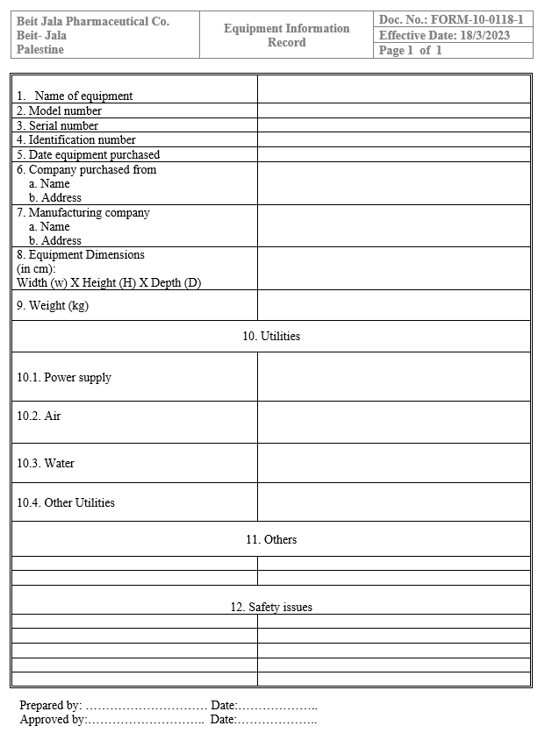
Figure A.1 — Official company form: Equipment Information Record (FORM-10-0118)

A.2 Maintenance Request & Corrective Maintenance Report
Reference: Company Form No. FORM-10-0975. This form corresponds to two separate, independently fillable system entries: the "New Maintenance Request" screen (Section 1, filled by the requesting department) and the "Corrective Maintenance Record" screen (Sections 2–3, completed by the technician). Each may be filled without waiting for the other; the two entries share the same Request/Report Number, and the system opens the matching linked entry automatically in either direction (see FR-6.9–FR-6.10).

Section 1 — Request (filled by the requesting department)
# | Field
1 | Request / Report Number
2 | Department / Section
3 | Priority — Normal / Urgent (checkbox)
4 | Machine name (area) / machine number
5 | Date
6 | Failure description
7 | Signature of the person reporting the failure
8 | Signature of the department supervisor
9 | QA Supervisor signature (approval, required before the request reaches Engineering — see FR-6.2)

Section 2 — Preliminary Findings (filled by maintenance)
# | Field
1 | Preliminary check results
2 | Expected work time — From / To
3 | Signature of the maintenance technician
4 | Signature of the concerned section supervisor

Section 3 — Actions Taken & Hand-over (filled by the technician)
# | Field
1 | Actions taken (free text)
2 | Remarks and recommendations
3 | Table: performing staff — No. / Name / Signature
4 | Machine / completed work hand-over — receiver's name, signature, date
5 | Engineering signature
Note: This form is the link between the Maintenance Requests module (Section 3.6) and the machine's Corrective Maintenance Record — they are separate entries sharing the same Request Number; opening that number from either side opens the matching linked entry (FR-6.9–FR-6.10).
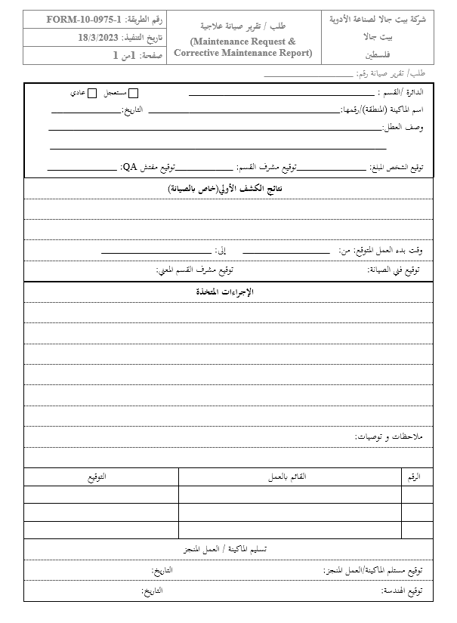
Figure A.2.1— Official company form: Maintenance Request & Corrective Maintenance Report (FORM-10-0975)

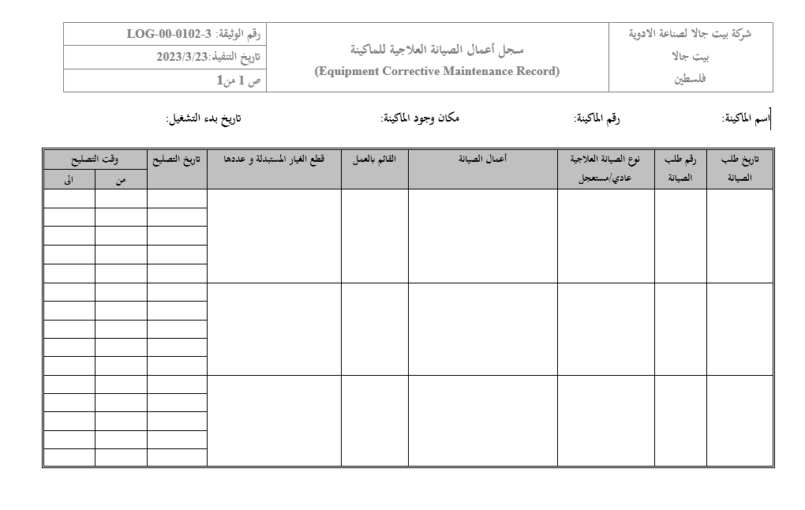

Figure A.2.2 — Official company form: سجل أعمال الصيانة العلاجية للماكينة) Equipment Corrective Maintenance((LOG-00-0102-3)

Header fields (LOG-00-0102-3): company name/logo (Beit Jala Pharmaceutical Industries Co., Palestine — fixed, same as every other form), document number, execution date, page count (fixed at 1 of 1), machine name, machine number, machine location, and start-up date. As noted in Section 3.6.1, the last four fields are unique to this form and are not part of the shared header on the Preventive Maintenance Record or any other official form.

A.3 Preventive Maintenance Record
Opened from a machine's profile → "Preventive Maintenance" tab. Consists of a fixed Header and a flexible Checklist, per Section 3.5 of this SRS.

Header (fixed on every page, entered once, editable only via "Edit Header")
# | Field
1 | Procedure / form number
2 | Effective date
3 | Department
4 | Page X of Y (auto-calculated)
Note: Machine name, machine number, machine location, and start-up date are deliberately not part of this header — those fields are specific to the Corrective Maintenance Record (Section 3.6.1, Appendix A.2) and are never duplicated here.

Checklist (flexible number of rows; a new column is added for every inspection)
Example layout — the number of rows (checklist points) is configured per machine (FR-5.4–FR-5.6); the number of columns grows automatically as inspections are performed, up to the configured limit per page (FR-5.9, FR-5.11). Regardless of how many checklist points a machine has, the record always ends with the same fixed block, shown after the last checklist point on every page: Action taken (in case of error/deviation), Examiner's name and signature, and Machine receiver's name and signature.
# | Checklist Point |  | Inspection 1 | Inspection 2 | …
1 | e.g., Check motor / bearings |  | Yes / No / Value | Yes / No / Value | …
2 | e.g., Check pressure |  | Value (e.g., 5.2 bar) | Value | …
3 | e.g., Check temperature |  | Value (e.g., 18 °C) | Value | …
… | … (as configured for this machine) |  | … | … | …
# |  | Field (recorded per inspection)
1 |  | Inspection date — Date Picker with "Today" shortcut
2 |  | Inspection time — Time Picker with "Now" shortcut
3 |  | Action taken (in case of error/deviation) — free text
4 |  | Examiner's name and signature
5 |  | Machine receiver's name and signature
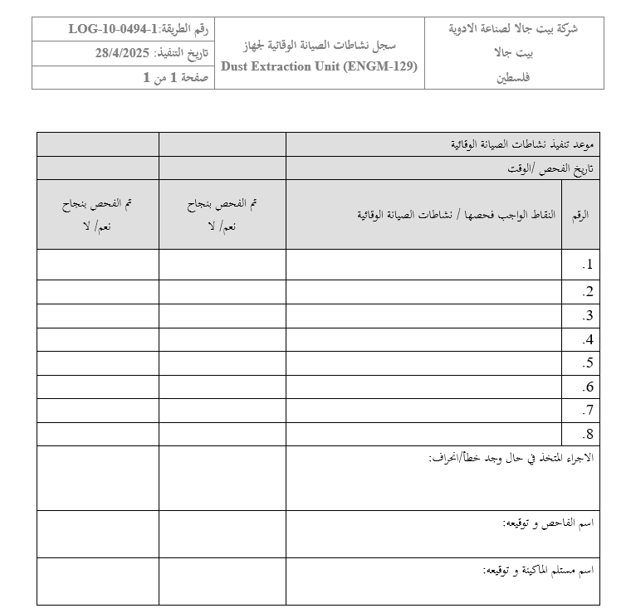
Figure A.3 — Example of an official Preventive Maintenance checklist form illustrating the fixed header, the checklist points, and repeated Yes/No inspection columns that the electronic PM Record must reproduce for each machine.

A.4 Preventive Maintenance Plan for Year (Annual Plan)
Reference: Company Form No. FORM-10-1025. Opened from Maintenance Plans → "Annual Plan".

Page 1 — Approval Page (fixed template)
# | Field
1 | Year
2 | Prepared by — Maintenance Supervisor (or Admin), signature, date
3 | Approved by — Engineering Department Manager, signature, date
4 | Approved by — Production Department Manager, signature, date
5 | Approved by — QC Department Manager, signature, date
6 | Approved by — R&D Department Manager, signature, date
7 | Approved by — QA Department Manager, signature, date
Note: This page is a fixed, company-approved template (see Figure A.4), generated once at the start of each year by the Maintenance Supervisor or Admin. The Engineering, Production, QC, R&D, and QA Department Managers must have view access to the plan and sign it as Approvers; signing uses the Electronic Signatures module (Section 3.11), which limits each signature field to users holding the matching permission (see FR-7.9).

Page 2 onward — Machine Schedule Table
# | Field
1 | Department
2 | Machine name / location / machine code (if applicable)
3 | Frequency
4 | Duration
5 | Start date
6 | Finish date
Note: Start and Finish dates are computed automatically from each machine's configured Start Date and Frequency (FR-7.5), and each scheduled activity also carries a Duration (FR-7.6); the Maintenance Supervisor may manually edit these calculated values if needed (FR-7.7).
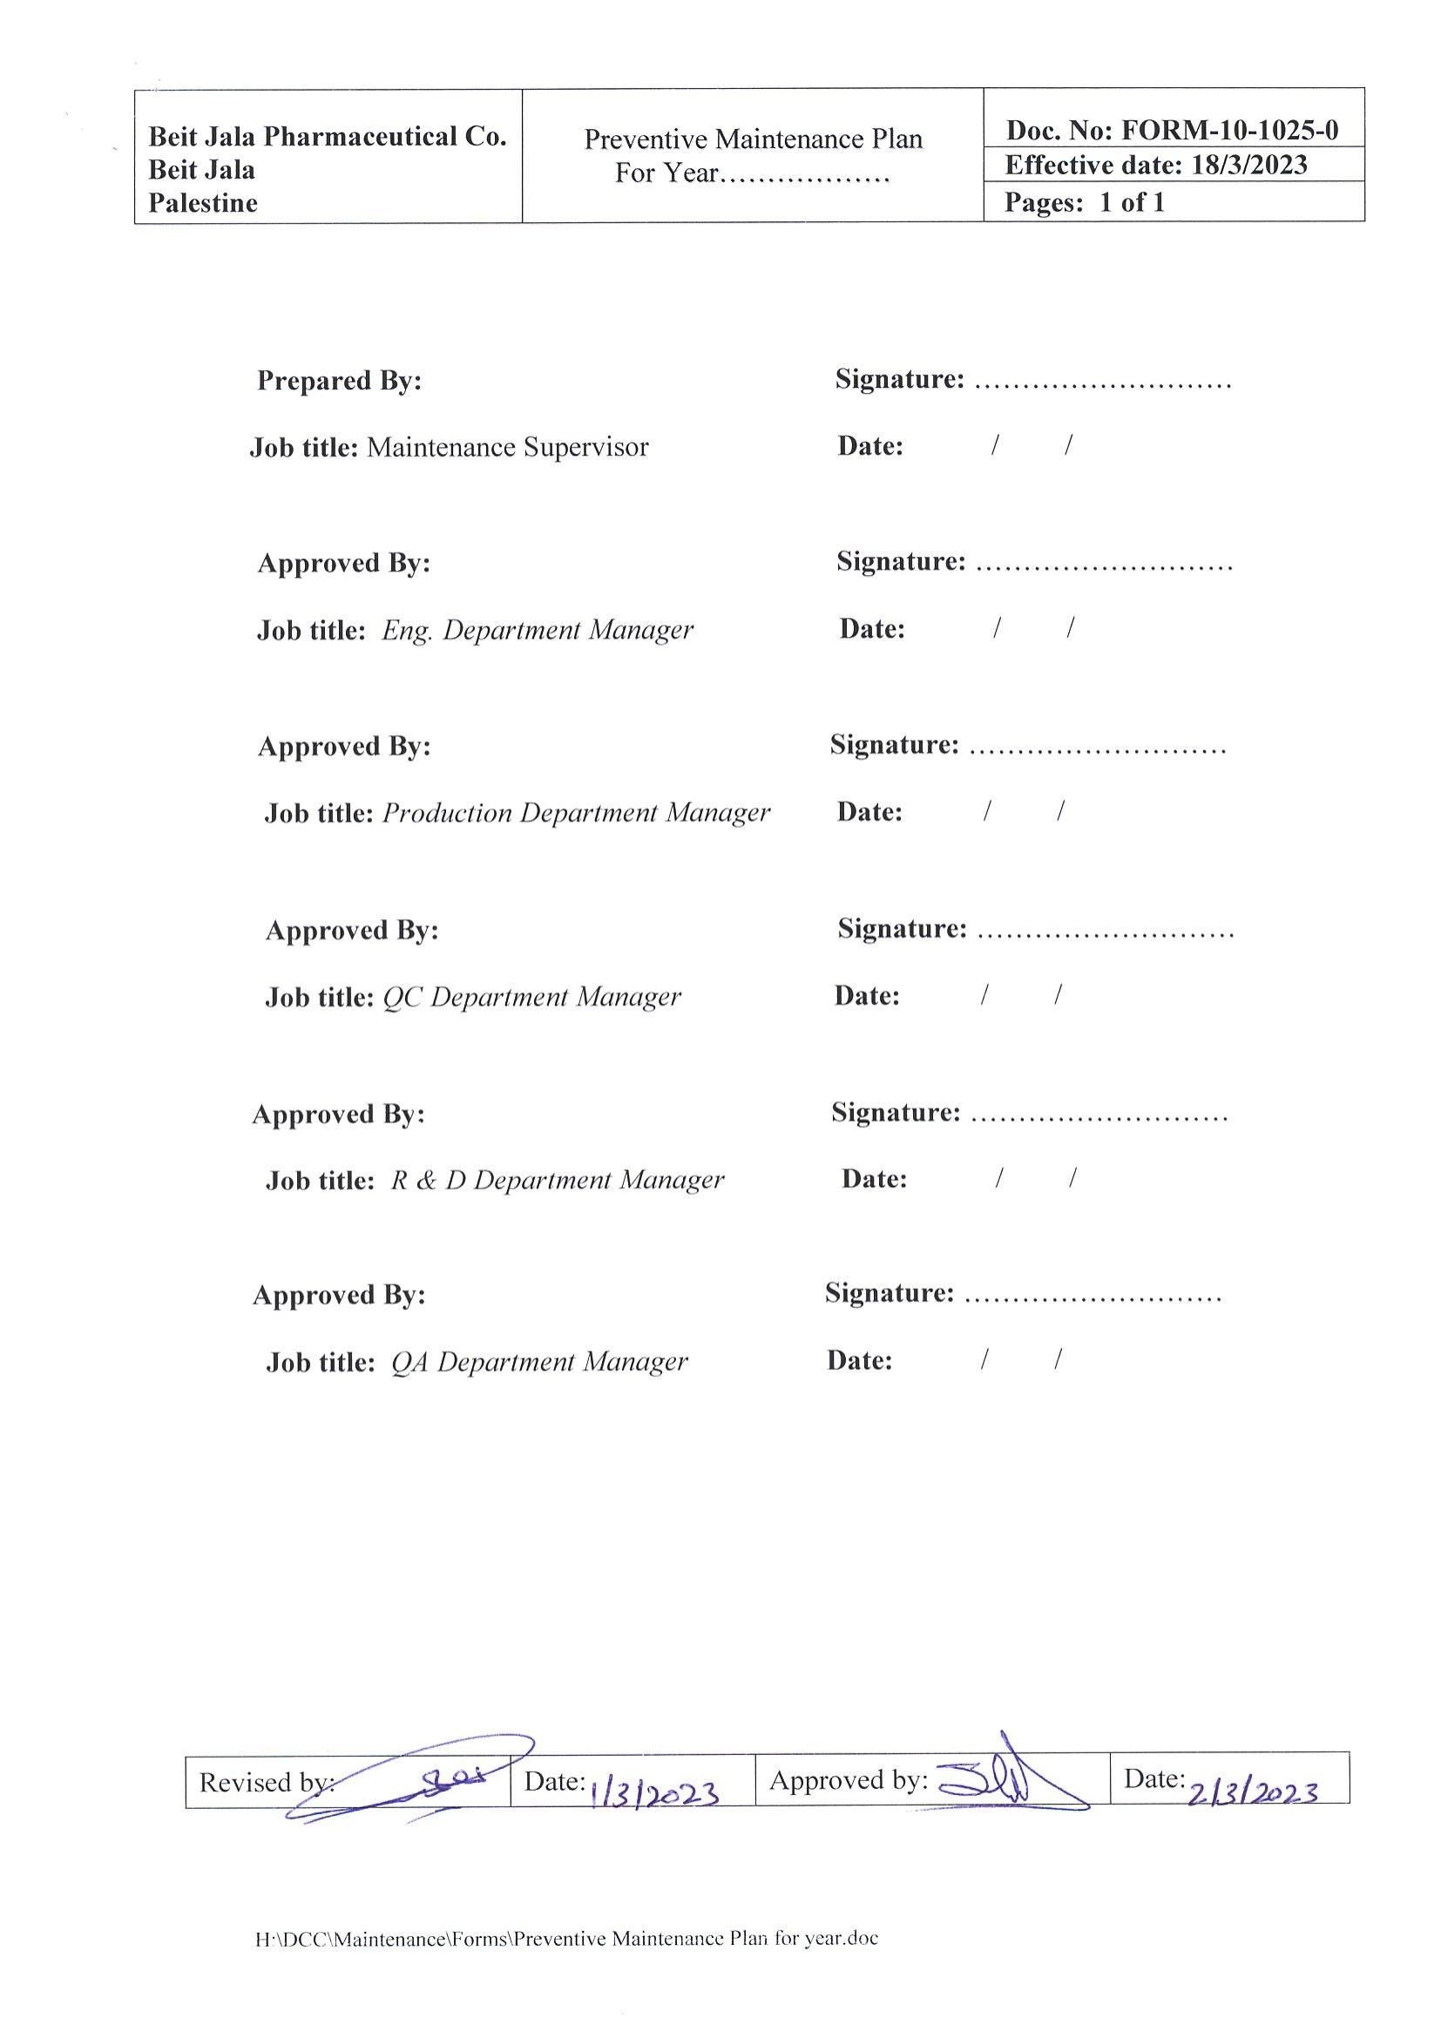
Figure A.4 — Official company form: Preventive Maintenance Plan for Year (FORM-10-1025)

A.5 Monthly Preventive Maintenance Program (Monthly Plan)
Reference: Company Form No. FORM-10-0117. Opened from Maintenance Plans → "Monthly Plan" → select Year → select Month (one of the 12 month buttons, FR-7.2–FR-7.3).
# | Field
1 | Month / Year
2 | No. (row 1–12, or as many machines scheduled that month)
3 | Department name
4 | Section name
5 | Machine name / identification number
6 | Planned date — From / To
7 | Actual date (filled after execution)
8 | Amendments (if the activity is postponed/rescheduled — free text)
9 | Prepared by — signature, date
10 | Maintenance Section Supervisor signature, date
11 | Department Manager sign, date
12 | Approved by, date
Note: Each row's Machine field links back to that machine's Preventive Maintenance Record (Appendix A.3).
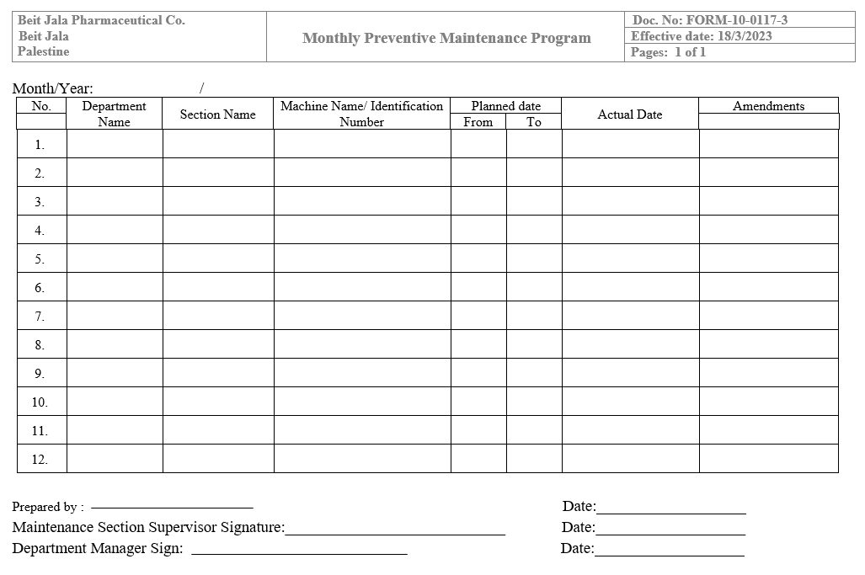
Figure A.5 — Official company form: Monthly Preventive Maintenance Program (FORM-10-0117)

A.6 Spare Parts Record
Opened from Spare Parts → select part. This record is designed for the system (not a 1:1 digitization of a single paper form) to satisfy the stock tracking requirement in Section 3.8.
Note: The company's current procedure does not include a dedicated stock-card form for real-time spare-parts quantities — the closest existing paper forms (Spare Parts Purchase Request, Receipt Form) cover procurement, not on-hand stock levels. The fields below are proposed to fill that gap.
# | Field
1 | Part name
2 | Part code
3 | Current quantity
4 | Stock-in movements — date, quantity, related maintenance record (if any)
5 | Stock-out movements — date, quantity, related maintenance record (if any)

