SQL syntax voor het aanmaken van de database

Groep: 10

Auteur: Nils Hettinga, Wiebe de Boer, Casper Hooft

Leden: Casper Hooft

Wiebe de Boer

Kevin Haakma

Elon Gielink

Nils Hettinga

Versie: 0.2

Datum: 12-04-2019

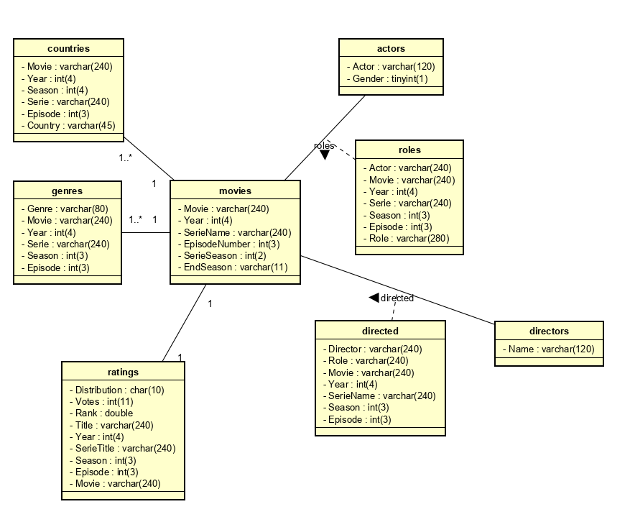

**Creates van Tabellen**

SET SQL_MODE = "NO_AUTO_VALUE_ON_ZERO";

SET AUTOCOMMIT = 0;

START TRANSACTION;

SET time_zone = "+00:00";

/*!40101 SET @OLD_CHARACTER_SET_CLIENT=@@CHARACTER_SET_CLIENT */;

/*!40101 SET @OLD_CHARACTER_SET_RESULTS=@@CHARACTER_SET_RESULTS */;

/*!40101 SET @OLD_COLLATION_CONNECTION=@@COLLATION_CONNECTION */;

/*!40101 SET NAMES utf8mb4 */;

--

-- Database: `chatbot`

--

-- --------------------------------------------------------

--

-- Tabelstructuur voor tabel `Actors`

--

CREATE TABLE `Actors` (

`Actor` varchar(120) NOT NULL,

`Gender` tinyint(1) NOT NULL

) ENGINE=InnoDB DEFAULT CHARSET=utf8;

-- --------------------------------------------------------

--

-- Tabelstructuur voor tabel `Countries`

--

CREATE TABLE `Countries` (

`Movie` varchar(240) NOT NULL,

`Year` int(4) NOT NULL,

`Season` int(4) NOT NULL,

`Serie` varchar(240) NOT NULL,

`Episode` int(3) NOT NULL,

`Country` varchar(45) NOT NULL

) ENGINE=InnoDB DEFAULT CHARSET=utf8;

-- --------------------------------------------------------

--

-- Tabelstructuur voor tabel `Directed`

--

CREATE TABLE `Directed` (

`Director` varchar(240) NOT NULL,

`Role` varchar(240) NOT NULL,

`Movie` varchar(240) NOT NULL,

`Year` int(4) NOT NULL,

`SerieName` varchar(240) NOT NULL,

`Season ` int(3) NOT NULL,

`Episode` int(3) NOT NULL

) ENGINE=InnoDB DEFAULT CHARSET=utf8;

-- --------------------------------------------------------

--

-- Tabelstructuur voor tabel `Directors`

--

CREATE TABLE `Directors` (

`Name` varchar(120) NOT NULL

) ENGINE=InnoDB DEFAULT CHARSET=utf8;

-- --------------------------------------------------------

--

-- Tabelstructuur voor tabel `Genres`

--

CREATE TABLE `Genres` (

`Genre` varchar(80) NOT NULL,

`Genre` varchar(120) NOT NULL,

`Year` int(4) NOT NULL,

`Serie` varchar(240) NOT NULL,

`Season` int(3) NOT NULL,

`Episode` int(3) NOT NULL

) ENGINE=InnoDB DEFAULT CHARSET=utf8;

-- --------------------------------------------------------

--

-- Tabelstructuur voor tabel `Movies`

--

CREATE TABLE `Movies` (

`Movie` varchar(240) NOT NULL,

`Year` int(4) DEFAULT '9999',

`SerieName` varchar(240) NOT NULL,

`SerieSeason` int(2) NOT NULL,

`EpisodeNumber` int(3) NOT NULL,

`EndSeason` varchar(11) NOT NULL

) ENGINE=InnoDB DEFAULT CHARSET=utf8;

-- --------------------------------------------------------

--

-- Tabelstructuur voor tabel `Ratings`

--

CREATE TABLE `Ratings` (

`Distribution` char(10) NOT NULL,

`Votes` int(11) NOT NULL,

`Rank` double NOT NULL,

`Year` int(4) DEFAULT '9999',

`SerieTitle ` varchar(240) NOT NULL,

`Season ` int(3) NOT NULL,

`Episode ` int(3) NOT NULL

) ENGINE=InnoDB DEFAULT CHARSET=utf8;

-- --------------------------------------------------------

--

-- Tabelstructuur voor tabel `Roles`

--

CREATE TABLE `Roles` (

`Actor` varchar(240) NOT NULL,

`Movie` varchar(240) NOT NULL,

`Year` int(4) NOT NULL,

`Serie` varchar(240) NOT NULL,

`Season` int(3) NOT NULL,

`Episode` int(3) NOT NULL,

`Role` varchar(280) NOT NULL

) ENGINE=InnoDB DEFAULT CHARSET=utf8;

-- --------------------------------------------------------

-- **Indexen voor geëxporteerde tabellen (primary keys & indexes)**

-- Indexen voor tabel `Actors`

--

ALTER TABLE `Actors`

--

-- Indexen voor tabel `Countries`

--

ALTER TABLE `Countries`

ADD KEY `movie` (`Movie`);

--

-- Indexen voor tabel `Directed`

--

ALTER TABLE `Directed`

ADD KEY `director` (`Director`),

ADD KEY `movie` (`Movie`);

--

-- Indexen voor tabel `Directors`

--

ALTER TABLE `Directors`

--

-- Indexen voor tabel `Genres`

--

ALTER TABLE `Genres`

ADD KEY `movie` (`Movie`);

--

-- Indexen voor tabel `Movies`

--

ALTER TABLE `Movies`

--

-- Indexen voor tabel `Ratings`

--

ALTER TABLE `Ratings`

ADD KEY `movie` (`Movie`);

--

-- Indexen voor tabel `Roles`

--

ALTER TABLE `Roles`

ADD KEY `actor` (`Actor`),

ADD KEY `movie` (`Movie`);

**Load data Post Parsen CSV to SQL**

**Roles Tabel**

LOAD DATA INFILE 'C:/ProgramData/MySQL/MySQL Server 8.0/Uploads/actorsRoles.csv'

INTO TABLE `imdb`.`roles`

FIELDS TERMINATED BY '|'

LINES TERMINATED BY '\r\n'

IGNORE 1 ROWS;

LOAD DATA INFILE 'C:/ProgramData/MySQL/MySQL Server 8.0/Uploads/actressesRoles.csv'

INTO TABLE `imdb`.`roles`

FIELDS TERMINATED BY '|'

LINES TERMINATED BY '\r\n'

IGNORE 1 ROWS;

**Actors Tabel**

LOAD DATA INFILE 'C:/ProgramData/MySQL/MySQL Server 8.0/Uploads/actresses.csv'

INTO TABLE `imdb`.`actors`

FIELDS TERMINATED BY '|'

LINES TERMINATED BY '\r\n'

IGNORE 1 ROWS;

LOAD DATA INFILE 'C:/ProgramData/MySQL/MySQL Server 8.0/Uploads/actors.csv'

INTO TABLE `imdb`.`actors`

FIELDS TERMINATED BY '|'

LINES TERMINATED BY '\r\n'

IGNORE 1 ROWS;

**Movies Tabel**

LOAD DATA INFILE 'C:/ProgramData/MySQL/MySQL Server 8.0/Uploads/movies.csv'

INTO TABLE `imdb`.`movies`

FIELDS TERMINATED BY '|'

LINES TERMINATED BY '\r\n'

IGNORE 1 ROWS;

**Directed Tabel**

LOAD DATA INFILE 'C:/ProgramData/MySQL/MySQL Server 8.0/Uploads/directed.csv'

INTO TABLE `imdb`.`directed`

FIELDS TERMINATED BY '|'

LINES TERMINATED BY '\r\n'

IGNORE 1 ROWS;

**Directors Tabel**

LOAD DATA INFILE 'C:/ProgramData/MySQL/MySQL Server 8.0/Uploads/directors.csv'

INTO TABLE `imdb`.`directors`

FIELDS TERMINATED BY '|'

LINES TERMINATED BY '\r\n'

IGNORE 1 ROWS;

**Genres Tabel**

LOAD DATA INFILE 'C:/ProgramData/MySQL/MySQL Server 8.0/Uploads/genres.csv'

INTO TABLE `imdb`.`genres`

FIELDS TERMINATED BY '|'

LINES TERMINATED BY '\r\n'

IGNORE 1 ROWS;

**Countries Tabel**

LOAD DATA INFILE 'C:/ProgramData/MySQL/MySQL Server 8.0/Uploads/countries.csv'

INTO TABLE `imdb`.`countries`

FIELDS TERMINATED BY '|'

LINES TERMINATED BY '\r\n'

IGNORE 1 ROWS;

**Ratings Tabel**

LOAD DATA INFILE 'C:/ProgramData/MySQL/MySQL Server 8.0/Uploads/ratings.csv'

INTO TABLE `imdb`.`ratings`

FIELDS TERMINATED BY '|'

LINES TERMINATED BY '\r\n'

IGNORE 1 ROWS;