AMP(1)-Lab04–Functions(trig+inverse)

# Content

AMP(1)Lab04–Functions(trig+inverse) 1

1. Content 1

2. Learning objectives 2

2.1. Exam objectives 2

2.2. Supportive objectives 2

3. Exercises 3

3.1. Basic exercises 3

3.1.1. From unit circle to the sine wave (Geogebra) 3

3.1.2. General sine function 3

3.2. Bridging exercises 5

3.2.1. Find the sine graph 5

3.2.2. Hovering Motion 5

3.3. Contextual practice 6

3.3.1. Moving Platforms 6

3.3.2. Advanced Platformer Puzzle 6

3.3.3. Inverse trigonometric functions 7

# Learning objectives

## Exam objectives

By the end of this lab you should be able to (pen and paper):

* Master specific vocabulary about sine functions like amplitude, angular frequency, phase and intercept, as well as period and periodicity
* Graph the general sine function $f\left(x\right)=r\sin\left(ωx+θ_{0}\right)+c$ based on its amplitude r, angular frequency omega, theta and intercept c
* Given the general sine function $f\left(x\right)=r\sin\left(ωx+θ_{0}\right)+c$ retrieve its amplitude r, angular frequency omega, the phase and intercept c
* Determine the domain and range of the general sine function
* Find the root(s) of the general sine function $f\left(x\right)=r\sin\left(ωx+θ_{0}\right)$ and display these

We advise you to **make your own summary of topics** which are new to you.

## Supportive objectives

Specifically related to the above you should in GeoGebra Classic **5.0** be able to:

* Graph the general sine function in the View/Graphics
* Visualize the domain and range of the general sine function
* Find the root(s) of the general sine function $f\left(x\right)=r\sin\left(ωx+θ_{0}\right)$

# Exercises

Dependent of the lab session you may work individually or teamed (organized by the lab attendant). In either case make sure that throughout the course of this lab, you re-save your solution file on a regular basis as

**1DAExx-yy-name1**(+name2+name3).GGB given **xx**=groupcode, **yy**=labindex

## Basic exercises

### From unit circle to the elementary sine function (Geogebra)

* Draw out the unit circle using $A=(cos(t),sin(t))$ by parameter *t*
* Now, Create a slider variable s for time ranging from 0 to 2*Pi.
* Create a point $P$ that travels on the unit circle, using this parameter *s*.
* Create a point $Q$ that has only the vertical movement of the point $P$
* Create a point $R$ that has the x position defined by *s* and shares the same vertical movement as $Q$
* Activate trace for $R$, what do you observe?

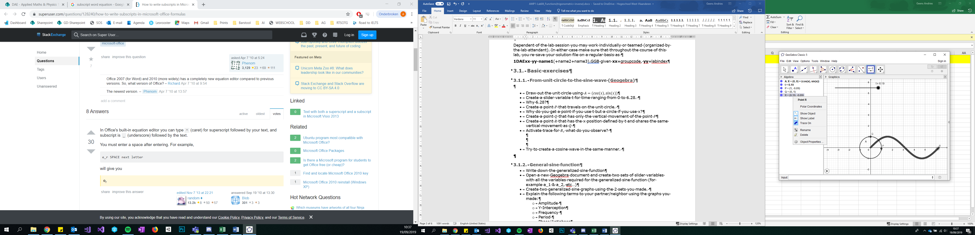

* Try to create a cosine wave in the same manner.

### General sine function

* Write down the generalized sine function
* Open a new Geogebra document and create two sets of slider variables with all the variables required for the generalized sine function (for example $r_{1} \& r_{2},$ $ω_{1} \& ω_{2}$, …)
* Create two generalized sine graphs $f\left(x\right)=r\sin\left(ωx+θ_{0}\right)$ using the two sets of variables you made.
* Explain the following terms using the graphs you made:
  + amplitude *r*
  + intercept *c*
  + pulsation $ω=\frac{2 Pi}{T}$
  + period T
  + phase
* Using the two sine waves create the following scenarios and write down the according sine waves:
  + Graph 1 has twice the amplitude of Graph 2
  + Graph 1 has a Period of 5 and Graph 2 has half of that
  + Graph 1 has double the pulsation of Graph 2

## Bridging exercises

### Find the sine graph

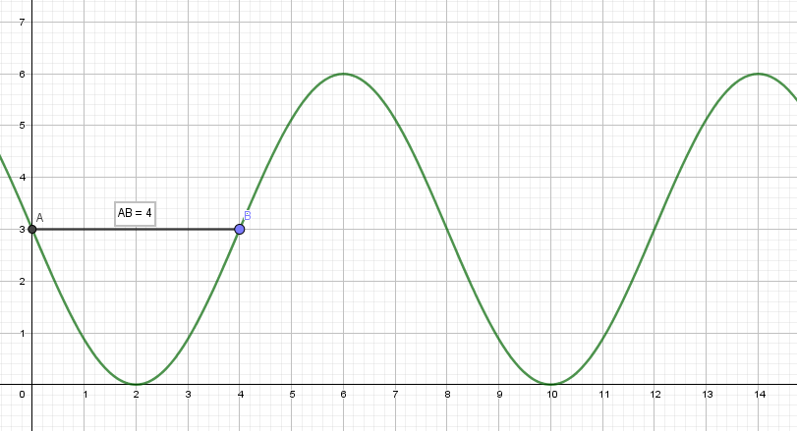

Retrieve all coefficients by the graph of this pictured general sine function $f\left(x\right)=r\sin\left(ωx+θ_{0}\right)+c$

* *r = 3*
* $ω$*= $\frac{π}{4}$*
$θ_{0}=π of-π$

* *c = 3*

### Hovering Motion

t

The sine-graph above describes the hovering motion of hovercraft when in idle state. The **height** **h** is plotted against the **time t**. Retrieve all four coefficients.

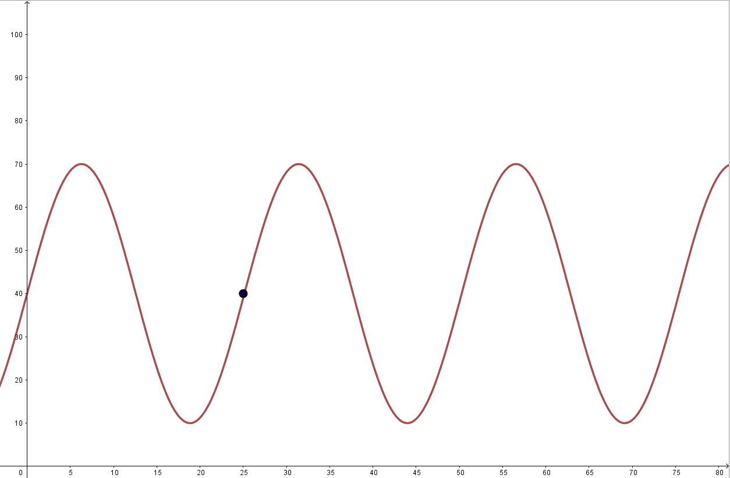

(25,40)

h

t

* Using the sine-graph above find the following coefficients:
  1. Pulsation = $\frac{2π}{25}$
  2. amplitude = 30
  3. intercept = 40
  4. phase = 0
* Write down the equation that is represented by the graph above.
$$f\left(x\right)=30∙\sin\left(\frac{2π}{25}x\right)+40$$

* Make a point in GeoGebra that follows the hovering Motion of the hovercraft.   
  The height is plotted on the y axis and the horizontal position on the x axis stays at 0.

The observation starts at t=0. At what time is the hovercraft at its closest to the ground for the first time. Estimate and then calculate an exact statement.

(25/4,10)

## Contextual practice

### Moving Platforms

Find the sine waves and points representing the following platforms:

* The platform moves between (2,5) and (12,5) with a pulsation of 2 Pi /10

r=(12-2)/2=5

c=2+5=7

$$5∙\sin\left(\frac{π}{5}x\right)+7$$

* The platform moves between (3,17) and (3,6) with a pulsation of 2 Pi

$$\frac{11}{2}\sin\left(2π∙x\right)+\frac{23}{2}$$

Make a representation of the platforms in GeoGebra. Assume that the movement above is observing the top left corner of the platform. The platforms are 1 unit high and 3 units wide.

* **BONUS1**: The third platform moves diagonally from (2, 4) to (10, 12). It takes the platform 15 seconds to go from the first point to the second and back. Be careful: Two individual movements run simultaneously to create the said movement in the diagonal direction.
* **BONUS2**: Configure the slider t from 0 to the period T (setting Repeat to ‘Increasing’) to obtain a smooth endless loop.

### Advanced Platformer Puzzle

For a Mario like platformer you want to create the following platform movement:

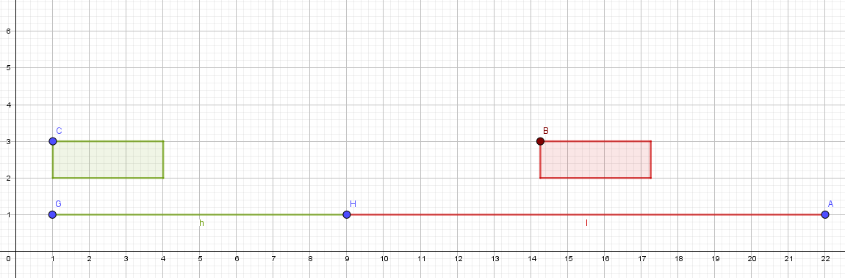

The lines under the platforms show the range that the corresponding platforms move. (Including the width of the platform. F.e. the point C on the green platform never moves further than 6)

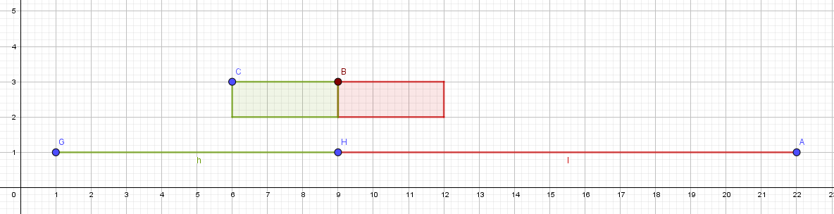

* Requested movement information:
  + Initial situation at time t=0 as shown.
  + Every 2nd movement of the left platform they touch each other.
  + They always touch at the same spot above H.
  + It takes the green platform 1.5 seconds to go from left to right. The red platform takes twice as long
  + The platforms have no vertical movement. The top points of both platforms stay at height 3.
  + Both platforms are 3 units wide and 1 unit high.

#### Make your own sketch to illustrate the problem and add all the information to the sketch

#### Tune the two general sine functions to control the wanted movement.

#### Simulate this platform movement using GeoGebra.

### Inverse trigonometric functions

#### Inverse Sine function

* Plot the $f(x) = arcsin(x)$ function
* Determine and explain to your neighbor the domain and range of this function

#### Inverse Cosine function

* Determine the range and domain
* Plot the function to check if the predetermined domain and range where correct
* Explain the difference between arcsine and arccosine ranges

#### Explain the difference between the Atan and Atan2 functions