AMP(1)-Lab02– Trigonometry Fundamentals

# Content

AMP(1)-Lab02– Trigonometry Fundamentals 1

1. Content 1

2. Learning objectives 1

2.1. Exam objectives 1

2.2. Supportive objectives 2

3. Exercises 2

3.1. Basic exercises 2

3.1.1. Exploring the triangle in Geogebra 2

3.1.2. Angles 3

3.1.3. Your summary of some trigonometric formulas 4

3.1.4. Applying these formulas in some basic situations 5

3.2. Contextual practice 8

3.2.1. Sonic the hedgehog loop 8

3.2.2. Frog 8

3.2.3. Through a tube to the next level 9

3.2.4. Pool 10

4. References 10

4.1. Trigonometry 10

4.2. Geogebra tutorials 10

4.2.1. The basics 10

4.2.2. Slider basics 10

4.2.3. Sine, cosine and tangent ratios 10

# Learning objectives

## Exam objectives

By the end of this lab you should be able to (pen and paper):

* Master the trigonometric primitives like (oriented) angle, radian, degree, sine, cosine, tangent and the Pythagorean Theorem
* Master the trigonometric vocabulary like types of triangles (scalene, isosceles, equilateral), types of lines (median, altitude, angular bisector, perpendicular bisector) and points (apex, foot, midpoint)
* Understand and apply the Pythagorean Identity and the relation tan=sin/cos
* Apply all formulas valid for the scalene triangle: Law of Sines, Law of Cosines and the general formula for its area

We advise you to **make your own summary of topics** which are new to you.

More info is available in Trigonometry

## Supportive objectives

More specifically related to the above you should in GeoGebra () be able to:

* Call and calculate primitives like degree, sine, cosine, tangent
* Visualize angles and triangles
* Draw types of lines (median, altitude, angular bisector, perpendicular bisector), vertices and points
* Solve formulas of the scalene triangle for one unknown (like in the Law of Sines, Law of Cosines and the general area-formula)

More information is available on the Web Geogebra tutorials

# Exercises

Dependent of the lab session you may work individually or teamed (organized by the lab attendant). In either case make sure that throughout the course of this lab, you re-save sufficiently your solution file on your local machine as

**1DAExx-0y-name1**(+name2+name3).GGB given **xx**=groupcode, **0y**=labindex

## Basic exercises

### Exploring the triangle in Geogebra

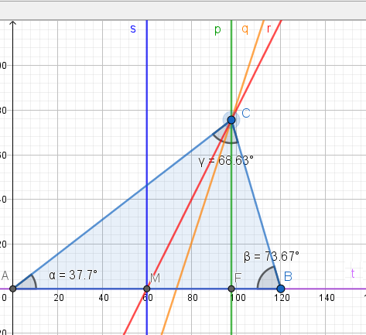

Have a look at the given AMP(1)-Lab02_TrigonometryFundamentals21-22_v3(Triangle).ggb file. The graphics view shows a triangle and its geometric lines. You can achieve the same result by performing the following steps:

* Draw the triangle ABC.
* Then draw the following objects:
* the perpendicular bisector (s),
* the angular bisector (q),
* the median or side bisector (r) and midpoint M
* the altitude (p) with apex C
* the foot F
* the base (t)

Then execute the following steps yourselves:

* Draw the 3 angles using the Angle button.
* And calculate the sum of the 3 angles in the input bar.

Answer these questions:

1. Move the vertex C around and have a look at the sum of the 3 angles, what do you notice?
2. Move point C until the sides [CA] and [CB] get the same length. What type of triangle do you get and what do you notice about the special lines and the angles ?
3. Move point C until all the sides have the same length value 120. What type of triangle do you get and what do you notice about the angles ?

### Angles

#### Recognize relationships

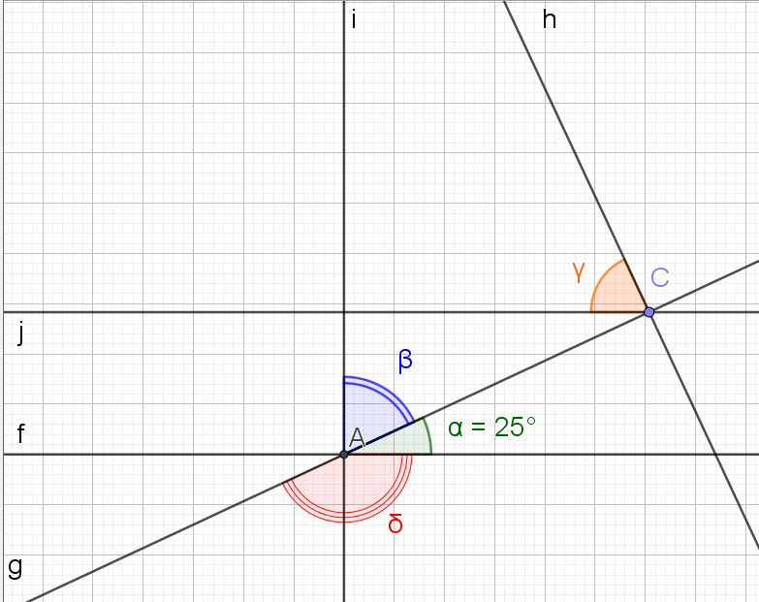

What is the size in degrees of angles β δ γ in the in the drawing above when:

* The size of α is 25°
* Line i is perpendicular to line f
* Line j is parallel to line f
* Line h is perpendicular to line g

|  |  |
| --- | --- |
| Angle | Size in degrees |
| β | 65 |
| δ | 155 |
| γ | 65 |

### Your summary of some trigonometric formulas

Before making the following exercises you should know very well which formulas are at your disposal. Write in the second column the formulas requested in the left column.

|  |  |
| --- | --- |
| 1. Definition of an angle | The circular arc length l to its radius |OR| = r. |
| 1. Conversion from radians to degrees |  |
| 1. Conversion from degrees to radians |  |
| 1. The Pythagorean theorem | a2 = b2 + c2 |
| 1. The formula of the sine, cosine and tangent of the acute angle in a right triangle |  |
| 1. The law of sines |  |
| 1. The law of cosines |  |
| 1. The area of a triangle | $$\frac{b∙h}{2}$$ |

### Applying these formulas in some basic situations

Before using trigonometry to solve problems in the real world or in games, you should be able to see which formulas to apply in some basic situations.

First calculate the results on paper, afterwards check your results using geogebra.

|  |  |
| --- | --- |
| Given | Questions |

|  |  |
| --- | --- |
| 1. Given is this right triangle. | 1. What is the length of the hypotenuse? 2. What is the tangent of angle α? 3. What is the tangent of angle β? 4. What is the size of angle α (radians and degrees)? 5. What is the size of angle β (radians and degrees)? |
| 1. Vertices B and C are on a circle with center A and radius 50 units. The length of the arc between B and C is 60 units. | 1. What is the angle α in radians? 2. What is the angle β in radians? 1,32 rad 3. What is the angle γ in radians? 1,32 rad 4. What is the length of the line segment [BC] 55 5. Is this a right, isosceles, equilateral or scalene triangle?  isosceles |
| 1. Vertex B is on a unit circle with center A. | 1. What is the length of line segment [AC]?  [AC] = 2. What is the length of the line segment [CB]?   [CB] = |
| 1. Given are these 2 similar right triangles JIH and LKH. Knowing the size of following sides:  * |HI|= 100 units * |HK|= 60 units * |IJ|= 40 units | 1. What is the length of [LK]? 2. How many degrees are the angles at the triangle vertices H, J and L ? H = 22,77 degrees J = 68,18 degrees   L = 68,18 degrees   1. Complete: These triangles are similar because …? gelijkvormig |
| 1. Given is this triangle ABC with known length of 2 sides and known angle between those 2 sides | 1. What is the length of the other side a and what formula(s) did you use? cos regel: 2. How many degrees is the angle β and what formula(s) did you use? Cos regel: 3. How many degrees is the angle γ, and what formula(s) did you use? 4. What is the area of this triangle? 5. Is this a right, isosceles, equilateral or scalene triangle?   Scalene triangle |
| 1. Given is this triangle of which the length of the 3 sides is known. | 1. What size in degrees do the 3 angles have and what formula(s) did you use ?   α: $a^{2}=b^{2}+c^{2}-2bc∙\cos\left(α\right)=> α=\operatorname{acos}\left(\frac{a^{2}-b^{2}-c^{2}}{-2∙b∙c}\right)$ β: $b^{2}=a^{2}+c^{2}-2ac∙\cos\left(β\right)=>β=\operatorname{acos}\left(\frac{b^{2}-a^{2}-c^{2}}{-2∙a∙c}\right)$ γ: $c^{2}=a^{2}+b^{2}-2ab∙\cos\left(Y\right)=>Y=\operatorname{acos}\left(\frac{c^{2}-a^{2}-b^{2}}{-2∙a∙b}\right)$ |

## Bridging exercises

**Inverse functions**: Retrieve for each of underneath the corresponding (restricted to one single default) angle α, firstly by pen and paper – secondly in GeoGebra (GeoGebra/View/Cas)

**Trump Tower**: Given the person is at 300m horizontally from the Trump Tower, retrieve the height of its flag pole, up to cm. Use GeoGebra freely for calculations (GeoGebra/View/CAS)

**Height**: Given the horizontal distance between both persons is 40m retrieve the HEIGHT of their garden’s pine, tree up to cm. Use GeoGebra freely for calculations (GeoGebra/View/CAS)

## Contextual practice

Now solving following real world examples should be a piece of cake.

### Sonic the hedgehog loop

The radius of the loop is 100 units. Sonic starts the loop in point A which is located on a line starting in point C and perpendicular on a horizontal line. After having done a distance of 52,36 units on the loop Sonic has reached point B.

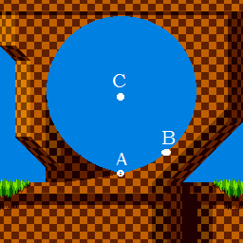

Answer these 4 questions.

1. What is the angle in radians between the lines CA and CB?
2. What is this angle in degrees?
3. What is the horizontal distance between the points A and B?
4. What is the vertical distance between the points A and B?

### Frog

Given is this start situation:



The frog wants to jump on the grass block to get extra strength. Knowing that:

* The distance between the horizontal centers of the frog and the grass block is 240 units when the frog starts its jump.
* The height of the grass block is 80 units
* It jumps in a straight line
* After the jump the horizontal centers of the frog and grass block coincide

Answer these 3 questions.

1. What was the jumped distance ?
2. At what angle (in radians) did the frog jump ?
3. At what angle (in degrees) did the frog jump ?

Following images should clarify some things.

|  |  |
| --- | --- |
| Before the jump |  |
| After the jump |  |

### Through a tube to the next level

The player can only get to the next level via a narrow tube. Therefor it needs to transform into a ball with the same diameter as the tube. This transformation costs a lot of energy that is greater as it shrinks more. So in order not to waste more energy than necessary, it should shrink until it reaches the same diameter as the tube and not more. To know this diameter the player uses a device that allows measuring the angle between the line from the device up to a point in the level and a horizontal reference line.

What is this diameter (d) when you know:

* The vertical position of the device (h) and
* The values of 2 angles (α and β ) as indicated on the picture below.
* That the terrain in front of the tube is horizontal
* That the entrance of the tube is perpendicular to the terrain.

h = 5 units

α = 36.87°

β = 51.34°

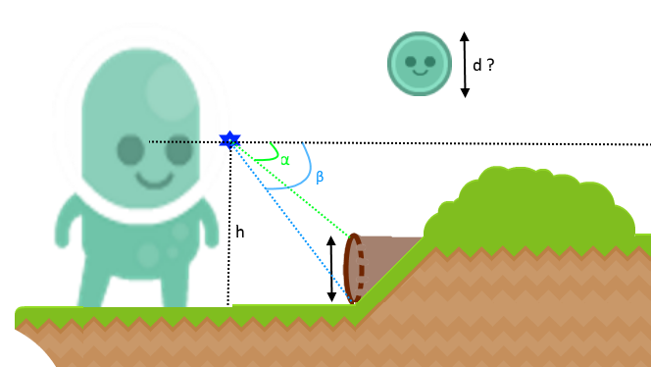

### Pool

In a game there is a medal at the bottom of a pool. The pool has the shape of a triangular right prism. The player needs this medal to get more power. It swims in a straight line to the medal as indicated by the black dotted line. The medal is located in the middle of that bottom side. the lengths of the sides of the base triangle are given (12.00, 15.62 and 10.00) as well as the height of the prism (2.00). How far swims the player before reaching the medal?

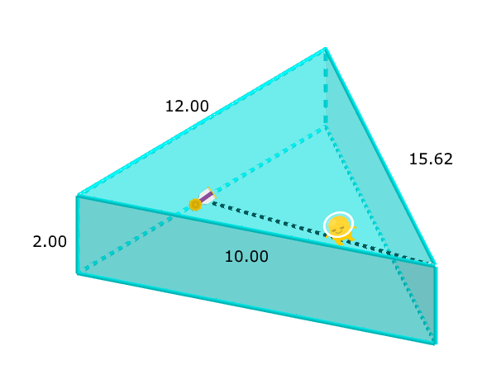

# References

## Trigonometry

ISBN 9789401474955 (Animation Maths NE/2021), **pars 3.1 – 3.3 (scalene triangles)**

## Geogebra tutorials

### The basics

<https://www.youtube.com/watch?v=1cBXWi66-tY>

### Slider basics

<https://www.youtube.com/watch?v=p1xeRhgEB2U>

### Sine, cosine and tangent ratios

<https://www.youtube.com/watch?v=im5b4plNNV0>