AMP(1) - Lab07 – Kinematics

# Content

Lab 4 – Kinematics 1

1. Content 1

2. Learning objectives 1

3. Exercises 2

3.1. Exercise 1 : Displacement - Distance 2

3.2. Exercise 2 : Displacement - Distance 2

3.3. Exercise 3 : Velocity - Speed 2

3.4. Exercise 4 : Velocity - Speed 2

3.5. Exercise 5 : Car slowing down 2

3.6. Exercise 6: Acceleration of a car 2

3.7. Excercise 7 : ball thrown upward 3

3.8. Excercise 8 : Driving of a cliff 3

3.9. Exercise 9 : racing 3

3.10. Exercise 10: Particle in a cube 3

3.11. Exercise 11 : Bananas 3

4. References 3

# Learning objectives

By the end of this lab you should be able to :

* Distinguish between displacement (vector) and distance (scalar)
* Distinguish between the velocity (vector) and its speed (norm)
* Apply the definition of velocity for Rectilinear Motions with Constant Velocity
* Apply the definition of acceleration (and deceleration) for Rectilinear Motions with Constant Acceleration
* Apply the location equation, the velocity equation and the time-independent formula for the Rectilinear Motion with Constant Acceleration
* Apply the independence of motion for the Projectile Motion (with properties horizontal range and height)
* Calculate the velocity for Rectilinear Motions with Constant Velocity
* Calculate the acceleration for Rectilinear Motions with Constant Acceleration
* Apply the location equation, the velocity equation and the time-independent formula for the Rectilinear Motion with Constant Acceleration
* Visualize the location equation and velocity equations in View/Graphics
* Visualize the motion’s trajectory in View/Graphics, like the Projectile Motion’s

# Exercises

Dependent of the lab session you may work individually or teamed (organized by the lab attendant). In either case make sure that throughout the course of this lab, you re-save sufficiently your solution file on your local machine as

**1DAExx-0y-name1**(+name2+name3).GGB given **xx**=groupcode, **0y**=labindex

## Exercise 1 : Displacement - Distance

Ash Ketchum walks 4 meters East, 2 meters South, 4 meters West, and finally 2 meters North. What is his displacement vector and the distance he travelled?

$$\left({4 \atop 0}\right)+\left({0 \atop -2}\right)+\left({-4 \atop 0}\right)+\left({0 \atop 2}\right)=\left({0 \atop 0}\right)$$

## Exercise 2 : Displacement - Distance

In a 2D game environment an airplane trip involves three legs, with two stopovers. The first leg is due east for 620 km, the second leg is southeast for 440 km; and the third leg is at 53° south of west, for 550 km. What is the plane’s total displacement vector? ( Angle and magnitude)

$$\left({620 \atop 0}\right)+\left({440∙cos⁡(45) \atop -440∙sin⁡(45)}\right)+\left({-550∙cos⁡(53) \atop -550∙sin⁡(53)}\right)=\left({600.12872 \atop -750.37651}\right)$$

$$\arctan\left(\frac{-750.37651}{600.12872}\right)=-51.34822 graden$$

## Exercise 3 : Velocity - Speed

Ash Ketchum walks 4 meters East, 2 meters South, 4 meters West, and finally 2 meters North. The entire motion lasted for 24 seconds. Determine the average velocity and the average speed.

3. Er moet een pijltje boven v

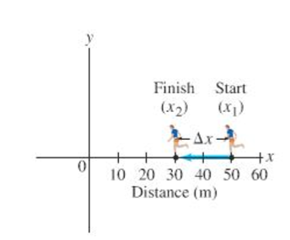

## Exercise 4 : Velocity - Speed

The position of a runner as a function of time is plotted as moving along the x axis of a coordinate system. During a 3.00 s time interval, the runner’s position changes from x_1 = 50.0 m to x_2 = 30.5 m as shown in the figure. What was the runner’s velocity? [Solution = -6.5 m/s]

$$\vec{v}=\left({-6.5 \atop 0}\right)$$

## Exercise 5 : Car slowing down

An automobile is moving to the right along a straight highway, which we choose to be the positive x axis. Then the driver puts on the brakes. If the initial velocity ( when the driver hits the brakes) is v_1 = 15.0 m/s, and it takes 5.0 s to slow down to v_2 = 5.0 m/s, what was the car’s deceleration? [Solution -2.0 m/s2]

$$5.0=15.0+a∙5.0=>a=\frac{5-15}{5}=-2.0\frac{m}{s^{2}}$$

## Exercise 6: Acceleration of a car

How long does it take for a car to cross a 30.0 m-wide intersection after the light turns green, if the car accelerates from rest at a constant rate of 2.00 m/s²? [Solution 5.48 s]

$$30=0+0∙t+\frac{2.00∙t^{2}}{2}=>t=5.48s$$

## Excercise 7 : ball thrown upward

Mario Bross throws a ball upward into the air with an initial velocity of 15.0 m/s.

1. Calculate the max height [Solution 11.5 m]
$$0=15.0+9.81∙t=>t=1.53s$$

$$s=0+15.0∙t+\frac{9.81∙t^{2}}{2}=>s=11.5m$$

2. How long is ball in the air before it comes back to his hand?[Solution 3.06 s]

$$1.53∙2=3.06$$

## Excercise 8 : Driving of a cliff

In a game a stunt driver on a motorcycle speeds horizontally off a 50.0 m high cliff. How fast must the motorcycle leave the cliff top to land on ground level below 90.0 m from the base of the cliff where the cameras are? Ignore air resistance. [Hint : Split up into vertical and horizontal motion] [Solution 28.2 m/s]

Vertical: $50=0+0∙t+\frac{9.81∙t^{2}}{2}=>t=3.19s$

Horizontal: $90=0+v∙t=>v=28.2\frac{m}{s}$

## Exercise 9 : racing

Two racing cars approach each other head-on on parallel tracks. Each has speed of 95 km/h with respect to the ground. If they are initially 8.5 km apart, how long will it be before they reach each other? [ Solution 0.045h]

$$4.25=0+95∙t=>t=0.045h$$

## Exercise 10: Particle in a cube

From a particle that moves in a 3D space , the positionvector on a timestamp t>0 (in seconds) is

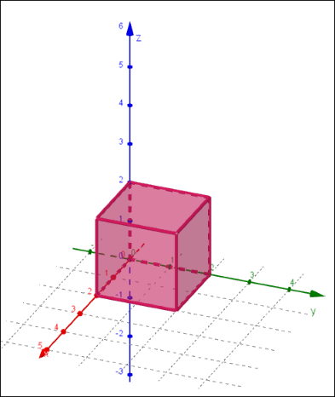 st = .

* What will be the **velocity vector?**
* Visualize the path of the particle in the cube
* How long will the particle be in the cube? [Solution : 2 seconds]

## Exercise 11 : Bananas

In a Donkey Kong game a banana is launched with an angle of $θ_{0}$ = 37° relative to the ground and with a speed of 20 m/s. Assume the banana is launched from ground level and ignore air resistance and rotation of the banana. Calculate :

1. the maximum height [Solution 7.35 m]
2. the time of travel before the banana reaches the ground again [Solution 2.45 s]
3. how far away it hits the ground [Solution 39.2 m]
4. the velocity vector at the maximum height
5. the acceleration vector at maximum height
6. Suppose the banana is launched at a height of 1.00m above the ground. How much further did the banana travel before hitting the ground? [Solution 1.3 m]

# References

[https://www.khanacademy.org/science/physics/one-dimensional-motion](https://www.khanacademy.org/science/physics/one-dimensional-motion/modal/a/what-is-displacement)

[https://www.khanacademy.org/science/ap-two-dimensional-motion](https://www.khanacademy.org/science/ap-physics-1/ap-two-dimensional-motion/horizontally-launched-projectiles-ap/e/2d-projectile-motion-with-components-given-exercise)

<https://www.physicsclassroom.com>

**Physics - Part 1**, Douglas C. Giancoli, Pearson Benelux