AMP(1) - Lab08 – Dot Product

# Content

Lab08 – Dot Product 1

1. Content 1

2. Learning objectives 3

2.1. Exam objectives 3

2.2. Supportive objectives 3

3. Exercises 3

3.1. Basic exercises 3

3.1.1. Recap length of a vector 3

3.1.2. Recap Normalising a vector 4

3.1.3. Calculate dot product 4

3.2. Bridging Practice 4

3.2.1. Calculate 2D Angle 4

3.2.2. Calculate 3D dot product 6

3.3. Contextual exercises 8

3.3.1. Bullet 8

3.3.2. Race 9

3.3.3. Backface culling 9

3.3.4. Reflection 11

4. References 11

4.1. Basics Explained 11

4.2. Applications 11

# Learning objectives

## Exam objectives

By the end of this lab you should be able to (pen and paper):

* Apply the dot product of vectors
* Be mindful of dot product’s properties: commutativity and square of a vector
* Apply the dot product’s geometric formula to retrieve the subtended angle
* Apply the dot product’s criterion for orthogonality

We advise you to **make your own summary of topics** which are new to you.

## Supportive objectives

More specifically related to the above you should in GeoGebra be able to:

* Apply the dot product of vectors
* Apply the dot product to retrieve and visualize the subtended angle in the View/Graphics

# Exercises

Dependent of the lab session you may work individually or teamed (organized by the lab attendant). In either case make sure that throughout the course of this lab, you re-save sufficiently your solution file on your local machine as

**1DAExx-0y-name1**(+name2+name3).GGB given **xx**=groupcode, **0y**=labindex

## Basic exercises

### Recap length of a vector

Calculate the length of the following vectors in 2 different ways:

-By using the Pythagorean Theorem

-By using the dot product

*Tip: the angle between a vector and itself is 0, so*

1) =

2) =

### Recap Normalising a vector

Lookup the definition of normalizing a vector and explain this in your own words

to your neighbour.

Normalize the following vectors.

1. $\vec{a}$ = $\left(\begin{aligned}3 \\ 2 \end{aligned}\right)$ $\left|\left|\vec{a}\right|\right|=\sqrt{3^{2}+2^{2}}=> \hat{a}=\left({\frac{3}{\sqrt{13}} \atop \frac{2}{\sqrt{13}}}\right)$
2. $\vec{b}$ = $\left( \begin{aligned}-2 \\ 3 \\ 1\end{aligned} \right)$ $\left|\left|\vec{b}\right|\right|=\sqrt{{(-2)}^{2}+3^{2}+1^{2}}=>\hat{b}=\left( \begin{aligned}\frac{-2}{\sqrt{14}} \\ \frac{3}{\sqrt{14}} \\ \frac{1}{\sqrt{14}}\end{aligned} \right)$

### Calculate dot product

Draw the following vectors

$\vec{a}$ = $\left(\begin{aligned}-8 \\ 9 \end{aligned}\right)$ $\vec{b}$ = $\left(\begin{aligned}0 \\ 2 \end{aligned}\right)$ $\vec{c}$ = $\left(\begin{aligned}-6 \\ 1 \end{aligned}\right)$ $\vec{d}$ = $\left(\begin{aligned}3 \\ 0 \end{aligned}\right)$

And calculate the dot product for the following combinations:



$\vec{a}⋅\vec{b}$ $=\left(-8\right)∙0+9∙2=18$

$\vec{c}⋅\vec{c}$ $=(-6)∙(-6)+1∙1=37$

$\vec{b}⋅\vec{c}$ $=0∙(-6)+2∙1=2$

$\vec{b}⋅\vec{d}$ $=0∙3+2∙0=0$

What does it mean when the dot product is 0?

De vectoren staan loodrecht op elkaar

## Bridging Practice

### Calculate 2D Angle

Given the two vectors $\vec{AB}$ and $\vec{AC}$ in this 2D-frame

### 

Answer (in positive degrees with 3 decimal places accurate) the angle α

subtended by these vectors using the dot product. You need to type all

intermediate steps (from spanning the free vectors up to the arccosine)!

### Calculate 3D dot product

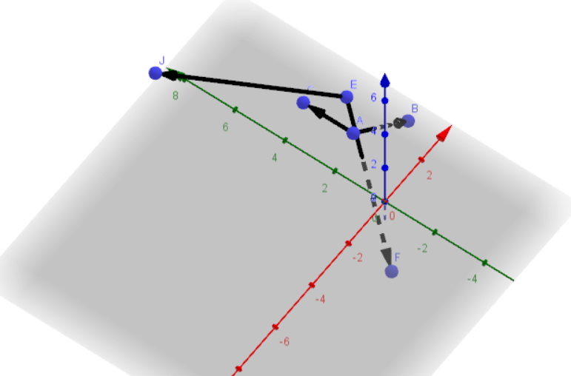

Given the points $A\left(1, 2, 1\right), B (4, 2 , -2), C (1, 4, 1)$

1. What is the dot product of $\vec{AB}$ and $\vec{AC}$
$$\vec{AB}=\vec{B}-\vec{A}=\left({4 \atop \begin{aligned}2 \\ -2\end{aligned}}\right)-\left({1 \atop \begin{aligned}2 \\ 1\end{aligned}}\right)=\left({3 \atop \begin{aligned}0 \\ -3\end{aligned}}\right)$$

$$\vec{AC}=\vec{C}-\vec{A}=\left({1 \atop \begin{aligned}4 \\ 1\end{aligned}}\right)-\left({1 \atop \begin{aligned}2 \\ 1\end{aligned}}\right)=\left({0 \atop \begin{aligned}2 \\ 0\end{aligned}}\right)$$

$$\vec{AB}∙\vec{AC}=3∙0+0∙2+\left(-3\right)∙0=0$$

2. Is the vector $\vec{AB}$ perpendicular to the vector $\vec{AC}$? Why/Why Not?

Ja, want het dot product is 0

1. Calculate the angle between these 2 vectors in radians

$$\vec{AB}∙\vec{AC}=\left|\left|\vec{AB}\right|\right|∙\left|\left|\vec{AC}\right|\right|∙\cos\left(\hat{\vec{AB},\vec{AC}}\right)=>\hat{\vec{AB},\vec{AC}}=\arccos\left(\frac{\vec{AB}∙\vec{AC}}{\left|\left|\vec{AB}\right|\right|∙\left|\left|\vec{AC}\right|\right|} \right)={90}^{°}$$

Given the points $E (2, 3, 1), F (-1, -1 , -2), J ( -3, 7, 5 )$

1. What is the dot product of $\vec{EF}$ and $\vec{EJ}$
$$\vec{EF}=\vec{F}-\vec{E}=\left({-1 \atop \begin{aligned}-1 \\ -2\end{aligned}}\right)-\left({2 \atop \begin{aligned}3 \\ 1\end{aligned}}\right)=\left({-3 \atop \begin{aligned}-4 \\ -3\end{aligned}}\right)$$

$$\vec{EJ}=\vec{J}-\vec{E}=\left({-3 \atop \begin{aligned}7 \\ 5\end{aligned}}\right)-\left({2 \atop \begin{aligned}3 \\ 1\end{aligned}}\right)=\left({-5 \atop \begin{aligned}4 \\ 4\end{aligned}}\right)$$

$$\vec{EF}∙\vec{EJ}=\left(-3\right)∙\left(-5\right)+\left(-4\right)∙4+\left(-3\right)∙4=-13$$

2. Is the vector $\vec{EF}$ perpendicular to the vector $\vec{EJ}$? Why?

Nee, want het dot product is niet 0

1. Calculate the angle between these 2 vectors in degrees

$$\vec{EF}∙\vec{EJ}=\left|\left|\vec{EF}\right|\right|∙\left|\left|\vec{EJ}\right|\right|∙\cos\left(\hat{\vec{EF},\vec{EJ}}\right)=>\hat{\vec{EF},\vec{EJ}}=\arccos\left(\frac{\vec{EF}∙\vec{EJ}}{\left|\left|\vec{EF}\right|\right|∙\left|\left|\vec{EJ}\right|\right|} \right)=\arccos\left(\frac{-13}{\sqrt{(({-1)-2)}^{2}+(({-1)-3)}^{2}+({(-2)-1)}^{2}}∙\sqrt{(({-3)-2)}^{2}+{\left(7-3\right)}^{2}+{\left(5-1\right)}^{2}}}\right)={107.17565}^{°}$$

## Contextual exercises

### Bullet

A Bullet $E$ is shot at a window between points $A$ and $B$ under direction

$\vec{v}$ = $\left(\begin{aligned}-1.25 \\ -3.25 \end{aligned}\right)$

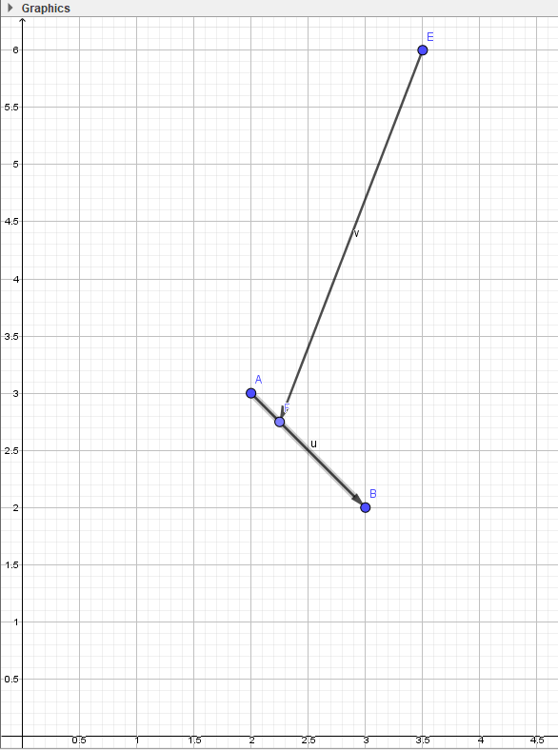

The window will break if the magnitude of the perpendicular force to the window is greater than 3.

1) Calculate the magnitude of the vector perpendicular to the window?

2) Will the window break or reflect the bullet?

*Tip: In a 2D world you can find the clockwise perpendicular from a vector $\vec{a}$*  = $\left(\begin{aligned}x \\ y \end{aligned}\right)$ as $\vec{p}$ = $\left(\begin{aligned}y \\ -x \end{aligned}\right)$

$$\vec{p}=\left({-3.25 \atop 1.25}\right)=>\left|\left|\vec{p}\right|\right|=\sqrt{{(-3.25)}^{2}+{(1.25)}^{2}}=3.4821=>\hat{p}=\left({\frac{-3.25}{3.4821} \atop \frac{1.25}{3.4821}}\right)$$

$\vec{v}∙\hat{p}=-1.25∙\left(-3.25\right)+\left(\frac{-3.25}{3.4821}\right)∙\left(\frac{1.25}{3.4821}\right)=3.72745$

### Race

You have 2 cars in a race :

-Car 1 with centroid $A(4.5, 3.5)$ and normalized forward vector $\vec{v}$ = $\left(\begin{aligned}-0.71 \\ 0.71 \end{aligned}\right)$

-Car 2 with centroid $B(3.43, 0.3)$

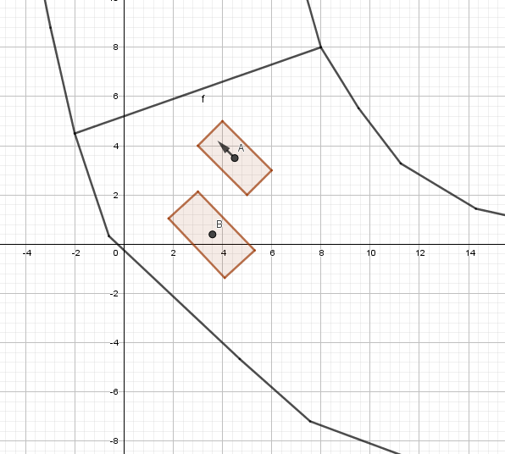

Determine if the car A is in front or behind of car B relative to car A’s forward direction?

$$0^{°}<α<{90}^{°}=>\cos\left(α\right)>0=>B ligt voor$$

$${90}^{°}<α<{180}^{°}=>\cos\left(α\right)<0=>B ligt achter$$

How can you know when the cars are next to each other? And on which side?

### Backface culling

A 3D object in a game is composed of triangles that have a front and back face.

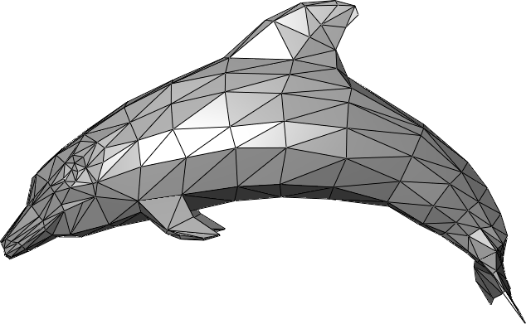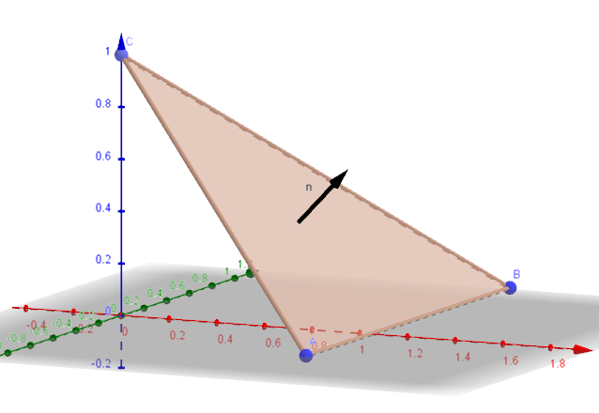

Front

Back

Normally when we are rendering, we only want to show the fronts of our triangles. Backfaces should not be rendered. The front of a triangle (face) is indicated by the direction of the normal.

Assume we have a camera at point $C (1, 4, 3)$ that is looking at a point $L (5, 2, 1)$. Below you ﬁnd some normals for faces which are within the view of the camera. Determine which are valid normals for rendering, and which normals are indicating a backface.

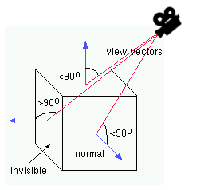

Dot product > 0 => zichtbaar

Dot product < 0 => onzichtbaar

Face $A \left(1.5, 0, 2\right) B\left(0, 0, 3\right) D(0, 2, 0)$ with perpendicular vector $\vec{n}$ = $\left( \begin{aligned}2 \\ 4.5 \\ 3\end{aligned} \right)$

Face $E \left(1.5, 3, 1\right) F\left(1.5, 4.5, 0\right) G(0, 3.5, 0)$ with perpendicular vector $\vec{n}$ = $\left( \begin{aligned}1 \\ -1.2 \\ -2.25\end{aligned} \right)$

Face $H \left(1, 2 , 2\right) I\left(1, 1 ,1\right) J(3, 1 , 1)$ with perpendicular vector $\vec{n}$ = $\left( \begin{aligned}0 \\ -2 \\ 2\end{aligned} \right)$

Think about how the camera vector should be oriented!

# References

## Basics Explained

Wikipedia Dot Product

<https://en.wikipedia.org/wiki/Dot_product>

Khan Academy Video

<https://www.khanacademy.org/math/linear-algebra/vectors-and-spaces/dot-cross-products/v/vector-dot-product-and-vector-length>

## Applications

Backface culling

<https://en.wikipedia.org/wiki/Back-face_culling>

Reflection

<http://immersivemath.com/ila/ch03_dotproduct/ch03.html>