AMP2-Lab03 – Beziers

# Content

Lab03 – Bezier Curves 1

1. Content 1

2. Learning objectives 1

2.1. Exam objectives 1

2.2. Supportive objectives 1

3. Exercises 2

3.1. Basic exercises 2

3.1.1. Linear interpolation 2

3.2. Bridging Practice 3

3.2.1. Quadratic Bezier 3

3.2.2. Cubic Bezier 4

3.3. Contextual exercises 4

3.3.1. Rollercoaster 4

4. References 5

4.1. Book Reference 5

4.2. Animated Bezier Curvers 5

4.2.1. Khan academy 5

# Learning objectives

## Exam objectives

By the end of this lab you should be able to (pen and paper):

* Apply the linear, quadratic and cubic Bezier segments
* Apply the positional and tangential continuous concatenations of Bezier segments
* Linearly transform objects made out of Bezier segments
* Convert between the vector equation and the matrix representation of Bezier segments

We advise you to **make your own summary of topics** which are new to you.

## Supportive objectives

Specifically related to the above you should in GeoGebra be able to:

* Insert the linear, quadratic and cubic Bezier segments
* Apply the positional and tangential continuous concatenations of Bezier segments
* Linearly transform objects made out of Bezier segments
* Visualize the (concatenations of) the linear, quadratic and cubic Bezier segments graphically

# Exercises

Dependent of the lab session you may work individually or teamed (organized by the lab attendant). In either case make sure that throughout the course of this lab, you re-save sufficiently your solution file on your local machine as

**1DAExx-0y-name1**(+name2+name3).GGB given **xx**=groupcode, **0y**=labindex

## Basic exercises

### Linear interpolation

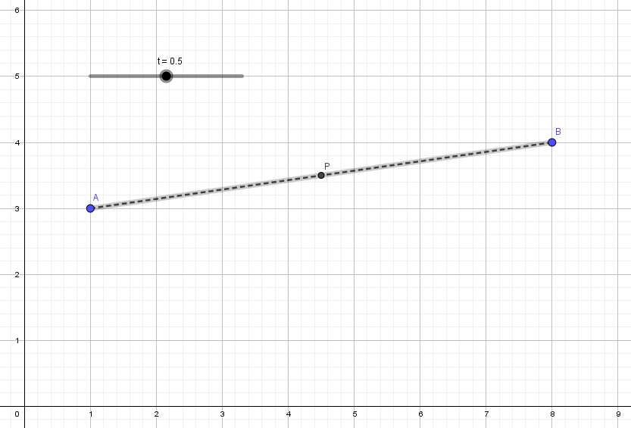

Figure 1. Linear interpolation between 2 points. With a factor t at 0.5 the point P is halfway between the start point A and the end point B

To describe a linear interpolation between 2 points we define the following:

* A parameter $t$ where $0 <= t <= 1$
* A point $A (1, 3)$ and $B (8, 4)$

Defined by the linear vector equation $\vec{p}(t)=\left(1-t\right)\vec{p_{0}}+t*p_{1}$

Recreate the following traced point $P$ that linearly interpolates between $A$ and $B$ using a slider value $t$ between 0 and 1.

Zie ggb_files

## Bridging Practice

### Quadratic Bezier

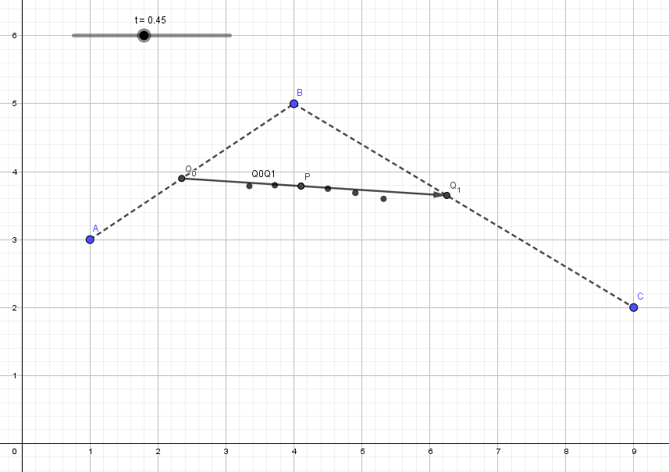

Recreate the situation depicted in the image above using the following steps:

Create a point $Q_{0}$ which linearly interpolates between $A$ and $B$ using the $t$ as a interpolation factor

Create a point $Q_{1}$ which linearly interpolates between $B$ and $C$ using the $t$ as a interpolation factor

Create a point $P$ which linearly interpolates between point $Q_{0}$ and point $Q_{1}$

#### If you did all of this correctly and enable tracing on point P you should get the same result as in the image

If you combine the 3 previous interpolations into 1 you would get the formula for a Quadratic Bezier Segment with 3 control points

$$\vec{p}(t)={\left(1-t\right)}^{2}\vec{p_{0}}+2t\left(1-t\right)\vec{p_{1}}+t^{2}\vec{p_{2}}$$

### Cubic Bezier

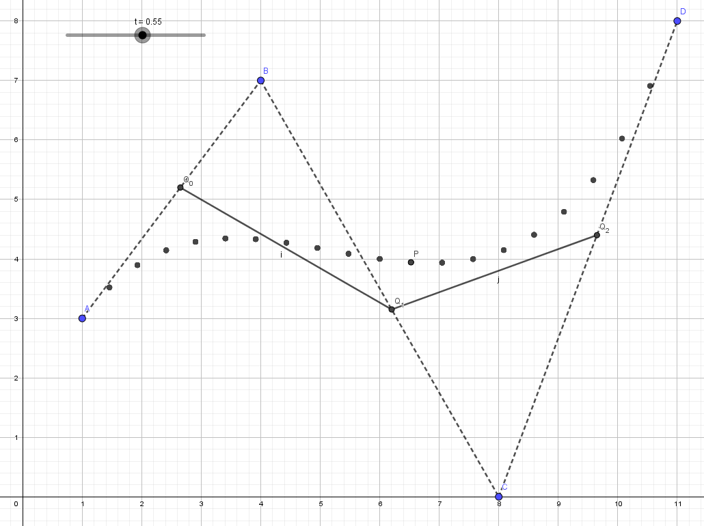

Recreate the Cubic Bezier Segment depicted above with the given 4 control points. You can use a similar approach as the Quadratic Bezier Segments or you can use the Cubic Bezier formula.

*Tip: If you want to visualize the spline you can use the* ***Locus*** *command within GeoGebra which will visualize a segment by displaying a path a point will follow with a certain parameter or enable tracing on the point*

## Contextual exercises

### Rollercoaster

*We will continue working on the previous exercise but since we are adding numerous items it might be a good idea to copy the .ggb file if you want to save your work.*

A rollercoaster cart is following a spline with its center bottom point located on the spline. The cart is rotating following the tangent to the spline segment.

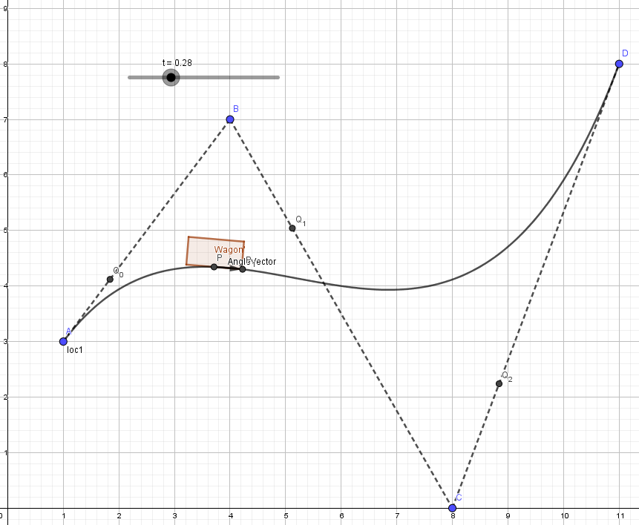 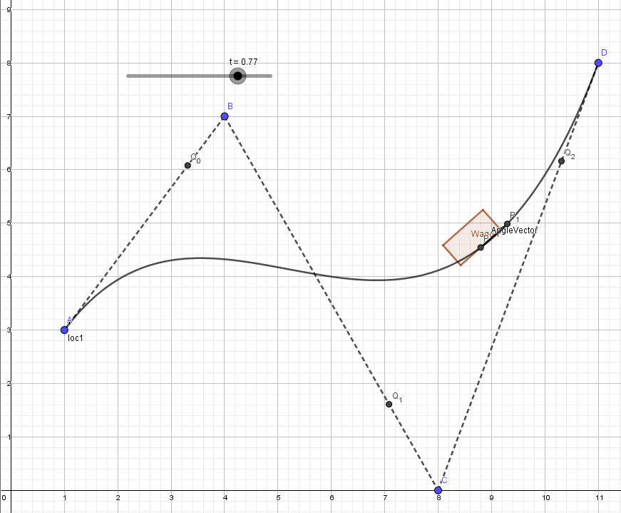

In this exercise we want to move a rollercoaster cart along the Cubic Bezier spline from previous exercise.

Steps:

Position the cart at the point $P$ on the spline

*Tip: You can use the x() and y() command in GeoGebra to get the x and y components of a point*

Calculate the tangent angle at position $P$ to know the rotation for your cart

Apply the rotation to the model

*Hint: To calculate the rotation angle: Define a second point on the curve at t+ epsilon. You could also find the tangent of a function at a certain point by calculating the derivative of that function but that is outside of the scope of this course*

### Guard

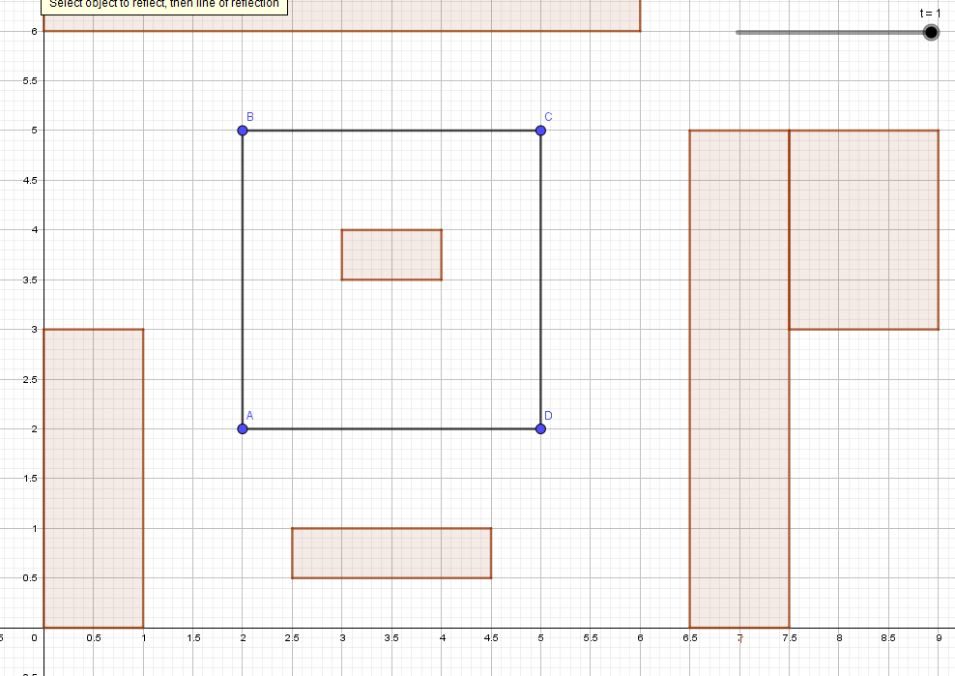

A guard is following a predetermined patrol path (A-B-C-D-Repeat).

If we use linear segments to connect the 4 vertices of the path the guard will change direction with a $90°$ angle at each vertex.

Instead we want a smooth transition between each path segment. Similar to the path below.

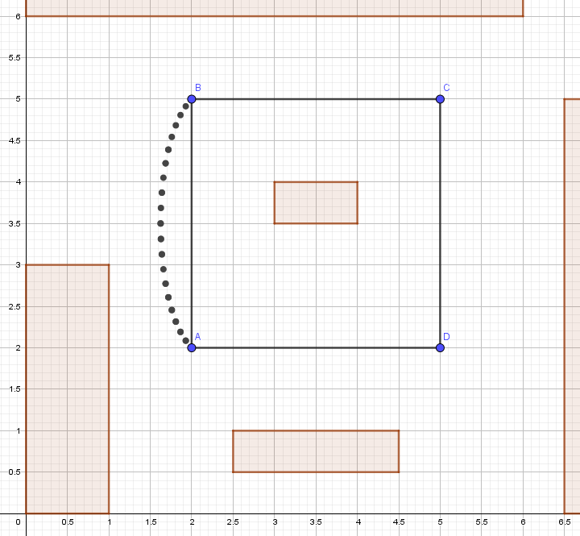 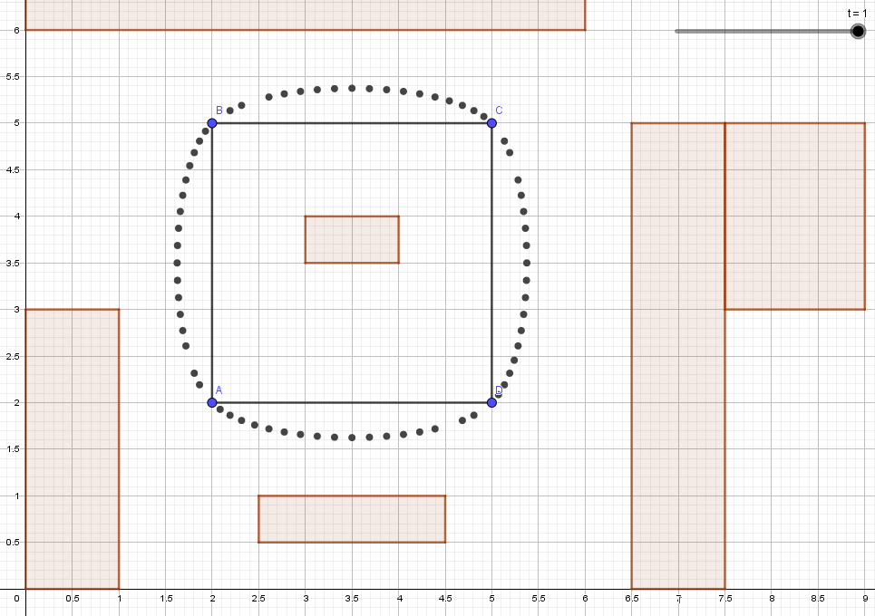

Create 4 cubic bezier segments, calculate their control points and concatenate them to create one continuous path in GeoGebra

Under what circumstance has the path a smooth transition? How do we call this?

# References

## Book Reference

ISBN **978-94 014 7495-5** (Animation Maths **(NE2021)**),

Chap12 Beziers.

## Animated Bezier Curvers

### Khan academy

<https://www.khanacademy.org/partner-content/pixar/animate/parametric-curves/a/lesson-brief-animation>