Market Anchor Analysis
Provider: Candidate A
Specialty: Pediatric Critical Care | YOE: 8

IMPORTANT CAVEAT — This analysis is based solely on market survey data and the candidate's CV. No internal equity cohort file or existing offer amount was available. Recommendations should be validated against internal equity before finalizing.

Blended Market Benchmarks (TCC)
Percentile | Blended TCC | Source
25th | $281,038 | Blended weighted-average
50th (Median) | $321,038 | Blended weighted-average
75th | $366,038 | Blended weighted-average
90th | $412,717 | Blended weighted-average

Recommended Range
LOW (≈P25–P30)  $281,000  conservative entry | MIDPOINT (≈P35)  $295,000  directional estimate | HIGH (≈P40–P50)  $305,000  upper governance bound | MARKET P50  $321,038  blended median

Low end (≈p25–p30): $281,000
Midpoint (≈p35, directional): $295,000
High end (≈p40–p50): $305,000
Methodology: Recommended range targets the p25–p50 band for a candidate at this YOE level, using piecewise linear interpolation between survey percentile points. Midpoint is a directional estimate at approximately p35, rounded to the nearest $1,000.

Market Position Exhibit
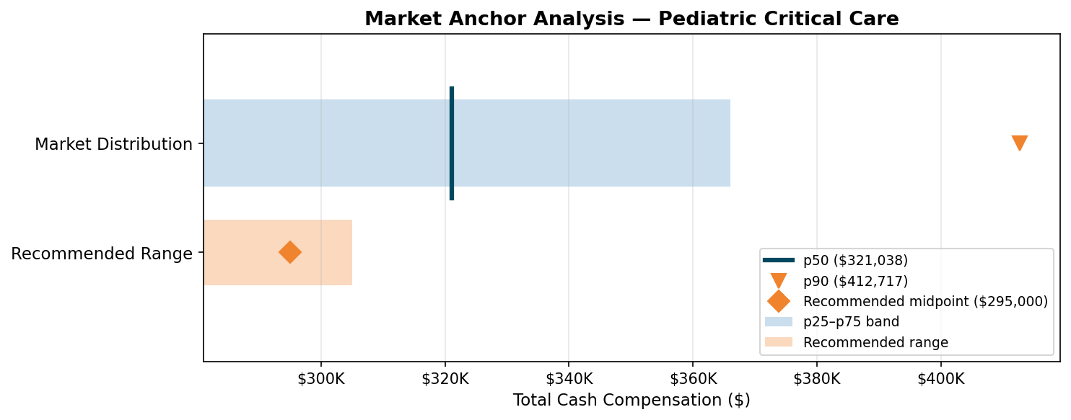

Footnotes
- Survey distributions are not linear between percentile points; interpolated estimates are directional, not exact.
- Blended benchmark = weighted average across aggregated survey data sources by n-count.
- No internal equity or cost impact analysis is included in this CV-only assessment.
- Analysis date: 2026-08-08

