Fair Market Value Review
Pediatric Critical Care Faculty · Prepared 2026-08-08 · Confidential — for compensation committee review
Cohort: Pediatric Critical Care Faculty Division/Service Line: N/A

Data Sources
Annual Salary Increases file (authoritative for current base, TCC percentile, wRVU percentile).
Survey Combined file (aggregated survey data by specialty).
FMV review workbook (output deliverable).
Snapshot date: 2026-08-08

Executive Summary
TOTAL CURRENT BASE  $830,000  3 provider(s) | TOTAL PROPOSED BASE  $968,000  post-adjustment | Δ VS CURRENT  +$138,000  +16.6% | Δ VS PLANNED  +$104,000  +12.0%

- Cohort size: 3 provider(s).
- Total current base: $830,000.
- Total planned base (post-annual-increase): $864,000.
- Total proposed base: $968,000.
- Incremental cost vs current: $138,000 (16.6%).
- Incremental cost vs planned: $104,000 (12.0%).
MARKET POSITION — Average proposed base ($322,667) vs market p50 ($320,000): +0.8% vs market median.

Cohort Detail
Name | YOE | Current Base | Planned Base | Proposed Base | Δ vs Current | Δ vs Planned
Provider 1 | 8.0 | $275,000 | $287,000 | $325,000 | $50,000 (+18.2%) | $38,000 (+13.2%)
Provider 2 | 12.0 | $295,000 | $307,000 | $345,000 | $50,000 (+16.9%) | $38,000 (+12.4%)
Provider 3 | 5.0 | $260,000 | $270,000 | $298,000 | $38,000 (+14.6%) | $28,000 (+10.4%)
Cohort Total |  | $830,000 | $864,000 | $968,000 | $138,000 | $104,000

Market Range Exhibit
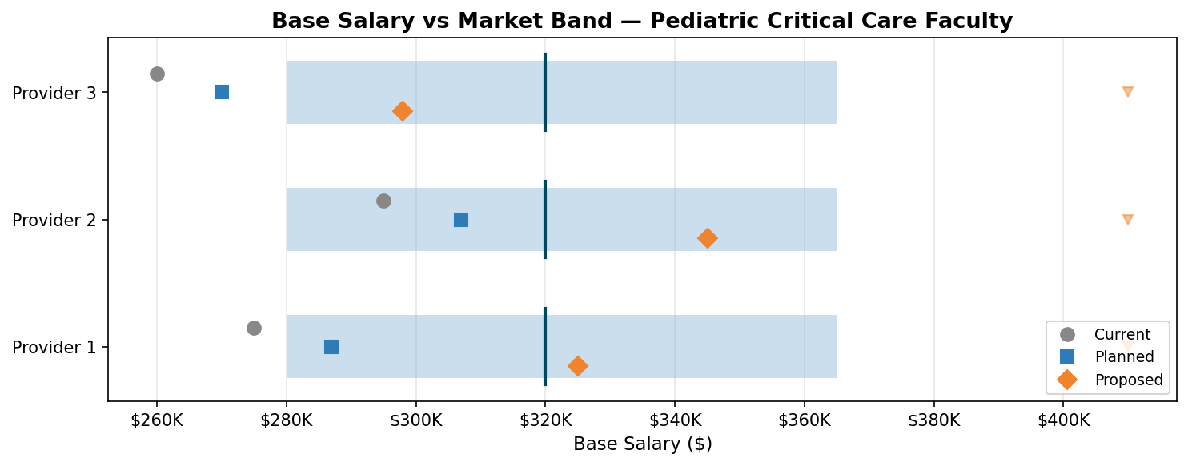
Market band: p25–p75 (shaded). p50 median (vertical line). p90 (triangle). Current (circle), Planned (square), Proposed (diamond).

Logic & Empirical Rationale
- Internal equity: proposed salaries maintain YOE-based progression without inversions.
- External anchoring: proposed bases position providers within the p25–p75 market band.
- Targeted adjustment: focuses on mid-career providers where compression risk is highest.
- Compression guardrails: no cascade adjustments proposed at this time.

Cost Impact
Annualized incremental base cost vs current: $138,000
Incremental beyond planned annual increases: $104,000
Note: Fringe/benefits excluded from above figures. Apply organization-specific benefits rate for fully loaded cost.

Governance Notes & Guardrails
- Proposed salaries do not create senior-junior inversions.
- All percentiles are from governance reference (post-annual-increase file).
- Percentiles are NOT FTE-adjusted — part-time lower percentile positioning is correct.
- Benchmark source: blended weighted-average of aggregated survey data (weighted by sample size).

Footnotes & Caveats
- Market percentiles are from published survey data; interpolated estimates are labeled as directional.
- Cost figures reflect base salary only unless otherwise noted.
- All data sourced from the most recent annual salary increases file and survey combined file.

