Exercise Sheet 2

Warmup (optional):
Suppose the following lines are found in the main() function. What is wrong here?
a) printf(enter a number:);
corrected: printf(„enter a number:“);
b) return "okay";
technicaly correct due to the conversion that it will get converted into int but should be a int return
c) void pause() { printf("PAUSE!"); }
is correct

Exercise 2.1.
Are the following programmes correct and error free?
a)
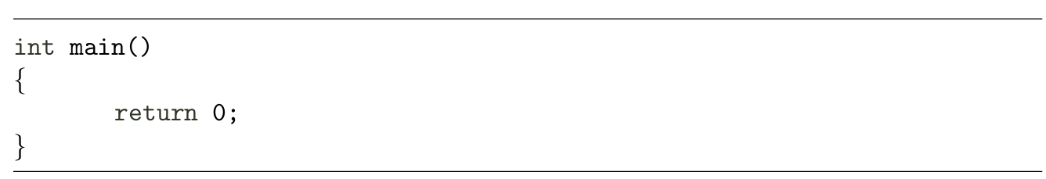
correct
b)
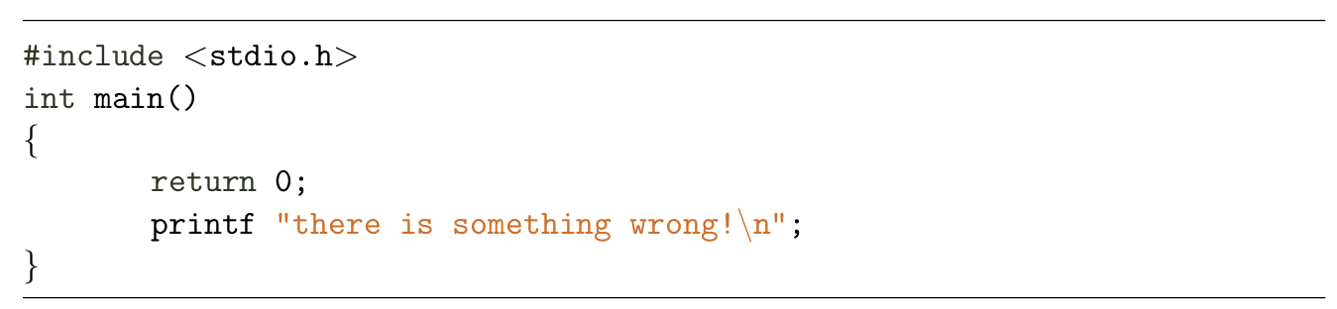
printf missing () and is after return so wont be executed
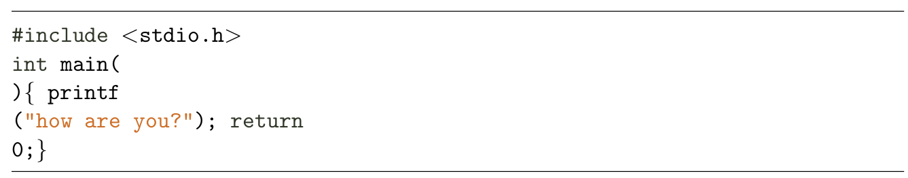
c)
horrible formating but will work

Exercise 2.2.
Write the declarations for the following, in a file source.c:
a) a global variable var of type long, which is defined in its own file, distinct from source.c
b) aglobal function gfunc() declared in its own file, distinct from source.c
c) a static function sfunc() declared in the same source file source.c
Both functions have no parameters and a return value of type double∗

