Part 1


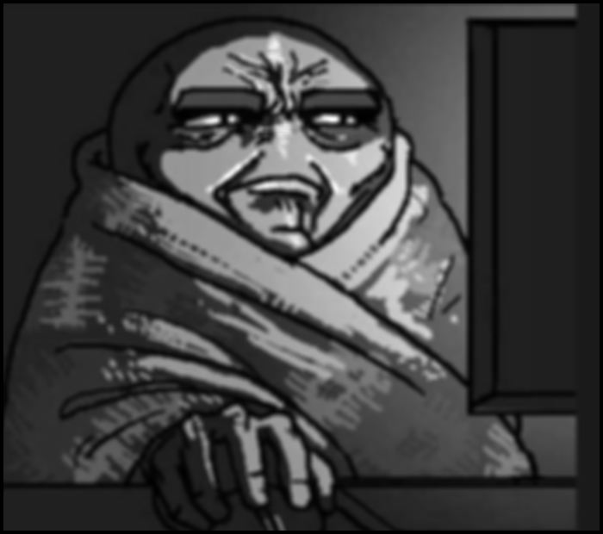

The image on the left is the original image. The one on the right is the greyscale blurred image.

Kernel size 5
Gaussian blur works by symmetrically blurring an image
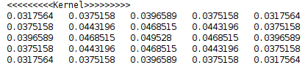

sequential
Grain size | undefined | 10 | 50 | 100 | 500 | 1000
Test 1 | 63 | 60 | 61 | 60 | 59 | 75
Test 2 | 63 | 62 | 59 | 60 | 60 | 78
Test 3 | 60 | 61 | 60 | 60 | 59 | 71
average | 62 | 61 | 60 | 60 | 59.3 | 74.7

This is sequential performance of a 5*5 kernel. The grain size does not affect the performance of the sequential performance of the program. At grain size 1000, the results may seem as though it is being affected however the result may just be anomaly.

parallel
Grain size | undefined | 10 | 50 | 100 | 500 | 1000
Test 1 | 47 | 40 | 43 | 43 | 39 | 85
Test 2 | 53 | 40 | 45 | 39 | 39 | 102
Test 3 | 40 | 41 | 42 | 40 | 39 | 83
average | 46.7 | 40.3 | 43.3 | 40.7 | 39 | 90

This is the parallel performance of a 5*5 kernel. When the grain size is undeclared the performance is not great. Compared to when the grain size is declared. However, if the grain size is declared like shown above the performance does improve to a point where does improve to a certain point. If the grain size is too large then the performance degrades to a point where even sequential is faster.

Kernel size 11

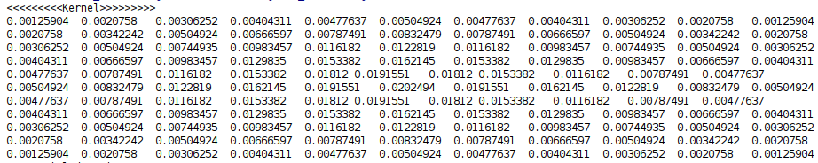

sequential
Grain size | undefined | 10 | 50 | 100 | 500 | 1000
Test 1 | 285 | 284 | 289 | 284 | 286 | 287
Test 2 | 282 | 294 | 289 | 290 | 287 | 289
Test 3 | 286 | 286 | 284 | 291 | 292 | 295
average | 284.3 | 288 | 287.3 | 288.3 | 288.3 | 290.3
This is sequential performance of a 11*11 kernel. The grain size does not affect the performance of the sequential performance of the program. The average speed for sequential stays the same when the grain size changed. Compared to the 5*5 kernel, the overall performance of the 11*11 kernel is slower because it is a larger kernel.
Kernel size 11
parallel
Grain size | undefined | 10 | 50 | 100 | 500 | 1000
Test 1 | 188 | 212 | 187 | 188 | 191 | 399
Test 2 | 187 | 208 | 188 | 187 | 251 | 420
Test 3 | 191 | 189 | 188 | 187 | 188 | 397
average | 188.7 | 203 | 187.7 | 187.3 | 210 | 405.3
This is the parallel performance of a 5*5 kernel. When the grain size is undeclared the performance is around the same as when the grain size is declared. As the grain size increases beyond 500, the performance starts to slow down. As the grain size exceeds 1000 the performance degrades to a point where even sequential is faster.

On average when comparing parallel and sequential performance, parallel is faster most of the time.

The kernel size affects the speed of the of performance.

Appendix

#define _USE_MATH_DEFINES
#include <tbb/parallel_for.h>
#include <tbb/parallel_reduce.h>
#include <tbb/blocked_range2d.h>
#include <random>
#include <chrono>
#include <iostream>
#include <vector>
//Thread building blocks library
#include <tbb/task_scheduler_init.h>
//Free Image library
#include <FreeImagePlus.h>
using namespace std::chrono;
using namespace std;
using namespace tbb;
int main()
{
int nt = task_scheduler_init::default_num_threads();
task_scheduler_init T(nt);
//Part 1 (Greyscale Gaussian blur): -----------DO NOT REMOVE THIS COMMENT----------------------------//
fipImage gaussianBlurInputImage;
gaussianBlurInputImage.load("../Images/image.jpg");
gaussianBlurInputImage.convertToFloat();
unsigned int width = gaussianBlurInputImage.getWidth();
unsigned int height = gaussianBlurInputImage.getHeight();
fipImage gaussianBlurOutputImage;
gaussianBlurOutputImage = fipImage(FIT_FLOAT, width, height, 24);
auto *inputBuffer = (float*)gaussianBlurInputImage.accessPixels();
auto *outputBuffer = (float*)gaussianBlurOutputImage.accessPixels();
//////////////////////////////////////////////////
const int kernelSize = 11;
float sigma = 3.0f;
double kernel[kernelSize][kernelSize];
int kernelRadius = kernelSize/ 2; //The radius of the input image
double sumTotal = 0;
///////////////////////////////////////////////////////
cout << "<<<<<<<<<Kernel>>>>>>>>>\n";
auto sequentialStart = high_resolution_clock::now();
//create gaussian filter
for (int y = -kernelRadius; y <= kernelRadius; ++y)
{
for (int x = -kernelRadius; x <= kernelRadius; ++x){
kernel[y + kernelRadius][x + kernelRadius] = 1.0f / (2.0f * float(M_PI)) * powf(sigma,2) * exp(-((powf(x,2) + powf(y,2)) / (2.0f * powf(sigma,2))));
sumTotal += kernel[y + kernelRadius][x + kernelRadius];
}
}
//normalise the kernel
for (int x = 0; x < kernelSize; x++){
for (int y = 0; y < kernelSize; y++){
kernel[y][x] = kernel[y][x] * (1.0 / sumTotal);
cout << kernel[y][x] << "\t";
}cout << endl;
}
//create the input Image kernel
for (int i = kernelRadius; i < height - kernelRadius; i++) {
for (int j = kernelRadius; j < width - kernelRadius; j++) {
for (int x = -kernelRadius; x <= kernelRadius; x++) {
for (int y = -kernelRadius; y <= kernelRadius; y++) {
outputBuffer[i * width + j] += inputBuffer[(i + x) * width + (j + y)] * kernel[x + kernelRadius][y + kernelRadius];
}
}
}
}
auto sequentialFinish = high_resolution_clock::now();
auto sequentialDuration = duration_cast<milliseconds>(sequentialFinish - sequentialStart);
std::cout << "Sequential duration: " << sequentialDuration.count() << " ms." << endl;
///////////////////////////////////////////////////////
auto parallelForStart = high_resolution_clock::now();
parallel_for(blocked_range2d<int,int>(kernelRadius, height - kernelRadius,1000, kernelRadius, height - kernelRadius,1000), [&](const blocked_range2d<int,int>& range) {
auto y1 = range.rows().begin();
auto y2 = range.rows().end();
auto x1 = range.cols().begin();
auto x2 = range.cols().end();
for (int i = x1; i < x2; i++) {
for (int j = y1; j < y2; j++) {
for (auto x = -kernelRadius; x <= kernelRadius; x++) {
for (auto y = -kernelRadius; y <= kernelRadius; y++) {
outputBuffer[i * width + j] += inputBuffer[(i + x) * width + (j + y)] * kernel[x + kernelRadius][y + kernelRadius];
}
}
}
}
});
auto parallelForFinish = high_resolution_clock::now();
auto parallelForDuration = duration_cast<milliseconds>(parallelForFinish - parallelForStart);
std::cout << "Parallel for duration: " << parallelForDuration.count() << " ms." << endl;
//////////////////////////////////////////////////
gaussianBlurOutputImage.convertToType(FREE_IMAGE_TYPE::FIT_BITMAP);
gaussianBlurOutputImage.convertTo24Bits();
gaussianBlurOutputImage.save("grey_blurred.png");
cout << "Gaussian blur image saved! " << endl;
//Part 2 (Colour image processing): -----------DO NOT REMOVE THIS COMMENT----------------------------//
////////////////////////////////ABSOLUTE DIFFERENCE BETWEEN 2 IMAGES//////////////////////////////
// Setup Input image array
fipImage inputImage[2];
inputImage[0].load("../Images/render_1.png");
inputImage[1].load("../Images/render_2.png");
width = inputImage[0].getWidth();
height = inputImage[0].getHeight();
// Setup Output image array
fipImage outputImage;
outputImage = fipImage(FIT_BITMAP, width, height, 24);
//2D Vector to hold the RGB colour data of an image
vector<vector<RGBQUAD>> rgbValues;
rgbValues.resize(height, vector<RGBQUAD>(width));
// parallel_for blocked_range version
parallel_for(blocked_range2d <int> (0,height,0,width),[&](const blocked_range2d <int>& range) {
auto y1 = range.rows().begin();
auto y2 = range.rows().end();
auto x1 = range.cols().begin();
auto x2 = range.cols().end();
for (uint64_t y = y1; y != y2; y++) {
for (uint64_t x = x1; x != x2; x++) {
RGBQUAD rgb[2]; //FreeImage structure to hold RGB values of a single pixel
inputImage[0].getPixelColor(x,y,&rgb[0]);
inputImage[1].getPixelColor(x,y,&rgb[1]);
if (abs(rgb[0].rgbRed - rgb[1].rgbRed) > 1 ||
abs(rgb[0].rgbGreen - rgb[1].rgbGreen) > 1 ||
abs(rgb[0].rgbBlue - rgb[1].rgbBlue) > 1 ) {
rgbValues[y][x].rgbRed = 255;
rgbValues[y][x].rgbGreen = 255;
rgbValues[y][x].rgbBlue = 255;
}
outputImage.setPixelColor(x, y, &rgbValues[y][x]);
}
}
});
//////////////////////////////////////////CALCULATE THE PERCENTAGE OF WHITE PIXELS////////////////////////////////
float totalNoOfPixels = height * width;
int noOfWhitePixels = parallel_reduce(blocked_range2d <int> (0,height,0,width),0,[&](const blocked_range2d <int>& range, int count) -> int{
auto y1 = range.rows().begin();
auto y2 = range.rows().end();
auto x1 = range.cols().begin();
auto x2 = range.cols().end();
for (int y = y1; y != y2; y++)
for (int x = x1; x != x2; x++) {
if (rgbValues[y][x].rgbRed > 1) count++;
}return count;
}, [&](int x, int y)->int {return x+y;}
);
float percentageOfWhitePixels = (noOfWhitePixels / totalNoOfPixels) * 100;
cout << "There is " << percentageOfWhitePixels << "% of white pixels." << endl;
//////////////////////////////////////////SET AND FIND RED DOT//////////////////////////////////////
random_device rd; // obtain a random number from hardware
mt19937 eng(rd()); // seed the generator
uniform_int_distribution<> yAxis(0, height); // define the range
uniform_int_distribution<> xAxis(0, width); // define the range
rgbValues[yAxis(eng)][xAxis(eng)].rgbRed = 255;
rgbValues[yAxis(eng)][xAxis(eng)].rgbGreen = 0;
rgbValues[yAxis(eng)][xAxis(eng)].rgbBlue = 0;
outputImage.setPixelColor(xAxis(eng), yAxis(eng), &rgbValues[yAxis(eng)][xAxis(eng)]);
auto t2b = high_resolution_clock::now();
int returnIndex[2];
parallel_for(blocked_range2d <int> (0,height,0,width),[&](const blocked_range2d <int>& range) {
auto y1 = range.rows().begin();
auto y2 = range.rows().end();
auto x1 = range.cols().begin();
auto x2 = range.cols().end();
for (int y = y1; y != y2; y++) {
for (int x = x1; x != x2; x++) {
if (rgbValues[y][x].rgbRed == 255 &&
rgbValues[y][x].rgbGreen == 0 &&
rgbValues[y][x].rgbBlue == 0){
if(task::self().cancel_group_execution()){
returnIndex[0] = x;
returnIndex[1] = y;
}
}
}
}
});
auto t2e = high_resolution_clock::now();
auto t2r = duration_cast<milliseconds>(t2e - t2b);
cout << t2r.count() << endl;
cout << "The red pixel has been located at x = " << returnIndex[0] << " and y = " << returnIndex[1] << endl;
//Save the processed image
outputImage.save("RGB_processed.png");
return 0;
}

