|  |  |  |  |  |  |
| --- | --- | --- | --- | --- | --- |
| **Name** | **Focus** | **Board** | **Interface** | **Project Name** | **Project Description** |
| Tarina Tomáš | **IoT**  Azure IoT Hub  LoRaWAN  LoRa Sensors | Atom Lite  M5Stack  Grove  **2** | LoRa  Distance Sensor  ENV III Sensor  GPS Sensor | IoT-LoRa-Waste- Tracking | Sledovanie odpadoveho kontainera :   1. Naplnenost (ultrasonic snimac HC-SR04) 2. Teplota, tlak a vlhkost vzduchu (BM280) 3. GPS locator M5Stack-U032 (option) |
| Klimant Erik | **IoT**  Azure IoT Hub  LoRaWAN  LoRa Sensors | Atom Lite  M5Stack  Grove  **4** | LoRa  Distance Sensor  ENV III Sensor | IoT-LoRa-Waste Tracking-Dashboard | Azure IoT Central Dashboard zobrazujuci odpadove kontainery a ich status (mapa)  Analyza s predikciou naplnovania |
| Marťák Erik | **IoT**  Azure IoT Hub  PnP Devices | Atom Lite  M5Stack  Grove  **1** | H+T Atom Sensor | IoT-PnP-Device | Azure IoT Central Dashboard  Analyza a report telemetry dat (vlhkost, teplota) |
| Bučko Daniel | **IoT**  Azure IoT Hub  PnP Devices | Atom lite  M5Stack  Grove  **3** | PIR Motion Sensor | IoT-PIR | Ovladanie osvetlenia podla pritomnosti |
| Barla Jakub | **Robotics** | Raspberry Pi  Pico WH  Breadboard  **7** | Ultrasonic Sensor  Traffic Lights | R-IoT-Speed-Control | Meranie vzdialenosti s obmedzenim rychlosti s pouzitym semaforu (RYG) |
| Harasti Jakub | **Robotics** | Raspberry Pi  Pico WH  Breadboard  **3** | Ultrasonic Sensor | R-IoT-Timestamp | Meranie a vyhodnocovanie Start-Stop casu. |
| Valo Leonard | Robotics/IoT | Raspberry Pi  Pico WH  Breadboard  **8** | H+T Sensor  Sound Sensor | R-IoT-Sound-Control | Meranie a vyhodnocovanue:   1. Teploty vzduchu 2. Vlkosti vzduchu 3. Intezity zvuku |
| Javorský Adrián | **Robotics** | Raspberry PI  Pico H  **4** |  | R-IoT-Web-Content- Design | Struktura Web Contentu stranky R-IoT a ukladanie projektov na GitHub |

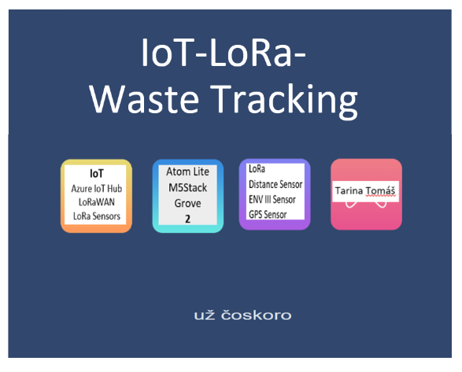

**Tooltips on the headers:**

**Meno** *Realizator projektu*

**Zameranie** *Pouzite Technologie, Services, …*

**Microcontroller** *Device hardware*

**Snimace** *Pozite snimace, technologia, …*

**Projekt** *Nazov projektu*

**Popis** *Vystizny popis projektu*

Pop-up photo (image):

FirstName Last Name

KlimantErik https://github.com/romankiss/R-IoT/blob/main/Projects/2022/IoT-LoRa-Waste-Tracking-Dashboard/Team/KlimantErik.JPG

TarinaTomas <https://github.com/romankiss/R-IoT/blob/main/Projects/2022/IoT-LoRa-Waste-Trackings/Team/TarinaTomas.JPG>

BuckoDaniel https://github.com/romankiss/R-IoT/blob/main/Projects/2022/IoT-PIR/Team/BuckoDaniel.JPG

MartakErik <https://github.com/romankiss/R-IoT/blob/main/Projects/2022/IoT-PnP-Device/Team/MartakEric.JPG>

ValoLeonard <https://github.com/romankiss/R-IoT/tree/main/Projects/2022/R-IoT-Sound-Control/Team>

BarlaJakub <https://github.com/romankiss/R-IoT/blob/main/Projects/2022/R-IoT-Speed-Control/Team/BarlaJakub.JPG>

HarastiJakub <https://github.com/romankiss/R-IoT/blob/main/Projects/2022/R-IoT-Timestamp/Team/HarastiJakub.JPG>

JavorskyAdrian <https://github.com/romankiss/R-IoT/blob/main/Projects/2022/R-IoT-Web-Content-Design/Team/JavorskyAdrian.JPG>

**Hyperlinks:**

IoT

Azure IoT Hub https://learn.microsoft.com/en-us/azure/iot-hub/

Azure IoT Central https://learn.microsoft.com/en-us/azure/iot-central/

LoRaWAN https://www.thethingsnetwork.org/docs/

LoRa Sensors https://www.thethingsnetwork.org/country/slovakia/

PnP Devices https://learn.microsoft.com/en-us/azure/iot-develop/overview-iot-plug-and-play

Robotics

Atom Lite https://docs.m5stack.com/en/core/atom_lite

M5Stack https://m5stack.com/

Grove https://www.seeedstudio.com/category/Grove-c-1003.html

Raspbery Pi Pico WH https://www.raspberrypi.com/products/raspberry-pi-pico/

Breadboard https://www.sciencedirect.com/topics/engineering/breadboard

LoRa https://www.thethingsnetwork.org/docs/

Distance Sensor https://docs.m5stack.com/en/unit/sonic.i2c

ENV III Sensor https://docs.m5stack.com/en/unit/envIII

GPS Sensor https://docs.m5stack.com/en/unit/gps

H+T Atom Sensor https://docs.m5stack.com/en/hat/hat_envIII

Ultrasonic Sensor https://www.sparkfun.com/products/15569

Traffic Lights https://lowvoltagelabs.com/products/pi-traffic/

Sound Sensor https://www.waveshare.com/sound-sensor.htm

IoT-LoRa-Waste Tracking https://github.com/romankiss/R-IoT/tree/main/Projects/2022/IoT-LoRa-Waste-Trackings

IoT-LoRa-Waste Tracking Dashboard https://github.com/romankiss/R-IoT/tree/main/Projects/2022/IoT-LoRa-Waste-Tracking-Dashboard

IoT-PnP Device https://github.com/romankiss/R-IoT/tree/main/Projects/2022/IoT-PnP-Device

IoT-PIR https://github.com/romankiss/R-IoT/tree/main/Projects/2022/IoT-PIR

R-IoT-Speed Control https://github.com/romankiss/R-IoT/tree/main/Projects/2022/R-IoT-Speed-Control

R-IoT-Timestamp https://github.com/romankiss/R-IoT/tree/main/Projects/2022/R-IoT-Timestamp

R-IoT-Sound Control https://github.com/romankiss/R-IoT/tree/main/Projects/2022/R-IoT-Sound-Control

R-IoT Web Content Design <https://github.com/romankiss/R-IoT/tree/main/Projects/2022/R-IoT-Web-Content-Design>

totasjdaspjdkpadkpaskdp