**E/17/407**

**Wijesooriya H.D**

**(Q1)**

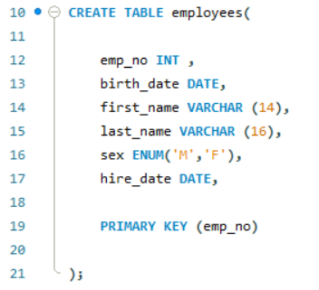

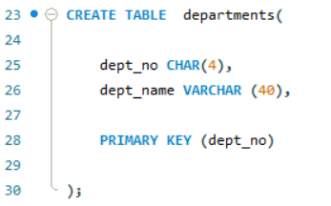

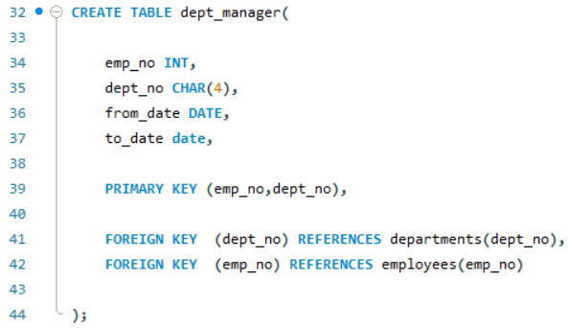

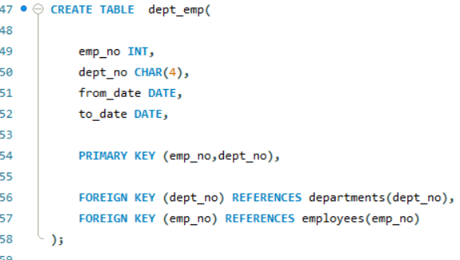

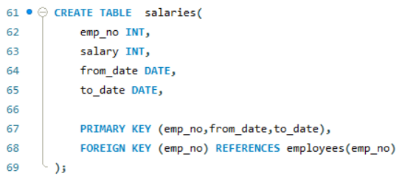

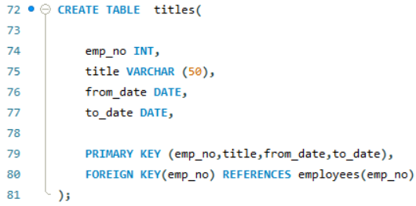

**(Q2)**

Find the top 10 family names(last_name) in the company

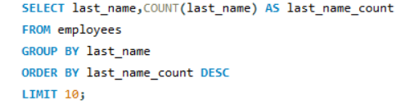

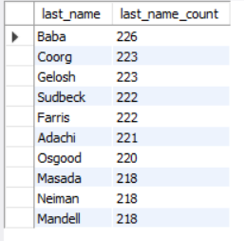

**(Q3)**

List the number of Engineers each department has.

(Here I only consider the current engineers)

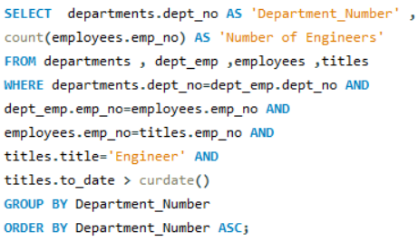

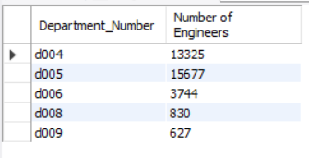

**(Q4)**

List all the female employees who are department managers and have worked as a senior engineer.

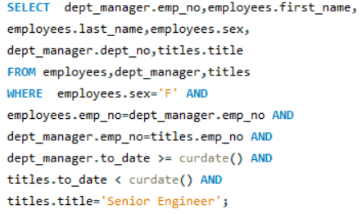



No records.

**(Q5)**

**(5.1)**

Display the departments and titles of employees who have a salary greater than 115000.

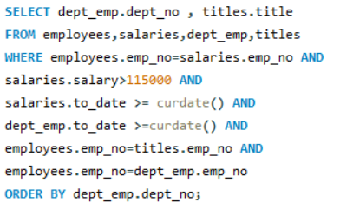

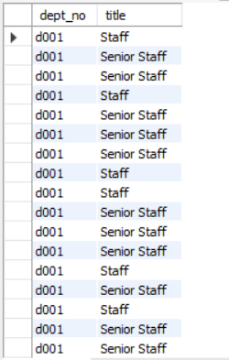

got 4711 number of records

**( 5.2)**

Display how many of such employees work for each department.

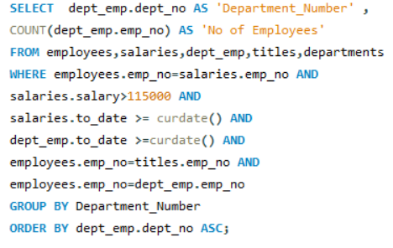

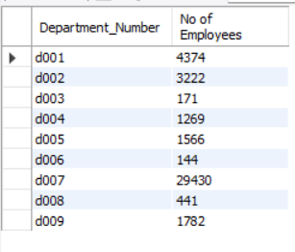

**(Q6)**

Assume that the company wants to reward the most senior employees who are more than 50 years of age and have contributed to the company for more than 10 years. Who is on the list? Display employee name, age, years of service in the company and joined date.

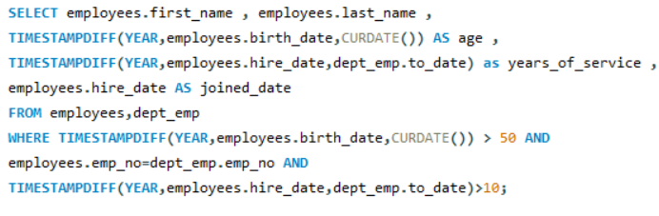

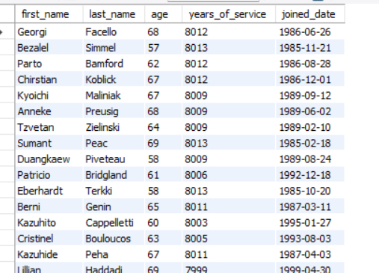

Got 259967 number of records

**( Q7 )**

Find all the names (first name + last name) of employees in the database who do not work in the Human Resources department. Assume that all the people work for exactly one department.

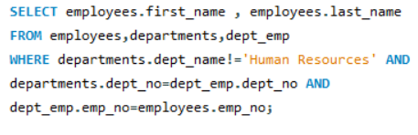

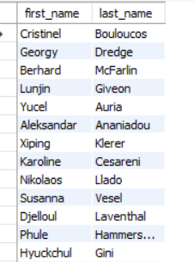

Got 313817 number of records

(Q8)

Find the names of all employees in the database who earn more than every employee in the Finance department. Assume that all people work for at most one company.

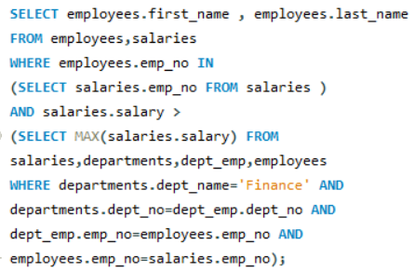

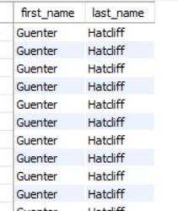

Got 17444064 number of rows.

(Q9)

Find the names of all employees who earn more than the average salary of all employees of their company.

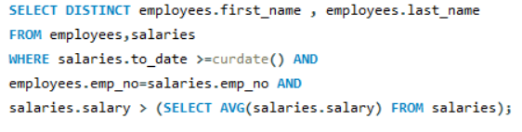

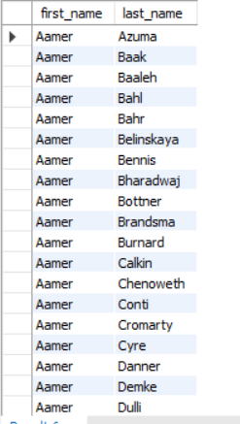

Got 99540 number of records.

(Q10)

Compute the difference between the average salary of a Senior Engineer and the average salary of all employees (including Senior Engineers).

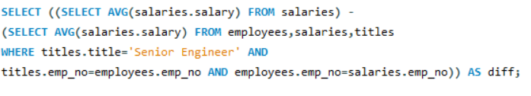

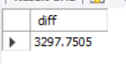

(Q11)

Create a view current dept emp (emp no, fromdate, todate) to show only the current department for each employee. You may have to use two views for this.

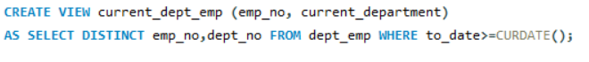

(Q12)

Write a normal SQL query to do the above task in problem 11.



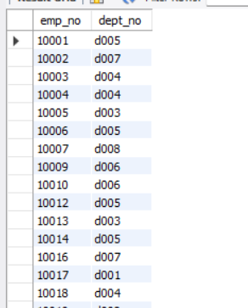

Got 240124 number of records

(Q13)

Create a trigger to print salary changes of employees. For example, if you enter an SQL statement such as UPDATE salaries SET salary = salary + 1000 WHERE emp no = 1500, the trigger should fire once for each row that is updated and it should print the new and old salaries, and the difference.

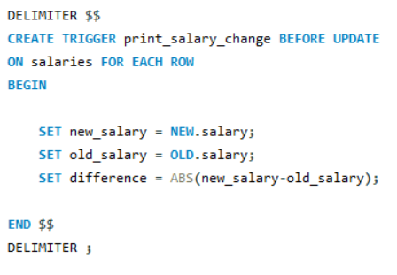

(Q14)

Create a trigger that will cause an error when an update occurs that would result in a salary increase greater than 10% of the current salary

