Physics-Informed AecroFormer for Stable Aerosol Microphysical Retrieval From Multiwavelength Lidar
Weijie Zou, Zhenping Yin, Zeyu Zhou, Zhichao Bu, Yaru Dai, Yun He, Longlong Wang, Yifan Zhou, Yinghao Lun, Jiarui Chen, Shuangliang Li, Siwei Li, Xuan Wang, Detlef Müller

Abstract—Aerosol microphysical retrieval from multiwavelength lidar is an ill-posed inverse problem because limited $3β+2α$optical observations must constrain multiple coupled aerosol properties through nonlinear Lorenz–Mie light-scattering physics. Small observational errors may therefore be amplified into unstable estimates of refractive index, particle size distribution, and concentration. Building on the AecroFormer backbone introduced in our previous work, this study develops a physics-informed estimator framework for stable aerosol microphysical retrieval from multiwavelength lidar under the established 3β+2α setting. The framework integrates normalized optical inputs, observation-space physical consistency, dynamic non-gridded sampling, uncertainty-aware supervision, and physically guided data augmentation, so that retrieval is constrained by both microphysical labels and the Lorenz–Mie forward operator. The retrieval problem considered here is formulated for fine-mode-dominated aerosols represented by a unimodal lognormal particle size distribution. Synthetic ablation experiments show improved generalization and fewer unstable local responses under noisy and weakly constrained conditions. Compared with a KNN-based lookup table (LUT) reference, the proposed configuration reduces the MAE of $m_{r}$ from 0.0675 to 0.0516 and the MARE of $r_{e}$from 22.50% to 18.02%. External validation using NASA DISCOVER-AQ California observations, including 30 matched profiles from 8 observation days and 14 B-200 flight segments, shows effective-radius accuracy comparable to LUT retrieval and reduces the MAE of 532-nm single-scattering albedo from 0.0370 to 0.0211. A full-day case on 1 February 2013 further demonstrates more continuous time–height retrieval structures with fewer abrupt local variations under the selected observational conditions. Mechanistic analyses based on noise degradation, empirical conditional distributions, and local perturbation-plane responses show that the benefit does not arise from additional observational information, but from reducing LUT-like candidate switching and producing more continuous and locally stable estimator responses. The advantage remains parameter dependent and bounded by observation quality, calibration accuracy, and forward-model assumptions.

Index Terms—Aerosol microphysical retrieval, Multiwavelength lidar, Ill-posed inverse problem, Physics-informed deep learning, Lookup table retrieval

I. INTRODUCTION
A
erosols are an important component of the atmosphere. They are closely related not only to air quality and human health, but also to the Earth’s atmospheric radiation balance through the scattering and absorption of solar radiation [1,2]. In addition, aerosols further influence cloud formation, precipitation processes, and regional climate change through aerosol–cloud interactions [3–5]. Therefore, accurate observation and retrieval of aerosol optical and microphysical properties have long been a central topic in atmospheric remote sensing and climate and environmental research. As a typical active remote sensing instrument, lidar can provide continuous vertical profile observations with high spatial and temporal resolution. In particular, multiwavelength Raman lidar and multiwavelength high-spectral-resolution lidar provide richer backscatter and extinction information [6–8], thereby offering a key observational basis for aerosol microphysical retrieval [9,10].
A relatively systematic theoretical and methodological framework has already been established for aerosol microphysical retrievals from multiwavelength lidar observations. Previous studies have shown that, under commonly used observational configurations, 3β+2α, i.e., three aerosol backscatter coefficients at 355, 532, and 1064 nm (β₃₅₅, β₅₃₂, and β₁₀₆₄) and two aerosol extinction coefficients at 355 and 532 nm (α₃₅₅ and α₅₃₂), can be regarded as the minimum information requirement for effective retrieval of aerosol microphysical properties for the case that the observed aerosol particles are spherical [11,12], while observational accuracy strongly affects retrieval stability and interpretability [13,14]. On this basis, Müller and coworkers developed a series of classical approaches, including regularization-based inversion and lookup table methods [14–17], which laid the theoretical foundation for multiwavelength lidar microphysical retrieval and promoted its practical applications [18]. At the same time, these studies clearly showed that aerosol microphysical retrieval from multiwavelength lidar is essentially an ill-posed inverse problem under limited observational constraints [14]. In this problem, a finite-dimensional vector of lidar optical observations is used to infer multiple microphysical parameters whose contributions to the measured optical quantities are strongly coupled through the nonlinear light-scattering forward model [19]. Consequently, different combinations of refractive index, particle size, distribution width, and particle concentration may produce similar optical responses within observational uncertainty. Even small measurement errors can therefore be amplified in the retrieved parameter space, leading to unstable solutions, local non-uniqueness, and strong dependence on prior constraints.
Against this background, subsequent methodological approaches have largely focused on improving three aspects of aerosol microphysical retrieval under ill-posed conditions: retrieval stability, computational and engineering applicability, and uncertainty characterization for quality assurance. One representative approach is the development of fast retrieval frameworks based on lookup tables (LUT). Wang, Zhou, and others introduced strategies such as machine learning pruning and k-nearest-neighbor retrieval (KNN) into the traditional framework, substantially improving the computational efficiency of LUT-based methods while maintaining good applicability to real observations [20,21]. Among these methods, FAST was selected as the LUT-based reference in this study because it has demonstrated competitive retrieval accuracy and computational efficiency for multiwavelength lidar aerosol microphysical inversion. Our implementation also confirmed its strong performance across most of the tested conditions and metrics. Using a competitive FAST-based reference, rather than a simplified LUT implementation, provides a stricter basis for evaluating the advantages and limitations of the proposed deep-learning estimator. By transforming a complicated inversion into a candidate search and screening problem, such methods have clear practical advantages. However, the essence of LUT retrieval still lies in the matching between discrete parameter grids and observations [13], and its output remains constrained by the predefined sample library, parameter discretization scheme, and candidate partition strategy. Even when combined with local interpolation or nearest-neighbor search, the sensitivity of this class of methods to observational perturbations, grid structure, and local candidate switching is difficult to eliminate fundamentally [22,23]. Therefore, although LUT methods can greatly improve retrieval efficiency, they do not alter the intrinsic sensitivity of the problem itself to noise amplification and local instability under ill-posed conditions [8,14].
By contrast, deep learning (DL) offers a new possibility for this class of ill-posed retrieval problems [24,25]. By directly learning the nonlinear mapping from optical observations to microphysical parameters, DL has the potential to move beyond explicit discrete lookup tables and gain advantages in retrieval efficiency, fitting ability in continuous parameter space, and local smoothness of the response. In our previous work, AecroFormer, an abbreviation of AErosol miCROphysical transFORMER Framework, was introduced as a lightweight MLP–MHA-based model for end-to-end aerosol microphysical retrieval from multiwavelength Raman lidar observations [24]. That study established the AecroFormer backbone, evaluated the 3β+2α retrieval configuration, investigated noise-robust training through augmentation and perturbation tests, compared the learned estimator with LUT-based retrieval methods, and included a lidar–in situ validation case. Accordingly, the present study does not claim novelty in the basic network architecture, the 3β+2αtask definition, the general motivation of noise-robust training, the use of LUT comparison, or the inclusion of real-observation validation itself. However, most existing DL methods still rely on the supervised-learning paradigm, and their performance depends strongly on the training-sample distribution, input representation, definition of supervisory targets, and the quality and uncertainty characteristics of the optical observations [26,27]. This dependence is particularly important for ill-posed problems such as aerosol microphysical retrieval from multiwavelength lidar. Once the error structure and uncertainty level of real observations become more complex than those represented in the training data, or when input perturbations fall outside the coverage of the training distribution, the model may suffer from extrapolation bias, locally non-smooth responses, and insufficient credibility of the retrieval results [11,26,28].
In parallel, previous studies have identified several relatively stable optical-microphysical relationships that can serve as important priors for constraining the solution space [19,29]. This implies that, if DL is expected to remain robust under real observational conditions, minimizing supervised error only in parameter space is often not sufficient. Physical consistency constraints also need to be incorporated explicitly into the training or inference procedure, so that the part of the solution space incompatible with the Lorenz–Mie-based forward operator can be suppressed [19,29]. In other words, the key value of DL in this problem does not simply lie in replacing a traditional retrieval algorithm with a more complex network, but rather in whether it can absorb the physical constraints, statistical priors, and robust training mechanisms required by an ill-posed inverse problem while learning a continuous mapping. Meanwhile, most existing studies, including our previous AecroFormer study, have focused primarily on whether DL outperforms traditional methods, whereas more detailed quantitative analyses are still lacking regarding why DL works in ill-posed retrieval, for which parameters it works better, and where its advantage begins to weaken [11,24,27].
In fact, ill-posedness is not unique to aerosol microphysical retrieval from multiwavelength lidar. It is widely encountered in atmospheric remote sensing and Earth system state estimation, such as the joint retrieval of cloud and aerosol parameters [30], ambiguity and non-uniqueness in multichannel passive remote sensing retrievals [31], parameter recovery under insufficient polarization or multiband constraints [32], and instability in data-assimilation-based state estimation caused by the coupling between observational errors and state variables [33].
In recent years, artificial intelligence methods have shown remarkable potential in many areas of atmospheric science, especially in weather forecasting, climate statistical modeling, and long sequence pattern learning [34,35]. However, these tasks usually involve stronger statistical regularities, more abundant samples, and clearer spatiotemporal dependence. By contrast, ill-posed retrieval problems are often characterized by limited observational information, strongly nonlinear forward physics, and pronounced parameter coupling. As a result, small observational perturbations can trigger substantial amplification in the solution space. Therefore, for these limited observations and strongly physics-constrained retrieval problems that are common in atmospheric science, the value of DL cannot simply be extrapolated from its success in prediction-oriented tasks. Using aerosol microphysical retrieval from multiwavelength lidar as a representative problem with limited information content, strong parameter coupling, and relatively clear physical mechanisms is therefore meaningful not only for improving the retrieval method itself, but also for understanding, in a more general sense, why DL can be advantageous, where its advantages are applicable, and where these advantages remain limited in ill-posed atmospheric retrieval problems.
Motivated by the above considerations, this study builds a physics-informed learning framework for robust and physically consistent retrievals based on AecroFormer [24]. Compared with previous work, the goal of this study is not simply to propose a more complicated network backbone, but to systematically reconstruct the training mechanism around the essential constraints of the ill-posed inverse problem. Specifically, we improve the model’s generalization ability in continuous parameter space, physical consistency, and result credibility through normalized optical input representation, observation-space physical consistency constraints, dynamic non-gridded sampling, heteroscedastic uncertainty modeling, and physically guided data augmentation. We further conduct external validation using in-situ observations to enhance the robustness of the DL retrieval framework in real-world scenarios. In addition, taking this representative ill-posed retrieval task as an entry point, we systematically discuss the advantages, boundaries, and limitations of DL in ill-posed retrieval, and interpret its essential differences from LUT methods from three perspectives: statistical degradation, conditional distribution, and local geometric response.
Therefore, this study is concerned not only with whether DL can outperform LUT, but also with three more fundamental questions. First, why does DL work in ill-posed retrieval? Second, for which parameters and under which noise conditions does this advantage mainly appear? Third, how can physical constraints and improved training strategies translate this advantage into stability and credibility under real observational conditions?
The remainder of this paper is organized as follows. Section II introduces the forward simulation, the retrieval framework, and the design of each training mechanism. Section III presents the simulation-based ablation experiments and the NASA external validation results which are based on data taken during the DISCOVER-AQ California field campaign. Section IV discusses the advantages, boundaries, and limitations of DL in ill-posed retrieval from the perspectives of perturbation analysis and noise analysis. Section V concludes the paper and provides an outlook.

II. Methods

This section introduces the retrieval framework adopted in this study and the associated training mechanisms. As shown in Fig. 1, AecroFormer is used as the backbone model, while its basic network architecture is kept unchanged. The training framework is systematically extended from three aspects: data processing, supervision form, and physical constraints. Specifically, on the data side, richer normalized input representations, physically guided data augmentation, and dynamic non-gridded sampling are introduced to improve generalization in continuous parameter space and alleviate the grid locking effect. On the model side, a heteroscedastic uncertainty output branch is added to characterize sample-dependent predictive credibility. On the training side, parameter space supervision and observation space physical consistency constraints are jointly optimized. Overall, this study does not propose a new network backbone. Instead, it extends AecroFormer into a physics-informed learning framework that is better suited to ill-posed aerosol microphysical retrieval problems.

A. Forward simulation and retrieval task definition
This study focuses on aerosol microphysical retrieval for fine-mode-dominated conditions represented by a unimodal lognormal particle size distribution. This parameterization defines the scope of the retrieval problem considered here and should not be interpreted as a general description of ambient aerosol populations. Although the model architecture and forward-model interface are structurally extensible to a bimodal state representation, a validated multimodal retrieval under the standard 3β+2αconfiguration involves substantially greater challenges in observability, forward-model fidelity, and independent validation. Within a controlled parameter space, the forward mapping from microphysical states to optical observables is constructed, and the corresponding inverse mapping is then learned. Compared with the bimodal case, the unimodal setting can greatly reduce the additional parameter coupling, compensation, and identifiability burden introduced by a bimodal parameterization. This choice is also motivated by the role of the mode width in the retrieval problem. Even in the unimodal case, the mode width $σ$, mathematically expressed as the geometric standard deviation of the lognormal size distribution, controls the spread of the particle size distribution and is strongly coupled with the median radius in shaping the optical response. For bimodal particle size distributions, the complexity does not increase in a purely additive manner, because multiple mode widths, characteristic radii, and relative volume contributions can compensate each other in the optical parameter space.

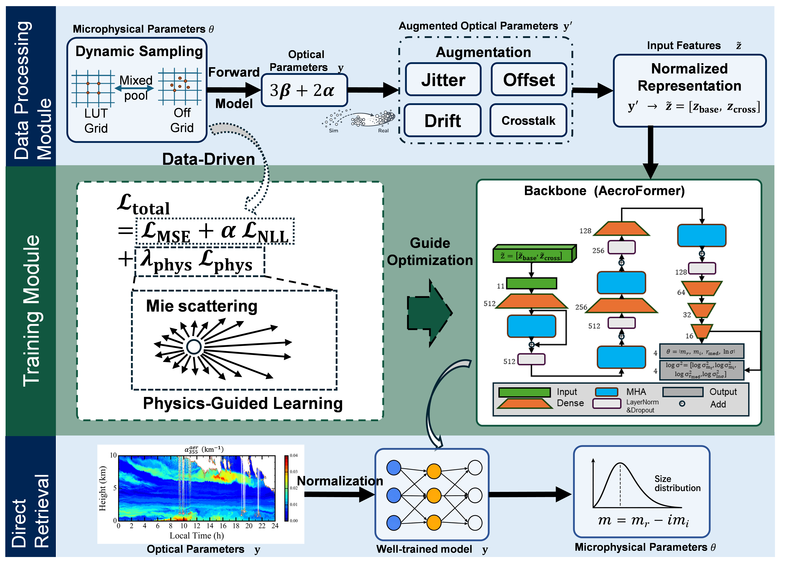
Fig. 1. Schematic diagram of the proposed physics-informed AecroFormer retrieval framework.

In this context, the ill-posedness of aerosol microphysical retrieval refers to the fact that the limited 3β+2α optical observations cannot uniquely determine the complete aerosol microphysical state. The forward mapping from microphysical parameters to lidar-measured optical quantities is nonlinear and highly coupled, so different combinations of complex refractive index, particle size (respectively particle size distribution), mode width, and particle number concentration may produce very similar optical responses within the observational uncertainty. Consequently, small perturbations in the optical observations can be amplified into large changes in the retrieved parameters, and the inverse solution may become locally non-unique or strongly dependent on the estimator. This property is the fundamental reason why retrieval stability, physical consistency, and estimator behavior under perturbations need to be examined in addition to conventional error metrics. Throughout this paper, scalar quantities are denoted by italic symbols, vectors by bold lowercase symbols, and matrices by bold uppercase symbols. Sets are denoted using calligraphic or uppercase Greek symbols. Descriptive subscripts are written in upright type, whereas sample, target, and channel indices are italic. A hat denotes an estimated quantity, and ⋅⊤denotes transpose.
Let the true microphysical parameter vector be denoted by $θ$, and the observation vector by $y$. They satisfy the condition
$$y=f(θ),$$ | (1)
where$f(⋅)$ denotes the forward operator based on the physical principles of light scattering. In this study, the microphysical parameter vector to be retrieved is defined as
$$θ={\left[m_{r}, m_{i}, r_{med}, ln⁡σ\right]}^{⊤},$$ | (2)
where $m_{r}$ and $m_{i}$ denote the real and imaginary parts of the complex refractive index, respectively, $r_{med}$ denotes the volume median radius of the investigated particle size distribution, and $σ$denotes the mode width of the lognormal size distribution, commonly expressed as the geometric standard deviation. In view of the limited lidar optical constraints, the inverse problem is highly ill-posed, and the estimation of the particle number concentration $N$is particularly sensitive to retrieval instability and scaling ambiguity. This is partly because the lidar wavelengths used here do not constrain the complete particle size distribution uniformly, but are most sensitive to a finite, wavelength- and refractive-index-dependent optically active size range. To reduce this effect and focus the comparison on size-distribution-related microphysical parameters, the total volume concentration is fixed at $V_{t}=1.0 μm^{3} {cm}^{-3}$in the forward simulation, and $N$is not treated as an independent retrieval variable during training. This treatment follows an established dimensionality-reduction strategy used in LUT-based and learning-based aerosol microphysical retrievals. By separating the size-distribution shape and refractive-index parameters from the absolute aerosol-loading scale, it reduces the number of simultaneously retrieved variables and partly alleviates the ill-posedness of the inverse problem. It does not imply that the aerosol volume concentration is fixed in real observations. After the shape-related parameters have been retrieved, the concentration scale can be recovered from the absolute magnitude of the measured optical quantities.
For this parameterization, the particle size distribution is assumed to follow a unimodal lognormal form, jointly determined by $r_{med}$ and $σ$. Given the fixed total volume concentration $V_{t},$ the corresponding particle number concentration $N$ can be derived, and the complete unimodal particle size distribution $n(r)$ is then determined. Based on this forward formulation, additional microphysical quantities can be derived. In particular, the effective radius is defined as
$$r_{e}=\frac{∫r^{3}n(r) dr}{∫r^{2}n(r) dr},$$ | (3)
which will be used later on as an important quantity in the external validation of the retrieval results.
Within this forward framework, the corresponding optical observables are calculated using Lorenz-Mie scattering theory. Specifically, for a given $θ$, Lorenz–Mie theory is used to calculate the single-particle extinction cross section and the 180° backscatter cross section at each wavelength as functions of particle radius and complex refractive index. These radius-dependent quantities are then weighted by the unimodal lognormal particle size distribution and integrated over radius using a precomputed high-resolution Mie lookup table:
y=[α355,β355,α532,β532,β1064]⊤y=α355 β355 α532 β532 β1064⊤. | (4)
Here, $α$ denotes the extinction coefficient and $β$ denotes the backscatter coefficient, i.e., exactly 180° in the case of lidar observations. The backscatter quantities include the 4π steradian normalization and are uniformly converted to the $km^{-1}$scale which is typically used as the height scale in lidar observations.
According to the practical distribution of aerosol microphysical properties [24], the parameter space used in the main experiments is set as follows: $m_{r}∈\left[1.30,1.70\right]$with a step of 0.02; $m_{i}∈0∪\left[{10}^{-6},0.5\right],$ where the nonzero part is sampled in logarithmic space with a total of 501 values; $lnσ∈\left[0.38,0.50\right]$ with a step of 0.01; and $r_{med}∈\left[50,500\right]nm$ with a step of 10 nm. Based on this discrete parameter space, a forward lookup table is precomputed, resulting in 6,291,558 parameter observation samples, which are used as the static lookup table training baseline. Furthermore, continuous random sampling is introduced within the same parameter ranges to generate dynamic training samples in real time, so as to support later comparisons among different training data construction strategies at a later stage.
It should be emphasized that both the static LUT samples and the dynamic samples are generated using the same forward computation process. This forward process is also used consistently for training data generation, synthetic validation set construction, and subsequent consistency-based evaluation, thereby ensuring physical consistency and comparability across all experimental stages.
These assumptions define the intended operating domain of the present framework. It is primarily applicable to fine-mode-dominated, approximately spherical aerosols that can be represented by a unimodal lognormal particle size distribution. Strongly nonspherical particles, such as mineral dust, may introduce systematic errors because of the mismatch with the spherical Lorenz–Mie kernels. Coarse-mode-dominated populations may be represented incorrectly as an enlarged or broadened unimodal distribution. Complex internally or externally mixed particles and strongly absorbing aerosols may not be adequately represented by a single homogeneous, wavelength-independent complex refractive index. Moreover, bimodal or multimodal populations introduce additional mode radii, widths, and relative contributions that cannot generally be constrained reliably by standard 3β+2αobservations. Under these conditions, the retrieved result should be interpreted as an effective solution within the assumed model class rather than as a unique physical decomposition.

B. Retrieval framework
AecroFormer is a deep learning model developed for aerosol microphysical retrieval from multiwavelength lidar observations. Its basic idea is to incorporate a multi-head attention mechanism into a lightweight perceptron backbone, so as to learn the nonlinear mapping from multichannel optical observations to microphysical parameters. The original AecroFormer is trained in a supervised manner using sample pairs generated by forward simulation and performs end-to-end regression from optical observations to microphysical state variables under the typical 3β+2α configuration [24]. Its overall network architecture is illustrated in Fig. 1.
For input representation, the original AecroFormer uses a small number of dimensionless ratio features to characterize spectral relationships among wavelengths. In this study, while retaining the AecroFormer backbone, the input representation is reorganized with reference to LUT-based approaches, including FAST and its related developments [20,21]. Specifically, the five-dimensional basic optical observation vector y defined in Eq. (4) is taken as the starting input. The backscatter channels and extinction channels are then normalized within their respective groups:

$$b_{norm}=\sqrt{β_{355}^{2}+β_{532}^{2}+β_{1064}^{2}},$$  $$a_{norm}=\sqrt{α_{355}^{2}+α_{532}^{2}}.$$ | (5)
Accordingly, the normalized basic optical feature vector is written as
$$z_{base}={\left[\frac{β_{355}}{b_{norm}} , \frac{β_{532}}{b_{norm}} , \frac{β_{1064}}{b_{norm}} , \frac{α_{355}}{a_{norm}} , \frac{α_{532}}{a_{norm}}\right]}^{⊤}.$$ | (6)
To further enhance the expression of cross channel coupling between extinction and backscatter, six cross ratio features are introduced：
$$z_{cross}={\left[\frac{α_{355}}{β_{355}} , \frac{α_{355}}{β_{532}} , \frac{α_{355}}{β_{1064}} , \frac{α_{532}}{β_{355}} , \frac{α_{532}}{β_{532}} , \frac{α_{532}}{β_{1064}}\right]}^{⊤}.$$ | (7)
The final input feature vector is defined as
$$z={\left[z_{base}^{⊤} , z_{cross}^{⊤}\right]}^{⊤}.$$ | (8)
Therefore, compared with the original AecroFormer, the input representation used here consists of normalized basic optical quantities together with their extinction backscatter cross relationships. This design preserves the original observation structure while enhancing the representation of multiwavelength coupling information. Intra-group spectral ratios, such as $α_{355}/α_{532}$and $β_{355}/β_{532}$, $β_{532}/β_{1064}$, or $β_{355}/β_{1064}$, were not added as separate features because their information is already largely represented by the group-normalized extinction and backscatter components. The additional ratio features were therefore restricted to extinction–backscatter combinations, which provide complementary information on the coupling between particle extinction and backscatter responses while avoiding excessive redundancy among highly correlated input features.
At the output side, the retrieved state is uniformly defined as the four-dimensional microphysical parameter vector $θ$, corresponding to the real part of the complex refractive index, the imaginary part of the complex refractive index, the volume median radius, and the logarithm of the mode width, $\ln{σ}$. This definition is consistent with the parameterization used in the forward simulation, so that the network output can be directly fed into the Lorenz–Mie-based forward operator $f\left(θ\right)$ to reconstruct the corresponding optical observations and to support the subsequent physical consistency constraint. The retrieval model can thus be written as
$$\hat{θ}=g(z),$$ | (9)
where $\hat{θ}$ denotes the retrieved estimate of the true microphysical parameter vector $θ and g(·)$denotes the nonlinear mapping implemented by AecroFormer or its extended configurations. For the uncertainty-enabled configurations, the model outputs both the predicted parameter values and their corresponding log variances， so as to support Gaussian negative log likelihood-based supervised training and predictive interval estimation. The details are given in Section II.E.

C. Physical consistency loss
Based on the retrieval framework explained above, a physical consistency loss is further introduced by explicitly incorporating the Lorenz–Mie-based forward operator that maps microphysical parameters to lidar optical observables [26,36]. When the inverse mapping is approximated solely through supervised learning, the optimization target is usually to minimize the discrepancy between the predicted microphysical parameters and the ground-truth microphysical labels. However, for an ill-posed inverse problem such as aerosol microphysical retrieval from multiwavelength lidar, a small local error in parameter space does not necessarily imply a small discrepancy in observation space. In particular, when the optical input is perturbed and the coupling among parameters is strong, the model may produce a solution that is numerically close to the label (microphysical parameters) but cannot remain consistent with the input optical observations after forward calculation, thereby weakening the consistency between the retrieved state and the observed optical response. For this reason, in addition to parameter space supervision, a physical consistency loss is introduced so that the network output is constrained jointly in both parameter space and observation space.
The total loss function is written as
$$L=L_{sup}+λ_{phys}L_{phys},$$ | (10)
where $L_{sup}$ is the supervised loss, $L_{phys}$ is the physical consistency loss, and $λ_{phys}$is the weight of the physical term. In the current implementation, $λ_{phys}=1$was selected empirically based on preliminary sensitivity experiments, in which it provided a stable balance between parameter-space accuracy and observation-space consistency. This coefficient acts as a regularization weight rather than a theoretically fixed constant. The physical constraint is introduced in a joint-training manner, i.e., as an additional observation-space consistency term on top of the parameter-space supervision loss.
The supervision term $L_{sup}$is defined in parameter space. For the standard configurations, the network directly outputs the predicted microphysical parameter values, and the supervised loss is calculated using the mean squared error. For the uncertainty-enabled configurations, the supervision term is extended to a Gaussian negative log-likelihood loss, in which the network predicts both the mean value and the log variance of each microphysical parameter. This uncertainty-aware formulation is intended to represent the predictive uncertainty of the retrieved parameters, which may arise from measurement perturbations in the input lidar optical quantities and from the ill-posed nature of the inverse mapping. Regardless of the specific supervision form, $L_{sup}$ provides the basic parameter-space constraint for learning the mapping from the five lidar optical observables $\left(α_{355} , β_{355} , α_{532} , β_{532} , β_{1064}\right)$ to the target microphysical parameters.
The physical term $L_{phys}$ is defined in the observation space. Specifically, let the network prediction be $\hat{θ}$. The predicted parameter vector is then fed into the Lorenz–Mie-based forward operator $f(⋅)$ described in Section II.A to reconstruct the corresponding optical observation vector. For fixed total volume concentration $V_{t}=1.0μm^{3}cm^{-3}$, the corresponding optical observation vector is reconstructed as
$$\hat{y}=f(\hat{θ}).$$ | (11)
The reconstructed optical vector $\hat{y}$ is then directly compared with the original optical observation vector $y$ of the considered measurement sample, thereby imposing a closed-loop constraint on observation-space physical consistency. The differentiable forward operator does not directly differentiate through the Lorenz–Mie series calculation. Instead, high-resolution single-particle extinction and backscatter kernels are precomputed on a fixed grid of particle radius, mr, and mi, and stored as constant tensors during training. For each predicted mrmi, the corresponding continuous optical kernels are obtained through multilinear interpolation implemented using torch.nn.functional.grid_sample. The predicted rmedand σare then used to construct the lognormal particle size distribution on the fixed radius grid, and the extinction and backscatter coefficients are reconstructed through trapezoidal integration. Because the interpolation, particle-size-distribution calculation, and numerical integration are implemented entirely as differentiable PyTorch tensor operations, gradients of Lphyscan propagate through y=f(θ)to the predicted microphysical parameters and network weights. Over the parameter domain considered in this study, the maximum relative difference between the interpolated operator and direct Lorenz–Mie calculations is below 0.1%, and the automatically differentiated gradients agree with finite-difference estimates in both direction and magnitude.
In its specific form, a hybrid optical consistency loss is adopted. Let $ŷ_{c}$ and $y_{c}$ denote the predicted and observed values of the $c_{th}$ measurement channel, respectively. A relative error term is first defined as
Lrel=1Cc=1C∣yc-yc∣max⁡(∣yc∣,ϵrel,c), | (12)
where $C$ is the number of observation channels, and $ϵ_{rel}$is a fixed numerical floor which is used to avoid unstable amplification of the relative error when the optical value of a channel approaches zero. In this study, $ϵ_{rel}$ is set to ${10}^{-12}$for all channels. This value is not a physical parameter or a theoretically optimized regularization coefficient, but a numerical stabilizer introduced to prevent division by zero or near-zero denominators. Since the optical quantities used in the loss are several orders of magnitude larger than ${10}^{-12}$in physically meaningful cases, this term has negligible influence except for numerically degenerate near-zero values. To further reduce the imbalance caused by the high dynamic range of the optical quantities, the corresponding logarithmic error term is defined as
$$L_{log}=\frac{1}{C}\sum_{c=1}^{C}{{\left[log⁡(1+{\hat{y}}_{c})-log⁡(1+y_{c})\right]}^{2}}.$$ | (13)
The final physical loss is written as
$$L_{phys}=ηL_{rel}+(1-η)L_{log},$$ | (14)
where $η∈[0,1]$is the mixing weight that controls the relative contribution of the relative-error and log-domain consistency terms. In this study, $η=0.5$was adopted as the final empirical setting after preliminary sensitivity experiments, giving equal weight to the two consistency terms. This value should be regarded as a practical loss-balancing choice rather than a theoretically prescribed constant. In the current implementation, this loss also supports smooth reweighting when the relative error exceeds a prescribed threshold, so that the training process pays more attention to samples with stronger observation-space inconsistency.
The purpose of Lphys is to provide an additional observation-space regularization by penalizing disagreement between the optical response reconstructed from the predicted state and the input observations. It is not intended to uniformly reduce the error of every retrieved microphysical parameter. Because the inverse mapping is intrinsically ill-posed, improved observation-space closure may coexist with unchanged or slightly increased errors for individual parameters. Its contribution is therefore evaluated separately in terms of parameter-space errors, selected bias structures, and forward-reconstruction residuals. A detailed field-based evaluation of the observation-space effect is provided in Supplementary Section D.

D. Dynamic non-gridded sampling
Traditional LUT methods and the supervised training schemes derived from them are usually built on discrete parameter grids. Even if an explicit lookup procedure is replaced by a neural network at the inversion stage, as long as the training samples are entirely drawn from a fixed sample set generated once in advance, the model still mainly learns an approximate mapping defined on a discretely sampled distribution rather than a stable inverse mapping in continuous parameter space [37,38]. For the ill-posed microphysical retrieval problem considered here, such grid-based training can easily make the model implicitly adapt to the predefined sampling structure, thereby weakening its generalization ability on off-grid samples or under continuous parameter perturbations.
To reduce this effect, a dynamic non-gridded sampling mechanism is introduced with reference to the parameterization used in the multivariate Full-permutAtion based Stochastic foresT method (FAST) [20]. Specifically, the training samples are no longer composed solely of precomputed lookup table samples. Instead, they are constructed by combining static LUT sampling with continuous random sampling, so that the stability of the training dataset is retained while non-gridded samples are continuously introduced.
Let the total number of samples used in each training round be $N$, and let the proportion of dynamically generated random samples be $r$. In this study, r=0.5 is used as a fixed empirical setting throughout training, so that each training round contains an equal mixture of static lookup-table samples and dynamically sampled non-gridded samples. The value of r is not adaptively updated or learned during training; instead, new dynamic samples are generated in each round under the same sampling proportion. In this way, the training process repeatedly samples from the same bounded continuous parameter domain, providing progressively richer coverage of off-grid regions without attempting to construct an exhaustive continuous lookup table. This setting was adopted to balance the coverage and reproducibility of the static LUT samples with the increased parameter-space continuity provided by dynamic sampling. Very small values of $r$ would make the training distribution close to the original gridded LUT and reduce the benefit of non-gridded sampling, whereas very large values of $r$ would weaken the anchoring effect of the precomputed LUT samples and may increase training variability. Therefore, $r=0.5$ was used as a balanced empirical choice rather than as a theoretically optimized constant
NBrand=rBN,BNlut=(1-r)BN | (15)
where NBlut is obtained by uniform sampling with replacement from the precomputed LUT, and NBrand is generated by resampling in continuous parameter space.
The dynamic samples are generated within the same parameter ranges defined in Section II.A for $m_{r}$, $m_{i}$, $r_{med}$, and $\ln{σ}$. Specifically, $m_{r}$, $r_{med}$, and $\ln{σ}$are uniformly sampled within their respective domains, whereas $m_{i}$ is sampled using a mixed strategy consisting of a point mass at zero and a logarithmically uniform distribution for the nonzero part. This strategy preserves both non-light-absorbing cases and absorbing cases spanning several orders of magnitude. Although the effective radius $r_{e}$ is not independently sampled, it is determined by the sampled $r_{med }$ and $σ$ and is later used as a derived quantity for external validation.
For each randomly sampled parameter vector $θ$, the corresponding five-dimensional optical observation vector $y$ is calculated using the same Lorenz–Mie-based forward operator $f(θ)$, and the feature vector $z$ is then constructed according to Section II.B. Thus, the dynamic samples are not restricted to the discrete support of the LUT but cover intermediate regions in continuous parameter space. Since new samples are independently generated in each training round from predefined distributions, the method avoids a fixed clustering pattern in a specific region of the parameter space, although small random fluctuations may occur within individual batches.
During training, the training set is therefore not treated as a fixed sample collection, but rather as a mixed distribution that is continuously updated throughout the training process. The key purpose is to avoid over adaptation to a limited discrete grid and to encourage the network to learn a more continuous and smoother inverse mapping in parameter space. For the ill-posed microphysical retrieval problem considered here, this dynamic data mechanism can continuously introduce new off-grid samples while keeping the physical parameter boundaries consistent, thereby alleviating the distribution locking effect caused by fixed lookup table sampling and improving model generalization to continuous perturbations, out-of-sample shifts, and locally unstable regions.

E. Heteroscedastic uncertainty modeling
Aerosol microphysical retrieval from multiwavelength lidar exhibits clear sample heterogeneity. The forward sensitivity of the optical observables to different microphysical parameters, the coupling strength among extinction and backscatter channels at different wavelengths, and the local degree of ill-posedness of the inverse problem all vary across different regions of the parameter space. As a result, different samples can differ substantially in retrieval difficulty and effective observability. Traditional point estimate regression assumes that all samples share the same noise structure and the same error scale, which is difficult to reconcile with the sample-dependent uncertainty encountered in the actual problem. For this reason, heteroscedastic uncertainty modeling is introduced in some model configurations [39], allowing the model to output both the predictive mean and the predictive variance for each sample and each target variable.
For the ith sample, letith θistd∈Rdθ̃i∈Rd denote the standardized target vector, where d=4 and the four components correspond to mr, mi, rmed, and lnσg, respectively. The uncertainty-enabled output head produces a predictive-mean vector μiand a log-variance vector si:d

gUNC(zi)=(μi,si),μi,si∈Rd.μi, log⁡σi2, | (16)
Here, μij and sijdenote the predicted mean and log variance, respectively, for the jth target variable of the ith sample. The corresponding predictive variance vij and standard deviation uij areμi∈Rdlog⁡σi2∈Rdjth

vij=exp⁡(sij),uij=exp⁡sij2σij=exp⁡(12logσij2). | (17)
During supervised learning, a hybrid loss-combining mean squared error and Gaussian negative log likelihood are adopted:
Lsup=LMSE+λNLLαLNLL, | (18)
where λNLLα is the weight assigned to the uncertainty term. The mean squared error term is defined as
LMSE=1BNdi=1NBj=1dμijθistdθij2, | (19)
where $N$ is the number of samples and $d$ is the target dimension. This term constrains the basic fitting accuracy of the predictive mean to the target parameters. Under the assumption of independent Gaussian outputs, the Gaussian negative log-likelihood (NLL) term is written as
LNLL=1BNdi=1BNj=1d(μijθijμij-θistd)22σsij2+12log⁡σsij2 | (20)
In practical implementation, a weak regularization term may also be added to suppress unconstrained divergence of the variance branch. During training, the NLL term is computed for each sample and each target variable in the standardized parameter space, then averaged over samples and variables, and finally combined with $L_{MSE}$ using the weight $α$ to form the supervised loss. Because all target variables are standardized before loss calculation, the different numerical ranges of $m_{r}$, $m_{i}$, $r_{med}$, and $\ln{σ}$ do not directly dominate the relative contributions of the variable-wise NLL terms.
It should be noted that all supervision terms are computed in the standardized parameter space. In other words, both the network outputs $μ$ and$logσ^{2}$ correspond to standardized target variables. Therefore, $L_{MSE}$ and $L_{NLL}$ are both defined on a consistent standardized scale during training.
With this design, the learning objective is no longer limited to a single-point estimate, but includes both the predicted parameter value and its associated uncertainty level. Consequently, the network can adaptively represent sample- and variable-dependent retrieval difficulty, that is, the difficulty of fitting different microphysical parameters under different local optical constraints. This reduces the excessive influence of highly ill-posed samples on the overall optimization and provides a more natural statistical basis for subsequent joint training with physical constraints.

F. Physically guided data augmentation
The results of the original AecroFormer showed that appropriate noise augmentation can improve model robustness to noise. However, if the augmentation strategy consists only of independent Gaussian perturbations with uniform amplitude, the resulting error structure remains close to idealized white noise and is insufficient to characterize the more complex error sources encountered in real multiwavelength lidar observations. In practice, observational errors are often not simply independent. They may simultaneously include overall gain variations, channel-correlated perturbations, heteroscedastic noise, and low-probability anomalies. Moreover, different lidar channels may have different uncertainty characteristics. For instance, backscatter coefficients at stronger signal channels, such as 532 nm, are often better constrained than those at weaker long-wavelength channels such as 1064 nm, while extinction coefficients can be more sensitive to noise propagation and smoothing choices than backscatter coefficients. This issue becomes particularly relevant when a weak or more uncertain channel contributes to normalized features or ratio-based representations, because its uncertainty may propagate to several derived input quantities. These differences motivate the use of channel-dependent and physically guided perturbations rather than uniform independent Gaussian noise. Therefore, for multiwavelength lidar retrieval, it is necessary to model error sources in a more structured random manner according to channel characteristics and error propagation behavior to reduce the gap between simulated and real observations [38,40]. Based on this consideration, a physically guided data augmentation strategy is introduced during training to impose perturbations on the input optical quantities that better reflect the characteristics of real observations.
Specifically, data augmentation is not treated here as simple noise injection, but as an approximate representation of realistic lidar observational error structures. Compared with a single independent Gaussian perturbation, this strategy incorporates overall gain changes, wavelength-group correlated errors, channel crosstalk, and low-probability anomalies [40], thereby constructing compound error patterns that are closer to real lidar observations during training. The purpose is to encourage the model to learn a more stable inverse mapping under multi-source perturbations, rather than being robust only to idealized white noise. For the ill-posed retrieval problem studied here, this physically guided augmentation does not eliminate the intrinsic non-uniqueness caused by limited optical constraints. Instead, it helps the network learn a more robust estimator within the range of observation uncertainties represented during training, thereby reducing the discrepancy between simulated and real observations.
In summary, this study does not alter the basic AecroFormer retrieval backbone. Instead, it systematically extends the training mechanism around generalization, stability, and physical consistency under ill-posed inverse conditions, thereby forming a physics-informed learning framework that is more suitable for aerosol microphysical retrievals from multiwavelength lidar. In this framework, dynamic non-gridded sampling alleviates the structural bias caused by discrete grid training at the sample distribution level. Heteroscedastic uncertainty modeling characterizes differences in retrieval difficulty across samples at the level of statistical supervision. The physical consistency loss explicitly introduces the Lorenz–Mie-based forward operator into the optimization objective and thereby suppresses infeasible solutions which are inconsistent with the observations. Finally, physically guided data augmentation improves the stability of the learned estimator by introducing representative observational uncertainty structures during training. The relevant training hyperparameters and augmentation settings are listed in Appendix A, and the effectiveness of these modules and strategies will be further examined in the validation and ablation experiments in Section III .

III. Ablation Experiments and Algorithm Validation

A. Ablation experiments on synthetic data
1) Experimental design and compared configurations
To systematically evaluate the effects of different improvement strategies on aerosol microphysical retrieval from multiwavelength lidar, a progressive ablation study was designed under a unified unimodal 3β+2α retrieval task. In all experiments, the forward parameterization, network backbone, parameter ranges, and evaluation protocol were kept unchanged, while only the training mechanisms and constraint modules were varied. In this way, the performance differences among configurations can be compared in a controlled manner.
As summarized in Table I, seven configurations were compared in total, including the original AecroFormer (ORI), the traditional LUT method (LUT), and the five progressively enhanced internal configurations developed in this study, namely BAS, PHY, DYN, UNC, and NOA. These abbreviations are defined in this section and used consistently throughout the following analysis. ORI and LUT serve as references for an existing deep learning method and a traditional retrieval method, respectively, whereas BAS, PHY, DYN, UNC, and NOA form the internal improvement chain of this study. Except for LUT, all deep learning configurations share essentially the same network backbone. Therefore, the performance differences among them can be attributed primarily to changes in input representation, training data construction, supervision form, and physical constraint strategy, rather than to differences in model capacity.
More specifically, ORI corresponds to the original AecroFormer setting, which uses the original ratio-based input and conventional noise augmentation. LUT denotes the KNN-based lookup table retrieval, named FAST [20,21], which is used as the traditional reference. FAST was selected because previous studies demonstrated its competitive accuracy and efficiency, and our implementation also showed strong performance across most tested conditions and metrics. Although KNN is used to accelerate candidate searching, the method remains fundamentally a LUT estimator that retrieves microphysical states by matching observations against a precomputed discrete physical state space. It therefore provides a stringent and directly relevant baseline for the present comparison between LUT-based candidate matching and deep-learning-based direct inversion under the same forward model and optical constraints. Regularization-based inversion, TiARA, and maximum-likelihood approaches involve different prior or regularization assumptions and are not included because the present study is not intended as an exhaustive benchmark of all established inversion methods. BAS is the unified baseline constructed in this study. It retains the AecroFormer backbone while adopting the reorganized normalized optical input representation proposed here. PHY further introduces the physical consistency constraint on top of BAS. DYN adds the dynamic non-gridded sampling mechanism based on PHY. UNC further incorporates heteroscedastic uncertainty modeling on top of DYN. NOA removes data augmentation from UNC and is used as a counterexample to verify the necessity of the augmentation strategy. This configuration chain makes it possible to examine the independent contributions and coupling effects of the different improvement modules step by step.
To avoid interference from fixed sampling structures, all methods were evaluated on the same independently generated non-gridded test set. This test set contains 800,000 samples, generated by random sampling in continuous parameter space followed by forward simulation. It is fully independent of the training data and is not involved in model training, early stopping, or hyperparameter selection. Therefore, the reported results are intended to provide an out-of-sample assessment of the generalization ability of each estimator in continuous parameter space, rather than its ability to memorize a discretely sampled distribution or interpolate between predefined grid points.
2) Standard noise setting
To ensure a fair comparison among different configurations, all statistical evaluations were conducted under a unified standard noise condition. This setting corresponds to the relative Gaussian noise standard deviations of the optical inputs obtained from a 3β+2α lidar observation system, with noise injected independently into each channel. Using the notation introduced earlier, let the basic optical observation vector be $y$, and let the noisy observation vector be denoted by $\tilde{y}$. Then

yk=yk(1+ϵk),ϵk∼N(0,τσk2),k=1,…,5. | (21)
Following the test setting used in previous work, the relative noise standard deviations for the five channels were fixed as
(τσα355,τσβ355,τσα532,τσβ532,στβ1064)=(0.10, 0.05, 0.10, 0.05, 0.15).

TABLE I. COMPOSITION OF THE COMPARED ABLATION CONFIGURATIONS
Configuration | Reorganized input representation | Physical consistency constraint | Dynamic non-gridded sampling | Heteroscedastic uncertainty modeling | Data augmentation | Description
ORI | × | × | × | × | √ | Original AecroFormer reference
LUT | √ | × | × | × | × | KNN-based lookup table (FAST)
BAS | √ | × | × | × | √ | Unified baseline proposed in this study
PHY | √ | √ | × | × | √ | BAS + physical consistency constraint
DYN | √ | √ | √ | × | √ | PHY + dynamic non-gridded sampling
UNC | √ | √ | √ | √ | √ | DYN + heteroscedastic uncertainty modeling
NOA | √ | √ | √ | √ | × | UNC without augmentation

That is, the extinction coefficients at 355 nm and 532 nm were assigned 10% noise, the backscatter coefficients at 355 nm and 532 nm were assigned 5% noise, and the backscatter coefficient at 1064 nm was assigned 15% noise. This setting defines the standard noise level used throughout this paper and serves as the common evaluation protocol for all subsequent tables and figures.
Under this setting, the output of any method can be uniformly denoted as $\hat{θ}\left(\tilde{y}\right)$, that is, the point estimate obtained from the noisy observation vector under the standard noise perturbation. For the deep learning configurations used here, the actual network input is the feature vector $\tilde{z}$ further constructed from$\tilde{ y}$. However, for simplicity of notation, this section still uses $\hat{θ}\left(\tilde{y}\right)$to represent the retrieval result driven by noisy observations. All subsequent error statistics are defined on this common notation.
3) Evaluation metrics
To comprehensively evaluate the effects of different strategies on the retrieval results, four metrics were adopted for different variables: mean absolute error (MAE), mean error (ME), mean absolute relative error (MARE), and mean relative error (MRE). For the real part $m_{r}$ and the imaginary part $m_{i}$ of the complex refractive index, absolute error metrics were mainly used. For variables related to particle size, distribution width, and particle number concentration, relative error metrics were used because they are more appropriate on a relative scale. In the result tables, in addition to the directly predicted variables, some metrics are also reported for quantities derived from the retrieved parameters, such as the particle number concentration $N$.
Let the true and predicted values of the $jth$ target variable for the $ith$ sample be denoted by${ θ}_{j,i}$ and $\hat{θ_{j,i}}$, respectively, and let the total number of samples be $n$. The four metrics are defined as follows:

MAEj=1ni=1n∣θij,i-θijj,i∣, | (22)
MEj=1ni=1nθijj,i-θijj,i, | (23)
MAREj=1ni=1n∣θjij,i-θijj,iθijj,i∣×100%, | (24)
MREj=1ni=1nθijj,i-θjij,iθjij,i×100%. | (25)
Here, MAE and MARE describe the average magnitude of the error and are used to measure retrieval accuracy, whereas ME and MRE preserve the sign of the error and are used to characterize whether the estimator tends to systematically overestimate or underestimate the target. In other words, the absolute error metrics answer the question “how far is the estimate from the truth,” whereas the signed error metrics answer the question “in which direction does the estimator tend to deviate.” In Section III , these metrics are mainly used to report the performance differences under the unified evaluation protocol, whereas their evolution with noise level and perturbation conditions is further analyzed in Section IV.

4) Ablation results and analysis
TABLE II. ERROR MAGNITUDE UNDER THE STANDARD NOISE SETTING FOR DIFFERENT ABLATION CONFIGURATIONS
Method | $m_{r}$ MAE | $m_{i}$ MAE | $r_{med}$ MARE (%) | $σ$ MARE (%) | $N$ MARE (%)
ORI | 0.0638 | 0.0197 | 20.00 | 3.12 | 69.62
BAS | 0.0519 | 0.0184 | 18.23 | 3.07 | 47.02
PHY | 0.0518 | 0.0187 | 18.48 | 3.08 | 65.34
DYN | 0.0514 | 0.0181 | 18.27 | 3.07 | 51.97
UNC | 0.0516 | 0.0183 | 18.02 | 3.07 | 54.71
NOA | 0.0802 | 0.0251 | 26.42 | 4.19 | 124.67
LUT | 0.0675 | 0.0212 | 22.50 | 4.02 | 87.20

TABLE III. MEAN SIGNED ERROR UNDER THE STANDARD NOISE SETTING FOR DIFFERENT ABLATION CONFIGURATIONS
Method | $m_{r}$ ME | $m_{i}$ ME | $r_{med}$ MRE (%) | $σ$ MRE (%) | $N$ MRE (%)
ORI | -0.0021 | -0.0016 | 5.03 | 0.08 | 31.99
BAS | -0.0020 | 0.0006 | 3.12 | 0.10 | 18.83
PHY | -0.0061 | 0.0008 | 1.10 | 0.09 | 42.81
DYN | -0.0060 | 0.0001 | 2.46 | 0.09 | 27.36
UNC | -0.0040 | 0.0003 | 1.86 | 0.09 | 30.46
NOA | 0.0186 | 0.0026 | 2.58 | -0.85 | 92.52
LUT | 0.0158 | 0.0031 | 2.72 | -0.55 | 57.03
Tables II and III report the error magnitudes and mean signed errors of all configurations under the standard noise condition. Overall, BAS already yields a stable improvement over the original AecroFormer (ORI): the MAE of $m_{r}$ decreases from 0.0638 to 0.0519, corresponding to a reduction of 18.7%; the MAE of $m_{i}$ decreases from 0.0197 to 0.0184, a reduction of 6.6%; the MARE of $r_{med}$ decreases from 20.00% to 18.23%; and the MARE of $N$ decreases from 69.62% to 47.02%, corresponding to a reduction of 32.5%. BAS also performs better than LUT overall, indicating that the unified input representation and the redefined training baseline already provide a clear gain.
After the physical consistency constraint is introduced on top of BAS, PHY does not further reduce the absolute error for all variables. For example, the MARE of $r_{med}$ becomes 18.48%, slightly higher than 18.23% for BAS, and the MARE of $N$ also increases to 65.34%. However, Table III shows that PHY achieves the lowest MRE for $r_{med}$, only 1.10%, which is clearly lower than 3.12% for BAS and 5.03% for ORI. This indicates that, although the physical constraint does not necessarily lead to a smaller mean absolute error, it substantially suppresses the systematic bias of the volume median radius. For retrieval problems, this means that the overall tendency to overestimate or underestimate particle size related parameters is reduced, making the solution more physically stable. The multi-seed results confirm that Lphys is not a uniformly accuracy-improving component. It reduces selected signed biases, whereas several absolute-error metrics remain nearly unchanged or increase. This behavior is consistent with its direct objective in observation space rather than independent minimization of every microphysical parameter error.
After the dynamic non-gridded sampling mechanism is further introduced, DYN achieves a better balance between accuracy and bias. Compared with PHY, the MAE of $m_{r}$ decreases from 0.0518 to 0.0514, the MAE of $m_{i}$ decreases from 0.0187 to 0.0181, the MARE of N decreases markedly from 65.34% to 51.97%, and the MRE of $N$ also decreases from 42.81% to 27.36%. These results indicate that the dynamic data mechanism effectively alleviates the structural limitation caused by a fixed discrete training distribution, thereby improving both generalization error and scale bias in continuous parameter space.
UNC further introduces heteroscedastic uncertainty modeling on top of DYN. Under this setting, the MARE of $r_{med}$ decreases to 18.02%, the lowest among all deep learning configurations, while $m_{r}$, $m_{i}$, and $σ$ remain at levels close to those of DYN. More importantly, UNC not only outputs point estimates, but also provides corresponding uncertainty estimates. Its significance therefore lies not only in the retrieval accuracy itself, but also in the direct support it offers for subsequent analyses of interval coverage, interval width, and result credibility.
The results of NOA provide the opposite evidence and highlight the importance of the augmentation strategy. Once augmentation is removed, the MAE of $m_{r}$ rises to 0.0802, the MAE of $m_{i}$ rises to 0.0251, the MARE of $r_{med}$ increases to 26.42%, and the MARE of $N$ reaches 124.67%. Correspondingly, the ME of $m_{r}$ changes from a negative bias to a positive bias of 0.0186, and the MRE of N rises to 92.52%.
The degradation of NOA should not be interpreted as evidence that the deep-learning estimator itself cannot handle observational noise. Instead, it reflects a fundamental property of ill-posed inverse retrieval. A deep neural network can approximate the inverse mapping effectively when the training distribution sufficiently represents the target observation space; however, it cannot recover information that is absent from the observations or guarantee an invariant solution under arbitrary perturbations. Therefore, removing augmentation exposes the model to a larger distribution shift between idealized synthetic observations and perturbed observations, resulting in an unstable estimator response.
Taken together, BAS demonstrates the necessity of the unified input representation and the unified training baseline; PHY shows that the physical constraint first improves the bias structure of the key size-related parameter; DYN further improves the overall generalization performance in continuous parameter space; UNC preserves competitive accuracy while additionally providing explicit uncertainty estimates; and the severe degradation of NOA shows, from the opposite side, that physically guided augmentation is crucial for robustness. The mode width $σ$ shows a relatively stable behavior across the improved configurations, with MARE values remaining close to 3% and almost negligible mean bias. Although $σ$ is less directly interpretable than $r_{med}$ or $N$, it controls the spread of the unimodal particle size distribution and therefore affects the derived size-related quantities. The degradation observed for NOA and LUT suggests that the proposed training strategies also help maintain a stable representation of the distribution shape. Overall, compared with LUT, the advantage of UNC is more prominent in systematic bias control, especially for the refractive-index-related variables. By contrast, the improvement in particle size related parameters is better reflected in the simultaneous improvement of error magnitude and bias structure, rather than in a dramatic gain in a single metric. Among the tested configurations, DYN and UNC are the two most competitive ones, with the former emphasizing overall accuracy and the latter further accounting for result credibility.
5) Retrieval efficiency
Computational efficiency was further assessed for the microphysical inversion step, defined here as the conversion of five-channel lidar optical measurements into aerosol refractive-index and size-distribution parameters. To avoid ambiguity, one retrieval sample refers to one height-resolved 3β+2α optical measurement vector, that is, one range-bin-level input consisting of five optical quantities, rather than a complete lidar profile. A batch of 64 retrieval samples therefore corresponds to 64 independent height-resolved input vectors. The benchmark was conducted on an AMD Ryzen 9 9950X 16-Core Processor. File loading, construction of the lookup table, Mie forward calculations, and number-concentration post-processing were excluded from the timing test, so that only the microphysical inversion step itself was compared. For the same batch of 64 retrieval samples, FAST required 124.42 s, corresponding to 1.94 s per sample. In contrast, the uncertainty-aware AecroFormer configuration used in this study required 1.41 ms per batch, corresponding to 0.022 ms per sample. This represents an acceleration of approximately $8.8×{10}^{4}$ for the same CPU-based inversion task. This benchmark should therefore be interpreted as a comparison of computational cost for retrieving microphysical parameters from the same five-channel optical inputs, rather than as a statement about a change in observational information content.

B. Real-world validation based on NASA in-situ observations obtained from DISCOVER-AQ California
To further evaluate the applicability of the proposed framework under real observational conditions, external validation was conducted using observations from the NASA DISCOVER-AQ California field campaign [41,42]. This campaign provides a well-coordinated airborne dataset for aerosol microphysical retrieval. The NASA Langley HSRL-2 system onboard the B-200 aircraft provided multiwavelength high-spectral-resolution lidar observations, including the 3β+2α optical input required in this study: backscatter coefficients at 355, 532, and 1064 nm and extinction coefficients at 355 and 532 nm. The P-3B aircraft performed in-situ measurements along multiple spiral profiles, providing independent aerosol microphysical references for evaluating the lidar retrieval results. Sawamura et al. systematically compared HSRL-2 aerosol microphysical retrievals with P-3B in-situ observations during DISCOVER-AQ 2013 California, demonstrating the suitability of this coordinated dataset for evaluating multiwavelength airborne lidar retrievals [43]. Subsequent studies by Wang, Zhou, and co-workers also used DISCOVER-AQ cases to validate and compare FAST and related lookup-table retrieval methods [20,21]. Therefore, this dataset provides both a realistic field-observation benchmark and an evaluation basis consistent with previous LUT/FAST-based studies.
The matchup procedure used here follows the pairing logic adopted by Sawamura et al. and by Wang and Zhou in their DISCOVER-AQ analyses [20,21,43]. The P-3B spiral was used as the basic matchup unit. When available, spirals were identified using ProfileNumber; otherwise, an auxiliary segmentation based on vertical flight structure was applied. To ensure sufficient vertical representativeness, each spiral was required to last at least 8 min and cover a vertical span of at least 1.5 km. Candidate HSRL-2 segments were searched within a time window from 15 min before the start of the spiral flight-pattern to 15 min after the end of the spiral and were required to be within 15 km of the spiral center. The HSRL-2 and in-situ observations were then resampled to a common resolution of 75 m in altitude and 90 s in time for point-by-point comparison.
Considering that the retrieval framework assumes a unimodal fine-mode particle size distribution, an additional Ångström exponent constraint was applied to select observations more consistent with this representation. Specifically, AE(355–532) was restricted to 1.5–2.5, thereby preferentially retaining fine-mode-dominated cases. This criterion improves consistency between the field observations and the adopted forward-model assumptions but does not imply that the ambient particle size distributions were strictly unimodal. The 532-nm depolarization ratio was retained as an auxiliary indicator of particle nonsphericity and possible coarse-mode influence, rather than being used as a primary hard-screening criterion.
After profile matching and vertical resampling, a height-resolved sample was retained only when all five HSRL-2 optical inputs and the required in situ reference variables were simultaneously available. Samples containing non-finite or negative values, physically inconsistent spectral relationships, very weak extinction or backscatter signals, or high relative humidity were further excluded. This procedure yielded 31 primary matched profiles from 8 observation days and 14 B-200 flight segments. After point-level quality control, 30 profiles retained valid comparison samples and were used for quantitative evaluation.
Accordingly, the present external validation should be interpreted as an applicability assessment under the selected fine-mode-dominated DISCOVER-AQ California conditions, rather than as evidence of broad generalization across aerosol types, humidity regimes, geographic regions, or particle morphologies.
1) Full-sample validation statistics
TABLE IV. EXTERNAL VALIDATION RESULTS FOR EFFECTIVE RADIUS AND 532-NM SINGLE-SCATTERING ALBEDO USING NASA DISCOVER-AQ CALIFORNIA OBSERVATIONS
Method | $r_{e}$ MARE (%) | $r_{e}$ MRE (%) | $SSA_{532}$ MAE | $SSA_{532}$ ME
ORI | 24.90 | 19.92 | 0.0191 | 0.0044
BAS | 13.58 | -5.56 | 0.0193 | 0.0108
PHY | 14.47 | -9.52 | 0.0185 | 0.0076
DYN | 14.30 | -8.98 | 0.0171 | 0.0039
UNC | 14.20 | -6.90 | 0.0211 | 0.0092
LUT | 14.36 | -10.92 | 0.0370 | -0.0274
Table IV summarizes the external validation results for the DISCOVER-AQ California matchup dataset. The statistics are calculated from 30 valid matched profiles obtained from 8 observation days and 14 B-200 flight segments after matchup and quality-control screening. Here, $r_{e}$denotes the effective radius derived from the retrieved particle size distribution, and ${SSA}_{532}$denotes the single-scattering albedo at 532 nm. Negative values of MRE and ME indicate underestimation relative to the P-3B in-situ airborne reference, whereas positive values indicate overestimation.
Overall, the improved deep-learning configurations maintain the same trend observed in the synthetic ablation experiments under real observational conditions. Compared with the original AecroFormer (ORI), BAS, PHY, DYN, and UNC substantially reduce the error in $r_{e}$and improve the mean bias. For ${SSA}_{532}$, the improved configurations also outperform LUT (FAST) overall. After data augmentation is removed, NOA degrades markedly, especially for ${SSA}_{532}$, with both the error magnitude and negative bias increasing strongly. This result indicates that data augmentation is important for maintaining model generalization and the stability of absorption-related quantities under real observational error structures.
For the effective radius $r_{e}$, BAS, DYN, and UNC achieve MARE values of 13.58%, 14.30%, and 14.20%, respectively, all clearly lower than 24.90% for ORI and comparable to 14.36% for LUT (FAST). BAS gives the lowest absolute relative error, whereas DYN and UNC remain close to the LUT (FAST) level. In terms of MRE, ORI shows a clear positive bias of 19.92%, while BAS, DYN, UNC, and LUT (FAST) yield -5.56%, -8.98%, -6.90%, and -10.92%, respectively. These results indicate that the improved deep-learning configurations not only reduce the error magnitude of $r_{e}$, but also weaken the overestimation tendency of ORI. Although UNC does not give the lowest absolute error for $r_{e}$, its error level remains comparable to LUT (FAST) under real field-observation conditions, and its mean bias magnitude is smaller than that of LUT (FAST). Considering the uncertainties associated with spatial–temporal collocation, vertical averaging, and the in-situ reference itself, these results should be interpreted as evidence of good external consistency rather than as a point-by-point verification against an absolute truth.
For $SSA_{532}$, the advantage of the improved deep-learning configurations over LUT (FAST) is more evident. LUT (FAST) yields an $SSA_{532}$ MAE of 0.0370 and an ME of -0.0274, indicating a clear tendency to underestimate SSA for this external dataset. In contrast, the $SSA_{532}$ MAE values of BAS, PHY, DYN, and UNC are 0.0193, 0.0185, 0.0171, and 0.0211, respectively, all substantially lower than that of LUT (FAST). DYN achieves the lowest MAE and the smallest mean bias. Although UNC is not the best configuration for this metric, its MAE is still reduced by about 43% relative to LUT (FAST), and its mean bias magnitude is also clearly smaller. Since ${SSA}_{532}$is bounded between 0 and 1 and, for atmospheric aerosol mixtures, commonly lies within a relatively high range rather than spanning the full mathematical interval, differences on the order of 0.01–0.02 can still be physically meaningful in external validation. These results suggest that the improved training strategies can better preserve optical consistency and the external credibility of absorption-related retrieval quantities.

The full-sample statistics show that the advantage of UNC should not be interpreted as achieving the best value for every individual metric. Rather, UNC maintains competitive accuracy while providing a stable basis for error control and uncertainty-aware interpretation. This makes it the most suitable configuration within the present framework for applications to experimental lidar data, although its extension to more complex aerosol size distributions and mixing states still requires further investigation.

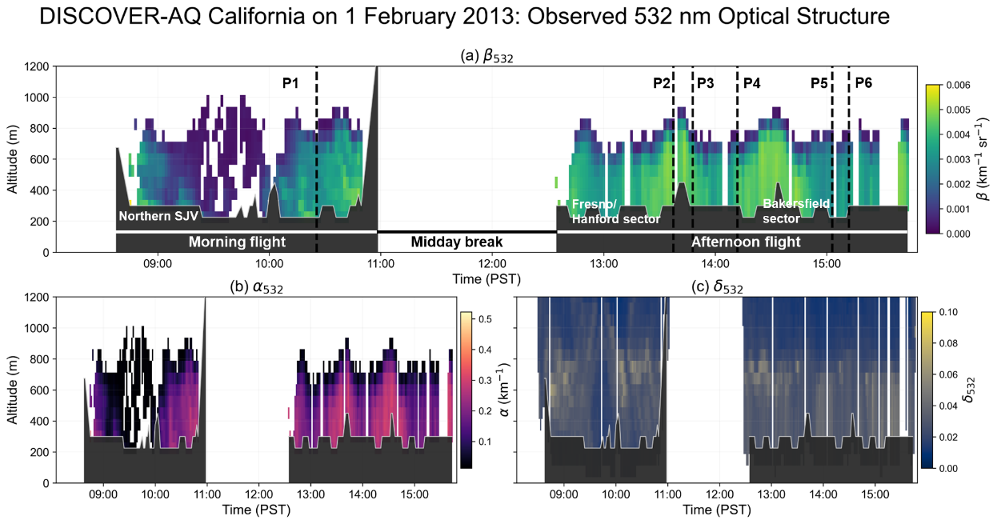
Fig. 2. Observed 532 nm optical structure during the DISCOVER-AQ California flight on 1 February 2013. Panels show (a) the aerosol backscatter coefficient at 532 nm, $β_{532}$, (b) the aerosol extinction coefficient at 532 nm, $α_{532}$, and (c) the linear particle depolarization ratio at 532 nm, $δ_{532}$. The dashed vertical lines P1–P6 indicate the six matched locations used for in-situ profile validation. The morning flight mainly sampled the northern San Joaquin Valley, while the afternoon flight covered the Fresno/Hanford and Bakersfield sectors. Altitude is given relative to mean sea level.

2) Case-based validation using curtain plots and in-situ profiles
To examine how this statistical behavior appears in a realistic two-dimensional observation scene, the DISCOVER-AQ California flight on 1 February 2013 was selected as a representative case for spatiotemporal analysis. This day was selected because it includes both morning and afternoon B-200 science flight segments, covering the regions marked in the figure as Northern SJV, Fresno/Hanford sector, and Bakersfield sector. It also contains a weak elevated aerosol layer, enhanced low-level aerosol loading, regional loading differences, and multiple matched profiles for in-situ validation. According to the NASA HSRL-2 quicklook report for this day, the morning flight used a new flight pattern toward the northern SJV, and the aerosol optical thickness (AOT) showed clear spatial variability during approximately 09:00–11:00 PST (Pacific Standard Time). The afternoon flight followed the standard DISCOVER-AQ pattern. During approximately 13:00–15:30 PST, AOT increased along the flight from the Fresno/Hanford sector toward the Bakersfield sector and reached relatively high values near the Bakersfield-sector sampling period [44]. Therefore, this case is suitable for examining how different retrieval methods respond to realistic regional pollution gradients and vertical structural variability.
Figure 2 shows strong spatiotemporal heterogeneity of the aerosols on 1 February 2013. During the morning flight, a weak elevated aerosol layer appears at approximately 0.4–0.9 km above mean sea level around 09:00–10:00 PST. This layer appears as a weak $β_{532}$ structure in Fig. 2(a), is also weak in $α_{532}$ (Fig. 2(b)), and shows low $δ_{532}$ (Fig. 2(c)). These optical signatures indicate that the layer is not dominated by nonspherical coarse-mode dust or strongly absorbing aerosol but is more consistent with near-spherical fine-mode pollution aerosol, which makes this case an ideal candidate for the comparison/validation test. After 10:00 PST, the low-level aerosol structure becomes more fragmented, with stronger vertical gradients. During the afternoon flight, a more continuous low-level aerosol load is observed over the Fresno/Hanford sector, followed by stronger low-level structures near the Bakersfield sector. This is consistent with the NASA report, which describes enhanced AOT during the afternoon sampling and relatively high AOT near the Bakersfield-related flight segment.
Based on the optical structures shown in Fig. 2, Fig. 3 further compares how LUT (FAST) and UNC interpret the same observation field in terms of aerosol microphysical properties. Both methods capture the main spatiotemporal heterogeneity of the case, including the weak elevated layer in the morning, the enhanced low-level aerosol loading in the afternoon, and the stronger aerosol load near the Bakersfield sector. This result indicates that both methods respond to the major aerosol structures observed by HSRL-2.
However, the two methods decompose the same optical structures into different combinations of microphysical parameters. LUT (FAST) produces locally higher $r_{e}$, $m_{r}$, and $m_{i}$in several regions, and these high values often appear as fragmented patches, as shown in Fig. 3(a), Fig. 3(e), and Fig. 3(g). In contrast, UNC shows smoother changes in loading- and absorption-related variables, with more continuous covariation among $r_{e}$, $SSA_{532}$, $m_{i}$, and $N$, as shown in Fig. 3(b), Fig. 3(d), Fig. 3(h), and Fig. 3(j). These differences should not be interpreted as direct proof that one retrieval is the truth; rather, they need to be assessed jointly with the optical constraints in Fig. 2 and the in-situ profile comparisons at P1–P6.
For the weak (in terms of AOD) elevated layer around 09:00–10:00 PST, Fig. 2 provides a relatively clear external constraint: the layer features weak backscatter and extinction signals and a low depolarization ratio. It is therefore not dominated by nonspherical coarse-mode dust or strongly absorbing aerosol. Under this optical condition, a retrieval that simultaneously produces a large effective radius, high real refractive index, and high imaginary refractive index should be interpreted with caution, because such a parameter combination is not directly supported by strong depolarization, strong extinction, or clear absorption-related optical evidence. In Fig. 3, LUT (FAST) more readily produces such local high-value combinations near this layer, including fragmented high-$r_{e}$ patches in Fig. 3(a), higher $m_{r}$values in Fig. 3(e), enhanced $m_{i}$values in Fig. 3(g), and less continuous variations in $N$in Fig. 3(i). By contrast, UNC shows a weak but continuous enhancement in $N$in Fig. 3(j), only moderate adjustment of $r_{e}$in Fig. 3(b), no obvious enhancement of $m_{i}$in Fig. 3(h), and only small variations in ${SSA}_{532}$under a high-SSA background in Fig. 3(d). Therefore, for this weak-layer case, the UNC response is more consistent with the low-depolarization and weak-loading optical constraints, whereas the local high values in LUT (FAST) more likely reflect parameter compensation in an ill-posed retrieval setting.

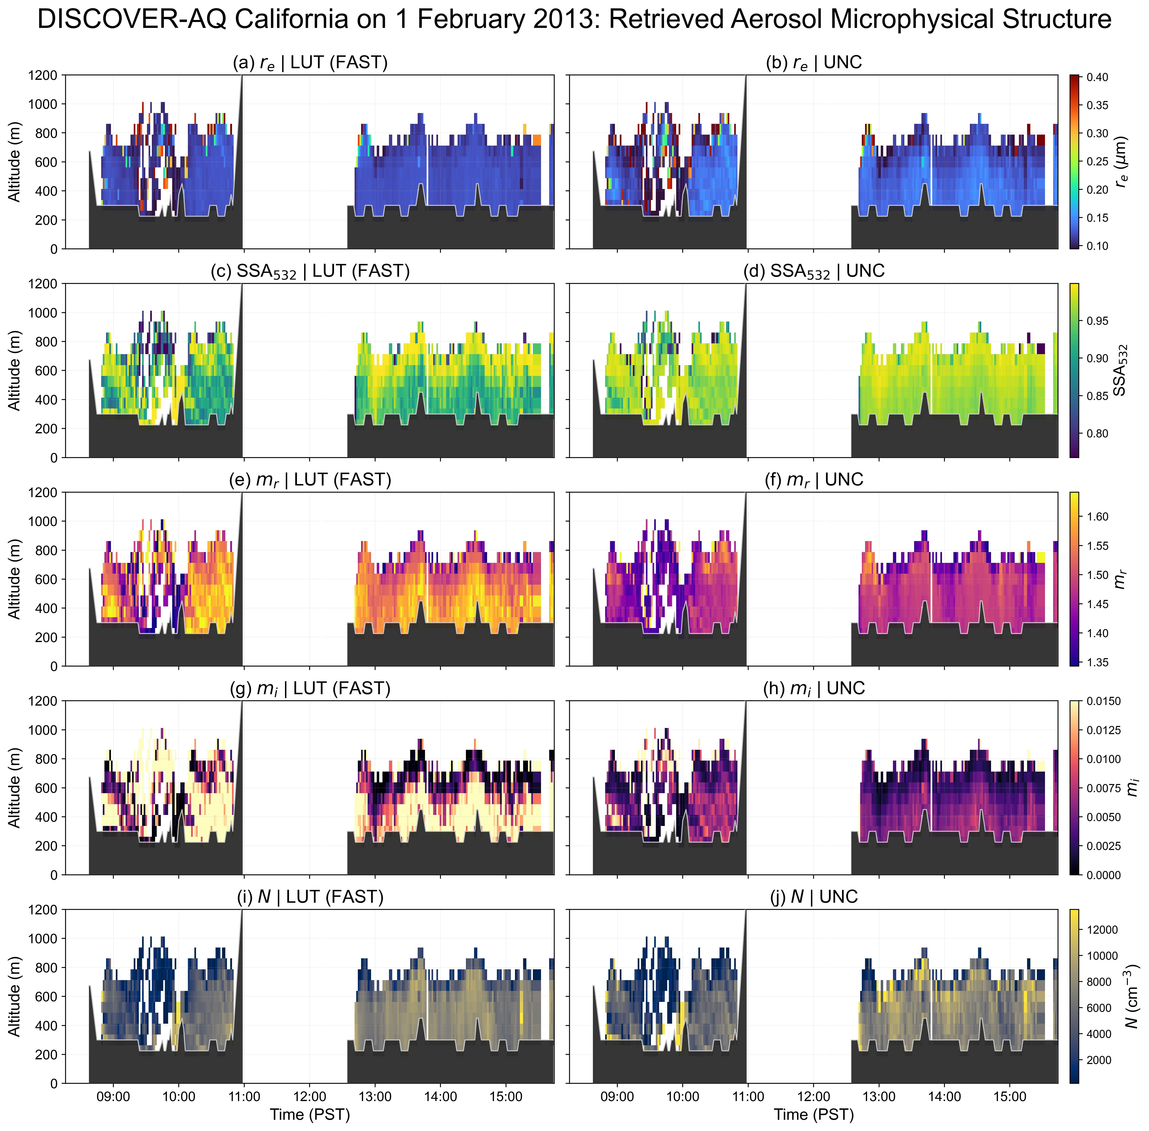
Fig. 3. Retrieved aerosol microphysical structure from LUT (FAST) and UNC on 1 February 2013. Panels show (a, b) effective radius $r_{e}$, (c, d) single-scattering albedo at 532 nm $SSA_{532}$, (e, f) real part of the complex refractive index $m_{r}$, (g, h) imaginary part $m_{i}$, and (i, j) particle number concentration $N$. The left column corresponds to LUT (FAST), and the right column corresponds to UNC. The retrievals are based on HSRL-2 optical inputs with a temporal resolution of 90 s and a vertical resolution of 75 m.

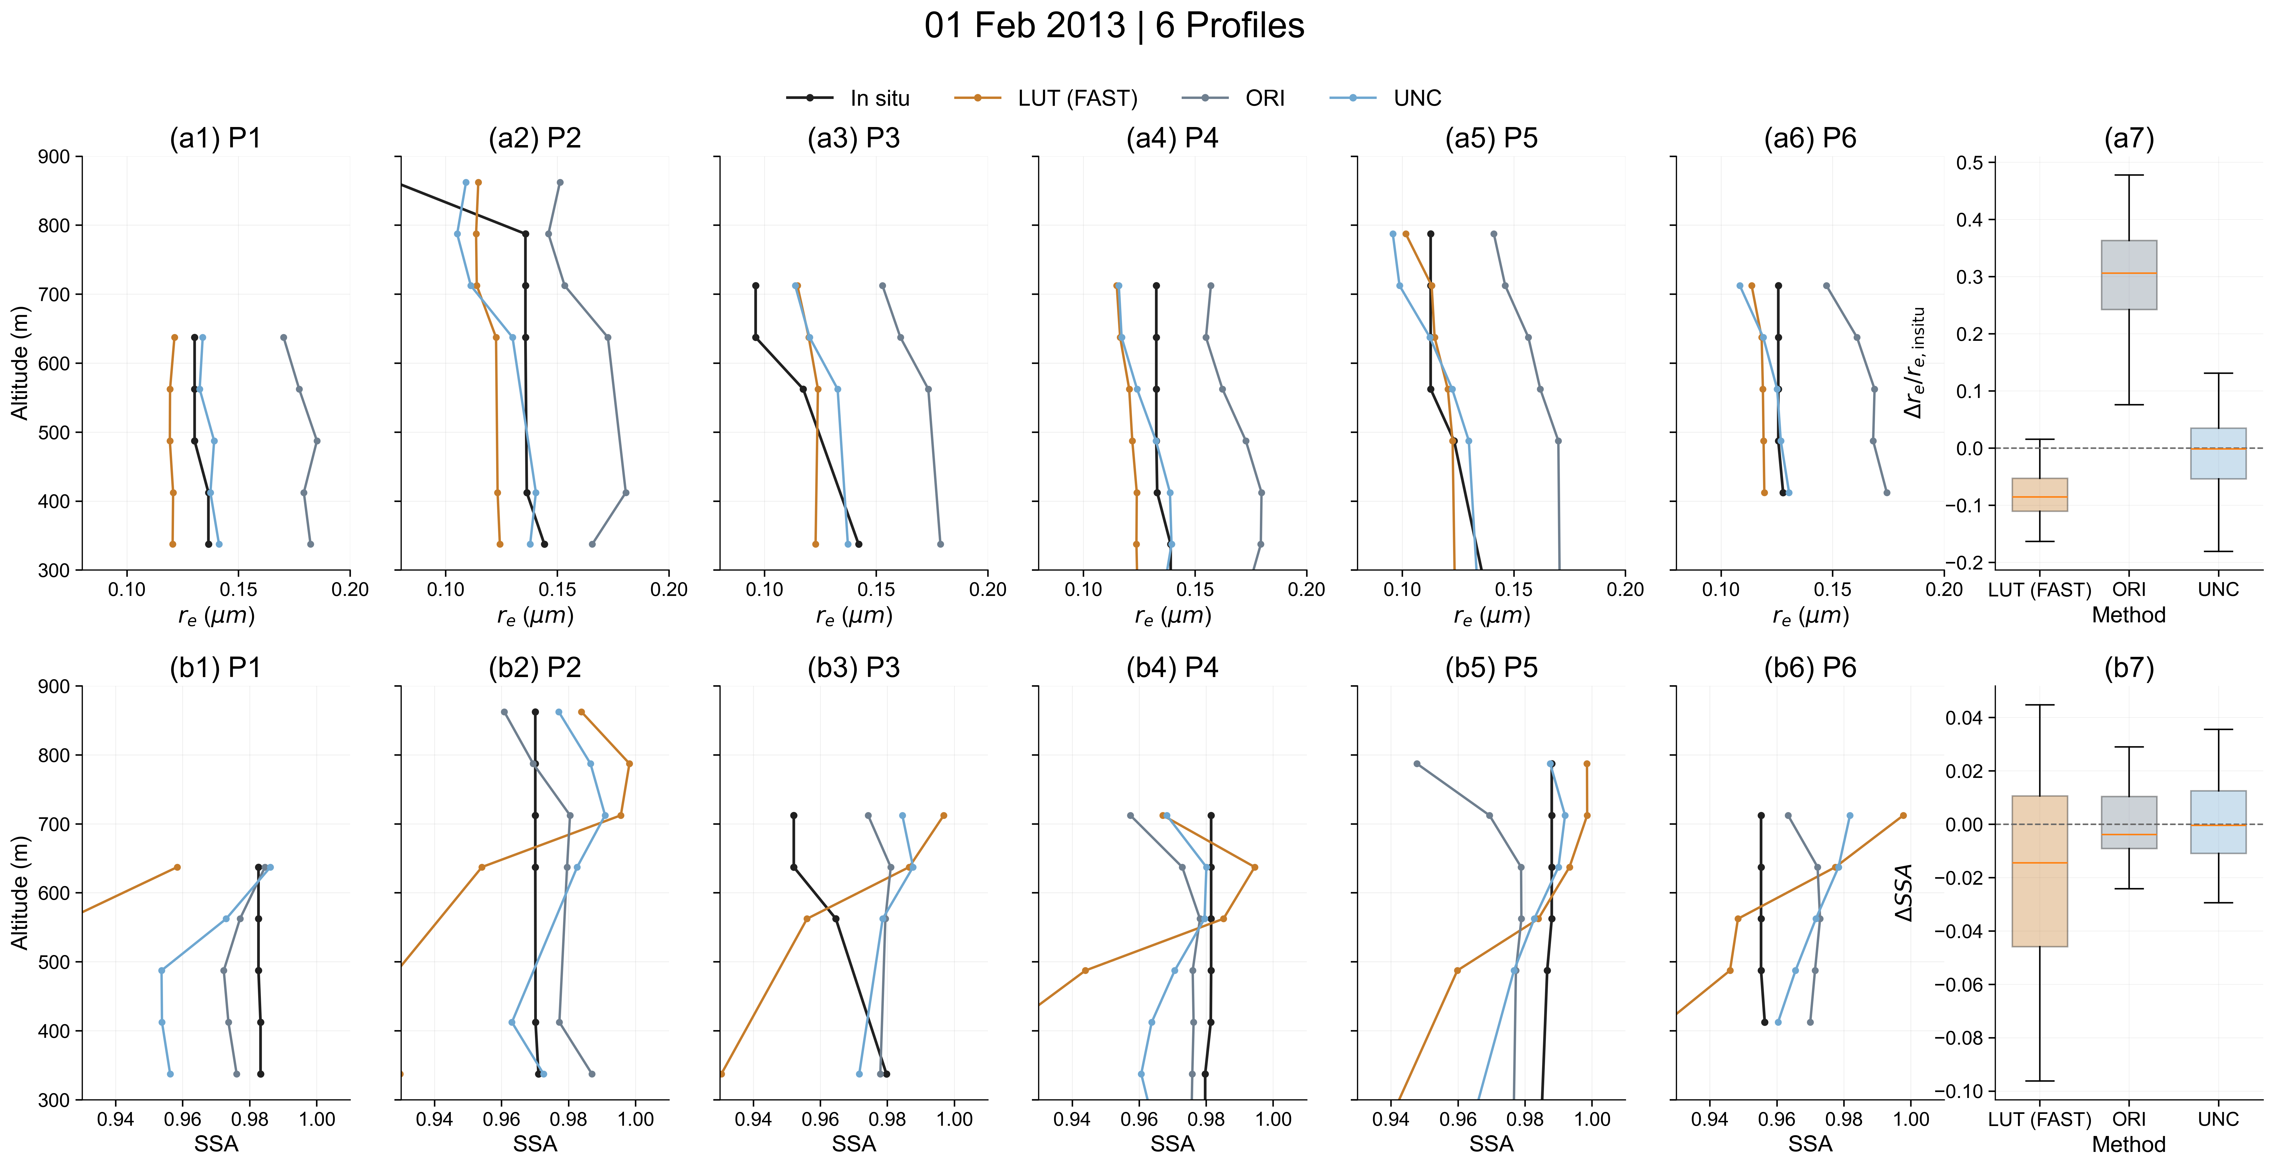
Fig. 4. In-situ validation at six matched profiles on 1 February 2013. P1–P6 correspond to the dashed vertical lines in Figs. 2 and 3. The upper row shows vertical profile comparisons of effective radius $r_{e}$ and the corresponding boxplot of relative bias, while the lower row shows vertical profile comparisons of $SSA_{532}$ and the corresponding boxplot of absolute bias. Black lines denote P-3B in-situ observations, orange lines denote LUT (FAST), gray lines denote the original AecroFormer (ORI), and blue lines denote UNC. The dashed lines indicate the zero-bias reference.

The afternoon segment can be interpreted in the same way. Figures 2(a) and 2(b) show that low-level aerosol loading increases from the Fresno/Hanford sector toward the Bakersfield sector. The NASA report also indicates that AOT increased during the afternoon flight and reached relatively high values near the Bakersfield-sector sampling period. This optical background supports a continuous increase in pollution loading rather than an abrupt change in aerosol type. Correspondingly, UNC shows more continuous variations in $N$, $r_{e}$, $m_{i}$, and $SSA_{532}$, mainly reflecting moderate microphysical adjustments under enhanced aerosol loading. LUT (FAST), however, shows more fragmented high-$r_{e}$, high-$m_{r}$, or high-$m_{i}$ patches in some time–height regions. Because these local high values are not always supported by corresponding strong features in $β_{532}$, $α_{532}$, or $δ_{532}$, they are more likely related to jump-like behavior of lookup-table matching in weakly constrained or multi-solution regions. Thus, the 1 February case does not demonstrate that UNC is closer to the in-situ reference at every comparison level. Rather, it shows that, in a complex but continuous real aerosol field, UNC exhibits stronger consistency among the observed optical structure, retrieved parameter covariation, and spatial continuity. Together with the P1–P6 in-situ profile comparisons, these results support the interpretation that UNC provides a more representative retrieval of the aerosol conditions than LUT (FAST) for this case, although the in-situ observations themselves are not treated as an absolute truth.
The smoother UNC curtain should be interpreted as evidence of a more continuous estimator response, rather than direct verification of greater physical accuracy. Although abrupt retrieval changes caused solely by small observational fluctuations are undesirable within a relatively homogeneous aerosol layer, genuine aerosol-layer boundaries and rapid changes in aerosol state may also produce physically meaningful discontinuities. The curtain smoothness is therefore considered together with, rather than as a substitute for, the pointwise in situ comparisons.
The P1–P6 in-situ profile comparisons provide an additional point-scale reference. For $r_{e}$, LUT (FAST) is close to the in-situ observations at some height levels, but the direction of bias and the vertical variation are not fully stable among different profiles. ORI shows a more evident bias. UNC is not the closest method at every height level, but its overall bias is relatively small and its profile variation is more continuous. For $SSA_{532}$, UNC generally lies between LUT (FAST) and ORI, avoiding the strong negative bias of LUT (FAST) at some heights and the bias tendency of ORI. The boxplots also show that UNC maintains a relatively small bias range for both the relative bias in $r_{e}$ and the absolute bias in $SSA_{532}$, indicating good external consistency for this case.
Because directly applicable pointwise uncertainty estimates for the derived in-situ $r_{e}$and ${SSA}_{532}$are not available, uncertainty bars are not shown in Fig. 4. The comparison is therefore interpreted as an assessment of external consistency under field conditions, rather than as a point-by-point validation against an error-free reference.
It should be noted that discrepancies between the retrievals and the P-3B in-situ observations remain, even for UNC. These differences should not be attributed solely to retrieval errors. On the one hand, aerosol microphysical retrieval from multiwavelength lidar is an ill-posed inverse problem, and the limited 3β+2α optical constraints cannot uniquely determine all microphysical parameters. On the other hand, the field comparison is also affected by imperfect temporal and spatial collocation between the B-200 and P-3B aircraft, horizontal drift, humidity correction of the in-situ observations, the representativeness of in-situ sampling, and strong vertical gradients. In addition, the two observing systems involve different averaging characteristics: HSRL-2 represents an optical-volume average within each time–height bin, whereas the P-3B in-situ reference is obtained from measurements sampled along the aircraft flight path and then averaged within the corresponding altitude interval. In shallow pollution layers or near the top of the boundary layer, these differences in sampling geometry and averaging scale may cause HSRL-2 and P-3B to represent slightly different aerosol volumes even when the matchup criteria are satisfied. Therefore, the results in this section should be interpreted as an assessment of overall external consistency under field conditions, rather than as a point-by-point validation against an error-free reference.
Overall, the DISCOVER-AQ California validation shows that the proposed training framework is not only effective under controlled synthetic data conditions, but also improves the physical usefulness and overall consistency of the retrieval results in real airborne observations. The full-sample statistics show that the improved deep-learning configurations clearly outperform ORI for both $r_{e}$ and $SSA_{532}$, and outperform LUT (FAST) overall for $SSA_{532}$. The 1 February case further shows that, in a real observation scene with weak (optically and/or geometrically thin) aerosol layers, enhanced regional aerosol loading, and multiple matched in-situ profiles, UNC provides a better balance among optical constraints, parameter covariation, and vertical continuity. For an ill-posed retrieval problem, this point is important: a successful estimator should not only reduce average error but also avoid abruptly changing or falsely compensating solutions in weakly constrained regions of data space. Compared with LUT (FAST), UNC maintains competitive accuracy and shows more stable profile behavior and more physically interpretable parameter covariation.
However, external validation mainly demonstrates performance-level differences and does not, by itself, explain why deep learning behaves more stably under ill-posed conditions, nor under which parameter and perturbation regimes this advantage holds. Therefore, Section IV turns to an estimator-level mechanistic analysis based on local perturbation responses.

IV. Perturbation and Noise Analyses: Advantages, Boundaries, and Limitations of Deep Learning in Ill-Posed Retrieval Problems
A central incremental contribution of the present study is to move beyond the performance-oriented comparison adopted in the original AecroFormer work and examine the behavior of the retrieval methods at the estimator level. The purpose of this section is not to argue that deep learning removes the intrinsic ill-posedness of the inverse problem, but to investigate how learned continuous estimation and discrete LUT-based candidate matching respond differently under the same limited optical information and observational perturbations.
Although the results in Section 3 show that the deep learning configurations generally outperform the traditional lookup-table method in overall accuracy, this advantage does not imply any increase in the amount of observational information itself. For the aerosol microphysical retrieval problem from multiwavelength lidar considered here, the inverse problem remains strongly nonlinear, highly coupled, and locally non-identifiable. As a result, small perturbations in observation space can still be substantially amplified in parameter space. Therefore, the essential difference between the different methods does not lie in whether they obtain “more information,” but in how they construct parameter estimates under the same observational uncertainty.
From this perspective, both LUT and deep learning can be regarded as different implementations of estimators constructed from observations. The former is closer to matching and switching over a discrete candidate set [19], whereas the latter is closer to a statistical compromise over a continuous conditional distribution. Consequently, when noise increases and local uncertainty broadens, the two types of estimators face the same observational constraints, but may exhibit markedly different degradation trajectories, bias evolution patterns, and local responses to perturbations. Following this unified perspective, this section analyzes the source of the advantage of deep learning in ill-posed retrieval, as well as its scope of applicability and limitations, from three levels: statistical degradation, conditional-distribution-based mechanism, and local geometric response to perturbations.

A. Macroscopic statistical degradation trajectories
To examine how different methods degrade as noise increases, we first compare the behavior of the LUT and UNC estimators under different error conditions from a statistical perspective. Following the evaluation strategy in Section III, mean error (ME) and mean relative error (MRE) are used here to characterize the systematic bias of the estimators and its evolution with noise level; the corresponding definitions are given in Eqs. (23) and (25). Unlike Section III, which focuses on comparisons under a unified evaluation protocol, the purpose here is to determine whether the bias trajectory remains smooth as noise increases, whether bias reversal occurs, and whether the uncertainty band expands rapidly.
TABLE V. STATISTICAL DEGRADATION UNDER INCREASING NOISE
Condition | Method | $m_{r}$ME | ${m }_{i}$ME | $r_{e}$MRE (%) | $N$MRE (%) | $σ$ MRE (%)
clean | LUT | -0.003 | -0.0002 | 0.678 | -1.115 | 0.077
clean | UNC | -0.007 | -0.0004 | -0.298 | 7.267 | 0.172
noisy | LUT | 0.016 | 0.0029 | -1.035 | 52.233 | -0.605
noisy | UNC | -0.004 | 0.0003 | 0.726 | 30.460 | 0.090

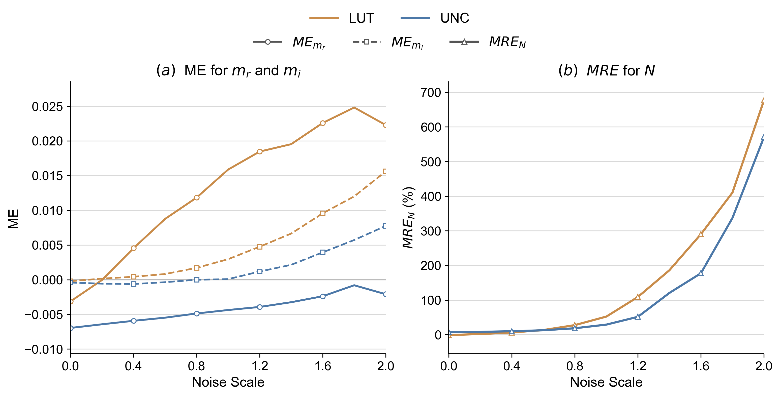

Fig. 5. Statistical degradation curves of LUT and UNC under increasing noise intensity. In panel (a), the mean errors (ME) of $m_{r}$ and $m_{i}$ are shown as functions of the noise scaling factor; solid lines with circle markers denote $m_{r}$, and dashed lines with square markers denote $m_{i}$. In panel (b), the mean relative error (MRE) of particle number concentration $N$ is shown as a function of the noise scaling factor. Orange denotes LUT and blue denotes UNC. This figure is used to illustrate the bias evolution trajectories and degradation differences of the two estimators as noise increases continuously.

Table V gives the statistics of the refractive index, effective radius, particle number concentration, and distribution width parameter under two representative conditions, namely clean and noisy, while Fig. 5 further shows how the bias trajectories of the key parameters evolve as the noise level increases continuously. For clarity, $r_{e}$and $σ$are not included in this figure; their statistics are reported in Table V and discussed in the text, as their bias variations are much smaller than the amplification observed for $N$. It should be emphasized that the focus of this subsection is not a particular number at a single point, but rather the overall degradation pattern shown by different methods as noise increases.
Overall, the advantage of deep learning is not expressed uniformly across all parameters but depends strongly on the ill-posedness associated with each variable. Different parameters have different sensitivities to noise and therefore exhibit different degradation modes. In addition, the two methods differ in how they form point estimates under the same observational uncertainty, which further leads to clearly different bias trajectories.
For $m_{r}$, LUT has a mean bias of -0.003 under the clean condition, which is slightly better than -0.007 for UNC. Under the noisy condition, however, the mean bias of LUT changes sign and increases to +0.016, whereas UNC changes only from -0.007 to -0.004 and remains within a relatively small negative-bias range. This indicates that $m_{r}$ is better constrained by the optical observations than strongly ill-posed quantities such as $N$, but it can still be affected by noise-induced bias drift. The main advantage of UNC is that its bias trajectory is much flatter and remains in a small negative range, whereas the LUT trajectory increases more steeply with noise and changes from negative to positive bias.
The degradation pattern of $m_{i}$ differs from that of $m_{r}$. The bias magnitude remains small under clean and moderate-noise conditions, and a clear increase appears only at higher noise levels. In Fig. 3(a), the $m_{i}$trajectories are nearly flat at low noise scales and become steeper only when the perturbation is large. The mean bias of LUT changes from -0.0002 to +0.0029, whereas UNC changes from -0.0004 to +0.0003. This indicates that the degradation of $m_{i}$ is delayed relative to $m_{r}$, and that UNC still provides a smoother bias trajectory under increasing noise.
Compared with the refractive index parameters, $N$ exhibits a more typical strongly ill-posed degradation pattern. The relative error of LUT increases from -1.12% under the clean condition to 52.23% under the noisy condition, whereas the corresponding value for UNC increases from 7.27% to 30.46%. Although both methods deteriorate substantially as noise increases, the growth rate is clearly smaller for UNC. Under the noisy condition, the relative error of UNC for $N$ is about 58.3% of that of LUT. This indicates that, for a strongly ill-posed parameter such as $N$, deep learning does not remove the ill-posedness itself but significantly delays the onset of instability. In other words, its advantage is mainly reflected in suppressing error explosion rather than recovering a uniquely correct value.
The effective radius $r_{e}$ and the width parameter $σ$ exhibit another type of degradation behavior that is more characteristic of statistical rebalancing. For $r_{e}$, the MRE of LUT changes from 0.68% under the clean condition to -1.03% under the noisy condition, whereas UNC changes from -0.30% to 0.73%. Both estimators undergo a sign change as noise increases, but the bias magnitude remains relatively small overall. For $σ$, the MRE of LUT changes from 0.08% to -0.61%, whereas UNC changes from 0.17% to 0.09%, showing only a small fluctuation. This suggests that, for size-distribution-related quantities that are influenced jointly by several microphysical parameters, noise-induced changes are more strongly reflected in a rebalancing of the estimate location than in a simple monotonic deterioration.
It should also be noted that not all parameters necessarily follow the simple rule that “larger noise leads to larger error.” For example, in Table V, the MRE of LUT for $r_{e}$ changes from 0.68% under the clean condition to -1.03% under the noisy condition. Such an apparent change more likely reflects a situation in which the estimate is pushed toward a more central statistical location by noise, rather than that noise itself provides additional information. Therefore, for parameters of this kind, conclusions should not be drawn from a few isolated error values alone. Instead, continuous noise curves, median trends, and expansion of dispersion should be considered together.
Taken together, Table V and Fig. 3 show that different parameters exhibit clearly different degradation modes [13,14]. The behavior of $m_{r}$ is mainly characterized by systematic drift under increasing noise, $m_{i}$ is more strongly characterized by smooth statistical compromise, and $N$ shows a typical strongly ill-posed amplification process. By contrast, the variation of $r_{e}$ and $σ$ is closer to local statistical redistribution. Correspondingly, LUT is more likely to exhibit sign reversal, local jumps, and rapid uncertainty expansion as noise increases, whereas UNC generally shows smoother bias trajectories, slower error growth, and milder uncertainty expansion. This indicates that the advantage of deep learning is not a uniform “better in every respect,” but rather depends closely on the local identifiability of each parameter and is mainly expressed through smoothing and delaying the degradation process.

B. Estimation mechanism under local conditional distributions
Here, the conditional distribution is considered from the inverse-retrieval perspective, namely $p(θ∣y)$: for a given optical observation vector $y$within its uncertainty range, multiple microphysical parameter vectors may remain physically compatible with the observation. This differs from the forward measurement distribution $p(y∣θ)$, which describes possible optical observations for a fixed microphysical state. The two are related through the forward model and the assumed error structure, but they are not interchangeable in an ill-posed inverse problem.
This empirical conditional-distribution view can be regarded as a statistical counterpart of the low-misfit solution valleys often discussed in deterministic inverse problems. It describes how multiple microphysical parameter states remain compatible with the same optical observation within the uncertainty bounds.
The previous subsection shows that, under the same increase in noise, different parameters exhibit different degradation patterns, and the same parameter can also show markedly different bias trajectories under different estimators. This means that the difference between the two methods lies not only in the error magnitude, but also in the mechanism by which they produce point estimates under the same observational uncertainty. To further explain this difference, we now turn to the conditional distribution perspective and examine the concentration region of possible parameter values under a given observation, as well as the relative positions of different estimators within that distribution.
Following the unified notation used above, the essence of retrieval for a given observation $y$ is to construct an estimator $\hat{θ}\left(y\right)$. When noise is small, the local conditional distribution is usually concentrated. As noise increases, however, the same observation neighborhood may correspond to a larger set of candidate parameter states, so that the conditional distribution broadens and may further exhibit skewness or even local multimodality. Based on this idea, Fig. 6 does not directly display the statistical distribution of the full sample set. Instead, it centers on a selected reference observation $y_{0}$ and its perturbed observations, uses a kernel-weighted screening of neighboring samples in the sample library according to their distance in observation space, and then constructs one-dimensional empirical conditional densities for each parameter. Therefore, the figure does not show a strict Bayesian posterior distribution, but rather an empirical approximation of the parameter conditional distribution under local observational constraints. Its purpose is to diagnose local identifiability and to compare the positions of the true value, the LUT estimate, and the UNC estimate with respect to the high-density part of the local empirical conditional density. Here, the “high-density part” refers to the region around the dominant mode of the kernel-weighted empirical density, rather than to a formally defined Bayesian credible interval. The relevant kernel bandwidth, neighborhood scale, effective sample size, and sensitivity settings are given in Appendix B.
Within this empirical conditional distribution framework, the mathematical mechanisms of the two methods can be stated more clearly. For LUT, the essence is to search for the candidate in the discrete parameter library ΘLUTh that best matches the current observation:

θLUT(y)=arg⁡min⁡θ∈ΘLUTh∥f(θ)-y∥2W2. | (26)

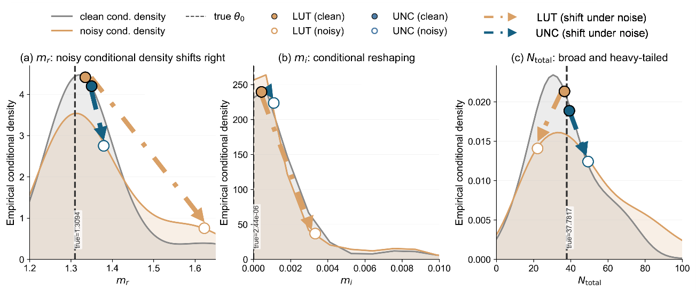
Fig. 6. Local empirical conditional densities of $m_{r}$, $m_{i}$, and $N$ under clean and noisy conditions. Panels (a)–(c) correspond to $m_{r}$, $m_{i}$, and $N$, respectively. The gray and orange curves denote the one-dimensional empirical conditional densities constructed from the local observation neighborhood under the clean and noisy conditions, and the black dashed line denotes the true value $θ_{0}$. Filled and hollow circles indicate the LUT and UNC point estimates under the clean and noisy conditions, respectively. Arrows denote the migration direction of the estimates as noise increases. The figure is used to illustrate how different estimators change their relative positions with respect to the main probability mass region as the local conditional distribution broadens.

Therefore, the output of LUT is influenced by the partition of the finite discrete candidate set. When the observation remains within the region associated with the same candidate, the retrieved parameter may stay nearly unchanged. Once the observation crosses the boundary between neighboring candidate regions, however, the selected grid point may change abruptly. This piecewise behavior can in principle be reduced by using a finer LUT resolution. In practice, however, the dimensionality of the aerosol microphysical parameter space makes exhaustive grid refinement computationally expensive and storage-demanding, and therefore finite-resolution effects may still appear in weakly constrained or multi-solution regions. More importantly for experimental applications, real lidar observations are affected by continuous and structured measurement errors, including channel-dependent noise, calibration uncertainty, and correlated perturbations, which cannot be fully represented by a finite set of discrete lookup-table candidates. Thus, the response of LUT to observational perturbations is often characterized by locally piecewise or switching-like behavior, rather than by a fully smooth estimator response.
By contrast, for a continuous regression model trained under the dominance of squared loss, the optimal solution tends statistically toward the conditional expectation:
$$g^{*}(y)=E[θ∣y].$$ | (27)
This does not mean that the network explicitly computes an analytic posterior mean. Rather, under a continuous regression framework dominated by squared error, its output can be interpreted, in a statistical sense, as a mean-like compromise over the local conditional distribution. Therefore, when the local conditional distribution broadens from concentrated to dispersed, the output of UNC usually remains near the region supported by the main probability mass and is less likely to exhibit abrupt switching induced by discrete candidate replacement.
This difference is illustrated intuitively in Fig. 6(a)–(c). For $m_{r}$, Fig. 6(a) shows that under the clean condition, the conditional distribution is relatively concentrated, and the true value, the LUT estimate, and the UNC estimate are all located near the main peak. Under the noisy condition, however, the distribution broadens significantly and shifts rightward. In this case, the LUT estimate is more likely to move away from the main high-density region, whereas UNC remains near the region supported by the dominant probability mass. This is consistent with the result in Section IV.A that the bias of $m_{r}$ changes from negative to positive for LUT while UNC maintains a small negative bias. This suggests that $m_{r}$ is better constrained by the optical observations than strongly ill-posed quantities such as $N$, but its estimate can still drift systematically when noise increases. In this case, the advantage of UNC is that its bias changes more slowly and remains in a small negative range, whereas the LUT estimate shows a steeper shift and changes from negative to positive bias.
For $m_{i}$, Fig. 6(b) shows that the conditional distribution remains concentrated in a narrow range close to zero. The main difference between the clean and noisy conditions is not a global shift of the distribution, but rather a reshaping of its form and a local broadening. Under such circumstances, the difference between the two methods is no longer primarily expressed as a clear sign reversal, but rather as a difference in how stable the estimate remains relative to the high-density region. Under noise, LUT is more likely to move toward the edge region, whereas UNC changes more continuously. This corresponds to the smoother bias evolution observed in Section IV.A, rather than to a simple absolute-error advantage.
The right-skewed tails in the empirical densities of $m_{r}$ and $m_{i}$ further indicate that, even when the dominant probability mass is concentrated near the true value, a set of higher-refractive-index solutions can still remain optically compatible with the observation within the local uncertainty range. This tail behavior is consistent with the existence of low-misfit solution valleys in ill-posed microphysical retrieval, where changes in the refractive index can be partially compensated by changes in the size-distribution parameters.
By contrast, the conditional distribution of $N$ in Fig. 6(c) exhibits a more typical strongly ill-posed structure. Even under the clean condition, its distribution is already much broader than that of the refractive index parameters. After noise is added, it broadens further and becomes more skewed with a longer tail. This means that, for $N$, even a small perturbation in observation space may correspond to a set of candidate parameter states that differ substantially from one another. Under such conditions, LUT is more likely to jump toward a discrete candidate far from the central region, thereby exhibiting a rapid increase in error. UNC is also affected by the broadening of the distribution, but its output remains more strongly concentrated near the main probability mass region. Therefore, for a strongly ill-posed parameter of this kind, the advantage of deep learning lies primarily in delaying instability, rather than in eliminating the ill-posedness itself.
Thus, what Fig. 6(a)–(c) reveals is not a simple comparison of “which estimate is closer to a single peak,” but rather the different response modes of the two estimators when faced with the broadening of the same local conditional distribution. LUT is more strongly governed by discrete candidate switching, whereas UNC is more inclined to produce a continuous statistical compromise located near the region supported by the main probability mass. For this reason, the advantage of deep learning lies not in increasing observational information, but in producing more continuous local responses under ill-posed conditions. This also lays the foundation for the next subsection, where the response geometry of the two estimators is visualized directly on a local perturbation plane.

C. Geometric response on the observation perturbation plane
The previous two subsections have shown that, under the same increase in noise, UNC tends to exhibit smoother bias trajectories and a slower degradation rate. The purpose of this subsection is therefore not to prove additionally that UNC is more robust to every possible perturbation. Rather, the goal is to explain directly from observation space why such smaller deviations arise in the local perturbation neighborhood considered here. One immediate reason is that the estimators have different response shapes to local observational variations. Accordingly, this subsection no longer examines the parameter distribution under fixed observations. Instead, it directly studies how the estimator $\hat{θ}\left(y\right)$ varies when the observation y is continuously perturbed within a local neighborhood, that is, its local geometric response.
To this end, $m_{r}$is selected as a representative parameter, and the local response surfaces given by different methods are visualized on a two-dimensional perturbation plane. This plane should be understood as a representative local slice of the five-dimensional observation space, rather than as an exhaustive description of all possible perturbation directions. Similar response surfaces could in principle be constructed for other pairs of optical channels and other retrieved parameters, but such a full analysis would be difficult to present and interpret in the main text. Specifically, with the reference observation $y_{0}$ from Section IV.B as the center, relative perturbations are applied only to two key optical quantities, $β_{1064}$and $α_{532}$. A local grid is therefore constructed along the directions $Δβ_{1064}/β_{1064,0}$and $Δα_{532}/α_{532,0}$, where the subscript 0 denotes the corresponding value in the reference observation $y_{0}$. The remaining observational components are kept at the reference state or synchronized according to the prescribed rule.
For each perturbed observation point $y_{0}+δy$ on this plane, the LUT and UNC estimators are evaluated separately to obtain the corresponding predicted value of $m_{r}$, and the signed relative error with respect to the truth is then constructed. Thus, what is shown in the figure is not a distribution of parameter samples, but rather the geometric projection of the mapping from “observation perturbation” to “parameter estimate” in a local observation neighborhood.
In this sense, Fig. 7 can be viewed as a geometric complement to the mechanism of “discrete matching versus continuous statistical compromise” discussed in Section IV.B. If an estimator changes continuously under local perturbations, its response on the two-dimensional perturbation plane will generally appear as a smooth and traceable surface. By contrast, if it is highly sensitive to small perturbations and involves discrete switching, it is more likely to exhibit steps, folded boundaries, and local jumps.
As shown in Fig. 7, within the same perturbation range, the $m_{r}$ surface corresponding to UNC is overall much smoother and varies continuously and progressively with the observations. By contrast, the LUT surface exhibits more pronounced segmented plateaus, folded boundaries, and local discontinuities. The error heatmaps above further provide quantitative evidence. Without additional shift, the Mean RE and Mean |RE| of UNC are +1.35% and 1.35%, respectively, whereas those of LUT reach +3.35% and 5.32%, which are about 2.48 and 3.94 times those of UNC. When the perturbation plane is additionally shifted along the $α_{532}$ direction, the Mean RE and Mean |RE| of UNC are +3.11% and 3.12%, whereas LUT increases to +5.67% and 6.38%, corresponding to about 1.82 and 2.04 times those of UNC. When the perturbation plane is additionally shifted along the $β_{1064}$ direction, the Mean RE of UNC is nearly unbiased at -0.09%, and Mean |RE| is 0.82%, whereas LUT gives -0.52% and 4.80%, respectively, with an average absolute relative error about 5.85 times that of UNC. These results indicate that the advantage of UNC is reflected not only in a smoother response surface, but also in a more uniform error field and a more concentrated low-error region, whereas LUT is more likely to form high-error bands near switching boundaries and to let them expand with perturbation.

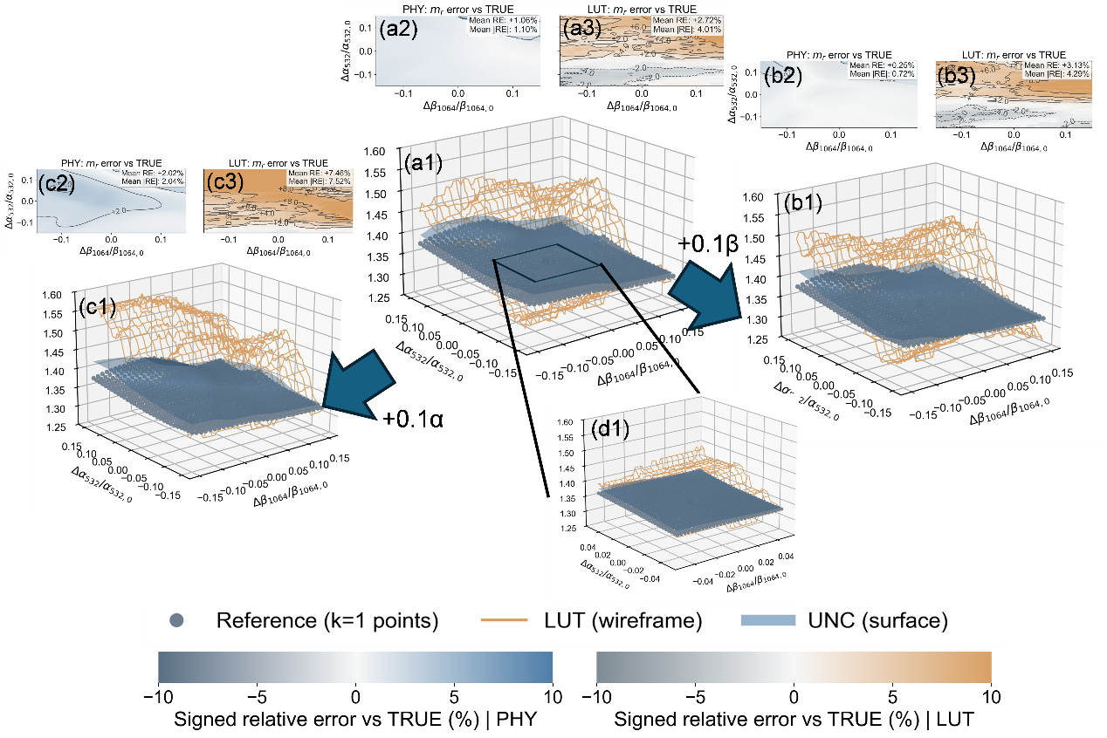
Fig. 7. Comparison of the $m_{r}$response surfaces on the original and additionally shifted local perturbation planes. Panel (a1) shows the $m_{r}$response surface on the original two-dimensional local perturbation plane defined by $Δβ_{1064}/β_{1064,0}$and $Δα_{532}/α_{532,0}$. The orange wireframe denotes LUT, the blue surface denotes UNC, and the gray-blue dots denote the local reference samples. Panels (a2) and (a3) show the signed relative error heatmaps of UNC and LUT with respect to the true value of the selected reference sample. Panels (b1)–(b3) correspond to the results under an additional shift along the $β_{1064}$direction, and panels (c1)–(c3) correspond to those under an additional shift along the $α_{532}$direction. Panel (d1) gives a zoomed-in view of the central region. The mean relative error (Mean RE) and mean absolute relative error (Mean $∣RE∣$) are annotated in each local region to compare the response continuity and error distribution characteristics of the two estimators under local perturbations. The perturbation axes are normalized by the corresponding values in the reference observation $y_{0}$; for example, $β_{1064,0}$and $α_{532,0}$denote the reference values of $β_{1064}$and $α_{532}$, respectively.

This difference is consistent with the results of the previous two subsections. In Section IV.A, $m_{r}$ under LUT shows a negative-to-positive bias reversal and faster error expansion. In Section IV.B, its empirical conditional density under the noisy condition broadens substantially and shifts rightward, making the LUT estimate more likely to jump into the right tail region, while UNC remains near the main probability mass region. Fig. 7 further reveals the local source of this phenomenon from the point of view of the observation space. The LUT response surface is assembled from multiple segmented regions; therefore, once a perturbation path crosses the boundary between them, the output may jump abruptly. By contrast, the UNC response surface is closer to a locally continuous surface; therefore, even when there is an overall shift, its variation trajectory remains comparatively smooth. Accordingly, the advantage of deep learning here does not lie in “creating new physical laws” or “obtaining more observational information,” but in exhibiting fewer abrupt local responses caused by discrete candidate switching within the local observation neighborhood considered here, thereby providing a smoother and more stable point estimate for ill-posed retrieval.
This behavior has practical relevance for atmospheric remote-sensing retrieval. Within a relatively homogeneous aerosol layer and in the absence of evidence for a genuine regime transition, small and continuous variations in the optical observations should not be unnecessarily amplified into abrupt changes in the retrieved microphysical parameters. Such jumps may arise from discrete candidate switching and can complicate time–height statistics and subsequent interpretation. A locally continuous estimator response is therefore desirable as a measure of numerical stability. However, smoothness alone does not establish physical accuracy: it may also arise from regularization or conditional averaging, and excessive smoothing could obscure genuine aerosol boundaries or rapid microphysical changes. The local-response analysis must therefore be interpreted jointly with synthetic truth, in situ comparisons, and observation-space consistency.
It should be emphasized that the statement “the local response surface is smoother” is valid only for the current reference sample and perturbation neighborhood and should not be interpreted as a comprehensive robustness guarantee for all out-of-distribution samples, worst-case perturbations, or systematic bias scenarios. To avoid overgeneralization, Appendix C further provides lightweight sensitivity tests under several structured perturbations. Their results are consistent with the conclusion in the main text: under typical structured perturbations, UNC exhibits fewer locally abrupt responses than LUT.

V. Conclusion and Discussion
This study addressed aerosol microphysical retrieval from multiwavelength lidar as a representative ill-posed inverse problem. Building on AecroFormer, we developed a physics-informed learning framework that combines normalized optical input representation, observation-space physical consistency constraints, dynamic non-gridded sampling generation, heteroscedastic uncertainty modeling, and physically guided data augmentation. The goal was not to increase the amount of observational information, but to construct a more stable estimator under the same 3β+2α optical constraints.
The practical relevance of the present 3β+2α configuration should also be emphasized. This configuration, consisting of three particle backscatter coefficients and two particle extinction coefficients, is not only a theoretical test case but also closely related to the measurement capabilities of several advanced multiwavelength lidar systems, including CMA-operated CARLNET Raman lidar systems, many EARLINET/ACTRIS Raman lidar stations (https://www.earlinet.eu/), and the NASA Langley airborne HSRL-2 system (https://airbornescience.nasa.gov/instrument/High_Spectral_Resolution_Lidar_2). Therefore, there is a clear need for retrieval schemes that can robustly convert lidar-derived aerosol optical products into physically meaningful aerosol microphysical parameters under real observational conditions.
The synthetic ablation experiments showed that the reconstructed training framework improves retrieval performance in a progressive and physically interpretable manner. The unified baseline already reduced the errors of the refractive-index and size-related variables compared with the original AecroFormer. The physical consistency loss improved selected parameter-bias structures and reduced the overall observation-space reconstruction error for the DISCOVER-AQ observations, although it did not uniformly improve every microphysical metric or optical channel. Its role is therefore interpreted primarily as observation-space regularization within the adopted Lorenz–Mie forward model. The uncertainty-enabled configuration maintained competitive point-estimate accuracy, and the strong degradation observed after removing data augmentation confirmed the importance of physically guided perturbation design for robustness. These results indicate that the improvement in retrieval accuracy, stability, and credibility does not arise from a single module, but from the combined effect of better input representation, more continuous sampling, physical consistency, and structured error modeling. A CPU-based timing benchmark further showed that the uncertainty-aware configuration reduced the retrieval time from 1.94 s to 0.022 ms per range-resolved sample compared with FAST, corresponding to an acceleration of approximately $8.8×{10}^{4}$ for the same microphysical inversion task.
External validation with NASA DISCOVER-AQ California in situ observations further supported the applicability of the framework under real observational conditions. Based on 30 valid matched profiles from 8 observation days and 14 B-200 flight segments, the improved deep learning configurations reduced the $r_{e}$ MARE from 24.90% for ORI to approximately 13.6%–14.5%, reaching a level comparable to LUT (FAST). The improvement was more pronounced for $SSA_{532}$, where the MAE was reduced from 0.0370 for LUT (FAST) to 0.0171–0.0211 for the improved configurations. This near-halving of the $SSA_{532}$discrepancy is particularly encouraging, although it should be further corroborated with additional field campaigns and independent validation datasets. The 1 February 2013 case also showed that UNC produced more continuous and physically coherent microphysical structures under realistic time–height aerosol variability, while LUT (FAST) remained locally competitive for some particle-size-related quantities. These results characterize estimator stability rather than independently verified physical truth; retrieval accuracy must be assessed separately using synthetic truth and collocated in situ observations.
The present external validation remains limited to 30 matched profiles collected during 8 DISCOVER-AQ observation days and 14 B-200 flight segments. The available sample size does not support reliable simultaneous stratification by date, aerosol loading, relative humidity, altitude, and aerosol type. Broader validation will require additional independent campaigns with collocated multiwavelength lidar and in situ microphysical observations, together with extensions of the forward model for coarse-mode, multimodal, and nonspherical aerosol populations. Future work will extend the evaluation to independent airborne campaigns, such as ORACLES for biomass-burning aerosol and, after appropriate forward-model extensions, ACTIVATE for more complex marine and mixed aerosol conditions.
The perturbation and noise analyses clarified why deep learning can be advantageous in this ill-posed setting. Different parameters showed different degradation modes: $m_{r}$ was mainly affected by noise-induced bias drift, $m_{i}$ by changes in the local statistical compromise, and $N$ by strong ill-posed amplification. The conditional-distribution and local perturbation-plane analyses further showed that LUT is more sensitive to discrete candidate switching, whereas UNC tends to produce smoother local responses near the dominant compatible solution region. Therefore, the advantage of deep learning should be understood as showing a smoother estimator behavior, slower degradation, and fewer abrupt local responses, rather than as a fundamental relaxation of the information limit imposed by the observations.
This interpretation of the results also defines the boundary of the proposed framework. The conclusions drawn in this study apply specifically to the fine-mode-dominated unimodal retrieval setting defined in Section II.A and should not be generalized directly to coarse-mode-dominated or strongly multimodal aerosol populations. Ill-posedness cannot be eliminated simply by increasing model complexity, and no learning method can recover information that is absent from the optical observations. Therefore, the role of deep learning in this context is not to remove the fundamental non-uniqueness of the inverse problem, but to construct a more stable estimator by integrating representative uncertainty structures and physical constraints into the learning process. Reliable calibration and high-quality optical inputs remain essential. If one or more lidar channels contain unnoticed calibration biases or processing-related offsets, a learning-based estimator may still generate a smooth solution that is internally consistent with biased observations but physically inaccurate. Future work should therefore examine calibration-bias sensitivity, channel-dependent systematic errors, and out-of-distribution optical inputs, and should combine retrieval models with independent calibration checks or consistency diagnostics.
More broadly, this work suggests that AI-based retrieval and observing-system development should be viewed as complementary. Deep learning can improve how existing observational information is used, but the upper limit of recoverable microphysical information is still determined by the forward physics, instrumental quality, and observational constraints. Future extensions should incorporate more realistic forward models, including nonspherical particles, bimodal or multimodal size distributions, core–shell particle-mixing structures, and wavelength- and size-dependent refractive indices. Another promising direction is to move from point-wise retrieval toward segment- or curtain-plot-level retrieval, where vertical and temporal coherence of aerosol fields can be used as additional regularization information.
Overall, the main contribution of this study is not a new network backbone, but a physically constrained and mechanism-interpretable learning framework for more stable aerosol microphysical retrieval under ill-posed multiwavelength lidar conditions.

Data availability
The code and pretrained models will be made available upon acceptance.

References
[1] P. Paasonen et al., “Warming-induced increase in aerosol number concentration likely to moderate climate change,” Nat. Geosci., vol. 6, pp. 438–442, 2013.
[2] N. Bellouin et al., “Bounding global aerosol radiative forcing of climate change,” Rev. Geophys., vol. 58, Art. no. e2019RG000660, 2020.
[3] J. S. Kikstra et al., “The IPCC Sixth Assessment Report WGIII climate assessment of mitigation pathways: From emissions to global temperatures,” Geosci. Model Dev., vol. 15, pp. 9075–9109, 2022.
[4] U. Dusek et al., “Size matters more than chemistry for cloud-nucleating ability of aerosol particles,” Science, vol. 312, pp. 1375–1378, 2006.
[5] C. D. O’Dowd et al., “Biogenically driven organic contribution to marine aerosol,” Nature, vol. 431, pp. 676–680, 2004.
[6] A. Ansmann et al., “Combined Raman elastic-backscatter lidar for vertical profiling of moisture, aerosol extinction, backscatter, and lidar ratio,” Appl. Phys. B, vol. 55, pp. 18–28, 1992.
[7] L. Wang et al., “1064 nm rotational Raman polarization lidar for profiling aerosol and cloud characteristics,” Opt. Express, vol. 32, pp. 14963–14977, 2024.
[8] S. P. Burton et al., “Aerosol classification using airborne high spectral resolution lidar measurements: Methodology and examples,” Atmos. Meas. Tech., vol. 5, pp. 73–98, 2012.
[9] I. Veselovskii, A. Kolgotin, D. Müller, and D. N. Whiteman, “Information content of multiwavelength lidar data with respect to microphysical particle properties derived from eigenvalue analysis,” Appl. Opt., vol. 44, pp. 5292–5303, 2005.
[10] C. Böckmann, I. Mironova, D. Müller, L. Schneidenbach, and R. Nessler, “Microphysical aerosol parameters from multiwavelength lidar,” J. Opt. Soc. Am. A, vol. 22, pp. 518–528, 2005.
[11] S. P. Burton et al., “Information content and sensitivity of the 3β + 2α lidar measurement system for aerosol microphysical retrievals,” Atmos. Meas. Tech., vol. 9, pp. 5555–5574, 2016.
[12] M. Tesche et al., “3 + 2 + X: What is the most useful depolarization input for retrieving microphysical properties of non-spherical particles from lidar measurements using the spheroid model of Dubovik et al. (2006)?,” Atmos. Meas. Tech., vol. 12, pp. 4421–4437, 2019.
[13] A. Kolgotin, D. Müller, and A. Romanov, “Particle microphysical parameters and the complex refractive index from 3β + 2α HSRL/Raman lidar measurements: Conditions of accurate retrieval, retrieval uncertainties and constraints to suppress the uncertainties,” Atmosphere, vol. 14, Art. no. 1159, 2023.
[14] D. Müller, U. Wandinger, and A. Ansmann, “Microphysical particle parameters from extinction and backscatter lidar data by inversion with regularization: Theory,” Appl. Opt., vol. 38, pp. 2346–2357, 1999.
[15] M. M. Mamun and D. Müller, “Retrieval of intensive aerosol microphysical parameters from multiwavelength Raman/HSRL lidar: Feasibility study with artificial neural networks,” Atmos. Meas. Tech. Discuss., pp. 1–46, 2016, doi: 10.5194/amt-2016-7.
[16] E. Chemyakin et al., “Retrieval of aerosol parameters from multiwavelength lidar: Investigation of the underlying inverse mathematical problem,” Appl. Opt., vol. 55, pp. 2188–2202, 2016.
[17] E. Chemyakin et al., “Arrange and average algorithm for the retrieval of aerosol parameters from multiwavelength high-spectral-resolution lidar/Raman lidar data,” Appl. Opt., vol. 53, pp. 7252–7266, 2014.
[18] D. Müller et al., “Automated, unsupervised inversion of multiwavelength lidar data with TiARA: Assessment of retrieval performance of microphysical parameters using simulated data,” Appl. Opt., vol. 58, pp. 4981–5008, 2019.
[19] A. Kolgotin, D. Müller, E. Chemyakin, and A. Romanov, “Improved identification of the solution space of aerosol microphysical properties derived from the inversion of profiles of lidar optical data, part 1: Theory,” Appl. Opt., vol. 55, pp. 9839–9849, 2016.
[20] N. Wang et al., “This is FAST: Multivariate Full-permutAtion based Stochastic foresT method—Improving the retrieval of fine-mode aerosol microphysical properties with multi-wavelength lidar,” Remote Sens. Environ., vol. 280, Art. no. 113226, 2022.
[21] Z. Zhou et al., “A modified look-up table based algorithm with a self-posed scheme for fine-mode aerosol microphysical properties inversion by multi-wavelength lidar,” Remote Sens., vol. 16, Art. no. 2265, 2024.
[22] Y. Chang, Q. Hu, P. Goloub, I. Veselovskii, and T. Podvin, “Retrieval of aerosol microphysical properties from multi-wavelength Mie–Raman lidar using maximum likelihood estimation: Algorithm, performance, and application,” Remote Sens., vol. 14, Art. no. 6208, 2022.
[23] Z. Chen et al., “K-nearest neighbors approximation for the multiwavelength lidar retrieval of bimodal aerosol microphysical properties,” Appl. Opt., vol. 64, pp. 10047–10055, 2025.
[24] W. Zou and D. Müller, “AecroFormer: First noise-robust aerosol microphysical retrieval with transformer framework for multiwavelength Raman lidar data,” IEEE Trans. Geosci. Remote Sens., vol. 63, Art. no. 4108316, pp. 1–16, 2025.
[25] Z. Huang et al., “Method for retrieving range-resolved aerosol microphysical properties from polarization lidar measurements,” Opt. Express, vol. 31, pp. 7599–7616, 2023.
[26] M. Tao et al., “A robust and flexible satellite aerosol retrieval algorithm for multi-angle polarimetric measurements with physics-informed deep learning method,” Remote Sens. Environ., vol. 297, Art. no. 113763, 2023.
[27] W. G. K. McLean, G. Fu, S. P. Burton, and O. P. Hasekamp, “Retrieval of aerosol microphysical properties from atmospheric lidar sounding: An investigation using synthetic measurements and data from the ACEPOL campaign,” Atmos. Meas. Tech., vol. 14, pp. 4755–4771, 2021.
[28] P. Harder, D. Watson-Parris, P. Stier, D. Strassel, N. R. Gauger, and J. Keuper, “Physics-informed learning of aerosol microphysics,” arXiv:2207.11786, 2022.
[29] A. Kolgotin, D. Müller, E. Chemyakin, and A. Romanov, “Improved identification of the solution space of aerosol microphysical properties derived from the inversion of profiles of lidar optical data, part 2: Simulations with synthetic optical data,” Appl. Opt., vol. 55, pp. 9850–9865, 2016.
[30] K. Knobelspiesse, B. Cairns, J. Redemann, R. W. Bergstrom, and A. Stohl, “Simultaneous retrieval of aerosol and cloud properties during the MILAGRO field campaign,” Atmos. Chem. Phys., vol. 11, pp. 6245–6263, 2011.
[31] L. Mei et al., “Retrieval of aerosol optical properties using MERIS observations: Algorithm and some first results,” Remote Sens. Environ., vol. 197, pp. 125–140, 2017.
[32] J. Chowdhary, B. Cairns, and L. D. Travis, “Case studies of aerosol retrievals over the ocean from multiangle, multispectral photopolarimetric remote sensing data,” J. Atmos. Sci., vol. 59, pp. 383–397, 2002.
[33] R. N. Bannister, “A review of forecast error covariance statistics in atmospheric variational data assimilation. I: Characteristics and measurements of forecast error covariances,” Q. J. Roy. Meteorol. Soc., vol. 134, pp. 1951–1970, 2008.
[34] K. Bi et al., “Accurate medium-range global weather forecasting with 3D neural networks,” Nature, vol. 619, pp. 533–538, 2023.
[35] K. Gui et al., “Advancing operational global aerosol forecasting with machine learning,” Nature, vol. 651, pp. 658–665, 2026.
[36] M. Raissi, P. Perdikaris, and G. E. Karniadakis, “Physics-informed neural networks: A deep learning framework for solving forward and inverse problems involving nonlinear partial differential equations,” J. Comput. Phys., vol. 378, pp. 686–707, 2019.
[37] J. Tobin et al., “Domain randomization for transferring deep neural networks from simulation to the real world,” in Proc. IEEE/RSJ Int. Conf. Intell. Robots Syst. (IROS), 2017, pp. 23–30.
[38] H. Zhang, M. Cisse, Y. N. Dauphin, and D. Lopez-Paz, “Mixup: Beyond empirical risk minimization,” in Proc. Int. Conf. Learn. Represent. (ICLR), 2018.
[39] A. Kendall and Y. Gal, “What uncertainties do we need in Bayesian deep learning for computer vision?,” in Adv. Neural Inf. Process. Syst., vol. 30, 2017.
[40] X. Wang et al., “Calibration of multi-wavelength Raman polarization lidar,” EPJ Web Conf., vol. 89, Art. no. 01002, 2015.
[41] B. E. Anderson, G. Dolgos, J. Lin, V. Martins, and K. L. Thornhill, “DISCOVER-AQ California deployment P-3B aircraft in situ aerosol data,” NASA Langley Atmospheric Science Data Center DAAC, 2022, doi: 10.5067/ASDC/SUBORBITAL/DISCOVERAQ_CALIFORNIA_AEROSOL_AIRCRAFTINSITU_P3B_DATA_1.
[42] NASA/LARC/SD/ASDC, “DISCOVER-AQ California deployment B-200 aircraft remotely sensed High Spectral Resolution Lidar (HSRL-2) data,” NASA Langley Atmospheric Science Data Center DAAC, 2025, doi: 10.5067/ASDC/SUBORBITAL/DISCOVERAQ_California_AircraftRemoteSensing_B200_HSRL2_Data_1.
[43] P. Sawamura et al., “HSRL-2 aerosol optical measurements and microphysical retrievals vs. airborne in situ measurements during DISCOVER-AQ 2013: An intercomparison study,” Atmos. Chem. Phys., vol. 17, pp. 7229–7243, 2017.
[44] NASA Langley Research Center, “HSRL data summary: DISCOVER-AQ flight, 1 February 2013,” NASA Langley HSRL-2 Quicklook Report, 2013. [Online]. Available: https://www-air.larc.nasa.gov/missions/discover-aq/reports.ca2013/2013-02-01-QL-HSRL-2.pdf


Weijie Zou has been pursuing a PhD degree in remote sensing from Wuhan University, Wuhan, China, since 2023.
His current research interests include machine learning, lidar and aerosol-cloud interaction.


Zhenping Yin received the Ph.D. degree in space physics from Wuhan University, Wuhan, China, in 2021.
Since 2021, he has been holding a post-doctoral position with the School of Remote Sensing and Information Engineering, Wuhan University. His research interests include lidar–radar synergistic and polarization lidar techniques.


Zeyu Zhou received his bachelor's degree from Wuhan University in 2025. He is currently an academic master's student at the State Key Laboratory of Information Engineering in Surveying, Mapping and Remote Sensing, Wuhan University. His research interests include quantitative retrieval of atmospheric aerosols.


Zhichao Bu received the Ph.D. degree in optical engineering from Beijing Institute of Technology, Beijing, China, in 2014.
Since 2014, she has been working at CMA Meteorological Observation Centre, engaged in the meteorological radar calibration and signal processing technology.


Yaru Dai received the Ph.D. degree in space physics from University of Chinese Academy of Sciences, Beijing, China, in 2020.
Since 2020, she has been working at CMA Meteorological Observation Centre, engaged in the technology and application of Lidar and weather radar.


Yun He received the Ph.D. degree in space physics from Wuhan University, Wuhan, China, in 2015.
Since 2019, he has been an Associate Research Fellow with Wuhan University. His research interest includes aerosol–cloud precipitation interaction.


Longlong Wang received the Ph.D. degree at University of Nova Gorica, Slovenia,in 2018. Since 2024, he has been an Associate Research Fellow with Hangzhou Institute of Advanced Studies, Zhejiang Normal University. His research interests include lidar remote sensing techniques for aerosols, clouds and greenhouse gases.


Yifan Zhou, Ph.D. graduate from Huazhong University of Science and Technology, specializes in research on lidar and optoelectronic detection technology. He has been working as an associate professor at the School of Integrated Circuit at Hubei University.


Yinghao Lun began pursuing his doctoral degree at the School of Remote Sensing and Information Engineering, Wuhan University in 2022. His main research focus is on aerosol scattering characteristic measurement techniques.


Shuangliang Li received the B.S. degree in Geographical Science from Hubei University, Wuhan, China, in 2019. And received the M.S. degree in Photogrammetry and Remote Sensing from China University of Geosciences, Wuhan, China, in 2023. He is now pursuing the Ph.D. degree in School of Remote Sensing and Information Engineering from Wuhan University, Wuhan, China. His research interests include weather forecasting, image fusion, and deep learning.


Jiarui Chen has been pursuing a PhD degree in remote sensing science and technology from Wuhan University, Wuhan, China, since 2025.
Since 2025, he has been a PhD student at School of Remote Sensing and Information Engineering, Wuhan University. His current research interests include polarization characteristics of aerosols and clouds.


Siwei Li received the Ph.D. degree in atmospheric sciences from the University at Albany, State Uni- versity of New York, Albany, NY, USA, in 2012, with a focus on remote sensing.
He is currently a Professor of atmospheric remote sensing with the School of Remote Sensing and Information Engineering, Wuhan University, Wuhan, China. He works on atmospheric remote sensing, fast atmospheric radiative transfer model and atmo- spheric correction, observation, simulation, and inv.


Xuan Wang received the Ph.D. degree in Laser Ablation from University di Napoli "Federico II", Napoli, Italy, in 2001.
He is Professor of the Institute of Aerospace Science and Technology, School of Remote Sensing and Information Engineering, Wuhan University, part-time professor of the State Key Laboratory of Surveying, Mapping, Remote Sensing and Information Engineering of Wuhan University, researcher of Wuhan Quantum Research Institute, and life-long researcher of the Institute of Superconductivity and New Material Devices of the National Research Council (CNRS). He has been engaged in the research of Lidar and femtosecond laser processing for many years.


Detlef Müller received the Ph.D. degree in Meteorology from Leipzig University, in 1997.
He works in the field of remote sensing of the atmosphere, the radiative, optical, physical, and chemical properties of man-made (anthropogenic) and natural (e.g., dust, forest-fire smoke, sea salt) air pollution, and the impact of this pollution on present and future climate.

Manuscript submitted on 06 04, 2026. This work was supported in part by the National Key Research and Development Program of China (Grant No. 2023YFC3007802), in part by the National Natural Science Foundation of China (NSFC) (Grant Nos. 42575141, 42475147, 42575138, and 62275202), and in part by the Fundamental Research Funds for the Central Universities (Grant No. 20251504004). Weijie Zou, Zhenping Yin, Yifan Zhou, Yinghao Lun, Jiarui Chen, Shuangliang Li, Siwei Li, Xuan Wang, and Detlef Müller are with the School of Remote Sensing and Information Engineering, Wuhan University, Wuhan, China. Zeyu Zhou is with the State Key Laboratory of Information Engineering in Surveying, Mapping and Remote Sensing, Wuhan University, Wuhan, China. Zhichao Bu and Yaru Dai are with the Meteorological Observation Center, China Meteorological Administration, Beijing, China. Yun He is with the State Observatory for Atmospheric Remote Sensing, Wuhan, China, and also with the School of Earth and Space Science and Technology, Wuhan University, Wuhan, China. Longlong Wang is with the Hangzhou Institute of Advanced Studies, Zhejiang Normal University, Hangzhou, China. Shuangliang Li and Siwei Li are also with the Hubei Luojia Laboratory, Wuhan University, Wuhan, China. Corresponding authors: Detlef Müller and Zhenping Yin (e-mail: dgmueller@whu.edu.cn; zp.yin@whu.edu.cn).

