Atomica

Jaws Segmentation Task



Muhammed El-Yamani

I have done the following steps:

1. Exploring the data and understanding it

* Jaws - labels - int. 0 - 1 - 2
* upper (Maxilla) - Label: 1
* Lower(Mandible) - Label: 2
* Background - Label: 0
* Images: float32 range(-1000, 18000) almost , more or less
* Images: square aspect ratio with different sizes
* Axial training dataset: 5043 slice
* Coronal training dataset: 7277 slice
* Sagittal training dataset: 7277 slice

2. Data pre-processing

The image & label need some preprocessing to feed them to the network.

Transformations:

* labels :
  + Resized NEAREST
  + tensor
  + Long
* images
  + Normalized float32 range(0, 1)
  + resized BICUBIC
  + tensor

3. Images Augmentation.

The dataset is small and they're a lot of variations. So the augmentation here is necessary to increase the training data set and the variations. and it is suggested by the paper UNET[1].

Spatial transformations common between images and masks (labels):

* Deformations like shearing.
* Translations
* Rotations
* Random resize crop to zoom in

Color transformations for images:

* Brightness
* Contrast

I can generate as much as I can with multiple dataset sizes.

To make the model robust to the variations.

4. Modeling

I chose UNET for several reasons

5. Results & visualizations

| plane | train size | score test | model | Augmatation | scheduler | GradScaler | Epochs |
| --- | --- | --- | --- | --- | --- | --- | --- |
| axial | 5043 | 0.56 | default Unet | FALSE | enabled:False | optimizer, 'max', patience=2 | 5 |
| coronal | 7277 | 0.7 | default Unet | FALSE | enabled:False | optimizer, 'max', patience=2 | 1 |
| sagittal | 7277 | 0.7 | default Unet | FALSE | enabled:False | optimizer, 'max', patience=2 | 1 |
| axial | 15129 | 0.54 | default Unet | spatial & color x3 | enabled:False | optimizer, 'max', patience=2 | 1 |
| coronal | 21831 | 0.78 | default Unet | spatial & color x3 | enabled:False | optimizer, 'max', patience=2 | 1 |
| sagittal | 21831 | 0.73 | default Unet | spatial & color x3 | enabled:False | optimizer, 'max', patience=2 | 1 |
| axial | 20172 | 0.59 | BILINEAR=True | spatial & color x4 | enabled:True | optimizer, 'max', patience=1 | 10 |
| coronal | 21831 | 0.84 | BILINEAR=True | spatial & color x3 | enabled:True | optimizer, 'max', patience=1 | 5 |
| sagittal | 21831 | 0.75 | BILINEAR=True | spatial & color x3 | enabled:True | optimizer, 'max', patience=1 | 3 |

**These visualizations after 1 epoch**

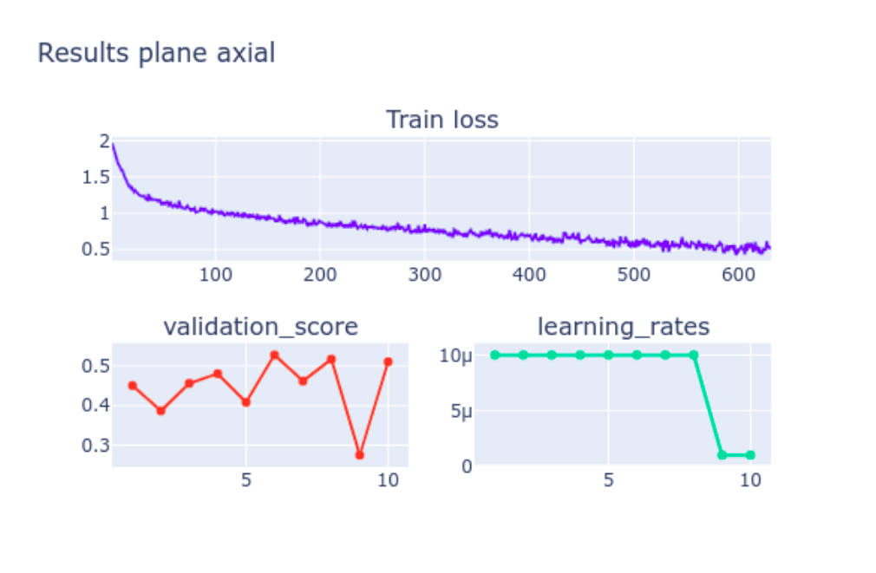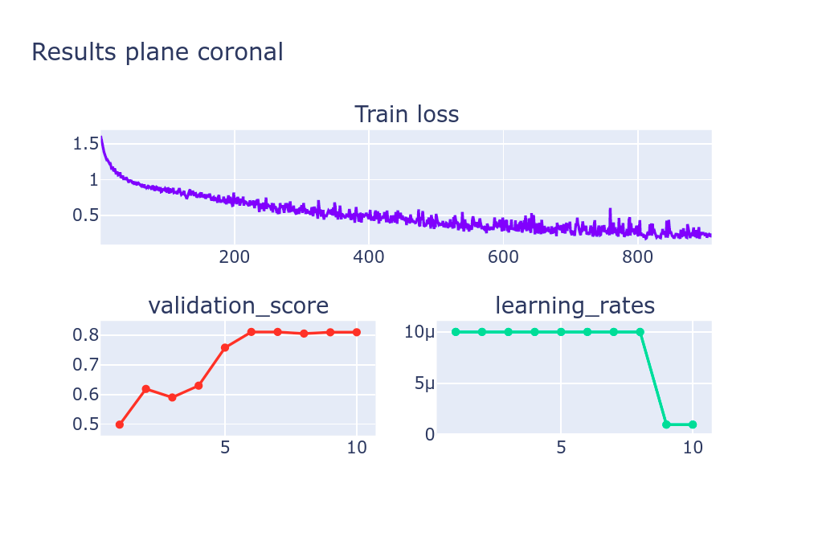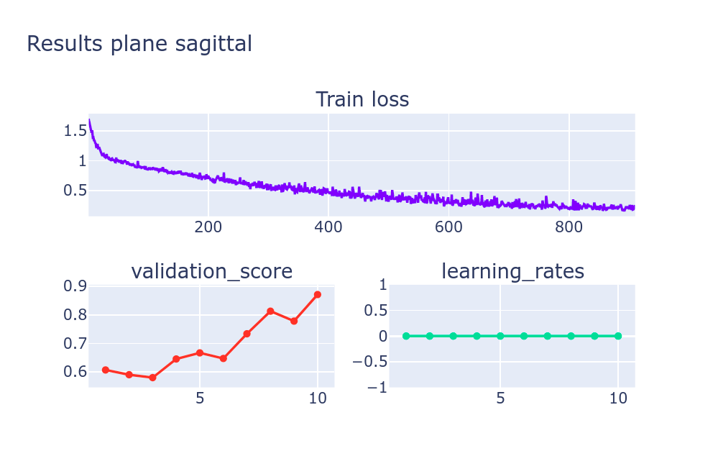

Test Dice score (axial): 0.59

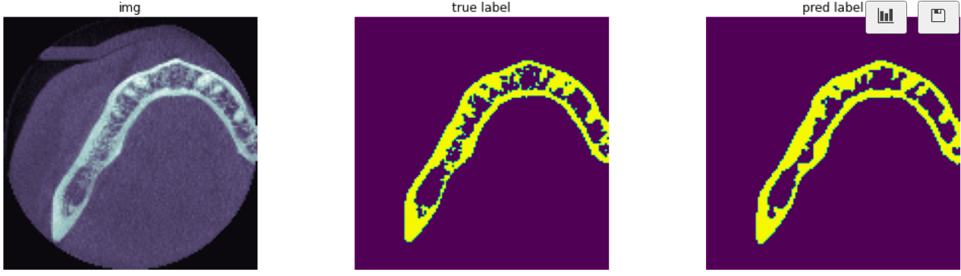

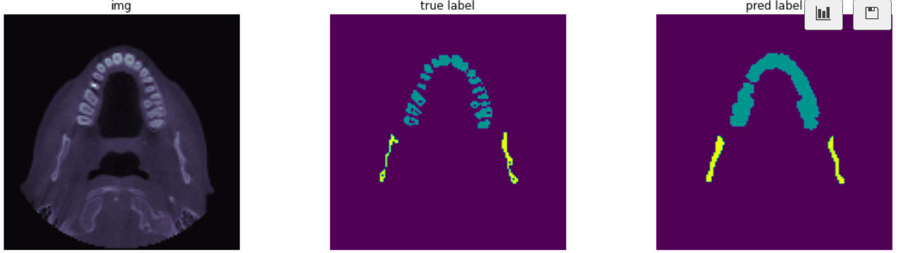

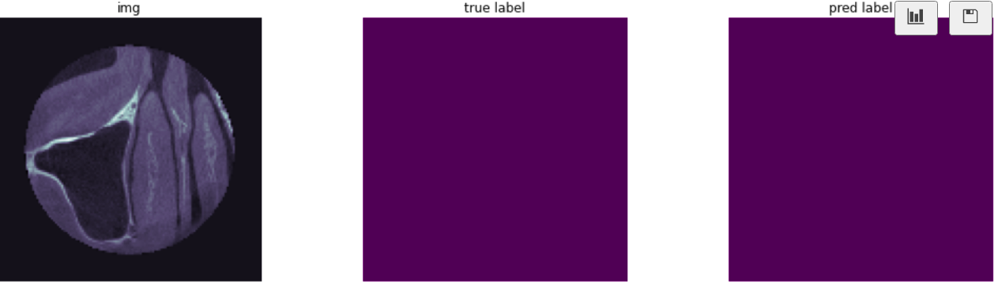

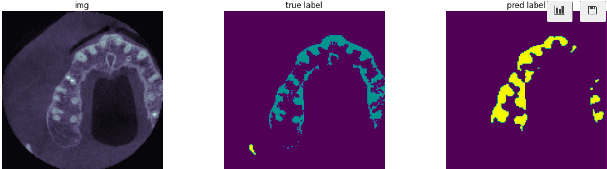

Test Dice score (coronal): 0.84

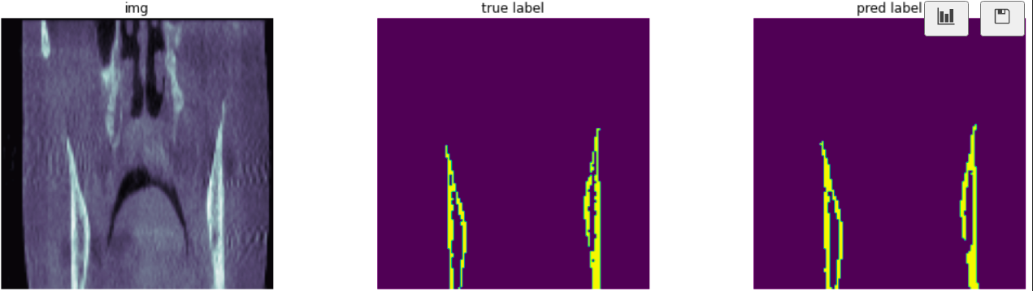

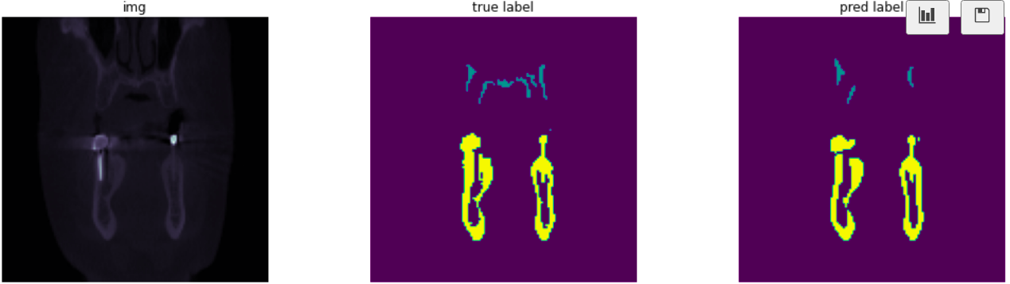

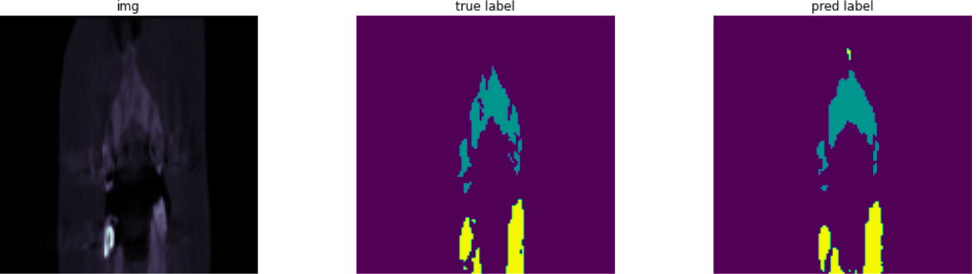

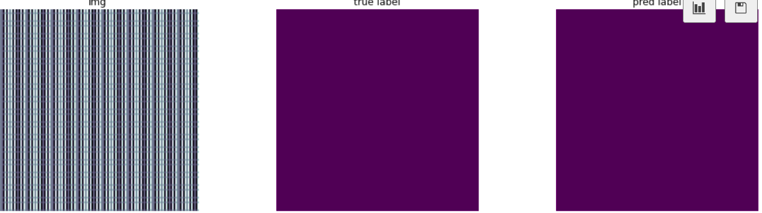

Test Dice score (sagittal): 0.75

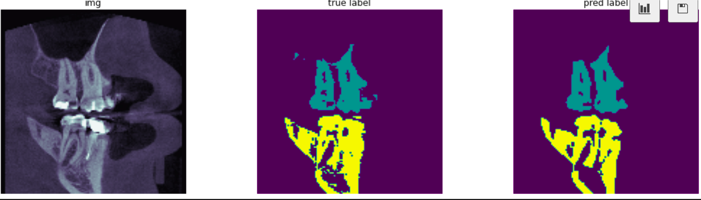

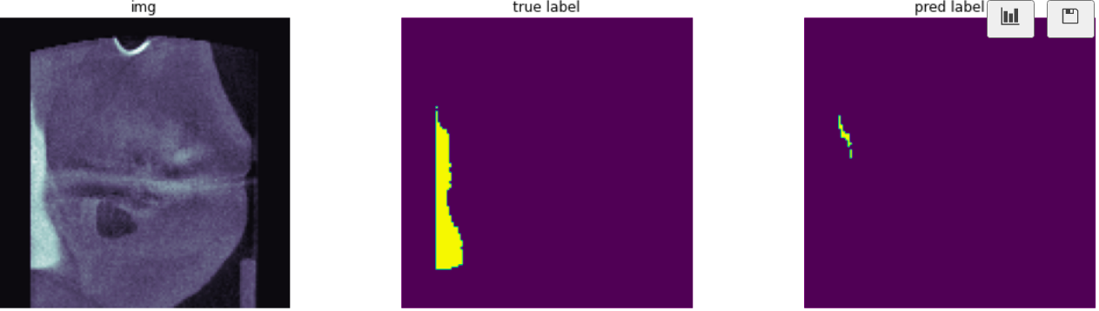

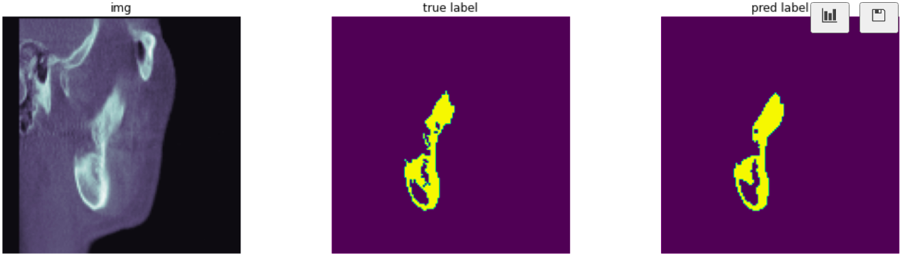

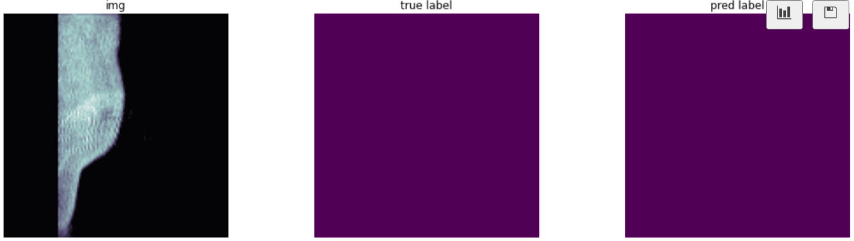

**Discussion:**

There are some holes in the masks. So I am not sure if these are good as Jaws or if they are noisy. So I left them as is.

The data set is very small compared with the variations they have whether positive or negative. To solve this we should gather more data to make the model robust for the variations. But I tried to solve this problem by using model like UNET and which is made for small datasets. and try to generate more augmented data as we see from the results. the model improved. but yet not enough. so we need more real-quality data.

**Future work:**

To improve the model

* I need to tune the hyperparameters
* I want to manipulate different optimizations
* I want to modify the UNET model by using different activation functions & playing with different regularization methods.
* Tune scheduler
* Using the cloud to increase the resolution of the images.
* Gathering more real data in good quality and increasing the negative objects.

**References**:

1. U-Net: Convolutional Networks for Biomedical Image Segmentation[1]: <https://arxiv.org/pdf/1505.04597.pdf>
2. Pytorch-UNet: <https://github.com/milesial/Pytorch-UNet>