**Model My Watershed BMP Spreadsheet Tool**

**User Manual**

Manual by Barry Evans, Drexel University & Penn State University

Manual version: 2018-07-27 at 12:15pm ET

* Repository & Archives: <https://github.com/WikiWatershed/MMW-BMP-spreadsheet-tool>
* Latest Version of Tool: <https://raw.githubusercontent.com/WikiWatershed/MMW-BMP-spreadsheet-tool/master/MMW_BMP_Spreadsheet_Tool.xlsx>
* Latest Version of Manual: <https://raw.githubusercontent.com/WikiWatershed/MMW-BMP-spreadsheet-tool/master/docs/MMW_BMP_Spreadsheet_Tool_UserManual.docx>

***Overview***

This tool was developed to support the evaluation of potential pollutant load reductions that might result from the implementation of various Best Management Practices (BMPs) and similar mitigation measures in a watershed where loads from a wide range of rural and urban sources have been quantified. Although it was designed to readily accept simulated output from the multi-year model in Model My Watershed, load estimates from other models and load estimation tools could theoretically be used as well to evaluate potential reductions.

The tool was initially developed to assist municipalities in Pennsylvania in meeting their obligations with respect to achieving load reductions specified by the Pennsylvania Department of Environmental Protection as part of the NPDES permit renewal process. However, the tool is generic enough that it can be used for similar evaluations undertaken by a much wider range of users. Once model output results have been entered into the appropriate tab within the spreadsheet tool, other tabs are automatically populated with data in a way that facilitates the analysis of various load reduction strategies that deal with sediment, nitrogen and phosphorus loads from both urban and rural upland sources, as well as from streambanks that might be eroded due to grazing animals and excess runoff from impervious surfaces in urbanized areas.

In this document, instructions are provided for doing load/BMP analyses for two basic situations:

1. Analysis of pollutant loads and potential BMP scenarios for a given watershed. In this case, the Multi-Year Model in MMW (i.e., the GWLF-E model) is used to estimate mean annual nutrient and sediment loads (kg/yr) and loading rates (kg/ha) from a variety of sources within the area of interest (AOI). The resulting model output is then entered into the customized Excel-based tool to estimate potential load reductions that might result from the implementation of BMPs and other remedial measures in both rural and urban areas throughout the watershed.
2. Analysis of pollutant loads and potential BMP scenarios for specific “targeted” areas within a larger watershed. In this case, specific functionality has been built into the tool to assist municipalities in Pennsylvania meet pollutant load reduction requirements mandated as part of their cyclical NPDES permit review process. In utilizing the tool, MMW model output is used to estimate pollutant loads and loading rates for the larger watershed area as described above. Then, portions of the watershed loads are subsequently “assigned” to one or more municipalities or “urban areas” located within that watershed based on the landscape characteristics of those areas (e.g., size, land cover type, and extent of impervious surface). Once the load assignments have been made, user of the tool can then simulate various BMP scenarios to evaluate potential load reductions. (Note: although this tool was initially developed for use in Pennsylvania, it could easily be used in other geographic regions for similar applications as well).

The following two sections briefly describe the steps for conducting analyses associated with the two basic situations outlined above.

***Analysis of Pollutant Loads and Potential BMP Scenarios for a Given Watershed***

Step 1: Load Output Data from Model My Watershed

Upon using the multi-year model in Model My Watershed, the user is presented with tabular results to the left of the “area of interest” map as shown in Figure 1 below. (Note: see the Appendix to this document if you are unsure of how to Model My Watershed to simulate pollutants loads for any given area of interest).

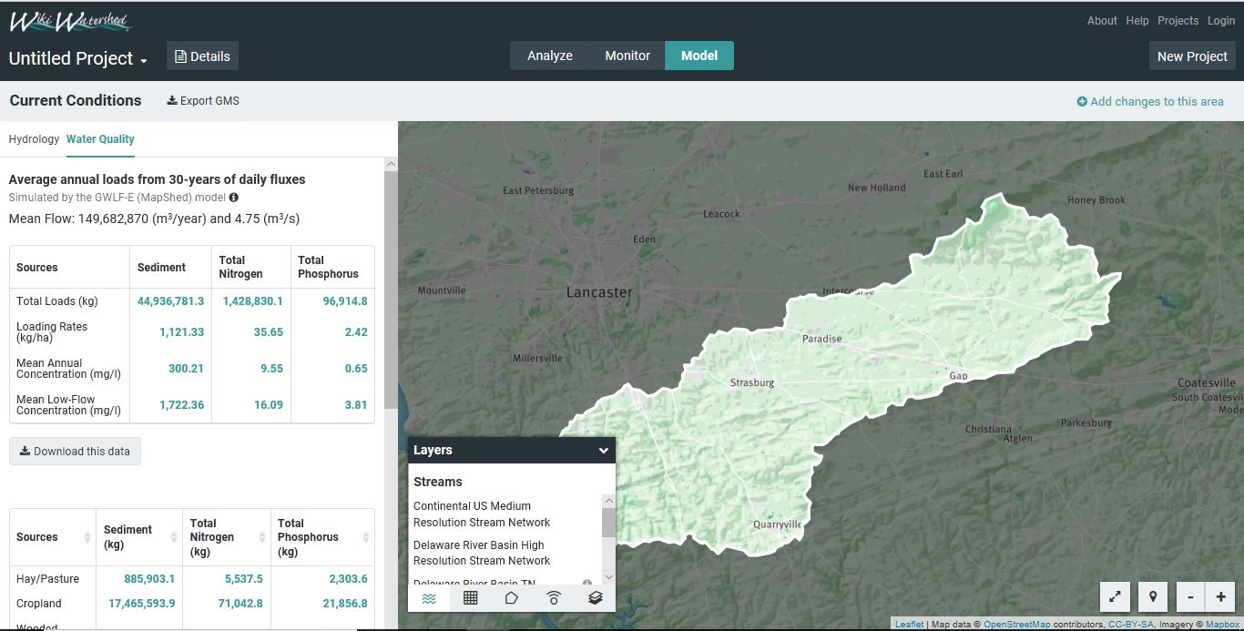

Figure 1.

The data required by the spreadsheet tool is included in the lower table which shows the more detailed load information by source category (e.g., land cover type, point sources, streambank erosion, etc.). As shown in Figure 2, this data can be downloaded in csv format by clicking on the “Download this data” button. (Note: the spreadsheet tool itself can be downloaded via the “Export” function also highlighted in Figure2).

Once downloaded, these data can be copied and pasted into the appropriate place in the “MMW Output” tab in the tool. Similarly, information on the areal extent of the different source areas also needs to be copied and pasted from the csv file that can be downloaded from the “Analyze” results for the particular area of interest as shown in Figure 3. Figure 4 illustrates the specific locations within the “MMW Output” tab where these model results should be inserted.

Once these data are inserted as shown, the table in the upper left-hand corner of this tab (shown in blue in Figure 4) is automatically populated with the correct model results required to populate other tabs in the spreadsheet and to support the various functions built into the tool.

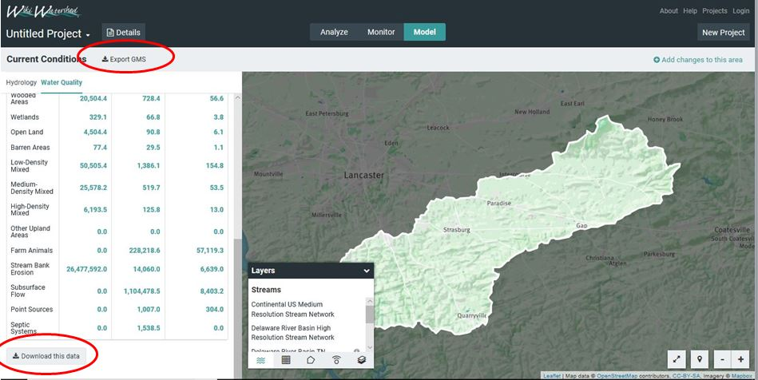

Figure 2.

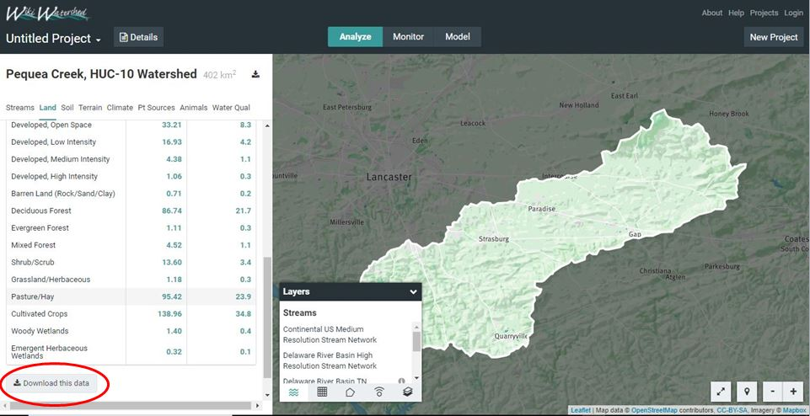

Figure 3.

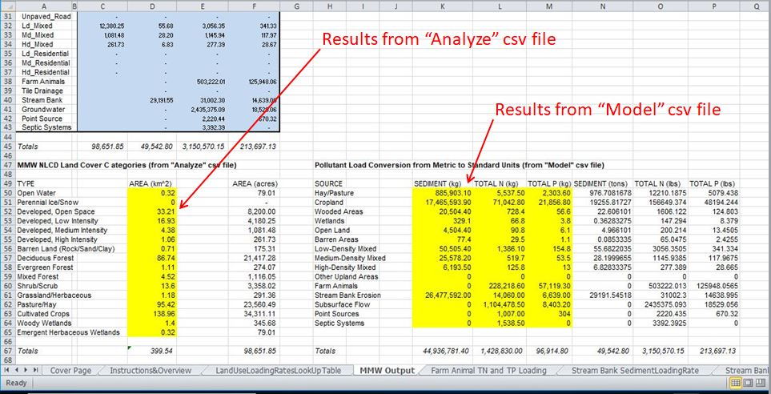

Figure 4.

One of the more important tabs populated with the MMW model results is the “Land Use Loading Rate Look-Up Table” shown in Figure 5. In this case, model results drawn from the “MMW Output” tab are used to calculate “upland” pollutant loading rates as wells as “streambank” loading rates that are attributed to the different land use areas. As described later, various BMPs can be simulated to evaluate potential load reductions from “upland” areas and streambanks. In the case of developed (urban) areas, various BMPs are simulated that have an effect on both “upland” loads as well as “downstream” loads caused by streambank erosion. Additionally, with urban stormwater BMPs, “composite” loading rates that combine loads from both upland and streambank sources are used in the simulation of potential load reductions as described in a later section.

To support loading rate calculations in the “Land Use Loading Rate Look-Up Table” tab, information is drawn from the “MMW Output” tab as well as other intermediate locations such as the “Streambank Sediment Loading”, “Streambank Nitrogen Loading”, and “Streambank Phosphorus Loading” tabs. While the user of this BMP spreadsheet tool is not required to add or modify data in these latter three tabs (which are automatically populated from other tabs), some users may find them informative with regard to how streambank-eroded loads are assigned to various upland sources as a result of runoff emanating from these areas.

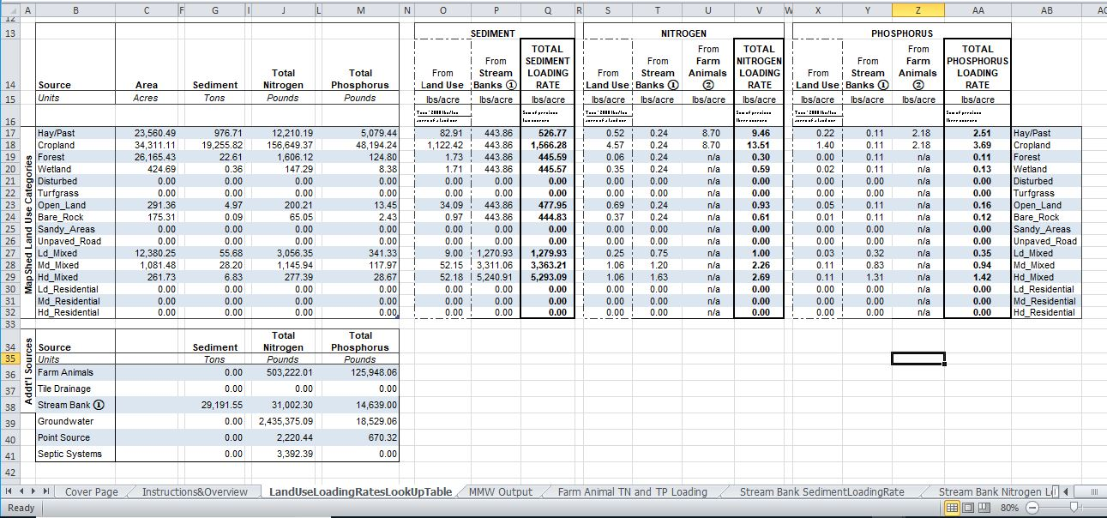

Figure 5.

Step 2: Evaluate Potential Load Reductions from BMPs in Rural Areas

Using the “Agricultural BMPs” tab, various mitigation measures can be simulated to evaluate potential load reductions from both upland areas (primarily agricultural) and in streams due to streambank erosion. To facilitate this activity, information from other tabs is extracted and used to populate key cells in this tab. More specifically, information is drawn from other tabs (primarily the “MMW Output” tab) to assign values to cells pertaining to watershed loads and the extent of available land on which various BMPs might be applied. For example, the cells highlighted in blue in Figure 6 provide available land areas or stream lengths to which measures such as conservation tillage, cover crops, riparian buffers, streambank stabilization, etc. might be applied. In the same figure, the cells highlighted in yellow are used to specify the proposed extent of such measures. Based on user input, the potential load reductions are summed for all proposed measures and provided at the bottom of this tab as illustrated in Figure 7.

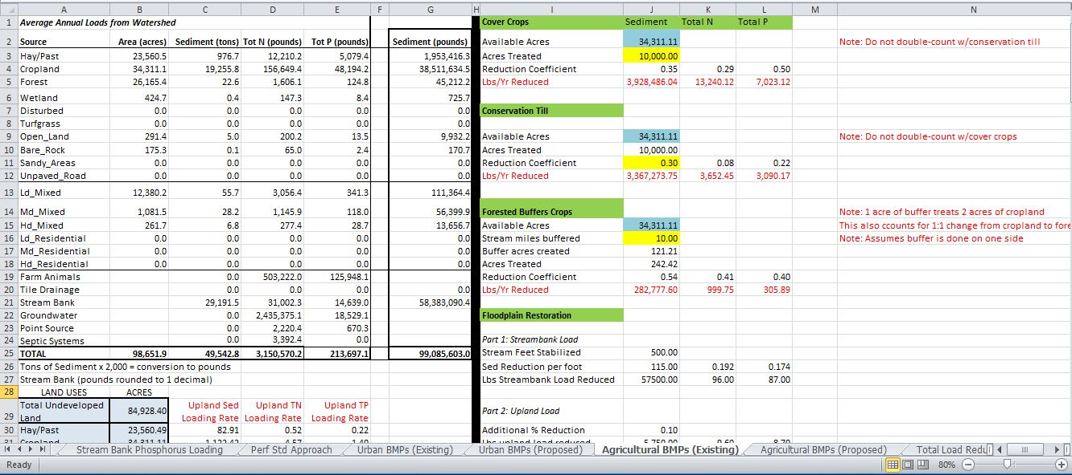

Figure 6.

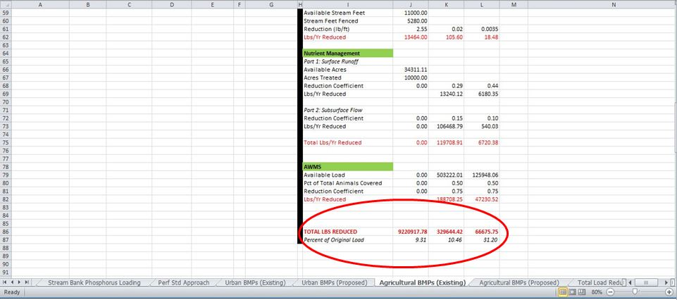

Figure 7.

Step 3: Evaluate Potential Load Reductions from BMPs in Urban Areas

In the case of rural landscapes, various agricultural BMPs and stream restoration measures are simulated to predict potential pollutant load reductions from either upland areas or in streams due to eroded streambanks. With urban areas, similar reductions are also considered with this spreadsheet tool (as is the case with streambank stabilization and street sweeping). However, most of the load reductions in urban areas are simulated by considering the combined load reduction effects of urban BMPS on both upland and streambank loads. As has been shown in numerous studies, stormwater runoff from impervious surfaces in developed areas not only transports pollutants that have accumulated on such surface in between precipitation events, but the increased runoff (relative to more pervious surfaces) also significantly contributes to downstream streambank erosion.

Accordingly, with this spreadsheet tool, the application of most urban BMPs that result in reduced overland and sub-surface flows to streams is assumed to result in reduced upland and streambank loads as well. To estimate such load reductions, the initial “treated” loads are calculated by multiplying the extent of the urban area treated by a given BMP by the “composite” loading rate discussed previously that considers both the upland and streambank loads attributed to that particular land use type (e.g., in this case higher-density land use types result in higher composite loads due to greater amounts of impervious surface). As described below, a reduction coefficient that represents the removal rate of sediment and nutrients for the BMP is then applied to estimate the reduced load.

In this spreadsheet tool, a “Performance Standard” approach is used to dynamically set the removal efficiency rates based on the type of BMP used and the runoff volume captured. This approach was originally developed for use within the Chesapeake Bay watershed model, and has been adopted by the states within the Chesapeake Bay watershed. With this approach, regression curves have been developed for two basic types of BMPs (RR – runoff reduction, and ST – stormwater treatment). Most urban BMP types used within the Bay watershed have been assigned to either of these two categories, and the value of sediment and/or nutrient removal efficiency varies as more runoff volume is captured via detention and/or infiltration (see Figures 8-10). For example, as shown in Figure 10, if a water volume equivalent to 1 inch of runoff per acre of impervious surface is captured, a sediment removal rate of 75% would be calculated

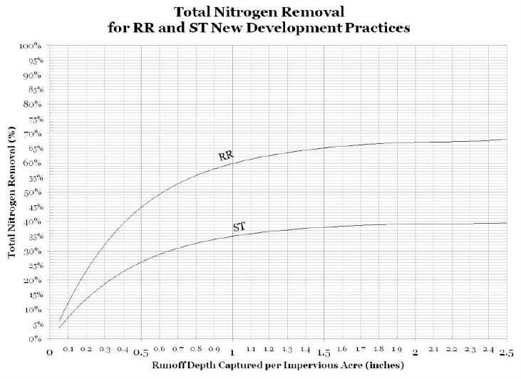

Figure 8.

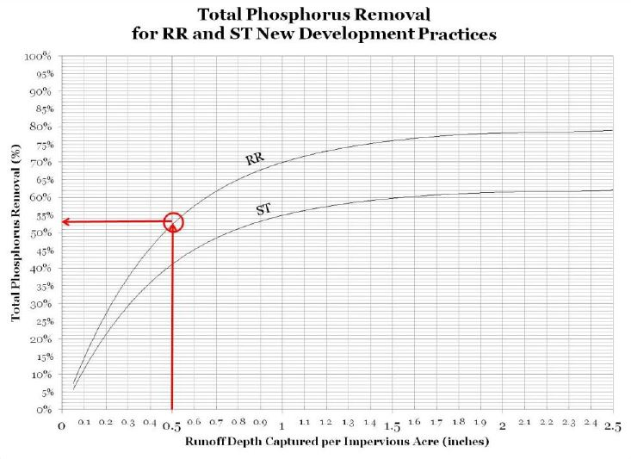

Figure 9.

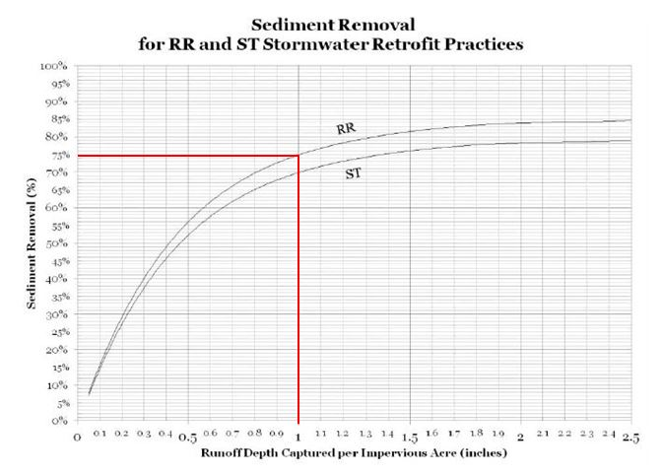

Figure 10.

With the MMW BMP spreadsheet tool, data about urban BMPs are entered using the “Urban BMPs” tab. First, the user must enter general information such as Project Name (any name), a BMP Name (which can be a single BMP or collection BMPs that drains a single area), the BMP type (RR or ST), whether it is Existing or Proposed, and the year of installation as shown by the red arrows in Figure 11. (For reference purposes, Figure 12 shows a table of the different BMPs that have been assigned to either category for Bay modeling purposes). Then, as shown in Figure 13, the user must enter information on: 1) the types of land uses treated by a BMP or collection of BMPs, 2) the extent to which different land use types are treated by the BMP or BMP system (i.e., number of acres), and 2) the quantity (runoff depth) captured by the BMP. Upon entering this information, the removal efficiency values for sediment, nitrogen and phosphorus, as well as potential load reductions, are automatically calculated as shown in Figure 14. Within this tab, data entry options for multiple “project areas” are provided so that load reductions for different part of an urban area, or for sub-areas treated by different BMP/collection systems, can be estimated.

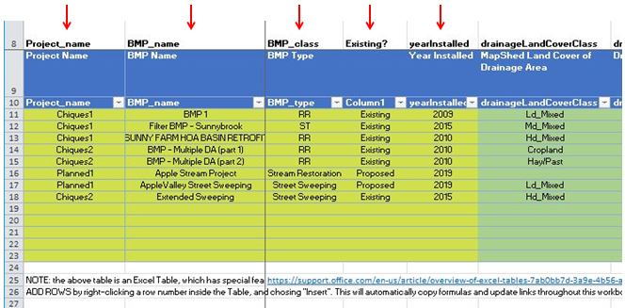

Figure 11.

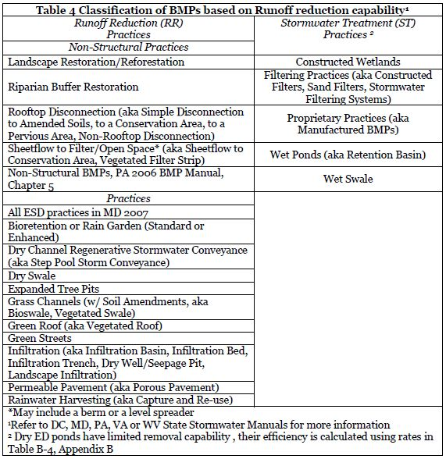

Source:

Recommendations of the Expert Panel to Define Removal Rates for New State Stormwater Performance Standards, Stewart Comstock, Scott Crafton, Randy Greer, Peter Hill, Dave Hirschman, Shoreh Karimpour, Ken Murin, Jennifer Orr, Fred Rose, Sherry Wilkins. Revised: January 20, 2015, Prepared by: Tom Schueler and Cecilia Lane, Chesapeake Stormwater Network

Figure 12.

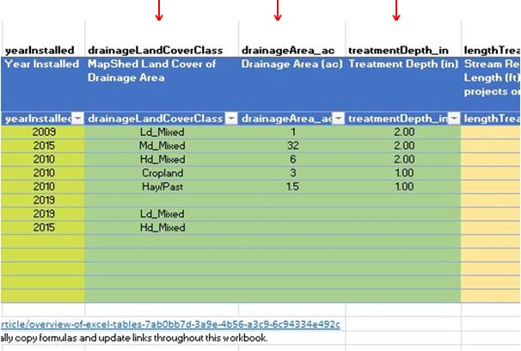

Figure 13.

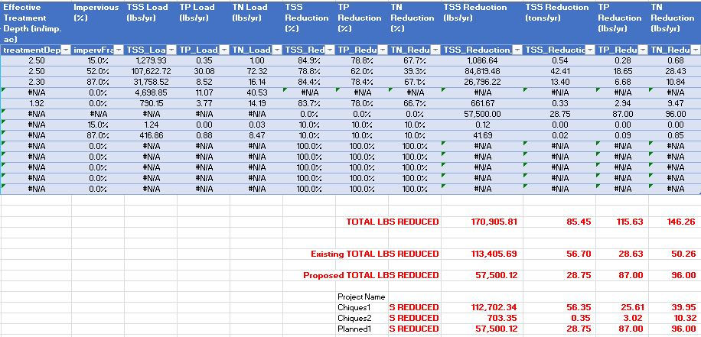

Figure 14.

Step 4: Review Total Load Reductions and Repeat Previous Steps as Necessary

The final tab in the spreadsheet (“Total Load Reductions”) summarizes the results based on the application of all the BMPs and measures specified by the user. As shown in Figure 15, load estimates are given for “pre-BMP” conditions, “current BMP” conditions, and after all proposed (future) BMPs are considered. Typically, plans for future reductions are compared against current or “baseline” loads. Depending on any sediment and/or nutrient load targets that the user might be comparing the simulated results against, additional simulations may need to be conducted before any final results are achieved with the spreadsheet tool. Also, as described earlier, multiple “project areas” are provided in the urban tab in case individual sub-areas need to be considered within a larger urban area. Additionally, if multiple areas or scenarios need to be addressed, the user can make as many copies of the tool as needed.

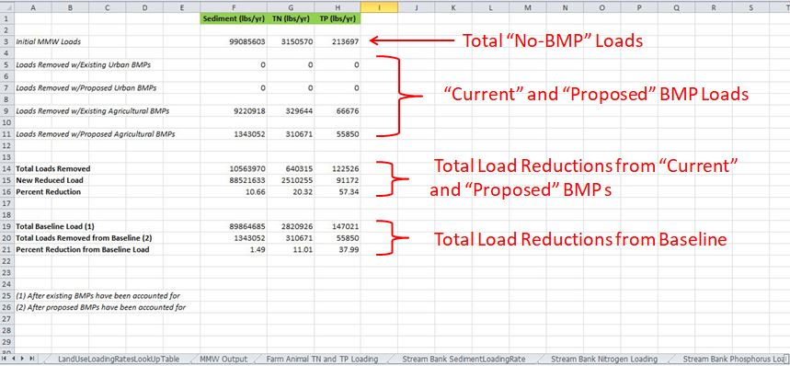

Figure 15.

***Analysis of Pollutant Loads and Potential BMP Scenarios for Specific “Targeted” Areas within a Larger Watershed***

Basically, the steps associated with this type of analysis are the same as those given above with the exception of two additional steps (Step 2 and Step 3) as described below.

Step 1: Load Output Data from Model My Watershed for the Larger Watershed

(Same as above)

Step2: Define the Boundary of the Target Area

The process for estimating the land cover distribution for a smaller target area (e.g., municipality or other user-defined urban area or BMP area) is essentially the same as when a boundary is selected or created for any watershed or area of interest (AOI) in Model My Watershed. In this case, instead of using either the “Select boundary” or “Delineate watershed” options to define an AOI, either the “Draw area” or “Upload file” options as shown in Figure 16 are used to define the AOI. (See the Appendix for more details on how to use these two options for defining an AOI for this particular purpose).

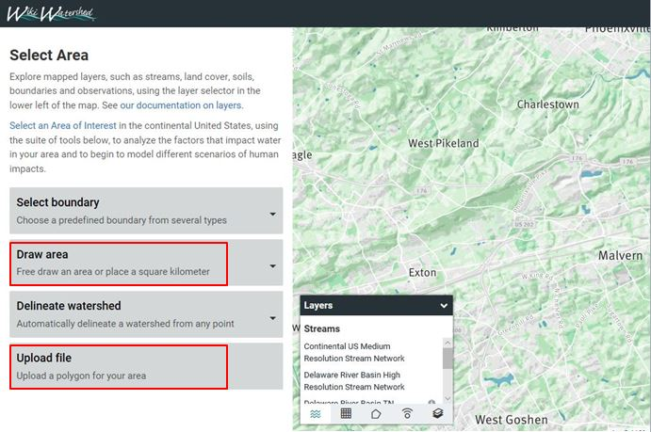

Figure 16

Step 3: Enter Land Cover Distribution Data for the “Target” Area within the Larger Watershed

After a boundary for the “target area” is defined using one of the two methods described above, Model My Watershed will summarize various characteristics of the AOI just as it does for any other area selected. As shown in Figure 3 in the previous section, the land cover distribution for the new AOI can be downloaded in a csv-formatted file. However, in this case, the data in this csv file are to be copied and pasted into a different location in the BMP spreadsheet tool. More specifically, data on the type and areal extent of the different land cover categories for the smaller, target area are to be pasted into the location shown in Figure 17. Once these data are pasted into this location in the spreadsheet, information on land cover for the target area is then carried over to the “Urban BMPs” tab to help the user determine the load reductions that might be obtained by applying different BMP scenarios in this specific area. (Note: in addition to using either the “Draw area” or “Upload file” options, it is also possible to just manually enter information on the areal extent of different land cover types in the target (urban) area if these are already known).

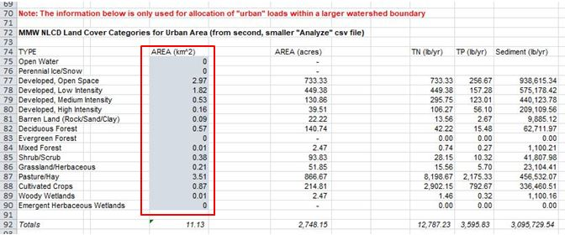

Figure 17

Subsequent Steps

After entering information for the smaller target area of interest as described in the two previous steps, an assessment of potential load reduction scenarios using various BMPs can be conducted by following Steps 2 through 4 outlined in the previous section. After any given scenario, the potential load reductions are then shown in the “Total Load Reductions” tab as shown earlier in Figure 15. In this case, however, the load reduction results are displayed in the “Urban Area” portion of this tab as shown in Figure 18, and any BMPs simulated are assumed to be applied in the target (urban) area first until available rural and urban land areas within that particular area are exhausted. Therefore, the percent load reduction values for the target area are usually higher than those for the larger watershed within which it is located.

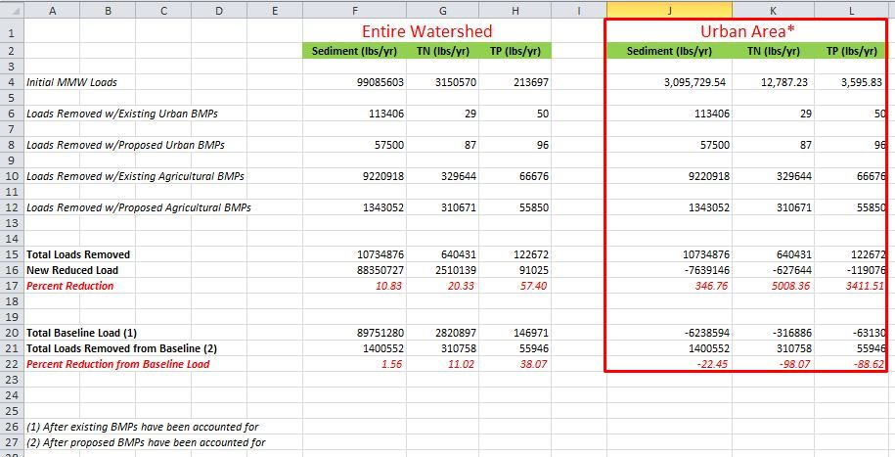

Figure 18

***APPENDIX - Selecting/Defining an Area of Interest for use in Watershed Modeling***

As shown in Figure A1 below, there are a number of tools available within Model My Watershed for selecting or defining an Area of Interest (AOI) for analysis or water quality simulation purposes, including “Select boundary”, “Draw area”, “Delineate watershed”, and “Upload file”. Some of the options included with these tools (e.g., “Square km” with the “Draw area” tool, and “County Lines” under the “Select boundary” tool) are not usually suitable since they do not necessarily represent watersheds or basins that are defined by topographic divides or stream networks. Brief descriptions of the most appropriate tools for use in water quality hydrologic/water quality modeling are provided below.

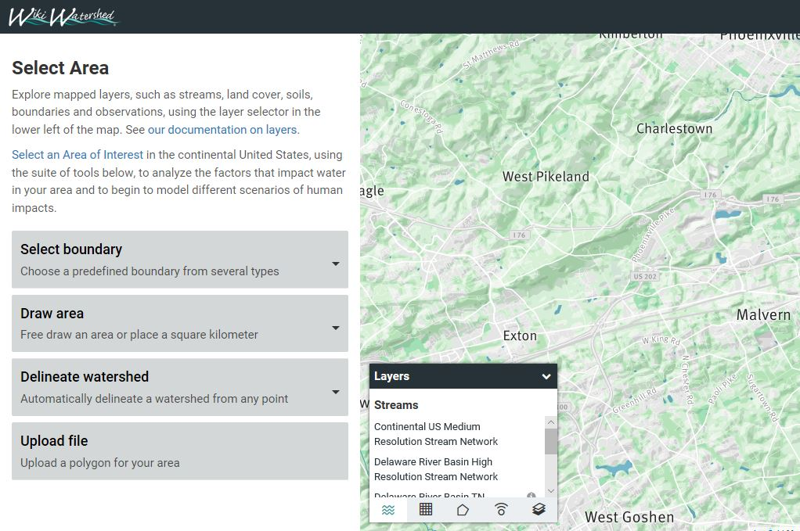

Figure A1.

Select Boundary

With this particular tool, the most suitable options for modeling include those which allow a user to depict and select pre-defined watershed/basin boundaries previously developed by the U.S. Geological Survey (i.e., the HUC12, HUC10 and HUC8 boundaries) as shown in Figures A2 and A3. Although all of these vary in average size depending upon where they are located geographically, across the country, HUC12 boundaries are typically on the order of 40 square miles in size, HUC10 boundaries are about 225 square miles in size, and HUC8 boundaries are about 700 square miles in size. Once particular option is chosen, the user then moves the cursor over to the boundary of interest and clicks on it to begin the process of extracting the necessary data to begin the modelling process.

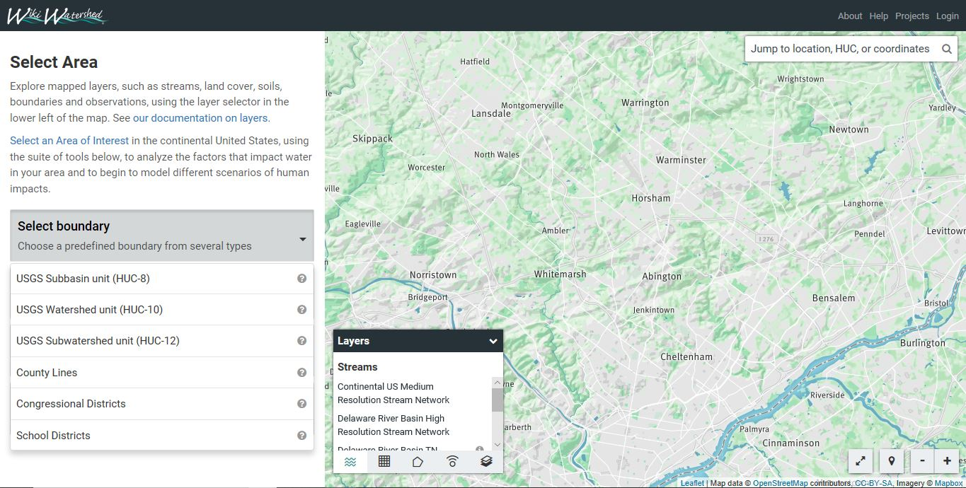

Figure A2

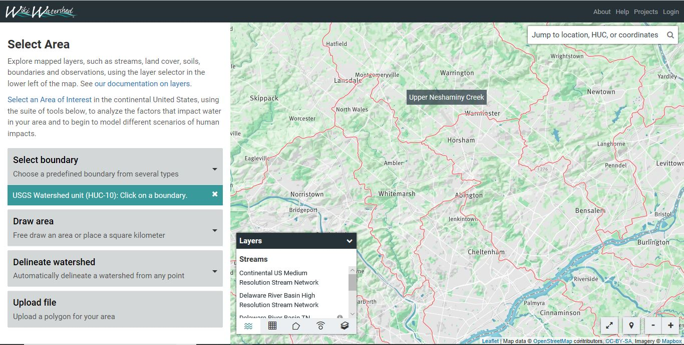

Figure A3

Draw Area

With this option, the user can manually draw a boundary of interest on their computer screen. In this case, the user begins by digitizing on-screen with the cursor by starting with a point and then finishing the polygon with that same point by clicking on it. Figure A4 shows a portion of such a polygon during the digitizing process. As soon as the polygon is finished, data will be extracted for that area as previously described. This procedure can be used for both defining a watershed boundary for subsequent analysis as well as the boundary for a smaller target (e.g., urban) area within the larger boundary. In drawing this boundary, the user may want to turn on other layers that can aid this process such as a satellite image (see Figure A5) or a layer that depicts a combination of municipal boundaries and “pre-defined” urban areas as shown in Figure A6. (Note: this latter option is only available in Pennsylvania).

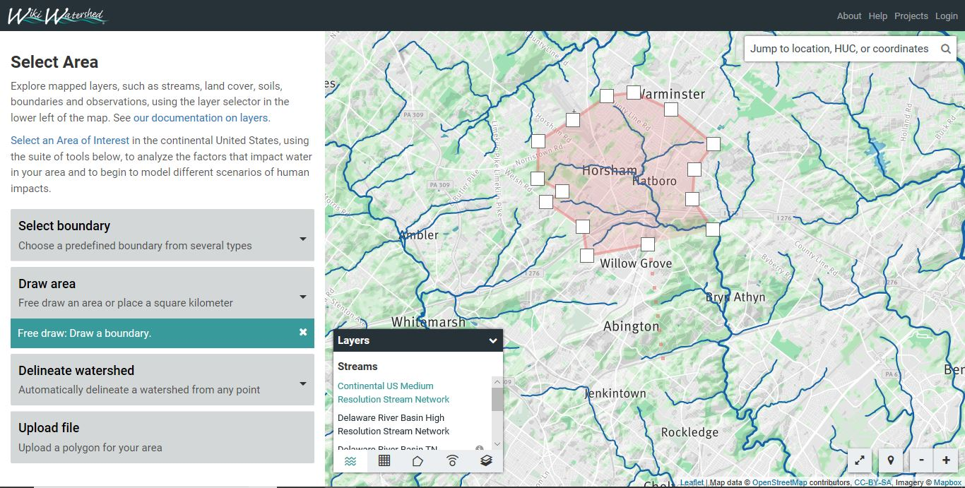

Figure A4.

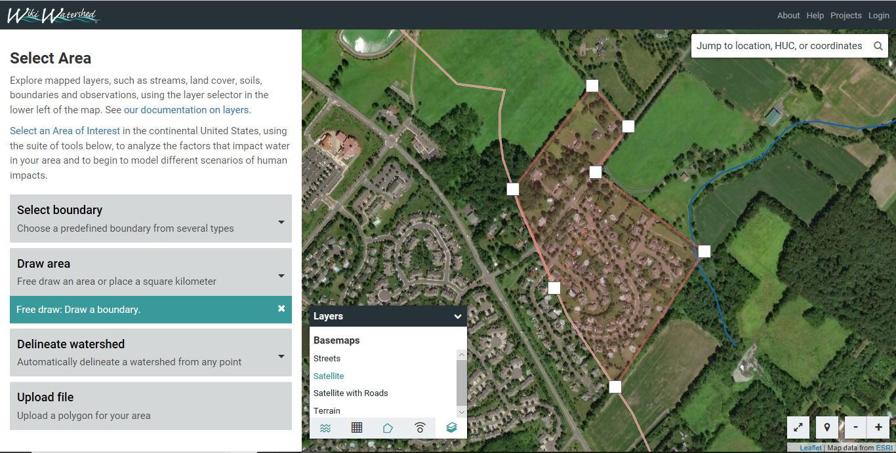

Figure A5

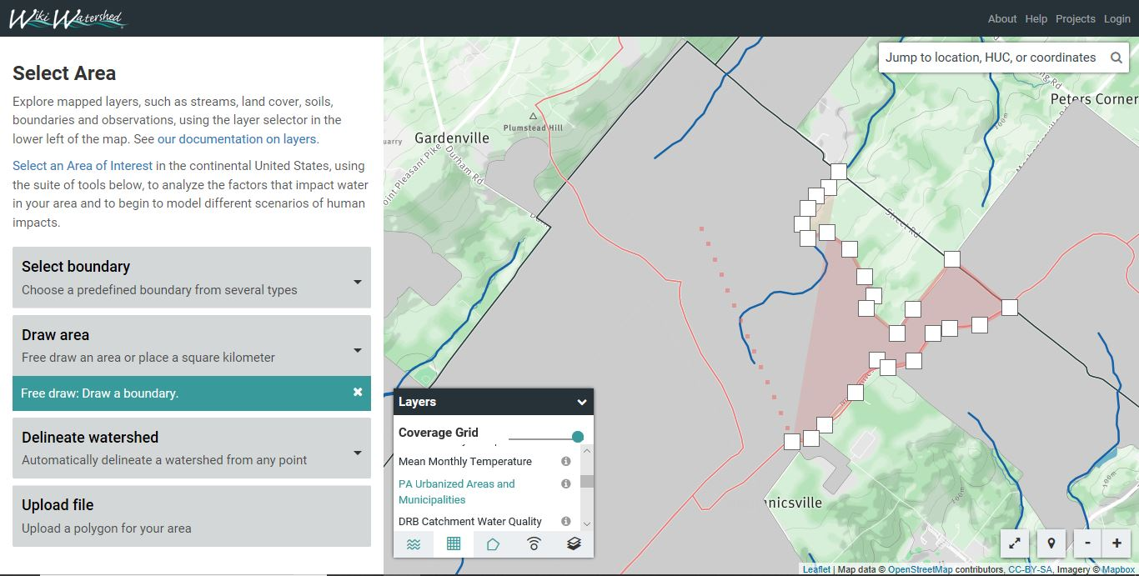

Figure A6

Delineate Watershed

With this option, a user can drop a point on a stream and have the boundary that defines the land area draining to that point (i.e., watershed boundary) automatically generated. Upon selecting a stream point, digital elevation data is used to find the topographic divides that separate adjacent drainage areas, and then delineate the appropriate boundary of interest. In utilizing this option, the user can select either of two stream networks for generating the polygon: 1) a high-resolution stream network that was specifically produced for the Delaware River Basin on the East Coast, or 2) a mid-resolution NHD stream network produced by the U.S. Geological Survey that is available for the entire country. A comparison between Figures A7 and A4 (which show the same geographic area) illustrates how much more accurate this approach is than manually digitizing such a boundary.

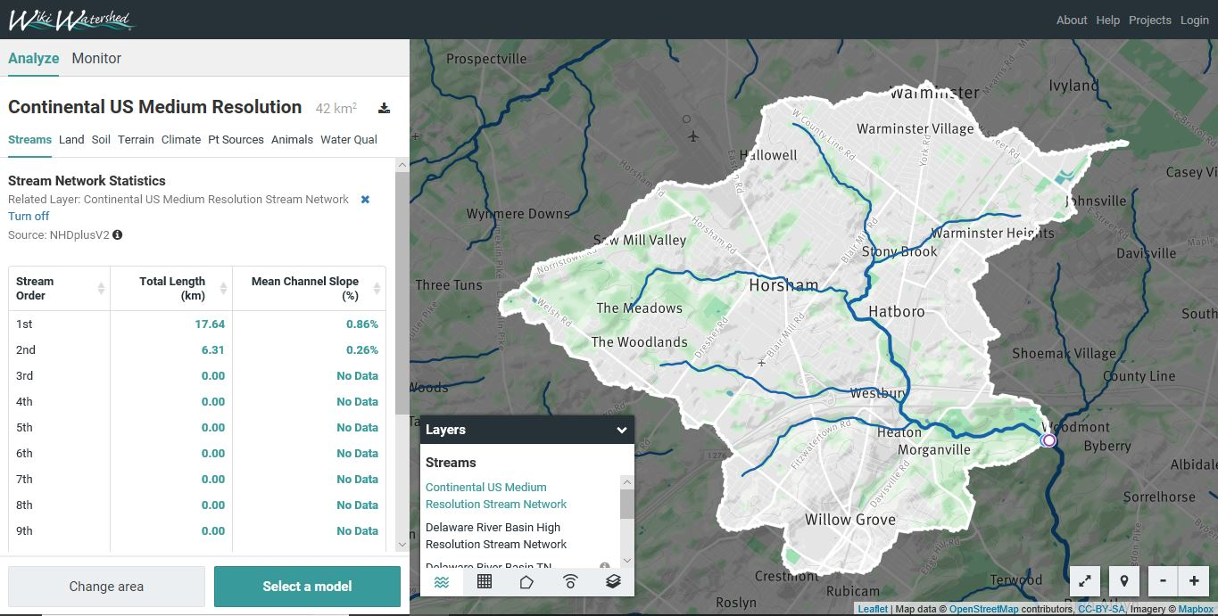

Figure A7

Upload File

With this option, a user can upload a digital boundary that has been previously created to define the area of interest. This can be used to define either a watershed boundary or a smaller target (urban) area within the larger watershed as described earlier in this document. Upon selecting this option, the user is presented with a screen as shown in Figure A8. Upon clicking on the “Select a file” button, the user is then asked to browse to the file to be uploaded. As noted in Figure A8, this can either be a zipped shapefile or a “geojson” file. Figure A9 shows an example of a boundary file uploaded for an area in eastern Pennsylvania.

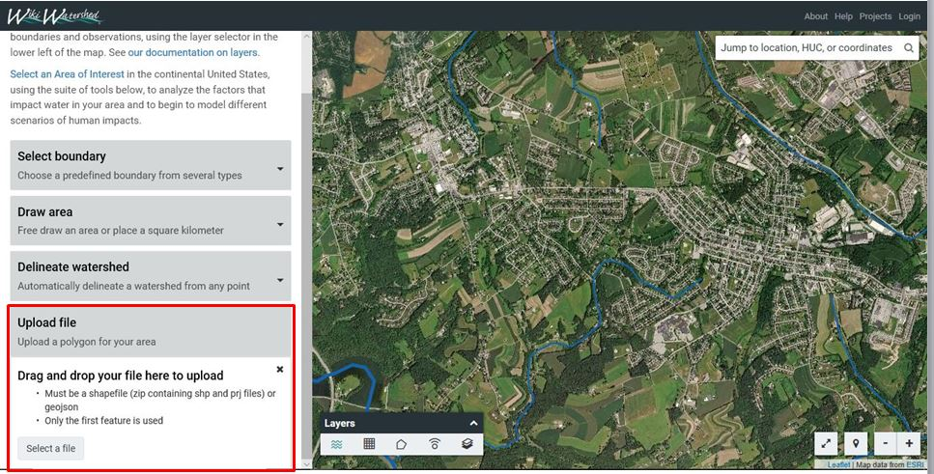

Figure A8

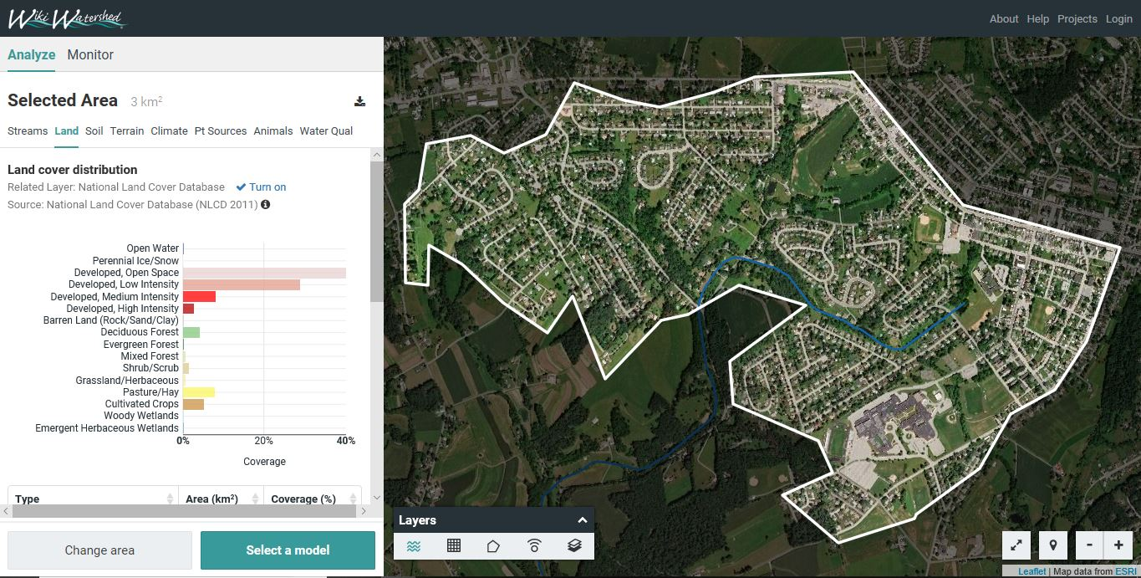

Figure A9.