Project Report

CS 4350.251

Spring 2017

Group 12

Project 1

Contact Manager

Mark McDermott

Jason Flinn

Carlo Rodriguez

Benjamin Winston

**Introduction**

Our group split up the different tasks of the database management code and the accompanying report. For the code, Mark built the menu, Jason built the add record function, Carlo built the find record function, and Benjamin built the update and remove records functions. For this report, Mark wrote Section I, II and III. Carlo wrote section IV. Our group communicated with the Slack chat app and used git and github to keep the code under version control.

**Task I**

Our database is a flat .txt file with fields separated by colons and each entry has its own row. We have a name field which has first and last names. We have an address field with the street address. We have a phone field with a user’s seven digit phone number (no dashes or other characters, just seven numbers). We have an email field with the user’s email.

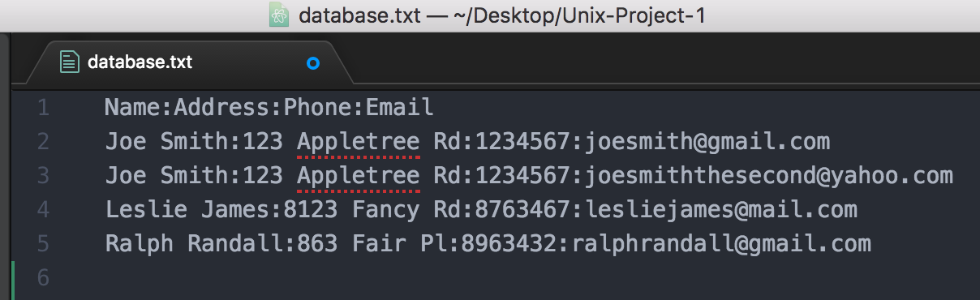

**Task II**

We designed our code to be object oriented, so each task is broken out into its own function. Our menu calls each function, depending on what input is entered by the user. Our find function takes user input for name, address, phone or email and then finds the record with that info or returns that the record is not found. To search the through database, for our find() function, we use grep.

For our add user functionality we ask the user a series of questions to prompt user input for the new name, address, phone and email. Each input is then validated to check if the input entered matches the type of data needed for that field. We then use echo with the stream extraction operator to put each new input, concatenated with a colon, into the database before moving on to the next.

/*** add update ***/

/*** add remove ***/

Our display all function assigns the database.txt file to a variable called database. Then we cat the variable to print out all the entries.

Our quit function uses printf to thank the user for using the program and then simply does exit 0.

/*** add screenshots of an update and explain step by step ***/

**Task III**