|  |  |  |  |  |
| --- | --- | --- | --- | --- |
|  | Size | Resolution | Storage Size per image | Storage Size of dataset |
| Original | 3.072MB | 32*32 | 3.072KB | 3.072MB |
| 10X Volume | 30.72MB | 32*32 | 3.072KB | 30.72MB |
| Low resolution | 1.536MB | 16*16 | 1.536KB | 1.536MB |

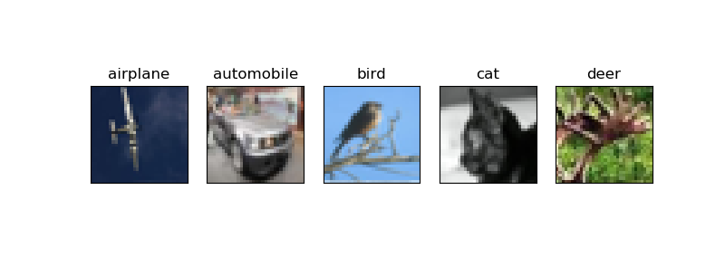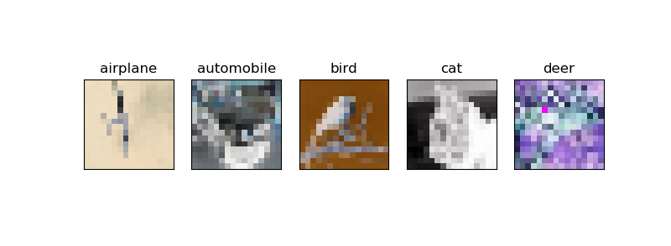

|  |  |  |  |
| --- | --- | --- | --- |
|  | Training Size | Validation Size | Test Size |
| Original | 700 images | 300 images | 10000images |
| 10X Volume | 7000 images | 3000 images | 10000images |
| Low resolution | 700 images | 300 images | 10000images |

Conv2D filter size = 32 kernel_size = 3*3

Activation relu

Conv2D filter size = 32 kernel_size = 3*3

Activation relu

Maxpooling2D poll_size = 2*2

Dropout 0.25

Conv2D filter size = 64 kernel_size = 3*3

Activation relu

Conv2D filter size = 64 kernel_size = 3*3

Activation relu

Maxpooling2D poll_size = 2*2

Dropout 0.25

Faltten

Dense 512

Activation relu

Dropout 0.5

Dense 10

Activation Softmax

Filter size: 32 in first and second Conv2D

64 in third and fourth Conv2D

Kernel size: 3*3

Pool size: 2*2

Batch size: 32

Epochs: 100

|  |  |
| --- | --- |
|  | Error Threshold |
| Original | 1.81 |
| 10x Volume | 1.25 |
| Low resolution | 1.85 |