|  |  |  |  |  |
| --- | --- | --- | --- | --- |
|  | Training Time | Training Accuracy | Testing Time | Testing Accuracy |
| Original | 303s | 0.8016 | 12s | 0.4078 |
| 10X Volume | 3105s | 0.9013 | 12s | 0.6351 |
| Low resolution | 71s | 0.4607 | 2s | 0.3691 |

|  |  |
| --- | --- |
|  | Training Model Size |
| Original | 9.819MB |
| 10X Volume | 9.819MB |
| Low resolution | 1.627MB |

Outlier Test

|  |  |  |  |
| --- | --- | --- | --- |
|  | Original | 10x Volume | Low resolution |
| apple | Airplane | Truck | Horse |
| Fish | Ship | Truck | Horse |
| Bear | Cat | Frog | Truck |
| Bed | Automobile | Automobile | Automobile |
| Flower | Horse | Bird | Deer |

|  |  |  |  |  |
| --- | --- | --- | --- | --- |
|  | Training Time | Training Accuracy | Testing Time | Testing Accuracy |
| Original | 6s | 0.8 | 1s | 0.6 |
| 10X Volume | 6s | 0.8 | 1s | 0.6 |
| Low resolution | 3s | 0.6 | 0.5s | 0.2 |

1. The larger of the volume size, the higher accuracy of the model
2. Low resolution will lead to less accuracy.
3. Low resolution means less data and costs less time.
4. 10X volume data size does not lead to a “**much much**” higher accuracy of the model, therefore, in order to cut the time cost, we can input a limit number of data.

Original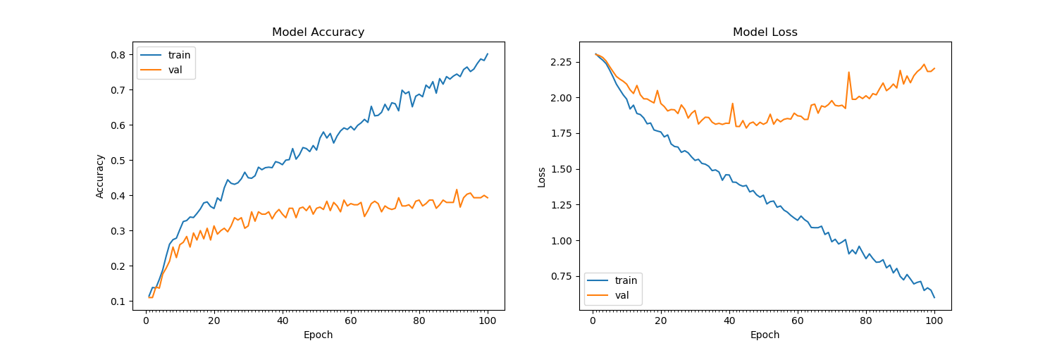

10x Volume:

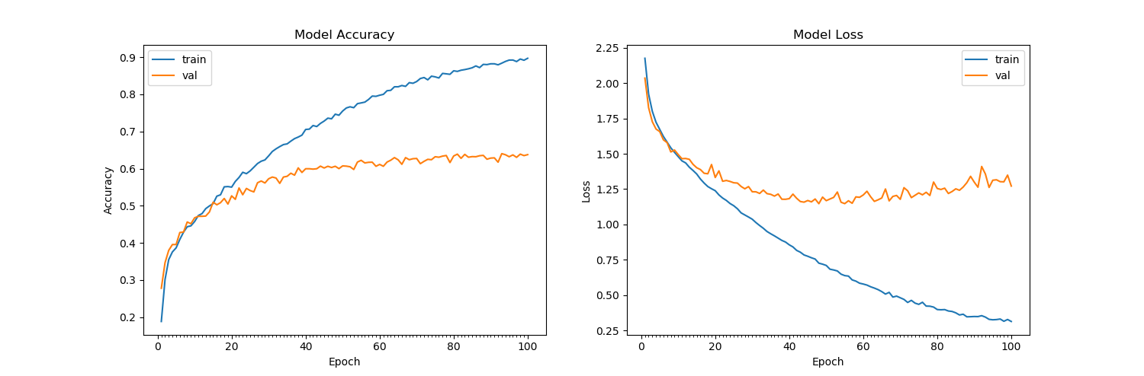

Low_Resolution