A STUDY ON SHORT-TERM VEGETABLE PRICE FORECASTING AT KOYAMBEDU WHOLESALE MARKET: A MACHINE LEARNING AND MULTI-AGENT AI APPROACH FOR SUPPLY CHAIN PROCUREMENT DECISION-MAKING
By
VIGNESH NATARAJAN
Roll No. 2406OBA0046
Reg. No. 69124100162
A PROJECT REPORT
Submitted to the
FACULTY OF MANAGEMENT SCIENCES
in partial fulfillment for the award of the degree
of
MASTER OF BUSINESS ADMINISTRATION

CENTRE FOR DISTANCE AND ONLINE EDUCATION
ANNA UNIVERSITY
CHENNAI 600 025
OCTOBER 2026
BONAFIDE CERTIFICATE
Certified that the Project report titled “A Study on Short-Term Vegetable Price Forecasting at Koyambedu Wholesale Market: A Machine Learning and Multi-Agent AI Approach for Supply Chain Procurement Decision-Making” is the bonafide work of Mr. VIGNESH NATARAJAN who carried out the work under my supervision. Certified further that to the best of my knowledge the work reported herein does not form part of any other project report or dissertation on the basis of which a degree or award was conferred on an earlier occasion on this or any other candidate.


Signature of Student | Signature of Project supervisor / Guide
Name: VIGNESH NATARAJAN | Name:
(in capital letters) | (in capital letters)
Roll No.: 2406OBA0046 | Designation:
Reg. No.: 69124100162 | Address:

Signature of Project In-charge | Signature of External Examiner
Name: | Name:
(in capital letters) | (in capital letters)
Study Centre: | Date of Viva-voce:
CERTIFICATE OF VIVA-VOCE-EXAMINATION
This is to certify that Thiru VIGNESH NATARAJAN (Roll No. 2406OBA0046 & Register No. 69124100162) has been subjected to Viva-voce-Examination on ……………………… (Date) at ……………… (Time).

Internal Examiner | External Examiner
Name: | Name:
(in capital letters) | (in capital letters)
Designation: | Designation:
Address: | Address:

Date:

ABSTRACT
Vegetable prices in India are volatile because supply is seasonal, perishable and weather-sensitive. For an institutional buyer, the cost of a poorly timed purchase is direct. This study asks whether short-term price forecasts, and a rule-based multi-agent decision layer built on them, can support procurement timing for eight vegetables traded at Koyambedu Wholesale Market, Chennai: Tomato, Onion, Potato, Cabbage, Carrot, Beans, Brinjal and Drumstick. A statewide Tamil Nadu series is analysed alongside as a comparison.
Two price datasets were analysed separately. The first is a Kaggle-hosted Agmarknet extract of 414,388 market-level records from 451 Tamil Nadu markets (24 January 2024 to 20 April 2026), aggregated to a daily statewide median. The second is a Koyambedu history-page series of 14,472 daily ₹/kg observations (4 November 2021 to 17 October 2026) attributed to the Koyambedu Vegetable Merchants’ Council. SARIMA, Prophet, Random Forest and XGBoost were compared with naive baselines under chronological validation; SHAP was used for interpretation; HAC regressions tested a Northeast Monsoon rainfall effect; and the procurement rules were backtested.
The central finding is that simple baselines were not beaten. On the statewide 90-day holdout, Random Forest recorded 11.32% mean MAPE and XGBoost 13.98%, but yesterday’s price alone gave 4.20%; a strictly seven-day-ahead XGBoost gave 27.09%. On Koyambedu data across seven origins and 7-, 14- and 30-day horizons, the last observed price had the lowest WAPE (11.88%), followed by SARIMA (12.28%), while XGBoost (15.36%), Random Forest (16.63%) and Prophet (23.82%) were worse. No rainfall-anomaly coefficient was significant (p = 0.26–0.92); SHAP ranked a Northeast Monsoon deviation index 12th to 15th of 16 features; and adding weather context to XGBoost did not significantly improve accuracy on a six-month holdout (Diebold–Mariano p = 0.10–0.98). Prior seven-day momentum was significantly negative for all eight vegetables, indicating short-run mean reversion. The procurement rules beat an immediate purchase in only 30.4% of 56 backtest cases. In the 2023 tomato episode the 30-day forecast gave an early warning, signalling a rise of more than 100% from 29 April, and correctly anticipated the rise at 7 of 9 dates (worth about ₹170/kg net to a forward buyer). The decision rules, however, rated these large forecast rises as high-risk, downgraded them to partial purchases and then advised delay in late June, producing a cumulative ₹219/kg loss relative to buying immediately.
All four objectives were tested and answered. The study contributes a reproducible end-to-end pipeline with a nine-page dashboard; a horizon-sensitivity check that exposes next-day persistence masquerading as forecast skill; evidence of short-run mean reversion; a documented failure case for automated advice during a supply shock; and safeguards designed to stop a local AI writer from altering prices. For these series and horizons, naive benchmarks should be the procurement baseline for routine purchases, the 30-day forecast is worth monitoring as an early-warning signal, and the decision rules require redesign (separating forecast direction from risk), a supply-shock override, uncertainty-scaled thresholds and a buyer pilot before operational use. No realized savings are claimed.
Keywords: vegetable price forecasting; procurement; Agmarknet; Koyambedu; SARIMA; XGBoost; SHAP; naive benchmark; multi-agent decision support; Tamil Nadu

VIGNESH NATARAJAN
Signature of the Candidate
ACKNOWLEDGEMENT
This project was carried out as part of the Online MBA (Business Analytics) programme, and I thank Anna University and its Centre for Distance and Online Education for making it possible. I am grateful to my project guide for academic direction, for the questions raised at the first and second reviews, and for feedback that shaped the evaluation design of this study.
I acknowledge the maintainers of the public data sources used: Agmarknet, the Kaggle daily commodity price compilation, the Vegetable Market Price history series attributed to the Koyambedu Vegetable Merchants’ Council, and Open-Meteo. My family and colleagues supported me throughout, and I am grateful to them. Any errors that remain are my own.

VIGNESH NATARAJAN
Signature of the Candidate
TABLE OF CONTENTS

LIST OF TABLES

LIST OF FIGURES

LIST OF ABBREVIATIONS
Abbreviation | Meaning
ADF | Augmented Dickey–Fuller (unit-root test)
AIC | Akaike Information Criterion
API | Application Programming Interface
APMC | Agricultural Produce Market Committee
CV | Coefficient of Variation
DM test | Diebold–Mariano test of equal forecast accuracy
EDA | Exploratory Data Analysis
EMA | Exponential Moving Average
HAC | Heteroskedasticity and Autocorrelation Consistent (standard errors)
LLM | Large Language Model
MAE | Mean Absolute Error
MAPE | Mean Absolute Percentage Error
NE / SW monsoon | Northeast / Southwest monsoon
OLS | Ordinary Least Squares
PIB | Press Information Bureau
RF | Random Forest
RMSE | Root Mean Squared Error
SARIMA | Seasonal Autoregressive Integrated Moving Average
SHAP | SHapley Additive exPlanations
sMAPE | Symmetric Mean Absolute Percentage Error
TN | Tamil Nadu
TOP | Tomato, Onion and Potato
WAPE | Weighted Absolute Percentage Error
WF | Walk-forward (rolling-origin) evaluation
XGBoost | Extreme Gradient Boosting

CHAPTER 1

INTRODUCTION

1.1 BACKGROUND OF THE STUDY
Vegetables are a large and volatile component of household and institutional food spending in India. Tomato, onion and potato carry only a small share of the CPI basket, yet they account for an outsized part of the swings in food and overall inflation. Their crop cycles are short, they spoil quickly, their cultivation is concentrated in a few regions, and their output depends heavily on the weather (Roy et al., 2024). In July 2023, consumers across India paid on average about ₹109.5 for a kilogram of tomatoes, and the tomato component of the CPI was more than three times its level a year earlier (Roy et al., 2024). Retail prices of up to ₹200/kg were widely reported at the time. In the Koyambedu series used in this study, tomato rose from ₹13–18/kg in April–May 2023 to a peak of ₹160/kg on 1 August, roughly nine to twelve times its spring level. Episodes of this kind are not isolated: onion and potato have shown similar boom-and-bust cycles in alternate years.
For buyers who procure vegetables regularly, such as hotels, institutional kitchens, hospital and hostel caterers, food processors and retail chains, the question is practical: should a purchase be made now, deferred, or split? A modest improvement in timing, applied across a large and recurring purchase volume, could matter financially. Data-driven forecasting appears to offer that improvement, and recent advances in machine learning and AI agents have made sophisticated forecasting pipelines easy to build.
This project, named AgriSight, builds such a pipeline for eight vegetables traded in Tamil Nadu and evaluates it critically. The emphasis of the final study is not only on whether a model can be fitted, but on whether its forecasts beat the simplest credible alternatives and whether the resulting procurement advice would actually have helped a buyer.

1.2 INDUSTRY PROFILE

1.2.1 Vegetable marketing in India
Most vegetables in India move from farmers to consumers through regulated wholesale markets administered by state Agricultural Produce Market Committees (APMCs), with traders, commission agents, wholesalers and retailers in between. Value-chain studies estimate that farmers receive only about one-third of the consumer rupee for tomato, onion and potato, with the remainder apportioned along the chain (Roy et al., 2024). Prices are discovered daily through auctions and negotiation, and the Directorate of Marketing and Inspection publishes reported market prices through the Agricultural Marketing Information Network (Agmarknet).

1.2.2 Tamil Nadu markets and the Koyambedu complex
Tamil Nadu has two distinct channels that appear in the data used here. The first is the network of regulated markets and Uzhavar Sandhai (farmers’ markets), the latter established by the Government of Tamil Nadu so that farmers can sell directly to consumers. In the statewide extract used in this study, Uzhavar Sandhai account for 90.7 per cent of all records, which is important for interpretation because their prices are closer to retail than to bulk wholesale. The second is the Koyambedu Wholesale Market Complex in Chennai, one of the largest wholesale markets for perishables in South India and the reference market for buyers in the Chennai region. Its daily prices are published by the Koyambedu Vegetable Merchants’ Council and redistributed by public websites.

1.2.3 Who uses short-term price forecasts
The intended users of this study are procurement managers who buy in recurring cycles and can shift purchases by days or weeks: institutional caterers, hotel and restaurant groups, food processors, retail chains and aggregators. Their decision variables are timing, quantity and supplier; their constraints are shelf life, storage, cash flow and service level. A forecast is useful to them only if it improves on what they already know, which at minimum is today’s price.

1.3 IDENTIFIED PROBLEM
Buyers have to decide when to purchase without knowing which way prices will move over the coming days and weeks. Machine-learning forecasts and AI-agent pipelines promise better information, but agricultural price series are short, noisy and subject to sudden supply shocks, and published forecast accuracy figures are often not compared with naive benchmarks or are computed in ways that leak future information. The problem addressed is therefore twofold: (a) to determine whether statistical and machine-learning models forecast Tamil Nadu vegetable prices better than naive benchmarks at procurement-relevant horizons; and (b) to determine whether a transparent rule-based decision layer built on those forecasts would have improved purchase outcomes.

1.4 NEED FOR THE STUDY
Koyambedu Wholesale Market sets reference prices for vegetables bought across Chennai and much of Tamil Nadu, so price swings there pass quickly to hotels, canteens, caterers and retailers. Published forecasting work on this market is limited to monthly SARIMA modelling, and it has not been tested whether machine-learning methods, weather signals or an AI agent layer improve on that work for daily, procurement-relevant horizons in a region whose rainfall is dominated by the Northeast Monsoon. Buyers considering such tools need evidence of whether they beat the simple rules of thumb already in use before relying on them.
For practitioners, the study shows how to test a forecasting tool before trusting it, and identifies the benchmark a vendor or in-house model must beat. For the academic programme, it demonstrates a full analytics life cycle on real data: acquisition, cleaning, feature engineering, modelling, explanation, decision rules, backtesting and a deployable dashboard. Its methodological contribution is a horizon-sensitivity check that exposes how next-day information can make a model look far more accurate than it is at the horizon a buyer needs. Because the study reports results whether or not they support the original hypotheses, its negative findings are as informative as its positive ones: they tell buyers which tools not to rely on and which information to acquire instead.

1.5 OBJECTIVES OF THE STUDY
Primary objective. To predict near-term vegetable prices at Koyambedu Wholesale Market, with a statewide Tamil Nadu comparison, using four model families (SARIMA, Prophet, Random Forest and XGBoost) and to assess whether AgriSight, a four-agent pipeline that turns these forecasts into advice, gives procurement buyers useful decision support.
Secondary objectives. The four secondary objectives of the approved proposal are retained; differences in data and method from the proposal, and their reasons, are set out in Section 3.12:
- S01 – Model comparison. Measure how accurately SARIMA, Prophet, Random Forest and XGBoost forecast prices 7, 14 and 30 days ahead, judged mainly by RMSE and secondarily by MAPE, and set these results against naive benchmarks.
- S02 – Monsoon effect. Determine whether departures of Northeast Monsoon rainfall from normal help to explain short-term vegetable price changes at a statistically significant level, and rank this effect against price-lag features using SHAP.
- S03 – AgriSight pipeline. Build a four-agent pipeline that integrates data collection, price forecasting, market intelligence and procurement advice into a buyer-facing brief and dashboard.
- S04 – Procurement retrospective analysis. Assess what the 30-day price forecast would have been worth to a buyer as a procurement signal during the three months leading up to the July–August 2023 tomato price episode at Koyambedu.

1.6 RESEARCH QUESTIONS AND HYPOTHESES
- What coverage, quality and price behaviour do the statewide and Koyambedu data show for the eight vegetables?
- Do SARIMA, Prophet, Random Forest and XGBoost forecast more accurately than naive benchmarks at 7-, 14- and 30-day horizons?
- Which inputs contribute most to fitted machine-learning predictions, and what do those contributions imply about forecast skill?
- Is Northeast Monsoon rainfall anomaly associated with subsequent seven-day price returns after controlling for recent price momentum?
- Would the rule-based procurement advice have reduced purchase cost relative to buying immediately, in routine periods and during the 2023 tomato episode?
Two hypotheses were stated in the second review:
- H1: Random Forest or XGBoost achieves lower walk-forward forecast error than SARIMA.
- H2: Abnormal Northeast Monsoon rainfall has a statistically significant effect on subsequent vegetable price changes.
In the course of the study a third, implicit hypothesis became central and is tested explicitly: H0 (benchmark): none of the fitted models outperforms the last observed price at the evaluated horizons.

1.7 SCOPE OF THE STUDY
- Commodities: Tomato, Onion, Potato, Cabbage, Carrot, Beans, Brinjal and Drumstick.
- Geography: Tamil Nadu statewide (451 markets, 36 districts) and, separately, the Koyambedu market in Chennai.
- Period: statewide prices from 24 January 2024 to 20 April 2026; Koyambedu prices from 4 November 2021 to 17 October 2026; Chennai weather from 1 January 2024 to 30 September 2026.
- Horizons: next-day (statewide holdout), and 7, 14 and 30 days (Koyambedu common-origin evaluation).
- Decision layer: deterministic, rule-based agents; an optional local language model and live news feed were implemented but not exercised in the reported runs.

1.8 DELIVERABLES
The study delivers: (i) a comparison of SARIMA, Prophet, Random Forest and XGBoost against naive benchmarks at 7-, 14- and 30-day horizons on Koyambedu prices, with a statewide comparison; (ii) SHAP feature-importance outputs, including beeswarm and dependence plots, and a significance test of the Northeast Monsoon effect; (iii) the AgriSight pipeline with a nine-page dashboard that produces a buyer brief; (iv) a delta-accuracy test of weather context on a six-month held-out period; (v) a procurement backtest and a retrospective analysis of the 2023 tomato episode using the 30-day forecast; and (vi) this report with recommendations for buyers.

1.9 LIMITATIONS OF THE STUDY (SUMMARY)
Source verification. Neither price source's upstream collection process was independently audited, and the Koyambedu API does not state whether quotes are wholesale or retail. The statewide series mixes farmers’ markets and wholesale markets and contains a small number of apparent unit errors. The weather record spans just two full monsoon seasons, and market-arrival volumes could not be obtained. Procurement results are counterfactual, not realized savings. These limitations are discussed in Section 5.5 and the assumptions behind the analysis in Section 3.13.

1.10 CHAPTER SCHEME
Chapter 1 introduces the problem, industry context, need, objectives, scope and deliverables. Chapter 2, the literature survey, reviews work on vegetable price volatility, forecasting methods, forecast evaluation, explainability, AI agents and procurement decisions, and identifies the research gap. Chapter 3 sets out the methodology: design, data, processing, models, evaluation protocols, statistical tools, decision rules, deviations from the approved proposal, and assumptions and constraints. Chapter 4 presents the data analysis and interpretation. Chapter 5 gives the conclusions: findings, suggestions, limitations and directions for future research. Appendices and references follow.
CHAPTER 2

LITERATURE SURVEY
This chapter reviews five bodies of work relevant to the study: the economics of vegetable price volatility in India; statistical and machine-learning forecasting methods; principles of forecast evaluation; model explanation and AI agents; and procurement decision-making under price uncertainty. It closes by identifying the research gap.

2.1 VEGETABLE PRICE VOLATILITY IN INDIA
Roy et al. (2024), in a Reserve Bank of India working paper, analyse tomato, onion and potato (TOP) prices using a monthly supply–demand balance sheet. They show that availability, or the availability-to-usage ratio, is significantly and negatively related to the CPI of all three vegetables after controlling for input costs, rainfall and wages, and that SARIMA-X models including balance-sheet variables forecast TOP inflation better than univariate SARIMA over 2- to 12-month horizons. Their value-chain analysis estimates farmers’ share of the consumer rupee at roughly one-third. The implication for this study is that supply volume, which is not available in either of the datasets used here, is likely the most informative missing predictor.
Padhi, Shekhar and Handa (2023) study daily TOP prices from 2011 to 2021 using multivariate GARCH models and show that volatility originating in tomato spills over into onion and potato in both wholesale and retail markets. For onion and tomato, shocks pass mainly in one direction, from the wholesale level to the retail level, whereas for potato they travel both ways. This supports the use of cross-commodity features in the present models and suggests that wholesale and retail series should not be treated as interchangeable.
Ajmal et al. (2024) examine monthly wholesale TOP prices across Indian states from 2005 to 2021 using seasonal indices, the Cuddy–Della Valle instability index and ARCH-GARCH models. They find a pronounced seasonal cycle, in which tomato is typically dearest in the second half of the year, and identify onion as the most volatile of the three crops. Birthal, Negi and Joshi (2019) attribute part of onion price volatility to irregular market arrivals and trading practices rather than climatic shocks alone, and Chand (2010) identifies weather-driven supply shocks as the most important driver of Indian food inflation episodes. Together these studies establish that vegetable price movements are seasonal, shock-prone and supply-driven, which makes short-horizon forecasting difficult without supply data.

2.2 STUDIES ON TAMIL NADU AND KOYAMBEDU
Tamilselvi and Mohan Naidu (2020) model monthly vegetable arrivals and wholesale prices at Koyambedu using SARIMA and report adequate fit for seasonal series. The project proposal identified two published SARIMA studies of Koyambedu prices; only this one could be located and verified. It is the closest market-specific precedent but uses monthly data, so its error figures are not directly comparable with the daily horizons used here. Mantaw et al. (2024) apply XGBoost to groundnut prices in Tamil Nadu and report favourable accuracy, illustrating the regional interest in gradient boosting, though for a storable crop and without a naive benchmark.

2.3 STATISTICAL TIME-SERIES FORECASTING
The Box–Jenkins approach models a series through autoregressive, differencing and moving-average terms, with seasonal extensions for repeating cycles (Box et al., 2015). Identification relies on stationarity assessment, commonly through the Augmented Dickey–Fuller (ADF) test (Dickey & Fuller, 1979), and model selection on information criteria such as AIC followed by residual diagnostics. Hyndman and Athanasopoulos (2021) emphasise that forecasting methods should be judged on genuine out-of-sample performance and recommend simple benchmarks, namely the naive (last value), seasonal naive and drift methods, as the reference against which more complex methods must justify themselves.
Prophet (Taylor & Letham, 2018) represents a series as a sum of piecewise-linear trend, Fourier-based yearly and weekly seasonality, and holiday effects. It is designed for business series with strong calendar effects and long histories; with fewer than two to three years of data, annual seasonality is weakly identified and trend changepoints can extrapolate poorly.

2.4 MACHINE-LEARNING FORECASTING
Random Forests average many decision trees grown on bootstrap samples with random feature subsets, reducing variance (Breiman, 2001). Gradient boosting builds trees sequentially to correct residual errors; XGBoost adds regularisation and efficient computation (Chen & Guestrin, 2016). Applied to time series, these methods are typically trained on engineered features such as lagged values, rolling statistics and calendar indicators, which converts forecasting into supervised regression. Manogna, Dharmaji and Sarang (2025) report improvements from deep-learning models for Indian agricultural commodity prices.
The evidence is not one-sided. In a large comparison on M3 competition series, Makridakis, Spiliotis and Assimakopoulos (2018a) found that popular machine-learning methods were frequently less accurate than simple statistical methods and were more computationally demanding. The subsequent M4 competition (Makridakis et al., 2018b) found that pure machine-learning methods performed poorly and that the best results came from combinations and hybrids. These findings motivate the inclusion of naive and statistical benchmarks in every comparison reported in this study.

2.5 FORECAST EVALUATION AND DATA LEAKAGE
Tashman (2000) reviews out-of-sample evaluation and recommends rolling-origin designs in which the forecast origin advances through time and the model is refitted using only information available at each origin. Bergmeir and Benítez (2012) discuss when cross-validation is valid for time series and caution against random splits. Hyndman and Koehler (2006) compare accuracy measures and show that MAPE is undefined or unstable near zero and penalises over- and under-forecasts asymmetrically; they recommend scale-free alternatives. Weighted absolute percentage error (WAPE), which divides total absolute error by total actual value, is widely used in demand forecasting because it is not dominated by low-price periods. Diebold and Mariano (1995) provide a test for whether accuracy differences between two forecasts are statistically significant.
Kaufman et al. (2012) define leakage as the introduction of information into model training or evaluation that would not be legitimately available at prediction time, and show how it produces over-optimistic results. In time-series feature engineering, a common and subtle form is a mismatch between the information horizon of the features and the decision horizon of the user: features built from yesterday’s value allow a model to score well on next-day prediction, which is not the same task as forecasting a week ahead.

2.6 STATISTICAL INFERENCE WITH AUTOCORRELATED DATA
Daily price returns computed over overlapping windows are serially correlated, which makes ordinary least-squares standard errors unreliable. Newey and West (1987) propose heteroskedasticity- and autocorrelation-consistent (HAC) standard errors that remain valid under such dependence. HAC inference is used in this study for the monsoon association test.

2.7 EXPLAINABLE MACHINE LEARNING
SHAP (Lundberg & Lee, 2017) attributes a model’s prediction to its input features using Shapley values from cooperative game theory, with an efficient exact algorithm for tree ensembles. Molnar (2022) stresses that such attributions describe how a fitted model uses its inputs and do not establish causal effects; correlated features can share or swap attribution. In this study, SHAP is used diagnostically: a large share of attribution on yesterday’s price is evidence that a model is mainly exploiting persistence.

2.8 AI AGENTS IN ANALYTICAL WORKFLOWS
Large-language-model-based autonomous agents, systems that plan, call tools and coordinate across roles, are surveyed by Wang et al. (2024). Domain applications include agricultural reasoning with code-executing agents that ground their answers in tools and data (Zhang et al., 2026) and multi-agent platforms that automate market analysis and report generation, demonstrated for carbon markets (Fagbohun et al., 2025). These works motivate AgriSight’s four-role design. However, most reported systems are evaluated on task completion rather than on the economic value of their recommendations; this study evaluates AgriSight’s advice against realized prices.

2.9 PROCUREMENT DECISIONS UNDER PRICE UNCERTAINTY
Supply chain texts frame procurement timing as a trade-off between purchase price, holding cost, perishability and service level (Chopra & Meindl, 2016; Silver, Pyke & Thomas, 2017). For perishables, the scope to buy ahead is limited by shelf life, and the value of a forecast depends on its accuracy relative to the buyer’s default, the cost of being wrong, and the buyer’s ability to act. A forecast that is right on average but wrong at turning points can be costly precisely when it matters most.

2.10 RESEARCH GAP
Table 2.1 summarises the most relevant studies. Indian research on vegetable prices has concentrated on monthly CPI inflation, volatility transmission and seasonal patterns, while machine-learning studies of agricultural prices commonly report accuracy without comparison to naive benchmarks or under evaluation designs whose information horizon is unclear. Few studies evaluate the procurement consequences of forecast-based advice, and none identified for Tamil Nadu vegetables do so on daily data across matched horizons. This study addresses that gap by comparing statistical and machine-learning models with naive benchmarks at procurement-relevant horizons, by checking whether reported accuracy reflects genuine forecast skill, and by backtesting the decision rules on realized prices, including a major price shock.
Table 2.1: Summary of reviewed studies and research gap
Study | Data / setting | Method | Key finding | Gap relative to this study
Roy et al. (2024) | All-India TOP, monthly CPI | ARDL, SARIMA-X | Supply balance-sheet variables improve monthly inflation forecasts | Monthly CPI; not daily market prices
Padhi et al. (2023) | All-India TOP, daily 2011–2021 | BEKK/DCC GARCH | Tomato volatility spills over to onion and potato | Volatility, not point forecasts
Ajmal et al. (2024) | Selected states, monthly 2005–2021 | Seasonal index, CDVI, ARCH-GARCH | Onion most volatile; strong seasonality | Descriptive; no forecast benchmark
Tamilselvi & Mohan Naidu (2020) | Koyambedu arrivals and wholesale prices | SARIMA | SARIMA fits seasonal vegetable series | Monthly; single model family
Mantaw et al. (2024) | Tamil Nadu groundnut | XGBoost | Boosting forecasts commodity prices well | Different crop; no naive comparison
Manogna et al. (2025) | Indian agricultural commodities | Deep learning | Deep models improve on classical methods | Monthly/aggregate; different scope
Makridakis et al. (2018a) | M3 competition series | Statistical vs ML | ML often less accurate than simple statistical methods | Not agricultural
This study | TN statewide + Koyambedu, daily | SARIMA, Prophet, RF, XGBoost, naive; SHAP; HAC; backtest | Naive benchmarks unbeaten; rules need recalibration | Source verification; short weather window
Source: Compiled by the author from the cited studies.
CHAPTER 3

METHODOLOGY

3.1 TYPE OF PROJECT AND RESEARCH DESIGN
The study follows a quantitative, explanatory–predictive design based entirely on publicly available datasets. No survey, interview or experiment was conducted. The analysis is retrospective and observational: it describes price behaviour, estimates forecasting models on historical observations, evaluates their out-of-sample accuracy in chronological order, and evaluates the consequences of a set of procurement rules against the prices actually observed. Because no purchases were made and no buyer transactions were recorded, procurement results are counterfactual comparisons rather than measured savings.
Two analytical tracks were run on two separate price sources (Figure 3.1). In line with the approved title, the Koyambedu track (Track B) carries the study’s objectives; the statewide track (Track A) provides a broader comparison and the input to the multi-agent pipeline. Track A uses a statewide Tamil Nadu compilation of Agmarknet records for model development, explanation and the multi-agent decision layer. Track B uses the Koyambedu history-page series for a common-origin, multi-horizon model comparison, the monsoon test, the retrospective analysis of the 2023 tomato episode and the procurement backtest. The sources are deliberately not merged, because they differ in unit (₹/quintal versus ₹/kg), market coverage and price definition.
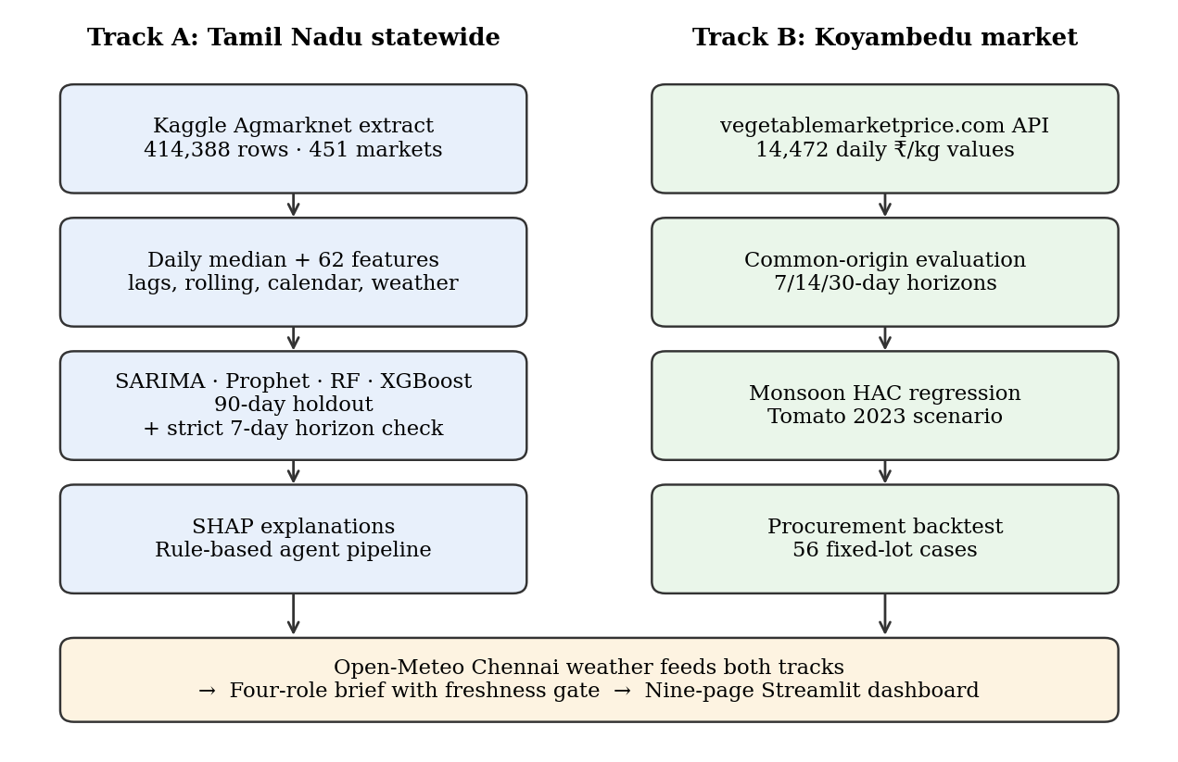
Figure 3.1: Analytical workflow of the AgriSight study
Source: Author’s design.

3.2 SOURCES OF DATA
Table 3.1: Data sources used in the study
Source | Content | Coverage | Use
Kaggle-hosted Agmarknet extract (Khandelwal, n.d.) | Market-level min, max and modal prices (₹/quintal), variety, grade | 414,388 rows; 451 markets; 36 districts; 24 Jan 2024 – 20 Apr 2026 | Track A modelling
Vegetable Market Price, Koyambedu history API | Daily price value per series (₹/kg), attributed to Koyambedu Vegetable Merchants’ Council | 14,472 values; 8 series × 1,809 days; 4 Nov 2021 – 17 Oct 2026 | Track B evaluation
Open-Meteo Historical Weather API (13.0827° N, 80.2707° E) | Daily precipitation, rain, max/mean/min temperature for Chennai | 1,004 days; 1 Jan 2024 – 30 Sep 2026 | Features; monsoon test
Press Information Bureau RSS (optional) | Official agriculture and price news items | Live mode only; not exercised in reported run | News Reader agent
Source: Khandelwal (n.d.); Vegetable Market Price (n.d.); Open-Meteo (n.d.).
Both price inputs are secondary data from public sources. Statewide data. The 2024–2026 annual files of the Kaggle dataset (Khandelwal, n.d.) were downloaded and filtered to Tamil Nadu, the eight vegetables and dates from 1 January 2024. The records were then cleaned: column names normalised column names, parses dates and numeric prices, maps commodity names (for example, “French Beans” and “Indian Beans (Seam)” to Beans) and removes duplicate date–market–commodity rows. The upstream compilation was not independently audited.
Koyambedu data. The public history API was queried in 180-day windows for 15 vegetable series, keeping every returned value with its unit label and extraction metadata. One series was then selected per study commodity without combining varieties: Big Onion represents Onion, French Beans is a provisional proxy for Beans, and regular Brinjal is kept separate from Big Brinjal. All values are copied unchanged; no interpolation is applied. The API labels the unit as 1 kg but does not state whether quotes are wholesale or retail.

3.3 TARGET RESPONDENTS, SAMPLING METHOD AND UNIT OF ANALYSIS
The project is analytical rather than survey-based, so there are no target respondents: no questionnaire or interview schedule was used, and the observations are market price records and weather readings. The intended users of the findings are procurement buyers (Section 1.2). The study uses all records available in the two sources after the filters above; it is not a sample survey and no probability sampling was involved. For Track A the unit of analysis is the commodity-day: market-level modal prices are aggregated to the daily statewide median for each vegetable, giving a feature table of 4,041 commodity-days (26 February 2024 to 20 April 2026) after the first 30 days of each series are consumed by lag construction. For Track B the unit is the commodity-day at Koyambedu (1,809 days per series). Forecast evaluation units are forecast origins × horizons × commodities.

3.4 DATA PROCESSING, VARIABLES AND FEATURE ENGINEERING
Data processing followed a fixed sequence: column names and dates were standardised, commodity names were mapped to the eight study vegetables, duplicate date–market–commodity records were removed, implausible values were flagged or removed (Section 4.2), market records were aggregated to a daily median, and gaps of up to three days were carried forward. The target in both tracks is the daily price level. Predictors were constructed for Track A in the groups listed in Table 3.2. Rolling statistics, exponential moving averages and momentum are computed on the price series shifted by one day, and weather sums and maximum temperature are lagged by one day, so that no same-day information enters a prediction. Three market records were also removed above ₹100,000 per quintal (a Drumstick value of ₹180,000 and Tomato values of ₹353,000 and ₹404,000), which are almost certainly entry errors.
Table 3.2: Feature groups constructed for the statewide models
Group | Features | Count
Own-price lags | Price 7, 14, 21 and 30 days earlier | 4
Rolling statistics | 7/14/30-day mean and standard deviation; 7/14-day min and max (all from t-1) | 10
Trend and momentum | 7/14/30-day EMA; 7/14/30-day % change; acceleration; position within 52-week range | 8
Calendar | Month, week of year, quarter, day of week, year, days since start | 6
Season and festival flags | SW monsoon (Jun–Sep), NE monsoon (Oct–Dec), Pongal, Tamil New Year, Diwali, Navratri | 6
Cross-commodity | Previous-day statewide price of each of the eight vegetables | 8
Market breadth | Number of reporting markets on the previous day | 1
Weather | 7- and 30-day rainfall sums, max temperature (t-1), heat-wave and cold-day flags | 5
Source: Author’s analysis. The tree models use 38 of these features (Appendix 2).
Two properties of this design matter for interpretation and are tested in Chapter 4. First, the target is the same-day price while the newest price information in the features is from the previous day, so the statewide holdout measures next-day forecasting skill even though several features are named after 7- to 30-day lags. Second, the cross-commodity block includes each model’s own commodity, so every model sees its own price from the previous day.
For Track B, a compact feature set is built for each horizon h directly from information available at the forecast origin: price at lags 1, 7, 14 and 30 days; 7- and 30-day means and standard deviations; 30-day minimum and maximum; 7-day momentum; and sine–cosine encodings of the target date’s day of year and weekday. Each model is trained only on (feature, target) pairs whose target date is on or before the origin.

3.5 FORECASTING MODELS
Table 3.3: Models and key settings
Model | Specification | Track
Naive (last value) | Forecast = most recent observed price | A, B
Seasonal naive (weekly) | Forecast = latest observed price on the target weekday; identical to the naive value at 7- and 14-day horizons | B1
SARIMA | Grid p∈{1,2}, q∈{0,1}, P,Q∈{0,1}; d from ADF (p<0.05 → d=0); D=1, m=7; best AIC. Track B: (1,1,1)(1,1,1,7) | A, B
Prophet | Track A: multiplicative yearly and weekly seasonality, Tamil Nadu holiday calendar ±3 days, SW/NE monsoon regressors, changepoint prior 0.05. Track B: yearly and weekly seasonality only | A, B
Random Forest | 300 trees, max depth 10, min leaf 5, max features 0.7 (Track B: 120 trees) | A, B
XGBoost | 400 trees, depth 5, learning rate 0.05, subsample 0.8, L1 0.1, L2 1 (Track B: 100 trees, depth 3) | A, B
Source: Author’s analysis.

3.6 EVALUATION PROTOCOLS
Because forecasting is temporal, every evaluation is chronological: models are trained only on data before the test period. Seven protocols were used (Table 3.4). Protocols A1 and A2 follow a standard holdout design; B1 and B2 meet objective S01 with matched origins and horizons; A3 is a robustness check on the information horizon of A2.
Table 3.4: Evaluation protocols
Code | Data | Design | Horizon
A1 | Statewide | Static: train on all but last 90 days, forecast 90 days (SARIMA, Prophet); SARIMA also refitted every 7 days | 1–90 days; 1–7 days (WF)
A2 | Statewide | Last 90 days, expanding window refitted every 30 days (RF, XGBoost) | Next day
A3 | Statewide | A2 repeated with naive benchmarks and with features rebuilt from t-7 and earlier | Next day vs strict 7 days
B1 | Koyambedu | 7 origins (1 Jan 2025 to 1 Jul 2026, quarterly), 6 methods, direct forecasts | 7, 14, 30 days
B2 | Koyambedu | 4 origins (23 Aug 2025 to 18 Aug 2026, 120-day spacing), 5 methods | 7, 14, 30 days
C1 | Koyambedu | Delta-accuracy test: XGBoost on price features only vs with weather context; 27 weekly origins over a six-month holdout (Apr–Sep 2026) | 7, 14, 30 days
C2 | Koyambedu | Tomato 2023 scenario: 13 weekly origins, 1 Apr to 24 Jun 2023, model retrained at each origin | 14 and 30 days
Source: Author’s analysis.

3.7 STATISTICAL TOOLS AND ACCURACY MEASURES
With y the actual and ŷ the forecast price over n scored points, the following measures are reported:
- MAE = (1/n) Σ |y − ŷ|, in the price unit (₹/quintal or ₹/kg).
- RMSE = √[(1/n) Σ (y − ŷ)²], which penalises large misses more heavily.
- MAPE = (100/n) Σ |y − ŷ| / |y|; intuitive but inflated when prices are low.
- WAPE = 100 × Σ |y − ŷ| / Σ |y|; the primary pooled measure for Track B because it weights errors by price level.
- sMAPE = (100/n) Σ 2|y − ŷ| / (|y| + |ŷ|).
- Diebold–Mariano (DM) test: tests whether two forecasts have equal expected absolute error, using the mean loss difference with HAC standard errors; used for the delta-accuracy test (protocol C1).
Other tools used are: the ADF test for stationarity (null hypothesis: unit root); AIC for SARIMA order selection; rolling z-scores (|z| > 2.5 over 30 days) for anomaly screening; Pearson correlation of monthly medians; a seasonal price index (monthly median ÷ annual mean × 100); SHAP values for model attribution; and OLS regression with HAC (Newey–West) standard errors with seven lags for the monsoon test. The monsoon model, estimated per commodity on Koyambedu data, is:
R(t, t+7) = β₀ + β₁ · RainAnomaly₇(t) + β₂ · Momentum₇(t) + ε(t) (3.1)
where R is the forward seven-day log price change (%), RainAnomaly₇ is the seven-day average of daily rainfall expressed as a z-score relative to other days of the same month in the weather record, and Momentum₇ is the prior seven-day log price change (%). H2 is supported if β₁ in Equation (3.1) is significant at the 5% level. As the proposal specified, the monsoon effect is also ranked against price-lag features using SHAP, with a Northeast Monsoon deviation index defined as the 30-day rainfall total standardised against the same calendar month, set to zero outside October–December.

3.8 MULTI-AGENT DECISION LAYER
Two implementations of the decision layer were built. The deterministic agent pipeline runs four agents in sequence: a Data Analyst computing 30-day mean, standard deviation, coefficient of variation, z-score of the latest price and seven-day trend; a Price Forecaster producing 7- and 14-day forecasts from the selected tree model; a Market Intelligence agent computing a risk score; and a Procurement Advisor mapping forecast change and risk to an action. The four-role pipeline implements the four roles named in the proposal (Data Collector, Price Forecaster, News Reader and Report Writer), produces recursive day-by-day forecasts, adds a freshness gate that abstains when prices are more than three days old, and can optionally fetch a live weather forecast, filter PIB news and call a locally hosted language model. The rules are shown in Table 3.5.
Table 3.5: Risk and procurement decision rules
Element | Rule
Risk score | min(100, 120 × CV₃₀ + 12 × |z₃₀| + 1.2 × |Δ₁₄|), where Δ₁₄ is the 14-day forecast change (%)
Risk level | HIGH if score ≥ 55; MEDIUM if ≥ 28; otherwise LOW
PROCURE NOW | Δ₁₄ > +5% and risk not HIGH → buy 70–100% within 1–2 days
DELAY PROCUREMENT | Δ₁₄ < −5% → defer discretionary volume; reassess in 7 days
PARTIAL PROCUREMENT | risk HIGH (and not DELAY) → buy 25–50%, split over 7–14 days
HEDGE | |Δ₁₄| > 3% → buy 25–50%, split over 7–14 days
HOLD | otherwise → normal replenishment
Freshness gate (four-role pipeline) | If latest price is more than 3 days old → ABSTAIN_STALE_DATA for every commodity
Source: Author’s analysis.

3.9 PROCUREMENT BACKTEST DESIGN
The backtest applies the rules in Table 3.5 to the stored 14-day XGBoost forecasts from protocol B1 (8 commodities × 7 origins = 56 cases). Each case is a fixed 100 kg lot. The baseline purchases all 100 kg on the forecast date. PROCURE NOW and HOLD do the same; DELAY purchases all of it fourteen days later at the price then observed; PARTIAL PROCUREMENT and HEDGE buy half at the origin and half at day 14. The result is the baseline cost minus the advice cost, so a positive value means the advice was cheaper. The same logic is applied to the 2023 tomato case, at 13 weekly origins from 1 April to 24 June 2023, with a 14-day XGBoost model retrained at each origin on data available up to that date. Storage, transport, spoilage, quality and stockout costs are excluded.

3.10 TOOLS AND SOFTWARE
All analysis was carried out in Python 3.12 using pandas 3.0 and NumPy 2.4 for data handling, statsmodels 0.15 for SARIMA, ADF and HAC regression (Seabold & Perktold, 2010), Prophet 1.5 (Taylor & Letham, 2018), scikit-learn 1.8 for Random Forest (Pedregosa et al., 2011), XGBoost 3.4 (Chen & Guestrin, 2016), SHAP 0.54 (Lundberg & Lee, 2017) and Matplotlib 3.10 for charts. The dashboard uses Streamlit 1.66. The complete pipeline was rerun end to end for this report; the run order and environment are recorded in Appendices 3 and 4.

3.11 ETHICAL CONSIDERATIONS
The study uses only publicly available aggregate market and weather data; no personal data were collected. Sources are cited and their limitations are stated. Results are reported as produced by the code, including results that do not support the original hypotheses, and no procurement savings are claimed that the evidence cannot support.

3.12 DEVIATIONS FROM THE APPROVED PROPOSAL
Table 3.6 lists each point on which the study departs from the approved project proposal, the reason, and where the matter is addressed. None of the changes alters the objectives; most arise from data that could not be obtained.
Table 3.6: Deviations from the approved proposal and their treatment
Proposal | This study | Reason / where addressed
Daily Agmarknet modal prices for Koyambedu, Jan 2010 – Jun 2026 | Koyambedu history-page series, Nov 2021 – Oct 2026; statewide Agmarknet compilation, Jan 2024 – Apr 2026 | Agmarknet’s Koyambedu history could not be retrieved programmatically; the available Agmarknet compilation begins in 2024 (Section 3.2)
Temporal holdout: train 2010–2022, test 2023–2026 | Rolling-origin evaluation (7 and 4 origins, 2025–2026); 2023 episode as a retrospective scenario | Shorter history; rolling origins give more independent test points (Section 3.6)
Comparison against the published SARIMA benchmark | Qualitative comparison only | The published study is monthly; daily 7–30-day errors are not comparable (Section 2.2)
Market arrival volume as a predictor | Not used | Not available in either price source (Section 5.5)
NE Monsoon deviation ranked with SHAP | SHAP ranking plus a formal HAC regression test | SHAP ranks contributions but does not test significance (Section 4.11)
AgriSight runs the best-performing model | AgriSight runs the tree models; the naive forecast performed best | Pipeline built before evaluation; recommendation in Section 5.3
Weekly brief from a locally hosted LLM | Implemented, run on demand; live run pending | Section 4.12
Delta accuracy: XGBoost vs context-enriched AgriSight, six-month holdout | XGBoost with vs without weather context, six-month holdout | Historical policy news is not archived, so only weather context could be tested (Section 4.11.3)
Economic value of the 30-day forecast before July 2023 | Done for 30-day and 14-day forecasts | Section 4.14
Tomato reached ₹200/kg, a ~700% spike | Koyambedu peak ₹160/kg on 1 Aug 2023, 9–12 times the April–May level | ₹200/kg refers to retail reports (Section 1.1)
Two published Koyambedu SARIMA studies; Bari et al. (2024) | One Koyambedu study cited; Bari et al. not cited | Only Tamilselvi and Mohan Naidu (2020) and not Bari et al. could be located and verified
Source: Approved project proposal; author’s analysis.

3.13 ASSUMPTIONS, CONSTRAINTS AND LIMITATIONS
Assumptions. The analysis assumes that the published price values are recorded consistently over time; that the statewide daily median is a reasonable summary of reporting markets; that Chennai weather is a usable proxy for conditions affecting Koyambedu supply; and, in the backtests, that a buyer can purchase the required quantity at the observed price on the chosen day.
Source verification. Neither price source’s upstream collection process was independently audited, and the Koyambedu API does not state whether quotes are wholesale or retail. The statewide median combines farmers’ and wholesale markets. Data availability. Market-arrival volumes, producer-region weather, archived policy news and buyer transaction records were unavailable, and the price history is shorter than the proposal envisaged (Table 3.6).
Limitations. Results describe these series, horizons and periods and may not generalise to other markets or years; procurement results are counterfactual rather than realised savings. The full list of limitations is given in Section 5.5.
CHAPTER 4

DATA ANALYSIS AND INTERPRETATION
This chapter presents the results in the order of the research questions: the data and their quality (Sections 4.1–4.4), statewide forecasting and its diagnosis (4.5–4.7), Koyambedu multi-horizon evaluation (4.8–4.10), the monsoon and weather-context tests (4.11), the multi-agent decision layer (4.12), the procurement backtest and Tomato episode retrospective analysis (4.13–4.14), and a summary of hypotheses and objectives (4.15–4.16). All figures and tables come from a single end-to-end run of the analysis pipeline (Appendices 3 and 4).

4.1 PROFILE OF THE STATEWIDE DATA
The statewide extract contains 414,388 market-level records for the eight vegetables from 451 markets in 36 districts between 24 January 2024 and 20 April 2026, with no missing values in any field. After aggregation to the daily statewide median and construction of 30-day lag features, the modelling table contains 4,041 commodity-days (about 504 days per vegetable) and 62 columns.
Table 4.1: Statewide records and daily median modal price (₹/quintal)
Commodity | Market records | Days | Mean | Median | Std. dev. | Min | Max | CV
Beans | 48,382 | 506 | 6,979 | 7,000 | 2,032 | 110 | 16,000 | 29%
Brinjal | 55,050 | 504 | 4,048 | 4,000 | 1,028 | 50 | 6,400 | 25%
Cabbage | 49,072 | 504 | 2,723 | 2,500 | 790 | 48 | 5,000 | 29%
Carrot | 49,130 | 504 | 6,061 | 6,000 | 2,010 | 70 | 12,500 | 33%
Drumstick | 50,268 | 504 | 8,240 | 7,000 | 5,103 | 100 | 21,500 | 62%
Onion | 59,560 | 503 | 3,993 | 3,250 | 1,543 | 45 | 7,000 | 39%
Potato | 47,305 | 504 | 4,078 | 4,000 | 951 | 48 | 5,500 | 23%
Tomato | 55,621 | 512 | 2,774 | 2,500 | 1,331 | 40 | 6,500 | 48%
Total / range | 414,388 | 4,041 |  |  |  |  |  | 23–62%
Source: Author’s analysis of the statewide data.
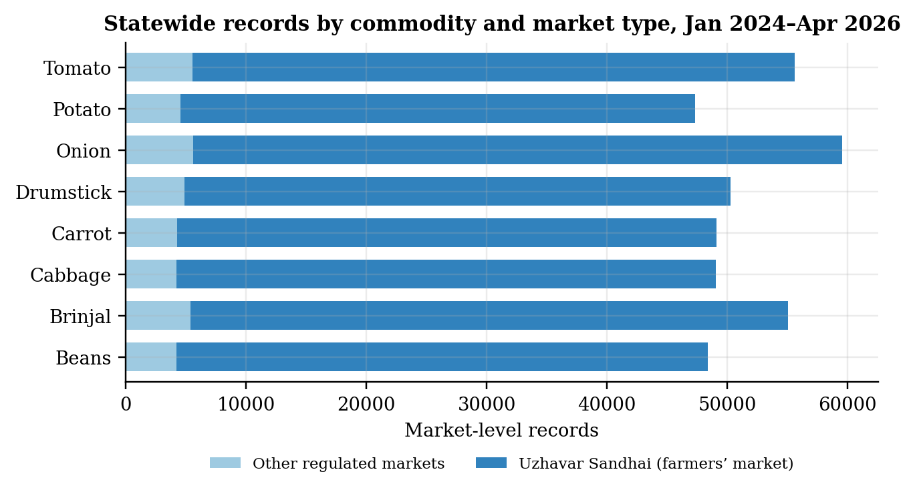
Figure 4.1: Statewide market-level records by commodity and market type
Source: Author’s analysis.
Interpretation. Drumstick (CV 62%) and Tomato (48%) are the most volatile series and Potato (23%) and Brinjal (25%) the least, consistent with the perishability ranking expected from the literature. The most important structural fact is shown in Figure 4.1: 90.7% of all records come from Uzhavar Sandhai, the state’s farmers’ markets, and only 9.3% from other regulated markets. A “statewide median” in this dataset is therefore largely a farmers’-market price. It is closer to a retail price than to the bulk wholesale price a procurement buyer pays, and this conditions every downstream use of Track A.

4.2 DATA QUALITY ASSESSMENT
Table 4.2: Data quality checks on the statewide data
Check | Result | Treatment
Missing values | None in any of 10 fields | None needed
Duplicate date–market–commodity keys | Removed during cleaning | Last record kept
Extreme values > ₹100,000/quintal | 3 records (Drumstick ₹180,000; Tomato ₹353,000 and ₹404,000) | Removed and logged
Implausibly low values < ₹300/quintal | 11,344 records (2.74%), 7,562 of them in June 2024 | Not removed; flagged as likely per-kg entries
Commodity-days affected by low values | 104 of 4,041 (12 per vegetable; 20 for Tomato) | Inflate holdout errors when in the test window
Rolling z-score anomalies (Tomato, |z| > 2.5) | 34 days | Retained; genuine spikes and data errors
Calendar gaps | Up to 3 missing days forward-filled; longer gaps left missing | Rows with incomplete features dropped
Source: Author’s analysis.
Interpretation. The data are complete but not clean. The cluster of values below ₹300 per quintal in June–July 2024, when the same vegetables otherwise trade at ₹2,000–8,000, is consistent with prices entered per kilogram in a per-quintal field. These days appear as sharp troughs in Figure 4.2. They also strengthen the cross-commodity correlations, because all eight series fall together on those days. They should be corrected at source before any operational use.
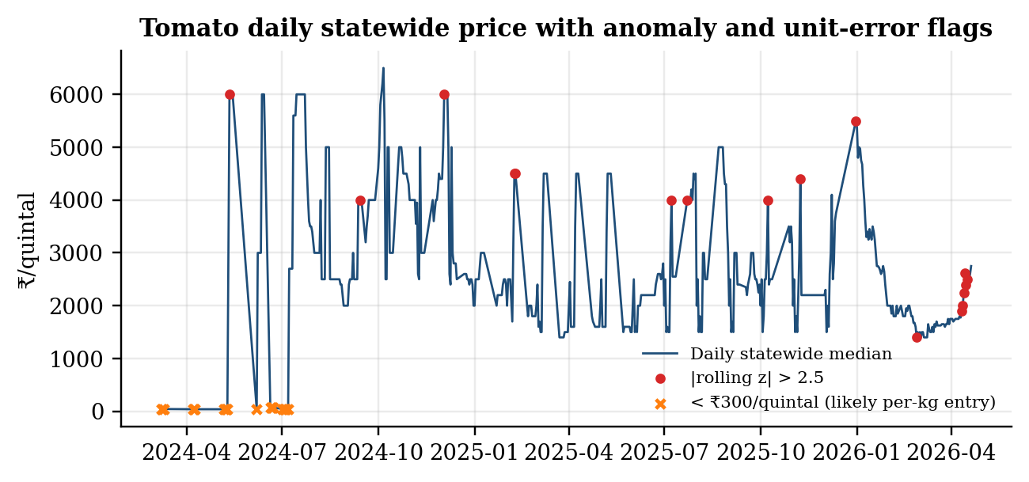
Figure 4.2: Tomato daily statewide median with rolling-z anomalies and suspected unit errors
Source: Author’s analysis.

4.3 PRICE BEHAVIOUR: TREND, SEASONALITY AND CO-MOVEMENT
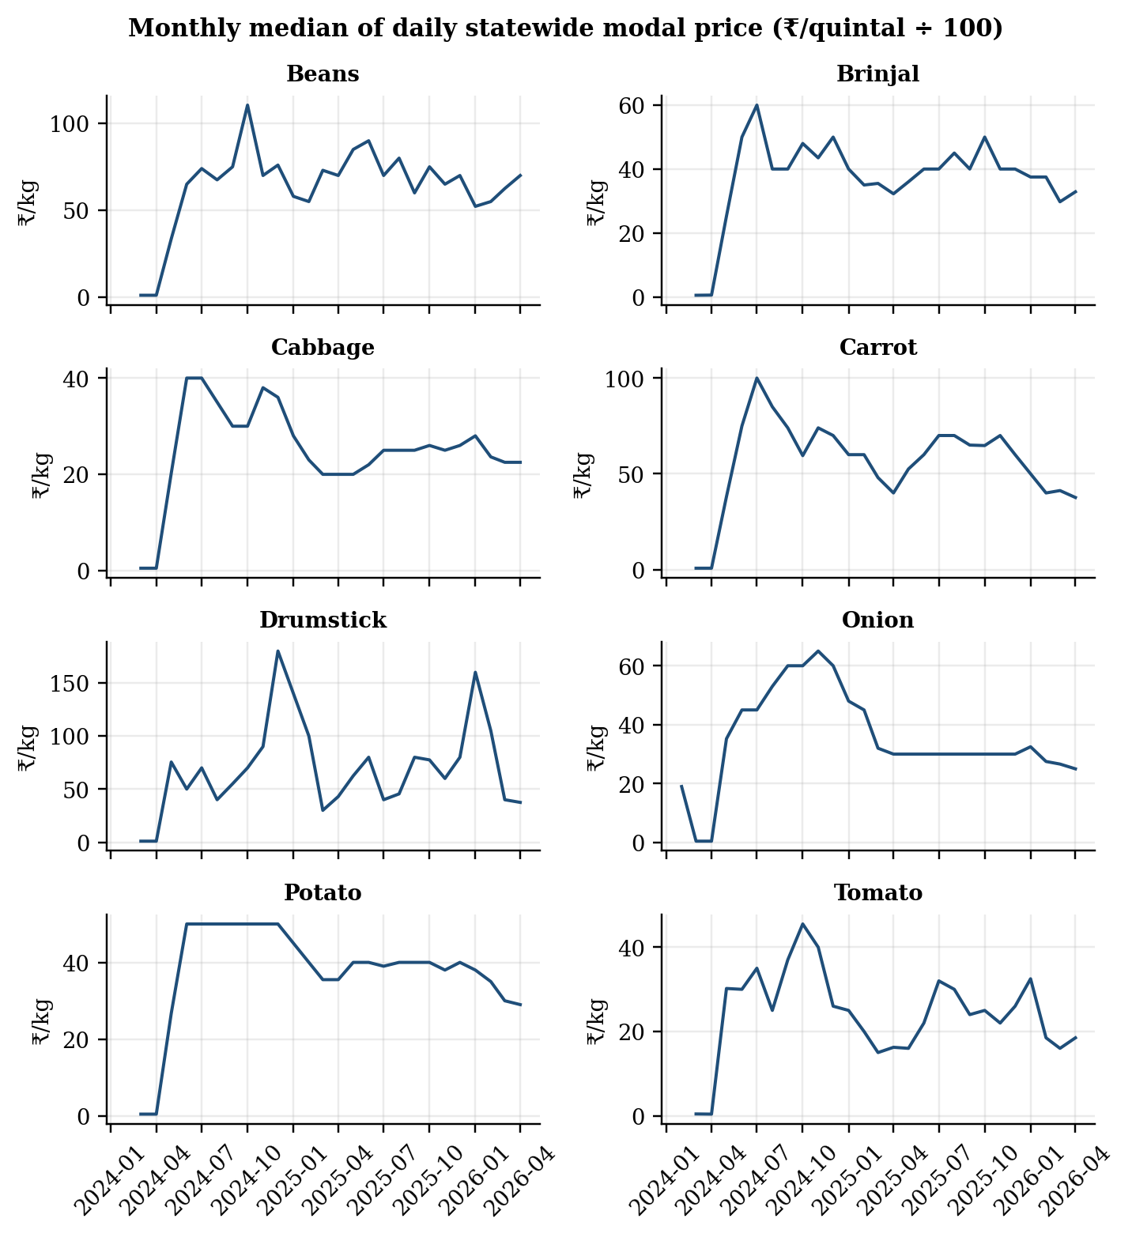
Figure 4.3: Monthly median of daily statewide modal price by commodity
Source: Author’s analysis.
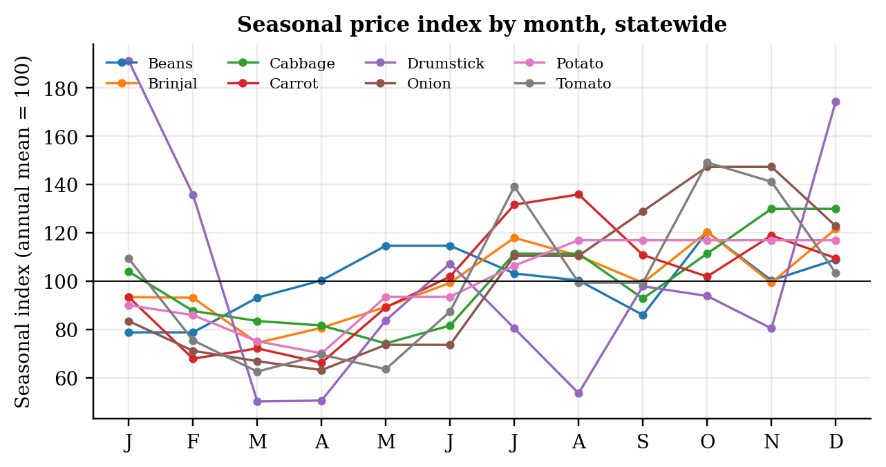
Figure 4.4: Seasonal price index by calendar month (annual mean = 100)
Source: Author’s analysis.
Interpretation of seasonality. Over the 27 months available, most vegetables were cheapest between March and May and dearest in the second half of the year. Tomato’s index ranges from 63 in March to 149 in October, Onion’s from 63 in April to 147 in October, and Carrot and Potato peak in August (136 and 117). Drumstick shows the widest swing, from 50 in March to 191 in January. With only about two observations of each calendar month, these indices are indicative rather than stable estimates, but they agree with the national pattern reported by Ajmal et al. (2024) and Roy et al. (2024), which describes tomato as dearest in the second half of the year and onion as peaking towards the end of the year.
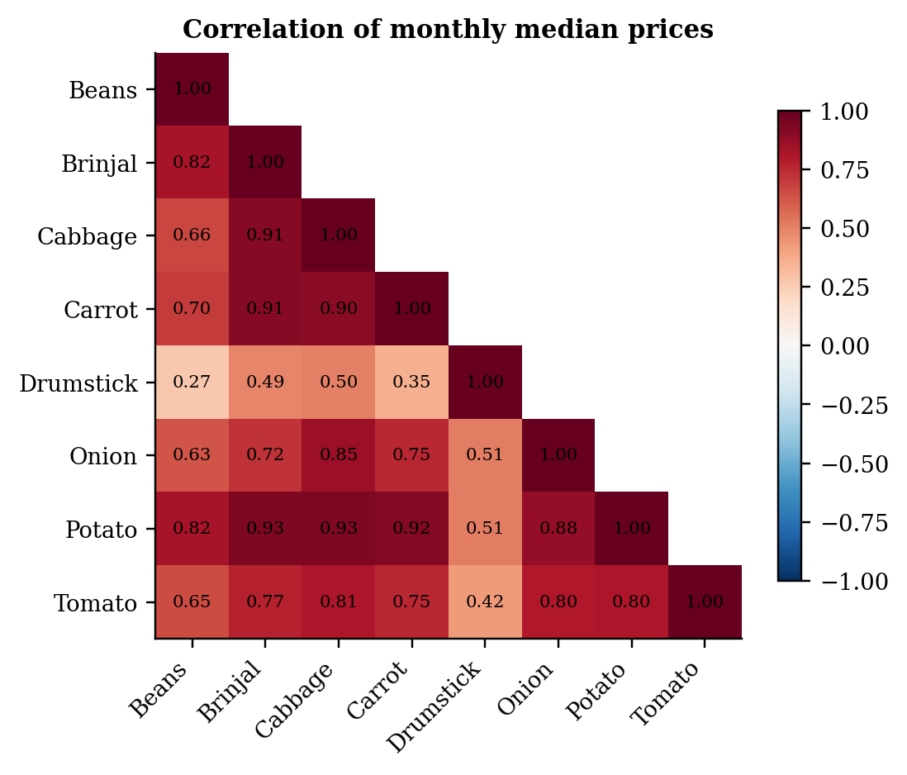
Figure 4.5: Correlation of monthly median prices across commodities
Source: Author’s analysis.
Interpretation of co-movement. Brinjal, Cabbage, Carrot and Potato move closely together (r = 0.90–0.93), and Tomato and Onion correlate at 0.80 with each other and with Potato. Drumstick is largely independent of the others (r = 0.27–0.51), consistent with its distinct tree-crop supply cycle. Part of the high co-movement reflects the common unit-error days noted in Section 4.2. Nonetheless, the pattern supports the use of cross-commodity features and matches the horizontal volatility transmission found by Padhi et al. (2023).

4.4 STATIONARITY TESTING
Table 4.3: Augmented Dickey–Fuller test on daily statewide median price
Commodity | ADF statistic | p-value | Lags used | Decision (5%)
Beans | -3.99 | 0.0014 | 5 | Reject unit root
Brinjal | -4.37 | 0.0003 | 4 | Reject unit root
Cabbage | -4.82 | <0.0001 | 1 | Reject unit root
Carrot | -4.66 | 0.0001 | 2 | Reject unit root
Drumstick | -5.63 | <0.0001 | 4 | Reject unit root
Onion | -5.15 | <0.0001 | 2 | Reject unit root
Potato | -4.43 | 0.0003 | 2 | Reject unit root
Tomato | -6.25 | <0.0001 | 6 | Reject unit root
Source: Author’s analysis.
Interpretation. The null hypothesis of a unit root is rejected for all eight series at the 1% level. Over this window the daily prices are mean-reverting around a level rather than drifting like a random walk. This is consistent with the SARIMA order selection in Table 4.4, where d = 0 was chosen for every commodity, and with the negative momentum coefficients found in Section 4.11.

4.5 STATEWIDE FORECASTING RESULTS
Table 4.4: Statewide 90-day holdout MAPE (%) by commodity and model
Commodity | SARIMA order | SARIMA static | SARIMA 7-day WF | Prophet | Random Forest | XGBoost | Naive (static)
Beans | (1,0,1)(0,1,1)₇ | 9.88 | 5.33 | 14.36 | 11.35 | 14.87 | 11.93
Brinjal | (1,0,1)(0,1,1)₇ | 20.62 | 6.52 | 11.27 | 13.05 | 14.68 | 14.33
Cabbage | (2,0,1)(0,1,1)₇ | 12.66 | 7.30 | 8.46 | 6.11 | 7.84 | 20.06
Carrot | (2,0,1)(0,1,1)₇ | 52.24 | 11.90 | 34.52 | 10.43 | 11.58 | 29.50
Drumstick | (2,0,0)(1,1,1)₇ | 55.81 | 23.07 | 31.76 | 19.97 | 25.72 | 225.66
Onion | (1,0,1)(1,1,1)₇ | 34.46 | 7.07 | 18.91 | 9.36 | 11.86 | 21.08
Potato | (1,0,1)(0,1,1)₇ | 21.55 | 6.51 | 10.34 | 8.00 | 9.81 | 18.49
Tomato | (1,0,1)(0,1,1)₇ | 53.57 | 15.99 | 25.05 | 12.26 | 15.49 | 51.65
Mean |  | 32.60 | 10.46 | 19.33 | 11.32 | 13.98 | 49.09
Source: Author’s analysis (protocols A1 and A2). “Naive (static)” repeats the last training value for all 90 days.
Table 4.5: Statewide holdout RMSE and MAE (₹/quintal)
Commodity | SARIMA WF RMSE | Prophet RMSE | RF RMSE | XGBoost RMSE | RF MAE | XGBoost MAE
Beans | 410 | 1,121 | 800 | 1,038 | 609 | 810
Brinjal | 285 | 455 | 514 | 602 | 404 | 453
Cabbage | 213 | 266 | 179 | 222 | 140 | 179
Carrot | 586 | 1,505 | 551 | 614 | 421 | 468
Drumstick | 1,410 | 1,979 | 1,513 | 2,019 | 1,119 | 1,352
Onion | 230 | 591 | 313 | 428 | 259 | 333
Potato | 257 | 380 | 322 | 383 | 247 | 302
Tomato | 344 | 602 | 283 | 362 | 234 | 291
Source: Author’s analysis.
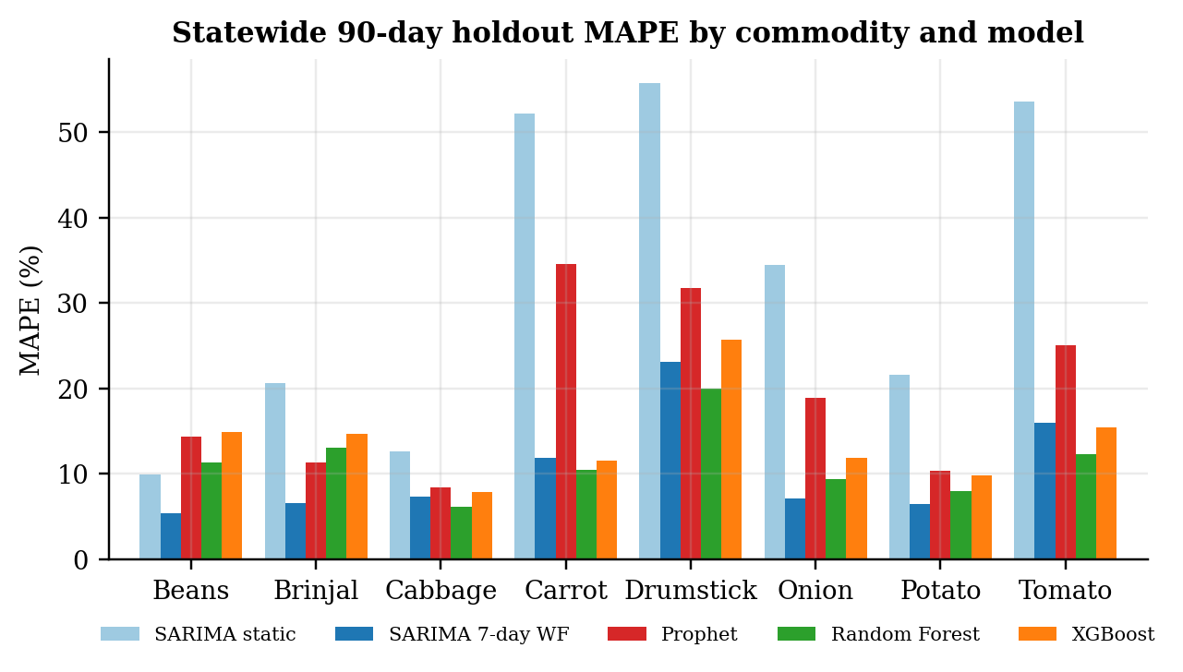
Figure 4.6: Statewide 90-day holdout MAPE by commodity and model
Source: Author’s analysis.
Interpretation. Three conclusions follow, but they must be read with the protocol differences in Table 3.4 in mind.
- Static forecasts are poor. A single 90-day SARIMA forecast averages 32.60% MAPE and Prophet 19.33%. Over a full quarter both models largely extrapolate a level or trend that the market then departs from, with errors above 50% for Carrot, Drumstick and Tomato under SARIMA.
- Frequent refitting matters more than model class. Refitting SARIMA every seven days cuts its error to 10.46%, better than both tree models on average. Random Forest (11.32%) beat XGBoost (13.98%) for all eight commodities.
- Note on second-review figures. The tree-model error presented at the second review (6.28%) came from an earlier feature build and could not be reproduced. The figures above are the reproducible results and supersede it.
More importantly, Protocol A2 scores next-day predictions, because the newest price information in the features is from the previous day (Section 3.4). Whether a 10–14% next-day error is good can only be judged against a next-day benchmark. Section 4.6 provides that benchmark.

4.6 HORIZON SENSITIVITY: IS THE STATEWIDE ACCURACY REAL FORECASTING SKILL?
Protocol A3 reruns A2 on the identical 90-day test window and adds two naive benchmarks and two altered XGBoost feature sets: one without the model’s own previous-day price, and one in which every price and cross-commodity feature is rebuilt from information at least seven days old, which is a genuine seven-day-ahead forecast.
Table 4.6: Horizon sensitivity on the statewide 90-day test window: MAPE (%)
Commodity | Naive: yesterday | Naive: 7 days ago | XGBoost (original features) | XGBoost w/o own t-1 | XGBoost strict 7-day
Beans | 4.08 | 13.29 | 13.85 | 13.71 | 22.60
Brinjal | 5.10 | 7.91 | 12.98 | 13.63 | 14.34
Cabbage | 4.80 | 5.99 | 6.55 | 6.39 | 6.08
Carrot | 4.30 | 6.77 | 10.30 | 9.61 | 12.71
Drumstick | 5.90 | 16.61 | 25.62 | 31.21 | 94.71
Onion | 1.74 | 4.69 | 9.76 | 10.19 | 15.96
Potato | 3.54 | 5.45 | 9.32 | 8.95 | 8.75
Tomato | 4.16 | 12.08 | 21.28 | 21.33 | 41.59
Mean | 4.20 | 9.10 | 13.71 | 14.38 | 27.09
Source: Author’s analysis (protocol A3).
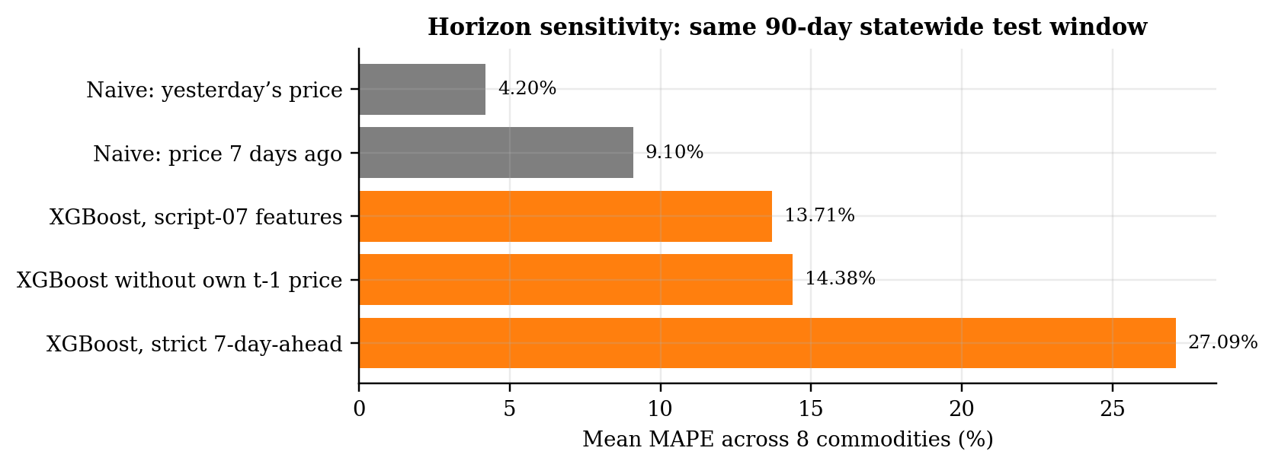
Figure 4.7: Mean MAPE of naive benchmarks and XGBoost variants on the same test window
Source: Author’s analysis.
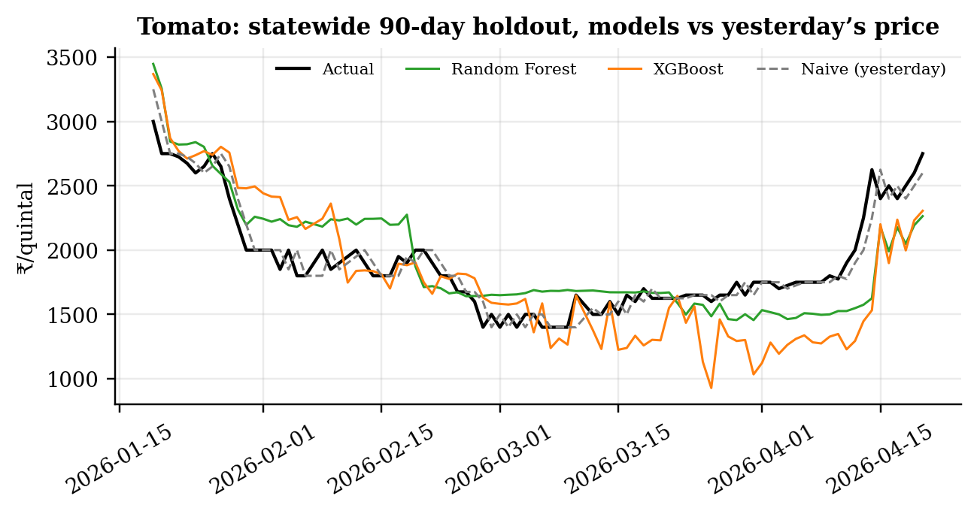
Figure 4.8: Tomato statewide holdout: actual price, Random Forest, XGBoost and yesterday’s price
Source: Author’s analysis.
Interpretation. This is the pivotal result of Track A. Simply using yesterday’s price gives 4.20% mean MAPE, beating XGBoost (13.71%) for every one of the eight commodities. Even the price from seven days earlier (9.10%) beats the tree models’ next-day predictions. When XGBoost is forced to forecast genuinely seven days ahead, its error rises to 27.09%, three times the seven-day naive benchmark, with especially poor results for Drumstick (94.71%) and Tomato (41.59%).
The tree models therefore do not add forecasting skill on this data; they add noise to a persistence signal. Two causes are likely. First, the daily statewide median is a noisy aggregate of about 80–160 reporting markets whose composition changes day to day. Second, with only about 400 training days per commodity and 38 features, the models overfit transient patterns. For a procurement buyer the practical lesson is that the minimum benchmark for any vendor or in-house forecast is the latest observed price at the horizon of the decision.

4.7 MODEL EXPLANATION WITH SHAP
Table 4.7: Top three SHAP drivers and share of attribution from own previous-day price
Commodity | Driver 1 | Driver 2 | Driver 3 | Own t-1 share of |SHAP|
Beans | Beans price (t-1) | 52-week position | 7-day EMA | 16.64%
Brinjal | Brinjal price (t-1) | 52-week position | 30-day rainfall | 24.98%
Cabbage | 52-week position | 7-day max | Tomato price (t-1) | 2.58%
Carrot | Carrot price (t-1) | 7-day mean | 52-week position | 27.19%
Drumstick | Drumstick price (t-1) | 52-week position | Max temperature | 36.90%
Onion | 52-week position | 14-day EMA | Potato price (t-1) | 10.42%
Potato | 7-day mean | Price t-14 | 52-week position | 2.14%
Tomato | 52-week position | Tomato price (t-1) | 7-day max | 19.01%
Source: Author’s analysis (XGBoost refit on all eligible rows).
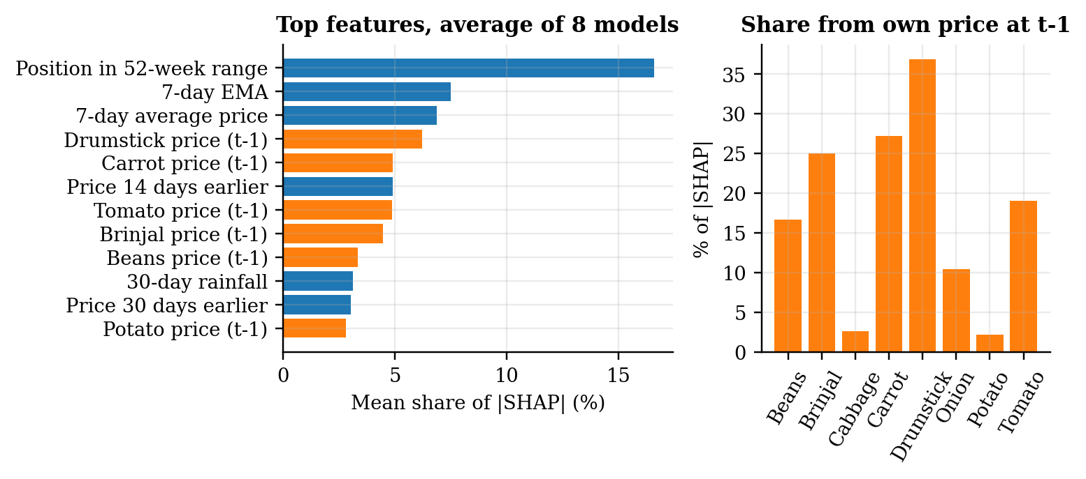
Figure 4.9: SHAP attribution: top features averaged over the eight models, and share from the own previous-day price
Source: Author’s analysis.
Interpretation. The position of the previous day’s price within its 52-week range is the most important feature on average, and each commodity’s own previous-day price (entered through the cross-commodity block) is the top driver for Beans, Brinjal, Carrot and Drumstick, accounting for 17–37% of total attribution in those models. Weather features appear in the top three only for Brinjal (30-day rainfall) and Drumstick (maximum temperature), and calendar and festival flags do not appear at all. In other words, the fitted models mostly encode “tomorrow will look like today, relative to the past year”. This agrees with the horizon-sensitivity result: the information that drives the predictions is persistence, which a naive forecast captures more cleanly. SHAP values describe model behaviour and are not causal effects (Molnar, 2022).

4.8 PROFILE OF THE KOYAMBEDU SERIES
Table 4.8: Koyambedu daily price series (₹/kg), 4 Nov 2021 – 17 Oct 2026
Series (study commodity) | Days | Mean | Median | Std. dev. | Min | Max | CV
French Beans (Beans) | 1,809 | 55.9 | 54 | 21.2 | 20 | 185 | 38.0%
Brinjal | 1,809 | 31.0 | 31 | 8.3 | 17 | 84 | 26.6%
Cabbage | 1,809 | 24.5 | 25 | 6.0 | 10 | 50 | 24.3%
Carrot | 1,809 | 43.5 | 42 | 10.1 | 22 | 74 | 23.3%
Drumsticks | 1,809 | 80.7 | 70 | 41.2 | 30 | 270 | 51.1%
Onion Big (Onion) | 1,809 | 31.6 | 29 | 10.9 | 16 | 69 | 34.6%
Potato | 1,809 | 29.7 | 29 | 5.7 | 14 | 49 | 19.2%
Tomato | 1,809 | 31.7 | 26 | 18.9 | 10 | 160 | 59.4%
Source: Author’s analysis of Vegetable Market Price (n.d.).
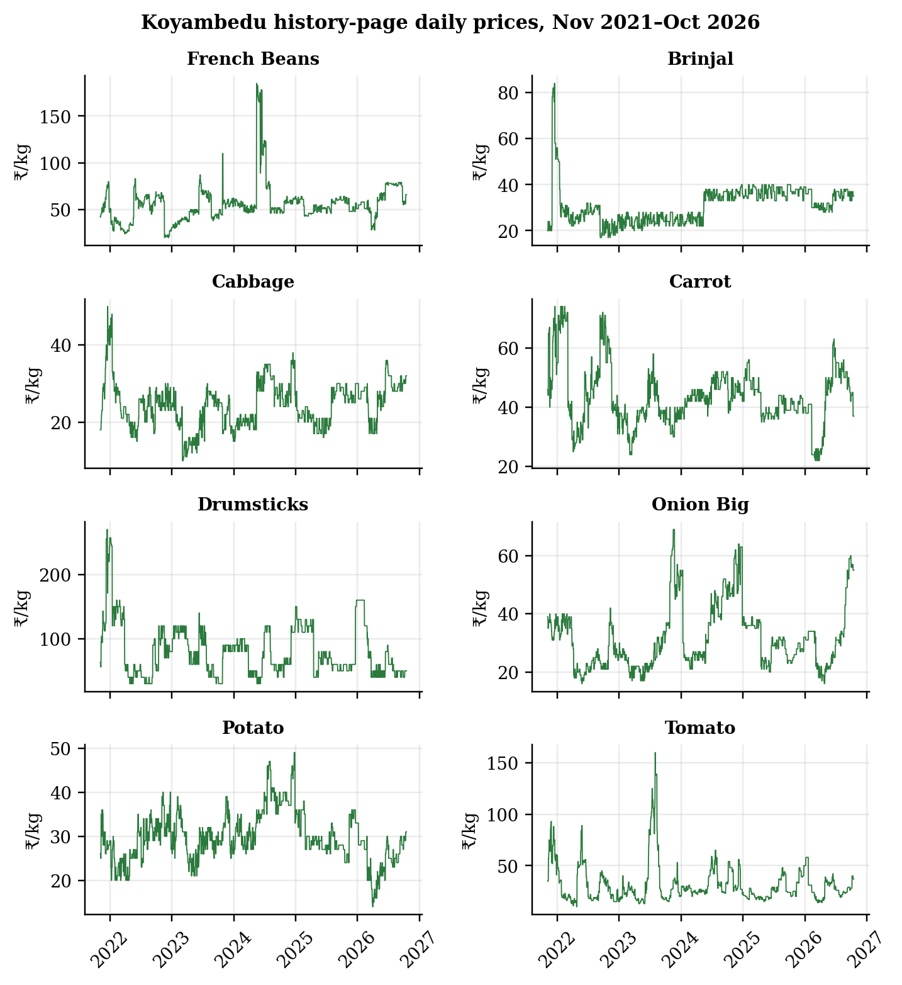
Figure 4.10: Koyambedu history-page daily prices by series
Source: Author’s analysis.
Interpretation. The Koyambedu panel is complete (1,809 consecutive days for each series, no gaps) and covers almost five years, including the 2023 tomato episode that the statewide data cannot reach. Tomato is again the most volatile series (CV 59.4%), followed by Drumsticks (51.1%) and French Beans (38.0%). Between 3 July and 22 August 2023 the Tomato series contains 51 daily observations, rising from ₹80/kg to a peak of ₹160/kg on 1 August (+100%) before falling to ₹49/kg on 22 August (−69.4%). Prices in this panel are in ₹/kg and are not directly comparable with the ₹/quintal statewide series.

4.9 KOYAMBEDU MULTI-HORIZON MODEL COMPARISON (PROTOCOL B1)
Six methods were evaluated at the same seven quarterly origins from 1 January 2025 to 1 July 2026, for 7-, 14- and 30-day horizons and all eight series, giving 168 scored forecasts per method.
Table 4.9: Koyambedu model comparison pooled over origins, series and horizons (₹/kg)
Model | Forecasts | MAE | RMSE | MAPE % | sMAPE % | WAPE %
NaiveLast | 168 | 4.89 | 9.99 | 12.28 | 11.57 | 11.88
SARIMA | 168 | 5.05 | 9.83 | 12.81 | 12.01 | 12.28
SeasonalNaive7 | 168 | 5.25 | 10.07 | 13.40 | 12.47 | 12.76
XGBoost | 168 | 6.32 | 10.82 | 14.35 | 13.66 | 15.36
RandomForest | 168 | 6.84 | 11.95 | 15.39 | 14.62 | 16.63
Prophet | 168 | 9.80 | 15.64 | 23.46 | 22.56 | 23.82
Source: Author’s analysis (protocol B1).
Table 4.10: Koyambedu WAPE (%) by forecast horizon
Model | 7 days | 14 days | 30 days
NaiveLast | 8.02 | 9.27 | 18.38
SeasonalNaive7 | 8.02 | 9.27 | 21.05
SARIMA | 8.17 | 9.61 | 19.11
XGBoost | 11.63 | 15.71 | 18.73
RandomForest | 10.75 | 18.01 | 21.13
Prophet | 22.11 | 23.93 | 25.42
Source: Author’s analysis.
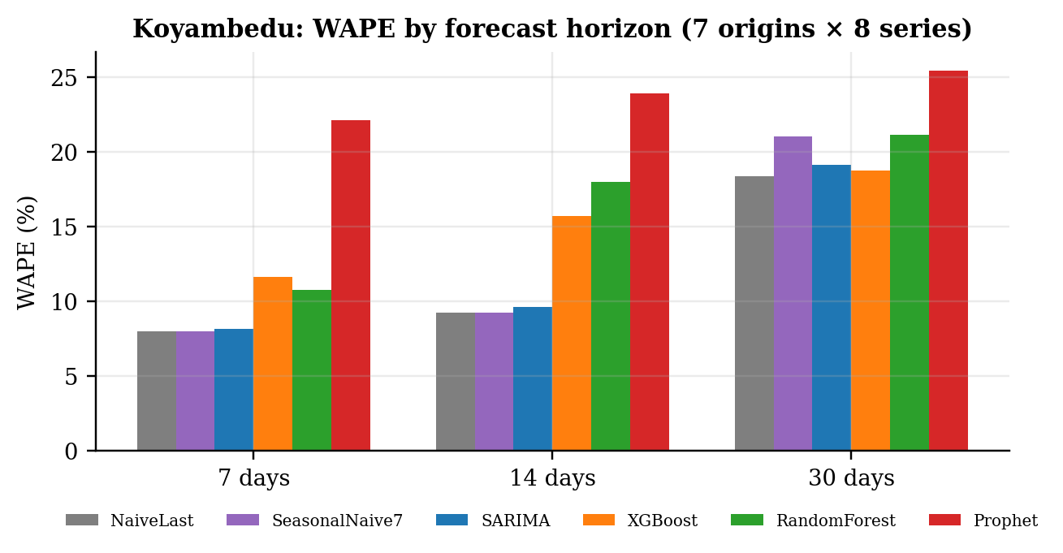
Figure 4.11: Koyambedu WAPE by forecast horizon and model
Source: Author’s analysis.
Table 4.11: Koyambedu WAPE (%) by series and model (lowest in bold)
Series | Naive | Seasonal naive | SARIMA | Prophet | Random Forest | XGBoost
Brinjal | 5.69 | 6.10 | 6.10 | 8.24 | 4.30 | 5.11
Cabbage | 11.02 | 13.78 | 12.90 | 17.07 | 12.81 | 11.62
Carrot | 9.07 | 9.62 | 10.01 | 14.79 | 8.49 | 8.42
Drumsticks | 17.13 | 17.13 | 16.61 | 30.75 | 25.97 | 22.74
French Beans | 9.89 | 9.40 | 9.85 | 22.25 | 16.41 | 15.98
Onion Big | 6.77 | 11.77 | 8.85 | 27.37 | 11.06 | 8.82
Potato | 9.36 | 11.48 | 10.17 | 9.92 | 15.00 | 12.72
Tomato | 20.98 | 21.34 | 20.81 | 56.57 | 27.78 | 28.29
Source: Author’s analysis.
Interpretation. At procurement-relevant horizons the last observed price is the best single forecast (11.88% WAPE), with SARIMA a close second (12.28%). Both tree models and Prophet are worse at every horizon. The ranking is stable across horizons: at 7 days the naive, seasonal-naive and SARIMA forecasts are all near 8%, and by 30 days all methods converge at 18–25%. The tree models win only for Brinjal (Random Forest, 4.30%) and Carrot (XGBoost, 8.42%), both low-volatility series. The naive forecast or SARIMA wins for the volatile ones (Tomato, Drumsticks, Onion, French Beans). The seasonal naive equals the naive forecast at 7 and 14 days by construction (Table 3.3), so its separate contribution appears only at 30 days, where it is worse. These results are consistent with the M-competition evidence that complex methods frequently fail to beat simple ones (Makridakis et al., 2018a).

4.10 MATCHED-HORIZON ROBUSTNESS CHECK (PROTOCOL B2)
Table 4.12: Koyambedu matched-horizon evaluation, 4 origins: mean MAPE (%) and MAE (₹/kg)
Model | MAPE 7d | MAPE 14d | MAPE 30d | MAE 7d | MAE 14d | MAE 30d
Naive (last value) | 8.58 | 12.94 | 17.31 | 3.44 | 5.78 | 6.72
SARIMA | 8.65 | 13.93 | 17.80 | 3.91 | 6.65 | 7.48
Random Forest | 9.85 | 15.45 | 17.97 | 4.62 | 7.13 | 7.22
XGBoost | 9.06 | 16.19 | 18.38 | 4.26 | 7.07 | 7.60
Prophet | 17.27 | 22.54 | 25.99 | 8.35 | 11.16 | 12.85
Source: Author’s analysis (protocol B2).
Interpretation. A second, independent set of four origins (23 August 2025 to 18 August 2026) gives the same ordering: the naive forecast is lowest at all three horizons (8.58%, 12.94% and 17.31% MAPE), SARIMA is close behind, and Prophet is worst. With only four origins the differences between the naive forecast, SARIMA and the tree models at 30 days are small and would not pass a formal significance test. The consistent conclusion across B1 and B2 is that no model reliably beats the naive benchmark, which answers research question 2 and leaves benchmark hypothesis H0 unrejected.

4.11 NORTHEAST MONSOON AND WEATHER CONTEXT

4.11.1 Regression test of the monsoon effect
Observed Chennai rainfall during the October–December Northeast Monsoon was 846.7 mm in 2024 and 965.5 mm in 2025, the only two complete seasons in the weather file. The HAC regression of Section 3.7 was estimated for each Koyambedu series on 1,000 overlapping daily observations.
Table 4.13: HAC regression of forward 7-day price return on rainfall anomaly and prior momentum
Commodity | n | β₁ rain | HAC s.e. | p (β₁) | β₂ momentum | p (β₂) | R²
Tomato | 1000 | 2.73 | 2.43 | 0.262 | -0.086 | 0.021 | 0.013
Onion | 1000 | -0.41 | 1.74 | 0.815 | -0.148 | 0.020 | 0.022
Potato | 1000 | -0.10 | 0.98 | 0.921 | -0.270 | <0.001 | 0.073
Cabbage | 1000 | -0.56 | 1.15 | 0.622 | -0.317 | <0.001 | 0.101
Carrot | 1000 | -0.79 | 0.88 | 0.371 | -0.171 | <0.001 | 0.030
Beans | 1000 | 0.86 | 1.55 | 0.577 | -0.248 | 0.002 | 0.063
Brinjal | 1000 | 0.55 | 0.91 | 0.543 | -0.387 | <0.001 | 0.149
Drumstick | 1000 | -1.73 | 2.55 | 0.496 | -0.176 | <0.001 | 0.031
Source: Author’s analysis; Newey–West standard errors with 7 lags.
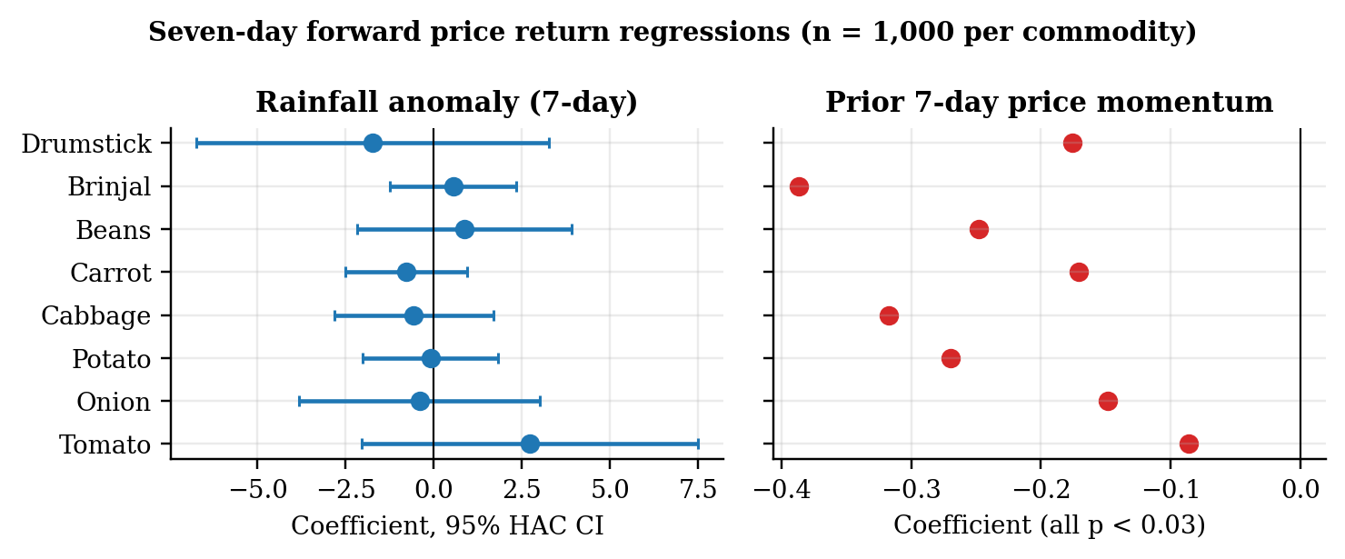
Figure 4.12: Rainfall-anomaly coefficients with 95% HAC intervals, and price-momentum coefficients
Source: Author’s analysis.
Interpretation. No rainfall-anomaly coefficient is significant: p-values range from 0.262 (Tomato) to 0.921 (Potato), and every 95% interval spans zero. H2 is not supported. This is not evidence that weather does not matter. The weather record covers only two monsoon seasons, rainfall is measured in Chennai rather than in the producing districts that supply Koyambedu, and arrival volumes, the channel through which weather would act according to Roy et al. (2024), were unavailable.
By contrast, prior seven-day momentum is negative and significant for all eight series (coefficients −0.09 to −0.39, all p < 0.03): a price that has risen over the past week tends to fall back over the next week, and vice versa. This short-run mean reversion is the same property detected by the ADF tests in Section 4.4. It is a genuine and usable finding for buyers: after a sharp weekly rise, waiting has on average been rewarded, except during sustained supply shocks of the kind examined in Section 4.14. The low R² values (0.01–0.15) show that most weekly variation remains unexplained.

4.11.2 SHAP ranking of the Northeast Monsoon deviation index
As the proposal specified, a seven-day XGBoost model was fitted to each Koyambedu series with sixteen features: ten price features (prices at the origin and earlier, rolling means and spread, momentum and season of the target date) and six weather features (7- and 30-day rainfall, maximum temperature, a seven-day rainfall anomaly, the Northeast Monsoon deviation index and a season flag), using January 2024 to September 2026, the period covered by the weather record. Market arrival volume could not be included. Table 4.14 ranks the features by share of mean absolute SHAP value.
Table 4.14: SHAP ranking of the Northeast Monsoon deviation index against price features (Koyambedu, 7-day XGBoost)
Series | Price at origin: share | NE Monsoon deviation: rank | NE Monsoon deviation: share | Rainfall anomaly: rank | All six weather features: share
Tomato | 42.10% | 13 of 16 | 1.63% | 7 of 16 | 11.20%
Onion | 36.70% | 14 of 16 | 0.90% | 9 of 16 | 10.50%
Potato | 27.00% | 15 of 16 | 0.32% | 10 of 16 | 5.80%
Cabbage | 37.90% | 12 of 16 | 1.67% | 15 of 16 | 9.70%
Carrot | 25.40% | 12 of 16 | 1.29% | 10 of 16 | 11.50%
Beans | 22.60% | 15 of 16 | 0.18% | 14 of 16 | 20.00%
Brinjal | 43.20% | 13 of 16 | 1.19% | 11 of 16 | 13.60%
Drumstick | 50.90% | 15 of 16 | 0.09% | 10 of 16 | 12.40%
Source: Author’s analysis; 975 daily observations per series.
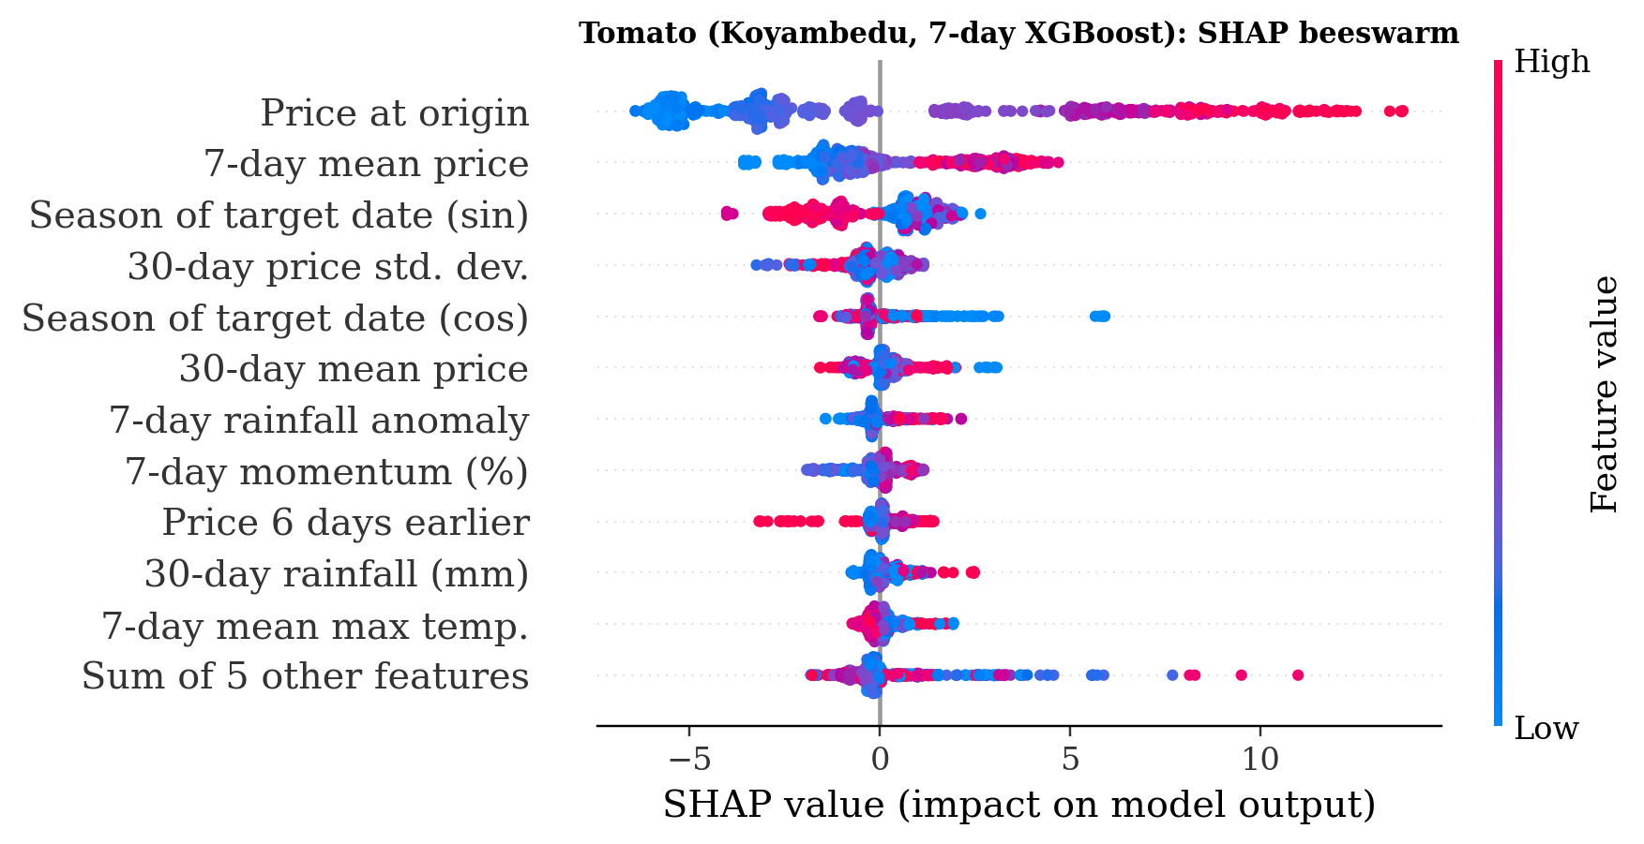
Figure 4.13: Tomato: SHAP beeswarm for the Koyambedu 7-day XGBoost model
Source: Author’s analysis.
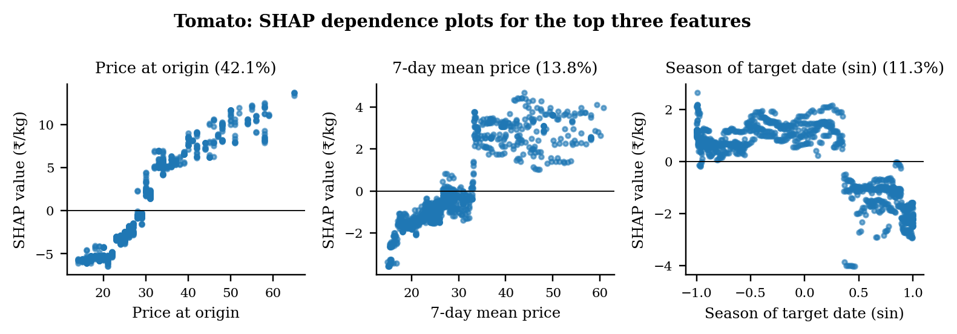
Figure 4.14: Tomato: SHAP dependence plots for the top three features
Source: Author’s analysis.
Interpretation. The price at the forecast origin is the strongest feature for all eight vegetables, accounting for 23–51% of attribution. The Northeast Monsoon deviation index ranks between 12th and 15th of 16 features and contributes at most 1.7%; all six weather features together contribute 6–20%. For Tomato (Figures 4.13 and 4.14) the top three features are the price at the origin (42.1%), the seven-day mean price (13.8%) and the season of the target date (11.3%), and their dependence plots show a near-linear persistence effect and a seasonal step. Consistent with the regression test, the SHAP ranking places monsoon deviation well behind price history, answering the proposal’s question of which predictor is strongest.

4.11.3 Delta-accuracy test: does weather context improve the forecast?
The proposal’s AgriSight evaluation asked whether adding real-time context to XGBoost measurably improves accuracy on a six-month held-out period. Historical policy news is not archived, so the context tested is the weather information that the live pipeline supplies, observed up to each forecast date. At 27 weekly origins from April to September 2026, two XGBoost models were trained on data available at each origin, one with the ten price features and one with the six weather features added, and scored at 7, 14 and 30 days (protocol C1).
Table 4.15: Delta-accuracy test: WAPE (%) on the six-month holdout, Koyambedu, 8 series
Horizon | Forecasts | Naive | XGBoost (prices) | XGBoost + weather | Gain from weather (pts) | DM p: weather vs prices | DM p: weather vs naive
7 days | 216 | 8.43 | 10.60 | 10.93 | -0.33 | 0.166 | 0.011
14 days | 216 | 11.06 | 14.37 | 14.36 | +0.01 | 0.981 | 0.026
30 days | 200 | 16.18 | 20.49 | 18.72 | +1.77 | 0.101 | 0.325
Source: Author’s analysis (protocol C1). DM = Diebold–Mariano test on absolute errors with HAC standard errors.
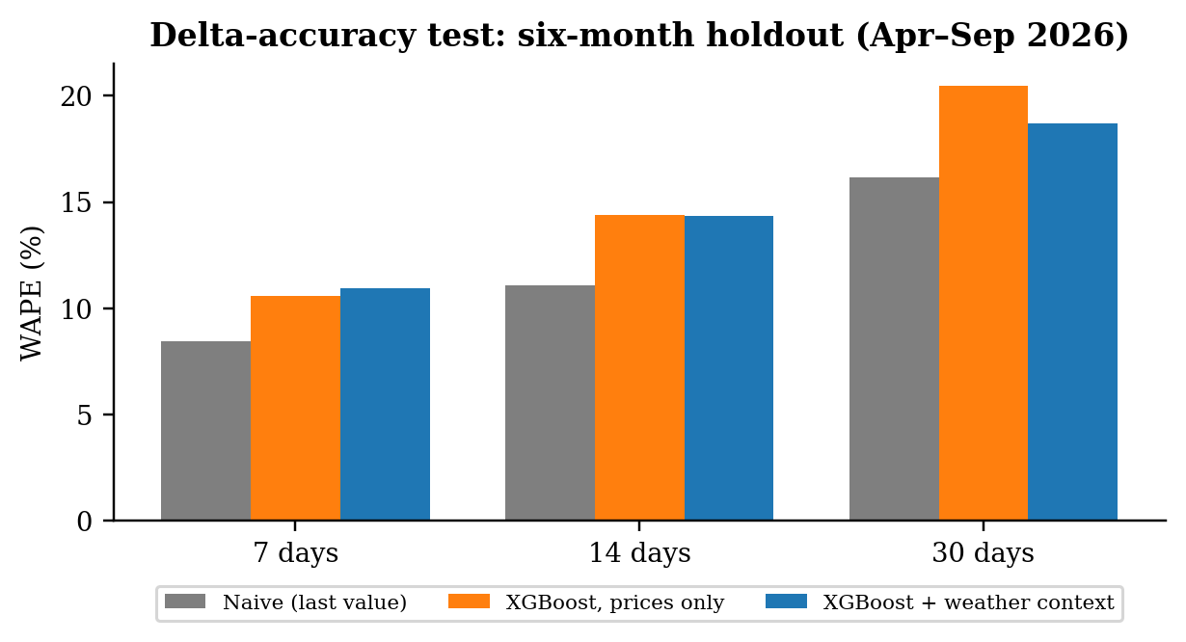
Figure 4.15: Delta-accuracy test: naive, XGBoost on prices, and XGBoost with weather context
Source: Author’s analysis.
Interpretation. Weather context made no significant difference at any horizon. At 7 and 14 days the two XGBoost models are practically identical (DM p = 0.166 and 0.981). At 30 days weather lowers WAPE by 1.77 points, from 20.49% to 18.72%, but the difference is not significant (p = 0.101). The naive forecast remains the most accurate at every horizon and is significantly better than the context-enriched model at 7 and 14 days (p = 0.011 and 0.026). The proposal’s question therefore receives a clear answer: on this evidence, real-time weather context does not add measurable forecast value, although the 30-day result suggests a possible small benefit that a longer weather record could confirm or rule out.

4.12 MULTI-AGENT DECISION LAYER OUTPUTS

4.12.1 Deterministic agent pipeline
Table 4.16: AgriSight agent recommendations at the last statewide date (20 April 2026, ₹/quintal)
Commodity | Current | 7-day | 14-day | Change | Risk score | Risk | Action | Signal
Beans | 7,600 | 7,420 | 7,420 | -2.4% | 28.5 | MEDIUM | HOLD | HOLD
Brinjal | 3,500 | 3,398 | 3,398 | -2.9% | 25.8 | LOW | HOLD | HOLD
Cabbage | 2,250 | 2,252 | 2,252 | +0.1% | 7.9 | LOW | HOLD | HOLD
Carrot | 3,750 | 3,758 | 3,758 | +0.2% | 13.6 | LOW | HOLD | HOLD
Drumstick | 3,750 | 3,831 | 3,831 | +2.2% | 13.4 | LOW | HOLD | HOLD
Onion | 2,500 | 2,486 | 2,486 | -0.6% | 11.8 | LOW | HOLD | HOLD
Potato | 2,800 | 2,855 | 2,855 | +2.0% | 20.8 | LOW | HOLD | HOLD
Tomato | 2,750 | 2,597 | 2,597 | -5.6% | 56.1 | HIGH | DELAY PROCUREMENT | BUY
Source: Author’s analysis.
Interpretation. Seven commodities receive HOLD and Tomato receives DELAY PROCUREMENT with a HIGH risk score of 56.1. The run also exposes three design weaknesses in this pipeline that matter for interpreting its advice. (i) The 7-day and 14-day forecasts are identical for every commodity, because the pipeline reuses the latest row’s price features and changes only calendar fields, so the “14-day forecast” is not a 14-day forecast. (ii) The action and signal disagree for Tomato: the action says DELAY while the signal field says BUY, because the signal is defined from the buyer’s viewpoint of a falling price while the action uses procurement wording; a single vocabulary is needed. (iii) The field labelled “estimated savings per quintal” is |forecast change| × current price, which is not a saving.
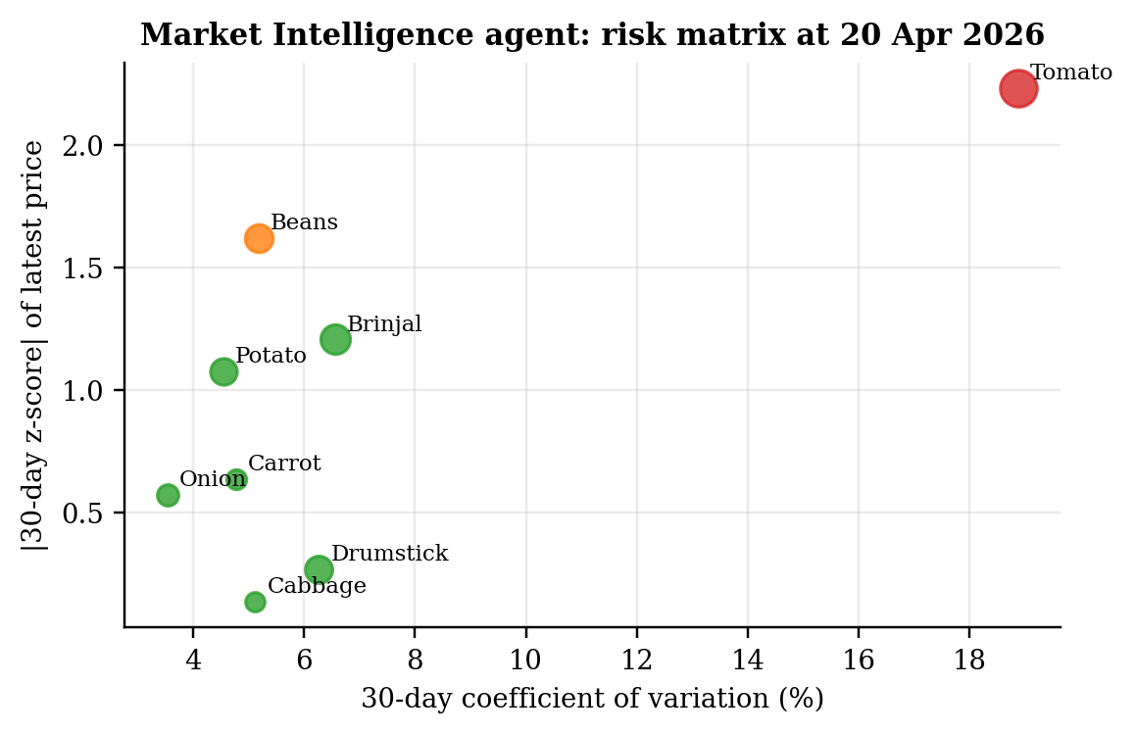
Figure 4.16: Market Intelligence agent risk matrix (colour = risk level; size = forecast change)
Source: Author’s analysis.

4.12.2 Four-role pipeline with freshness gate
Table 4.17: AgriSight four-role brief, offline run (₹/quintal)
Commodity | Current | 7-day | 14-day | Change | Signal
Beans | 7,600 | 7,333 | 7,336 | -3.5% | ABSTAIN_STALE_DATA
Brinjal | 3,500 | 3,374 | 3,373 | -3.6% | ABSTAIN_STALE_DATA
Cabbage | 2,250 | 2,235 | 2,236 | -0.6% | ABSTAIN_STALE_DATA
Carrot | 3,750 | 3,882 | 3,951 | +5.4% | ABSTAIN_STALE_DATA
Drumstick | 3,750 | 3,835 | 3,818 | +1.8% | ABSTAIN_STALE_DATA
Onion | 2,500 | 2,492 | 2,486 | -0.5% | ABSTAIN_STALE_DATA
Potato | 2,800 | 2,862 | 2,854 | +1.9% | ABSTAIN_STALE_DATA
Tomato | 2,750 | 2,602 | 2,467 | -10.3% | ABSTAIN_STALE_DATA
Source: Author’s analysis.
The four-role pipeline corrects the first weakness by forecasting recursively day by day, so its 7- and 14-day values differ (for example, Tomato falls from ₹2,750 to ₹2,602 at 7 days and ₹2,467 at 14 days). Because the latest statewide price is from 20 April 2026, 181 days before the run, the freshness gate correctly marks every commodity ABSTAIN_STALE_DATA instead of issuing advice on stale data.

4.12.3 Live context and local language-model writer
The four-role pipeline has two optional components. A live mode adds a seven-day Chennai weather forecast (Open-Meteo) and official agriculture news from the Press Information Bureau RSS feed to the buyer brief; the forecast is summarised as total rainfall, wettest day, number of rainy days and maximum temperature, and news items are filtered for agriculture and price relevance. A language-model writer rewrites the brief in plain prose using a model running on the buyer’s own computer. Two safeguards are built into the writer: it may only use a model on the buyer’s own computer, never an external service, and its rewrite is accepted only if every price, forecast, percentage change and weather figure in the original brief is reproduced exactly and no new figure appears; otherwise the unedited brief is used. If a weather or news service is unavailable, the pipeline records this in the brief and still delivers the price forecasts. Both components are implemented; their run against the live services is pending and is listed as a limitation in Section 5.5. Even when they are run, all signals will remain ABSTAIN_STALE_DATA until the statewide price data are refreshed, because weather and news do not update prices.

4.12.4 Dashboard
The Streamlit dashboard presents the outputs on nine pages: Agent Recommendations, Price Forecast, Model Trust, Price Movers, Market Trends and Seasonality, SHAP Explainability, Research and Scenario Validation, Dataset Snapshot and Data Quality. All nine pages were tested automatically and render without errors. Figures 4.17 and 4.18 show two pages; further screenshots are in Appendix 5.
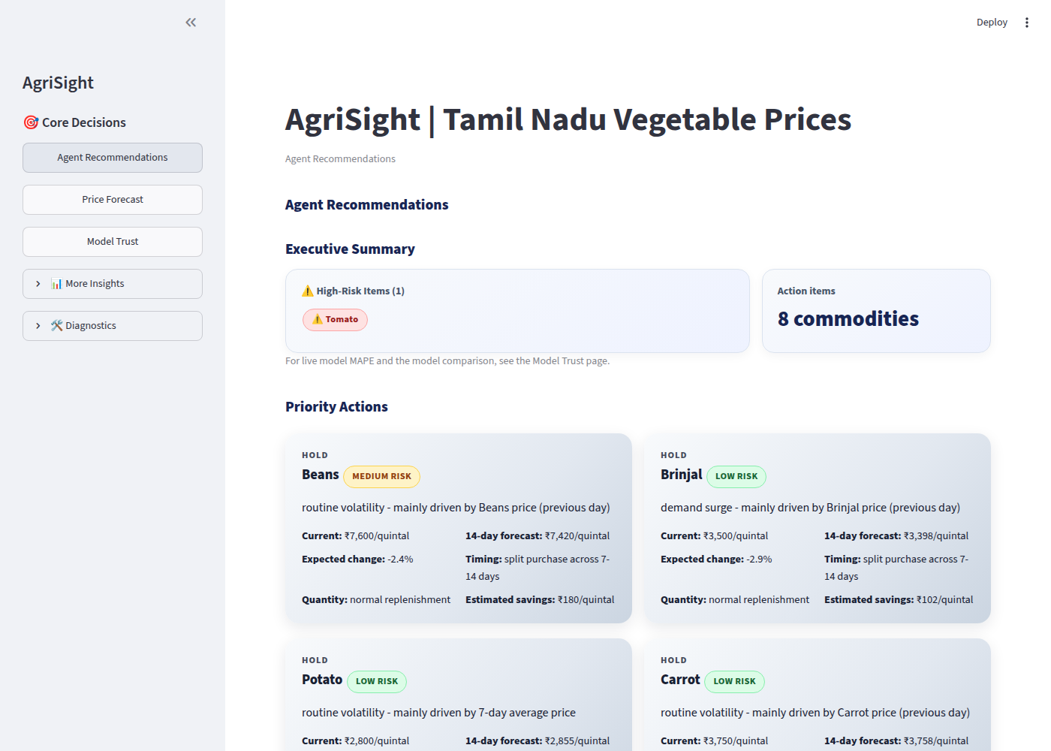
Figure 4.17: Dashboard: Agent Recommendations page
Source: Screenshot of the AgriSight dashboard.
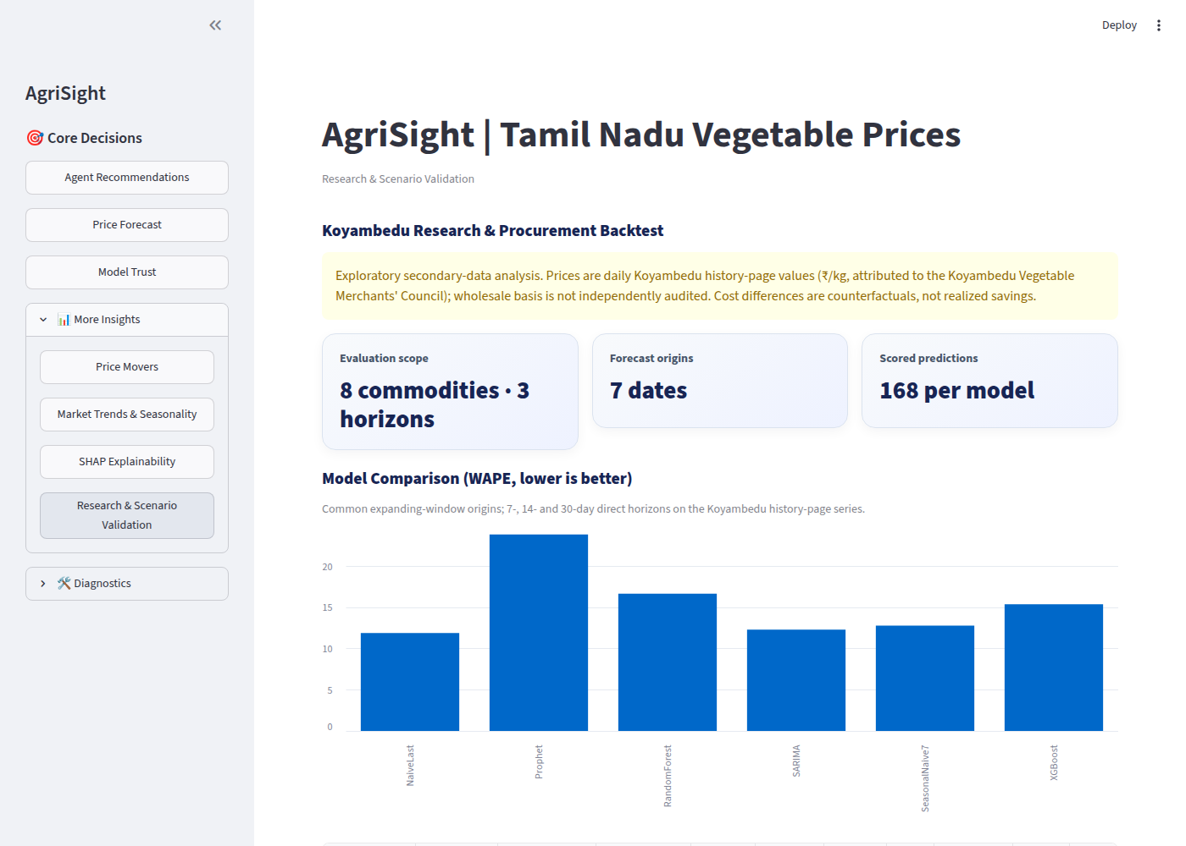
Figure 4.18: Dashboard: Koyambedu Research and Procurement Backtest page
Source: Screenshot of the AgriSight dashboard.

4.13 PROCUREMENT ADVICE BACKTEST
Table 4.18: Procurement backtest: counterfactual result versus buying immediately (₹ per 100 kg lot)
Advice action | Cases | Mean difference | Median difference
DELAY PROCUREMENT | 14 | ₹278.57 | ₹100.00
HEDGE | 10 | −₹5.00 | ₹25.00
HOLD | 9 | ₹0.00 | ₹0.00
PARTIAL PROCUREMENT | 9 | −₹16.67 | ₹0.00
PROCURE NOW | 14 | ₹0.00 | ₹0.00
Source: Author’s analysis. Positive = advice cheaper than buying at the origin.
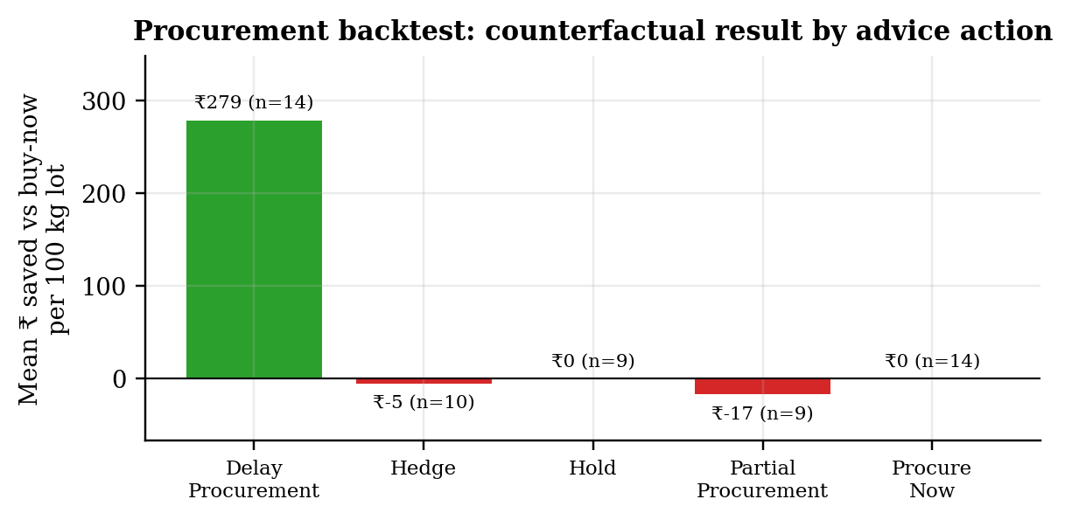
Figure 4.19: Mean counterfactual result by advice action
Source: Author’s analysis.
Interpretation. Across 56 cases the advice was cheaper than buying immediately in 30.4% of cases, more expensive in 19.6%, and identical in the remaining 50% (PROCURE NOW and HOLD buy at the origin by definition). The mean result is ₹66.07 per 100 kg lot. Almost all of the gain comes from 14 DELAY decisions (mean ₹278.57, median ₹100), while HEDGE and PARTIAL PROCUREMENT were slightly loss-making. This is consistent with the mean reversion found in Section 4.11: delaying after a forecast fall has usually paid. However, the cases are not independent (they share origins), the lot convention evaluates DELAY at day 14 although the advice text says “reassess in 7 days”, and handling costs are excluded.
A robustness check exposed a further weakness. Rerunning the identical pipeline with different library versions changed the stored XGBoost forecasts slightly, and 8 of the 56 actions (14%) changed category: for example, Cabbage on 1 October 2025 moved from DELAY (−5.05% forecast change) to HEDGE (−3.66%). The headline rate moved from 28.6% to 30.4%. Hard ±3% and ±5% thresholds applied to forecasts whose typical error is 10–15% make the advice unstable. Thresholds should be expressed relative to forecast uncertainty.

4.14 RETROSPECTIVE ANALYSIS OF THE 2023 TOMATO PRICE EPISODE (OBJECTIVE S04)
The rules were applied at 13 weekly origins from 1 April to 24 June 2023, before and at the start of the episode, with a 14-day XGBoost model retrained at each origin on data up to that date.
Table 4.19: Tomato 2023 retrospective scenario: advice at weekly origins (₹/kg; one-unit purchase)
Origin | Price at origin | Forecast day 14 | Actual day 14 | Action | Risk | Result vs buy-now
2023-04-01 | 27.00 | 19.52 | 16.00 | DELAY PROCUREMENT | MEDIUM | 11.00
2023-04-08 | 18.00 | 20.41 | 18.00 | PARTIAL PROCUREMENT | HIGH | 0.00
2023-04-15 | 16.00 | 18.00 | 13.00 | PROCURE NOW | MEDIUM | 0.00
2023-04-22 | 18.00 | 20.71 | 14.00 | PROCURE NOW | MEDIUM | 0.00
2023-04-29 | 13.00 | 21.50 | 16.00 | PARTIAL PROCUREMENT | HIGH | -1.50
2023-05-06 | 14.00 | 26.71 | 17.00 | PARTIAL PROCUREMENT | HIGH | -1.50
2023-05-13 | 16.00 | 49.01 | 13.00 | PARTIAL PROCUREMENT | HIGH | 1.50
2023-05-20 | 17.00 | 43.42 | 20.00 | PARTIAL PROCUREMENT | HIGH | -1.50
2023-05-27 | 13.00 | 20.16 | 27.00 | PARTIAL PROCUREMENT | HIGH | -7.00
2023-06-03 | 20.00 | 20.97 | 38.00 | HEDGE | MEDIUM | -9.00
2023-06-10 | 27.00 | 24.59 | 70.00 | DELAY PROCUREMENT | HIGH | -43.00
2023-06-17 | 38.00 | 29.85 | 80.00 | DELAY PROCUREMENT | HIGH | -42.00
2023-06-24 | 70.00 | 43.84 | 97.00 | DELAY PROCUREMENT | HIGH | -27.00
Source: Author’s analysis. Negative = advice more expensive than buying at the origin.
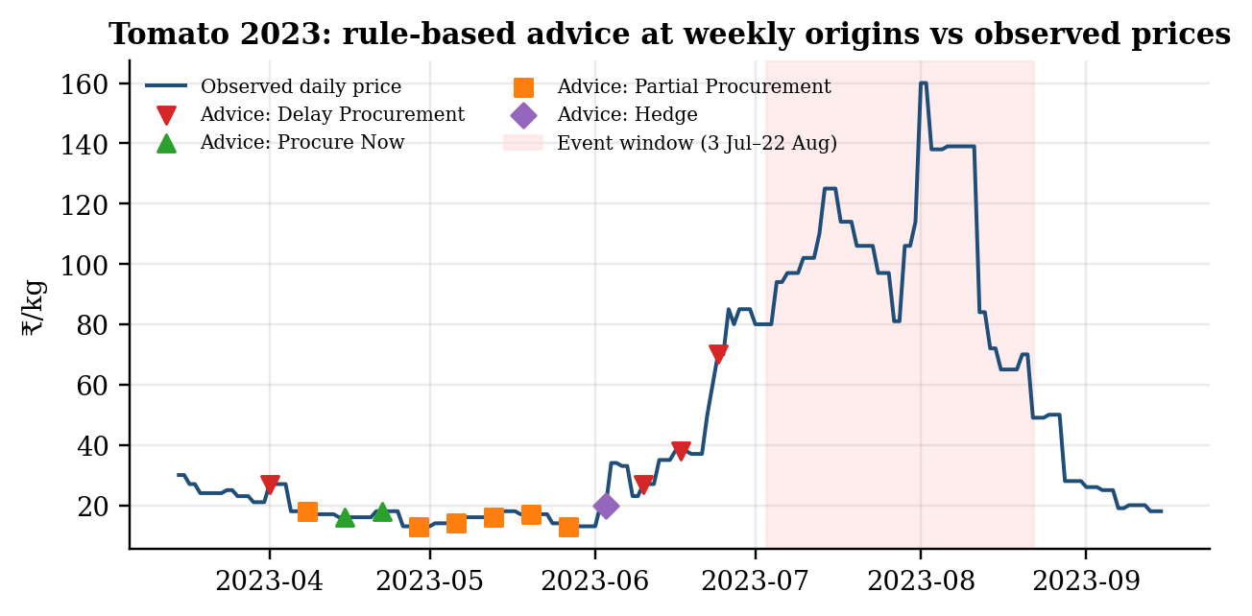
Figure 4.20: Tomato 2023: rule-based advice at weekly origins against observed Koyambedu prices
Source: Author’s analysis.
Interpretation. This is the most consequential finding for procurement. From April to May, when prices were low, the advice made only small differences (between −₹7 and +₹11/kg per decision, mostly ±₹1.50). As the shock began, the model forecast falling prices on 10, 17 and 24 June 2023 (₹24.59, ₹29.85 and ₹43.84 against origin prices of ₹27, ₹38 and ₹70) and advised DELAY three weeks in a row. Actual day-14 prices were ₹70, ₹80 and ₹97/kg, so the delays cost ₹43, ₹42 and ₹27/kg relative to buying immediately. Over the 13 origins the cumulative result is −₹120/kg for a one-kilogram-per-week buyer: the advice would have increased cost.
The mechanism is clear. Models trained on mean-reverting history forecast reversion after a rise, and that is usually correct (Section 4.11). In a sustained supply shock it is exactly wrong. The 14-day model did not anticipate the shock; Section 4.14.1 shows that the 30-day horizon specified in the proposal behaved differently.

4.14.1 The 30-day forecast specified in the proposal
The proposal asked for the economic value of the 30-day forecast in the three months before July 2023. The scenario was therefore rerun with a 30-day direct XGBoost model at the same 13 weekly origins (protocol C2), together with a 14-day model on the same feature set for comparison.
Table 4.20: Tomato 2023: advice from 30-day forecasts at weekly origins (₹/kg)
Origin | Price | Forecast day 30 | Actual day 30 | Forecast change | Risk | Action | Result vs buy-now
2023-04-01 | 27.00 | 21.12 | 13.00 | -22% | MEDIUM | DELAY PROCUREMENT | 14.00
2023-04-08 | 18.00 | 18.52 | 16.00 | +3% | MEDIUM | HOLD | 0.00
2023-04-15 | 16.00 | 20.12 | 18.00 | +26% | HIGH | PARTIAL PROCUREMENT | -1.00
2023-04-22 | 18.00 | 19.60 | 17.00 | +9% | MEDIUM | PROCURE NOW | 0.00
2023-04-29 | 13.00 | 27.02 | 13.00 | +108% | HIGH | PARTIAL PROCUREMENT | 0.00
2023-05-06 | 14.00 | 60.57 | 34.00 | +333% | HIGH | PARTIAL PROCUREMENT | -10.00
2023-05-13 | 16.00 | 72.84 | 27.00 | +355% | HIGH | PARTIAL PROCUREMENT | -5.50
2023-05-20 | 17.00 | 40.52 | 37.00 | +138% | HIGH | PARTIAL PROCUREMENT | -10.00
2023-05-27 | 13.00 | 68.06 | 85.00 | +424% | HIGH | PARTIAL PROCUREMENT | -36.00
2023-06-03 | 20.00 | 51.19 | 80.00 | +156% | HIGH | PARTIAL PROCUREMENT | -30.00
2023-06-10 | 27.00 | 36.25 | 102.00 | +34% | HIGH | PARTIAL PROCUREMENT | -37.50
2023-06-17 | 38.00 | 31.23 | 114.00 | -18% | HIGH | DELAY PROCUREMENT | -76.00
2023-06-24 | 70.00 | 43.87 | 97.00 | -37% | HIGH | DELAY PROCUREMENT | -27.00
Source: Author’s analysis (protocol C2). Negative = advice more expensive than buying at the origin.
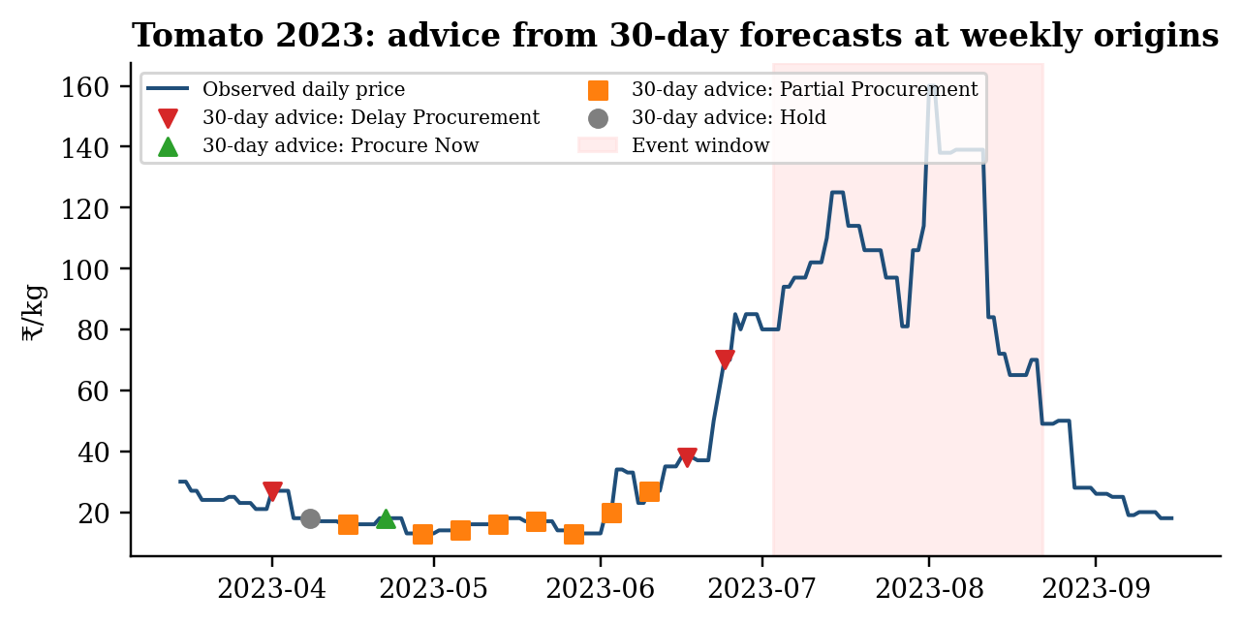
Figure 4.21: Tomato 2023: advice from 30-day forecasts at weekly origins
Source: Author’s analysis.
Table 4.21: Economic value of the forecast signal in the three months before July 2023 (₹/kg, one unit per signal)
Horizon | Rise signals correct | Forward-buying value | Fall signals correct | Deferral value | Net signal value | Rules as designed | Direction-only rule
14 days | 5 of 9 | ₹31.00 | 1 of 3 | −₹58.00 | −₹27.00 | −₹88.00 | −₹58.00
30 days | 7 of 9 | ₹259.00 | 1 of 3 | −₹89.00 | ₹170.00 | −₹219.00 | −₹89.00
Source: Author’s analysis. Forward-buying value = price at the target date minus price at the origin when a rise above 5% is forecast; deferral value = price at the origin minus price at the target date when a fall below −5% is forecast. Rule results are relative to buying immediately.
Interpretation. The 30-day forecast did carry an early warning. From 29 April 2023 it forecast rises of more than 100%, two months before the crisis, and 7 of its 9 rise signals were correct. A buyer who used each rise signal to lock in the next month’s price, for example through a supplier contract (tomatoes cannot be stored for 30 days), would have avoided about ₹259/kg of cost over the period; net of the two wrong late-June fall signals, the signal was worth about ₹170/kg. The 14-day signal had no net value (−₹27/kg). The model learned the seasonal mid-year rise from the 2022 history, which explains why the longer horizon saw it.
The decision rules, however, destroyed this value. Because the risk score adds 1.2 × the forecast change, every large forecast rise produced a HIGH risk rating, and the rules then chose PARTIAL PROCUREMENT instead of PROCURE NOW; two late-June fall forecasts then triggered DELAY just before the peak. The result was −₹219/kg relative to buying immediately. A rule that simply bought on any forecast rise and deferred only on a forecast fall would have reduced the loss to −₹89/kg. Objective S04 is therefore answered with a qualified result: the 30-day forecast had economic value as an early-warning signal in this episode, but the rule design turned it into a loss. The decision layer must separate forecast direction from risk and add a shock override (for example, never delay when price has risen for two consecutive weeks). This is one episode, and forward-contract costs are not included, so the value is indicative rather than a savings estimate.

4.15 SUMMARY OF HYPOTHESIS TESTING
Table 4.22: Results of hypothesis testing
Hypothesis | Evidence | Result
H1: RF or XGBoost has lower walk-forward error than SARIMA | Statewide: SARIMA 7-day WF 10.46% vs RF 11.32% and XGBoost 13.98% (RF better for 4 of 8). Koyambedu: SARIMA WAPE 12.28% vs XGBoost 15.36% and RF 16.63% | Not supported
H2: NE Monsoon rainfall anomaly significantly predicts price movement | No β₁ significant (p = 0.262–0.921); SHAP rank of the NE Monsoon deviation index 12th–15th of 16; weather context gives no significant gain (DM p = 0.10–0.98) | Not supported (short weather record)
H0: No model beats the last observed price | Statewide naive 4.20% vs best model 11.32%; Koyambedu naive WAPE 11.88% lowest; B2 naive lowest at all horizons | Not rejected
Source: Sections 4.5–4.11.

4.16 STATUS OF STUDY OBJECTIVES
Table 4.23: Objective-by-objective status
Objective | What was done | Status
S01 Model comparison at 7/14/30 days | Protocols B1 (7 origins) and B2 (4 origins) on Koyambedu with naive benchmarks; statewide holdout plus horizon check | Achieved; result negative for complex models
S02 NE Monsoon significance | HAC regressions for 8 series; SHAP ranking of the NE Monsoon deviation index with beeswarm and dependence plots | Achieved; effect not detected
S03 Four-agent AgriSight pipeline | Deterministic agent pipeline and four-role pipeline with freshness gate; nine-page dashboard; live news, weather and local language-model writer implemented | Achieved as prototype; live run pending
S04 2023 tomato procurement case | 13-origin scenario with the 30-day forecast specified in the proposal, and a 14-day comparison | Achieved; 30-day signal worth ₹170/kg net, but the rules turned it into a ₹219/kg loss
Deliverable: delta-accuracy test | XGBoost with vs without weather context, six-month holdout, DM tests | Achieved; no significant gain
Primary: useful procurement decision support | Backtest: 30.4% of cases better than buy-now; unstable thresholds; no shock override | Not yet established
Source: Chapter 4.
CHAPTER 5

CONCLUSIONS

5.1 SUMMARY OF FINDINGS

5.1.1 Data and price behaviour
- The statewide extract (414,388 records, 451 markets) is complete but dominated by Uzhavar Sandhai (90.7% of records), so its daily median approximates a farmers’-market price rather than a bulk wholesale price.
- About 2.7% of statewide records, concentrated in June–July 2024, carry values below ₹300 per quintal that are consistent with per-kg entry; three extreme records above ₹100,000 were removed.
- Drumstick and Tomato are the most volatile vegetables in both sources (statewide CV 62% and 48%; Koyambedu CV 51% and 59%). Prices are generally lowest in March–May and highest from August to January.
- All eight statewide series are stationary (ADF p < 0.002), and Brinjal, Cabbage, Carrot and Potato move closely together (r = 0.90–0.93).

5.1.2 Forecasting
- Statewide 90-day holdout: SARIMA refitted weekly 10.46% MAPE; Random Forest 11.32%; XGBoost 13.98%; Prophet 19.33%; static SARIMA 32.60%.
- Those model scores are next-day scores. On the same test window, yesterday’s price alone gives 4.20% MAPE and beats every model for every commodity; a genuine seven-day-ahead XGBoost gives 27.09%.
- SHAP shows that the fitted models rely mainly on recent price level: the 52-week position and each model’s own previous-day price. Weather and festival features contribute little.
- Koyambedu, seven origins, 7–30 days: the last observed price has the lowest WAPE (11.88%), then SARIMA (12.28%); XGBoost (15.36%), Random Forest (16.63%) and Prophet (23.82%) are worse. A second four-origin evaluation gives the same ranking.
- The tree-model error presented at the second review (6.28%) came from an earlier feature build, could not be reproduced and is superseded.

5.1.3 Monsoon, decision layer and procurement
- No Northeast Monsoon rainfall-anomaly effect was detected (p = 0.26–0.92). Prior seven-day momentum is significantly negative for all eight vegetables, indicating short-run mean reversion.
- The four-agent pipeline works end to end and the freshness gate correctly abstained on 181-day-old statewide data. The deterministic agent pipeline was found to produce identical 7- and 14-day forecasts and contradictory action and signal labels. The live weather and news components and the local language-model writer, with a safeguard against altered prices, are implemented; their live run is pending.
- In 56 backtest cases the advice beat buying immediately in 30.4% of cases, with a mean gain of ₹66 per 100 kg lot, almost entirely from DELAY decisions. 14% of actions changed under a library-version change.
- In the 2023 tomato episode the 14-day advice recommended delay on 10, 17 and 24 June, just before prices rose to ₹70–97/kg (cumulative −₹120/kg against buying immediately).
- The 30-day forecast specified in the proposal gave an early warning: it signalled a rise of more than 100% from 29 April 2023 and was right at 7 of 9 rise signals, a signal worth about ₹170/kg net to a forward buyer. The rules rated these large rises as high-risk, downgraded them to partial purchases and then delayed in late June, turning the signal into a −₹219/kg result.
- SHAP ranked the Northeast Monsoon deviation index 12th to 15th of 16 features, far behind the price at the forecast origin (23–51% of attribution), and adding weather context to XGBoost gave no significant gain on a six-month holdout (DM p = 0.10–0.98).

5.2 RESULTS AT A GLANCE AND CONTRIBUTIONS OF THE STUDY
A negative result means that the evidence did not support a hypothesis. It is not a failure of the study. Each objective was tested with a defined, reproducible procedure, and each produced a clear answer. Table 5.1 summarises what was expected, what was found and what the finding means for a procurement buyer.
Table 5.1: Results at a glance: expectation, finding and implication
Objective / hypothesis | Expected | Finding | Implication for buyers
S01 / H1: ML models beat SARIMA and naive forecasts | Yes | No. Yesterday’s price (4.20% statewide) and the last observed price (11.88% WAPE, Koyambedu) were best | Use the naive forecast as the benchmark any tool must beat
S02 / H2: NE Monsoon rainfall predicts price movement | Yes | No significant effect (p = 0.26–0.92); SHAP rank 12th–15th of 16; no gain from weather context; short-run mean reversion significant for all 8 vegetables | Expect partial reversal after sharp weekly moves, except in supply shocks
S03: four-agent AgriSight pipeline | Working prototype | Achieved: end-to-end pipeline, freshness gate, 9-page dashboard, safeguards on the AI writer | A transparent monitoring and evaluation platform
S04: value of the 30-day forecast before July 2023 | Savings | Qualified. The 30-day signal warned from 29 April and was worth about ₹170/kg net, but the rules turned it into a −₹219/kg loss | Use the 30-day forecast as an early warning; redesign the rules before acting on it
Benchmark hypothesis H0: no model beats the last price | (Implicit) | Not rejected on either dataset or any horizon | Invest in supply data and decision rules, not more complex price-only models
Source: Chapter 4.
The study makes six contributions:
- A rigorous benchmark comparison. Four model families were compared with naive baselines on two independent price sources, at matched origins and 7-, 14- and 30-day horizons, which is the comparison objective S01 required and which much of the applied literature omits.
- Detection of a common evaluation pitfall. The horizon-sensitivity check (protocol A3) showed that apparently good machine-learning accuracy was next-day persistence: a genuine seven-day-ahead model was three times worse than the naive benchmark. The same check can be applied to any vendor or published forecast.
- A usable market regularity. Weekly price moves partly reverse (negative momentum, all eight vegetables, p < 0.03), which explains when delaying a purchase has paid and when it has not.
- Evidence of when automated advice fails, and why. The 2023 tomato case shows that the 30-day forecast contained a genuine early warning, but that a risk score built partly from the size of the forecast change suppressed exactly the strongest buy signals. This identifies a specific, fixable design flaw rather than a general failure of forecasting.
- A working, reproducible system. The AgriSight pipeline runs end to end from raw data to dashboard, with a freshness gate, documented code corrections, automated checks, and a safeguard designed to reject any AI-written brief that alters a price.
- Data-quality findings with practical value. The statewide Agmarknet extract is 90.7% farmers’-market records and contains apparent per-kg entries in per-quintal fields, which any user of this dataset needs to know.

5.3 SUGGESTIONS AND RECOMMENDATIONS
The following recommendations are addressed to procurement managers considering forecast-based purchasing and to anyone extending the AgriSight pipeline.
- Adopt the naive forecast as the procurement benchmark. Any forecast offered to buyers, whether in-house or from a vendor, should be reported alongside the last-observed-price forecast at the same horizon. A model that does not beat it should not drive purchase timing.
- Use SARIMA refitted weekly as the default statistical model where a model is needed, for example to produce intervals. It was consistently second to the naive forecast and far cheaper to maintain than the tree models.
- Exploit short-run mean reversion cautiously. After a sharp weekly price rise, deferring discretionary volume has on average paid. This rule must carry a shock override (Recommendation 4).
- Separate forecast direction from risk in the decision rules. The risk score should measure uncertainty, for example forecast error or recent volatility, and must not rise with the size of the forecast change; otherwise the strongest buy signals are downgraded, as happened in the 2023 tomato case.
- Use the 30-day forecast as an early-warning signal. In the 2023 episode it flagged the rise two months ahead. Buyers can use such a signal to negotiate forward prices or secure supply, rather than to time individual purchases.
- Add a supply-shock override to the decision rules. Never advise DELAY when price has risen for two or more consecutive weeks, or when arrivals fall below their seasonal norm. In the 2023 tomato case this rule would have converted three loss-making delays into purchases.
- Replace hard thresholds with uncertainty-scaled thresholds. Act only when the forecast change exceeds, for example, one forecast standard error, and abstain otherwise. This removes the instability that changed 14% of backtest actions between library versions.
- Correct the identified design weaknesses before further use: true multi-step forecasts in the deterministic agent pipeline, one action vocabulary instead of separate action and signal fields, removal of the misleading “savings” field, and exclusion of each model’s own previous-day price when a horizon longer than one day is intended.
- Clean and segment the statewide data. Correct or exclude the per-kg entries in per-quintal fields, and model Uzhavar Sandhai (retail-like) and regulated wholesale markets separately, so that buyers see a price relevant to bulk purchase.
- Acquire market-arrival volumes and producer-region weather. The literature (Roy et al., 2024) and this study’s null monsoon result both point to supply volume as the missing predictor. Agmarknet arrival data for Koyambedu and rainfall for Kolar, Krishnagiri and Anantapur are the first candidates.
- Validate the Koyambedu price basis. Obtain documentation from the Koyambedu Vegetable Merchants’ Council on grade, quote type (wholesale or retail) and collection time, and compare prospectively with invoices.
- Run a prospective buyer pilot before claiming savings. Record purchase date, quantity, grade, invoice price, spoilage and stockouts for a defined comparison period, with a pre-registered baseline, and evaluate delivered cost per usable kilogram.

5.4 MANAGERIAL IMPLICATIONS
For a procurement manager, the study’s message is reassuring as much as cautionary. The best available short-term forecast of a Tamil Nadu vegetable price is close to what an experienced buyer already watches: today’s price, adjusted for the tendency of sharp weekly moves to partly reverse. Sophisticated models did not improve on this, and an automated rule that trusted them would have delayed purchases at the worst moment of the 2023 tomato shock. Investment is therefore better directed at information the market does not yet reflect, such as arrival volumes, producer-region weather and supply news, and at decision discipline (uncertainty-aware thresholds, shock overrides and abstention when data are stale) than at more complex price-only models. The AgriSight pipeline is valuable as a monitoring and evaluation platform: it makes these comparisons repeatable and visible on a dashboard.

5.5 LIMITATIONS OF THE STUDY
- Source verification. Neither price source’s upstream collection process was independently audited, and the Koyambedu API does not state whether quotes are wholesale or retail. The statewide median mixes farmers’ and wholesale markets.
- Short statewide history. About 27 months of statewide data, with 90-day holdouts, limit seasonal estimation and give few test periods.
- Limited evaluation origins. Protocols B1 and B2 use 7 and 4 origins; differences between close methods were not tested for significance (for example with the Diebold–Mariano test).
- Weather proxy. Rainfall is measured at Chennai, not in producing districts, and spans just two full monsoon seasons; market-arrival volumes could not be obtained.
- Counterfactual procurement. Backtests exclude storage, transport, spoilage, quality and stockout costs, use a fixed-lot convention, and cases are not independent. No realized savings are measured.
- Deviations from the proposal. The data period, validation design and some inputs differ from the approved proposal because data could not be obtained; Table 3.6 lists each change and its reason.
- Mapping choices. French Beans proxies Beans, and Big Onion proxies Onion, at Koyambedu.
- Software sensitivity. Tree-model forecasts, and hence some advice actions, change with library versions; package versions should be pinned.
- Live components not yet run. The live weather, news and local language-model components are implemented, but their run against the live services remains to be done.

5.6 SCOPE FOR FUTURE RESEARCH
Future work should (i) add Agmarknet arrival volumes and producer-region rainfall to test the supply channel directly; (ii) extend the statewide series back to 2015 or earlier so that seasonal models and rare shocks can be estimated; (iii) replace the fixed thresholds with probabilistic forecasts and expected-cost decision rules; (iv) evaluate forecast combinations, which won the M4 competition, against the naive benchmark; (v) test the News Reader agent’s ability to flag supply shocks earlier than prices do; and (vi) run a prospective, pre-registered buyer pilot to measure delivered cost per usable kilogram.

5.7 CONCLUSION
This study set out to show whether machine learning and a multi-agent decision layer could improve short-term vegetable procurement in Tamil Nadu. A complete, reproducible pipeline was built and run end to end: data acquisition and cleaning, feature engineering, four forecasting model families, SHAP explanation, a monsoon significance test, a four-role agent pipeline with a dashboard, and procurement backtests including the 2023 tomato shock.
The answer is clear and, for an analytics project, valuable. Every objective was tested and answered, and the central finding is that on these data and horizons, simple benchmarks were not beaten. Yesterday’s price outperformed every statewide model, the last observed price was the best Koyambedu forecast at 7 to 30 days, no monsoon effect was detected, weather context did not improve accuracy, and the rule-based advice would have raised costs during the one major shock in the record, even though the 30-day forecast had warned of it two months in advance. Apparent machine-learning accuracy was shown to be next-day persistence, a pitfall that the horizon-sensitivity check developed here can expose in other settings.
AgriSight is therefore best positioned not as an autonomous buying system but as a transparent evaluation and monitoring platform: one that tells a buyer what the market is doing, how much any forecast can be trusted relative to a naive benchmark, and when the data are too stale or uncertain to act on. The next steps are better supply-side information, uncertainty-aware rules with shock overrides, and a prospective buyer pilot. Only after those can procurement savings be claimed. In that sense the study has done what applied analytics should do: it has replaced an appealing assumption with tested evidence, and shown buyers where real gains are likely to come from.

APPENDIX 1 DATA DICTIONARY
Table A 1.1: Fields of the processed price data
Field | Source | Meaning | Caution
arrival_date | Statewide | Reported trading date | Daily calendar; missing days forward-filled up to 3
market / district | Statewide | Reporting market and district (451 / 36) | 90.7% Uzhavar Sandhai
commodity | Both | One of 8 study vegetables | Variety names mapped (Appendix 2)
min / max / modal_price | Statewide | Reported prices, ₹/quintal | ~2.7% values look per-kg
market_count | Statewide | Markets reporting the commodity on the previous day | Breadth, not arrival volume
observed_price_inr_per_kg | Koyambedu | API yValue, copied unchanged | Wholesale/retail basis not stated
veg_id / mapping_note | Koyambedu | Source series and mapping rule | French Beans, Big Onion proxies
precipitation, temp_max, temp_avg | Weather | Daily Chennai observations | Point location; lagged 1 day in features
Source: Project data files.

APPENDIX 2 MODEL FEATURES AND SETTINGS
Features used by the statewide tree models (38): lag_7, lag_14, lag_21, lag_30; rolling_mean_7, rolling_mean_14; rolling_std_7, rolling_std_14; rolling_min_7, rolling_max_7; ema_7, ema_14; momentum_7, momentum_14, momentum_30; price_acceleration; position_52w; month, week_of_year, day_of_week; sw_monsoon, ne_monsoon; pongal, tamil_new_year, diwali, navratri; market_count; rain_7d_sum, rain_30d_sum, temp_max; and cross_<commodity>_lag1 for each of the eight vegetables (including the model’s own commodity).
Table A 2.1: Commodity name mappings
Study commodity | Statewide names mapped | Koyambedu series
Beans | Beans, French Beans, Indian Beans (Seam), Seam | French Beans (provisional)
Brinjal | Brinjal, Eggplant | Brinjal (not Big Brinjal)
Onion | Onion | Big Onion (not small or green)
Drumstick | Drumstick | Drumsticks
Tomato, Potato, Cabbage, Carrot | Same name | Same name
Source: Author’s analysis.
Table A 2.2: Festival and season flags
Flag | Definition
Pongal | 13–17 January
Tamil New Year | 13–15 April
Diwali | October–November, ISO weeks 40–46 (broad; about 7 weeks)
Navratri | September–October, ISO weeks 38–42
SW monsoon | June–September
NE monsoon | October–December
Source: Author’s analysis. Prophet uses exact dated holidays for 2024–2026.

APPENDIX 3 PIPELINE STAGES AND REPORT MAPPING
The analysis is implemented as numbered Python scripts in the project repository. Table A 3.1 maps each stage to the results it produces in this report.
Table A 3.1: Pipeline stages and where their results appear
Stage (scripts) | Purpose | Results in this report
Data acquisition (00, 01, 11) | Download weather, statewide prices and Koyambedu series | Tables 3.1, 4.1, 4.8
Cleaning and EDA (02, 03) | Normalise records; descriptive statistics, anomalies, ADF tests | Tables 4.2, 4.3; Figures 4.1–4.5
Feature engineering (04) | Daily statewide median and 62-column feature table | Table 3.2; Appendix 2
Forecasting (05, 06, 07) | SARIMA, Prophet, Random Forest, XGBoost (protocols A1, A2) | Tables 4.4, 4.5; Figure 4.6
Horizon check (16) | Naive benchmarks and strict seven-day models (protocol A3) | Table 4.6; Figures 4.7, 4.8
Explanation (08) | SHAP attribution | Table 4.7; Figure 4.9
Koyambedu evaluation (12, 14) | Protocols B1 and B2; monsoon regressions; 2023 tomato scenario | Tables 4.9–4.13, 4.19; Figures 4.10–4.12, 4.20
Decision layer (09, 15) | Deterministic agent pipeline; four-role pipeline with freshness gate | Tables 4.16, 4.17; Figure 4.16
Proposal alignment (18) | SHAP monsoon ranking; delta-accuracy test; 30-day tomato scenario | Tables 4.14, 4.15, 4.20, 4.21; Figures 4.13–4.15, 4.21
Procurement backtest (13) | Fixed-lot counterfactual of advice actions | Table 4.18; Figure 4.19
Dashboard (10) | Nine-page Streamlit application | Figures 4.17, 4.18; Appendix 5
Source: Project repository.

APPENDIX 4 REPRODUCIBILITY RECORD
Environment. Python 3.12.3 with pandas 3.0.2, NumPy 2.4.4, statsmodels 0.15.0, Prophet 1.5.0, scikit-learn 1.8.0, XGBoost 3.4.1, SHAP 0.54.1, Matplotlib 3.10.8 and Streamlit 1.66.0. Random seeds are fixed at 42 for all tree models.
Run. All results in this report come from a single end-to-end run of the pipeline on 18 October 2026, in the order shown in Table A 3.1, using the data files listed in Table 3.1. The source data, code, intermediate outputs and figures are retained in the project repository so that every table and figure can be regenerated.
Quality checks. Every stage was rerun from the processed data; the nine dashboard pages were tested automatically; and the Koyambedu results were confirmed by rerunning the evaluation, which reproduced the model rankings exactly.
Sensitivity to software versions. Tree-model forecasts, and therefore some advice actions, changed slightly between library versions (Section 4.13). Library versions should be fixed in the project’s requirements file for any future rerun. Design weaknesses that affect interpretation are discussed in Sections 4.5–4.7 and 4.12, and their recommended corrections in Section 5.3.

APPENDIX 5 DASHBOARD PAGES
Navigation is grouped into Core Decisions (Agent Recommendations, Price Forecast, Model Trust), More Insights (Price Movers, Market Trends and Seasonality, SHAP Explainability, Research and Scenario Validation) and Diagnostics (Dataset Snapshot, Data Quality).
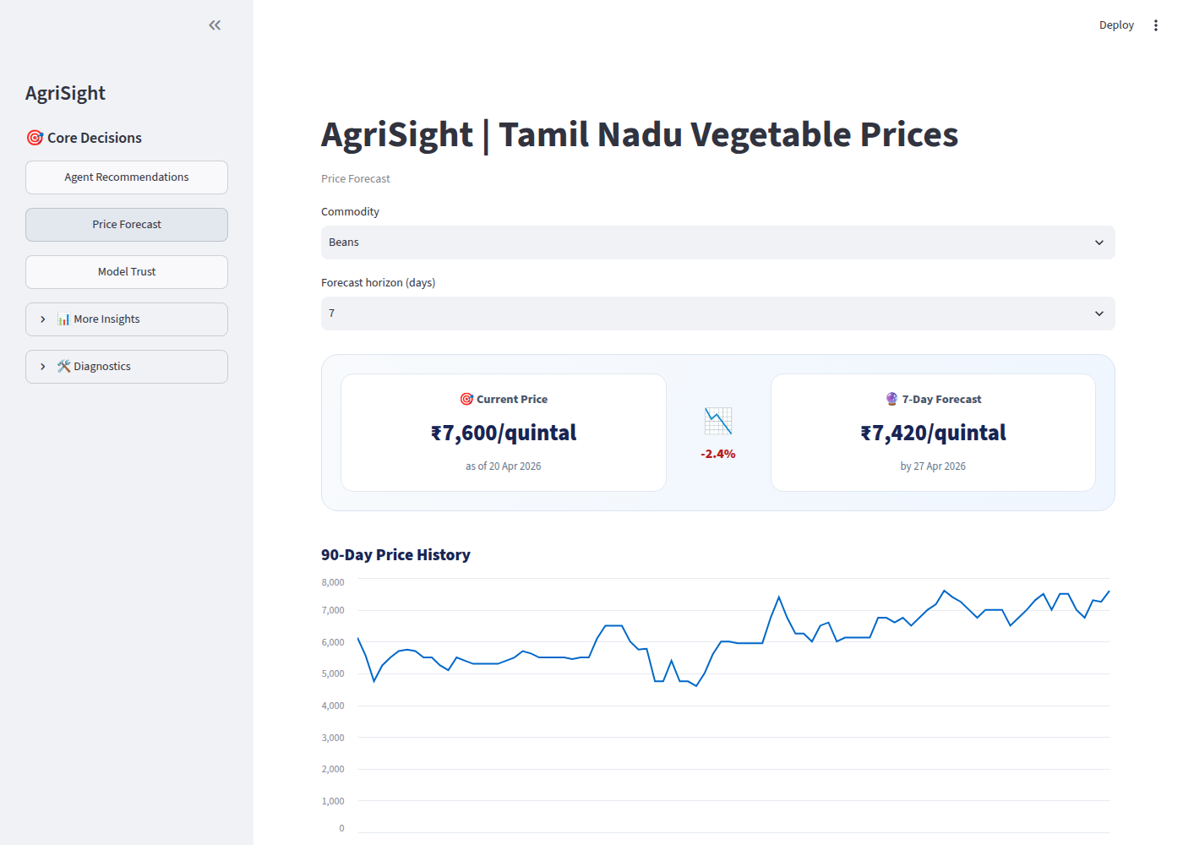
Figure A 5.1: Dashboard: Price Forecast page
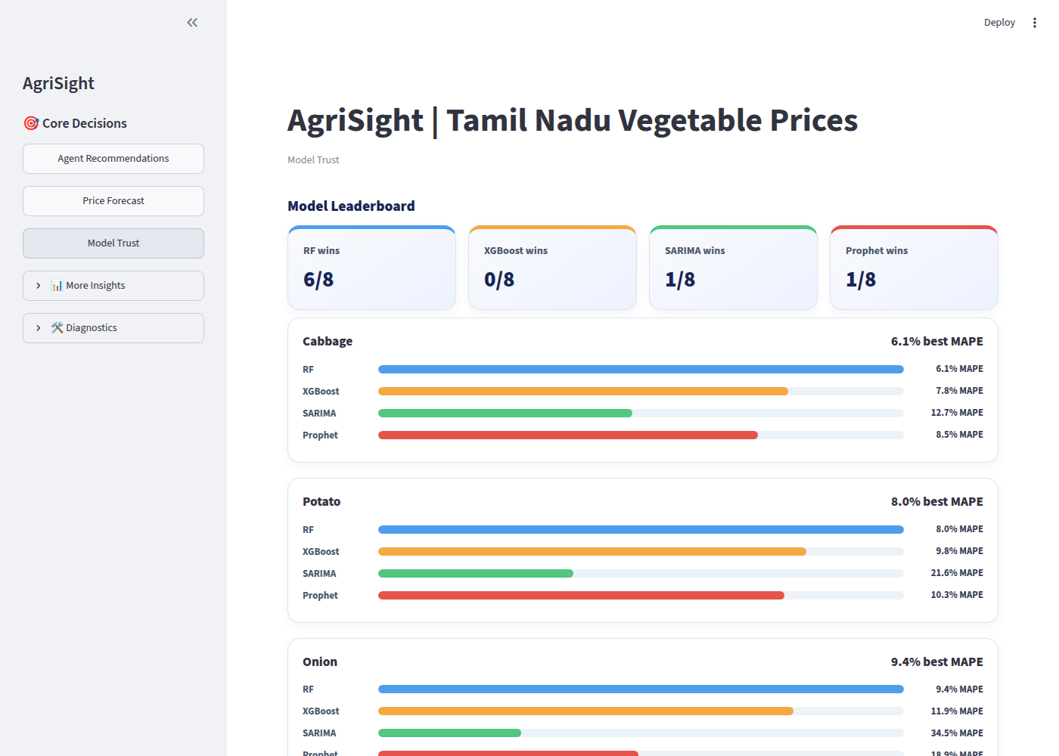
Figure A 5.2: Dashboard: Model Trust page

APPENDIX 6 PROSPECTIVE BUYER PILOT DESIGN
To establish whether forecast-informed purchasing reduces cost, a prospective pilot should be designed before any savings are estimated. The essential elements are as follows.
Table A 6.1: Pilot design elements
Element | Specification
Participants | One or more institutional buyers purchasing at Koyambedu at least weekly
Commodities | Tomato, Onion and Potato first (highest volume and volatility)
Comparator | Pre-registered: buyer’s usual timing, or alternating weeks with and without advice
Records | Date, quantity, grade, supplier, invoice price, transport, rejected and spoiled quantity, stockouts
Primary outcome | Delivered cost per usable kilogram
Secondary outcomes | Forecast error vs naive; advice acceptance and override reasons; service level
Duration | At least one full year, to include a monsoon season and price shocks
Governance | Consent, anonymised identifiers, restricted access to commercial data; buyer retains decision authority
Source: Author’s design.

REFERENCES
Ajmal, S., Rohith, S., Unniravisankar, P., & Nabay, O. (2024). Price dynamics of tomato, onion and potato (TOP) in India. Asian Journal of Agricultural Extension, Economics & Sociology, 42(3). https://ideas.repec.org/a/ags/ajaees/367914.html
Bergmeir, C., & Benítez, J. M. (2012). On the use of cross-validation for time series predictor evaluation. Information Sciences, 191, 192–213. https://doi.org/10.1016/j.ins.2011.12.028
Birthal, P. S., Negi, A., & Joshi, P. K. (2019). Understanding causes of volatility in onion prices in India. Journal of Agribusiness in Developing and Emerging Economies, 9(3). https://doi.org/10.1108/JADEE-06-2018-0068
Box, G. E. P., Jenkins, G. M., Reinsel, G. C., & Ljung, G. M. (2015). Time series analysis: Forecasting and control (5th ed.). Wiley.
Breiman, L. (2001). Random forests. Machine Learning, 45, 5–32. https://doi.org/10.1023/A:1010933404324
Chand, R. (2010). Understanding the nature and causes of food inflation. Economic and Political Weekly, 45(9), 10–13.
Chen, T., & Guestrin, C. (2016). XGBoost: A scalable tree boosting system. In Proceedings of the 22nd ACM SIGKDD International Conference on Knowledge Discovery and Data Mining (pp. 785–794). https://doi.org/10.1145/2939672.2939785
Chopra, S., & Meindl, P. (2016). Supply chain management: Strategy, planning, and operation (6th ed.). Pearson.
Dickey, D. A., & Fuller, W. A. (1979). Distribution of the estimators for autoregressive time series with a unit root. Journal of the American Statistical Association, 74(366), 427–431. https://doi.org/10.2307/2286348
Diebold, F. X., & Mariano, R. S. (1995). Comparing predictive accuracy. Journal of Business & Economic Statistics, 13(3), 253–263. https://doi.org/10.1080/07350015.1995.10524599
Fagbohun, O., Yashwanth, S., Akintola, A. S., Wurola, I., Shittu, L., Inyang, A., Odubola, O., Offia, U., Olanrewaju, S., Toluwaleke, O., Abutu, I., & Akinbolaji, T. (2025). GreenIQ: A deep search platform for comprehensive carbon market analysis and automated report generation. arXiv:2503.16041. https://doi.org/10.48550/arXiv.2503.16041
Hyndman, R. J., & Athanasopoulos, G. (2021). Forecasting: Principles and practice (3rd ed.). OTexts. https://otexts.com/fpp3/
Hyndman, R. J., & Koehler, A. B. (2006). Another look at measures of forecast accuracy. International Journal of Forecasting, 22(4), 679–688. https://doi.org/10.1016/j.ijforecast.2006.03.001
Kaufman, S., Rosset, S., Perlich, C., & Stitelman, O. (2012). Leakage in data mining: Formulation, detection, and avoidance. ACM Transactions on Knowledge Discovery from Data, 6(4), Article 15. https://doi.org/10.1145/2382577.2382579
Khandelwal, M. (n.d.). Daily commodity prices India [Data set]. Kaggle. Retrieved 2026, from https://www.kaggle.com/datasets/khandelwalmanas/daily-commodity-prices-india (compiled from Agmarknet, Directorate of Marketing and Inspection, Government of India).
Lundberg, S. M., & Lee, S.-I. (2017). A unified approach to interpreting model predictions. Advances in Neural Information Processing Systems, 30, 4765–4774.
Makridakis, S., Spiliotis, E., & Assimakopoulos, V. (2018a). Statistical and machine learning forecasting methods: Concerns and ways forward. PLoS ONE, 13(3), e0194889. https://doi.org/10.1371/journal.pone.0194889
Makridakis, S., Spiliotis, E., & Assimakopoulos, V. (2018b). The M4 Competition: Results, findings, conclusion and way forward. International Journal of Forecasting, 34(4), 802–808. https://doi.org/10.1016/j.ijforecast.2018.06.001
Manogna, R. L., Dharmaji, V., & Sarang, S. (2025). Enhancing agricultural commodity price forecasting with deep learning. Scientific Reports, 15, Article 20903. https://doi.org/10.1038/s41598-025-05103-z
Mantaw, C. S., Prahadeeswaran, M., Karthick, V., Sumathi, C. S., & Patil, S. G. (2024). Leveraging machine learning for accurate groundnut price forecasting in Tamil Nadu: An XGBoost approach. Research Square [Preprint]. https://doi.org/10.21203/rs.3.rs-4293571/v1
Molnar, C. (2022). Interpretable machine learning: A guide for making black box models explainable (2nd ed.). https://christophm.github.io/interpretable-ml-book/
Newey, W. K., & West, K. D. (1987). A simple, positive semi-definite, heteroskedasticity and autocorrelation consistent covariance matrix. Econometrica, 55(3), 703–708. https://doi.org/10.2307/1913610
Open-Meteo. (n.d.). Historical weather API. Retrieved 2026, from https://open-meteo.com/en/docs/historical-weather-api
Padhi, P., Shekhar, H., & Handa, A. (2023). Anatomy of price volatility transmission in Indian vegetables market (DRG Study No. 49). Reserve Bank of India.
Pedregosa, F., Varoquaux, G., Gramfort, A., Michel, V., Thirion, B., Grisel, O., et al. (2011). Scikit-learn: Machine learning in Python. Journal of Machine Learning Research, 12, 2825–2830.
Roy, R., Gupta, S., Wardhan, H., Sarkar, S., Tewari, S., Bansal, R., Bhatia, S., & Gulati, A. (2024). Vegetables inflation in India: A study of tomato, onion and potato (TOP) (RBI Working Paper Series No. 08/2024). Reserve Bank of India. https://rbi.org.in/scripts/PublicationsView.aspx?Id=22723
Seabold, S., & Perktold, J. (2010). Statsmodels: Econometric and statistical modeling with Python. In Proceedings of the 9th Python in Science Conference (pp. 92–96).
Silver, E. A., Pyke, D. F., & Thomas, D. J. (2017). Inventory and production management in supply chains (4th ed.). CRC Press.
Tamilselvi, C., & Mohan Naidu, G. (2020). Forecasting of vegetable arrivals and wholesale prices of Koyambedu market in Chennai using SARIMA approach. International Journal of Current Microbiology and Applied Sciences, 9(10), 3059–3068. https://doi.org/10.20546/ijcmas.2020.910.368
Tashman, L. J. (2000). Out-of-sample tests of forecasting accuracy: An analysis and review. International Journal of Forecasting, 16(4), 437–450. https://doi.org/10.1016/S0169-2070(00)00065-0
Taylor, S. J., & Letham, B. (2018). Forecasting at scale. The American Statistician, 72(1), 37–45. https://doi.org/10.1080/00031305.2017.1380080
Vegetable Market Price. (n.d.). Koyambedu market price history. Retrieved 17 October 2026, from https://vegetablemarketprice.com/market/koyambedu/history (daily series attributed to the Koyambedu Vegetable Merchants’ Council).
Wang, L., Ma, C., Feng, X., Zhang, Z., Yang, H., Zhang, J., et al. (2024). A survey on large language model based autonomous agents. Frontiers of Computer Science, 18(6), 186345. https://doi.org/10.1007/s11704-024-40231-1
Zhang, Z., Zhang, J., Liu, H., Lv, Q., Yang, J., Cai, K., & Wang, K. (2026). AgriWorld: A World Tools Protocol framework for verifiable agricultural reasoning with code-executing LLM agents. arXiv:2602.15325. https://doi.org/10.48550/arXiv.2602.15325

