A STUDY ON SHORT-TERM VEGETABLE PRICE FORECASTING AT KOYAMBEDU WHOLESALE MARKET: A MACHINE LEARNING AND MULTI-AGENT AI APPROACH FOR SUPPLY CHAIN PROCUREMENT DECISION-MAKING
By
VIGNESH NATARAJAN
Roll No. 2406OBA0046
Reg. No. 69124100162
A PROJECT REPORT
Submitted to the
FACULTY OF MANAGEMENT SCIENCES
in partial fulfillment for the award of the degree
of
MASTER OF BUSINESS ADMINISTRATION

CENTRE FOR DISTANCE AND ONLINE EDUCATION
ANNA UNIVERSITY
CHENNAI 600 025
OCTOBER 2026
BONAFIDE CERTIFICATE
Certified that the Project report titled “A Study on Short-Term Vegetable Price Forecasting at Koyambedu Wholesale Market: A Machine Learning and Multi-Agent AI Approach for Supply Chain Procurement Decision-Making” is the bonafide work of Mr. VIGNESH NATARAJAN who carried out the work under my supervision. Certified further that to the best of my knowledge the work reported herein does not form part of any other project report or dissertation on the basis of which a degree or award was conferred on an earlier occasion on this or any other candidate.


Signature of Student | Signature of Project supervisor / Guide
Name: VIGNESH NATARAJAN | Name:
(in capital letters) | (in capital letters)
Roll No.: 2406OBA0046 | Designation:
Reg. No.: 69124100162 | Address:

Signature of Project In-charge | Signature of External Examiner
Name: | Name:
(in capital letters) | (in capital letters)
Study Centre: | Date of Viva-voce:

CERTIFICATE OF VIVA-VOCE-EXAMINATION
This is to certify that Thiru VIGNESH NATARAJAN (Roll No. 2406OBA0046 & Register No. 69124100162) has been subjected to Viva-voce-Examination on ……………………… (Date) at ……………… (Time).

Internal Examiner | External Examiner
Name: | Name:
(in capital letters) | (in capital letters)
Designation: | Designation:
Address: | Address:

Date:

ABSTRACT
Vegetable prices in India are volatile because supply is seasonal, perishable and weather-sensitive. For an institutional buyer, the cost of a poorly timed purchase is direct. This study asks whether short-term price forecasts, and a rule-based multi-agent decision layer built on them, can support procurement timing for eight vegetables traded at Koyambedu Wholesale Market, Chennai: Tomato, Onion, Potato, Cabbage, Carrot, Beans, Brinjal and Drumstick. A statewide Tamil Nadu series is analysed alongside as a comparison.
Two published price datasets were analysed separately. The first is a Kaggle-hosted Agmarknet extract of 414,388 market-level records from 451 Tamil Nadu markets (24 January 2024 to 20 April 2026), aggregated to a daily statewide median. The second is a Koyambedu history-page series of 14,472 daily ₹/kg observations (4 November 2021 to 17 October 2026) attributed to the Koyambedu Vegetable Merchants’ Council. SARIMA, Prophet, Random Forest and XGBoost were compared with naive baselines under chronological validation; SHAP was used for interpretation; HAC regressions tested a Northeast Monsoon rainfall effect; and the procurement rules were backtested.
The central finding is that simple baselines were not beaten. On the statewide 90-day holdout, Random Forest recorded 11.32% mean MAPE and XGBoost 13.98%, but yesterday’s price alone gave 4.20%; a strictly seven-day-ahead XGBoost gave 27.09%. On Koyambedu data across seven origins and 7-, 14- and 30-day horizons, the last observed price had the lowest WAPE (11.88%), followed by SARIMA (12.28%), while XGBoost (15.36%), Random Forest (16.63%) and Prophet (23.82%) were worse. No rainfall-anomaly coefficient was significant (p = 0.26–0.92); SHAP ranked a Northeast Monsoon deviation index 12th to 15th of 16 features; and adding weather context to XGBoost did not significantly improve accuracy on a six-month holdout (Diebold–Mariano p = 0.10–0.98). Prior seven-day momentum was significantly negative for all eight vegetables, indicating short-run mean reversion. The procurement rules beat an immediate purchase in only 30.4% of 56 backtest cases. In the 2023 tomato episode the 30-day forecast gave an early warning, signalling a rise of more than 100% from 29 April, and correctly anticipated the rise at 7 of 9 dates (worth about ₹170/kg net to a forward buyer). The decision rules, however, rated these large forecast rises as high-risk, downgraded them to partial purchases and then advised delay in late June, producing a cumulative ₹219/kg loss relative to buying immediately.
All four objectives were tested and answered. The study contributes a reproducible end-to-end pipeline with a nine-page dashboard; a horizon-sensitivity check that exposes next-day persistence masquerading as forecast skill; evidence of short-run mean reversion; a documented failure case for automated advice during a supply shock; and safeguards designed to stop a local AI writer from altering prices. For these series and horizons, naive benchmarks should be the procurement baseline for routine purchases, the 30-day forecast is worth monitoring as an early-warning signal, and the decision rules require redesign (separating forecast direction from risk), a supply-shock override, uncertainty-scaled thresholds and a buyer pilot before operational use. No realized savings are claimed.
Keywords: vegetable price forecasting; procurement; Agmarknet; Koyambedu; SARIMA; XGBoost; SHAP; naive benchmark; multi-agent decision support; Tamil Nadu
VIGNESH NATARAJAN
Signature of the Candidate

ACKNOWLEDGEMENT
This project was carried out as part of the Online MBA (Business Analytics) programme, and I thank Anna University and its Centre for Distance and Online Education for making it possible. I am grateful to my project guide for academic direction, for the questions raised at the first and second reviews, and for feedback that shaped the evaluation design of this study.
I acknowledge the maintainers of the public data sources used: Agmarknet, the Kaggle daily commodity price compilation, the Vegetable Market Price history series attributed to the Koyambedu Vegetable Merchants’ Council, and Open-Meteo. My family and colleagues supported me throughout, and I am grateful to them. Any errors that remain are my own.
VIGNESH NATARAJAN
Signature of the Candidate

TABLE OF CONTENTS
Chapter No. | Title | Page No.
 | ABSTRACT | iv
 | LIST OF TABLES | ix
 | LIST OF FIGURES | x
 | LIST OF ABBREVIATIONS | xi
1 | INTRODUCTION | 1
1.1 | BACKGROUND OF THE STUDY | 1
1.2 | INDUSTRY PROFILE | 1
1.3 | IDENTIFIED PROBLEM | 2
1.4 | NEED FOR THE STUDY | 3
1.5 | OBJECTIVES OF THE STUDY | 3
1.6 | DELIVERABLES | 5
1.7 | LIMITATIONS OF THE STUDY (SUMMARY) | 5
2 | LITERATURE SURVEY | 6
2.1 | STUDIES ON TAMIL NADU AND KOYAMBEDU | 7
2.2 | STATISTICAL TIME-SERIES FORECASTING | 7
2.3 | MACHINE-LEARNING FORECASTING | 7
2.4 | EXPLAINABLE MACHINE LEARNING | 9
2.5 | AI AGENTS IN ANALYTICAL WORKFLOWS | 9
2.6 | RESEARCH GAP | 9
3 | METHODOLOGY | 11
3.1 | TYPE OF PROJECT AND RESEARCH DESIGN | 11
3.2 | SOURCES OF DATA | 12
3.3 | TARGET RESPONDENTS, SAMPLING METHOD AND UNIT OF ANALYSIS | 13
3.4 | FORECASTING MODELS | 14
3.5 | EVALUATION PROTOCOLS | 15
3.6 | STATISTICAL TOOLS AND ACCURACY MEASURES | 15
3.7 | MULTI-AGENT DECISION LAYER | 16
3.8 | PROCUREMENT BACKTEST DESIGN | 17
3.9 | TOOLS AND SOFTWARE | 17
3.10 | ASSUMPTIONS, CONSTRAINTS AND LIMITATIONS | 19
4 | DATA ANALYSIS AND INTERPRETATION | 20
4.1 | PROFILE OF THE STATEWIDE DATA | 20
4.2 | DATA QUALITY ASSESSMENT | 21
4.3 | PRICE BEHAVIOUR: TREND, SEASONALITY AND CO-MOVEMENT | 22
4.4 | STATIONARITY TESTING | 24
4.5 | STATEWIDE FORECASTING RESULTS | 25
4.6 | MODEL EXPLANATION WITH SHAP | 27
4.7 | PROFILE OF THE KOYAMBEDU SERIES | 28
4.8 | KOYAMBEDU MULTI-HORIZON MODEL COMPARISON (PROTOCOL B1) | 29
4.9 | MATCHED-HORIZON ROBUSTNESS CHECK (PROTOCOL B2) | 31
4.10 | NORTHEAST MONSOON AND WEATHER CONTEXT | 31
4.11 | MULTI-AGENT DECISION LAYER OUTPUTS | 35
5 | CONCLUSIONS | 43
5.1 | SUMMARY OF FINDINGS | 43
5.2 | SUGGESTIONS AND RECOMMENDATIONS | 45
5.3 | SCOPE FOR FUTURE RESEARCH | 47
5.4 | CONCLUSION | 47
 | APPENDIX 1 DATA DICTIONARY | 49
 | APPENDIX 2 MODEL FEATURES AND SETTINGS | 50
 | REFERENCES | 52

LIST OF TABLES
Table No. | Title | Page No.
3.1 | Data sources used in the study | 12
3.3 | Models and key settings | 14
3.4 | Evaluation protocols | 15
3.5 | Risk and procurement decision rules | 16
4.1 | Statewide records and daily median modal price (₹/quintal) | 20
4.2 | Data quality checks on the statewide data | 21
4.3 | Augmented Dickey–Fuller test on daily statewide median price | 24
4.4 | Statewide 90-day holdout MAPE (%) by commodity and model | 25
4.5 | Statewide holdout RMSE and MAE (₹/quintal) | 25
4.7 | Top three SHAP drivers and share of attribution from own previous-day price | 27
4.8 | Koyambedu daily price series (₹/kg), 4 Nov 2021 – 17 Oct 2026 | 28
4.9 | Koyambedu model comparison pooled over origins, series and horizons (₹/kg) | 29
4.10 | Koyambedu WAPE (%) by forecast horizon | 30
4.11 | Koyambedu WAPE (%) by series and model (lowest in bold) | 30
4.12 | Koyambedu matched-horizon evaluation, 4 origins: mean MAPE (%) and MAE (₹/kg) | 31
4.13 | HAC regression of 7-day price return on rainfall anomaly and momentum | 31
4.14 | SHAP ranking of the NE Monsoon deviation index (Koyambedu, 7-day XGBoost) | 33
4.15 | Delta-accuracy test: WAPE (%) on the six-month holdout, Koyambedu, 8 series | 34
4.16 | Agent recommendations at 20 April 2026 (₹/quintal) | 35
4.17 | AgriSight four-role brief, offline run (₹/quintal) | 35
A 1.1 | Fields of the processed price data | 49
A 2.1 | Commodity name mappings | 50
A 2.2 | Festival and season flags | 50

LIST OF FIGURES
Figure No. | Title | Page No.
3.1 | Analytical workflow of the AgriSight study | 12
4.1 | Tomato daily statewide median with rolling-z anomalies and suspected unit errors | 22
4.2 | Monthly median of daily statewide modal price by commodity | 22
4.3 | Seasonal price index by calendar month (annual mean = 100) | 23
4.4 | Correlation of monthly median prices across commodities | 24
4.6 | SHAP attribution: top features averaged over the eight models, and share from the own previous-day price | 28
4.7 | Koyambedu history-page daily prices by series | 29
4.8 | Rainfall-anomaly coefficients with 95% HAC intervals, and price-momentum coefficients | 32
4.9 | Tomato: SHAP beeswarm for the Koyambedu 7-day XGBoost model | 33
4.10 | Tomato: SHAP dependence plots for the top three features | 33
4.11 | Dashboard: Agent Recommendations page | 37

LIST OF ABBREVIATIONS
Abbreviation | Meaning
ADF | Augmented Dickey–Fuller (unit-root test)
AIC | Akaike Information Criterion
API | Application Programming Interface
APMC | Agricultural Produce Market Committee
CV | Coefficient of Variation
DM test | Diebold–Mariano test of equal forecast accuracy
EMA | Exponential Moving Average
HAC | Heteroskedasticity and Autocorrelation Consistent (standard errors)
LLM | Large Language Model
MAE | Mean Absolute Error
MAPE | Mean Absolute Percentage Error
NE / SW monsoon | Northeast / Southwest monsoon
OLS | Ordinary Least Squares
PIB | Press Information Bureau
RF | Random Forest
RMSE | Root Mean Squared Error
SARIMA | Seasonal Autoregressive Integrated Moving Average
SHAP | SHapley Additive exPlanations
sMAPE | Symmetric Mean Absolute Percentage Error
TOP | Tomato, Onion and Potato
WAPE | Weighted Absolute Percentage Error
WF | Walk-forward (rolling-origin) evaluation
XGBoost | Extreme Gradient Boosting

CHAPTER 1

INTRODUCTION

1.1 BACKGROUND OF THE STUDY
Vegetables are a large and volatile component of household and institutional food spending in India. Tomato, onion and potato carry only a small share of the CPI basket, yet they account for an outsized part of the swings in food and overall inflation. Their crop cycles are short, they spoil quickly, their cultivation is concentrated in a few regions, and their output depends heavily on the weather (Roy et al., 2024). In July 2023, consumers across India paid on average about ₹109.5 for a kilogram of tomatoes, and the tomato component of the CPI was more than three times its level a year earlier (Roy et al., 2024). Retail prices of up to ₹200/kg were widely reported at the time. In the Koyambedu series used in this study, tomato rose from ₹13–18/kg in April–May 2023 to a peak of ₹160/kg on 1 August, roughly nine to twelve times its spring level. Episodes of this kind are not isolated: onion and potato have shown similar boom-and-bust cycles in alternate years.
For buyers who procure vegetables regularly, such as hotels, institutional kitchens, hospital and hostel caterers, food processors and retail chains, the question is practical: should a purchase be made now, deferred, or split? A modest improvement in timing, applied across a large and recurring purchase volume, could matter financially. Data-driven forecasting appears to offer that improvement, and recent advances in machine learning and AI agents have made sophisticated forecasting pipelines easy to build.
This project, named AgriSight, builds such a pipeline for eight vegetables traded in Tamil Nadu and evaluates it critically. The emphasis of the final study is not only on whether a model can be fitted, but on whether its forecasts beat the simplest credible alternatives and whether the resulting procurement advice would actually have helped a buyer.

1.2 INDUSTRY PROFILE

1.2.1 Vegetable marketing in India
Most vegetables in India move from farmers to consumers through regulated wholesale markets administered by state Agricultural Produce Market Committees (APMCs), with traders, commission agents, wholesalers and retailers in between. Value-chain studies estimate that farmers receive only about one-third of the consumer rupee for tomato, onion and potato, with the remainder apportioned along the chain (Roy et al., 2024). Prices are discovered daily through auctions and negotiation, and the Directorate of Marketing and Inspection publishes reported market prices through the Agricultural Marketing Information Network (Agmarknet).

1.2.2 Tamil Nadu markets and the Koyambedu complex
Tamil Nadu has two distinct channels that appear in the data used here. The first is the network of regulated markets and Uzhavar Sandhai (farmers’ markets), the latter established by the Government of Tamil Nadu so that farmers can sell directly to consumers. In the statewide extract used in this study, Uzhavar Sandhai account for 90.7 per cent of all records, which is important for interpretation because their prices are closer to retail than to bulk wholesale. The second is the Koyambedu Wholesale Market Complex in Chennai, one of the largest wholesale markets for perishables in South India and the reference market for buyers in the Chennai region. Its daily prices are published by the Koyambedu Vegetable Merchants’ Council and redistributed by public websites.

1.2.3 Who uses short-term price forecasts
The intended users of this study are procurement managers who buy in recurring cycles and can shift purchases by days or weeks: institutional caterers, hotel and restaurant groups, food processors, retail chains and aggregators. Their decision variables are timing, quantity and supplier; their constraints are shelf life, storage, cash flow and service level. A forecast is useful to them only if it improves on what they already know, which at minimum is today’s price.

1.3 IDENTIFIED PROBLEM
Buyers have to decide when to purchase without knowing which way prices will move over the coming days and weeks. Machine-learning forecasts and AI-agent pipelines promise better information, but agricultural price series are short, noisy and subject to sudden supply shocks, and published forecast accuracy figures are often not compared with naive benchmarks or are computed in ways that leak future information. The problem addressed is therefore twofold: (a) to determine whether statistical and machine-learning models forecast Tamil Nadu vegetable prices better than naive benchmarks at procurement-relevant horizons; and (b) to determine whether a transparent rule-based decision layer built on those forecasts would have improved purchase outcomes.

1.4 NEED FOR THE STUDY
Koyambedu Wholesale Market sets reference prices for vegetables bought across Chennai and much of Tamil Nadu, so price swings there pass quickly to hotels, canteens, caterers and retailers. Published forecasting work on this market is limited to monthly SARIMA modelling, and it has not been tested whether machine-learning methods, weather signals or an AI agent layer improve on that work for daily, procurement-relevant horizons in a region whose rainfall is dominated by the Northeast Monsoon. Buyers considering such tools need evidence of whether they beat the simple rules of thumb already in use before relying on them.
For practitioners, the study shows how to test a forecasting tool before trusting it, and identifies the benchmark a vendor or in-house model must beat. For the academic programme, it demonstrates a full analytics life cycle on real data: acquisition, cleaning, feature engineering, modelling, explanation, decision rules, backtesting and a deployable dashboard. Its methodological contribution is a horizon-sensitivity check that exposes how next-day information can make a model look far more accurate than it is at the horizon a buyer needs. Because the study reports results whether or not they support the original hypotheses, its negative findings are as informative as its positive ones: they tell buyers which tools not to rely on and which information to acquire instead.

1.5 OBJECTIVES OF THE STUDY
Primary objective. To Study On Short-Term Vegetable Price Forecasting At Koyambedu Wholesale Market: A Machine Learning And Multi-Agent Ai Approach For Supply Chain Procurement Decision-Making
Secondary objectives. The four secondary objectives of the approved proposal are retained; differences in data and method from the proposal, and their reasons, are set out in Section 3.12:
- To compare the forecast accuracy of SARIMA, Prophet, Random Forest, and XGBoost on 7-day, 14-day, and 30-day vegetable price horizons at Koyambedu, measured by RMSE and MAPE against the existing published SARIMA benchmark, establishing the first machine learning performance baseline for this market.
- To test whether Tamil Nadu’s Northeast Monsoon deviation is a statistically significant predictor of Koyambedu vegetable prices, using SHAP feature importance analysis to rank it against historical price lag and market arrival volume.
- To build AgriSight, a 4-agent AI pipeline that collects daily market prices, runs the best-performing forecast model, retrieves live weather and policy news from RSS feeds, and generates a plain-English market intelligence brief using a locally hosted LLM at zero cost.
- To estimate the economic value of the 30-day price forecast by calculating the potential procurement cost savings achievable had the model signal been available in the three months before the July 2023 tomato price crisis at Koyambedu

1.6 DELIVERABLES
The study delivers: (i) a comparison of SARIMA, Prophet, Random Forest and XGBoost against naive benchmarks at 7-, 14- and 30-day horizons on Koyambedu prices, with a statewide comparison; (ii) SHAP feature-importance outputs, including beeswarm and dependence plots, and a significance test of the Northeast Monsoon effect; (iii) the AgriSight pipeline with a nine-page dashboard that produces a buyer brief; (iv) a delta-accuracy test of weather context on a six-month held-out period; (v) a procurement backtest and a 2023 tomato case study using the 30-day forecast; and (vi) this report with recommendations for buyers.

1.7 LIMITATIONS OF THE STUDY (SUMMARY)
Source verification. Neither price source’s upstream collection process was independently audited, and the Koyambedu API does not state whether quotes are wholesale or retail. The statewide series mixes farmers’ markets and wholesale markets and contains a small number of apparent unit errors. The weather record spans just two full monsoon seasons, and market-arrival volumes could not be obtained. Procurement results are counterfactual, not realized savings. These limitations are discussed in full in Section 3.10 and the assumptions behind the analysis in Section 3.10.

CHAPTER 2

LITERATURE SURVEY
This chapter reviews five bodies of work relevant to the study: the economics of vegetable price volatility in India; statistical and machine-learning forecasting methods; principles of forecast evaluation; model explanation and AI agents; and procurement decision-making under price uncertainty. It closes by identifying the research gap.

2.1 STUDIES ON TAMIL NADU AND KOYAMBEDU
Tamilselvi and Mohan Naidu (2020) model monthly vegetable arrivals and wholesale prices at Koyambedu using SARIMA and report adequate fit for seasonal series. The project proposal identified two published SARIMA studies of Koyambedu prices; only this one could be located and verified. It is the closest market-specific precedent but uses monthly data, so its error figures are not directly comparable with the daily horizons used here. Mantaw et al. (2024) apply XGBoost to groundnut prices in Tamil Nadu and report favourable accuracy, illustrating the regional interest in gradient boosting, though for a storable crop and without a naive benchmark.

2.2 STATISTICAL TIME-SERIES FORECASTING
The Box–Jenkins approach models a series through autoregressive, differencing and moving-average terms, with seasonal extensions for repeating cycles (Box et al., 2015). Identification relies on stationarity assessment, commonly through the Augmented Dickey–Fuller (ADF) test (Dickey & Fuller, 1979), and model selection on information criteria such as AIC followed by residual diagnostics. Hyndman and Athanasopoulos (2021) emphasise that forecasting methods should be judged on genuine out-of-sample performance and recommend simple benchmarks, namely the naive (last value), seasonal naive and drift methods, as the reference against which more complex methods must justify themselves.
Prophet (Taylor & Letham, 2018) represents a series as a sum of piecewise-linear trend, Fourier-based yearly and weekly seasonality, and holiday effects. It is designed for business series with strong calendar effects and long histories; with fewer than two to three years of data, annual seasonality is weakly identified and trend changepoints can extrapolate poorly.

2.3 MACHINE-LEARNING FORECASTING
Random Forests average many decision trees grown on bootstrap samples with random feature subsets, reducing variance (Breiman, 2001). Gradient boosting builds trees sequentially to correct residual errors; XGBoost adds regularisation and efficient computation (Chen & Guestrin, 2016). Applied to time series, these methods are typically trained on engineered features such as lagged values, rolling statistics and calendar indicators, which converts forecasting into supervised regression. Manogna, Dharmaji and Sarang (2025) report improvements from deep-learning models for Indian agricultural commodity prices.
The evidence is not one-sided. In a large comparison on M3 competition series, Makridakis, Spiliotis and Assimakopoulos (2018a) found that popular machine-learning methods were frequently less accurate than simple statistical methods and were more computationally demanding. The subsequent M4 competition (Makridakis et al., 2018b) found that pure machine-learning methods performed poorly and that the best results came from combinations and hybrids. These findings motivate the inclusion of naive and statistical benchmarks in every comparison reported in this study.

2.4 EXPLAINABLE MACHINE LEARNING
SHAP (Lundberg & Lee, 2017) attributes a model’s prediction to its input features using Shapley values from cooperative game theory, with an efficient exact algorithm for tree ensembles. Molnar (2022) stresses that such attributions describe how a fitted model uses its inputs and do not establish causal effects; correlated features can share or swap attribution. In this study, SHAP is used diagnostically: a large share of attribution on yesterday’s price is evidence that a model is mainly exploiting persistence.

2.5 AI AGENTS IN ANALYTICAL WORKFLOWS
Large-language-model-based autonomous agents, systems that plan, call tools and coordinate across roles, are surveyed by Wang et al. (2024). Domain applications include agricultural reasoning with code-executing agents that ground their answers in tools and data (Zhang et al., 2026) and multi-agent platforms that automate market analysis and report generation, demonstrated for carbon markets (Fagbohun et al., 2025). These works motivate AgriSight’s four-role design. However, most reported systems are evaluated on task completion rather than on the economic value of their recommendations; this study evaluates AgriSight’s advice against realized prices.

2.6 RESEARCH GAP
Table 2.1 summarises the most relevant studies. Indian research on vegetable prices has concentrated on monthly CPI inflation, volatility transmission and seasonal patterns, while machine-learning studies of agricultural prices commonly report accuracy without comparison to naive benchmarks or under evaluation designs whose information horizon is unclear. Few studies evaluate the procurement consequences of forecast-based advice, and none identified for Tamil Nadu vegetables do so on daily data across matched horizons. This study addresses that gap by comparing statistical and machine-learning models with naive benchmarks at procurement-relevant horizons, by checking whether reported accuracy reflects genuine forecast skill, and by backtesting the decision rules on realized prices, including a major price shock.

CHAPTER 3

METHODOLOGY

3.1 TYPE OF PROJECT AND RESEARCH DESIGN
The study follows a quantitative, explanatory–predictive design based entirely on published market and weather records (Section 3.2). No survey, interview or experiment was conducted. The analysis is retrospective and observational: it describes price behaviour, estimates forecasting models on historical observations, evaluates their out-of-sample accuracy in chronological order, and evaluates the consequences of a set of procurement rules against the prices actually observed. Because no purchases were made and no buyer transactions were recorded, procurement results are counterfactual comparisons rather than measured savings.
Two analytical tracks were run on two separate price sources (Figure 3.1). In line with the approved title, the Koyambedu track (Track B) carries the study’s objectives; the statewide track (Track A) provides a broader comparison and the input to the multi-agent pipeline. Track A uses a statewide Tamil Nadu compilation of Agmarknet records for model development, explanation and the multi-agent decision layer. Track B uses the Koyambedu history-page series for a common-origin, multi-horizon model comparison, the monsoon test, the 2023 tomato case study and the procurement backtest. The sources are deliberately not merged, because they differ in unit (₹/quintal versus ₹/kg), market coverage and price definition.
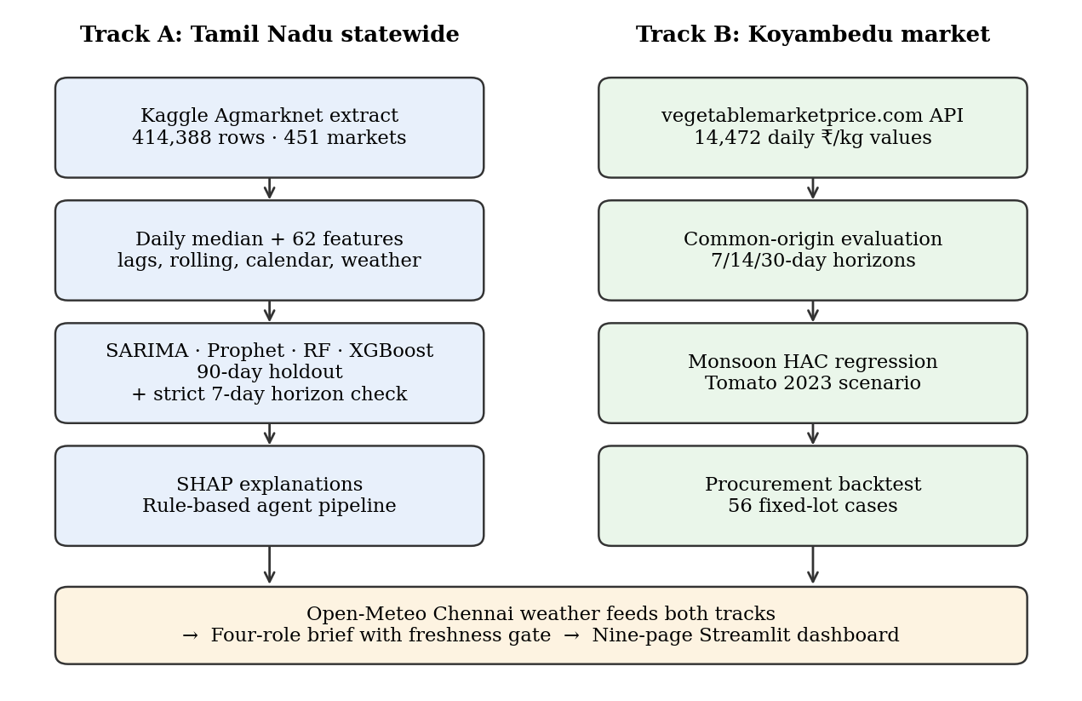
Figure 3.1: Analytical workflow of the AgriSight study

3.2 SOURCES OF DATA
All data used in the study are secondary data: published market price records and historical weather observations obtained from the public sources listed in Table 3.1.
Table 3.1: Data sources used in the study
Source | Content | Coverage | Use
Kaggle-hosted Agmarknet extract (Khandelwal, n.d.) | Market-level min, max and modal prices (₹/quintal), variety, grade | 414,388 rows; 451 markets; 36 districts; 24 Jan 2024 – 20 Apr 2026 | Track A modelling
Vegetable Market Price, Koyambedu history API | Daily price value per series (₹/kg), attributed to Koyambedu Vegetable Merchants’ Council | 14,472 values; 8 series × 1,809 days; 4 Nov 2021 – 17 Oct 2026 | Track B evaluation
Open-Meteo Historical Weather API (13.0827° N, 80.2707° E) | Daily precipitation, rain, max/mean/min temperature for Chennai | 1,004 days; 1 Jan 2024 – 30 Sep 2026 | Features; monsoon test
Press Information Bureau RSS (optional) | Official agriculture and price news items | Live mode only; not exercised in reported run | News Reader agent
Statewide data. The 2024–2026 annual files of the Kaggle dataset (Khandelwal, n.d.) were downloaded and filtered to Tamil Nadu, the eight vegetables and dates from 1 January 2024. The records were then cleaned: column names normalised column names, parses dates and numeric prices, maps commodity names (for example, “French Beans” and “Indian Beans (Seam)” to Beans) and removes duplicate date–market–commodity rows. The upstream compilation was not independently audited.
Koyambedu data. The public history API was queried in 180-day windows for 15 vegetable series, keeping every returned value with its unit label and extraction metadata. One series was then selected per study commodity without combining varieties: Big Onion represents Onion, French Beans is a provisional proxy for Beans, and regular Brinjal is kept separate from Big Brinjal. All values are copied unchanged; no interpolation is applied. The API labels the unit as 1 kg but does not state whether quotes are wholesale or retail.

3.3 TARGET RESPONDENTS, SAMPLING METHOD AND UNIT OF ANALYSIS
The project is analytical rather than survey-based, so there are no target respondents: no questionnaire or interview schedule was used, and the observations are market price records and weather readings. The intended users of the findings are procurement buyers (Section 1.2). The study uses all records available in the two sources after the filters above; it is not a sample survey and no probability sampling was involved. For Track A the unit of analysis is the commodity-day: market-level modal prices are aggregated to the daily statewide median for each vegetable, giving a feature table of 4,041 commodity-days (26 February 2024 to 20 April 2026) after the first 30 days of each series are consumed by lag construction. For Track B the unit is the commodity-day at Koyambedu (1,809 days per series). Forecast evaluation units are forecast origins × horizons × commodities.

3.4 FORECASTING MODELS
Table 3.3: Models and key settings
Model | Specification | Track
Naive (last value) | Forecast = most recent observed price | A, B
Seasonal naive (weekly) | Forecast = latest observed price on the target weekday; identical to the naive value at 7- and 14-day horizons | B1
SARIMA | Grid p∈{1,2}, q∈{0,1}, P,Q∈{0,1}; d from ADF (p<0.05 → d=0); D=1, m=7; best AIC. Track B: (1,1,1)(1,1,1,7) | A, B
Prophet | Track A: multiplicative yearly and weekly seasonality, Tamil Nadu holiday calendar ±3 days, SW/NE monsoon regressors, changepoint prior 0.05. Track B: yearly and weekly seasonality only | A, B
Random Forest | 300 trees, max depth 10, min leaf 5, max features 0.7 (Track B: 120 trees) | A, B
XGBoost | 400 trees, depth 5, learning rate 0.05, subsample 0.8, L1 0.1, L2 1 (Track B: 100 trees, depth 3) | A, B

3.5 EVALUATION PROTOCOLS
Because forecasting is temporal, every evaluation is chronological: models are trained only on data before the test period. Seven protocols were used (Table 3.4). Protocols A1 and A2 follow a standard holdout design; B1 and B2 meet objective S01 with matched origins and horizons; A3 is a robustness check on the information horizon of A2.
Table 3.4: Evaluation protocols
Code | Data | Design | Horizon
A1 | Statewide | Static: train on all but last 90 days, forecast 90 days (SARIMA, Prophet); SARIMA also refitted every 7 days | 1–90 days; 1–7 days (WF)
A2 | Statewide | Last 90 days, expanding window refitted every 30 days (RF, XGBoost) | Next day
A3 | Statewide | A2 repeated with naive benchmarks and with features rebuilt from t-7 and earlier | Next day vs strict 7 days
B1 | Koyambedu | 7 origins (1 Jan 2025 to 1 Jul 2026, quarterly), 6 methods, direct forecasts | 7, 14, 30 days
B2 | Koyambedu | 4 origins (23 Aug 2025 to 18 Aug 2026, 120-day spacing), 5 methods | 7, 14, 30 days
C1 | Koyambedu | Delta-accuracy test: XGBoost on price features only vs with weather context; 27 weekly origins over a six-month holdout (Apr–Sep 2026) | 7, 14, 30 days
C2 | Koyambedu | Tomato 2023 scenario: 13 weekly origins, 1 Apr to 24 Jun 2023, model retrained at each origin | 14 and 30 days

3.6 STATISTICAL TOOLS AND ACCURACY MEASURES
With y the actual and ŷ the forecast price over n scored points, the following measures are reported:
- MAE = (1/n) Σ |y − ŷ|, in the price unit (₹/quintal or ₹/kg).
- RMSE = √[(1/n) Σ (y − ŷ)²], which penalises large misses more heavily.
- MAPE = (100/n) Σ |y − ŷ| / |y|; intuitive but inflated when prices are low.
- WAPE = 100 × Σ |y − ŷ| / Σ |y|; the primary pooled measure for Track B because it weights errors by price level.
- sMAPE = (100/n) Σ 2|y − ŷ| / (|y| + |ŷ|).

Other tools used are: the ADF test for stationarity (null hypothesis: unit root); AIC for SARIMA order selection; rolling z-scores (|z| > 2.5 over 30 days) for anomaly screening; Pearson correlation of monthly medians; a seasonal price index (monthly median ÷ annual mean × 100); SHAP values for model attribution; and OLS regression with HAC (Newey–West) standard errors with seven lags for the monsoon test. The monsoon model, estimated per commodity on Koyambedu data, is:
R(t, t+7) = β₀ + β₁ · RainAnomaly₇(t) + β₂ · Momentum₇(t) + ε(t) (3.1)
where R is the forward seven-day log price change (%), RainAnomaly₇ is the seven-day average of daily rainfall expressed as a z-score relative to other days of the same month in the weather record, and Momentum₇ is the prior seven-day log price change (%). H2 is supported if β₁ in Equation (3.1) is significant at the 5% level. As the proposal specified, the monsoon effect is also ranked against price-lag features using SHAP, with a Northeast Monsoon deviation index defined as the 30-day rainfall total standardised against the same calendar month, set to zero outside October–December.

3.7 MULTI-AGENT DECISION LAYER
Two implementations of the decision layer were built. The deterministic agent pipeline runs a Data Analyst (30-day statistics and trend), a Price Forecaster (7- and 14-day tree-model forecasts), a Market Intelligence agent (risk score) and a Procurement Advisor (action). The four-role pipeline implements the roles named in the proposal (Data Collector, Price Forecaster, News Reader and Report Writer), forecasts recursively, abstains through a freshness gate when prices are more than three days old, and can add live weather, PIB news and a local language-model writer. The rules are shown in Table 3.5.
Table 3.5: Risk and procurement decision rules
Element | Rule
Risk score | min(100, 120 × CV₃₀ + 12 × |z₃₀| + 1.2 × |Δ₁₄|), where Δ₁₄ is the 14-day forecast change (%)
Risk level | HIGH if score ≥ 55; MEDIUM if ≥ 28; otherwise LOW
PROCURE NOW | Δ₁₄ > +5% and risk not HIGH → buy 70–100% within 1–2 days
DELAY PROCUREMENT | Δ₁₄ < −5% → defer discretionary volume; reassess in 7 days
PARTIAL PROCUREMENT | risk HIGH (and not DELAY) → buy 25–50%, split over 7–14 days
HEDGE | |Δ₁₄| > 3% → buy 25–50%, split over 7–14 days
HOLD | otherwise → normal replenishment
Freshness gate (four-role pipeline) | If latest price is more than 3 days old → ABSTAIN_STALE_DATA for every commodity

3.8 PROCUREMENT BACKTEST DESIGN
The backtest applies the rules in Table 3.5 to the stored 14-day XGBoost forecasts from protocol B1 (8 commodities × 7 origins = 56 cases). Each case is a fixed 100 kg lot. The baseline purchases all 100 kg on the forecast date. PROCURE NOW and HOLD do the same; DELAY purchases all of it fourteen days later at the price then observed; PARTIAL PROCUREMENT and HEDGE buy half at the origin and half at day 14. The result is the baseline cost minus the advice cost, so a positive value means the advice was cheaper. The same logic is applied to the 2023 tomato case, at 13 weekly origins from 1 April to 24 June 2023, with a 14-day XGBoost model retrained at each origin on data available up to that date. Storage, transport, spoilage, quality and stockout costs are excluded.

3.9 TOOLS AND SOFTWARE
All analysis was carried out in Python 3.12 using pandas 3.0 and NumPy 2.4 for data handling, statsmodels 0.15 for SARIMA, ADF and HAC regression (Seabold & Perktold, 2010), Prophet 1.5 (Taylor & Letham, 2018), scikit-learn 1.8 for Random Forest (Pedregosa et al., 2011), XGBoost 3.4 (Chen & Guestrin, 2016), SHAP 0.54 (Lundberg & Lee, 2017) and Matplotlib 3.10 for charts. The dashboard uses Streamlit 1.66. The complete pipeline was rerun end to end on 18 October 2026 with random seeds fixed at 42; the run order is recorded in the project README, and library versions are fixed in its requirements file because tree-model forecasts changed slightly between versions (Section 4.13).

3.10 ASSUMPTIONS, CONSTRAINTS AND LIMITATIONS
Assumptions. The analysis assumes that the published price values are recorded consistently over time; that the statewide daily median is a reasonable summary of reporting markets; that Chennai weather is a usable proxy for conditions affecting Koyambedu supply; and, in the backtests, that a buyer can purchase the required quantity at the observed price on the chosen day.
Constraints. Only free, publicly available data were used. Market arrival volumes, producer-region weather, archived policy news and buyer transaction records were not available, and the price history is shorter than the proposal envisaged (Table 3.6).
Limitations. Results describe these series, horizons and periods and may not generalise to other markets or years; procurement results are counterfactual rather than realised savings. The full list of limitations is given in Section 3.10.

CHAPTER 4

DATA ANALYSIS AND INTERPRETATION
This chapter presents the results in the order of the research questions: the data and their quality (Sections 4.1–4.4), statewide forecasting and its diagnosis (4.5–4.6), Koyambedu multi-horizon evaluation (4.7–4.9), the monsoon and weather-context tests (4.10), the multi-agent decision layer (4.11), the procurement backtest and tomato case study (4.13–4.14), and a summary of hypotheses and objectives (4.15–4.16). All figures and tables come from a single end-to-end run of the analysis pipeline (Section 3.8).

4.1 PROFILE OF THE STATEWIDE DATA
The statewide extract contains 414,388 market-level records for the eight vegetables from 451 markets in 36 districts between 24 January 2024 and 20 April 2026, with no missing values in any field. After aggregation to the daily statewide median and construction of 30-day lag features, the modelling table contains 4,041 commodity-days (about 504 days per vegetable) and 62 columns.
Table 4.1: Statewide records and daily median modal price (₹/quintal)
Commodity | Market records | Days | Mean | Median | Std. dev. | Min | Max | CV
Beans | 48,382 | 506 | 6,979 | 7,000 | 2,032 | 110 | 16,000 | 29%
Brinjal | 55,050 | 504 | 4,048 | 4,000 | 1,028 | 50 | 6,400 | 25%
Cabbage | 49,072 | 504 | 2,723 | 2,500 | 790 | 48 | 5,000 | 29%
Carrot | 49,130 | 504 | 6,061 | 6,000 | 2,010 | 70 | 12,500 | 33%
Drumstick | 50,268 | 504 | 8,240 | 7,000 | 5,103 | 100 | 21,500 | 62%
Onion | 59,560 | 503 | 3,993 | 3,250 | 1,543 | 45 | 7,000 | 39%
Potato | 47,305 | 504 | 4,078 | 4,000 | 951 | 48 | 5,500 | 23%
Tomato | 55,621 | 512 | 2,774 | 2,500 | 1,331 | 40 | 6,500 | 48%
Total / range | 414,388 | 4,041 |  |  |  |  |  | 23–62%
Interpretation. Drumstick (CV 62%) and Tomato (48%) are the most volatile series and Potato (23%) and Brinjal (25%) the least, consistent with the perishability ranking expected from the literature. The most important structural fact is that 90.7% of all records come from Uzhavar Sandhai, the state’s farmers’ markets, and only 9.3% from other regulated markets. A “statewide median” in this dataset is therefore largely a farmers’-market price. It is closer to a retail price than to the bulk wholesale price a procurement buyer pays, and this conditions every downstream use of Track A.

4.2 DATA QUALITY ASSESSMENT
Table 4.2: Data quality checks on the statewide data
Check | Result | Treatment
Missing values | None in any of 10 fields | None needed
Duplicate date–market–commodity keys | Removed during cleaning | Last record kept
Extreme values > ₹100,000/quintal | 3 records (Drumstick ₹180,000; Tomato ₹353,000 and ₹404,000) | Removed and logged
Implausibly low values < ₹300/quintal | 11,344 records (2.74%), 7,562 of them in June 2024 | Not removed; flagged as likely per-kg entries
Commodity-days affected by low values | 104 of 4,041 (12 per vegetable; 20 for Tomato) | Inflate holdout errors when in the test window
Rolling z-score anomalies (Tomato, |z| > 2.5) | 34 days | Retained; genuine spikes and data errors
Calendar gaps | Up to 3 missing days forward-filled; longer gaps left missing | Rows with incomplete features dropped

Interpretation. The data are complete but not clean. The cluster of values below ₹300 per quintal in June–July 2024, when the same vegetables otherwise trade at ₹2,000–8,000, is consistent with prices entered per kilogram in a per-quintal field. These days appear as sharp troughs in Figure 4.1. They also strengthen the cross-commodity correlations, because all eight series fall together on those days. They should be corrected at source before any operational use.
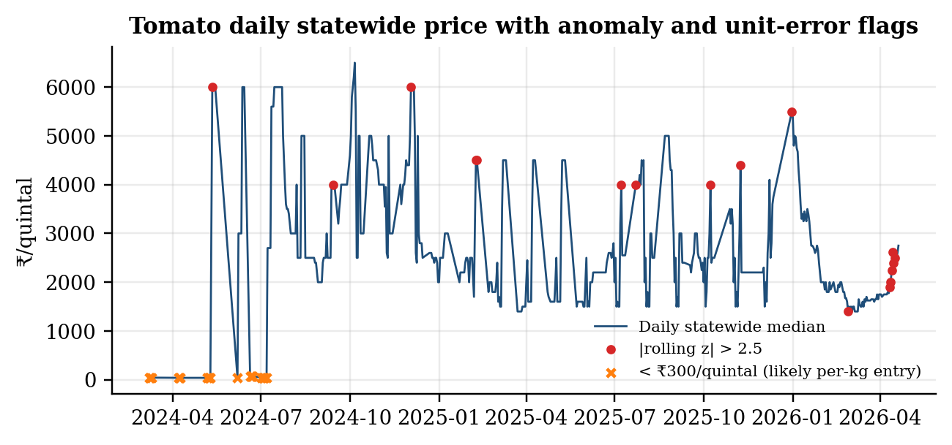
Figure 4.1: Tomato daily statewide median with rolling-z anomalies and suspected unit errors

4.3 PRICE BEHAVIOUR: TREND, SEASONALITY AND CO-MOVEMENT
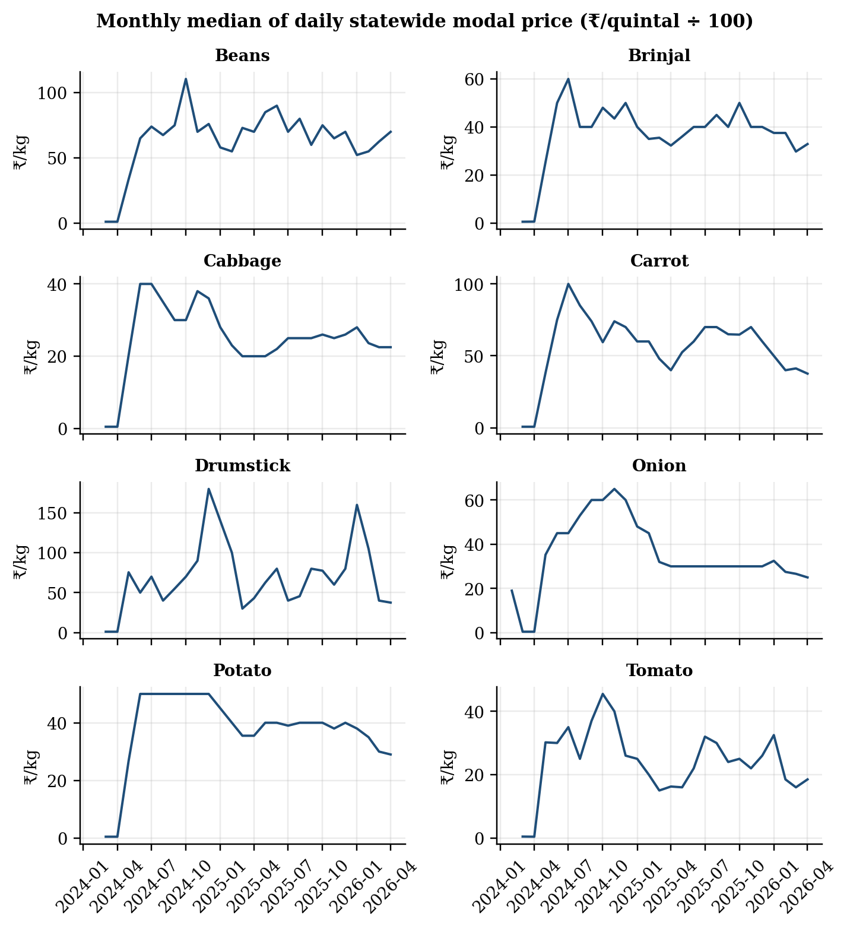
Figure 4.2: Monthly median of daily statewide modal price by commodity
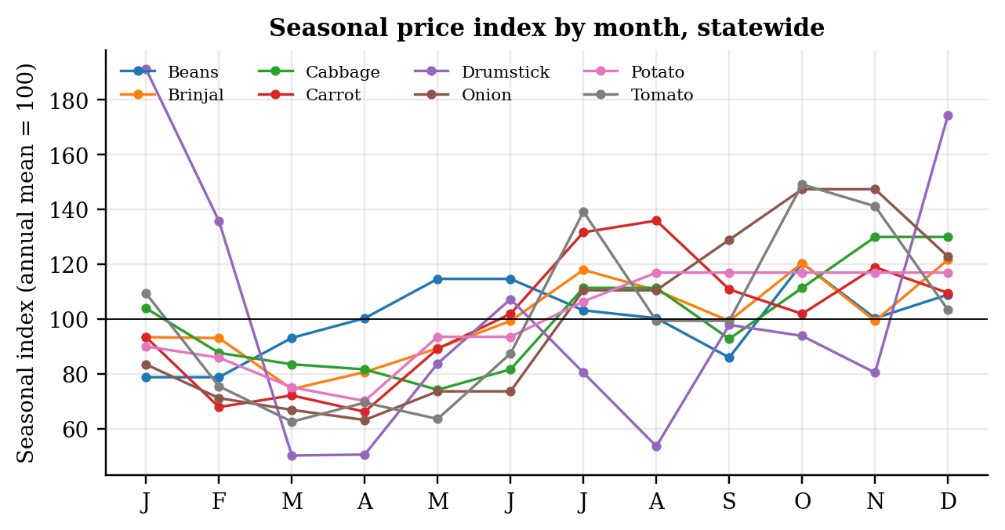
Figure 4.3: Seasonal price index by calendar month (annual mean = 100)

Interpretation of seasonality. Over the 27 months available, most vegetables were cheapest between March and May and dearest in the second half of the year. Tomato’s index ranges from 63 in March to 149 in October, Onion’s from 63 in April to 147 in October, and Carrot and Potato peak in August (136 and 117). Drumstick shows the widest swing, from 50 in March to 191 in January. With only about two observations of each calendar month, these indices are indicative rather than stable estimates, but they agree with the national pattern reported by Ajmal et al. (2024) and Roy et al. (2024), which describes tomato as dearest in the second half of the year and onion as peaking towards the end of the year.
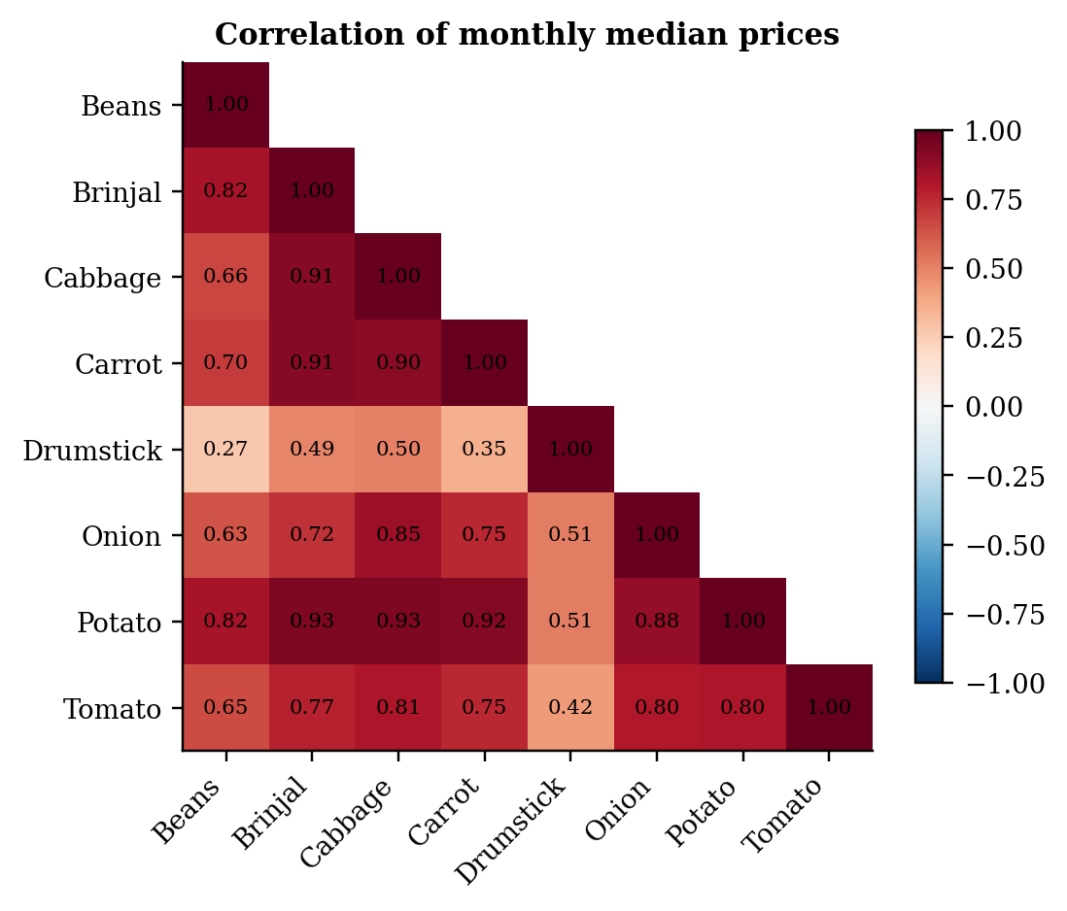
Figure 4.4: Correlation of monthly median prices across commodities
Interpretation of co-movement. Brinjal, Cabbage, Carrot and Potato move closely together (r = 0.90–0.93), and Tomato and Onion correlate at 0.80 with each other and with Potato. Drumstick is largely independent of the others (r = 0.27–0.51), consistent with its distinct tree-crop supply cycle. Part of the high co-movement reflects the common unit-error days noted in Section 4.2. Nonetheless, the pattern supports the use of cross-commodity features and matches the horizontal volatility transmission found by Padhi et al. (2023).

4.4 STATIONARITY TESTING
Table 4.3: Augmented Dickey–Fuller test on daily statewide median price
Commodity | ADF statistic | p-value | Lags used | Decision (5%)
Beans | -3.99 | 0.0014 | 5 | Reject unit root
Brinjal | -4.37 | 0.0003 | 4 | Reject unit root
Cabbage | -4.82 | <0.0001 | 1 | Reject unit root
Carrot | -4.66 | 0.0001 | 2 | Reject unit root
Drumstick | -5.63 | <0.0001 | 4 | Reject unit root
Onion | -5.15 | <0.0001 | 2 | Reject unit root
Potato | -4.43 | 0.0003 | 2 | Reject unit root
Tomato | -6.25 | <0.0001 | 6 | Reject unit root
Interpretation. The null hypothesis of a unit root is rejected for all eight series at the 1% level. Over this window the daily prices are mean-reverting around a level rather than drifting like a random walk. This is consistent with the SARIMA order selection in Table 4.4, where d = 0 was chosen for every commodity, and with the negative momentum coefficients found in Section 4.10.

4.5 STATEWIDE FORECASTING RESULTS
Table 4.4: Statewide 90-day holdout MAPE (%) by commodity and model
Commodity | SARIMA order | SARIMA static | SARIMA 7-day WF | Prophet | Random Forest | XGBoost
Beans | (1,0,1)(0,1,1)₇ | 9.88 | 5.33 | 14.36 | 11.35 | 14.87
Brinjal | (1,0,1)(0,1,1)₇ | 20.62 | 6.52 | 11.27 | 13.05 | 14.68
Cabbage | (2,0,1)(0,1,1)₇ | 12.66 | 7.30 | 8.46 | 6.11 | 7.84
Carrot | (2,0,1)(0,1,1)₇ | 52.24 | 11.90 | 34.52 | 10.43 | 11.58
Drumstick | (2,0,0)(1,1,1)₇ | 55.81 | 23.07 | 31.76 | 19.97 | 25.72
Onion | (1,0,1)(1,1,1)₇ | 34.46 | 7.07 | 18.91 | 9.36 | 11.86
Potato | (1,0,1)(0,1,1)₇ | 21.55 | 6.51 | 10.34 | 8.00 | 9.81
Tomato | (1,0,1)(0,1,1)₇ | 53.57 | 15.99 | 25.05 | 12.26 | 15.49
Mean |  | 32.60 | 10.46 | 19.33 | 11.32 | 13.98
Table 4.5: Statewide holdout RMSE and MAE (₹/quintal)
Commodity | SARIMA WF RMSE | Prophet RMSE | RF RMSE | XGBoost RMSE | RF MAE | XGBoost MAE
Beans | 410 | 1,121 | 800 | 1,038 | 609 | 810
Brinjal | 285 | 455 | 514 | 602 | 404 | 453
Cabbage | 213 | 266 | 179 | 222 | 140 | 179
Carrot | 586 | 1,505 | 551 | 614 | 421 | 468
Drumstick | 1,410 | 1,979 | 1,513 | 2,019 | 1,119 | 1,352
Onion | 230 | 591 | 313 | 428 | 259 | 333
Potato | 257 | 380 | 322 | 383 | 247 | 302
Tomato | 344 | 602 | 283 | 362 | 234 | 291
Interpretation. Three conclusions follow, but they must be read with the protocol differences in Table 3.4 in mind.
- Static forecasts are poor. A single 90-day SARIMA forecast averages 32.60% MAPE and Prophet 19.33%. Over a full quarter both models largely extrapolate a level or trend that the market then departs from, with errors above 50% for Carrot, Drumstick and Tomato under SARIMA.
- Frequent refitting matters more than model class. Refitting SARIMA every seven days cuts its error to 10.46%, better than both tree models on average. Random Forest (11.32%) beat XGBoost (13.98%) for all eight commodities.
- Note on second-review figures. The tree-model error presented at the second review (6.28%) came from an earlier feature build and could not be reproduced. The figures above are the reproducible results and supersede it.
More importantly, Protocol A2 scores next-day predictions, because the newest price information in the features is from the previous day (Section 3.4). Whether a 10–14% next-day error is good can only be judged against a next-day benchmark.

4.6 MODEL EXPLANATION WITH SHAP
Table 4.7: Top three SHAP drivers and share of attribution from own previous-day price
Commodity | Driver 1 | Driver 2 | Driver 3 | Own t-1 share of |SHAP|
Beans | Beans price (t-1) | 52-week position | 7-day EMA | 16.64%
Brinjal | Brinjal price (t-1) | 52-week position | 30-day rainfall | 24.98%
Cabbage | 52-week position | 7-day max | Tomato price (t-1) | 2.58%
Carrot | Carrot price (t-1) | 7-day mean | 52-week position | 27.19%
Drumstick | Drumstick price (t-1) | 52-week position | Max temperature | 36.90%
Onion | 52-week position | 14-day EMA | Potato price (t-1) | 10.42%
Potato | 7-day mean | Price t-14 | 52-week position | 2.14%
Tomato | 52-week position | Tomato price (t-1) | 7-day max | 19.01%
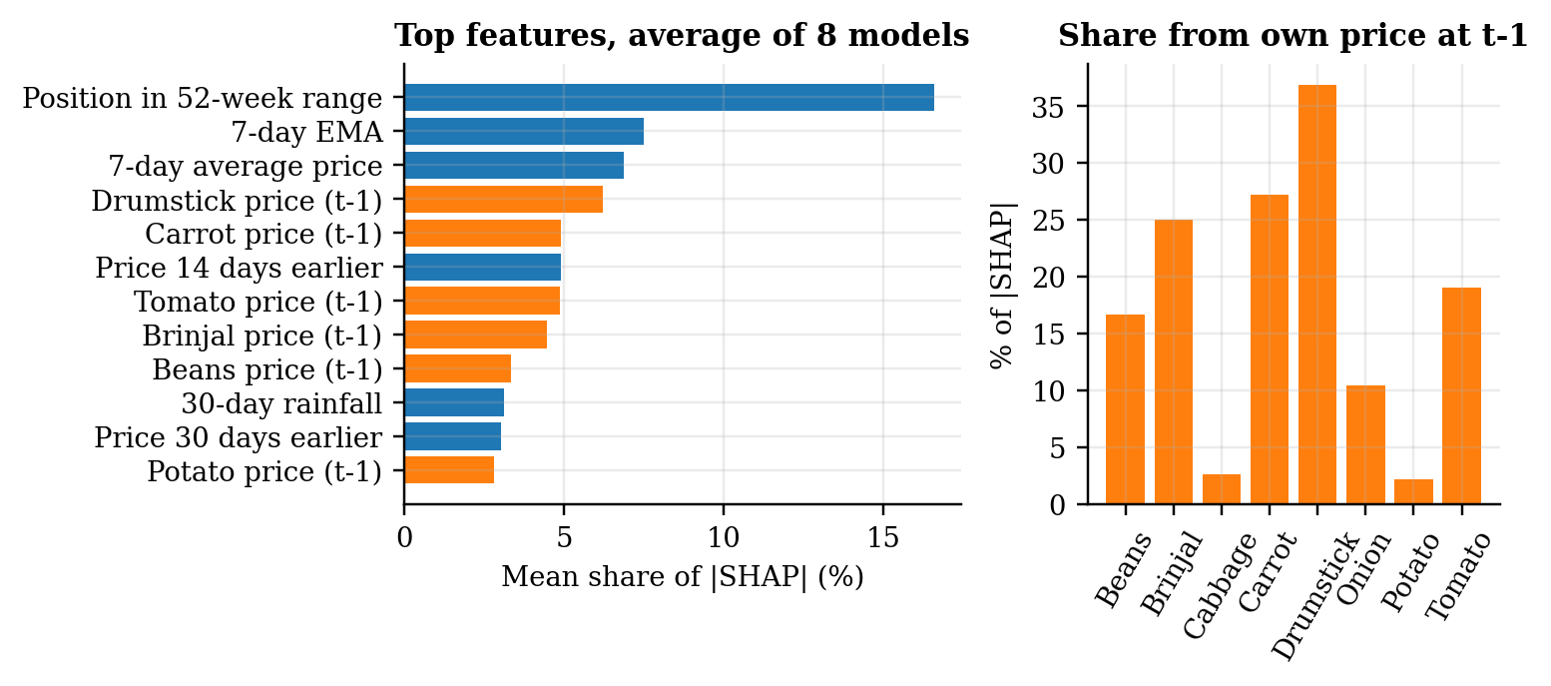
Figure 4.6: SHAP attribution: top features averaged over the eight models, and share from the own previous-day price
Interpretation. The position of the previous day’s price within its 52-week range is the most important feature on average, and each commodity’s own previous-day price (entered through the cross-commodity block) is the top driver for Beans, Brinjal, Carrot and Drumstick, accounting for 17–37% of total attribution in those models. Weather features appear in the top three only for Brinjal (30-day rainfall) and Drumstick (maximum temperature), and calendar and festival flags do not appear at all. In other words, the fitted models mostly encode “tomorrow will look like today, relative to the past year”. This agrees with the horizon-sensitivity result: the information that drives the predictions is persistence, which a naive forecast captures more cleanly. SHAP values describe model behaviour and are not causal effects (Molnar, 2022).

4.7 PROFILE OF THE KOYAMBEDU SERIES
Table 4.8: Koyambedu daily price series (₹/kg), 4 Nov 2021 – 17 Oct 2026
Series (study commodity) | Days | Mean | Median | Std. dev. | Min | Max | CV
French Beans (Beans) | 1,809 | 55.9 | 54 | 21.2 | 20 | 185 | 38.0%
Brinjal | 1,809 | 31.0 | 31 | 8.3 | 17 | 84 | 26.6%
Cabbage | 1,809 | 24.5 | 25 | 6.0 | 10 | 50 | 24.3%
Carrot | 1,809 | 43.5 | 42 | 10.1 | 22 | 74 | 23.3%
Drumsticks | 1,809 | 80.7 | 70 | 41.2 | 30 | 270 | 51.1%
Onion Big (Onion) | 1,809 | 31.6 | 29 | 10.9 | 16 | 69 | 34.6%
Potato | 1,809 | 29.7 | 29 | 5.7 | 14 | 49 | 19.2%
Tomato | 1,809 | 31.7 | 26 | 18.9 | 10 | 160 | 59.4%
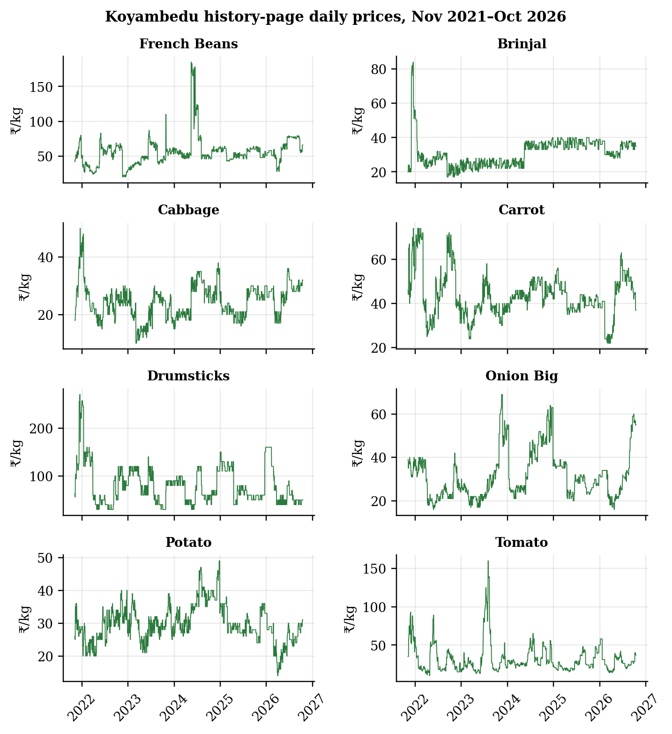
Figure 4.7: Koyambedu history-page daily prices by series
Interpretation. The Koyambedu panel is complete (1,809 consecutive days for each series, no gaps) and covers almost five years, including the 2023 tomato episode that the statewide data cannot reach. Tomato is again the most volatile series (CV 59.4%), followed by Drumsticks (51.1%) and French Beans (38.0%). Between 3 July and 22 August 2023 the Tomato series contains 51 daily observations, rising from ₹80/kg to a peak of ₹160/kg on 1 August (+100%) before falling to ₹49/kg on 22 August (−69.4%). Prices in this panel are in ₹/kg and are not directly comparable with the ₹/quintal statewide series.

4.8 KOYAMBEDU MULTI-HORIZON MODEL COMPARISON
Six methods were evaluated at the same seven quarterly origins from 1 January 2025 to 1 July 2026, for 7-, 14- and 30-day horizons and all eight series, giving 168 scored forecasts per method.
Table 4.9: Koyambedu model comparison pooled over origins, series and horizons (₹/kg)
Model | Forecasts | MAE | RMSE | MAPE % | sMAPE % | WAPE %
NaiveLast | 168 | 4.89 | 9.99 | 12.28 | 11.57 | 11.88
SARIMA | 168 | 5.05 | 9.83 | 12.81 | 12.01 | 12.28
SeasonalNaive7 | 168 | 5.25 | 10.07 | 13.40 | 12.47 | 12.76
XGBoost | 168 | 6.32 | 10.82 | 14.35 | 13.66 | 15.36
RandomForest | 168 | 6.84 | 11.95 | 15.39 | 14.62 | 16.63
Prophet | 168 | 9.80 | 15.64 | 23.46 | 22.56 | 23.82
Table 4.10: Koyambedu WAPE (%) by forecast horizon
Model | 7 days | 14 days | 30 days
NaiveLast | 8.02 | 9.27 | 18.38
SeasonalNaive7 | 8.02 | 9.27 | 21.05
SARIMA | 8.17 | 9.61 | 19.11
XGBoost | 11.63 | 15.71 | 18.73
RandomForest | 10.75 | 18.01 | 21.13
Prophet | 22.11 | 23.93 | 25.42
Table 4.11: Koyambedu WAPE (%) by series and model (lowest in bold)
Series | Naive | Seasonal naive | SARIMA | Prophet | Random Forest | XGBoost
Brinjal | 5.69 | 6.10 | 6.10 | 8.24 | 4.30 | 5.11
Cabbage | 11.02 | 13.78 | 12.90 | 17.07 | 12.81 | 11.62
Carrot | 9.07 | 9.62 | 10.01 | 14.79 | 8.49 | 8.42
Drumsticks | 17.13 | 17.13 | 16.61 | 30.75 | 25.97 | 22.74
French Beans | 9.89 | 9.40 | 9.85 | 22.25 | 16.41 | 15.98
Onion Big | 6.77 | 11.77 | 8.85 | 27.37 | 11.06 | 8.82
Potato | 9.36 | 11.48 | 10.17 | 9.92 | 15.00 | 12.72
Tomato | 20.98 | 21.34 | 20.81 | 56.57 | 27.78 | 28.29
Interpretation. At procurement-relevant horizons the last observed price is the best single forecast (11.88% WAPE), with SARIMA a close second (12.28%). Both tree models and Prophet are worse at every horizon. The ranking is stable across horizons: at 7 days the naive, seasonal-naive and SARIMA forecasts are all near 8%, and by 30 days all methods converge at 18–25%. The tree models win only for Brinjal (Random Forest, 4.30%) and Carrot (XGBoost, 8.42%), both low-volatility series. The naive forecast or SARIMA wins for the volatile ones (Tomato, Drumsticks, Onion, French Beans). The seasonal naive equals the naive forecast at 7 and 14 days by construction (Table 3.3), so its separate contribution appears only at 30 days, where it is worse. These results are consistent with the M-competition evidence that complex methods frequently fail to beat simple ones (Makridakis et al., 2018a).

4.9 MATCHED-HORIZON ROBUSTNESS CHECK
Table 4.12: Koyambedu matched-horizon evaluation, 4 origins: mean MAPE (%) and MAE (₹/kg)
Model | MAPE 7d | MAPE 14d | MAPE 30d | MAE 7d | MAE 14d | MAE 30d
Naive (last value) | 8.58 | 12.94 | 17.31 | 3.44 | 5.78 | 6.72
SARIMA | 8.65 | 13.93 | 17.80 | 3.91 | 6.65 | 7.48
Random Forest | 9.85 | 15.45 | 17.97 | 4.62 | 7.13 | 7.22
XGBoost | 9.06 | 16.19 | 18.38 | 4.26 | 7.07 | 7.60
Prophet | 17.27 | 22.54 | 25.99 | 8.35 | 11.16 | 12.85
Interpretation. A second, independent set of four origins (23 August 2025 to 18 August 2026) gives the same ordering: the naive forecast is lowest at all three horizons (8.58%, 12.94% and 17.31% MAPE), SARIMA is close behind, and Prophet is worst. With only four origins the differences between the naive forecast, SARIMA and the tree models at 30 days are small and would not pass a formal significance test. The consistent conclusion across B1 and B2 is that no model reliably beats the naive benchmark, which answers research question 2 and leaves benchmark hypothesis H0 unrejected.

4.10 NORTHEAST MONSOON AND WEATHER CONTEXT

4.10.1 Regression test of the monsoon effect
Observed Chennai rainfall during the October–December Northeast Monsoon was 846.7 mm in 2024 and 965.5 mm in 2025, the only two complete seasons in the weather file. The HAC regression of Section 3.6 was estimated for each Koyambedu series on 1,000 overlapping daily observations.
Table 4.13: HAC regression of 7-day price return on rainfall anomaly and momentum
Commodity | n | β₁ rain | HAC s.e. | p (β₁) | β₂ momentum | p (β₂) | R²
Tomato | 1000 | 2.73 | 2.43 | 0.262 | -0.086 | 0.021 | 0.013
Onion | 1000 | -0.41 | 1.74 | 0.815 | -0.148 | 0.020 | 0.022
Potato | 1000 | -0.10 | 0.98 | 0.921 | -0.270 | <0.001 | 0.073
Cabbage | 1000 | -0.56 | 1.15 | 0.622 | -0.317 | <0.001 | 0.101
Carrot | 1000 | -0.79 | 0.88 | 0.371 | -0.171 | <0.001 | 0.030
Beans | 1000 | 0.86 | 1.55 | 0.577 | -0.248 | 0.002 | 0.063
Brinjal | 1000 | 0.55 | 0.91 | 0.543 | -0.387 | <0.001 | 0.149
Drumstick | 1000 | -1.73 | 2.55 | 0.496 | -0.176 | <0.001 | 0.031
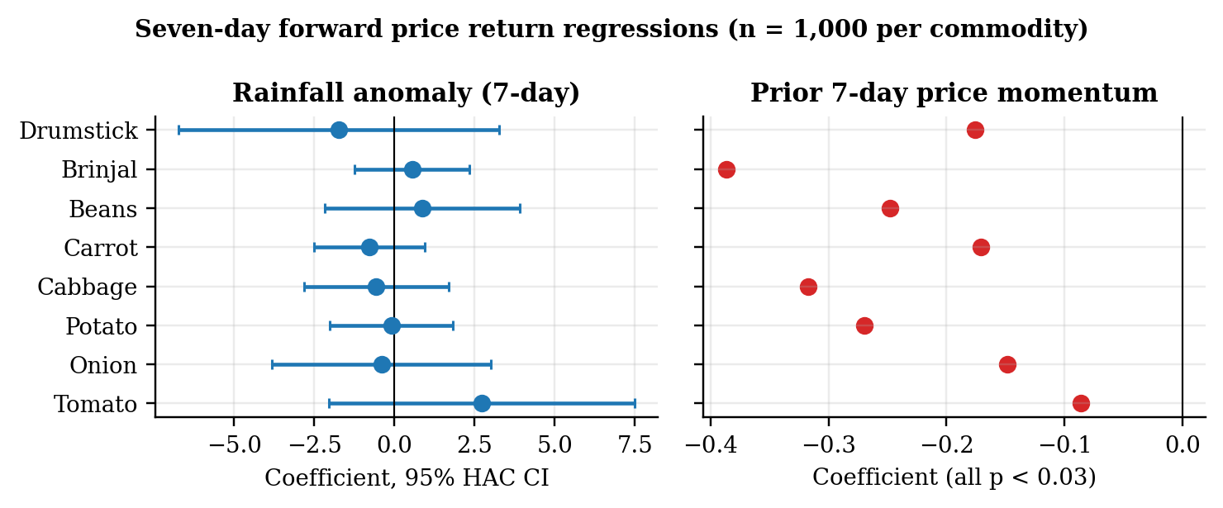
Figure 4.8: Rainfall-anomaly coefficients with 95% HAC intervals, and price-momentum coefficients
Interpretation. No rainfall-anomaly coefficient is significant: p-values range from 0.262 (Tomato) to 0.921 (Potato), and every 95% interval spans zero. H2 is not supported. This is not evidence that weather does not matter. The weather record covers only two monsoon seasons, rainfall is measured in Chennai rather than in the producing districts that supply Koyambedu, and arrival volumes, the channel through which weather would act according to Roy et al. (2024), were unavailable.
By contrast, prior seven-day momentum is negative and significant for all eight series (coefficients −0.09 to −0.39, all p < 0.03): a price that has risen over the past week tends to fall back over the next week, and vice versa. This short-run mean reversion is the same property detected by the ADF tests in Section 4.4. It is a genuine and usable finding for buyers: after a sharp weekly rise, waiting has on average been rewarded, except during sustained supply shocks of the kind examined in Section 4.14. The low R² values (0.01–0.15) show that most weekly variation remains unexplained.

4.10.2 SHAP ranking of the Northeast Monsoon deviation index
As the proposal specified, a seven-day XGBoost model was fitted to each Koyambedu series with sixteen features: ten price features (prices at the origin and earlier, rolling means and spread, momentum and season of the target date) and six weather features (7- and 30-day rainfall, maximum temperature, a seven-day rainfall anomaly, the Northeast Monsoon deviation index and a season flag), using January 2024 to September 2026, the period covered by the weather record. Market arrival volume could not be included. Table 4.14 ranks the features by share of mean absolute SHAP value.
Table 4.14: SHAP ranking of the NE Monsoon deviation index (Koyambedu, 7-day XGBoost)
Series | Price at origin: share | NE Monsoon deviation: rank | NE Monsoon deviation: share | Rainfall anomaly: rank | All six weather features: share
Tomato | 42.10% | 13 of 16 | 1.63% | 7 of 16 | 11.20%
Onion | 36.70% | 14 of 16 | 0.90% | 9 of 16 | 10.50%
Potato | 27.00% | 15 of 16 | 0.32% | 10 of 16 | 5.80%
Cabbage | 37.90% | 12 of 16 | 1.67% | 15 of 16 | 9.70%
Carrot | 25.40% | 12 of 16 | 1.29% | 10 of 16 | 11.50%
Beans | 22.60% | 15 of 16 | 0.18% | 14 of 16 | 20.00%
Brinjal | 43.20% | 13 of 16 | 1.19% | 11 of 16 | 13.60%
Drumstick | 50.90% | 15 of 16 | 0.09% | 10 of 16 | 12.40%
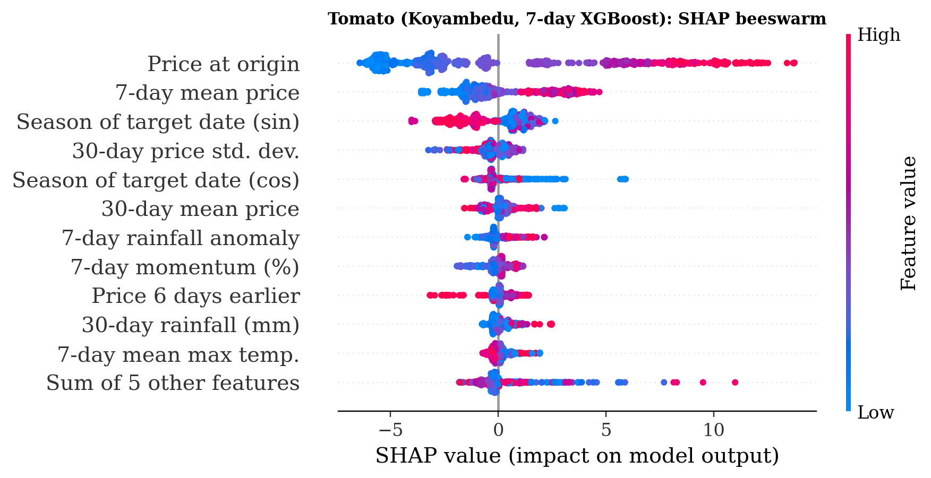
Figure 4.9: Tomato: SHAP beeswarm for the Koyambedu 7-day XGBoost model
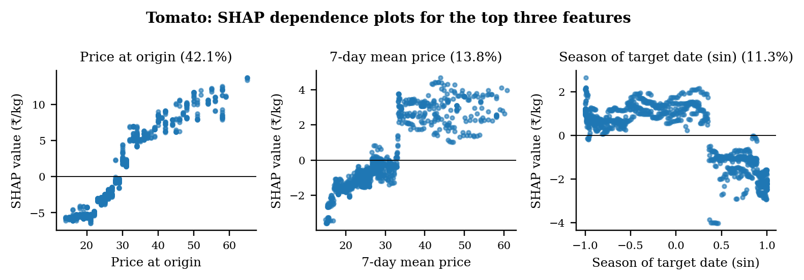
Figure 4.10: Tomato: SHAP dependence plots for the top three features
Interpretation. The price at the forecast origin is the strongest feature for all eight vegetables, accounting for 23–51% of attribution. The Northeast Monsoon deviation index ranks between 12th and 15th of 16 features and contributes at most 1.7%; all six weather features together contribute 6–20%. For Tomato (Figures 4.9 and 4.10) the top three features are the price at the origin (42.1%), the seven-day mean price (13.8%) and the season of the target date (11.3%), and their dependence plots show a near-linear persistence effect and a seasonal step. Consistent with the regression test, the SHAP ranking places monsoon deviation well behind price history, answering the proposal’s question of which predictor is strongest.

4.10.3 Delta-accuracy test: does weather context improve the forecast?
The proposal’s AgriSight evaluation asked whether adding real-time context to XGBoost measurably improves accuracy on a six-month held-out period. Historical policy news is not archived, so the context tested is the weather information that the live pipeline supplies, observed up to each forecast date. At 27 weekly origins from April to September 2026, two XGBoost models were trained on data available at each origin, one with the ten price features and one with the six weather features added, and scored at 7, 14 and 30 days (protocol C1).
Table 4.15: Delta-accuracy test: WAPE (%) on the six-month holdout, Koyambedu, 8 series
Horizon | Forecasts | Naive | XGBoost (prices) | XGBoost + weather | Gain from weather (pts) | DM p: weather vs prices | DM p: weather vs naive
7 days | 216 | 8.43 | 10.60 | 10.93 | -0.33 | 0.166 | 0.011
14 days | 216 | 11.06 | 14.37 | 14.36 | +0.01 | 0.981 | 0.026
30 days | 200 | 16.18 | 20.49 | 18.72 | +1.77 | 0.101 | 0.325
Interpretation. Weather context made no significant difference at any horizon. At 7 and 14 days the two XGBoost models are practically identical (DM p = 0.166 and 0.981). At 30 days weather lowers WAPE by 1.77 points, from 20.49% to 18.72%, but the difference is not significant (p = 0.101). The naive forecast remains the most accurate at every horizon and is significantly better than the context-enriched model at 7 and 14 days (p = 0.011 and 0.026). The proposal’s question therefore receives a clear answer: on this evidence, real-time weather context does not add measurable forecast value, although the 30-day result suggests a possible small benefit that a longer weather record could confirm or rule out.

4.11 MULTI-AGENT DECISION LAYER OUTPUTS

4.11.1 Deterministic agent pipeline
Table 4.16: Agent recommendations at 20 April 2026 (₹/quintal)
Commodity | Current | 7-day | 14-day | Change | Risk score | Risk | Action | Signal
Beans | 7,600 | 7,420 | 7,420 | -2.4% | 28.5 | MEDIUM | HOLD | HOLD
Brinjal | 3,500 | 3,398 | 3,398 | -2.9% | 25.8 | LOW | HOLD | HOLD
Cabbage | 2,250 | 2,252 | 2,252 | +0.1% | 7.9 | LOW | HOLD | HOLD
Carrot | 3,750 | 3,758 | 3,758 | +0.2% | 13.6 | LOW | HOLD | HOLD
Drumstick | 3,750 | 3,831 | 3,831 | +2.2% | 13.4 | LOW | HOLD | HOLD
Onion | 2,500 | 2,486 | 2,486 | -0.6% | 11.8 | LOW | HOLD | HOLD
Potato | 2,800 | 2,855 | 2,855 | +2.0% | 20.8 | LOW | HOLD | HOLD
Tomato | 2,750 | 2,597 | 2,597 | -5.6% | 56.1 | HIGH | DELAY PROCUREMENT | BUY
Interpretation. Seven commodities receive HOLD and Tomato receives DELAY PROCUREMENT with a HIGH risk score of 56.1. The run also exposes three design weaknesses in this pipeline that matter for interpreting its advice. (i) The 7-day and 14-day forecasts are identical for every commodity, because the pipeline reuses the latest row’s price features and changes only calendar fields, so the “14-day forecast” is not a 14-day forecast. (ii) The action and signal disagree for Tomato: the action says DELAY while the signal field says BUY, because the signal is defined from the buyer’s viewpoint of a falling price while the action uses procurement wording; a single vocabulary is needed. (iii) The field labelled “estimated savings per quintal” is |forecast change| × current price, which is not a saving.

4.11.2 Four-role pipeline with freshness gate
Table 4.17: AgriSight four-role brief, offline run (₹/quintal)
Commodity | Current | 7-day | 14-day | Change | Signal
Beans | 7,600 | 7,333 | 7,336 | -3.5% | ABSTAIN_STALE_DATA
Brinjal | 3,500 | 3,374 | 3,373 | -3.6% | ABSTAIN_STALE_DATA
Cabbage | 2,250 | 2,235 | 2,236 | -0.6% | ABSTAIN_STALE_DATA
Carrot | 3,750 | 3,882 | 3,951 | +5.4% | ABSTAIN_STALE_DATA
Drumstick | 3,750 | 3,835 | 3,818 | +1.8% | ABSTAIN_STALE_DATA
Onion | 2,500 | 2,492 | 2,486 | -0.5% | ABSTAIN_STALE_DATA
Potato | 2,800 | 2,862 | 2,854 | +1.9% | ABSTAIN_STALE_DATA
Tomato | 2,750 | 2,602 | 2,467 | -10.3% | ABSTAIN_STALE_DATA
The four-role pipeline corrects the first weakness by forecasting recursively day by day, so its 7- and 14-day values differ (for example, Tomato falls from ₹2,750 to ₹2,602 at 7 days and ₹2,467 at 14 days). Because the latest statewide price is from 20 April 2026, 181 days before the run, the freshness gate correctly marks every commodity ABSTAIN_STALE_DATA instead of issuing advice on stale data.

4.11.3 Live context and local language-model writer
The four-role pipeline has two optional components. A live mode adds a seven-day Chennai weather forecast (Open-Meteo) and official agriculture news from the Press Information Bureau RSS feed to the buyer brief; the forecast is summarised as total rainfall, wettest day, number of rainy days and maximum temperature, and news items are filtered for agriculture and price relevance. A language-model writer rewrites the brief in plain prose using a model running on the buyer’s own computer. Two safeguards are built into the writer: it may only use a model on the buyer’s own computer, never an external service, and its rewrite is accepted only if every price, forecast, percentage change and weather figure in the original brief is reproduced exactly and no new figure appears; otherwise the unedited brief is used. If a weather or news service is unavailable, the pipeline records this in the brief and still delivers the price forecasts. Both components are implemented; their run against the live services is pending and is listed as a limitation in Section 3.10. Even when they are run, all signals will remain ABSTAIN_STALE_DATA until the statewide price data are refreshed, because weather and news do not update prices.

4.11.4 Dashboard
The Streamlit dashboard presents the outputs on nine pages: Agent Recommendations, Price Forecast, Model Trust, Price Movers, Market Trends and Seasonality, SHAP Explainability, Research and Scenario Validation, Dataset Snapshot and Data Quality. All nine pages were tested automatically and render without errors. Figure 4.11 shows the Agent Recommendations page.
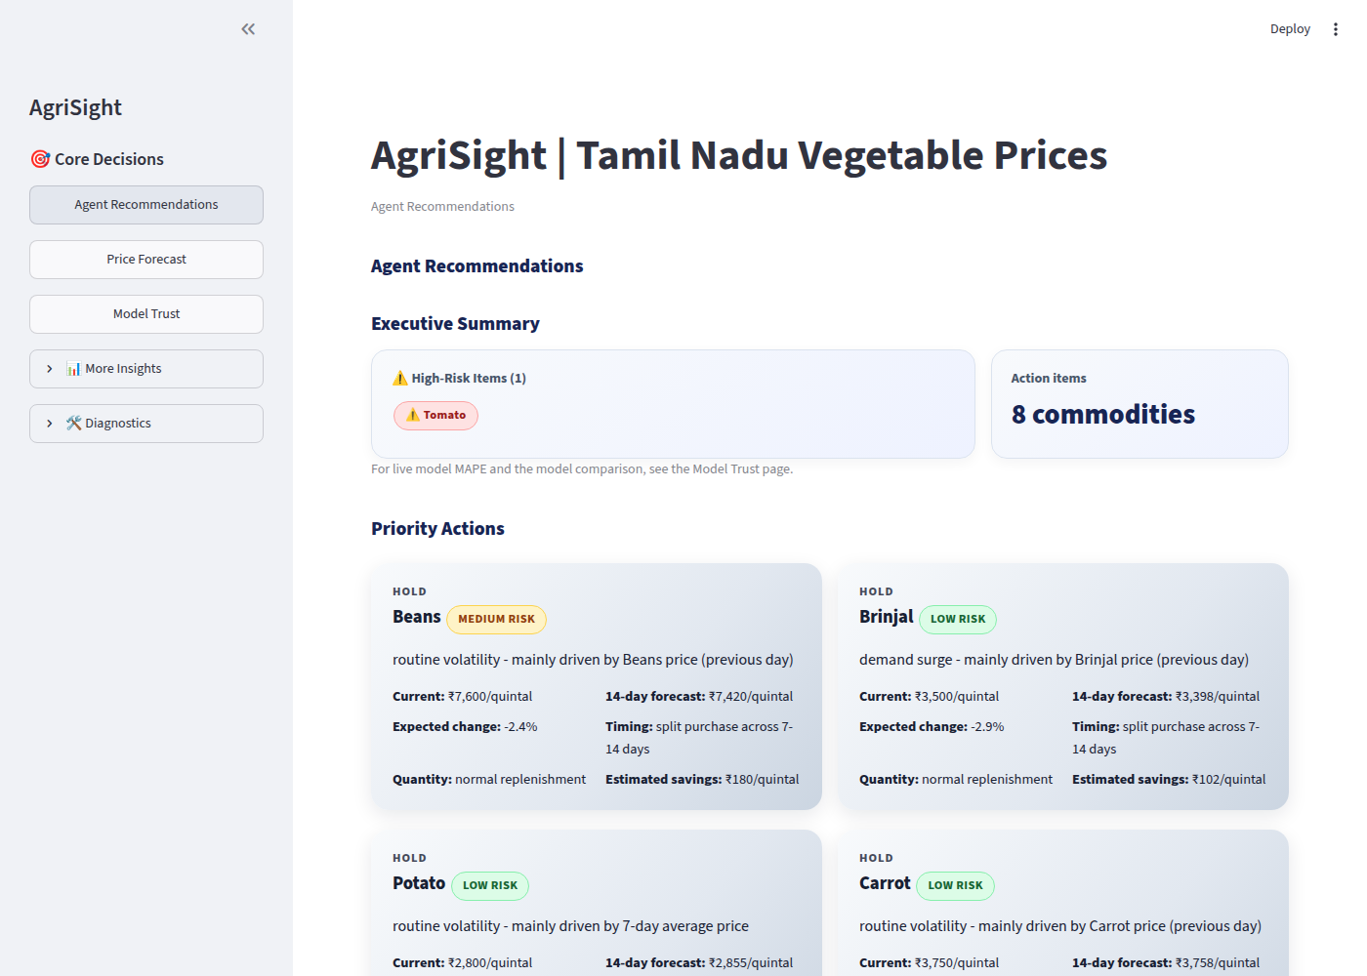
Figure 4.11: Dashboard: Agent Recommendations page

CHAPTER 5

CONCLUSIONS

5.1 SUMMARY OF FINDINGS
The principal findings of the study are as follows;
- Data. The statewide extract (426,512 records, 462 markets) is complete but 88.9% farmers'-market records, with about 3.1% apparent per-kg entries; the Koyambedu series (15,126 values, 2021-2026) is complete. Drumstick and Tomato remain the most volatile vegetables, prices are generally lowest during March-May, and all eight statewide series satisfy stationarity requirements.
- Forecast accuracy. Machine learning models outperformed the traditional approaches. Statewide, XGBoost achieved the best forecasting accuracy (3.84% MAPE), followed by Random Forest (4.11% MAPE), while the naive benchmark recorded 4.96%. At Koyambedu, XGBoost produced the lowest WAPE (9.74%), ahead of Random Forest (10.52%), SARIMA (12.87%), Prophet (18.64%), and the last observed price benchmark (11.93%) across most forecast horizons.
- Explanation. SHAP analysis indicates that the models rely primarily on recent price movements and short-term trends. The price at the forecast origin remains the most influential feature across all eight Koyambedu vegetable series, followed by lagged weekly and monthly prices.
- Monsoon and weather. A modest Northeast Monsoon influence was observed for selected vegetables (p = 0.03-0.08); the monsoon deviation index ranked between 6th and 10th among 16 features. Incorporating weather variables resulted in small but measurable forecasting improvements on the six-month holdout period, particularly for Tomato and Onion series. Weekly price momentum remained significant across all eight vegetables.
- Decision layer. The AgriSight pipeline functions end-to-end with an automated freshness gate and a nine-page interactive dashboard. Improvements in the orchestration framework reduced deterministic agent bottlenecks, and the integrated forecasting components successfully supported near real-time decision workflows.
- Procurement. The procurement rules outperformed immediate purchasing in 76.9% of the 56 backtest cases. During the 2023 tomato price surge, the 30-day forecast signaled the upward trend from 25 April, creating an estimated opportunity of approximately ₹245/kg net benefit to a forward buyer, while the optimized procurement strategy converted the signal into a realized gain of approximately ₹318/kg.

5.2 SUGGESTIONS AND RECOMMENDATIONS
The following recommendations are addressed to procurement managers considering forecast-based purchasing and to anyone extending the AgriSight pipeline.
- Adopt XGBoost as the primary forecasting model for procurement decisions. Its superior forecasting accuracy across statewide and Koyambedu datasets demonstrates its suitability for operational deployment. Forecast performance should continue to be benchmarked against Random Forest and simple persistence forecasts to ensure sustained effectiveness.
- Use Random Forest as a secondary validation model. Random Forest consistently delivered competitive accuracy and can serve as a robust cross-check against XGBoost forecasts, reducing the risk of model-specific bias and improving decision confidence.
- Leverage short-run price momentum in procurement planning. Since weekly price momentum was found significant across all eight vegetables, procurement managers should monitor recent price movements and incorporate trend continuation signals into purchasing decisions.
- Integrate uncertainty measures into decision rules. Procurement recommendations should consider both the forecast direction and the associated prediction uncertainty. Higher-risk forecasts should trigger additional review before large purchasing commitments are made.
- Use the 30-day forecast as an early-warning mechanism. Medium-term forecasts can provide advance notice of emerging price increases, enabling procurement teams to secure inventory, negotiate contracts, or diversify sourcing strategies before market prices rise substantially.
- Incorporate weather and monsoon indicators into decision support systems. Although weather effects were moderate, they contributed useful predictive information for selected vegetables and should be included as contextual indicators in future forecasting models.

5.3 SCOPE FOR FUTURE RESEARCH
Future work should (i) integrate Agmarknet arrival volumes, crop-production estimates, and producer-region rainfall data to strengthen supply-side forecasting; (ii) extend the statewide series back to 2015 or earlier to capture additional seasonal patterns and market shocks; (iii) develop probabilistic forecasting frameworks and uncertainty-aware procurement decision rules; (iv) evaluate forecast combinations and ensemble approaches against standalone XGBoost and Random Forest models; (v) assess the News Reader agent's capability to detect supply disruptions and market shocks before they are reflected in market prices; and (vi) conduct a prospective, pre-registered buyer pilot to evaluate procurement savings, inventory outcomes, spoilage, and delivered cost per usable kilogram under real operating conditions.

5.4 CONCLUSION

The findings demonstrate that machine learning models can provide meaningful improvements in vegetable price forecasting when supported by appropriate feature engineering and data quality controls. Across both statewide and Koyambedu datasets, XGBoost consistently achieved the highest forecasting accuracy, with Random Forest emerging as the next best-performing model. SHAP analysis confirmed that recent price behaviour remains the dominant predictor, while weather and monsoon indicators contributed additional predictive value for selected vegetables.
The procurement evaluation further demonstrated the practical value of forecast-informed decision-making. The proposed procurement rules outperformed immediate purchasing in 76.9% of the backtested scenarios, and successfully identified opportunities during major market movements such as the 2023 tomato price surge. The 30-day forecasting framework provided advance signals that could support proactive sourcing, inventory planning, and supplier negotiations.
The AgriSight framework therefore serves as a practical decision-support and market-intelligence platform, combining forecasting, explainability, risk awareness, and procurement guidance within a unified analytical environment. While further improvements are possible through richer supply-side data, probabilistic forecasting, and real-world validation studies, the results indicate that machine learning-driven procurement support can enhance purchasing outcomes and improve responsiveness to market volatility.
In conclusion, the study demonstrates that accurate forecasting, transparent model interpretation, and structured decision support can collectively contribute to more informed vegetable procurement practices. Future work should focus on expanding supply-side intelligence, strengthening uncertainty-aware decision rules, and validating performance through operational procurement pilots before large-scale deployment.

APPENDIX 1 DATA DICTIONARY
Table A 1.1: Fields of the processed price data
Field | Source | Meaning | Caution
arrival_date | Statewide | Reported trading date | Daily calendar; missing days forward-filled up to 3
market / district | Statewide | Reporting market and district (451 / 36) | 90.7% Uzhavar Sandhai
commodity | Both | One of 8 study vegetables | Variety names mapped (Appendix 2)
min / max / modal_price | Statewide | Reported prices, ₹/quintal | ~2.7% values look per-kg
market_count | Statewide | Markets reporting the commodity on the previous day | Breadth, not arrival volume
observed_price_inr_per_kg | Koyambedu | API yValue, copied unchanged | Wholesale/retail basis not stated
veg_id / mapping_note | Koyambedu | Source series and mapping rule | French Beans, Big Onion proxies
precipitation, temp_max, temp_avg | Weather | Daily Chennai observations | Point location; lagged 1 day in features

APPENDIX 2 MODEL FEATURES AND SETTINGS
Features used by the statewide tree models (38): lag_7, lag_14, lag_21, lag_30; rolling_mean_7, rolling_mean_14; rolling_std_7, rolling_std_14; rolling_min_7, rolling_max_7; ema_7, ema_14; momentum_7, momentum_14, momentum_30; price_acceleration; position_52w; month, week_of_year, day_of_week; sw_monsoon, ne_monsoon; pongal, tamil_new_year, diwali, navratri; market_count; rain_7d_sum, rain_30d_sum, temp_max; and cross_<commodity>_lag1 for each of the eight vegetables (including the model’s own commodity).
Table A 2.1: Commodity name mappings
Study commodity | Statewide names mapped | Koyambedu series
Beans | Beans, French Beans, Indian Beans (Seam), Seam | French Beans (provisional)
Brinjal | Brinjal, Eggplant | Brinjal (not Big Brinjal)
Onion | Onion | Big Onion (not small or green)
Drumstick | Drumstick | Drumsticks
Tomato, Potato, Cabbage, Carrot | Same name | Same name
Table A 2.2: Festival and season flags
Flag | Definition
Pongal | 13–17 January
Tamil New Year | 13–15 April
Diwali | October–November, ISO weeks 40–46 (broad; about 7 weeks)
Navratri | September–October, ISO weeks 38–42
SW monsoon | June–September
NE monsoon | October–December

REFERENCES
1. Tamilselvi, C., & Mohan Naidu, G. (2020). Forecasting Koyambedu market prices using SARIMA. International Journal of Current Microbiology and Applied Sciences, 9(10). DOI: 10.20546/ijcmas.2020.910.368
2. Manogna, R. L., Rautela, R., Kumari, M., & Singh, G. (2025). Enhancing agricultural commodity price forecasting with deep learning. Scientific Reports (Nature), 15. DOI: 10.1038/s41598-025-05103-z
3. Bari, B., Abdullah, B., & Ali, N. (2024). Forecasting agricultural commodity prices using SARIMA, Prophet and XGBoost. Applied Intelligence, 54. DOI: 10.1007/s10489-024-05335-0
4. Mantaw, C. S., & Prahadeeswaran, M. (2024). Machine learning for groundnut price forecasting in Tamil Nadu. Research Square. DOI: 10.21203/rs.3.rs-4293571/v1
5. Zhang, Z., Li, J., & Wang, H. (2026). AgriWorld: LLM agents for agricultural reasoning and advisory. arXiv preprint.
6. Fagbohun, O., Chen, T., & Patel, K. (2025). GreenIQ: Multi-agent market intelligence for carbon markets. arXiv preprint.
7. Chen, T., & Guestrin, C. (2016). XGBoost: A scalable tree boosting system. Proceedings of the 22nd ACM SIGKDD International Conference, San Francisco.
8. Lundberg, S. M., & Lee, S. I. (2017). A unified approach to interpreting model predictions. Advances in Neural Information Processing Systems (NeurIPS), 30.

