Belfast English

Introduction
Belfast English
Social networks
Investigations
Map of Belfast city centre
Map of Belfast hinterland
References

Introduction

The city of Belfast was founded by Sir Arthur Chichester in 1603. It lies at the mouth of the River Lagan, a fact reflected in the Irish name Béal Feirste ‘the mouth of the sandbank or ford’. Belfast was intended for English and Scots settlers. The present-day Catholic population, particularly in West Belfast, stems from those who migrated into the city from surrounding areas in search of work in the linen and cotton industries and later in ship-building which blossomed in the late 19th and the first half of the 20th century. However, throughout the 18th century Belfast was a small town on the west bank of the Lagan, with Ballymacarrett a separate settlement on the east bank. By 1821 the population was still only 37,000, by 1861 it had increased threefold to 121,000 and by the close of the 19th century it was 350,000, tens times its size at the beginning of the century (J. Milroy 1981: 22). By the middle of the 20th century the population had risen to over 440,000 and then dropped off with people spreading into neighbouring towns such as Newtownabbey, Finaghy, Newtownbreda.
There are two main rises in population in the 19th century. The first is concentrated around the late 1840s: due to the Great Famine, many rural inhabitants moved into urban centres after the massive failure of the potato crop (this affected cities throughout Ireland, notably Dublin in the south). The second and more important reason was increasing industrialisation. This set in somewhat later in Ulster than in Great Britain. The mechanisation of linen production and the development of ship-building were the two main industrial developments in 19th century Belfast. There was in-migration from all nine counties of Ulster. The area of contemporary Belfast is characterised by a conurbation which now stretches along the north shore of Belfast Lough at least to Newtownabbey in County Antrim and, on the south shore, at least to Holywood in County Down.
Along the Lagan Valley, the city stretches to the south-west at least to Lisburn. The Lagan Valley is the hinterland of Belfast and is now served by a motorway which links up Belfast with the triad of towns Lurgan, Craigavon and Portadown to the south of Lough Neagh. There is a similarity between accents in the city and those in its hinterland to the south-west. The east of the city shows greater similarity with accents from rural North Down, an originally Scots area of settlement as opposed to the Lagan Valley which was settled largely by people from England.

Belfast English

When trying to determine what Belfast English was like in the formative period of the city’s industrial expansion (mid 19th century) one is fortunate is having a book which has, as the express aim of its author, the description of non-standard features of English in and around the city along with suggestions about how to correct and avoid them. This is David Patterson’s The provincialisms of Belfast and the surrounding districts pointed out and corrected from 1860 which has been put to good use by linguists attempting to ascertain the profile of Belfast English a century and a half ago (J. Milroy 1981: 26f.). Biggar (1897) is also a source of information, though somewhat later, and for Ulster in general.
English in Belfast is an amalgam of features which come from the two main sources of English in Ulster, western Scotland and northern England, along with some independent traits only found in the capital city (see the list of features in J. Milroy 1981: 25f.). The following is a list of features which can be clearly attributed to one of the two main English-language sources in Ulster (J. Milroy 1981: 25f.).
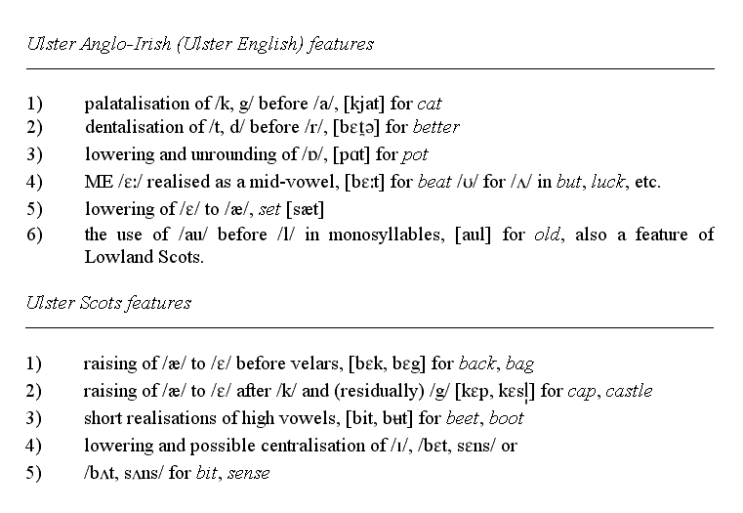

Social networks

James and Lesley Milroy began investigating language use in Belfast in the 1970s and continued for over a decade. At the centre of the Milroys’ work is the notion of social network, adapted from work on sociology. All speakers have a place in the network of their social environment. This network consists of ties of varying strength depending on the social bonds speakers entertain within their neighbourhood. There is a general assumption that for those on the lower end of the socio-economic scale the ties are stronger than for those further up this scale. Networks can be defined by how dense and multiplex they are. For instance, if a speaker A not only knows other speakers B, C, D, E, etc. but the latter also know each other then the network is dense. If the individuals in a network are more isolated and not mutual acquaintances then it shows low-density. A network is multiplex if its members interact in more than one way, e.g. if members have a number of work colleagues in their network with whom they also spend their spare time, through communal neighbourhood activities or sports for example, then the network is multiplex because there is more than one factor uniting members.
A focussed and bound network can impose rigid linguistic norms on its members which in turn acquire a defining character, albeit an unconscious one, for the network itself. Such networks tend to be impervious to influence from outside, specifically from the prestigious norm of the society of which they are part. Speakers who engage in loose-knit networks, such as the suburban middle-classes, are relatively more accessible to language norms. Because loose networks do not show clear defining features, these speakers adopt the norms of the socially prestigious standard. Conversely, working-class sections of society – those with strong networks – do not see middle-class speech as a model because they have their own linguistic norms from within their network.
Certain generalisations about networks can be made. The relative strength of a network depends on the weight accorded by speakers to two conflicting forces in society: status and solidarity. If speakers opts for status then they are likely to have weak ties, to try to move upwards on a social scale, striving to achieve professional status and economic success. Should speakers opt for solidarity then they generally remain in their surroundings, maintaining ties with neighbours and participating in the life of the community. Solidarity is an aspect of social behaviour which has a linguistic component: speakers who demonstrate solidarity exhibit allegiance to the vernacular norms of their neighbourhood, frequently in contradistinction to those of the socially prestigious form of language. The linguistic norms of a community are local whereas status features are diffuse and hold for a much wider area, typically for an entire country. The number of defining features of low-status, high-solidarity varieties is usually quite high. The linguistic norms of such communities can be difficult, if not impossible, for non-natives to acquire. The identity function of high-solidarity varieties implies that one can exclude those who are not native to the community. Dense multiplex network ties seem furthermore to hold especially for young males. Women and middle-aged speakers in general tend to opt more for status and to tone down the linguistic signs of strong network ties.
A network is much smaller than a class which is a general characterisation of social status whereas a network is an areal reality, typically a part of a city. There is of course a correlation to class inasmuch as people in a network usually belong to a single socioeconomic group and those in the strongest networks tend to be lowest on this scale. Given their relatively small scale, networks form a consensus-based microlevel within society. The bonding within a class is achieved through similarity in socio-political outlook and not by identification with a certain locale.


The Belfast investigations

The insights into sociolinguistic behaviour just sketched were gained by a close study of the following three areas of Belfast.
1) | Ballymacarrett | (Protestant East Belfast)
2) | The Hammer | (Lower Shankhill Road, Protestant West-Central Belfast)
3) | Clonard | (Lower Falls Road, Catholic West-Central Belfast)
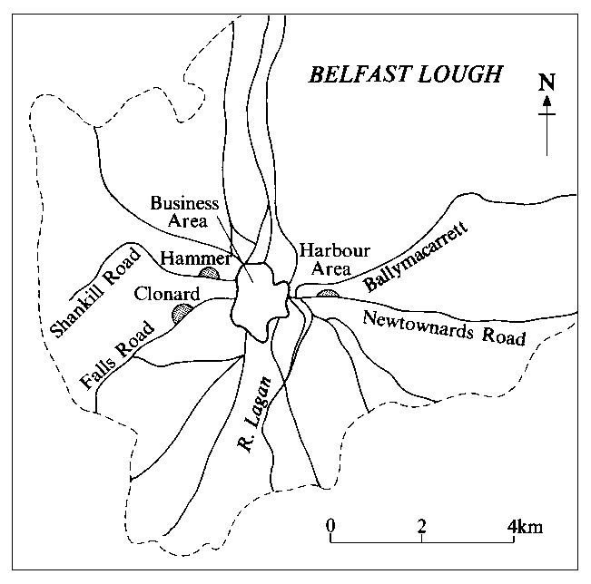
Map of central Belfast showing the areas investigated (from Lesley Milroy Language and Social Networks)
The three areas are different in the social importance they attach to certain features. For instance, the palatalisation of /k, g/, as in cap /kjap/ and gap /gjap/, is generally regarded as a rural feature of Ulster English and in Belfast is found most with older males (40-55) chiefly in Catholic west Belfast. In the eastern section of the city – which has had a largely Ulster Scots input from north Co. Down where the palatalisation is not an indigenous feature – this trait is avoided as can be seen from its percentual representation in the data collected by the Milroys (J. Milroy 1981: 94).
Clonard | 62% palatalisation
Hammer | 14%
Ballymacarrett | 0%

This pattern would also seem to apply to the dental realisation of /t/ before /r/ in unstressed syllables, i.e. the pronunciation [bʌṯɚ] rather than [bʌtɚ] for butter, which occurred with older males more than with younger men and women in west Belfast (Clonard and Hammer).
The raising of /a/ before velars, as in bag /bɛg/, is quite common and is more frequent in west Belfast then in east Belfast, young males in east Belfast seem to have lost this raised vowel entirely, perhaps as the result of peer-group pressure. With the variable (ʌ) the Milroys found that young males display vernacular loyalty and preserve this dialect feature in words such as pull /pʌl/.
Correlates of community structure Lesley Milroy has analysed the relation between realisations of three phonological variables, (th), (ʌ) and (a) within the framework of the network model of language ties. With regard to (th) Milroy notes that the deletion of [ð] intervocalically – as in brother [brʌər] – has been a stable marker of lower-class speech for some time and shows little change. (ʌ) on the other hand would appear for young men – particularly in Catholic west Belfast – to have overcome its inherent stigma in the community and be used more frequently. With regard to (a) the situation is more complex as there is a phonetically conditioned front raising before velars and back raising before labials, as in hand [hɒ:nd]. It too is subject to socially determined variation within the phonotactic constraints just mentioned.
The insight here is that not just the use of one realisation as opposed to another is sociolinguistically significant but the numbers of tokens for a given realisation are relevant, i.e. both the qualitative and the quantitative aspects of a variable are important as linguistic markers within a social network.
Wider implications The Milroys’ work on vernacular speech in Belfast has had wider implications for linguistic studies, for instance for the development of phonological norms in English. James Milroy has devoted his attention to the relationship between standard and vernacular norms, stressing the uniform nature of the standard and the essentially variant structure of vernaculars where rules governing the variation are understood by those within the vernacular community but not those outside.

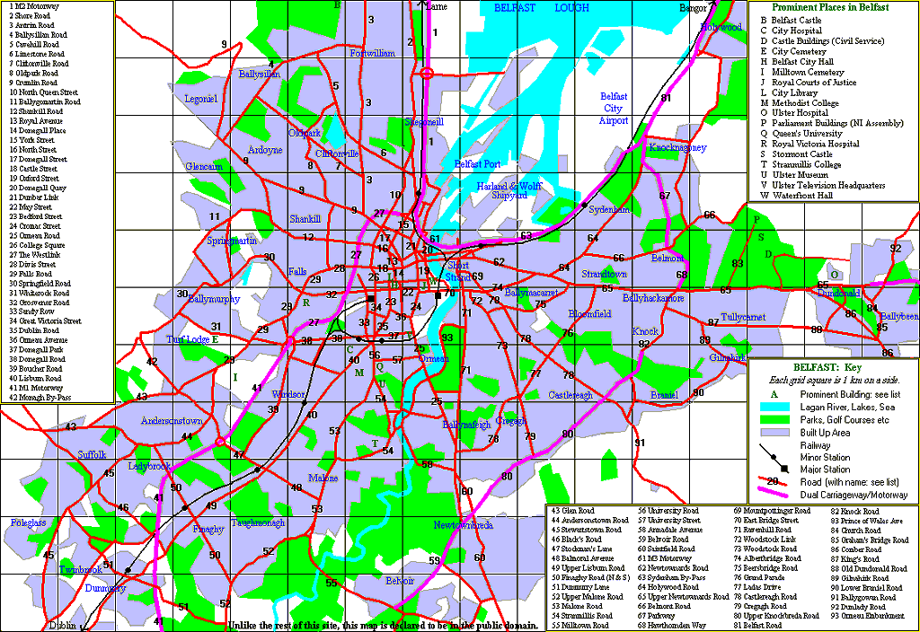


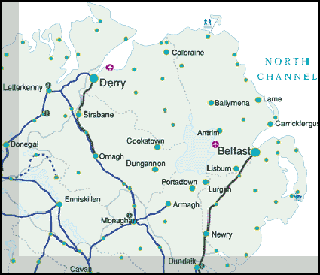

References

Biggar, J. J. 1897. Our Ulster Accent and Ulster Provincialisms. Belfast: The Religious Tract and Book Depot. Appeared unter the pseudonym of ‘One Who Listens’.
Cheshire, Jenny, ed. 1991. English Around the World. Sociolinguistic Perspectives. Cambridge: University Press.
Harris, John, David Little and David Singleton, eds. 1986. Perspectives on the English Language in Ireland. Proceedings of the First Symposium on Hiberno-English, Dublin 1985. Dublin: Centre for Language and Communication Studies, Trinity College.
Henry, Alison. 1997. “The syntax of Belfast English”, in Kallen, ed., 89-108.
Henry, Alison. 1997. “The syntax of Belfast English”, in Kallen, ed., 89-108.
Jahr, Ernst Håkon, ed. 1999. Language Change. Advances in Historical Sociolinguistics. Berlin: Mouton de Gruyter.
Kallen, Jeffrey L., ed. 1997. Focus on Ireland. Amsterdam: John Benjamins.
Milroy, James. 1986. “The methodology of urban language studies: The example of Belfast”, in Harris et al., eds., 31-48.
Milroy, James 1981. Regional Accents of English: Belfast. Belfast: Blackstaff.
Milroy, James. 1991. “The interpretation of social constraints on variation in Belfast English”, in Cheshire, ed., 75-85.
Milroy, James. 1992. Linguistic Variation and Change. Oxford: Blackwell.
Milroy, James. 1999. “Toward a speaker-based account of language change”, in Jahr, ed., 21-36.
Milroy, James and Lesley Milroy 1993. “Mechanisms of change in urban dialects: The role of class, social network and gender”, International Journal of Applied Linguistics 3,1: 57-77.
Milroy, Lesley. 1976. “Phonological correlates to community structure in Belfast”, Belfast Working Papers in Language and Linguistics 1: 1-44.
Milroy, Lesley 1987 [1980]. Language and Social Networks. 2nd edition. Oxford: Blackwell.
Patterson, David. 1860. The Provincialisms of Belfast and the Surrounding Districts Pointed Out and Corrected; to Which is Added an Essay on Mutual Improvement Societies. Belfast: Alexander Mayne.
Patterson, David 1860. The Provincialisms of Belfast and the Surrounding Districts Pointed Out and Corrected; to which is Added an Essay on Mutual Improvement Societies. Belfast: Alexander Mayne.
Rahilly, Joan. 1997. “Aspects of prosody in Hiberno-English: The case of Belfast”, in Kallen, ed., 109-32.

