**Website Kalkulator Matematik (Segitiga & Jajar Genjang)**

**Preparations and Submission Details**

- **The deadline** will be on Thursday in 2nd week at 23.59 (WIB)

- Link to submit the assignment will be shared on Discord and Email

**Introduction**

In this ten-day short course, you’ll learn all about becoming a software engineer, including the career path possibilities. We’ll also give you the opportunity to practice the main responsibilities of a software engineer as well!

Before you start...

1. Make sure you have downloaded **Visual Studio Code, Git** and have access to **Google Chrome**

**Mini Project Instructions**

As Software Engineer, you are asked to create a website of ***Kalkulator Matematik Segitiga & Jajar Genjang*** with a Create a website using the design below:

***Page With Result***

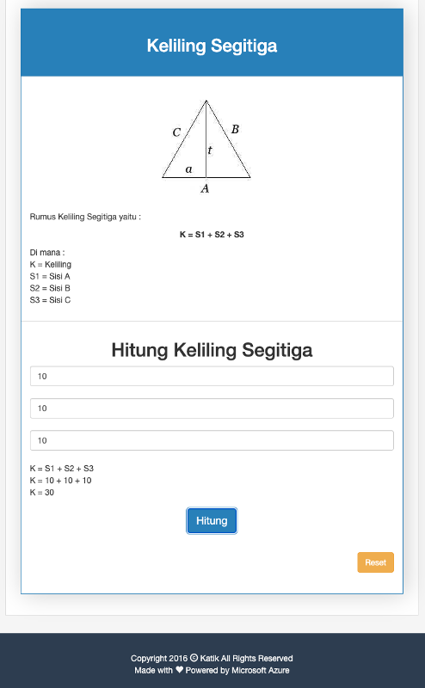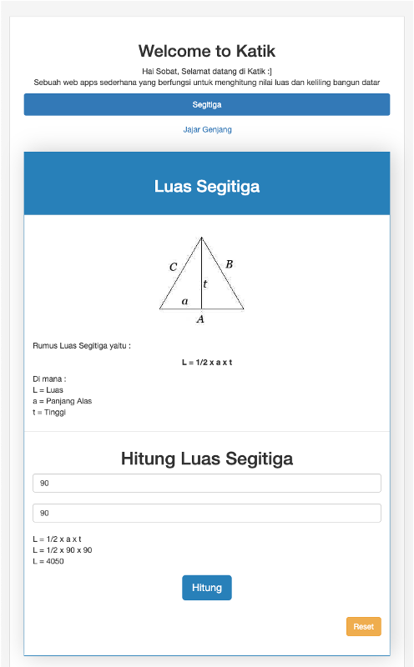

***Ex : Page with No Result***

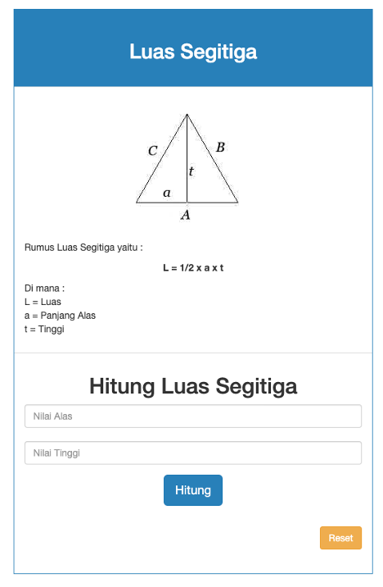

Workflow:

1. Design is only reference, you can improve for your own design but you must have the feature :

- Hitung Luas & Keliling Segitiga

- Hitung Luas & Keliling Jajar Genjang

1. Validate Input Form Hitung Luas & Keliling
2. Create Logic For Hitung Luas & Keliling Segitiga & Jajar Genjang with JavaScript
3. Luas Segitiga & Keliling Segitiga on the same page in web
4. Luas & Keliling result is display when submitted by button “Hitung”
5. After finish your website, upload Source Code in [Github](https://github.com/) or [Gdrive](https://www.google.com/intl/in/drive/about.html) and publish the website in [Github Pages](https://pages.github.com/)
6. Submit URL Github or Gdrive with screenshot of published website

Mandatory pages (*required*) :

1. index.html
2. index.css
3. index.js