6

The HTML5 Video And The Canvas
One of the major things drawning developers to HTML5 is the prospect of showing video directly in HTML without the use of any plug-in technologies. The HTML5 specification allows for support of video using the new <video> tag. However, if things were that easy, we not have to dedicte an entire chapter of this book to video and how it relates to the HTML5 Canvas. In reality, the simply <video> tag opens-up a whole slew of complexities and opportunities for developers. While we can’t cover everything related to video in this chapter, we will intrduce you to the HTML5 <video> tag, and then show you ways in which video can be incorporated and manipulated by the HTML5 Canvas.

The HTML5 Video Support
HTML5 specifies a new tag, <video> that allows developers to place video directly in an HTML page. With a few simply options, you can “auto play”, “loop”, and add playback controls to the embedded video.
Before we get to the video tag itself, let’s talk about video format support. Video formats are a very complicated issue. Some video formats are free, and others are licensed. Some formats look better than others, some make smaller file sizes, and some are supported and other not supported by various browsers. There are three formats that we will concentrate on for this chapter. These three either have broad support now, or promise to have broad support in the future. They are: .ogg, .mp4, and .webm.
We will discuss these video formats in terms of video codecs. Each format uses one or more codecs to compress and decompress video. Codecs are usually the “secret sauce” of a video format, as compression is the key to making video that, in the wild, can convert very large files, into file sizes that can be easily transported on the Internet.

Theora + Vorbis = .ogg
Theora is an open source, free video codec that is developed by Xiph.org and available here: http://www.theora.org/. Vorbis is a free, open source audio codec that is used in conjunction with Theora. Ogg is the container for both Theroa and Vorbis, and they are stored in an .ogg file. .ogg files have the broadest support among traditional web browsers, but, unfortunately, not on hand held devices. Many commercial companies (i.e. Apple) have balked at using Theora/Vorbis because they are not sure if, somewhere, someplace, someone might own a patent that covers part of the technology, and thus they might get sued for using it.
Note: Sometimes technology companies get hit with what is known as a Submarine Patent. This was a patent tactic, available up until 1995 in the USA that allowed a filer to delay the publication of patent. Since patents were only enforceable for 17 years, if someone filed one, but delayed the publication they could wait years (even decades) until someone else came up with the same idea, then hit them with a lawsuit.

H.264 + $$$ = .mp4
H.264 is a high quality video standard that has received the backing of some very big players such as Apple, Adobe, and Microsoft. However, while h.264 does offer high quality video, it only defines a standard, not a video codec. An organization named MPEG LA owns the intellectual property, and they license it out to software and hardware vendors. Many companies who have implemented H.264 have done so with their own proprietary codecs that are incompatible with each other. The varying codecs and make this a tricky format to use across multiple platforms. H.264 videos have the .mp4 extension. Most for-profit corporations have implemented support for this format on their platforms, but the developers of browsers like Firefox and Opera have not done so. In late 2010, Google dropped H.264 support in Chrome in favor of WebM.

WebM = VP8 + Vorbis = .webm
WebM is a new open source video standard supported by Google, Adobe, Mozilla and Opera. It is based on the VP8 codec and includes Vorbis (just like Theora) as an audio codec. When YouTube.com announced they had converted many of their videos to be HTML5 compatible, one of the formats they used was WebM. Right now, only Google Chrome supports WebM, but broader support should be coming in the future.
To summarize, here is a chart of the video formats supported by various browsers
.ogg .mp4 .webm
Android: x
Fire Fox: x
Chrome: x x
iPhone: x
Internet Explorer 9: x
Opera: x x
Safari: x

As you can see, there is no one format that is supported by all browsers or platforms. Since the HTML5 Canvas only supports video in the format supported by the browser it is implemented within, that means we must implement a strategy that uses multiple formats to play video.

We Will Use All Three
For the examples in this chapter, we will introduce a strategy that may appear to be crazy at first: We will use all three formats at once. While this might appear to be more work than necessary, right now it is the only way to ensure broad support across as many platforms as possible. The HTML5 <video> tag allows us to specify multiple formats for a single video, and this will help us achieve our goal of broad video support when working with the HTML5 Canvas

Converting Video Formats
Before we get into some video demonstrations, we should talk about video conversions. Since are going to use .ogg, .mp4 and .webm videos in all of our projects, we need to have a way to convert videos to those formats so we can use them. Converting video formats can be daunting task for someone not familiar with all the existing and competing video formats. Luckily, there are some great free tools to help us do just that,
- Miro Video Converter: http://www.mirovideoconverter.com/: This application will quickly convert most video types to .ogg, mp4, and webm. It is available for both Windows and Mac.
- Super C: http://www.erightsoft.com/SUPER.html: This is a free video conversion tool for Windows only. It can create .mp4 and .ogg formats. If you can navigate the maze of screens that are trying to sell you other products, it can be a very useful tool for video conversions:
- Handbrake: http://handbrake.fr/ : A video converter for the Macintosh platform. This application can create .mp4 and .ogg file types.
- ffmpeg: http://ffmpeg.org/: This is the ultimate, cross-platform, command-line tool for doing video conversions. It works in Windows/Mac/Linux, and can do nearly any conversion you desire. However, there is no GUI interface, and it can be daunting for beginners. Some of the tools above use ffmpeg as their engine to do the video conversions.

Basic HTML5 Video Implementation
The most basic implementation of video in HTML5 is the <video> tag in HTML. In its most minimal implementation, the tag only requires a valid src atrribute. For example, if we took a nifty little video of the waves crashing at Muir Beach California (just north of the San Francisco), and we encoded it as an H.264 .mp4 file, the code might look like this:
<video src="muirbeach.mp4" />

Note: To see an example of this basic code, look at the CH6EX0.html file in the code distribution.
There are many properties that can be set in an HTML5 video embed. These properties are actually part of the HTMLMediaElement interface, implemented by HTMLVideoElement object. Some of the more important ones include:
- src: The URL to the video that you want to play.
- autoplay: “true” or “false”. Forces the video to play automatically when loaded.
- loop: “true” or “false”. Loops the video back to the beginning when it has finished playing (at the times of this writing, this did not work in Firefox)
- volume: A number between 0 and 1, sets the volumes level of the playing video.
- poster: A URL to an image that will be shown while the video is loading.
There are also some methods of the HTML5VideoElement that are necessary when playing video in conjunction with JavaScript and the Canvas:
- play(): A method used to start a playing a video.
- pause(): A method used to pause a video that is playing
As well, there are some properties you can use to check the status of a video. Some of those include:
- duration: The length of the video in seconds
- currentTime: The current playing time of the video in seconds. This can be used in conjunction with duration for some interesting effects. We will explore this a bit later.
- ended: “true” or “false” if the video has finished playing or not.
- muted: “true” or “false”. Used to inquire if the sound of the playing video has been muted.
- paused: “true” or “false”. Used to inquire if the video is currently not playing.

Note: There are more properties that exist for the HTMLVideoElement. Check them out here:
http://www.w3.org/2010/05/video/mediaevents.html

Plan Vanilla Video Embed
To demonstrate a “plain vanilla” embed, we are going to work under the rules we established earlier in regards to video formats: We will use three formats because no one format will work in every browser. We have created a version of the “Muir Beach” video as a .webm, .ogg, and .mp4. For the rest of the chapter we will use all three of these formats in all of our video embeds.
However, to support all three formats at once, we must use an alternative method for setting the src attribute of the <video> tag. Why? Because we need to specify three different video formats instead of one in out HTML page. To do this, we add <source> tags within the <video> tag to specify each format:
<video id="thevideo" width="320" height="240">
<source src="muirbeach.mp4" type='video/mp4; codecs="avc1.42E01E, mp4a.40.2"' >
<source src="muirbeach.webm"type='video/webm; codecs="vp8, vorbis"' >
<source src="muirbeach.ogg" type='video/ogg; codecs="theora, vorbis"'>
</video>

Note: Notice that we put the .mp4 file first in the src list. This is because on certain iOS (iPhone, iPad) devices, the browser will not attempt to load any other src type than the first one listed. Since those devices support .mp4 files, we list them first to get the most broad support for HTML5 video.
When a web browser reads this HTML, it will attempt to load each video in succession. If it does not support one format, it will try the next one. Using this style of embed allows the code in Example CH6EX1 to execute on all HTML5 complaint browsers.
Notice also, that we have set the width hand the height properties of the video. While these are not necessarily needed (as we saw in earlier), it is proper HTML form to include them, and we will need them a bit later when we start to manipulate the video size in code.

CH6EX1 – Basic HTML5 Video
<!doctype html>
<html lang="en">
<head>
<meta charset="UTF-8">
<title>CH6EX1: Basic HTML5 Video </title>
</head>
<body>
<div>
<video id="thevideo" width="320" height="240">
<source src="muirbeach.mp4" type='video/mp4; codecs="avc1.42E01E, mp4a.40.2"' >
<source src="muirbeach.webm"type='video/webm; codecs="vp8, vorbis"' >
<source src="muirbeach.ogg" type='video/ogg; codecs="theora, vorbis"'>
</video>
</div>
<div>
(Right click To Control)
</div>
</body>
</html>
Figure 6-1 is an example of the plain vanilla video embed in an HTML5 page. There are no controls displayed in the default settings, but if you right-click on the video you will controls will appear that can be used in conjunction with the embedded video.

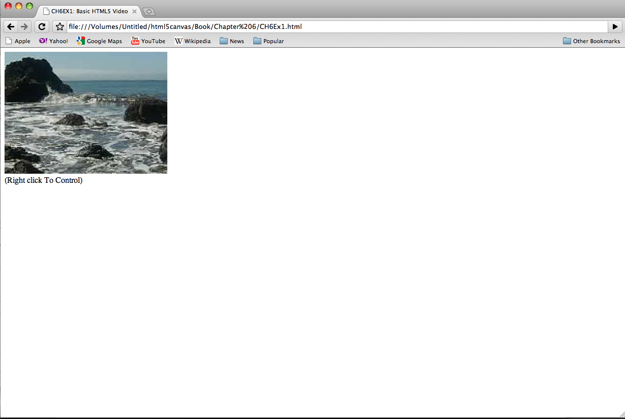
Figure 6-1: HTML5 Video Embed

Video With Controls, Loop, AutoPlay
While a video displayed without controls might suit your needs, most users expect to see some way to control a video automatically appear. As well, as the developer, you might want a video to play automatically, or loop back to the beginning when it finishes. All of these things (when supported in the browser) are very easy to accomplish in HTML5.
Adding controls, looping and autoplay to an HTML5 video embed is quite easy. All you need to do is specify the options of controls, loop and/or autoplay in the <video> tag like this:
<video autoplay loop controls id="thevideo" width="320" height="240">
<source src="muirbeach.mp4" type='video/mp4; codecs="avc1.42E01E, mp4a.40.2"' >
<source src="muirbeach.webm"type='video/webm; codecs="vp8, vorbis"' >
<source src="muirbeach.ogg" type='video/ogg; codecs="theora, vorbis"'>

</video>

Note: As of this writing, loop does not work in Firefox, however support is expected in version 4.0.

The code to embed our Muir Beach video with controls, loop and autoplay is below (CH6EX2.html). Figure 6-2 shows what a video looks like with the controls showing (in Google Chrome).

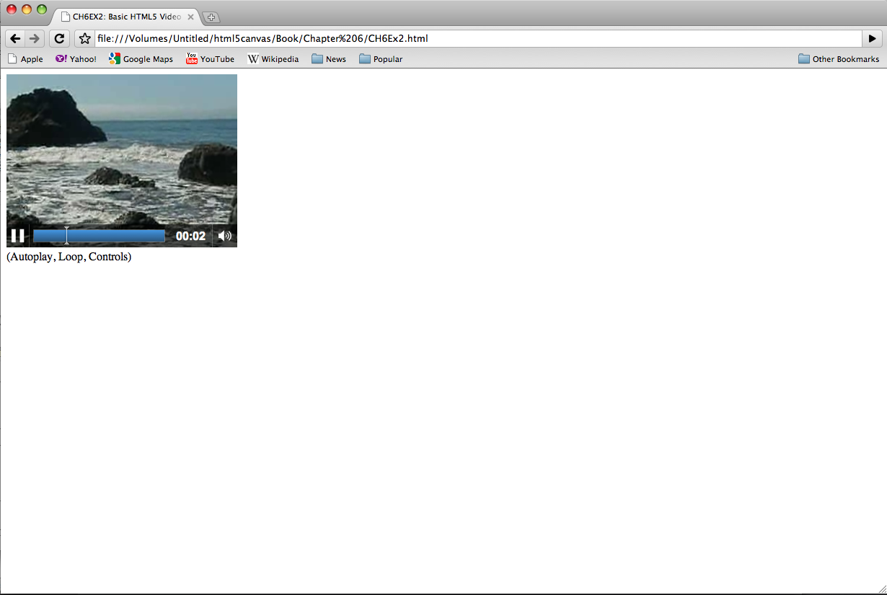
Figure 6-2: HTML5 Video Embed with Controls

Altering the Width And Height Of The Video
In our first example, we showed how you could embed a video without specifying a width or height. However, there are many good reasons why you might want to change the width and height of a video in the HTML page. You might want to fit it into particular part of the page, or enlarge it so it is easier to see, etc. Similar embedding an image into HTML with the <img> tag, a video will scale to whatever width and height you provide in the <video> tag. Also, just like with an <img> tag, this “scale” does not affect the size of the object downloaded. If the video is 5 megabytes at 640x480, it will still be 5 megabytes when displayed at 180x120, it is just scaled to fit that size.
In the example below (CH6EX3.html), we have scaled the same video to three different sizes, and displayed them on the same page. Figure 6-3 shows what this looks like in HTML (again, rendered in the Google Chrome browser)

CH6EX3 – Basic HTML5 Video : 3 Sizes
<div>
<video autoplay loop controls width="640" height="480" id="thevideo">
<source src="muirbeach.mp4" type='video/mp4; codecs="avc1.42E01E, mp4a.40.2"' >
<source src="muirbeach.webm"type='video/webm; codecs="vp8, vorbis"' >
<source src="muirbeach.ogg" type='video/ogg; codecs="theora, vorbis"'>
</video>
</div>
<div>
(640x480)
<div>
<video autoplay loop controls width="320" height="240"id="thevideo">
<source src="muirbeach.mp4" type='video/mp4; codecs="avc1.42E01E, mp4a.40.2"' >
<source src="muirbeach.webm"type='video/webm; codecs="vp8, vorbis"' >
<source src="muirbeach.ogg" type='video/ogg; codecs="theora, vorbis"'>

</video>
</div>
<div>
(320x240)
</div>
<div>
<video autoplay loop controls width="180" height="120"id="thevideo">
<source src="muirbeach.mp4" type='video/mp4; codecs="avc1.42E01E, mp4a.40.2"' >
<source src="muirbeach.webm"type='video/webm; codecs="vp8, vorbis"' >
<source src="muirbeach.ogg" type='video/ogg; codecs="theora, vorbis"'>

</video>
</div>
<div>
(180x120)
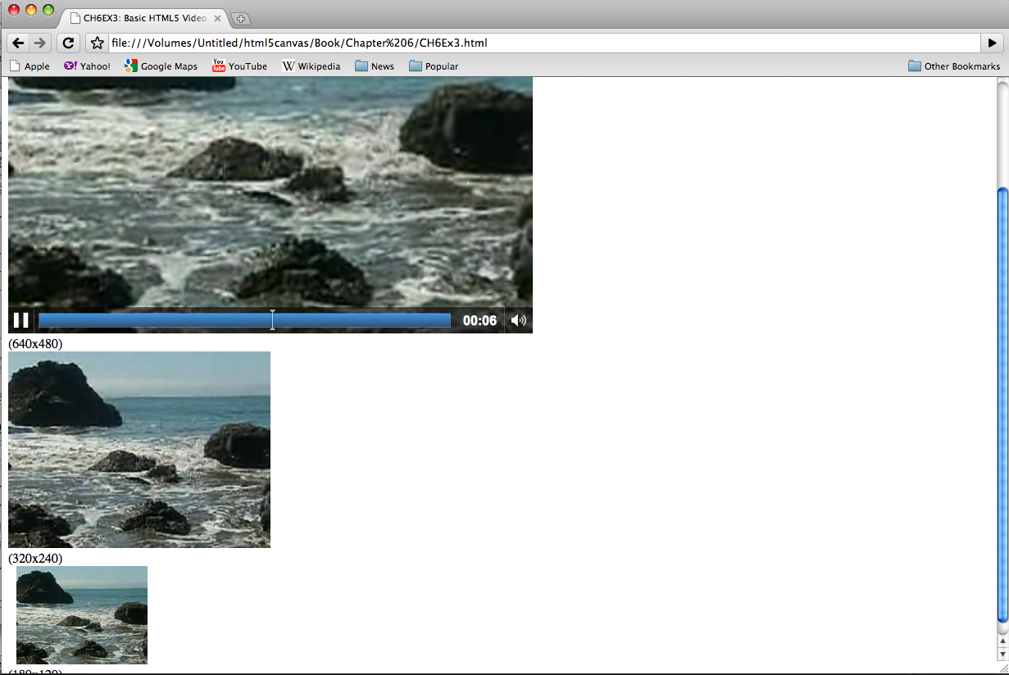
Figure 6-3: Controlling video width and height in the embed

Dynamically Scaling A Video
Now it is time for a more elaborate (and we think more effective) example of scaling a video. By changing the width and height attributes of the <video> tag, we can scale the video on the fly. While there may be few practical reasons why you would do this in a real-world situation, it is an affective way to demonstrate some of the power of the HTML5 Video tag.
The first this we need to do is add an HTML5 <range> control to the page like this:
<form>
Video Size : <input type="range" id="videoSize"
min="80"
max="1280"
step="1"
value="320"/>
</form>
We discussed the details of the <range> control in Chapter 2, but just to refresh, the <range> is a new <form> control added to HTML 5 that creates a slider of values. We are going to use this slider to set the video size.
Note: If the browser does not support the <range> element, a text box will appear that will allow them to enter text directly.
To capture the change to the video size, we need to add some JavaScript. First, we create an event listener for the load event that calls the eventWindowLoaded() function when the page loads (this should look very familiar to you by now).
window.addEventListener('load', eventWindowLoaded, false);
In the eventWindowLoaded() function we need to set-up a couple things. The first this we need to do is create an event listener for a change to the “videoSize” <form> control we created in the HTML page. A “change” to the control (e.g. someone slides it right or left), will create an event hanled by the videoSizeChanged() event handler.
var sizeElement = document.getElementById("videoSize")
sizeElement.addEventListener('change', videoSizeChanged, false);
Next, we need to create a value that can be used to set both the width and the height of the video at once. We do this because we want to keep the proper aspect ratio of the video (the ratio of width to height) when the video is resized. To do this, we create the variable widthtoHeightRatio, which is simply the width or the video divided by the height.
var widthtoHeightRatio = videoElement.width/videoElement.height;
Finally, when the user changes the “videoSize” range control, the videoSizeChanged() event handler is called. This functions sets the width property of the video to the value of the <range> control (target.value), then sets the height of the video to the same value, divided by the widthtoHeightRatio value we just created. The effect is the video resizing on the fly, while playing.
Below is the full code listing for this application:
function videoSizeChanged(e) {

var target = e.target;
var videoElement = document.getElementById("theVideo");
videoElement.width = target.value;
videoElement.height = target.value/widthtoHeightRatio;

}

CH6EX4 – Basic HTML5 Video With Resize Range Control
<!doctype html>
<html lang="en">
<head>
<meta charset="UTF-8">
<title>CH6EX4: Basic HTML5 Video With Resize Range Control </title>
<script type="text/javascript">
window.addEventListener('load', eventWindowLoaded, false);
function eventWindowLoaded() {
var sizeElement = document.getElementById("videoSize")
sizeElement.addEventListener('change', videoSizeChanged, false);
var videoElement = document.getElementById("theVideo");
var widthtoHeightRatio = videoElement.width/videoElement.height;

function videoSizeChanged(e) {

var target = e.target;
var videoElement = document.getElementById("theVideo");
videoElement.width = target.value;
videoElement.height = target.value/widthtoHeightRatio;

}

}

</script>
</head>
<body>
<div>
<form>
Video Size : <input type="range" id="videoSize"
min="80"
max="1280"
step="1"
value="320"/>
</form>
<br>
</div>
<div>
<video autoplay loop controls id="theVideo" width="320" height="240">
<source src="muirbeach.mp4" type='video/mp4; codecs="avc1.42E01E, mp4a.40.2"' >
<source src="muirbeach.webm"type='video/webm; codecs="vp8, vorbis"' >
<source src="muirbeach.ogg" type='video/ogg; codecs="theora, vorbis"'>
</video>
</div>

</body>
</html>

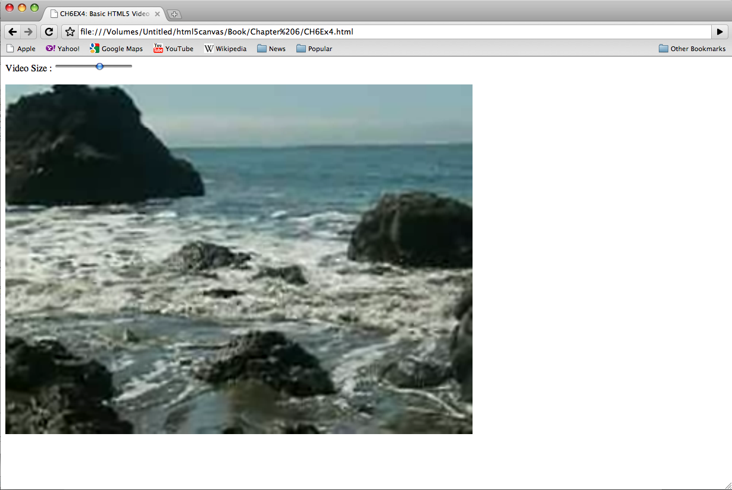
Figure 6-4: Controlling video with and height with JavaScript

Preloading Video In JavaScript
Many times it is necessary to preload a video before you do anything with it. This is especially true when using video with the HTML5 Canvas because many times, what you want do with the video goes beyond the simple act of playing it.
We are going to create a preload architecture that can be reused and expanded upon. We need to leverage the DOM and JavaScript to make this work. We are still not using the Canvas, but this process will lead directly to it.
To this, we must first embed the video in the HTML page, the same way we have done it previously in this chapter. However, we are going to add <div> with the id of “loadingStatus”. We will use this <div> to report the percentage loaded of the video that we retrieve through JavaScript.
Note: In practice, you probably would not display the loading status on the HTML page.
<div>
<video loop controls id="thevideo" width="320" height="240" preload="auto">
<source src="muirbeach.mp4" type='video/mp4; codecs="avc1.42E01E, mp4a.40.2"' >
<source src="muirbeach.webm"type='video/webm; codecs="vp8, vorbis"' >
<source src="muirbeach.ogg" type='video/ogg; codecs="theora, vorbis"'>
</video>

<div>

<div id="loadingStatus">
0%
</div>
In JavaScript, we need to create the same type of eventWindowLoaded() function that we have done many times previously in this book. This function is called when that HTML page has finished loading. In this function we need to create two listeners for two more events that are dispatched from the HTMLVideoElement object:
- ‘progress’: An event dispatched when then Video object has updated information about the loading progress of a video. We will sue this event to update the percentage text in the “loadingStatus” <div>.
- ‘canplaythrough’ : An event dispatched when the video has loading enough so that it can play the entire video. We will use this event so we will know when to start playing the video.
Below is the code that creates the listeners for those events.
function eventWindowLoaded() {
var videoElement = document.getElementById("thevideo");

videoElement.addEventListener('progress',updateLoadingStatus,false);
videoElement.addEventListener('canplaythrough',playVideo,false);

}
The updateLoadingStatus() function is called when the ‘progress’ event is dispatched from the video element. This function calculates the percent loaded by calculating the ratio of the already loaded bytes (videoElement.buffered.end(0)), by the total bytes (videoElement.duration) and dividing that value by 100. That value is then displayed by setting the innerHTML property of the “loadingStatus” <div>. Remember, this is only for displaying the progress. We still need to do something once the video has loaded.
Note: At the time of this writing, Firefox did not support the videobuffered property, but it was planned for Firefox 4.0
function updateLoadingStatus() {

var loadingStatus = document.getElementById("loadingStatus");
var videoElement = document.getElementById("thevideo");
var percentLoaded = parseInt(((videoElement.buffered.end(0) /videoElement.duration) * 100));
document.getElementById("loadingStatus").innerHTML = percentLoaded + '%';

}
The playVideo() function is called when the video object dispatches a “canplaythrough” event. playVideo() calls the play() function of the video object, and the video starts to play.
function playVideo() {
var videoElement = document.getElementById("thevideo");
videoElement.play();

}
Here is the full code for the preloading example:

CH6EX5 – Basic HTML5 Preloading Video

<!doctype html>
<html lang="en">
<head>
<meta charset="UTF-8">
<title>CH6EX5: Basic HTML5 Preleoading Video</title>
<script type="text/javascript">
window.addEventListener('load', eventWindowLoaded, false);
function eventWindowLoaded() {
var videoElement = document.getElementById("thevideo");

videoElement.addEventListener('progress',updateLoadingStatus,false);
videoElement.addEventListener('canplaythrough',playVideo,false);

}

function updateLoadingStatus() {

var loadingStatus = document.getElementById("loadingStatus");
var videoElement = document.getElementById("thevideo");
var percentLoaded = parseInt(((videoElement.buffered.end(0) /videoElement.duration) * 100));
document.getElementById("loadingStatus").innerHTML = percentLoaded + '%';

}

function playVideo() {
var videoElement = document.getElementById("thevideo");
videoElement.play();

}
</script>

</head>
<body>
<div>
<video loop controls id="thevideo" width="320" height="240" preload="auto">
<source src="muirbeach.mp4" type='video/mp4; codecs="avc1.42E01E, mp4a.40.2"' >
<source src="muirbeach.webm"type='video/webm; codecs="vp8, vorbis"' >
<source src="muirbeach.ogg" type='video/ogg; codecs="theora, vorbis"'>

</video>

<div>

<div id="loadingStatus">
0%
</div>

</div>
</body>
</html>

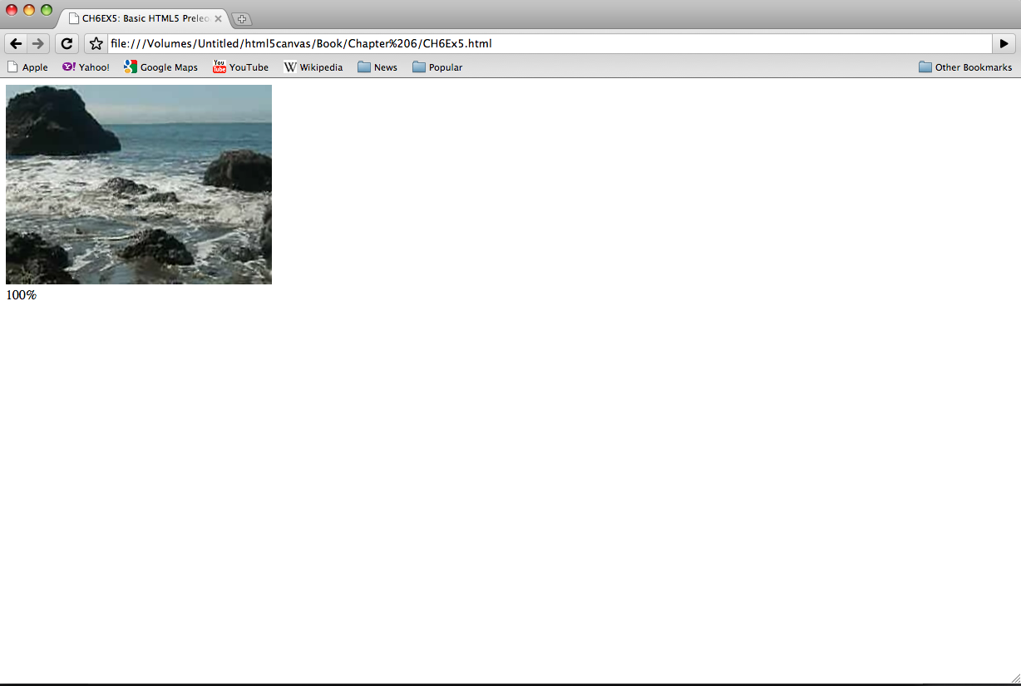
Figure 6-5: Preloading a video in JavaScript

A Problem with Events And Embedded Video And HTML5
So now that we have gone through this exercise, we have some upsetting news. While the code we have presented for CH6EX5.html works in most HTML5 complaint web browsers, right about the time we were finishing up the first draft of this book, they stopped working in Google Chrome. This was upsetting because we had developed all the examples and tested them with Chrome as our primary platform.
With a bit of investigation, we discovered that the issue was that neither the “canplaythrough” or “progress” events were being fired by Chrome. At the same time, the “load” event was being removed from Firefox. While these were anecdotal occurrences, they lead to one common truth: the HTML5 specification is not finished. This is an obvious, but important fact to note. If you are developing for HTML5 or the Canvas, you are developing with a moving target.
In the specific example of CH6EX5.html, we found that the process of embedding the <video> tag in the HTML page was the reason why none of the events were not in Chrome. Because of this, the previous example will not work in Chrome. To make it work in Chrome, you need to add a call to playVideo() in the eventWindowLoaded() function like this:

function eventWindowLoaded() {
var videoElement = document.getElementById("thevideo");

videoElement.addEventListener('progress',updateLoadingStatus,false);
videoElement.addEventListener('canplaythrough',playVideo,false);
playVideo()
}
However, this code will not solve the core problem: we need a reliable way to know when a video has finished loading so we can use it on the Canvas. In the next example we will show you a way to make that happen.

Video And The Canvas
So now you can preload a video and play it once it has finished loading, but why do you need to do that? The HTML Video object already has a poster property for displaying an image before the video starts to play, and has functions to autoplay and loop. When then, do you need to preload the video? Well we alluded to it in the last section, but simply playing a video is one thing, however manipulating it with the HTML5 Canvas is quite another. If you want to start manipulating video while it is displayed on the Canvas, you first need to make sure it is loaded.
In this section we are going load video onto the Canvas, and then manipulate it in various ways so you can see how powerful the Canvas can become when it is mixed with other HTML5 elements.

Displaying A Video On The HTML5 Canvas
First, we must learn the basics of displaying video on the HTML Canvas. There are a few important things to note about displaying video on the Canvas. These things are not readily obvious when you start working with video and the Canvas, but we stumbled through them so you don’t have to do it yourself. You are welcome.

Video Must Still Be Embedded In HTML
Even though the video is only displayed on the HTML5 Canvas, you still need a <video> tag in HTML. The key is to put the video in a <div> (or a similar construct) and set the “display” CSS style property of that <div> to “none” in HTML, which will make sure that while the video is loaded in the page, it is not displayed. If we wrote the code in HTML, it might look like this:
<div style="position: absolute; top: 50px; left: 600px; display:none">
<video loop controls id="thevideo" width="320" height="240" preload="auto">
<source src="muirbeach.mp4" type='video/mp4; codecs="avc1.42E01E, mp4a.40.2"' >
<source src="muirbeach.webm"type='video/webm; codecs="vp8, vorbis"' >
<source src="muirbeach.ogg" type='video/ogg; codecs="theora, vorbis"'>
</video>

However, we already know that we don’t want to use an HTML embed. As we stated at the end of the last section, video events do not appear to fire reliably when <video> elements are embedded in the HTML page. For this reason, we need to create a new strategy to load video dynamically
What we need to do is dynamically create the <div> and <video> elements in JavaScript. The first thing we do in our JavaScript, is create a couple variables to hold references to the dynamic HTML elements we will create. The videoElement variable will hold the dynamically created <video> tag, while videoDiv will hold the dynamically created <div> that will hold the video. We need to create a <div> to hold the <video> because we will need to make the <video> invisible on the HTML page, and the will do that by setting the CSS style of the <div> to “display:none”;
var videoElement;
var videoDiv;
Note: We use this method to create global variables throughout this chapter. There are many reasons to not use global variables, but for these simple applications that are quickest way to get something on the Canvas. However, if you want to learn a better way to handle loading assets, the final section of “Chapter 7 Audio” employs a strategy to preload assets without the use of global variables.
Next, we create our dynamic form elements in the eventWindowLoaded() function. First, we use the createElement() method of the document DOM object to create a <video> element and a <div> element, placing references to them in the variables we just created.
function eventWindowLoaded() {

videoElement = document.createElement("video");
videoDiv = document.createElement('div');
document.body.appendChild(videoDiv);
Next, we add the videoElement as a child of the videoDiv, essentially putting it inside of that <div> on the HTML page. We then set the style attribute of the <div> to “display:none;”, which will make it invisible on the HTML page. We do this because , while we want the video to display on the Canvas, we don’t want to it in HTML page.
videoDiv.appendChild(videoElement);
videoDiv.setAttribute("style", "display:none;");
We then create another new variable named videoType that holds the results of a new function we will create named supportedVideoFormat(). This function returns the file extension of the supported video format for the browser, or “” which means we alert the user that there is no video support in the app for their browser.
var videoType = supportedVideoFormat(videoElement);
if (videoType == "") {
alert("no video support");
return;
}
Finally, we set the src property of the video element using the file extension we just received from supportedVideoFormat(), and create the event handler for the “canplaythrough” event.
videoElement.setAttribute("src", "muirbeach." + videoType);
videoElement.addEventListener("canplaythrough",videoLoaded,false);

}

When video has finished loading, the videoLoaded event handler is called, which in turn calls the canvasApp() function.

function videoLoaded(event) {

canvasApp();

}

Before the code in the last section will work, we will need to define the supportedVidioFormat() function. The reason for this function is simple: since we are adding <video> objects dynamically to the HTML page, we do not have a way to define multiple <source> tags like we can in HTML. Instead, we are going to use the canPlayType() method of the <video> object to tell us which type of audio file to load.
The canPlayType() method takes a single parameter, a MIME type. It returns a text string of “maybe”, “probably” or nothing (an empty string).
- empty (nothing): This is returned is the browser knows the type cannot be rendered.
- maybe: This is returned is the browser does not confidently know that the type can be displayed.
- probably: This is returned if the browser knows the type can be displayed using an <audio> or <video> element

We are going to use these values to figure out which media type to load and play. For the sake of this exercise, we are going to assume that both “maybe” and “probably” equate to “yes”. If we encounter either result with any of our three MIME types ("video/webm ", " video/mp4"," video/ogg "), we will return the extension associated that MIME type so the sound file can be loaded.
In the function below, video represents the instance of HTMLVideoElement that we are going to test. The returnExtension variable represents that valid extension for the first MIME type found that has the value of “maybe” or “probably” returned from the call to canPlayType().

function supportedVideoFormat(video) {
var returnExtension = "";
if (video.canPlayType("video/webm") =="probably" || video.canPlayType("video/webm") == "maybe") {
returnExtension = "webm";
} else if(video.canPlayType("video/mp4") == "probably" || video.canPlayType("video/mp4") == "maybe") {
returnExtension = "mp4";
} else if(video.canPlayType("video/ogg") =="probably" || video.canPlayType("video/ogg") == "maybe") {
returnExtension = "ogg";
}

return returnExtension;

}

Notice, we do not check for a condition when no valid video format is found, and the return value is “”. If that is the case, the code that has called this function might need to be written in a way to catch that condition and alter the program execution. We did that with the test of the return value and the alert() we described in the previous section.

Video Is Displayed Like An Image
When you write code to display a video on the Canvas, you use the context.drawImage() function, as if it was a static image you are displaying. Don’t go looking for a drawVideo() function in the HTML5 Canvas spec, because you won’t find it. The code to display a video stored in variable named videoElement, displayed at the x,y position of 85,30 would look like this:
context.drawImage(videoElement , 85, 30);
However, when you draw a video for the first time, you will notice that it will not move. It stays on the first frame. At first you might think you have done something wrong, but in reality, you have not. You just need to add one more thing to make it work.

You Need An Interval Set To Update The Display
Just like when we discussed animation in the previous chapters, a video placed on the HTML5 Canvas using drawImage() will not update itself. You need to call drawImage() in some sort of loop to continually update the image with new data from the playing video in the HTML page (hidden or not). To do this, we first start the video playing by calling its play() method, and then use setInterval() to call the drawScreen() function every 33 milliseconds. This will give you about 30 fps (frames per second). We put this code in our canvasApp() function that is called after we know the video has loaded.
videoElement.play();
setInterval(drawScreen, 33);

In drawScreen() we will call drawImage() to display the video but since it will be called every 33 seconds, the video will be updated, and play on the Canvas.
function drawScreen () {

context.drawImage(videoElement , 85, 30);

}
Below is the full code for displaying a video on the Canvas as and updating it using setInterval().

CH6EX6 – Basic HTML5 Load Video Onto The Canvas
<!doctype html>
<html lang="en">
<head>
<meta charset="UTF-8">
<title>CH6EX6 : Basic HTML5 Load Video Onto The Canvas</title>
<script src="modernizr-1.6.min.js"></script>
<script type="text/javascript">
window.addEventListener('load', eventWindowLoaded, false);
var videoElement;
var videoDiv;
function eventWindowLoaded() {

videoElement = document.createElement("video");
videoDiv = document.createElement('div');
document.body.appendChild(videoDiv);
videoDiv.appendChild(videoElement);
videoDiv.setAttribute("style", "display:none;");
var videoType = supportedVideoFormat(videoElement);
if (videoType == "") {
alert("no video support");
return;
}
videoElement.setAttribute("src", "muirbeach." + videoType);
videoElement.addEventListener("canplaythrough",videoLoaded,false);

}

function supportedVideoFormat(video) {
var returnExtension = "";
if (video.canPlayType("video/webm") =="probably" || video.canPlayType("video/webm") == "maybe") {
returnExtension = "webm";
} else if(video.canPlayType("video/mp4") == "probably" || video.canPlayType("video/mp4") == "maybe") {
returnExtension = "mp4";
} else if(video.canPlayType("video/ogg") =="probably" || video.canPlayType("video/ogg") == "maybe") {
returnExtension = "ogg";
}

return returnExtension;

}

function canvasSupport () {
return Modernizr.canvas;
}

function videoLoaded(event) {

canvasApp();

}

function canvasApp() {

if (!canvasSupport()) {
return;
}

function drawScreen () {

//Background

context.fillStyle = '#ffffaa';
context.fillRect(0, 0, theCanvas.width, theCanvas.height);
//Box
context.strokeStyle = '#000000';
context.strokeRect(5, 5, theCanvas.width-10, theCanvas.height-10);
//video
context.drawImage(videoElement , 85, 30);

}

var theCanvas = document.getElementById('canvasOne');
var context = theCanvas.getContext('2d');
videoElement.play();

setInterval(drawScreen, 33);

}

</script>

</head>
<body>
<div style="position: absolute; top: 50px; left: 50px;">

<canvas id="canvasOne" width="500" height="300">
Your browser does not support the HTML 5 Canvas.
</canvas>
</div>

</body>
</html>

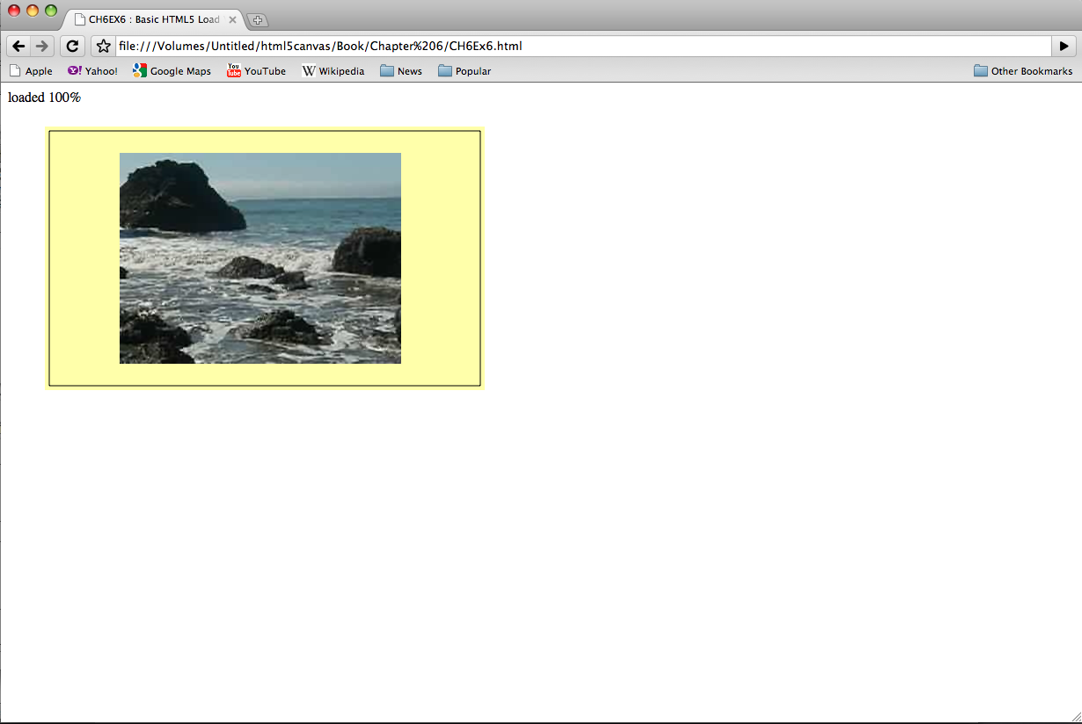
Figure 6-6: Displaying A Video On The HTML5 Canvas

HTML5 Video Properties
We have already talked about some of properties of the HTMLVideoElement pr(inherited from HTMLMediaElement), but now that we have a video loaded onto the Canvas, it would be interesting to see them in action.
In this example, we are going to display seven properties of a playing video, taken from the HTMLVideoElement object: duration, currentTime, loop, autoplay, muted, controls, volume. Of these, duration, loop, and autoplay will not update, because they are set when the video is embedded. Also, since we call the play() function of the video after it is preloaded in JavaScript, autoplay will may set to false, but the video will play anyway. The other properties will update as the video is played.
To display these values on the Canvas, we will draw them as text in the drawScreen() function called by setInterval(). Below is the drawScreen() that we have created to display these values.
function drawScreen () {

//Background

context.fillStyle = '#ffffaa';
context.fillRect(0, 0, theCanvas.width, theCanvas.height);
//Box
context.strokeStyle = '#000000';
context.strokeRect(5, 5, theCanvas.width-10, theCanvas.height-10);
//video
context.drawImage(videoElement , 85, 30);
// Text
context.fillStyle = "#000000";
context.fillText ("Duration:" + videoElement.duration, 10 ,280);
context.fillText ("Current time:" + videoElement.currentTime, 260 ,280);
context.fillText ("Loop: " + videoElement.loop, 10 ,290);
context.fillText ("Autoplay: " + videoElement.autoplay, 100 ,290);
context.fillText ("Muted: " + videoElement.muted, 180 ,290);
context.fillText ("Controls: " + videoElement.controls, 260 ,290);
context.fillText ("Volume: " + videoElement.volume, 340 ,290);

}
Figure 6-7 shows what the attributes look like when we display them on the Canvas. Notice, we have placed the <video> embed next to the Canvas, and we have not set the CSS display style to “none”. We did this to demonstrate the relationship between the video embedded in the HTML page, and the one playing on the Canvas. If you rollover the video in the HTML page, you can see the control panel. If you set the volume, you will notice that the volume attribute displayed on the Canvas will change. If you pause the embedded video, the video on the Canvas will stop playing, and the currentTime value will stop.
This demo should give you a very good idea of the relationship between the video on the Canvas, and the one embedded wit the <video> tag. Even though they are displayed using completely different methods, they are in fact, one and the same.

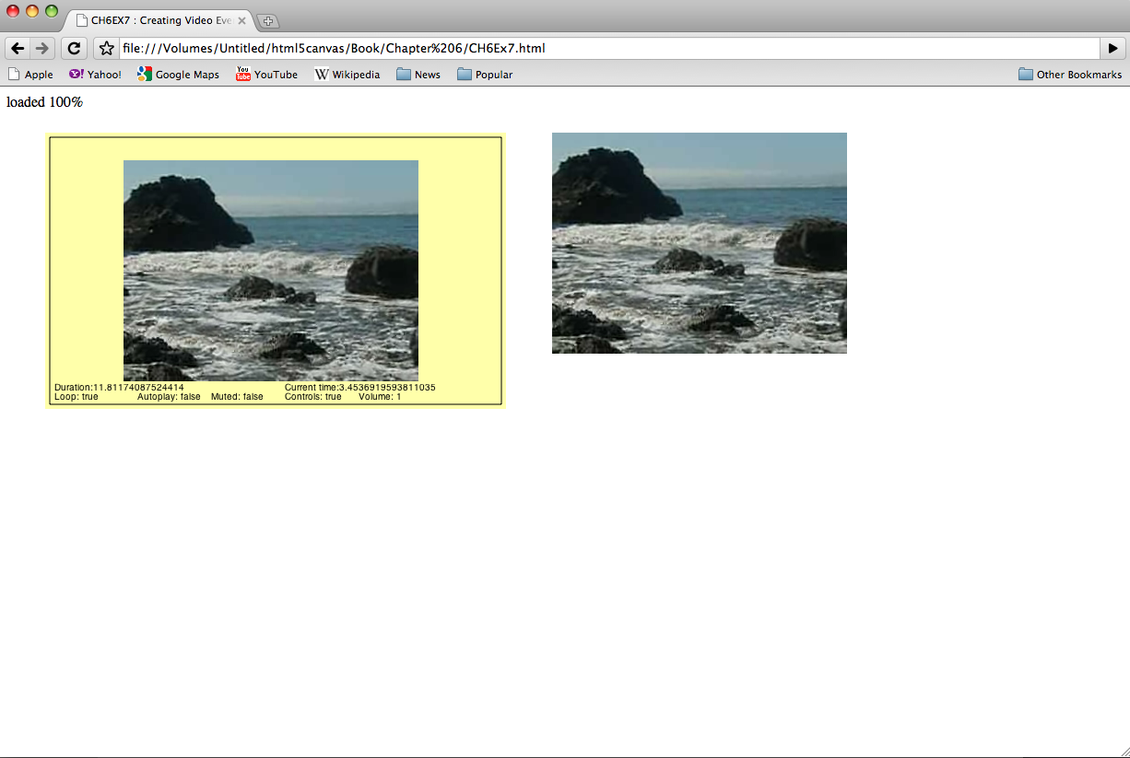
Figure 6-7: Video On The Canvas With Properties Display and <video> Embed

CH6EX7 – Video Properties
<!doctype html>
<html lang="en">
<head>
<meta charset="UTF-8">
<title>CH6EX7 : Video Properties</title>
<script src="modernizr-1.6.min.js"></script>
<script type="text/javascript">
window.addEventListener('load', eventWindowLoaded, false);
var videoElement;
var videoDiv;
function eventWindowLoaded() {

videoElement = document.createElement("video");
var videoDiv = document.createElement('div');
document.body.appendChild(videoDiv);
videoDiv.appendChild(videoElement);
videoDiv.setAttribute("style", "position: absolute; top: 50px; left: 600px; ");
var videoType = supportedVideoFormat(videoElement);
if (videoType == "") {
alert("no video support");
return;
}
videoElement.setAttribute("src", "muirbeach." + videoType);
videoElement.addEventListener("canplaythrough",videoLoaded,false);

}

function supportedVideoFormat(video) {
var returnExtension = "";
if (video.canPlayType("video/webm") =="probably" || video.canPlayType("video/webm") == "maybe") {
returnExtension = "webm";
} else if(video.canPlayType("video/mp4") == "probably" || video.canPlayType("video/mp4") == "maybe") {
returnExtension = "mp4";
} else if(video.canPlayType("video/ogg") =="probably" || video.canPlayType("video/ogg") == "maybe") {
returnExtension = "ogg";
}

return returnExtension;

}

function canvasSupport () {
return Modernizr.canvas;
}

function videoLoaded() {
canvasApp();

}

function canvasApp() {

if (!canvasSupport()) {
return;
}

function drawScreen () {

//Background

context.fillStyle = '#ffffaa';
context.fillRect(0, 0, theCanvas.width, theCanvas.height);
//Box
context.strokeStyle = '#000000';
context.strokeRect(5, 5, theCanvas.width-10, theCanvas.height-10);
//video
context.drawImage(videoElement , 85, 30);
// Text
context.fillStyle = "#000000";
context.fillText ("Duration:" + videoElement.duration, 10 ,280);
context.fillText ("Current time:" + videoElement.currentTime, 260 ,280);
context.fillText ("Loop: " + videoElement.loop, 10 ,290);
context.fillText ("Autoplay: " + videoElement.autoplay, 100 ,290);
context.fillText ("Muted: " + videoElement.muted, 180 ,290);
context.fillText ("Controls: " + videoElement.controls, 260 ,290);
context.fillText ("Volume: " + videoElement.volume, 340 ,290);

}

var theCanvas = document.getElementById('canvasOne');
var context = theCanvas.getContext('2d');
videoElement.play();

setInterval(drawScreen, 33);

}

</script>

</head>
<body>
<div style="position: absolute; top: 50px; left: 50px;">

<canvas id="canvasOne" width="500" height="300">
Your browser does not support the HTML 5 Canvas.
</canvas>
</div>

</body>
</html>
You can see this example in action by executing CH6EX7.html from the code distribution.
Note: you can see all the events properties for the HTMLVideoElement here:
http://www.w3.org/2010/05/video/mediaevents.html

Video On The Canvas Examples
In the last section we learned that the video playing on the Canvas and the video embedded with the <video> tag are in fact, the same video. It also took a lot more code for us to play the video on the Canvas than it did to embed the video JavaScript and play it in the first place. This then begs the question:
Why load video on the Canvas at all?
Well, often times simply displaying a video and playing it is not enough. You might want events to occur as the video is playing, you my want to use transformations on it, use it in a game, create custom video controls, or animate it and movie on the Canvas.
The following five examples will show you in very specific and details ways why the Canvas can be an exciting way to display video.

Using currentTime Property To Create Video Events
The first way we will use video in conjunction with Canvas is to use the currentTime property of a playing video to trigger events on the Canvas. Recall that the currentTime property is updated as the video plays, and it shows the elapsed running time of the playing video.
For our example, we are going to create a dynamic object in JavaScript that contains the following properties:
- time: The elapsed time to trigger the event
- message: A text message to display on the canvas
- x: The x position of the text message
- y: The y position of the text message

Here is what we are going to do. We will first create an array of these objects and place them into a variable named messages. We will create four “events” (messages that will appear), and they will take place at the elapsed currentTime of 0 seconds, 1 second, 4 seconds and 8 seconds.
var messages = new Array();
messages[0] = {time:0,message:"", x:0 ,y:0};
messages[1] = {time:1,message:"This Is Muir Beach!", x:90 ,y:200};
messages[2] = {time:4,message:"Look At Those Waves!", x:240 ,y:240};
messages[3] = {time:8,message:"Look At Those Rocks!", x:100 ,y:100};
To display the messages, we will for a for:next loop inside our drawScreen() function. Inside the loop, we test each message in the messages array to see if the currentTime property of the video is greater than the time property of the message. If so, we know that it is okay to display the message. We then display the message on the canvas using the fillStyle and property and fillText() function of the Canvas context.

for (var i =0; i < messages.length ; i++) {
var tempMessage = messages[i];
if (videoElement.currentTime > tempMessage.time) {
context.font = "bold 14px sans";
context.fillStyle = "#FFFF00";
context.fillText (tempMessage.message, tempMessage.x ,tempMessage.y);
}
}

Of course, this is a very simple way to create events. The various text messages will not disappear after others are created, but that is just a small detail. The point of this exercise is that, with code like this, you could do almost anything with a running video. You could pause the video, show an animation, and then continue once the animation is done. You could pause to ask the user for input, and then load a different video. In essence, you can make the video completely interactive in any way you choose. However, the model for these events could be very similar to the one we just created.
Here is the full code listing for this application.

CH6EX8 – Creating Simple Video Events
<!doctype html>
<html lang="en">
<head>
<meta charset="UTF-8">
<title>CH6EX8 : Creating Simple Video Events</title>
<script src="modernizr-1.6.min.js"></script>
<script type="text/javascript">
window.addEventListener('load', eventWindowLoaded, false);
var videoElement;
var videoDiv;
function eventWindowLoaded() {

videoElement = document.createElement("video");
videoDiv = document.createElement('div');
document.body.appendChild(videoDiv);
videoDiv.appendChild(videoElement);
videoDiv.setAttribute("style", "display:none;");
var videoType = supportedVideoFormat(videoElement);
if (videoType == "") {
alert("no video support");
return;
}
videoElement.setAttribute("src", "muirbeach." + videoType);
videoElement.addEventListener("canplaythrough",videoLoaded,false);

}
function supportedVideoFormat(video) {
var returnExtension = "";
if (video.canPlayType("video/webm") =="probably" || video.canPlayType("video/webm") == "maybe") {
returnExtension = "webm";
} else if(video.canPlayType("video/mp4") == "probably" || video.canPlayType("video/mp4") == "maybe") {
returnExtension = "mp4";
} else if(video.canPlayType("video/ogg") =="probably" || video.canPlayType("video/ogg") == "maybe") {
returnExtension = "ogg";
}

return returnExtension;

}

function canvasSupport () {
return Modernizr.canvas;
}

function videoLoaded() {
canvasApp();

}

function canvasApp() {

if (!canvasSupport()) {
return;
}

function drawScreen () {

//Background

context.fillStyle = '#ffffaa';
context.fillRect(0, 0, theCanvas.width, theCanvas.height);
//Box
context.strokeStyle = '#000000';
context.strokeRect(5, 5, theCanvas.width-10, theCanvas.height-10);
//video
context.drawImage(videoElement , 85, 30);
// Text
context.fillStyle = "#000000";
context.font = "10px sans";
context.fillText ("Duration:" + videoElement.duration, 10 ,280);
context.fillText ("Current time:" + videoElement.currentTime, 260 ,280);
context.fillText ("Loop: " + videoElement.loop, 10 ,290);
context.fillText ("Autoplay: " + videoElement.autoplay, 80 ,290);
context.fillText ("Muted: " + videoElement.muted, 160 ,290);
context.fillText ("Controls: " + videoElement.controls, 240 ,290);
context.fillText ("Volume: " + videoElement.volume, 320 ,290);

//Display Message
for (var i =0; i < messages.length ; i++) {
var tempMessage = messages[i];
if (videoElement.currentTime > tempMessage.time) {
context.font = "bold 14px sans";
context.fillStyle = "#FFFF00";
context.fillText (tempMessage.message, tempMessage.x ,tempMessage.y);
}
}

}

var messages = new Array();
messages[0] = {time:0,message:"", x:0 ,y:0};
messages[1] = {time:1,message:"This Is Muir Beach!", x:90 ,y:200};
messages[2] = {time:4,message:"Look At Those Waves!", x:240 ,y:240};
messages[3] = {time:8,message:"Look At Those Rocks!", x:100 ,y:100};

var theCanvas = document.getElementById('canvasOne');
var context = theCanvas.getContext('2d');
videoElement.play();

setInterval(drawScreen, 33);

}

</script>

</head>
<body>
<div style="position: absolute; top: 50px; left: 50px;">

<canvas id="canvasOne" width="500" height="300">
Your browser does not support the HTML 5 Canvas.
</canvas>
</div>

</body>
</html>
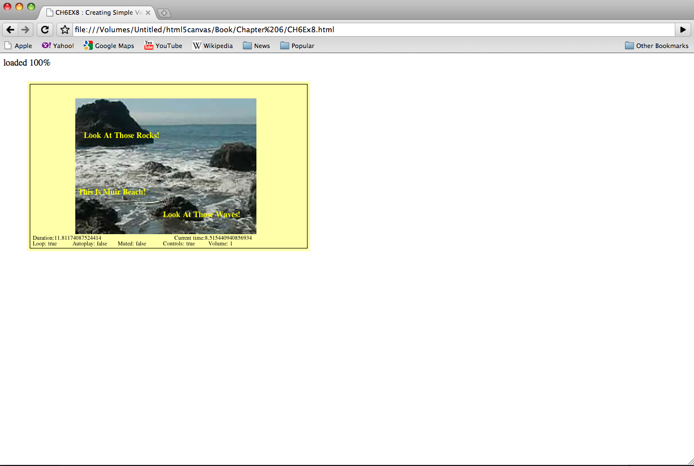
Figure 6-8: Canvas Video Displaying Text Overlay Events

Canvas Video Transformations: Alpha And Rotation
Showing a static video on the screen is one thing, but transforming it on the screen with things like alpha transparency and rotations is quite another. These types of transformations can be easily applied to video on the Canvas, the in much the same way they would apply to an image or a drawing object.
In this example, we will create a video that fades onto the canvas while rotating clock-wise. To achieve this effect, we first create a couple variables, rotation and alpha, that we will use to hold the current values of both the rotation and alpha properties that we will apply to the video. We also create the variables videoX and videoY, which will act as the origin (upper left corner) point to place the video on the Canvas. We create these variables outside of the drawScreen() function, inside canvasApp().
var rotation = 0;
var alpha = 0;
var videoX=100;
var videoY=100;

Next, we must reset the context.globalAlpha property of the Canvas context to 1 at the beginning of the drawScreen() function. Recall, that valid globalAlpha values are the number between 0 and 1. We reset this value so that we can draw the background and bounding box on the screen with no globalAlpha transparency applied. If we did not set this value, the background and bounding box would fade with the video.
function drawScreen () {

context.globalAlpha = 1;

context.fillStyle = '#ffffaa';
context.fillRect(0, 0, theCanvas.width, theCanvas.height);
//Box
context.strokeStyle = '#000000';
context.strokeRect(5, 5, theCanvas.width-10, theCanvas.height-10);

After drawing the background and bounding box, we are ready to apply the globalAlpha value to the video, as it is the next thing we are going to draw on the Canvas.
Since the alpha variable is set to 0 when the JavaScript is first executed, we are going to increase the value a little bit on each interval to make the video appear to fade-in slowly. To do this, we increase the alpha variable by .01 each time drawScreen() is called. We also test to see if the value is greater than 1, and if so, set it back to 1. We do this because again, the only valid globalAlpha values are between 0 and 1. Finally, after we have calculated the value of the alpha variable, we apply it to the globalAlpha property of the Canvas context.
alpha += .01;
if (alpha > 1) {
alpha = 1;
}
context.globalAlpha = alpha;
Next, we need to save the current Canvas context so we can restore it after we perform the transformation. We covered this in depth in Chapter 3, but to refresh your memory, we will remind you a bit of how it works. Transformations on the Canvas are global in nature, which means they affect everything. Since the Canvas works in immediate mode, there is no stack of objects to manipulate. Instead, we need to save the Canvas context before the transformation, apply the transformation, and then restore the saved context afterwards. First, we save it.
context.save();
Next, we reset the context transformation to the identity, which clears anything that was set prior.
context.setTransform(1,0,0,1,0,0);
Now it is time to use the rotation variable. The rotation variable represents the angle that we have rotated the video on the Canvas. It starts at 0, and we will increase it every time drawScreen() is called. However, the context.rotate() method requires an angle to be converted to radians when passed as its’ lone parameter. The following line of code coverts the value in the rotation variable to radians and stores it in a variable named angleInRadians.
var angleInRadians = rotation * Math.PI / 180;
Now we need to find the center of the video on the Canvas so we can start our rotation from that point. We find the x value by taking our videoX variable and adding ½ width of the video. We find the y value by taking our videoY variable and adding ½ the height of the video. We supply both of those values as parameters to the context.translate() function so the rotation will start at that point. We need to do this because, again, we are not rotating the video object, we are rotating the entire Canvas in relation to the video being displayed.
context.translate(videoX+.5*videoElement.width, videoY+.5*videoElement.height);
The rest of the code is really straightforward. First, we call the rotate() function of the context, passing our angle (converted to radians) to perform the rotation.
context.rotate(angleInRadians);
Then we call drawImage() passing the video object, and the x, y position of where we want the video to be displayed. This is a bit tricky, but should make sense. Since we have used the translate() function to move to the center of the video, we now need to place it using the upper left-hand corner. To find that corner, we need to subtract ½ the width to find the x position, and ½ the height to find the y position to place the video.
context.drawImage(videoElement ,-.5*videoElement.width, -.5*videoElement.height);
Finally, we restore the canvas we saved before the transformation started, and we update the rotation variable so that we will have a new angle on the next call to drawScreen().
context.restore();
rotation++;
Now the video should rotate at 1 degree clockwise per call to drawScreen() while fading onto the Canvas. You can easily increase the speed of the rotation by changing the value that you increase the rotation variable in the last line above in the drawScreen() function.
Here is the code for the updated canvasApp() function for this example.
function canvasApp() {

if (!canvasSupport()) {
return;
}

function drawScreen () {

context.globalAlpha = 1;

//Background

context.fillStyle = '#ffffaa';
context.fillRect(0, 0, theCanvas.width, theCanvas.height);
//Box
context.strokeStyle = '#000000';
context.strokeRect(5, 5, theCanvas.width-10, theCanvas.height-10);

alpha += .01;
if (alpha > 1) {
alpha = 1;
}
context.globalAlpha = alpha;
context.save();
context.setTransform(1,0,0,1,0,0);

var angleInRadians =rotation * Math.PI / 180;

context.translate(videoX+.5*videoElement.width, videoY+.5*videoElement.height); // move the origin of the transform to the center of the video window;
context.rotate(angleInRadians);
context.drawImage(videoElement ,-.5*videoElement.width, -.5*videoElement.height);
context.restore();
rotation++;

}

var theCanvas = document.getElementById('canvasOne');
var context = theCanvas.getContext('2d');
var videoElement = document.getElementById("thevideo");
videoElement.play();

//*** set transforation values
var rotation = 0;
var alpha = 0;
var videoX=100;
var videoY=100;
//***
setInterval(drawScreen, 33);
}

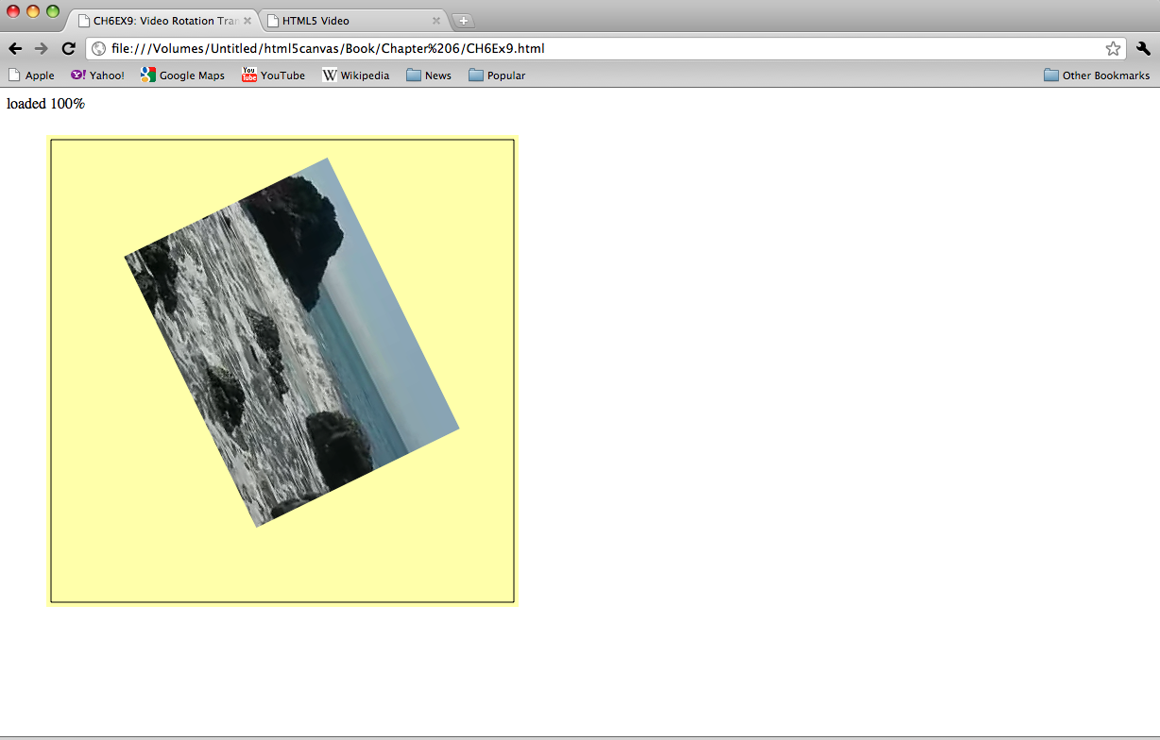
Figure 6-9: Canvas video rotation

CH6EX9 – Rotating A Video
<!doctype html>
<html lang="en">
<head>
<meta charset="UTF-8">
<title>CH6EX9: Video Rotation Transform</title>
<script src="modernizr-1.6.min.js"></script>
<script type="text/javascript">
window.addEventListener('load', eventWindowLoaded, false);
var videoElement;
var videoDiv;
function eventWindowLoaded() {

videoElement = document.createElement("video");
videoDiv = document.createElement('div');
document.body.appendChild(videoDiv);
videoDiv.appendChild(videoElement);
videoDiv.setAttribute("style", "display:none;");
var videoType = supportedVideoFormat(videoElement);
if (videoType == "") {
alert("no video support");
return;
}
videoElement.setAttribute("src", "muirbeach." + videoType);
videoElement.addEventListener("canplaythrough",videoLoaded,false);

}

function supportedVideoFormat(video) {
var returnExtension = "";
if (video.canPlayType("video/webm") =="probably" || video.canPlayType("video/webm") == "maybe") {
returnExtension = "webm";
} else if(video.canPlayType("video/mp4") == "probably" || video.canPlayType("video/mp4") == "maybe") {
returnExtension = "mp4";
} else if(video.canPlayType("video/ogg") =="probably" || video.canPlayType("video/ogg") == "maybe") {
returnExtension = "ogg";
}

return returnExtension;

}

function canvasSupport () {
return Modernizr.canvas;
}

function videoLoaded() {
canvasApp();

}

function canvasApp() {

if (!canvasSupport()) {
return;
}

//*** set roationvalue
var rotation = 0;
//***

function drawScreen () {

//Background
context.fillStyle = '#ffffaa';
context.fillRect(0, 0, theCanvas.width, theCanvas.height);
//Box
context.strokeStyle = '#000000';
context.strokeRect(5, 5, theCanvas.width-10, theCanvas.height-10);

//video
//*** Start rotation calculation
context.save();
context.setTransform(1,0,0,1,0,0); //resets the transformation back to the "identity" - basically clears it.

var angleInRadians =rotation * Math.PI / 180;
var x=100;
var y=100;
var videoWidth=320;
var videoHeight=240;
context.translate(x+.5*videoWidth, y+.5*videoHeight); // move the origin of the transform to the center of the video window;
context.rotate(angleInRadians);
//****
context.drawImage(videoElement ,-.5*videoWidth, -.5*videoHeight);
//*** restore screen
context.restore();
rotation++;
//***

}

var theCanvas = document.getElementById('canvasOne');
var context = theCanvas.getContext('2d');
videoElement.play();

setInterval(drawScreen, 33);

}

</script>

</head>
<body>
<div style="position: absolute; top: 50px; left: 50px;">

<canvas id="canvasOne" width="500" height="500">
Your browser does not support the HTML 5 Canvas.
</canvas>
</div>

</body>
</html>

Canvas Video Puzzle
Now we arrive at the most involved example of this section. We are going to create a puzzle-game based on the video we have displayed on the Canvas. The game will operate like this:
- We will load the video onto the Canvas, but not display it.
- We will decide how many parts we want to be in our puzzle
- We will create a board array that holds all the puzzle pieces.
- The pieces will be displayed in a 4x4 grid
- We will randomize the pieces on the board to mix-up the puzzle.
- We will add an event listener for the mouse button
- We will set an interval to call drawScreen()
- We will wait for the user to click a puzzle piece
- While we are waiting, the various parts of the video will play just like they were one video.
- When a user clicks a puzzle piece we will highlight it in yellow
- If the user has selected two pieces we will swap their positions
- The user will attempt to put the puzzle back together so they can see the video as it was created.

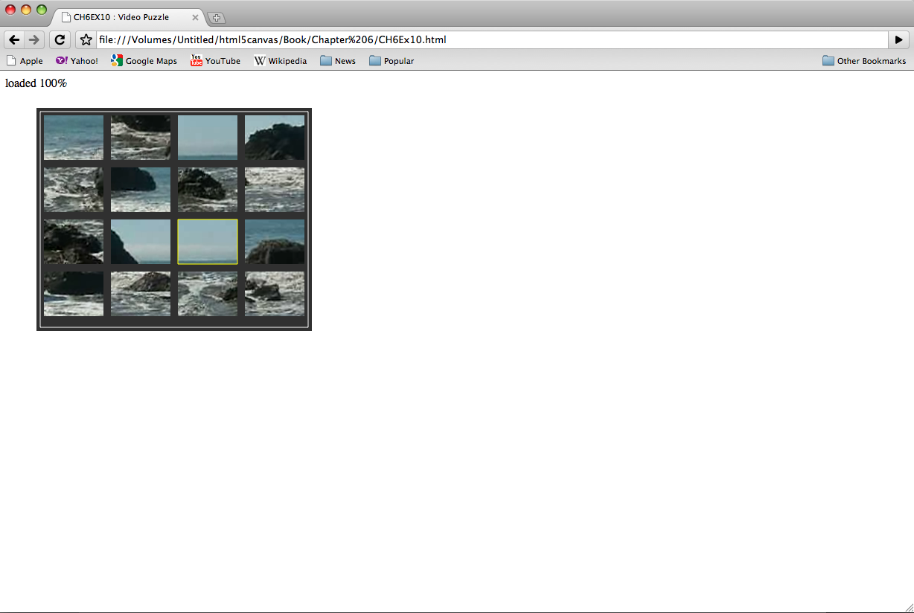Figure 6-10: Video Puzzle

Setting-Up The Game
To start, we are going set-up some variables that will define the playfield for the game. Here is a rundown of the variables and how they will be used:
- rows: The numbers of rows in the grid of puzzle pieces.
- cols: The number of columns in the grid of puzzle pieces.
- xPad: The space, in pixels between each column.
- yPad: The space, in pixels, between each row.
- startXOffset: The number of pixels from the left of the Canvas to the location where we will start drawing the grid of puzzle pieces.
- startYOffset : The number of pieces from the top of the Canvas to the location where we will start drawing the grid of puzzle pieces.
- partWidth: The width of each puzzle piece.
- partHeight: The height of each puzzle piece.
- board: A two dimensional array that holds the puzzle pieces.
var rows = 4;
var cols = 4;
var xPad = 10;
var yPad = 10;
var startXOffset = 10;
var startYOffset = 10;
var partWidth = videoElement.width/cols;
var partHeight = videoElement.height/rows;
var board = new Array();
Next we need to initialize the board array and fill it with some dynamic objects that represent each piece of the puzzle. We loop through the numbers of cols in the board and create rows amount of dynamic objects in each one. The dynamic objects we are creating has these properties:
- finalCol: The final column resting place of the piece when the puzzle is complete. We use this value to figure out what part of the video cut out to make this piece.
- finalRow : The final row resting place of the piece when the puzzle is complete. We use this value to figure out what part of the video cut out to make this piece.
- selected: A Boolean that is initially set to false. We will use this to see if we should highlight a piece or switch two pieces when a piece is clicked by the user.
Notice that we use a two nested for:next loops to fill the board array with these objects. Familiarize yourself with this construct, as we use it many times in this game. Two nested loops used like this are particularly useful for games and apps that require a 2D grid to be displayed and manipulated.
for (var i = 0; i < cols; i++) {
board[i] = new Array();
for (var j =0; j < rows; j++) {
board[i][j] = { finalCol:i,finalRow:j,selected:false };
}
}
Now that we have the board array initialized we call randomizeBoard() to mix-up the puzzle by randomly placing the pieces on the screen. We will talk about this in just a moment. We finish the set-up section of the game by adding an event listener for the “mouseup” event (when the user releases the mouse button), and by setting an interval to call drawScreen() every 33 milliseconds.
board = randomizeBoard(board);

theCanvas.addEventListener("mouseup",eventMouseUp, false);

setInterval(drawScreen, 33);

Randomizing The Puzzle Pieces
The randomizeBoard() function requires that you to pass in the board variable so we can operate on it. We’ve set-up the function this way so it will be portable to other applications.
To randomize the puzzle pieces, we first we need to set-up an array named newBoard. We will use this array to hold the randomized puzzle pieces. This will be what we call a “parallel array”. It’s purpose to become the original array, but randomized. We then create a local cols variable and initialize it to the length of board array that was passed in the to the function, and a local rows variable, initialized to the length of the first column, board[0] in the array. This works because all of our rows and cols are the same length, so the number of rows in the first column is the same as all the others. We now have the building blocks required to randomize the pieces.
function randomizeBoard(board) {
var newBoard = new Array();
var cols = board.length;
var rows = board[0].length
Next, we loop through every column and row, randomly choosing a piece from the board array and move it into newBoard. Note: we use two nested for:next loops here once again.
for (var i = 0; i < cols; i++) {
Every time we come to an iteration of the outer nested loop, we create a new array that we will fill-up in the second nested loop. Then we drop into that nested loop. The found variable will be set to true when we have found a random location to place the piece in the newBoard array. The rndRow and rndCol variables hold the random values we will create to try find a random location the puzzle pieces.

newBoard[i] = new Array();
for (var j =0; j < rows; j++) {
var found = false;
var rndCol = 0;
var rndRow = 0;
Now we need to find a location to put the puzzle piece from the board array into newBoard. We use a while() loop that continues to iterate while the found variable is false. To find a piece to move, we randomly choose a row and column, and then use them to see if that space (board[rndCol][rndRow]) is set to not set to false. If it is not false, we have found a pieced in the board array to move to the newBoard array. We then set found equal to true so we can get out of the while loop and move to the next space in newBoard we need to fill.
while (!found) {
var rndCol = Math.floor(Math.random() * cols);
var rndRow = Math.floor(Math.random() * rows);
if (board[rndCol][rndRow] != false) {
found = true;
}
}
Finally, we move the piece we found in board to the current location we are filling in newBoard. Then we set the piece in the board array to false so that when we test for the next piece we won’t try to use the piece we just found in board again. When we are done filling-up newBoard, we return it as the newly randomized array of puzzle pieces.
newBoard[i][j] = board[rndCol][rndRow];
board[rndCol][rndRow] = false;
}

}

return newBoard;

}

Drawing The Screen
The drawScreen() function is the heart of the video puzzle application. It is called on an interval, and it is used to update the video frames so the video plays, and to draw the puzzle pieces on the screen. A good portion of drawScreen() looks like applications we have built many times already in this chapter and this book. When it begins, we draw the background and a bounding back on the screen.
function drawScreen () {

//Background

context.fillStyle = '#303030';
context.fillRect(0, 0, theCanvas.width, theCanvas.height);
//Box
context.strokeStyle = '#FFFFFF';
context.strokeRect(5, 5, theCanvas.width-10, theCanvas.height-10);
However, the primary work of this function is (you guessed it) and another set of two nested for:next loops that draw the puzzle pieces on the Canvas. This loops needs to do three things:
- Draw a grid of puzzle pieces on the Canvas based on their placement in the board two-dimensional array.
- Find the correct part of the video to render for each piece based on the finalCol and finalRow properties we set in the dynamic object for each piece.
- Draw a yellow box around the piece that has its’ selected property set to true.
We start our loop by finding the x and y (imageX, imageY) location to “cut” the piece from the video object to create our puzzle piece. We do this by taking the finalRow and finalCol properties of the dynamic piece objects we created, and multiplying them by the partWidth and partHeight respectively. We then have the origin point, (top. left x and y location) for the piece of the video to display.

for (var c = 0; c < cols; c++) {
for (var r = 0; r < rows; r++) {

var tempPiece = board[c][r];
var imageX = tempPiece.finalCol*partWidth;
var imageY = tempPiece.finalRow*partHeight;
Now that we know the origin point of part of the video we will display for a particular piece of the puzzle, we need to know where it will be placed on the Canvas. While this might look confusing, it’s really just simple arithmetic. To find the x location (placeX) of a piece, we multiply the partWidth times the current iterated column, add the current iterated column multiplied by the xPad (the number pixels between each piece) and then add the startXOffeset which is the x location of the upper left corner of the entire board of pieces. Finding placeY is very similar, but you use the current row, yPad, and partHeight in the calculation.
var placeX = c*partWidth+c*xPad+startXOffset;
var placeY = r*partHeight+r*yPad+startYOffset;
Now it is time to draw the piece on the Canvas. We need to “cut” out the part of the video that we will display for each piece of the puzzle. We won’t actually “cut” anything though. We will use the drawImage() function that we have used many other times already in this book. However, now we use the version of drawImage() that accepts nine parameters:
- videoElement: The image that we are going to display. In this case it is the video.
- imageX: The x location of the upper-right-hand order of the part if the image to display.
- imageY: The y location of the upper-right-hand order of the part if the image to display.
- partWidth: The width from the x location of the rectangle to display
- partHeight: The height from the y location of the rectangle to display
- placeX: The x location to place the image on the Canvas
- placeY: The y location to place the image on the Canvas
- partWidth: The width of the image as displayed on the Canvas.
- partHeight: The height of the image as displayed on the Canvas.

We’ve already discussed how we calculated most of these values, so it is just a matter of knowing the drawImage() API function and plugging-in the variables.
context.drawImage(videoElement, imageX, imageY, partWidth, partHeight, placeX, placeY, partWidth, partHeight);
There is one last thing that we are going to do in this function. If a puzzle piece is marked as “selected” (the selected Boolean property is true) we will draw a yellow box around the piece.
if (tempPiece.selected) {

context.strokeStyle = '#FFFF00';
context.strokeRect( placeX, placeY, partWidth, partHeight);

}
}
}

}

Detecting Mouse Interactions And The Canvas
Recall that back in the canvasApp() function we set an event listener for the “mouseup” action with the event handler function set to eventMouseUp. We now need to create that function.
theCanvas.addEventListener("mouseup",eventMouseUp, false);
The first thing we do in the eventMouseUp() function is test to find the x and y location of the mouse pointer when the button was pressed. We will use those coordinates to figure out if the user clicked on any of the puzzle pieces.
Since some browsers support the layerX/layerY properties of the event object, while others support the offsetX/offsetY properties, we need to support both. No matter which one is set, we will use those properties to set our mouseX and mouseY variables to the x and y location of the mouse pointer.
function eventMouseUp(event) {

var mouseX;
var mouseY;
var pieceX;
var pieceY;
if ( event.layerX || event.layerX == 0) { //Firefox
mouseX = event.layerX ;
mouseY = event.layerY;
} else if (event.offsetX || event.offsetX == 0) { // Opera
mouseX = event.offsetX;
mouseY = event.offsetY;
}

Creating Hit Test Point Style Collision Detection
Now that we know where the user clicked, we need to test to see if that x and y location “hits” any of the puzzle pieces. If so, we need to set the selected property of that piece to true. What we are going to perform is a simple “hit test point” style hit detection. It will tell us if the x, y position (point) of the mouse is inside (hits) any one of the puzzle pieces when the mouse button was clicked.
First, we create a local variable named selectedList that we will use when we need to swap the pieces in the board array. Next, we will again, use a set of two nested for:next loops to traverse through all the pieces in the board array. Inside the for:next loops, the first thing we do is find the top left corner x and y point of the current piece pointed to by board[c][r]. We calculate those values an put them into the placeX and placeY variables
var selectedList= new Array();
for (var c = 0; c < cols; c++) {

for (var r =0; r < rows; r++) {
pieceX = c*partWidth+c*xPad+startXOffset;
pieceY = r*partHeight+r*yPad+startYOffset;
Next, we use those calculated values to text for a “hit test point” collision. We do this with a semi- complicated if:then statement that tests fours conditions simultaneously. All of the conditions must evaluate to true for a “hit” to be registered on any one piece on the board:
- mouseY >= pieceY: The mouse pointer lies lower than or equal to the top of the piece.
- mouseY <= pieceY+partHeight: The mouse pointer lies above or equal to the bottom of a piece.
- mouseX >= pieceX: The mouse pointer lies to the right or equal to the left side of the piece.
- mouseX <= pieceX+partWidth: The mouse pointer lies to the left or equal to the right side of the piece
if ( (mouseY >= pieceY) && (mouseY <= pieceY+partHeight) && (mouseX >= pieceX) && (mouseX <= pieceX+partWidth) ) {
If all these conditions are true, we set the selected property of the piece object to true, if it was already false, or set it to false if it was already true. This allows the users to “deselect” the selected piece if they have decided not to move it.

if ( board[c][r].selected) {
board[c][r].selected = false;

} else {
board[c][r].selected = true;

}
}
At the end of the nested for:next loop, we make sure to test each piece to see if its’ selected property is true. If so, we push it into the selectedList local array so we can perform the swap operation on the pieces.
if (board[c][r].selected) {
selectedList.push({col:c,row:r})
}

}

}

Swapping Two Elements In A Two Dimensional Array
Now, after we have tested to see if a puzzle piece was clicked, we need to test to see if two pieces have been marked as selected. If so, we need to swap the positions of those pieces. In this way, it appears that the player is clicking on puzzle pieces and swapping their locations to try to solve the puzzle.
To achieve the swap, we use a classic “three-way swap” programming construct utilizing a temporary variable, tempPiece1 as a placeholder for the values we are going to swap. First we need to create a couple variables to hold the pieces that have been selected. We will use selected1 and selected2 for that purpose. Next, we move the reference to the piece represented by selelect1 into the tempPiece1 (the place holder) variable.
if (selectedList.length == 2) {
var selected1 = selectedList[0];
var selected2 = selectedList[1];
var tempPiece1 = board[selected1.col][selected1.row];
board[selected1.col][selected1.row] =
Next, we move the piece referenced by selected2, to the location in the board array of the piece represented by selected1 (the first swap). Then we apply the piece referenced in selected1 to the position in the board array represented by selected2 (the second swap). Finally we make sure to set the selected properties of both pieces to false, now that they are swapped.
board[selected2.col][selected2.row];
board[selected2.col][selected2.row] = tempPiece1;
board[selected1.col][selected1.row].selected = false;
board[selected2.col][selected2.row].selected = false;
}

}
Note: that this part of the function works because we have limited the number of pieces that can be selected to 2. For a different kind of game, for example a poker game that requires the player to select 5 cards, you would use a slightly different algorithm that tests for 5 cards instead of 2, and then calculated the value of the hand instead of swapping them.

Testing The Game
Believe it or not, that is all the code we need to talk about. The rest you have seen many times before. Try out the game (CH6EX10.html). When the game loads, you should see the video cut into 16 pieces, organized in a grid. Each part of the video will be playing, just like one of those magic tricks where a woman is cut into multiple boxes, but her legs, arms and head are still moving. In fact, this game is sort of like one of those magic tricks, because, in reality, the video was never “cut” in any way. We simply display the parts of the video in way that makes it appear to be cut into 16, independent, moving pieces that can be swapped to reform the original video.
Below is the full code listing for this application.

CH6EX10 – Video Puzzle

<!doctype html>
<html lang="en">
<head>
<meta charset="UTF-8">
<title>CH6EX10 : Video Puzzle</title>
<script src="modernizr-1.6.min.js"></script>
<script type="text/javascript">
window.addEventListener('load', eventWindowLoaded, false);
var videoElement;
var videoDiv;
function eventWindowLoaded() {

videoElement = document.createElement("video");
videoDiv = document.createElement('div');
document.body.appendChild(videoDiv);
videoDiv.appendChild(videoElement);
videoDiv.setAttribute("style", "display:none;");
var videoType = supportedVideoFormat(videoElement);
if (videoType == "") {
alert("no video support");
return;
}
videoElement.setAttribute("src", "muirbeach." + videoType);
videoElement.addEventListener("canplaythrough",videoLoaded,false);

}

function supportedVideoFormat(video) {
var returnExtension = "";
if (video.canPlayType("video/webm") =="probably" || video.canPlayType("video/webm") == "maybe") {
returnExtension = "webm";
} else if(video.canPlayType("video/mp4") == "probably" || video.canPlayType("video/mp4") == "maybe") {
returnExtension = "mp4";
} else if(video.canPlayType("video/ogg") =="probably" || video.canPlayType("video/ogg") == "maybe") {
returnExtension = "ogg";
}

return returnExtension;

}

function canvasSupport () {
return Modernizr.canvas;
}

function videoLoaded() {
canvasApp();

}

function canvasApp() {

if (!canvasSupport()) {
return;
}

function drawScreen () {

//Background

context.fillStyle = '#303030';
context.fillRect(0, 0, theCanvas.width, theCanvas.height);
//Box
context.strokeStyle = '#FFFFFF';
context.strokeRect(5, 5, theCanvas.width-10, theCanvas.height-10);

for (var c = 0; c < cols; c++) {
for (var r = 0; r < rows; r++) {

var tempPiece = board[c][r];
var imageX = tempPiece.finalCol*partWidth;
var imageY = tempPiece.finalRow*partHeight;
var placeX = c*partWidth+c*xPad+startXOffset;
var placeY = r*partHeight+r*yPad+startYOffset;
//context.drawImage(videoElement , imageX, imageY, partWidth, partHeight);
context.drawImage(videoElement, imageX, imageY, partWidth, partHeight, placeX, placeY, partWidth, partHeight);
if (tempPiece.selected) {

context.strokeStyle = '#FFFF00';
context.strokeRect( placeX, placeY, partWidth, partHeight);

}
}
}

}

function randomizeBoard(board) {
var newBoard = new Array();
var cols = board.length;
var rows = board[0].length
for (var i = 0; i < cols; i++) {
newBoard[i] = new Array();
for (var j =0; j < rows; j++) {
var found = false;
var rndCol = 0;
var rndRow = 0;
while (!found) {
var rndCol = Math.floor(Math.random() * cols);
var rndRow = Math.floor(Math.random() * rows);
if (board[rndCol][rndRow] != false) {
found = true;
}
}

newBoard[i][j] = board[rndCol][rndRow];
board[rndCol][rndRow] = false;
}

}

return newBoard;

}

function eventMouseUp(event) {

var mouseX;
var mouseY;
var pieceX;
var pieceY;
if ( event.layerX || event.layerX == 0) { // Firefox
mouseX = event.layerX ;
mouseY = event.layerY;
} else if (event.offsetX || event.offsetX == 0) { // Opera
mouseX = event.offsetX;
mouseY = event.offsetY;
}
var selectedList= new Array();
for (var c = 0; c < cols; c++) {

for (var r =0; r < rows; r++) {
pieceX = c*partWidth+c*xPad+startXOffset;
pieceY = r*partHeight+r*yPad+startYOffset;
if ( (mouseY >= pieceY) && (mouseY <= pieceY+partHeight) && (mouseX >= pieceX) && (mouseX <= pieceX+partWidth) ) {

if ( board[c][r].selected) {
board[c][r].selected = false;

} else {
board[c][r].selected = true;

}
}
if (board[c][r].selected) {
selectedList.push({col:c,row:r})
}

}

}
if (selectedList.length == 2) {
var selected1 = selectedList[0];
var selected2 = selectedList[1];
var tempPiece1 = board[selected1.col][selected1.row];
board[selected1.col][selected1.row] = board[selected2.col][selected2.row];
board[selected2.col][selected2.row] = tempPiece1;
board[selected1.col][selected1.row].selected = false;
board[selected2.col][selected2.row].selected = false;
}

}

var theCanvas = document.getElementById('canvasOne');
var context = theCanvas.getContext('2d');
videoElement.play();

//Puzzle Settings

var rows = 4;
var cols = 4;
var xPad = 10;
var yPad = 10;
var startXOffset = 10;
var startYOffset = 10;
var partWidth = videoElement.width/cols;
var partHeight = videoElement.height/rows;
//320x240
partWidth=80;
partHeight=60;
var board = new Array();

//Initialize Board

for (var i = 0; i < cols; i++) {
board[i] = new Array();
for (var j =0; j < rows; j++) {
board[i][j] = { finalCol:i,finalRow:j,selected:false };
}
}

board = randomizeBoard(board);

theCanvas.addEventListener("mouseup",eventMouseUp, false);

setInterval(drawScreen, 33);

}

</script>

</head>
<body>
<div style="position: absolute; top: 50px; left: 50px;">

<canvas id="canvasOne" width="370" height="300">
Your browser does not support the HTML 5 Canvas.
</canvas>
</div>

</body>
</html>

Creating Video Controls On The Canvas
One obvious use of the Canvas video display functionality is to create custom video controls for play, pause, stop, etc. You may have already noticed, that when a video is rendered on the Canvas it does not retain any of the HTML5 video controls. That may or may not have been specified in the HTML page. If you want to create controls on the Canvas, you need to make them your self. Thankfully, we have already learned most everything we need to create video controls on the Canvas; we simply need to put it all together.

Creating Video Buttons
We are going to use some video control buttons that were quickly created specifically for this example. This is tile sheet that consists of off and on states for play, pause, and stop. The top image is the on state; the bottom is the off state. Here is what it looks like:

Figure 6-11: Video Control Button Tile Sheet
Note: We don’t use the “off” state of the Stop button in this application, but we included it in case you, the amazing reader and programmer that you are, want to use it later.
We will load this image dynamically onto the Canvas, and then place the buttons onto the Canvas individually. Each button is 32x32 pixels. We use the width and height to calculate which part of the image to display as a control.

Pre-Loading The Buttons
The first thing we need to do is preload the button tile sheet. Since we are already testing for the video to preload before we display the Canvas, we need a slightly new strategy to preload multiple objects. For this example, we will use a counter variable named loadCount that we will increment each time we detect that an item has loaded. In conjunction with that variable, we will create another named itemsToLoad, which will hold the number of things we are preloading. For this app that number is two: the video and the tile sheet. These two variables are created outside of all functions, at the top of our JavaScript.
var loadCount=0;
var itemsToLoad = 2;
Along with videoElement and videoDiv, we also create another new variable named buttonSheet. We will use this as a reference to the image we load that holds the graphical buttons we will use for the video player interface.
var videoElement;
var videoDiv;
var buttonSheet

We now must make some updates to our standard eventWindowLoaded() function that we have used for most of this chapter. The first update: we are going to change the “canplaythrough” event handler for the video to a new function named itemLoaded.
videoElement.addEventListener('canplaythrough',itemLoaded,false);

Next, we need to load our tile sheet. We create a new Image object, and set the src property to videobuttons.png, the file we created above, with the 6 button tiles. We also set it’s onload event handler to itemLoaded, just like the video.
buttonSheet = new Image();
buttonSheet.onload = itemLoaded;
buttonSheet.src = "videobuttons.png";
}
Finally, we create the itemLoaded() event handler function. When this function is called, we increment the loadCount variable. We then test it against the itemsToLoad variable. If it is equal or greater than itemsToLoad, we call canvasApp() to start the application.
Note: loadCount should never be greater than itemsToLoad if you application is running correctly. However, we find it safer to limit the use of the strict “==“ test if possible. Why? Because if somehow, somewhere, something gets counted twice, the app will never load properly.
function itemLoaded() {
loadCount++;
if (loadCount >= itemsToLoad) {
canvasApp();
}
}

Placing The Buttons
In the canvasApp() function we need to set some variables that will represent the locations of the three buttons we are going to display: play, pause and stop. We start by specifying the standard button height and width as the variables bW and bH. All the images in the videobuttons.png tile sheet are 32x32 pixels, so we will set these two variables accordingly. Then we proceed to create variables that represent the x and y location of each button: playX, playY, pauseX, pauseY, stopX, stopY. We could use literal values instead, however these variables will make a couple of the more complicated calculations a bit easier to swallow.
var bW = 32;
var bH = 32;
var playX = 190;
var playY = 300;
var pauseX = 230;
var pauseY = 300;
var stopX = 270
var stopY = 300;
In the drawImage() function we need to test for the current state of the playing video, and render the buttons accordingly. For this application, we are going to use the state of the paused attribute of the video object to render the buttons properly in their “up” or down “state”.
When a video first loads on the page, and is not playing, its’ paused attribute is set to true. When a video is playing, its’ paused attribute is set to false. Knowing this, we can create the actions for these simple buttons.
First, if we know that the video is not in a paused state, it must be playing, so we display the “down” version of the “play” button. The “down” position is in the second row on the tile sheet, so that is why the 3rd parameter of the call to the drawImage() function is 32, because that is where the y position of the image we want to display starts on the tile sheet. If paused is true, it means the video is not playing, so we display the “up” version of the “play” button. It starts at y position 0.

if (!videoElement.paused) {
context.drawImage(buttonSheet, 0,32,bW,bH,playX,playY,bW,bH); //Play Down

} else {
context.drawImage(buttonSheet, 0,0,bW,bH,playX,playY,bW,bH); //Play up
}
Displaying the “pause” button is simply the opposite of “play”. If the video paused property is true, we display the “down” version of “pause” button. If the video is playing, it means it means the pause property is false, so we display the “up” version of the “pause” button. Notice that the 2nd parameter is 32, because to display the “pause” buttons in the tile sheet we need to skip over the “play” button and start at the x position of the pause buttons.
if (videoElement.paused) {
context.drawImage(buttonSheet, 32,32,bW,bH,pauseX,pauseY,bW,bH); //down
} else {
context.drawImage(buttonSheet, 32,0,bW,bH,pauseX,pauseY,bW,bH); // up
}

context.drawImage(buttonSheet, 64,0,bW,bH,stopX,stopY,bW,bH); // Stop up

Listening For The Button Presses
Now we also need to listen of the mouse button click. This process is very similar to how we accomplished much the same thing in the “Video Puzzle” application. First, back in the canvasApp() function we set an event handler function, eventMouseUp(), for the “mouseup” event.
theCanvas.addEventListener("mouseup",eventMouseUp, false);
The eventMouseUp() function works very similar to the same function we created for the “Video Puzzle” application. First, we find the mouse pointer’s x and y position based on the way the browser tracks those values, and we put those values into local mouseX and mouseY variables.
function eventMouseUp(event) {

var mouseX;
var mouseY;
if ( event.layerX || event.layerX == 0) { // Firefox
mouseX = event.layerX ;
mouseY = event.layerY;
} else if (event.offsetX || event.offsetX == 0) { // Opera
mouseX = event.offsetX;
mouseY = event.offsetY;
}
//Hit Play
Next, we test for a “hit test point” inside each button. For a full description of how we accomplished this, check back to the “Video Puzzle” application. However, to refresh your memory, we check the bounds of each button (right, left, top bottom) on the Canvas to see if the mouse pointer was over any of our buttons when it was clicked. If so, we detect a “hit”, which means the button was clicked.
First we test the “play” button. Notice that those variables we created to represent the upper left hand x and y location of the button (playX and playY) help us make this calculation. They also help us because the names of the buttons self document what we are trying to accomplish in each test of this function.
If the “play” button has been clicked, and the video paused property is true, we call the play() function of the video to start playing.
if ( (mouseY >= playY) && (mouseY <= playY+bH) && (mouseX >= playX) && (mouseX <= playX+bW) ) {
if (videoElement.paused) {
videoElement.play();

}

}
If the “stop” button was clicked, then we set the paused property of the video to true, and set the currentTime property to 0, so that the video will return to the first frame.
//Hit Stop

if ( (mouseY >= stopY) && (mouseY <= stopY+bH) && (mouseX >= stopX) && (mouseX <= stopX+bW) ) {

videoElement.pause();
videoElement.currentTime = 0;
}
If the “pause” button is clicked and the paused property of the video is false, we call the pause() function of the video, to, you guessed it, pause the video on the current frame. If the paused property is true, we call the play() function of the video so it will resume playing.
//Hit Pause
if ( (mouseY >= pauseY) && (mouseY <= pauseY+bH) && (mouseX >= pauseX) && (mouseX <= pauseX+bW) ) {

if (videoElement.paused == false) {
videoElement.pause();
} else {
videoElement.play();
}

}
Figure 6-12 shows what the Canvas looks like when the video is displayed with controls.
Note: You will notice there is an odd relationship between the “play” and “pause” buttons. When one is “on”, the other is “off”. This is because we only have one property to look at, paused. There is a property named playing that exists in the HTML5 specification, but it did not work in all browsers, so we only used paused. In reality, you could have only one button, and swap out the “play” or “paused” graphic depending on the paused state. That would make these controls work more like the default HTML <video> controls.

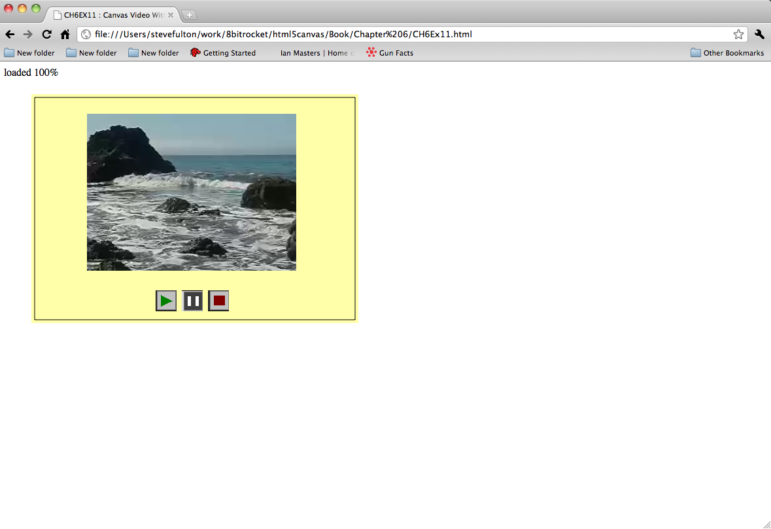
Figure 6-12: Canvas Video Player Buttons

Below is the full source for the “video with controls” application.

CH6EX11 – Canvas Video With Controls
<!doctype html>
<html lang="en">
<head>
<meta charset="UTF-8">
<title>CH6EX11 : Canvas Video With Controls</title>
<script src="modernizr-1.6.min.js"></script>
<script type="text/javascript">
window.addEventListener('load', eventWindowLoaded, false);
var loadCount=0;
var itemsToLoad = 2;
var videoElement;
var videoDiv;
var buttonSheet

function eventWindowLoaded() {
videoElement = document.createElement("video");
videoDiv = document.createElement('div');
document.body.appendChild(videoDiv);
videoDiv.appendChild(videoElement);
videoDiv.setAttribute("style", "display:none;");
var videoType = supportedVideoFormat(videoElement);
if (videoType == "") {
alert("no video support");
return;
}
videoElement.setAttribute("src", "muirbeach." + videoType);
videoElement.addEventListener("canplay",itemLoaded,false);
buttonSheet = new Image();
buttonSheet.onload = itemLoaded;
buttonSheet.src = "videobuttons.png";
}

function supportedVideoFormat(video) {
var returnExtension = "";
if (video.canPlayType("video/webm") =="probably" || video.canPlayType("video/webm") == "maybe") {
returnExtension = "webm";
} else if(video.canPlayType("video/mp4") == "probably" || video.canPlayType("video/mp4") == "maybe") {
returnExtension = "mp4";
} else if(video.canPlayType("video/ogg") =="probably" || video.canPlayType("video/ogg") == "maybe") {
returnExtension = "ogg";
}

return returnExtension;

}

function canvasSupport () {
return Modernizr.canvas;
}

function itemLoaded() {
loadCount++;
if (loadCount >= itemsToLoad) {
canvasApp();
}

}

function canvasApp() {

if (!canvasSupport()) {
return;
}

function drawScreen () {

//Background

context.fillStyle = '#ffffaa';
context.fillRect(0, 0, theCanvas.width, theCanvas.height);
//Box
context.strokeStyle = '#000000';
context.strokeRect(5, 5, theCanvas.width-10, theCanvas.height-10);
//video
context.drawImage(videoElement , 85, 30);
//Draw Buttons
//Play

if (!videoElement.paused) {
context.drawImage(buttonSheet, 0,32,bW,bH,playX,playY,bW,bH); //Play Down

} else {
context.drawImage(buttonSheet, 0,0,bW,bH,playX,playY,bW,bH); //Play up

}

if (videoElement.paused) {
context.drawImage(buttonSheet, 32,32,bW,bH,pauseX,pauseY,bW,bH); // Pause down
} else {
context.drawImage(buttonSheet, 32,0,bW,bH,pauseX,pauseY,bW,bH); // Pause up
}

context.drawImage(buttonSheet, 64,0,bW,bH,stopX,stopY,bW,bH); // Stop up

}

function eventMouseUp(event) {

var mouseX;
var mouseY;

if ( event.layerX || event.layerX == 0) { // Firefox
mouseX = event.layerX ;
mouseY = event.layerY;
} else if (event.offsetX || event.offsetX == 0) { // Opera
mouseX = event.offsetX;
mouseY = event.offsetY;
}
//Hit Play
if ( (mouseY >= playY) && (mouseY <= playY+bH) && (mouseX >= playX) && (mouseX <= playX+bW) ) {
if (videoElement.paused) {
videoElement.play();

}

}

//Hit Stop

if ( (mouseY >= stopY) && (mouseY <= stopY+bH) && (mouseX >= stopX) && (mouseX <= stopX+bW) ) {

videoElement.pause();
videoElement.currentTime = 0;
}

//Hit Pause
if ( (mouseY >= pauseY) && (mouseY <= pauseY+bH) && (mouseX >= pauseX) && (mouseX <= pauseX+bW) ) {

if (videoElement.paused == false) {
videoElement.pause();
} else {
videoElement.play();
}

}

}

var theCanvas = document.getElementById('canvasOne');
var context = theCanvas.getContext('2d');

var bW = 32;
var bH = 32;
var playX = 190;
var playY = 300;
var pauseX = 230;
var pauseY = 300;
var stopX = 270
var stopY = 300;

theCanvas.addEventListener("mouseup",eventMouseUp, false);

setInterval(drawScreen, 33);

}

</script>

</head>
<body>
<div style="position: absolute; top: 50px; left: 50px;">

<canvas id="canvasOne" width="500" height="350">
Your browser does not support the HTML 5 Canvas.
</canvas>
</div>

</body>
</html>

Animation Revisited: Moving Videos
Now we are going to revisit the “bouncing balls” demo from chapter 5, to show you how you can achieve the same effect with images and videos. Since we covered this in detail in Chapter 5 (CH5Ex4.html) we don’t need to examine all the code, just the changes that make the videos move.
Note: Remember videos are drawn the in much the same way as images, so with very few changes this application would work just as well with a static image as with a video.
While there are a few other changes, the most important is in the drawScreen() function when we draw the videos onto the Canvas. Recall, that in Chapter 5 we created an array named balls and dynamic object to hold the properties of each ball that looked like this:
tempBall = {x:tempX,y:tempY,radius:tempRadius, speed:tempSpeed, angle:tempAngle, xunits:tempXunits, yunits:tempYunits}
For videos, we will create a similar array, named videos, but we will alter the dynamic object to look like this:
tempvideo = {x:tempX,y:tempY,width:180, height:120, speed:tempSpeed, angle:tempAngle, xunits:tempXunits, yunits:tempYunits}
The big difference here is that we no longer need a radius that represents the size of the ball, but instead we need the width and height so we can render the video the size we want in the drawScreen() function.
Back in Chapter 5, we used the Canvas drawing command to draw balls on the screen like this:
context.beginPath();
context.arc(ball.x,ball.y,ball.radius,0,Math.PI*2,true);
context.closePath();
context.fill();
To draw videos, we need to change the code to look like this:
context.drawImage(videoElement ,video.x, video.y, video.width, video.height);
That is pretty much all you need to do! There are some others changes here, (for example, we start all the videos in the center of the screen before they start moving) but the items mentioned above are main things you need concentrate on to move video around the screen instead of yellow balls.
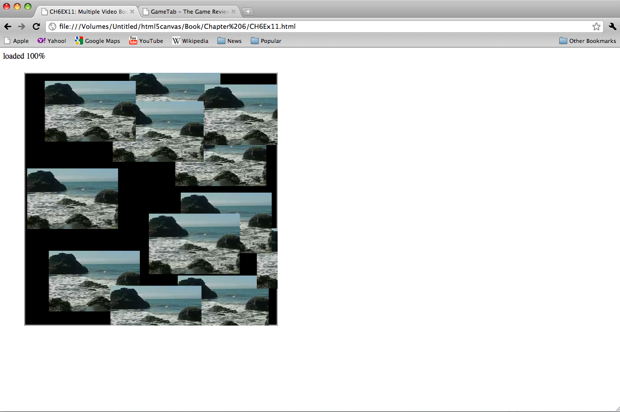
=
Figure 6-13: Canvas Video Animation Demo

CH6EX12 – Multiple Video Bounce
<!doctype html>
<html lang="en">
<head>
<meta charset="UTF-8">
<title>CH6EX12: Multiple Video Bounce</title>
<script src="modernizr-1.6.min.js"></script>
<script type="text/javascript">
window.addEventListener('load', eventWindowLoaded, false);

var videoElement;
var videoDiv;
function eventWindowLoaded() {

videoElement = document.createElement("video");
var videoDiv = document.createElement('div');
document.body.appendChild(videoDiv);
videoDiv.appendChild(videoElement);
videoDiv.setAttribute("style", "display:none;");
var videoType = supportedVideoFormat(videoElement);
if (videoType == "") {
alert("no video support");
return;
}
videoElement.setAttribute("src", "muirbeach." + videoType);
videoElement.addEventListener("canplaythrough",videoLoaded,false);

}

function supportedVideoFormat(video) {
var returnExtension = "";
if (video.canPlayType("video/webm") =="probably" || video.canPlayType("video/webm") == "maybe") {
returnExtension = "webm";
} else if(video.canPlayType("video/mp4") == "probably" || video.canPlayType("video/mp4") == "maybe") {
returnExtension = "mp4";
} else if(video.canPlayType("video/ogg") =="probably" || video.canPlayType("video/ogg") == "maybe") {
returnExtension = "ogg";
}

return returnExtension;

}

function canvasSupport () {
return Modernizr.canvas;
}

function videoLoaded() {
canvasApp();

}

function canvasApp() {

if (!canvasSupport()) {
return;
}

function drawScreen () {

context.fillStyle = '#000000';
context.fillRect(0, 0, theCanvas.width, theCanvas.height);
//Box
context.strokeStyle = '#ffffff';
context.strokeRect(1, 1, theCanvas.width-2, theCanvas.height-2);

//Place videos

context.fillStyle = "#FFFF00";
var video;

for (var i =0; i <videos.length; i++) {
video = videos[i];
video.x += video.xunits;
video.y += video.yunits;

context.drawImage(videoElement ,video.x, video.y, video.width, video.height);

if (video.x > theCanvas.width-video.width || video.x < 0 ) {
video.angle = 180 - video.angle;
updatevideo(video);
} else if (video.y > theCanvas.height-video.height || video.y < 0) {
video.angle = 360 - video.angle;
updatevideo(video);
}
}

}

function updatevideo(video) {

video.radians = video.angle * Math.PI/ 180;
video.xunits = Math.cos(video.radians) * video.speed;
video.yunits = Math.sin(video.radians) * video.speed;

}

var numVideos = 12 ;
var maxSpeed = 10;
var videos = new Array();
var tempvideo;
var tempX;
var tempY;
var tempSpeed;
var tempAngle;
var tempRadians;
var tempXunits;
var tempYunits;

var theCanvas = document.getElementById('canvasOne');
var context = theCanvas.getContext('2d');
videoElement.play();

for (var i = 0; i < numVideos; i++) {

tempX = 160 ;
tempY = 190 ;
tempSpeed = 5;
tempAngle = Math.floor(Math.random()*360);
tempRadians = tempAngle * Math.PI/ 180;
tempXunits = Math.cos(tempRadians) * tempSpeed;
tempYunits = Math.sin(tempRadians) * tempSpeed;

tempvideo = {x:tempX,y:tempY,width:180, height:120, speed:tempSpeed, angle:tempAngle, xunits:tempXunits, yunits:tempYunits}
videos.push(tempvideo);
}

setInterval(drawScreen, 33);

}

</script>

</head>
<body>
<div style="position: absolute; top: 50px; left: 50px;">

<canvas id="canvasOne" width="500" height="500">
Your browser does not support the HTML 5 Canvas.
</canvas>
</div>

</body>
</html>

Note: The HTML5 <video> element combined with the Canvas is an exciting, emerging area that is being explored on the world wide web as you read this. One great example of this is the exploding 3D video example at CraftyMind.com : http://www.craftymind.com/2010/04/20/blowing-up-html5-video-and-mapping-it-into-3d-space/

What’s Next?
In this chapter we introduced the concept of the HTML <video> tag and showed some basic ways that it could be used on an HTML page. Then we introduced the HTML5 Canvas, and showed you how to manipulate loaded video in numerous ways. While we showed you how to do some pretty cool stuff with the video and the HTML5 Canvas, this is really just the tip of the iceberg. We believe that these two, very powerful and flexible new features of HTML5 (Video and the Canvas) will prove to be a very potent combination for web applications of the future. In the next chapter we will dive into HTML5 Audio and how it can be used with applications created on the Canvas.

