**Wildenslo Osias**

**Homework 5**

1. What are the #prods whose name begins with a ’p’ and are less than $300.00?

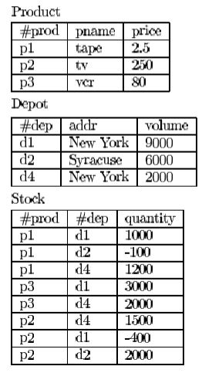SELECT P.prods

FROM Product P

WHERE P.pname=’p%%%’ and P.price < 300.00

1. Names of the products stocked in "d2".

(a) without in/not in

SELECT P.name

FROM Product P AND Stock S

WHERE P.prod = S.prod AND S.dep =’d2’

(b) with in/not in

SELECT P.name

FROM Product P

WHERE P.prod IN

(SELECT S.prod

FROM Stock S

WHERE S.dep=’d2’)

1. #prod and names of the products that are out of stock.

(a) without in/not in

SELECT P.prod , P.pname

FROM Product P AND Stock S

WHERE P.prod=S.prod AND S.quantity < 1

(b) with in/not in

SELECT P.prod, P.pname

FROM Product P

WHERE P.Prod IN

(SELECT S.quantity

FROM Stock S

WHERE S.quantity < 1)

1. Addresses of the depots where the product "p1" is stocked.

(a) without exists/not exists and without in/not in

SELECT D.addr

FROM Depot D AND Stock S

WHERE D.dep = S.dep AND S.dep = ‘d1’ AND S.quantity > 0

(b) with in/not in

SELECT D.addr

FROM Depot D AND Stock S

WHERE D.dep IN

(SELECT S.dep

FROM Stock

WHERE S.dep = ‘d1’ AND S.quantity > 0

(c) with exists/not exists

SELECT D.addr

FROM Depot D

WHERE NOT EXIST

(SELECT S.dep, S.quantity

FROM Stock S

WHERE S.dep = ‘d1’ AND S.quantity > 0)

1. #prods whose price is between $250.00 and $400.00.

(a) using intersect.

SELECT P.prod

FROM Product P

WHERE P.price > 250.00

INTERSECT

(SELECT P.prod

FROM Product P

WHERE P.price < 400.00)

(b) without intersect.

SELECT P.prod

FROM Product P

WHERE P.price BETWEEN 250.00 AND 400.00

1. How many products are out of stock?

SELECT COUNT (S.prod)

FROM Stock S

WHERE S.quantity < 1

1. Average of the prices of the products stocked in the "d2" depot.

SELECT S.prod, AVG(P.price)

FROM Product P, Stock S

WHERE P.prod = S.prod AND S.prod = ‘d2’

1. #deps of the depot(s) with the largest capacity (volume).

SELECT D.dep, MAX(D.volume) AS Largest_Capacity

FROM Depot D

GROUP BY D.dep

1. Sum of the stocked quantity of each product.

SELECT S.prod , SUM(S.quantity), COUNT(S.prod)

FROM Stock S

GROUP BY P.prod

1. Products names stocked in at least 3 depots.

(a) using count

SELECT P.name, COUNT (DISTINCT S.prod)

FROM product P, Stock S

GROUP BY S.dep

HAVING COUNT (DISTICNT S.prod )> 2

(b) without using count

1. #prod stocked in all depots.

(a) using count

SELECT P.prod, COUNT(S.prod)

FROM Product P, Stock S

WHERE P.prod = S.prod

GROUP BY P.prod

(b) using exists/not exists

SELECT S.prod

FROM Stock S

WHERE EXIST

(SELECT D.dep

FROM Depot

WHERE D.dep = S.dep)