# OpenDrop Quick Start Guide

# Flashing the PCB Firmware

1. Download the programming files from: <https://github.com/Wild-Spy/OpenDrop/tree/master/Code/Firmware/NichDrop/Debug>
2. Download Atmel Studio 7 from: <https://www.microchip.com/mplab/avr-support/avr-and-sam-downloads-archive>
3. Observe the correct pinout on new PCBs (see below)
4. Connect pinout converter to ISP/PDI port on AVR Dragon (or alternative programmer such as Atmel ICE)
5. Connect programmer to PC and to the drop-off via the pinout converter
6. Drop-off must have power to program (i.e. be connected to a suitable 3.7-4.2V LiPo battery, both during firmware flashing and date/time programming). Remember, if the drop-off loses power during date/time programming it will not drop-off!
7. Battery power (+ve) on the drop-off is square (see red wire), and ground (-ve) is round (see black wire)
8. SPI connections are as follows: GND (ground) is square pin (also GND for UART), then VCC, Rst, SCK, MISO and MOSI

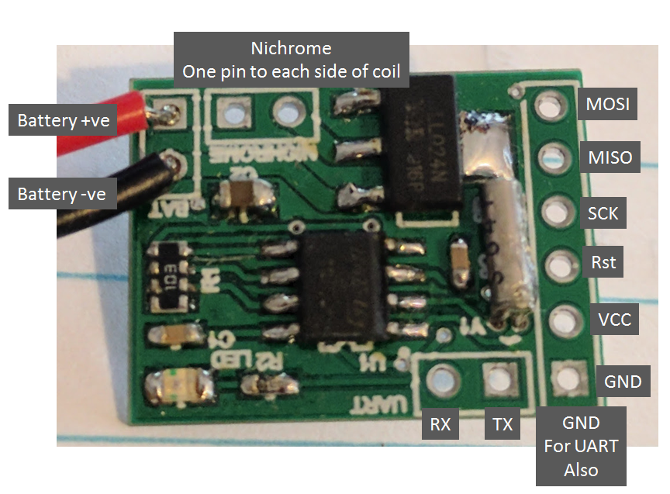

*Drop-off PCB pinout overview*

1. Open Atmel Studio 7
2. Open Tools -> Device Programming then choose:

Tool: Select your programmer from the dropdown (e.g. AVR Dragon)

Interface: ISP

Device: Atmega168p

Click the Apply button, then click the Read button. A device signature and target voltage (~3.3V) should appear. Then follow programming steps below.

**Step 1.** Load NichDrop_V1.1.0.hex in the Flash section of the Memories tab and click program.

**Step 2.** Load NichDrop_NORF_EEPROM_V1.0.eeprom in the EEPROM section of the Memories tab and click program.

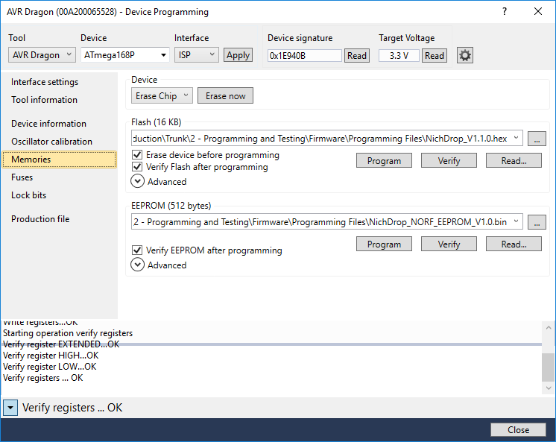

*The Memories (i.e flash and EEPROM) tab in Atmel Studio 7*

**Step 3.** On the Fuses tab, under the Fuses Register section, enter the following values:

Extended 0x01

High 0xDF

Low 0xE2

and click program.

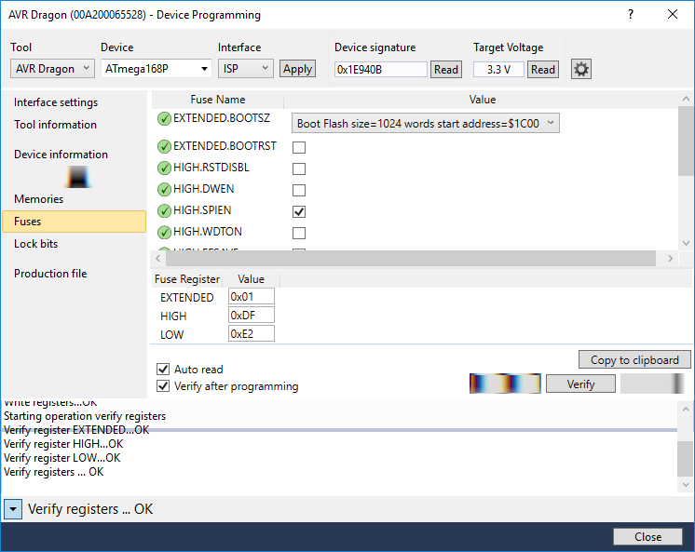

*The Fuses tab in Atmel Studio 7*

You can then unplug the programmer.

# Connecting to the Drop-Off

Once the firmware has been flashed, you can plug in a USB-to-Serial board and UART to program the drop-off’s time and date etc.

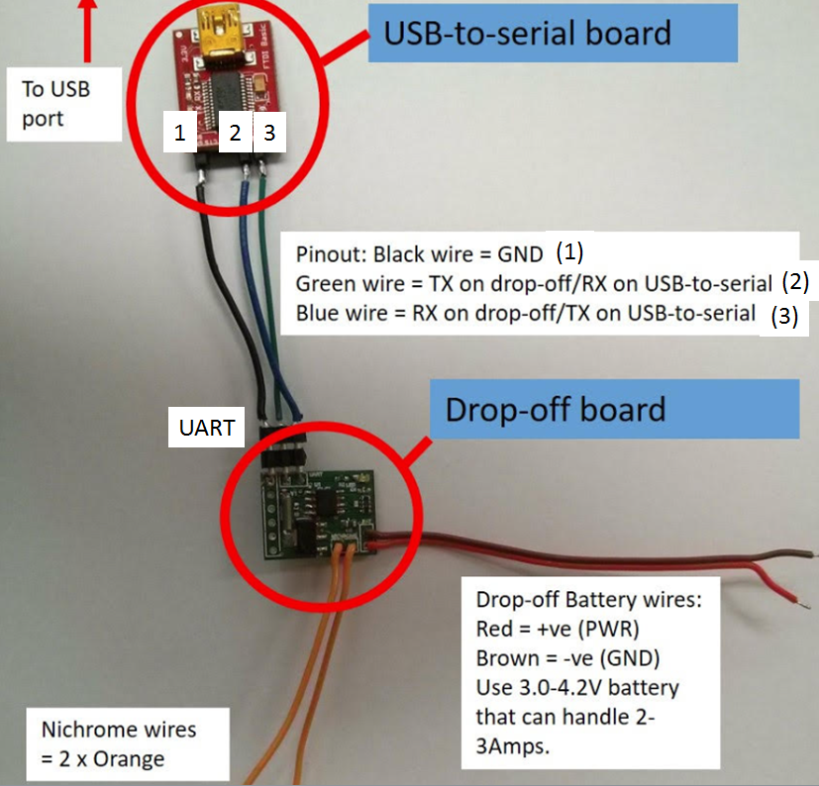

*Drop-off PCB ready to be connected to PC via UART and USB-to-Serial breakout board*

Once the USB-to-serial device has been assigned a virtual COM port, you can connect to the drop-off via the NichDropComms software (download from the repository’s Releases page). Use of the NichDropComms software is fairly straightforward. However, a PC running Windows with the .NET Framework 4 or later is required. You can download .NET installers from here: <https://dotnet.microsoft.com/download/dotnet-framework>.

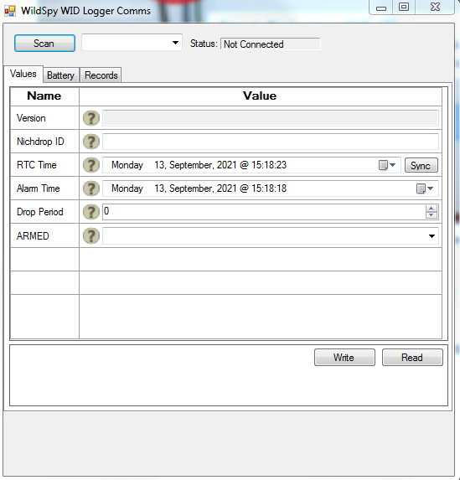

*NichDropComms PC software (ignore incorrect title bar text)*

# Turning the Drop-Off On

To power on a drop-off, a small, u-shaped jumper pin must be inserted into two of the three holes of the battery port.

***CAUTION: Avoid incorrect pin installation as the device has no reverse polarity protection!***

The correct pin ports are labeled with an upside down ‘U’, and correspond with the outside left (red dot) and middle holes with the drop-off oriented so the writing can be read normally.

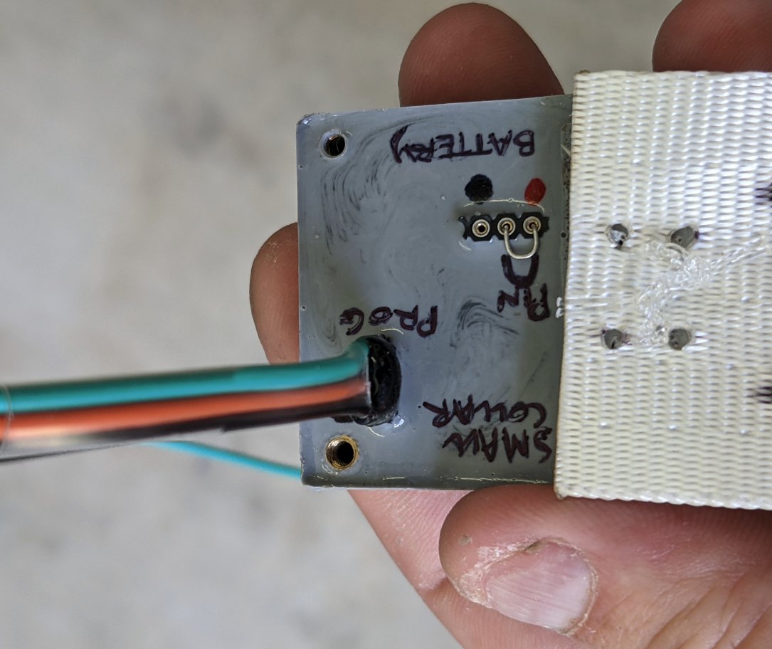

*Drop-off with power pin and programming cable connected correctly*

At all costs, avoid any electrical connection between the outside pins of the battery port (red and black spots) other than via the charging cable (see below) as these are the battery power and ground points respectively. **The power pin must be inserted to program the drop-off.**

# Programming the Drop-Off

The version of the software shown below may differ slightly to the most recent revision, but the ‘Values’ tab is essentially the same. Connect a drop-off to a computer with the installed and opened software, via the programming board and USB cables. Once connected, click, “Scan” on the software window, and then click the small drop down tab arrow in the nearby mini window (shown with a red circle and arrow respectively in figure 3). A long set of zeros (e.g. 00000000) should appear in the window beside the “Scan” button, and these must be selected by clicking on them, to initially populate the various parameter tabs shown with the green ticked circles ( ) in figure 3. If no numbers appear the drop-off has not been detected. Try unplugging both the cable and power pins, leaving everything disconnected for approximately 30-60sec and then trying again

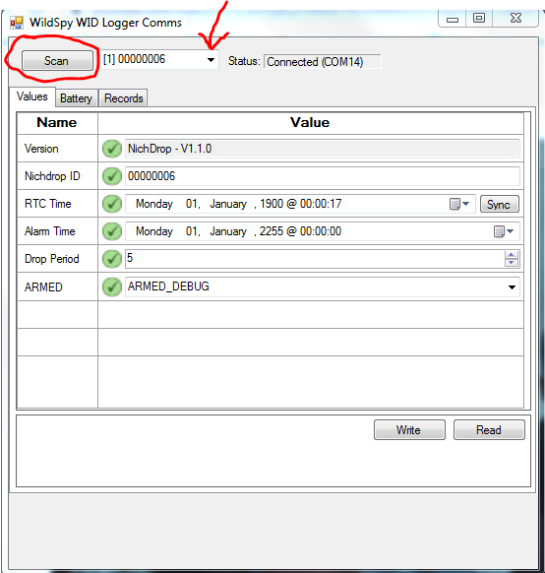

*Drop-off window of the programming software showing a drop-off year far ahead in time*

Before programming in any information, click the ‘Battery’ tab, and check to make sure the battery value is around 4.10-4.20 volts. Once the information is populated, you should see an ‘Alarm Time’ set to a point in the future (e.g. year 2222). If this is not the case, this should be the first thing you enter. Simply click on the year and change it to something like 2222 and then click the ‘Write’ button at the bottom of the window. This ensures that when you press ‘Sync’ you will not inadvertently activate the drop-off.

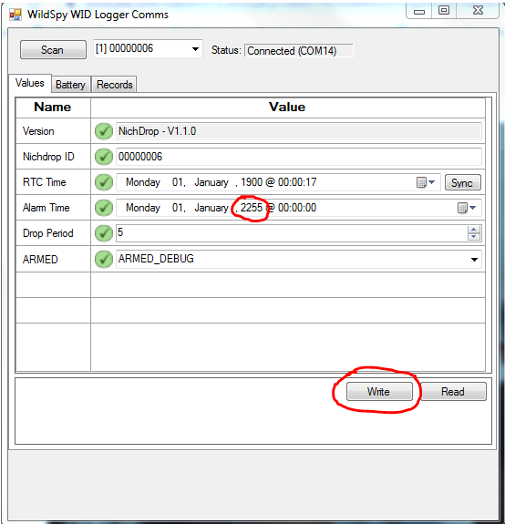

*Alarm Time set to a point in the future*

Once the ‘Alarm Time’ is set in advance of the current date, press ‘Sync’ to synchronize the current drop-off and PC times. Remember that whenever you change a setting you must also click write for it to take effect. Note also that any time a setting is changed but isn’t yet programmed, it will appear as an exclamation point with a yellow background, as opposed to a tick with a green background.

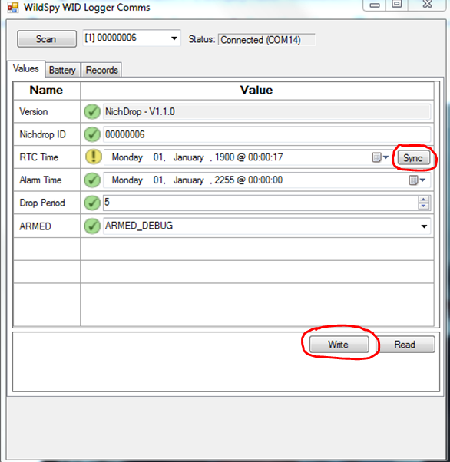

*RTC current time/date setting*

Once the time is correctly synced, you can program a preferred time and date for the drop-off to activate using the ‘Alarm Time’ setting. Click on the ‘Alarm Time’ year and change it to the current year. Then use the calendar drop down button to select a month and day. Finally, set the desired activation time. Once the ‘Alarm Time’ is correct, ***change the ‘ARMED’ setting to ‘ARMED_ON’***. If you don’t, the drop-off will not activate.

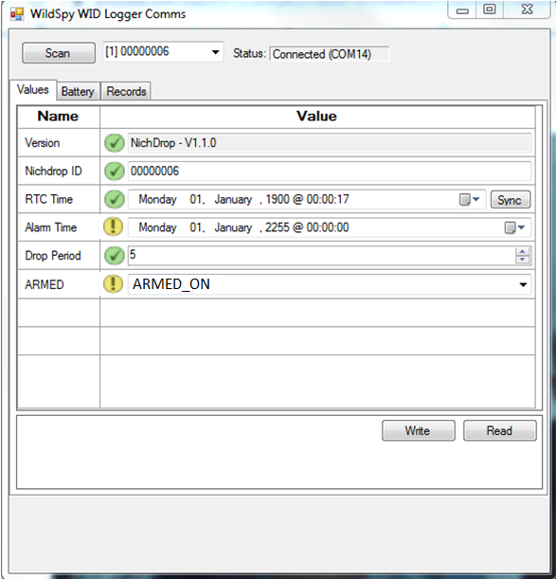

*ARMED setting changes to ARMED_ON*

The drop-off is programmed once Write is clicked (and all the exclamation marks will change to tick marks). The drop-off can then be unplugged from the cable.

# Making the Drop-Off Field-Ready

Once the drop-off is programmed, all the exposed battery and programming ports need to be covered in adhesive silicone/silicone putty, to ensure they are water resistant. Be careful not to get any silicone on the nylon line or the section of collar material the line is attached to because this might hamper or even prevent a clean detachment. The putty takes about 30min to not be tacky anymore, as do most adhesive silicones, but it usually takes at least 24 hours for them to fully cure. Avoid any heat source (e.g. heat gun) getting close to the nylon line as this might damage or melt it.

**Notes and Troubleshooting**

The drop-off activation process involves a heating element (nichrome wire) getting hot enough to melt nylon line that attaches the drop-off to the collar material. ***CAUTION:*** *This wire reaches temperatures of multi-hundred degrees centigrade and should* ***never*** *be touched during activation!* In a complete drop-off, this entire section is typically sealed off behind a 3mm acrylic plate. Regardless, it’s advisable to keep fingers away from this section when the drop-off is in activation mode. A drop-off is set by default to activate approximately five times over a few minutes to ensure it has completely detached a collar, so it’s possible you might pick it up during this activation period if you are present when it starts and the collar detaches from an animal. On the animal there should be an additional layer of collar material between it and the underside of the drop-off. That way almost no heat should be detectable by the animal and it won’t be harmed.