(1 of 2) : Instal R

https://www.r-project.org/

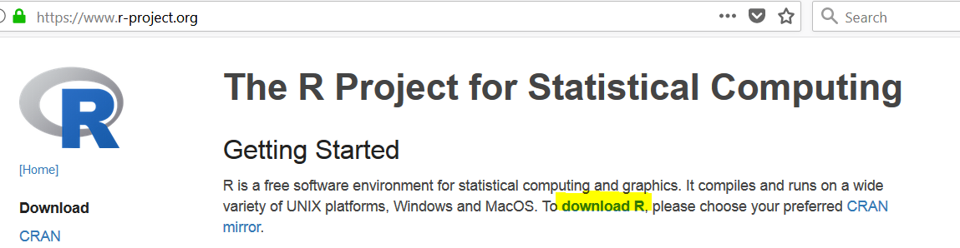

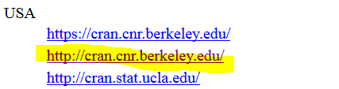

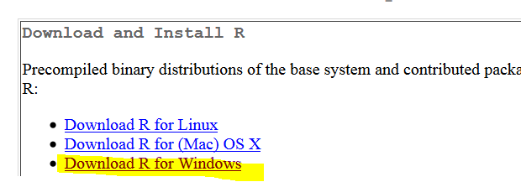

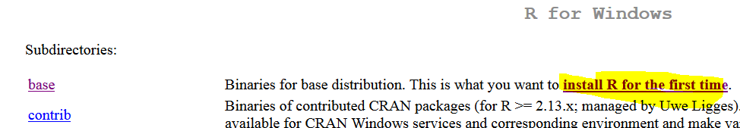

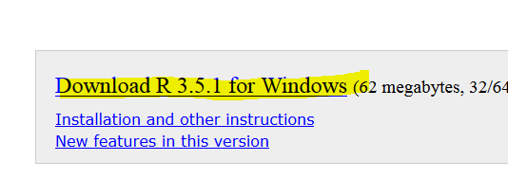

(2 of 2) Install Rstudio Preview

https://www.rstudio.com/products/rstudio/download/preview/

