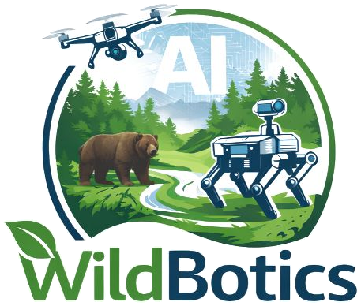 | DC ECTS overview  WildBotics doctoral training programme

DC name |  | Host institution
Supervisor |  | Enrolled at
ECTS planned |  | ECTS awarded

Tick the WildBotics modules you intend to take for credit, and add courses from your home institution and elsewhere at the end. Doctoral schools usually require 30 ECTS, but check what your awarding institution needs. Keep this overview up to date through your PhD. Save it as dcN-wildbotics-ects-overview.docx, with your DC number. Delete this note once you have read it.
Credit for a module is awarded on a training report, with an activity log showing at least 10 hours of work per ECTS. Taught sessions count towards the hours; follow-on work on your own project makes up the rest.

Code | Module | ECTS | Leads | When and where | Taking for credit | Report submitted | ECTS awarded
M9 · FBK, Italy · Sep 2026
S1 | Drone operator training workshop | 1 | SDU, UB | Sep 2026, FBK, Italy | ☐
S2 | Conservation fieldwork workshop | 2 | FBK, SDU, MUSE, PNAB, ING, Trentino Firefighters | Sep 2026, FBK, Italy | ☐
T1 | Nature conservation robotics basics | 1 | ING, BIOC | Sep 2026, FBK, Italy | ☐
T2 | Ethics, security & innovation workshop (part 1 of 2) | 1 | SDU, UB | Sep 2026, FBK, Italy | ☐
T3 | Science communication workshop | 1 | SDU | Sep 2026, FBK, Italy | ☐
T5 | Presentation, didactic, writing workshop | 1 | UB, FBK | Sep 2026, FBK, Italy | ☐
M12 · eLearning · Dec 2026
S3 | Animal ecology course | 2 | AU, UKON | Dec 2026, eLearning | ☐
S4 | Programming, AI & data science basics | 2 | FBK | Dec 2026, eLearning | ☐
S5 | Sensor technologies in conservation | 2 | DMR | Dec 2026, eLearning | ☐
S6 | Applied AI for conservation | 2 | FBK, BIOC, NIBIO | Dec 2026, eLearning | ☐
T6 | Environmentally sustainable practices in R&D activities | 1 | FBK, SDU | Dec 2026, eLearning | ☐
M18 · To be confirmed · Jun 2027
S8 | Robotics technology workshop | 2 | TUD, ING, UB, DF | Jun 2027, To be confirmed | ☐
T7 | Ethics, security & innovation workshop (part 2 of 2) | 1 | UB, SDU, ING | Jun 2027, To be confirmed | ☐
S9 | PNT workshop | 1 | USAL, FBK, ING | Jun 2027, To be confirmed | ☐
M23 · Italy · Nov 2027
S10 | Fieldwork and ecology hackathon | 3 | FBK, UB, UKON, MUSE, FoW, DF, BEL, MEP | Nov 2027, Italy | ☐
M30 · USAL, Spain · Jun 2028
S11 | Summer school (open to outsiders) | 5 | USAL, BIOC | Jun 2028, USAL, Spain | ☐
T8 | Career development, IPR & entrepreneurship | 1 | ING, DMR, BIOC, UB, FBK, DF | Jun 2028, USAL, Spain | ☐
M36 · FBK, Italy · Dec 2028
S14 | Nature conservation practitioner hackathon | 3 | FBK, MUSE, UB, UKON, NIBIO, BEL | Dec 2028, FBK, Italy | ☐
Courses taken outside WildBotics
 | [Course name, provider]
 | Total

