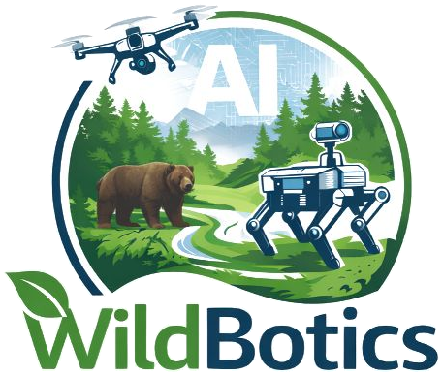 | Personal Career Development Plan  WildBotics doctoral training programme

DC name |  | DC number
Host institution |  | Enrolled at
Project supervisor |  | Academic supervisor
Co-supervisor(s) |  | Career mentor
Research theme |  | PhD start date
Version |  | Date

Prepare your PCDP with your supervisors, and review it with them and your career mentor as your PhD goes on. Be specific: name the papers, courses, events and people you mean, with rough dates. Save it as dcN-wildbotics-pcdp-v1.docx, with your DC number, and increase the version number each time you revise it.
Delete the grey prompts once you have completed each section.

1 Your research project

A brief overview of your research project and the major accomplishments you expect from it. Half a page should be enough.

2 Long-term career objectives (5 years and beyond)

2.1 Goals
Where do you want to be in five years or more? Academia, industry, conservation practice, policy, entrepreneurship, or a mix; the kind of role, and the kind of organisation.

2.2 What you need to get there
What further research, training or experience will you need to reach these goals?

3 Short-term objectives (1 to 2 years)

3.1 Research results
Anticipated publications, with target venues where you know them.
Conferences, workshops, courses and seminars you plan to attend or present at.

3.2 Research skills and techniques
Training in specific new areas, or technical expertise you need to acquire.

3.3 Research management
Fellowship, grant, travel award or other funding applications you plan, with names and deadlines if known.

3.4 Communication skills
Presentations, writing, outreach and public engagement you want to develop.

3.5 Other professional training
Coursework, teaching and supervision experience, and other professional development.

3.6 Networking
People, groups, societies and events that would widen your network, inside and outside WildBotics.

3.7 Other activities
Community, service or other activities with professional relevance.

4 Your WildBotics plan

4.1 Network and local training
Which WildBotics modules you plan to take for credit (list them on your ECTS overview), and the training at your host institution and doctoral school. Say how the two complement each other.

4.2 Secondments, fieldwork and key events
What has been agreed for your secondments, field trips and other major events. Attach or refer to a Gantt chart for the overview.
When | What | Where | With whom

4.3 Collaboration clusters
Your plans for working with other WildBotics DCs, in your theme and across themes: shared data, platforms, fieldwork or papers.

4.4 Career mentor
Your career mentor is a senior researcher, not your academic supervisor, assigned through the training coordinator. How often you will meet, and what you want from the mentoring.

5 Reviews

Review the plan with your supervisors and career mentor at least once a year, and at the network follow-up in M16. Record each review here.
Date | Reviewed with | Main changes

Sign-off

Doctoral candidate | I have prepared this plan with my supervisors. | Date
Project supervisor | I have agreed this plan with the doctoral candidate. | Date
Academic supervisor | Where different from the project supervisor. | Date

