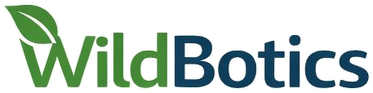 T2 · Capability audit canvas Ethics, security & innovation workshop (part 1) · M9 Trento · 2 October 2026
Name | DC | Theme | Project

1 Mission  What must your system do, and for whom? One sentence. | Where it will operate  Country, protected area, habitat; people or settlements nearby?
2 Capability audit List the capabilities your system needs, then ask of each: do we need it, and how could it be misused?
Capability  e.g. thermal detection, autonomous landing, eDNA sampling, open-source release | Need  Essential · Useful · Incidental | Who or what is affected  People, animals, habitats, data subjects, communities | Misuse or dual-use scenario  How could someone else use this capability? | Value at stake  e.g. privacy, animal welfare, safety, fairness, autonomy | Caution option  Limit · Remove · Geofence · Anonymise · Restrict release · None

3 Red team  Misuses your theme group found, and what you would change in response. | 4 Stakeholders  Direct, indirect and non-human: who is affected, who decides, who benefits? | 5 My institution's ethics process  Approval needed? ☐ Yes ☐ No ☐ Don't know  Triggers:  ☐ Animals ☐ Human participants or personal data  ☐ Fieldwork outside the EU ☐ Export-controlled items  ☐ eDNA or genetic resources ☐ Other: ____________  Committee or contact:  Status: ☐ Not started ☐ Submitted ☐ Approved ☐ Reviewing existing  Next step, and by when: | 6 A question for T7  One question you want to take to part 2, at M18.
☐ I agree that this canvas may be used, anonymised, in the WildBotics ethics review report (D4.9). Photograph it or upload it after the session. Your report in M19 builds on parts 1–6.

