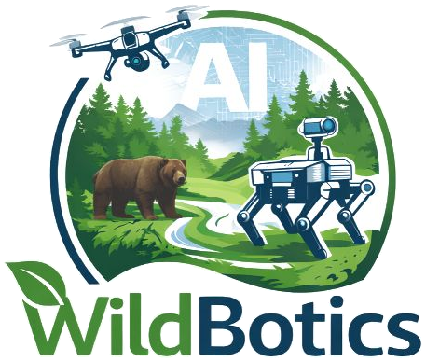 | Data Management Plan  WildBotics doctoral project · Horizon Europe template

DC name |  | DC number
Project title |  | Host institution
Supervisor |  | Research theme
Version |  | Date

Your DMP describes the data your project will collect or re-use, and how it will be stored, documented, shared and preserved. It feeds the WildBotics network DMP. It is a living document: keep a version number, review it with your supervisor, and update it as the project changes. Save it as dcN-wildbotics-dmp-v1.docx, with your DC number.
The questions are those of the Horizon Europe template. Answer them for your own project; if a question does not apply, say briefly why. Delete the grey prompts once you have completed each section.

1 Data summary

1.1 Re-use of existing data
Will you re-use any existing data, and what for? If re-use was considered but discarded, why?
WildBotics: for example public imagery or tracking datasets, partners' survey records, or pretrained models.

1.2 Types, formats and purpose
What types and formats of data will the project generate or re-use?
What is the purpose of the data, and how does it relate to the project's objectives?
WildBotics: list each kind separately: drone and camera imagery and video, flight logs and telemetry, sensor readings, acoustic recordings, physical or eDNA samples, annotations, trained models and code.

1.3 Size and origin
What is the expected size of the data? What is its origin or provenance?
WildBotics: imagery and video grow quickly; estimate terabytes per field season.

1.4 Data utility
To whom might your data be useful outside your project?

2 FAIR data

2.1 Findable: identifiers and metadata
Will data be identified by a persistent identifier?
What metadata will be created, and what disciplinary or general standards will be followed? If none exist, what metadata will you create, and how?
Will search keywords be provided? Will metadata be offered so that it can be harvested and indexed?
WildBotics: record where, when and how each dataset was collected: platform, sensor, flight parameters, species and site.

2.2 Accessible: repository
Will the data be deposited in a trusted repository? Have you explored arrangements with it?
Does the repository assign an identifier, and resolve it to a digital object?
WildBotics: for example Zenodo for general datasets, Movebank for tracking data, GBIF for occurrence records, and GitHub archived to Zenodo for code.

2.2 Accessible: data
Will all data be made openly available? If some cannot be shared, or only under restrictions, explain why, separating legal and contractual reasons from intentional restrictions.
Will an embargo apply, for publication or protection of intellectual property? For how long?
Will the data be accessible through a free, standardised access protocol? If use is restricted, how will access be provided during and after the project? How will the identity of whoever accesses it be established? Is a data access committee needed?
WildBotics: the locations of threatened species can put them at risk: say how you will generalise or withhold them.

2.2 Accessible: metadata
Will metadata be openly available and licensed CC0, as the Grant Agreement requires? If not, why not? Will it tell users how to access the data?
How long will the data remain available and findable? Will the metadata remain available after the data are not?
Will documentation of any software needed to read the data be included? Can the software itself be included, for example as open source?

2.3 Interoperable
What vocabularies, standards, formats or methods will make your data interoperable within and across disciplines? Will you follow community-endorsed practice?
If you create project-specific vocabularies or ontologies, will you map them to common ones and publish them?
Will your data include qualified references to other data?
WildBotics: for example Darwin Core for biodiversity records, and COCO or similar formats for image annotations.

2.4 Re-usable
How will you document the data to allow re-use: readme files, methods, codebooks, variable definitions, units?
Will the data be freely available in the public domain, or licensed under standard re-use licences in line with the Grant Agreement?
Will the data be usable by third parties after the project? Will its provenance be documented to appropriate standards?
What quality assurance processes will you apply?

3 Other research outputs

Plan how you will manage and share outputs other than data, applying the FAIR questions above where they fit. They can be digital, such as software, workflows, protocols and models, or physical, such as samples.
WildBotics: robot designs, flight and control software, trained AI models and field protocols all belong here.

4 Allocation of resources

4.1 Costs
What will it cost to make your data and other outputs FAIR, including storage, archiving, re-use and security? How will these costs be covered? Research data management costs are eligible under the grant if they comply with the Grant Agreement.

4.2 Responsibility and preservation
Who will be responsible for data management in your project?
How will long-term preservation be ensured? What data will be kept, for how long, and who decides?

5 Data security

5.1 Storage, recovery and transfer
What provisions will be in place for data security, including recovery, secure storage and archiving, and transfer of sensitive data? Will the data be stored in trusted repositories for long-term preservation?
WildBotics: field data are most at risk between collection and the first backup: say how you will copy them off cards and drives in the field.

6 Ethics

6.1 Ethical and legal issues
Are there, or could there be, ethical or legal issues that affect data sharing? Refer to your ethics review where relevant.
Will informed consent for data sharing and long-term preservation be included where you collect personal data?
WildBotics: imagery can capture people, vehicles or property incidentally, which is personal data under the GDPR. Permits and landowner or partner agreements may also limit how data can be shared.

7 Other issues

7.1 Other procedures
Do you, or will you, use other national, funder, sector or institutional procedures for data management? If so, list and briefly describe them.
WildBotics: your host institution and doctoral school will have their own research data policy.

Version history

Version | Date | Changes

