How to Install
Before to start to install the project, you are going to need to get installed the following, since the project is open source, it’s cross-platform:
- Microsoft .Net Core SDK (ver 3.1.401)
- MariaDB
- NodeJs
The IDE
Since the project is cross-platform, you can use Visual Studio, VS Code, IntelliJ or any program that can handle .Net Core, in this case we are going to use Visual Studio Code, before to clone the project, you have to get installed the following extensions to work:
- C#
- Angular Language Service
- .Net Core Add REference
- Git Extension Pack
- Nuget Package Manager
- Git History (optional)
- vscode-icons (optional)
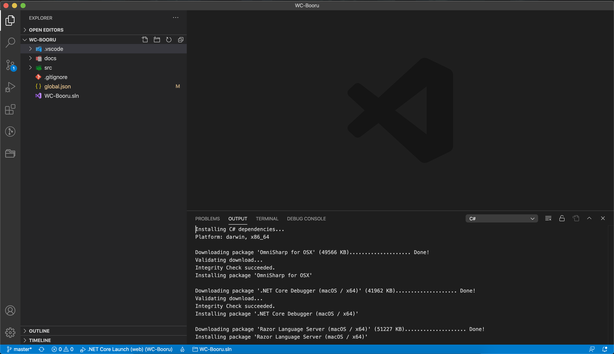
Having all those basics extensions installed, the next step is clone the repository in a local folder of your computer using git clone.
Remind it: Before to do the first build, check in global.json if the SDK version have selected 3.1.401 version
So then the next thing is going to Terminal tab inside the root project folder, type the next command:
Dotnet build
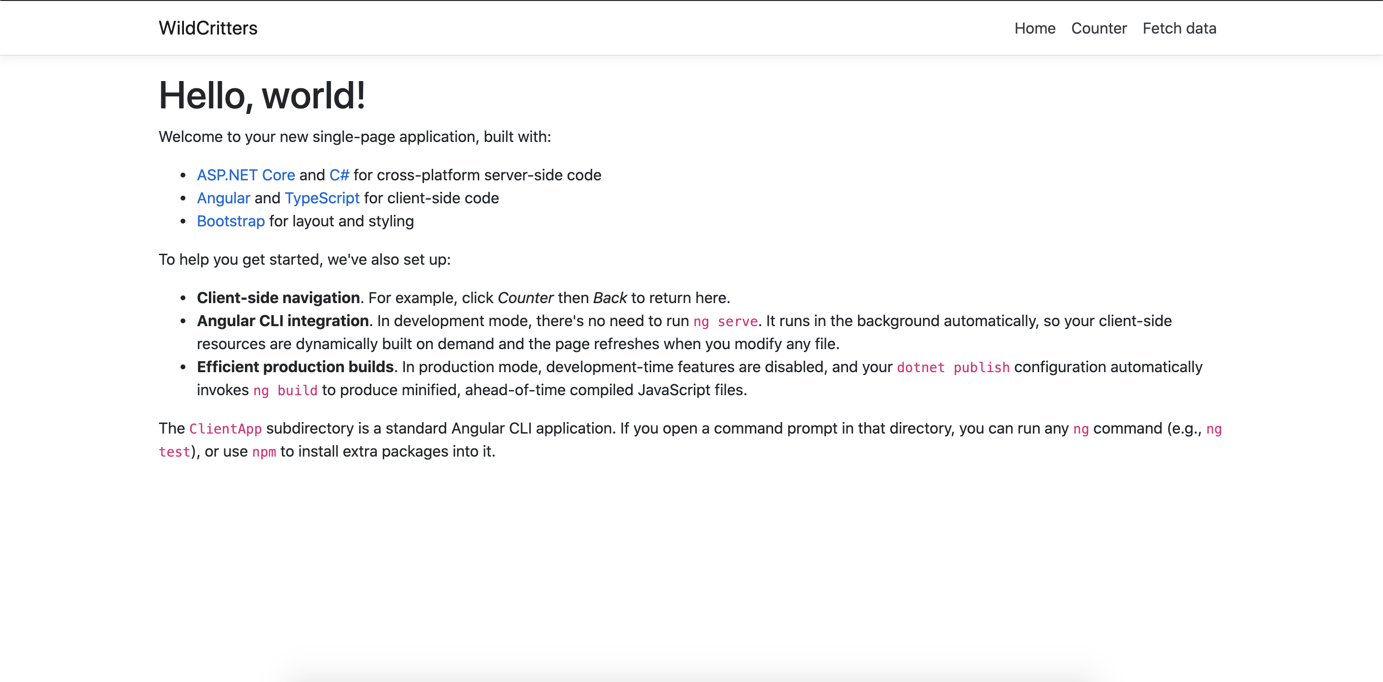
To do the first build of the project and then run the project selecting Wildcritters project in the launch file.
Install the Database using migrations
As we said before, the DB engine that we are going to use is MySQL Workbench (or MariaDB), in this case are going to use MySQL Workbench version 8.0.
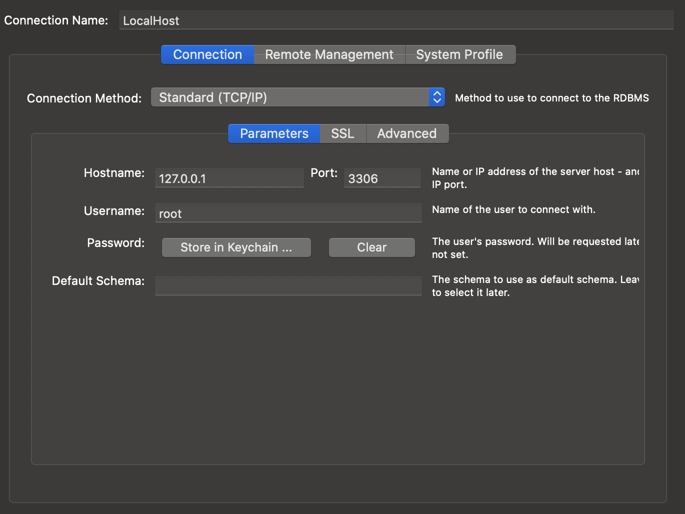
- Create a localhost connection on MySQL with root authentications

2) Create new Schema called wildcritterscore
Remind it: before to do this, you have to check if you have installed dotnet ef to run entity framework migrations commands, in this case, you have to type dotnet tool install --global dotnet-ef
3) Now, in the project, first you have to check if in appsettings.json file, in WildCritters folders, in “ConnectionStrings” settings is pointing to your local database, then go to Terminal tab, and do the following commands:
- Type cd src/WC.Context
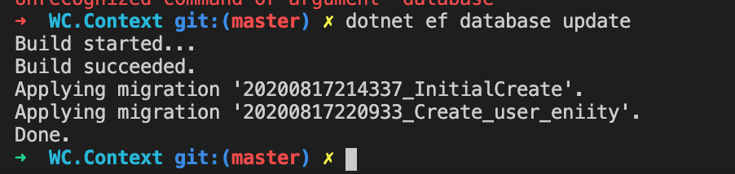
- Type dotnet ef database update
After that, you can check the database in MySQL and see the changes that it was applied.

