
DBA5103
  - Operations Research and Analytics

Assignment 1
Semester I, Academic Year 2026/2027
Reagan
MSBA | NUS
Student No: A0319086X
Solution conventions
All decision variables are continuous unless stated otherwise. Vectors are column vectors, the superscript T denotes transpose, and inequalities between vectors are componentwise. Monetary figures are in dollars.

1. Production Planning

1(a)(i) Linear programming model
Using the production and procurement variables defined in the question, a correct linear program is:
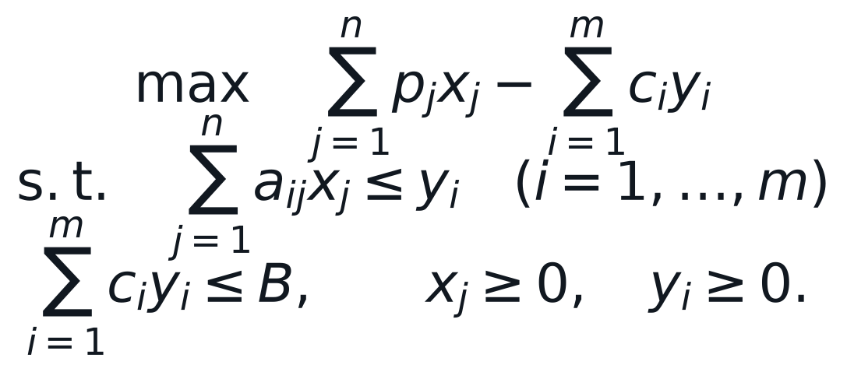
The first set of constraints ensures that enough of each raw material is procured, and the second constraint enforces the budget.

1(a)(ii) Matrix form
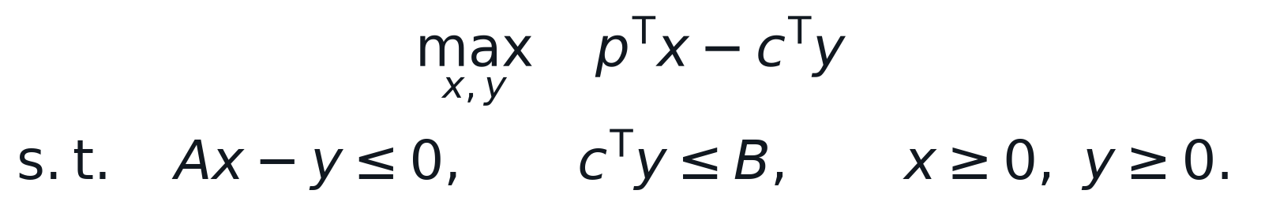
Equivalently, the variables and constraints can be stacked into one block model.
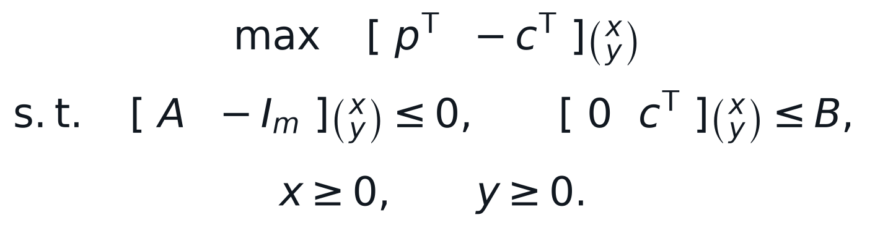

1(b) Model without procurement variables
Substituting material usage for procurement removes the procurement variables and gives:
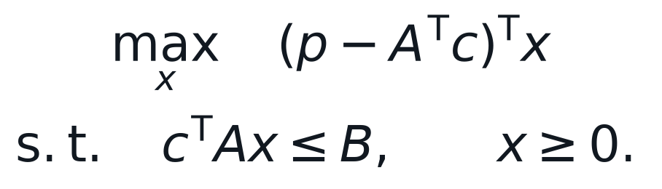
Interpretation: The unit profit vector is the selling-price vector less the raw-material cost attributable to one unit of each product.

2. Matrix Completion

2(a) Rank of the given matrix
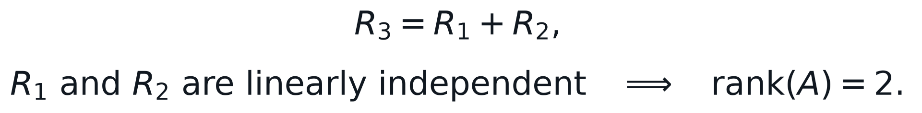
The third row therefore adds no new dimension, while the first two rows establish two independent directions.

2(b) Rank of an outer product
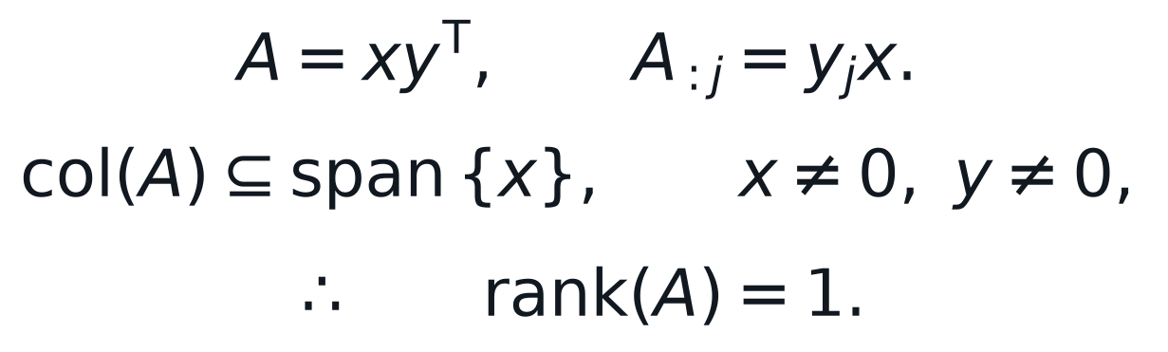
Every column is a scalar multiple of the same nonzero vector. Since the second vector is nonzero, at least one column is nonzero, so the rank cannot be zero.

2(c) Completion of the ratings matrix
The observed one in the first row and first column makes both associated factors nonzero. The observed zero in column 2 therefore forces the second movie factor to zero. The observed one in column 3 equates its factor to that of column 1. The observations in the third row then make the third user factor equal to the first, force the column 4 factor to zero, and equate the column 5 factor to the column 1 factor. Finally, the zero in row 2 and column 3 forces the second user factor to zero.
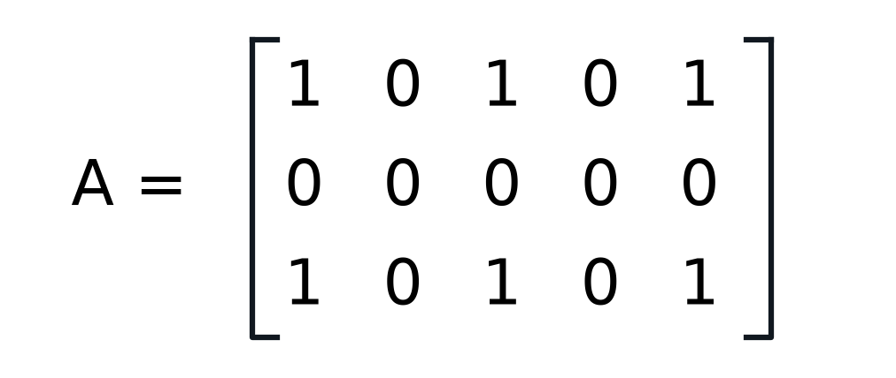
Completed rank-one ratings matrix
Check: Rows 1 and 3 are identical and nonzero, while row 2 is zero. The completed matrix consequently has rank one and matches every observed entry.

3. Polyhedra

3(a) Parameterized linear feasible set
Yes. For every fixed nonnegative value of the parameter, all coefficients are constants, so the set is the intersection of three linear halfspaces. It is therefore a polyhedron. When the parameter is zero, the first inequality is redundant and the feasible set is the unbounded first quadrant, which remains a polyhedron.
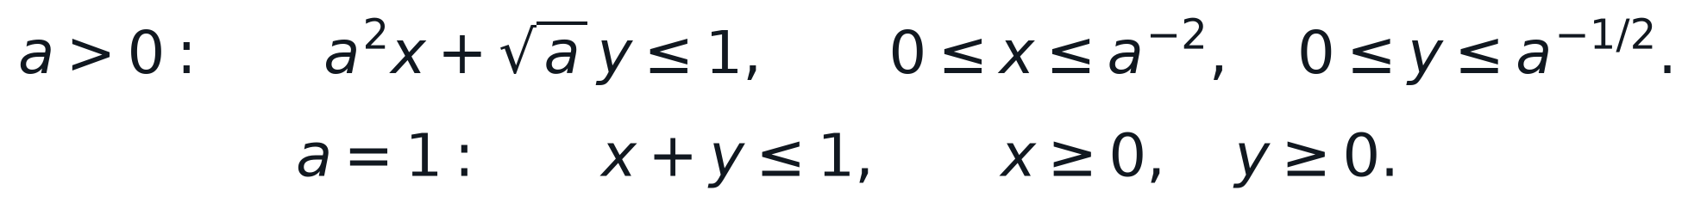
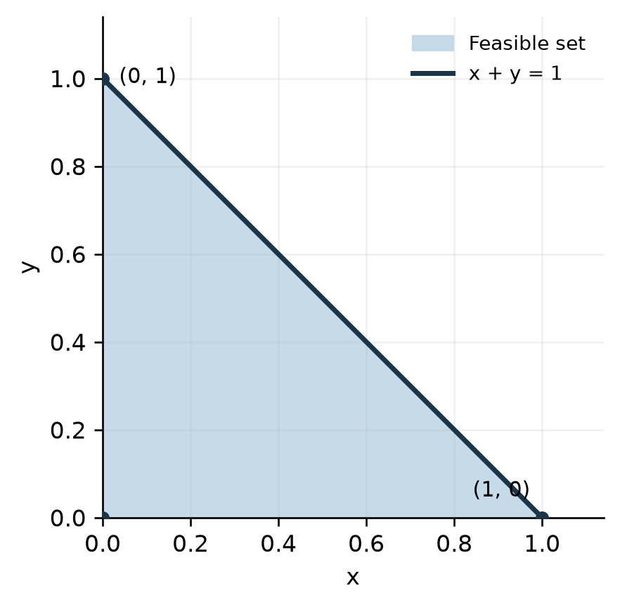
Figure 1. Feasible set for a = 1

3(b) Quarter unit disk
The feasible region is the quarter of the closed unit disk in the first quadrant. It is not a polyhedron because its circular arc cannot be generated by a finite number of linear halfspace boundaries.
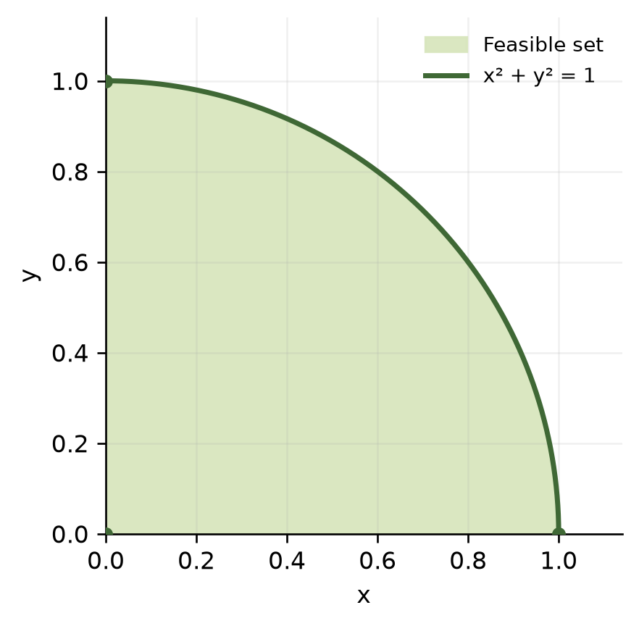
Figure 2. Feasible quarter unit disk

3(c) Quadratic inequality with a bounded solution set
Answer: Yes. The interval is the intersection of the two halfspaces defined by its lower and upper bounds, so it is a polyhedron in one dimension.

3(d) Quadratic inequality with a disconnected solution set
Answer: No. The union of the two rays is not convex. Every polyhedron, as an intersection of halfspaces, must be convex.

4. Manpower Scheduling
Let M, A, and E denote the numbers of full-time clerks starting the morning, afternoon, and evening shifts. Let P1, P2, P3, and P4 denote part-time clerks assigned to the four consecutive four-hour periods. All variables are continuous and nonnegative, as requested.
Period | Full-time clerks on duty | Part-time variable | Minimum staff
8 A.M. to noon | M | P1 | 4
Noon to 4 P.M. | M + A | P2 | 8
4 P.M. to 8 P.M. | A + E | P3 | 10
8 P.M. to midnight | E | P4 | 6

An eight-hour full-time shift costs $320 and a four-hour part-time shift costs $120. The objective is:
The minimum coverage requirements are:
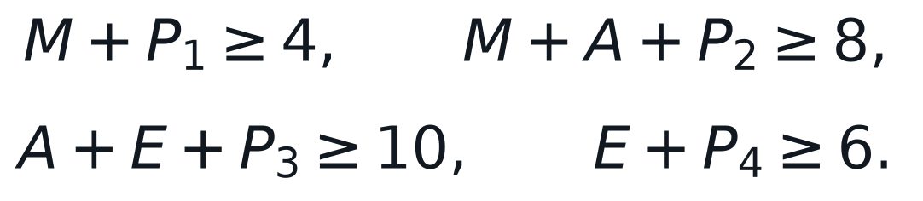
The full-time staffing requirement in each period is:
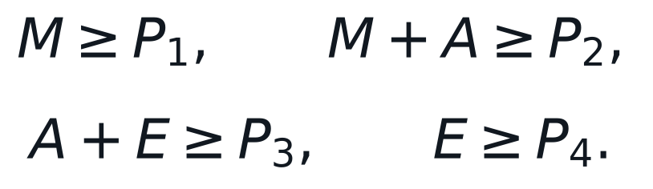

LP status: The objective, coverage constraints, staffing-mix constraints, and nonnegativity restrictions are all linear. Integer restrictions have been omitted as instructed.

5. Absolute-Value Reformulation
Introduce nonnegative auxiliary variables t, u, and v to represent the three absolute-value expressions. Keep the original decision variables unrestricted in sign. An equivalent linear program is:
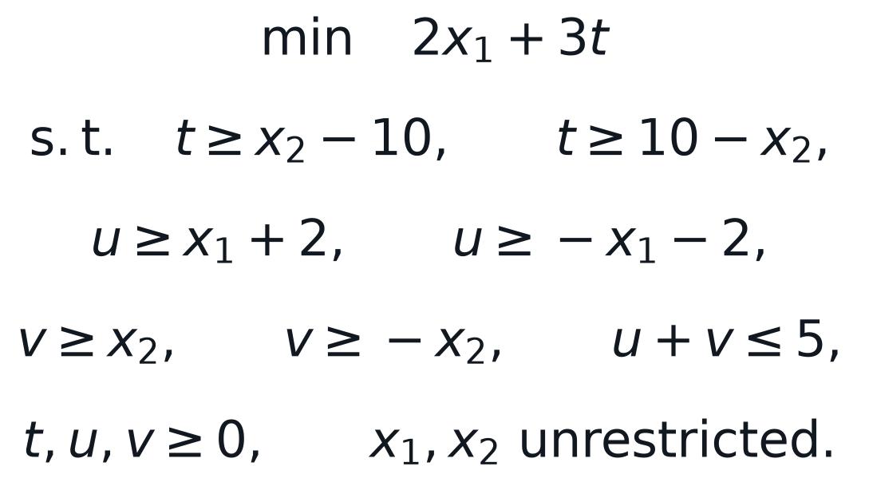
At an optimum, minimization makes t equal to the objective absolute value. The inequalities for u and v ensure that their sum is at least the left side of the original constraint; requiring that sum to be at most five is therefore exact.

6. Investment under Taxation

6(a) Linear programming formulation
Let the sale variable denote the number of shares of stock i sold now. The net cash coefficient deducts the one percent transaction cost from current proceeds and deducts tax only from a positive capital gain. Since all price data are known, this coefficient is a constant.
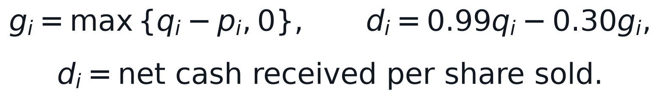
The investor's problem is the following continuous linear program:
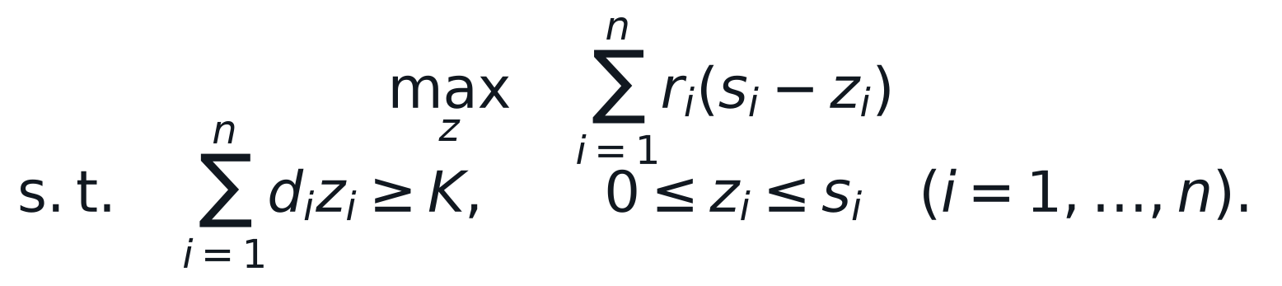
The constant initial portfolio value may be removed from the objective, yielding the equivalent minimization of expected future value sold. The model treats shares as divisible, which is consistent with a linear programming formulation.

6(b) Numerical solution for K = $9,000
Stock | Buy price | Shares | Current | Expected | Net cash/share | Future loss/$
S1 | $1.20 | 1,000 | $2.10 | $2.00 | $1.809 | 1.1056
S2 | $2.10 | 1,000 | $3.20 | $3.70 | $2.838 | 1.3037
S3 | $3.20 | 1,000 | $4.10 | $5.20 | $3.789 | 1.3724
S4 | $4.10 | 1,000 | $5.10 | $7.10 | $4.749 | 1.4951
S5 | $4.50 | 1,000 | $6.70 | $9.10 | $5.973 | 1.5235

The last column is the expected future value forgone per dollar of net cash raised. Its ascending order is S1, S2, S3, S4, then S5. Thus, the first three holdings are sold in full, after which only the amount of S4 needed to reach the target is sold.
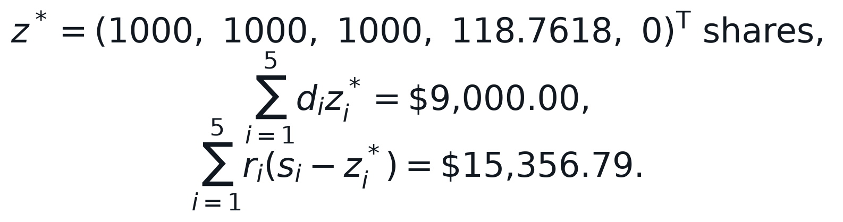
Stock | Shares sold | Shares retained | Net cash raised | Expected value retained
S1 | 1,000.000 | 0.000 | $1,809.00 | $0.00
S2 | 1,000.000 | 0.000 | $2,838.00 | $0.00
S3 | 1,000.000 | 0.000 | $3,789.00 | $0.00
S4 | 118.762 | 881.238 | $564.00 | $6,256.79
S5 | 0.000 | 1,000.000 | $0.00 | $9,100.00
Total | 3,118.762 | 1,881.238 | $9,000.00 | $15,356.79

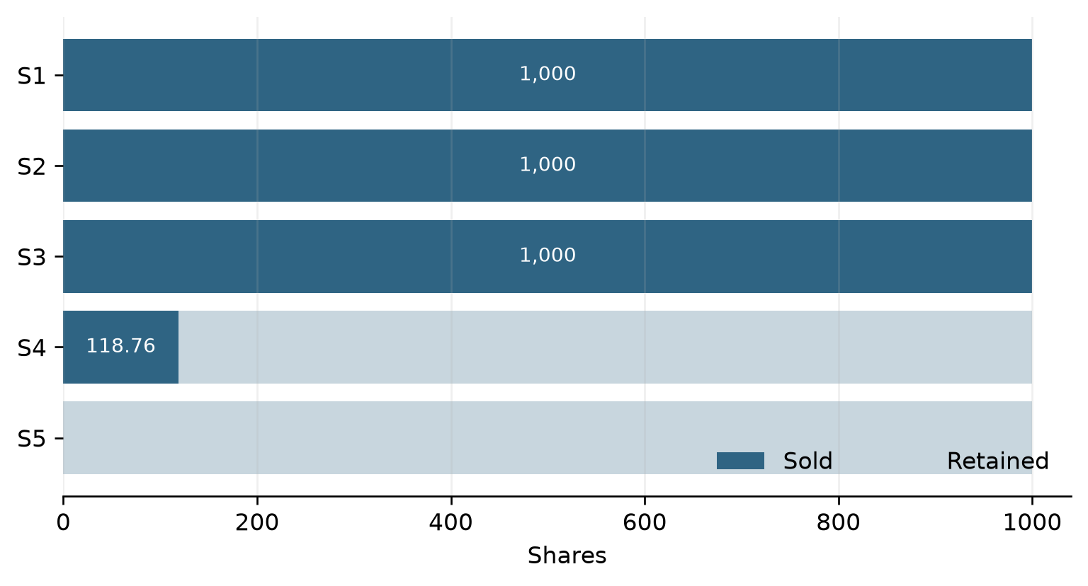
Figure 3. Optimal sale and retention of shares
Optimal decision: Sell all shares of S1, S2, and S3, sell approximately 118.762 shares of S4, and retain all shares of S5. This raises exactly $9,000.00 and leaves an expected one-year portfolio value of $15,356.79.

Computational code for Question 6(b)
The following code is the numerical optimization core used to produce the reported solution.
import csv
import numpy as np
from scipy.optimize import linprog

with open("sources/investment.csv", newline="", encoding="utf-8-sig") as f:
rows = list(csv.DictReader(f))

p = np.array([float(row["Buying Price"]) for row in rows])
s = np.array([float(row["Current Share"]) for row in rows])
q = np.array([float(row["Current Price"]) for row in rows])
r = np.array([float(row["Expected Future Price"]) for row in rows])

net = 0.99 * q - 0.30 * np.maximum(q - p, 0.0)
result = linprog(
c=r,
A_ub=-net.reshape(1, -1),
b_ub=np.array([-9000.0]),
bounds=[(0.0, limit) for limit in s],
method="highs",
)
assert result.success
sold = result.x
cash_raised = net @ sold
future_value = r @ (s - sold)
print(sold, cash_raised, future_value)

