
DBA5103
Operations Research and Analytics

HDB EV Charging
Placement and Cost-Effectiveness

A capacitated facility-location study
2027 planning case and 2030 outlook

Semester I, Academic Year 2026/2027
MSBA | National University of Singapore
11 November 2026
Reproducible model results for team review. Source vintages, assumptions and numerical certificates are preserved in the companion workbook and Python appendix.

1. Problem and decision
This study asks where HDB carparks need additional slow charging and how much service each investment level delivers. National charger counts cannot establish local access. Infrastructure expenditure covers participating parties, not a proposed government budget.
All 2,273 HDB carparks are retained. Existing address-supported AC/DC supply is fixed; new base additions are 7.4 kW AC points. Integer investment decisions and continuous energy allocation link nearby carparks. Non-HDB investment, carbon valuation and petrol savings are excluded.
Base result: 2,332 additional AC points at S$15.158m serve 90.0% of estimated 2027 demand, versus 61.1% using matched existing supply alone.
The allocation is designed for end-2027 demand. The September 2026 benchmark has a modelled energy shortfall of 17.0%; unchanged supply leaves 38.9% unmet in 2027. The proposed additions reduce the 2027 gap to 10.0%. These are estimated energy gaps, not observed charger shortages. Planning-area allocations are the main decision output; individual sites remain implementation details requiring verification.

2. Data and demand estimation
Input | Frozen evidence / treatment
HDB candidate sites [1] | 2,273 unique IDs; projected SVY21 coordinates.
Car-lot snapshot [1] | 31 Oct 2026; 706,663 matched lots; 276 missing and 2 zero records.
Public charger register [2] | Sep 2026; 11,489 unique points, 9,279 registrations; 5,342 base matched points.
Vehicle stock / flows [3] | Cars/Electric only; Sep 2026 stock 74,887. Other fuels retained only in the all-car denominator.
Housing / population [4] | 2025 with MP2019 geography; 2026 with MP2025 separately.
Costs and operation [5–7] | Vendor components and historical public-carpark usage inform scenarios; no site-level HDB quote or utilisation panel.
Base supply requires a unique literal block and normalised street match within 150 metres, with non-HDB-looking buildings excluded. Registration conflicts are not assigned. The broader sensitivity adds block-range and same-street candidates. A 48-location desk sample checks the source records; neither this check nor proximity establishes ownership on site.
Missing or zero lot counts use an area/carpark-type median with at least five observations, falling back to type and then national medians. This adds 71,123.5 assumed lots. All demand remains represented; no-build at unknown-capacity sites and 0.5×/1.5× imputations test the effect. The complete exceptions and match ledgers accompany the workbook.

2.1 Demand, capacity and scenario assumptions
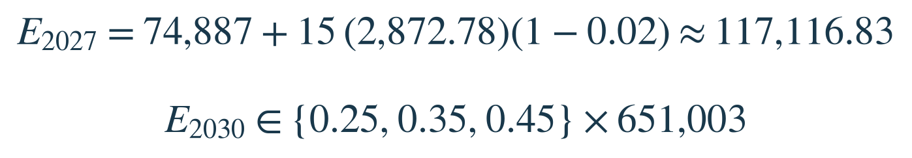
Stock scenarios: 15 months of average registrations with assumed 2% exits; 2030 uses 25/35/45% of the frozen car fleet. Displayed inputs are rounded.
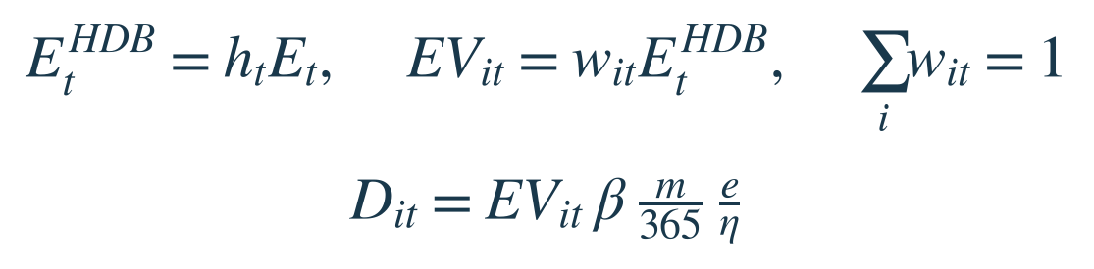
Demand D is grid-side kWh/day. Spatial weights sum to one; lots are not vehicle counts.
Parameter | Base | Interpretation
National EV stock E | 117,116.83 | 2027 assumption from stock-flow identity
HDB share h / dependence β | 0.40 / 0.80 | HDB-associated EVs / energy sought here
Mileage m / intensity e | 16,200 / 0.16 | km/year / battery kWh per km
Efficiency η | 0.90 | Battery energy divided by grid energy
Catchment / lot share | 400 m / 10% | Straight-line access / assumed space limit
Spare power / upgrade | 44.4 / 88.8 kW | Incremental power beyond existing load
The base allocates 46,847 estimated HDB-associated EVs by normalised car-lot weights, yielding 295,712 kWh/day. The 0.40 share is only weakly anchored by 8,800 HDB season-parking EVs versus 21,796 national electric cars in September 2024 [5]. Housing and population weights provide alternatives.
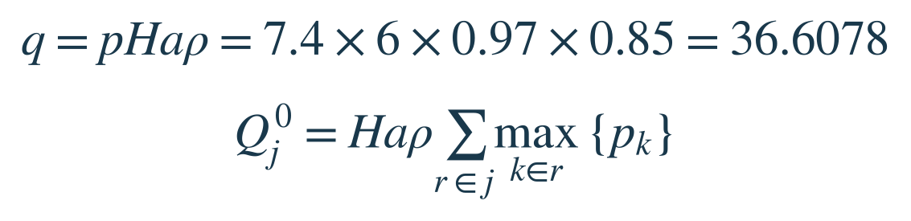
Registration maximum-port power is the conservative bound; summed port power is a sensitivity.
Effective hours, uptime and accepted-power factors are design assumptions. The public-carpark average of about five hours/day in 2026 does not measure HDB-only delivered energy [6]. Charging losses enter demand once; the power factor represents accepted charging rate. Capacity does not guarantee short queues.

3. Model and methodology
The facility-location model combines integer investment and continuous energy flows [8,9]. HDB carparks are both demand nodes i and candidate sites j. Catchment arcs may cross planning-area boundaries.
Symbol | Meaning
xⱼ; zⱼ; yⱼ | AC points; activation binary; upgrade binary
fᵢⱼ; sᵢ | Served and unmet grid-side kWh/day
Q⁰ⱼ; q | Existing and per-new-point effective daily capacity
Mⱼ; L̄ⱼ; b⁰ⱼ | Addition bound; total bay limit; existing occupied bays

Constraints  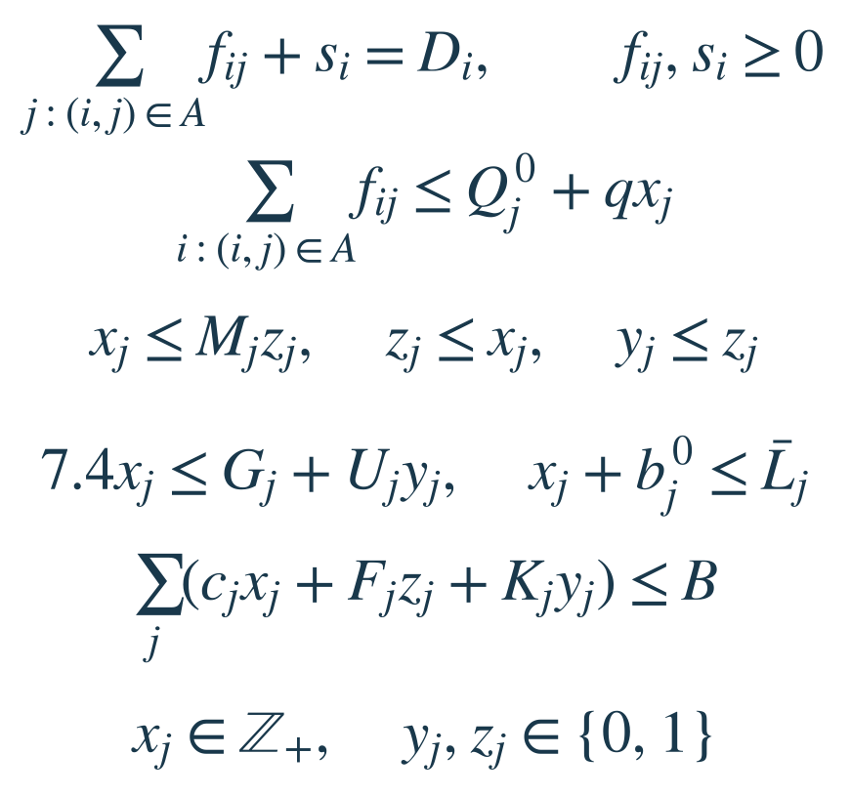 | Objectives and annual cost  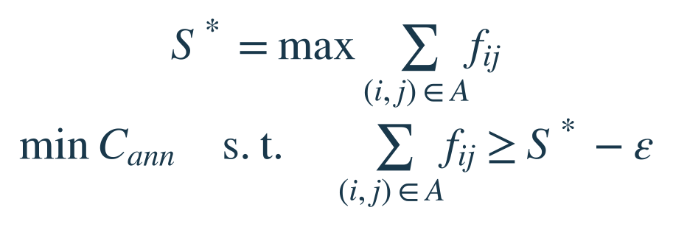  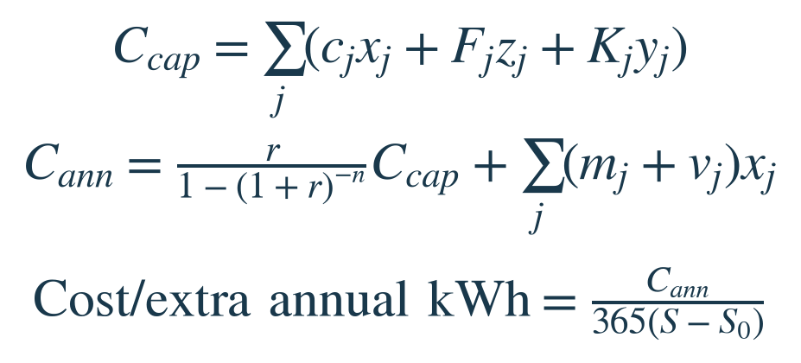
Constraints conserve demand and enforce capacity, activation, power, space and budget. The bay limit is max(existing bays, floor(0.10 × lots)); existing bays are grandfathered. One connector per existing bay is tested against deduplicated bay labels.
Unmet demand preserves feasibility; s is implemented as demand minus outgoing flow. Spare headroom is assumed.

3.1 Objectives, cost and numerical checks
Pass 1 maximises served energy. Pass 2 minimises annual infrastructure cost while retaining service within ε = 0.002957 kWh/day. A subsequent fixed-investment LP minimises energy-weighted travel distance. Objectives are sequential and deterministic.
Costs [7]: S$6,500/AC point including ordinary installation; S$580/point/year maintenance and network reserves; S$50,000/site upgrade. Capital uses a 10-year life and 5% rate. Constant 2026 SGD excludes GST, electricity, sunk investment and revenue.
Each point adds at most q kWh/day: at least ceil((target − existing-only service)/q) points are needed. Attaining this bound without upgrades certifies minimum capex. Expected-answer tests cover integrality, upgrades, sharing and infeasibility; national runs check residuals and service locks.

4. Planning-area allocation for end-2027
The 90%-service plan adds 2,332 AC points across 549 carparks in 28 planning areas, at S$15.158m. These are new additions for end-2027 demand, not total installed supply or a 2030 build plan.
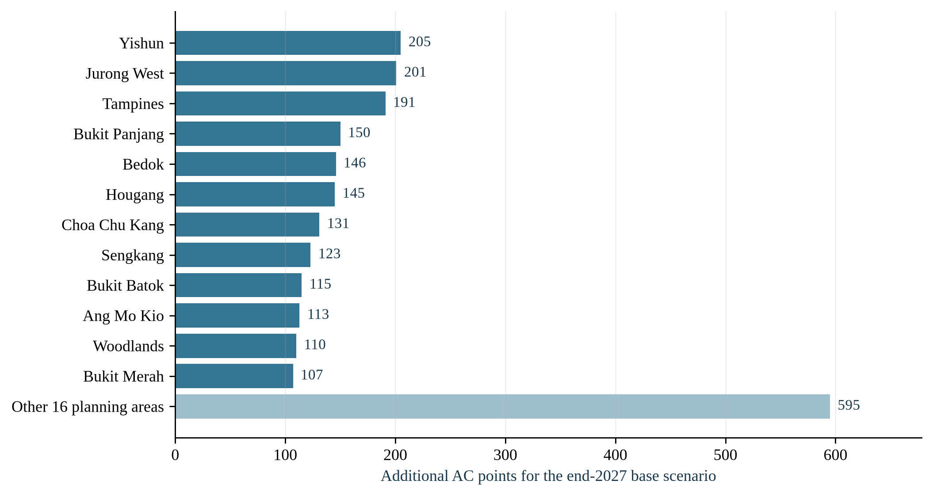
Figure 1. End-2027 base allocation by planning area. The final bar combines 16 areas.
Selected planning areas | Carparks receiving additions | Additional AC points
Yishun | 43 | 205
Jurong West | 44 | 201
Tampines | 47 | 191
Bedok | 33 | 146
Sengkang | 30 | 123
Ang Mo Kio | 22 | 113
Woodlands | 27 | 110
Punggol | 21 | 84
Other 20 planning areas | 282 | 1159
Total | 549 | 2332
The workbook lists all 28 areas. Site coordinates and verification examples are retained in the appendix and detailed sheets. Imputed-capacity sites receive 11.4% of expenditure and require confirmation.

4.1 Top 100 carparks for site review
The map highlights 100 review candidates within the saved end-2027 plan: 528 proposed AC points across 21 planning areas. The full national plan remains 549 carparks and 2,332 points.
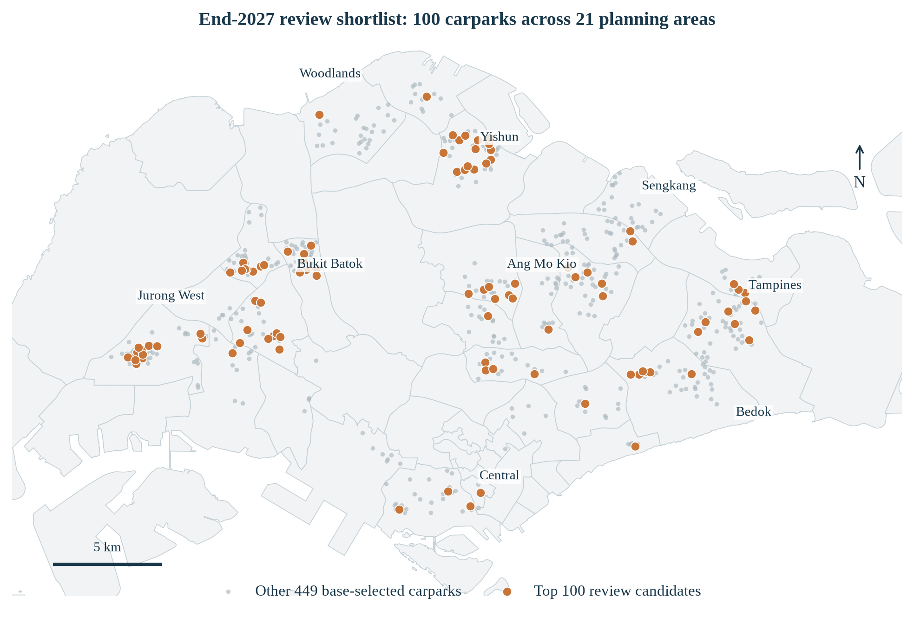
Figure 2. Orange: top 100 ranked carparks. Grey: other 449 selected carparks. Locations use source coordinates transformed to WGS84; boundaries are URA MP2019.
Ranking step | Rule
Eligibility | Base-selected carparks with observed parking capacity and night parking.
Primary order | Selection frequency across 37 scenarios with both objective passes certified, descending.
Ties | More AC additions in the base solution first, then carpark ID alphabetically.
Traceability | Top_100_Sites in Excel gives all 100 ranks, addresses, planning areas, latitude and longitude.
These sites appear in 56.8–81.1% of certified scenarios. Selection frequency measures recurrence under the tested assumptions; it is not a probability or a marginal-benefit score. No geographic quota was applied.
This is a transparent review shortlist, not a separately optimised 100-site deployment. The 90% service result applies to the entire national plan. Existing chargers, local demand, access and electrical headroom still require confirmation at every highlighted site.

4.2 Comparison with simple rules
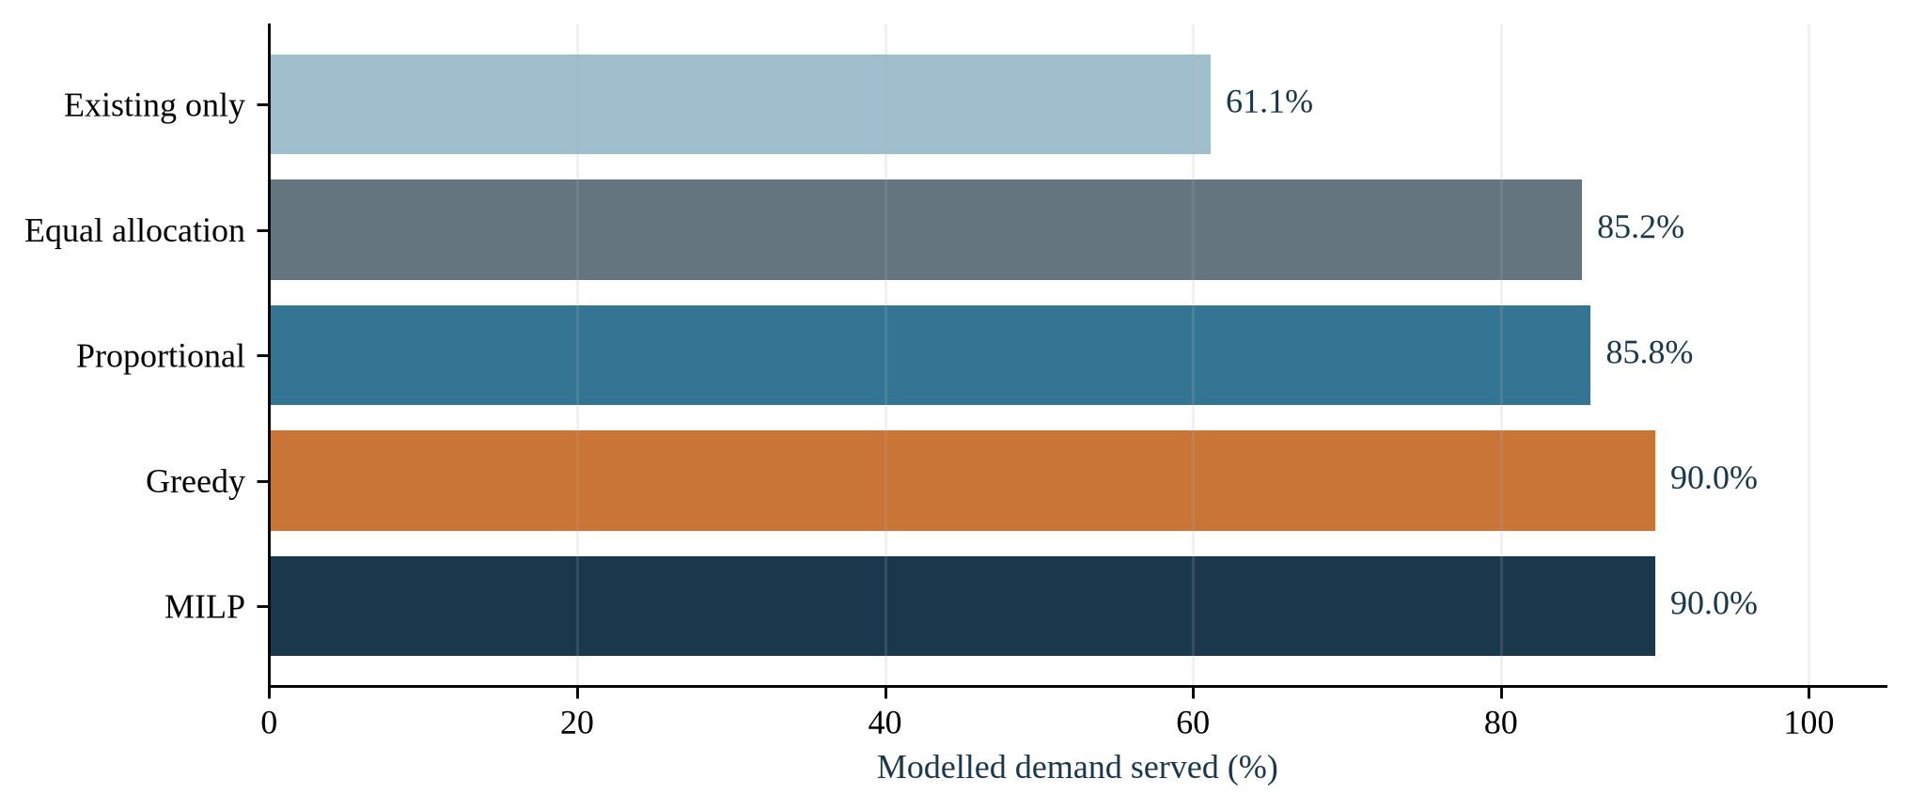
Figure 3. Same modelled demand and feasibility rules. Actual expenditure is reported below.
Allocation | Capital | AC points | Served
Equal | S$15.158m | 2,332 | 85.2%
Proportional | S$15.156m | 2,324 | 85.8%
Greedy | S$15.158m | 2,332 | 90.0%
MILP | S$15.158m | 2,332 | 90.0%
The MILP improves service over proportional placement by 4.19 percentage points. Equal allocation cycles through eligible site IDs; proportional allocation uses largest remainders and feasibility repair. Neither rule directly accounts for overlapping catchments or unused existing capacity.
Greedy placement chooses additional served energy per step dollar, including upgrade thresholds and full flow reassignment. Its service is 90.0%, versus 90.0% for the MILP. Greedy matches the MILP to numerical tolerance in this base case; the MILP chiefly supplies an optimum certificate here. The workbook also reoptimises each rule’s actual spend; time-limited comparison incumbents retain their gaps.

5. Cost-effectiveness and budget choices
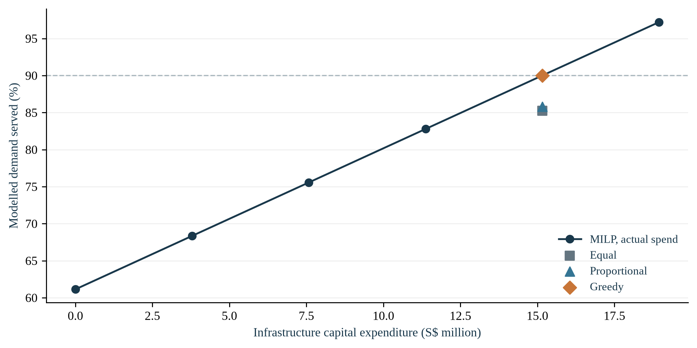
Figure 4. Discrete actual-spend frontier. Points are computed scenarios, not a smooth forecast.
Service target | Minimum capital | Certificate
80% | S$9.912m | Capacity lower bound attained
90% | S$15.158m | Capacity lower bound attained
95% | S$17.784m | Capacity lower bound attained
At the base budget, annualised infrastructure cost is S$3.316m/year, or S$0.106 per additional annual kWh served. This excludes electricity and is not a charging tariff or a social benefit-cost ratio. It divides incremental annual infrastructure cost by service above the fixed existing-only baseline.
Across the computed budget intervals, marginal capex per extra annual kWh ranges from S$0.486 to S$0.487. A nearly constant slope is possible while each added point remains fully useful; diminishing returns must be observed, not presumed. The physically bounded maximum service is 100.0% under the base assumptions.

6. Sensitivity and fixed-plan performance
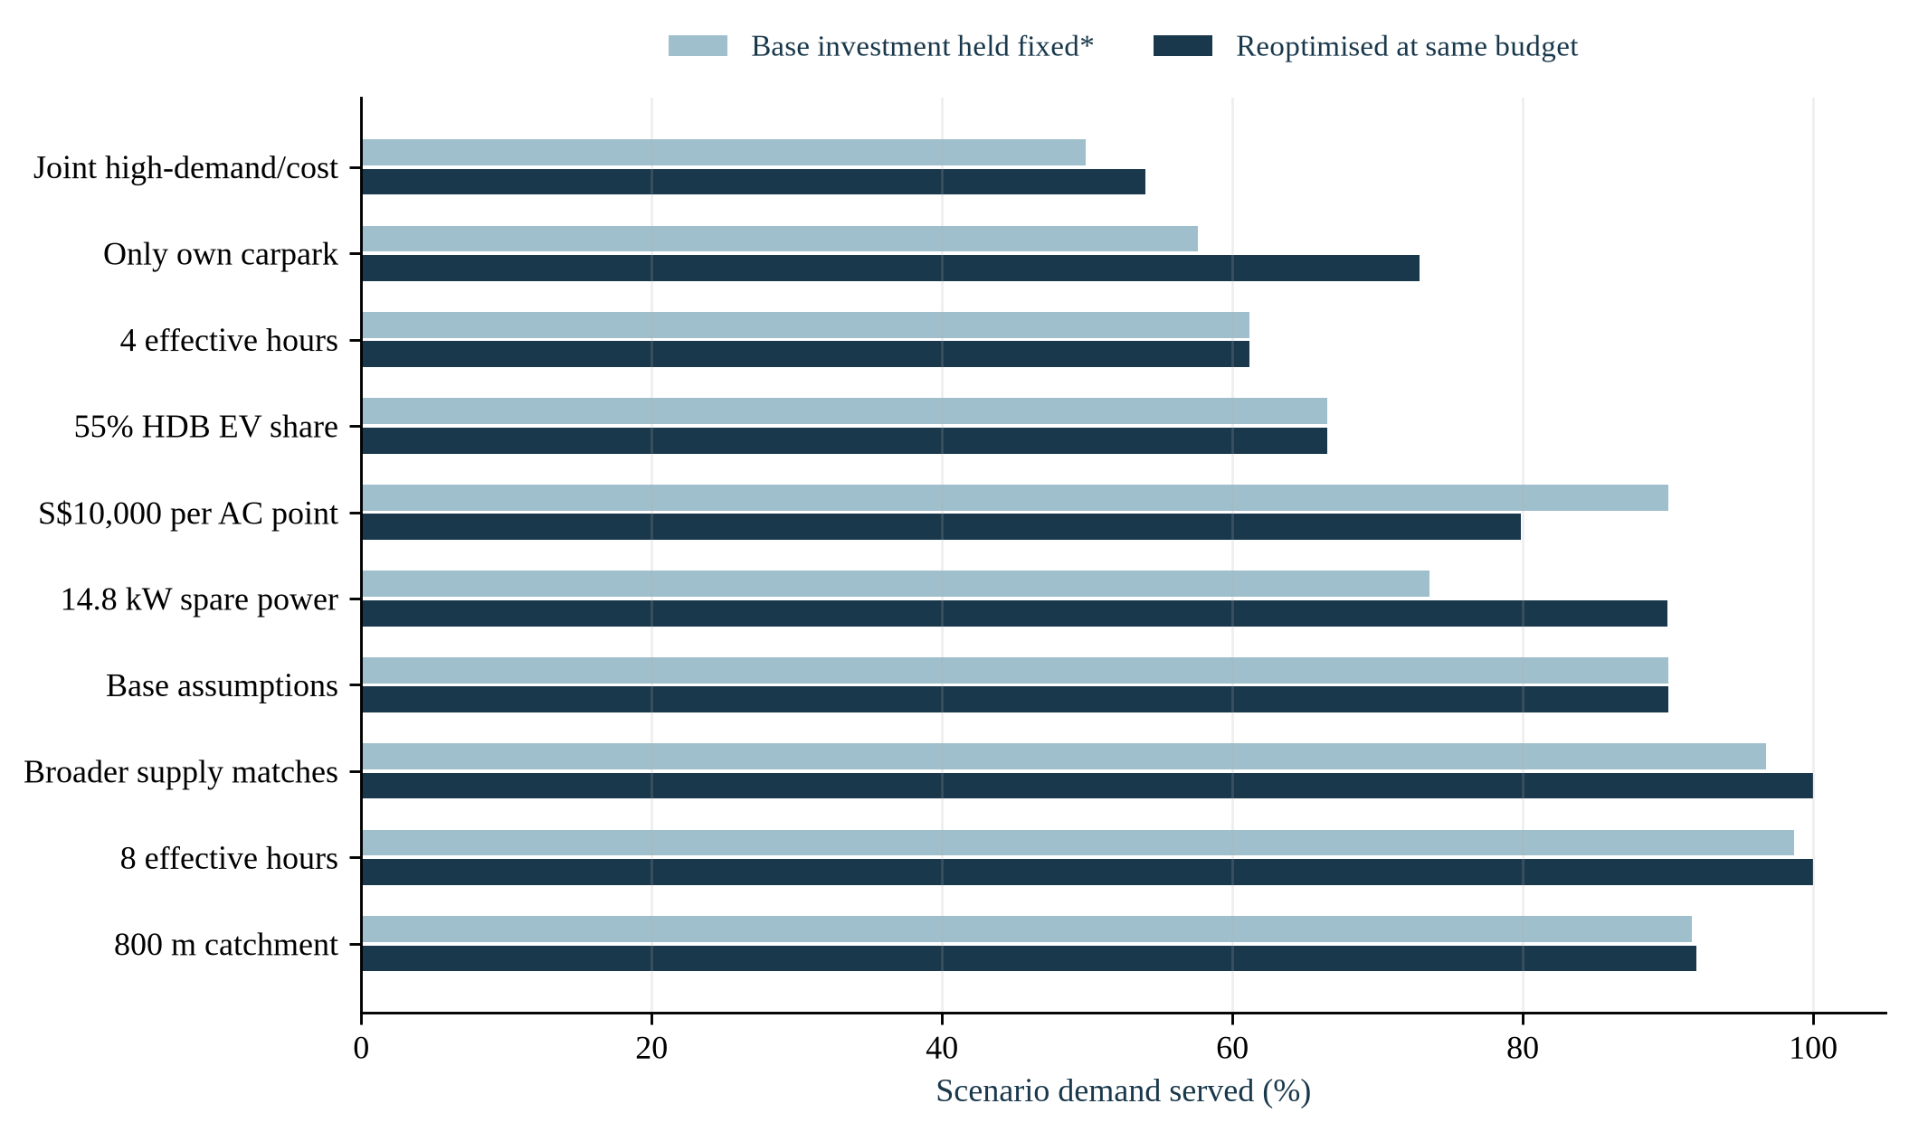
Figure 5. Selected stresses at the base nominal budget. *Fixed-plan capacity is derated where power/space assumptions invalidate operation; repriced capex may exceed budget.
Broader supply matching changes reoptimised service to 100.0%. Four effective charging hours reduce it to 61.2%; restricting service to the home carpark gives 72.9%. These differences show why supply identification, usable hours and access rules must be checked before converting model outputs into construction decisions.
The workbook contains 52 specified stress cases, each with a fixed-plan evaluation and reoptimisation. 5 service solves lack optimal status; bounds and gaps remain visible. Secondary cost gaps can be larger, so stressed annual costs are attained costs, not automatically minimum costs. Feasible fixed-plan regret is bounded using the scenario incumbent and service bound. Scenario frequencies are not probabilities.

6.1 Current and future energy shortfalls
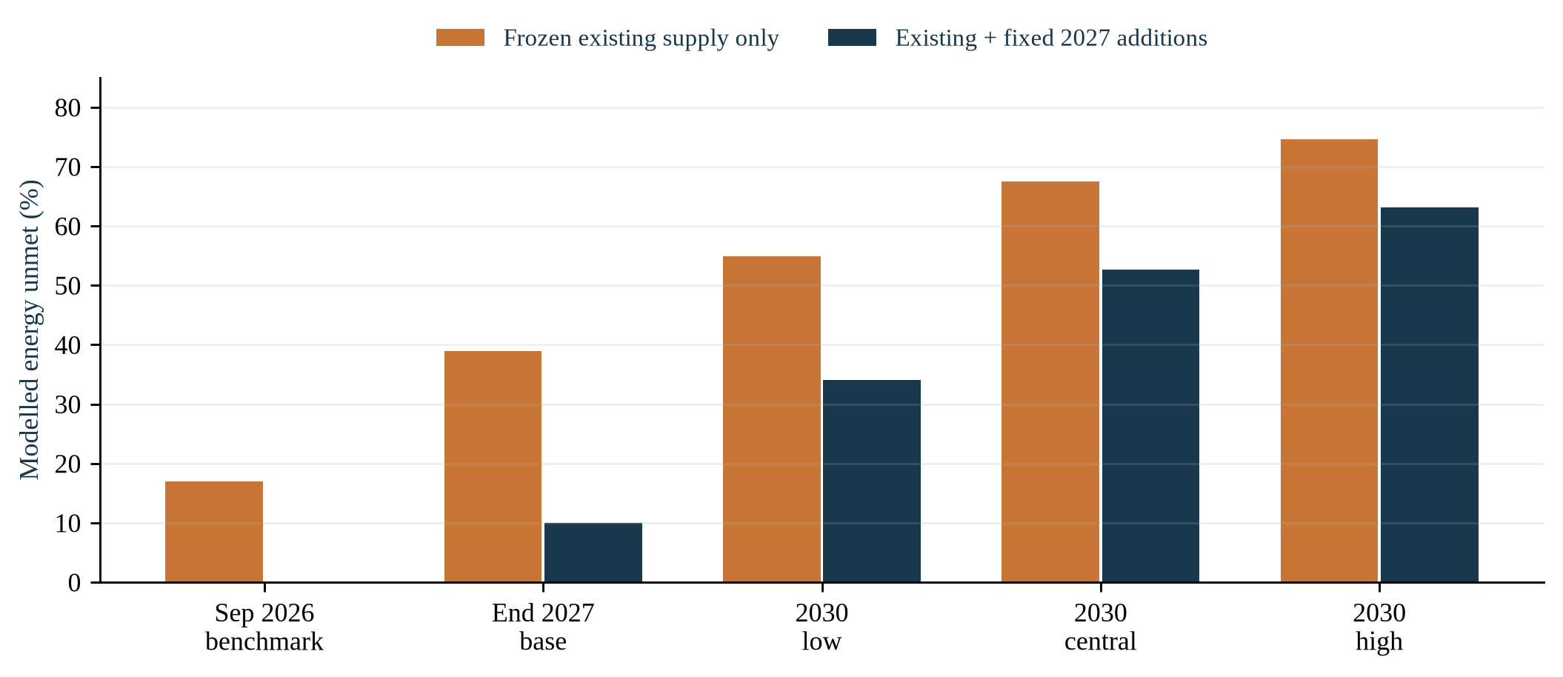
Figure 6. Energy shortfalls under frozen supply and the fixed 2027 additions. Future additions are not shown as installed in 2026.
Demand period | Demand (MWh/day) | Unmet: existing only | Unmet: +2027 plan
Sep 2026 benchmark | 189.1 | 17.0% | —
End 2027 base | 295.7 | 38.9% | 10.0%
2030 low | 410.9 | 54.9% | 34.1%
2030 central | 575.3 | 67.5% | 52.6%
2030 high | 739.7 | 74.7% | 63.1%
The 2026 benchmark uses observed September national EV stock but estimated HDB energy demand. The 2027 base extends registration flows for 15 months with assumed exits. The 2030 cases assume 25/35/45% of the frozen car fleet is electric; they are scenarios, not fitted forecasts. Existing supply stays frozen, and the second supply case adds the same 2,332 AC points with no further expansion.
The central 2030 case leaves 67.5% unmet under existing supply, or 52.6% with the 2027 plan. Meeting 90% in 2027 therefore does not establish adequacy in 2030. A separate 2030 target-cost investment plan has not been solved.
The 2027 AC/DC extension selects 0 new DC points and serves 90.0%; the tested costs provide no case for forcing a fast-charging quota.

7. Recommendations and limitations
Use the 28-area allocation and S$15.158m envelope to discuss a conditional end-2027 plan serving 90% of estimated energy demand. Yishun, Jurong West and Tampines receive the largest point allocations. The lower-bound certificate supports the national point count and budget; it does not make each area allocation uniquely optimal.
Before construction | Why it can change the decision
Confirm supply and access | Check existing HDB ownership, shared cabinet output, bay labels, walking routes and parking entitlement.
Measure local demand | Obtain resident EV counts, session energy and occupation patterns; update spatial weights and effective hours.
Survey electrical feasibility | Verify spare headroom and obtain a site-specific upgrade design and installed-cost quotation.
Stage and rerun | Prioritise observed-capacity review candidates; verify uncertain sites before committing their allocations. Reoptimise after measured changes.
Keep the three time horizons distinct: the 2026 modelled benchmark, the end-2027 investment decision, and the 2030 demand stress. The proposed plan leaves a deliberate 10% energy gap in 2027 and requires further expansion as demand grows. Update area-level budgets when better local demand and confirmed supply become available.
Individual locations are less stable: alternate seeds produce only 22.9% site-set overlap at near-equivalent service. The five reviewed sites are examples in the appendix, not the national deployment list or a geographically balanced priority ranking.
Demand remains a spatial proxy. Conservative matching can inflate apparent need, and uniform headroom, costs and charging hours cannot replace site evidence. Straight-line access can overstate feasible parking and walking connections.
The current model does not estimate queues, reliability at peak times or adoption causality. Its strongest contribution is a reproducible chain from dated inputs to feasible decisions, comparison rules and sensitivity tests. LP allocation, integer investment, relaxation bounds and finite budget differences supply the relevant analytical foundation; an additional dynamic programme is unnecessary for this static decision.

References
[1] HDB. Carpark Information; carpark availability snapshot, 31 October 2026. Local master and lot files frozen for this analysis. HDB dataset
[2] LTA. Public EV charging point register, September 2026. Unique point IDs and registration-level power bounds. LTA DataMall
[3] LTA. Monthly vehicle population by fuel; new car registrations; annual private vehicle mileage. September 2026 / 2025 vintages. Vehicle statistics
[4] Singapore Department of Statistics. Resident population and dwelling stock by planning area/subzone and dwelling type, 2025 and 2026. URA MP2019/MP2025 boundaries. SingStat geographic distribution
[5] Ministry of Transport. EVs registered for season parking in HDB carparks. Parliamentary reply, 11 November 2024. Historical calibration reply
[6] Ministry of Transport. Utilisation rates of EV charging points at petrol kiosks relative to public carparks. 10 September 2026. Utilisation reply
[7] Electric Pte Ltd. EV charger hardware and maintenance schedule; archived 9 November 2026. Commercial comparator, not an HDB installed-cost contract. Vendor evidence
[8] Gurobi Optimization. Facility-location example and Multiple Objectives documentation, archived 9 November 2026. Structural references; this implementation uses HiGHS. Facility-location example
[9] Church, R. and ReVelle, C. (1974). The maximal covering location problem. Papers of the Regional Science Association, 32, 101–118. Bibliographic context; original full text was not retrieved. DOI
[10] Huangfu, Q. and Hall, J. A. J. (2018). Parallelizing the dual revised simplex method. Mathematical Programming Computation, 10, 119–142. HiGHS solver documentation accessed 10 November 2026. HiGHS documentation
[11] DBA5103 Project Guideline. Semester I, 2026/2027, NUS. Local course document: sources/references/Project_Guideline.pdf.
Full file paths, collection timestamps, source URLs, parameter evidence and SHA-256 hashes are retained in the workbook and local research manifest. All numerical results use frozen local inputs, rather than a live data refresh.

Appendix A. Model audit and reproducibility
Item | Audit result
Model size | 2,273 sites; 21,003 allowable service arcs; continuous flows plus integer and binary investment decisions.
Source points | 11,489 unique IDs; 5,342 address-supported; remaining classes stay separate.
Capacity imputation | 278 sites; 71,123.5 lots. Base total 777,786.5.
Solver | HiGHS 1.15.1; Python 3.14.4; one thread; seed 17.
Tolerances | Base relative MIP gap 0.0001; stresses 0.001. Feasibility tolerance 1e-7. Service lock max(1e-6, 1e-8 × total demand).
Runtime limits | Base 45 seconds per MILP pass; sensitivity 25 seconds. Actual elapsed times and overshoot appear in logs.
Repeatability | Identical-input repeat: additions identical = True; service difference 0.000000 kWh/day.
Artifacts | HDB_EV_Charging_Analysis.xlsx; code/outputs/runs, solver_logs, inputs, figures; code/requirements.txt; code/venv/.
Space and power residuals, demand conservation, nonnegative flows, cost reconciliation, service locks and integrality are checked before saving integer results. A mathematical lower bound certifies the service-target budgets when attained. An LP relaxation provides an upper bound on service, but its fractional decisions are not installable. Marginal investment comparisons use finite differences, not MILP shadow prices.
Fixed-plan stress holds investment and upgrade binaries constant. If the scenario allows fewer bays or less power, usable added energy is derated by the tighter proportional limit, while sunk point counts remain unchanged. Such plans are flagged as construction-infeasible; repriced plans can also exceed the scenario budget. Their difference from a same-budget optimum is not labelled feasible-plan regret.
The 2027 stock path assumes the Jan–Sep 2026 mean registration flow persists for 15 months; exits are a stated fraction of these additions. It is not a fitted forecast, so no statistical confidence interval or forecasting back-test is claimed. Existing DC uses the same declared effective-hours base while retaining recorded power.

Appendix A.1 Site-level verification examples
The main recommendation is the 28-area allocation. The five examples below were chosen by scenario selection frequency among base-selected sites with observed capacity and night parking; no geographical-diversity constraint was applied. Their western concentration does not represent the island-wide deployment.
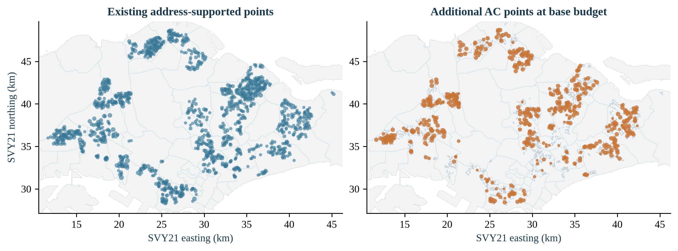
Appendix figure. Existing matched supply and all 549 selected carparks; not only the five review examples.
Review example | Added AC | Source-record review gate
JM18 · Jurong West | 6 | Source-supported; electrical/access survey
U15 · Bukit Batok | 1 | HOLD: resolve six provisional points
J98M · Jurong West | 6 | HOLD: resolve duplicate-address supply
JM13 · Jurong West | 6 | Source-supported; electrical/access survey
U13 · Bukit Batok | 6 | HOLD: resolve nearby address mismatch
Frequencies use 37 certified stress cases. Supply uncertainties remain explicit holds; all locations require electrical and access surveys. Equal-budget replacement solves recover nearly all service. Full addresses, coordinates, quantities and review findings remain in the workbook.

Appendix B. Execution and AI-use declaration
From the repository root, use the commands below. The environment already exists in code/venv/; requirements.txt pins the installed libraries. LibreOffice is used only to render the DOCX to a checked PDF and is a system dependency.
python3 -m venv project/code/venv
project/code/venv/bin/python -m pip install -r project/code/requirements.txt
project/code/venv/bin/python project/code/prepare_data.py
project/code/venv/bin/python project/code/test_models.py
project/code/venv/bin/python project/code/run_analysis.py --mode all
project/code/venv/bin/python project/code/review_shortlist.py
project/code/venv/bin/python project/code/audit_outputs.py
project/code/venv/bin/python project/code/build_figures.py
project/code/venv/bin/python project/code/build_workbook.py
project/code/venv/bin/python project/code/build_report.py
AI assistance: OpenAI Codex assisted with Python implementation, analysis checks, drafting and document formatting. No external party was contacted and no site verification was performed. The submitting authors remain responsible for reviewing the assumptions, evidence and final submission.
The following appendix attaches the complete data preparation, model, comparison, scenario and test code. Office-document and plotting generators are also supplied as Python files in code/. Machine-readable outputs and solver logs accompany the report rather than being repeated as long printed tables.

Appendix C. Python — prepare_data.py
001 """Freeze auditable HDB inputs from the supplied local source vintage."""
002 from pathlib import Path
003 import hashlib
004 import json
005 import re
006 import numpy as np
007 import pandas as pd
008 from pyproj import Transformer
009 from scipy.spatial import cKDTree
010 from shapely.geometry import Point, shape
011 from shapely.strtree import STRtree
012
013 ROOT = Path(__file__).resolve().parents[1]
014 DATA = ROOT / 'data'
015 OUT = Path(__file__).resolve().parent / 'outputs'
016 INPUTS = OUT / 'inputs'
017 USED = set()
018
019
020 def read(rel, **kw):
021 p = DATA / rel
022 USED.add(p)
023 return pd.read_csv(p, **kw)
024
025
026 def normal(text):
027 s = str(text).upper() if pd.notna(text) else ''
028 for a, b in {'AVE': 'AVENUE', 'ST': 'STREET', 'RD': 'ROAD',
029 'DR': 'DRIVE', 'CRES': 'CRESCENT', 'CTRL': 'CENTRAL',
030 'BT': 'BUKIT', 'NTH': 'NORTH', 'STH': 'SOUTH',
031 'UPP': 'UPPER', 'TG': 'TANJONG', 'JLN': 'JALAN',
032 'CL': 'CLOSE', 'PL': 'PLACE', 'TER': 'TERRACE',
033 'KG': 'KAMPONG', 'LOR': 'LORONG', 'GDNS': 'GARDENS'}.items():
034 s = re.sub(r'\b' + a + r'\b', b, s)
035 return ' '.join(re.sub(r'[^A-Z0-9 ]', ' ', s).split())
036
037
038 def address_parts(address):
039 s = str(address).upper()
040 m = re.match(r'(?:BLKS?\s*)?(\d+[A-Z]?(?:\s*[/,&-]\s*\d+[A-Z]?)*)\s+([A-Z].*)', s)
041 if not m:
042 return set(), '', []
043 blocks = set(re.findall(r'\d+[A-Z]?', m[1]))
044 ranges = []
045 for a, b in re.findall(r'(\d+)\s*[/\-]\s*(\d+)(?![A-Z])', m[1]):
046 if 0 <= int(b) - int(a) <= 60:
047 ranges.append((int(a), int(b)))
048 street = re.sub(r'\b(?:MULTI.?STOREY|BASEMENT|SURFACE|CAR PARK|CARPARK|MSCP).*', '', m[2]).strip()
049 return blocks, normal(street), ranges
050
051
052 def geotag(sites, year):
053 p = DATA / f'05_geospatial_boundaries/URA_MP{year}_planning_area_boundary.geojson'
054 USED.add(p)
055 fs = json.loads(p.read_text())['features']
056 gs = [shape(f['geometry']) for f in fs]
057 tree = STRtree(gs)
058 names = []
059 for lon, lat in zip(sites.longitude, sites.latitude):
060 pt = Point(lon, lat)
061 hits = [int(k) for k in tree.query(pt) if gs[k].covers(pt)]
062 names.append(fs[hits[0]]['properties']['PLN_AREA_N'] if hits else 'UNMAPPED')
063 sites[f'area_{year}'] = names
064
065
066 def build_sites():
067 s = read('03_carparks_candidate_sites/HDB_carpark_information.csv').sort_values('car_park_no').reset_index(drop=True)
068 l = read('03_carparks_candidate_sites/HDB_carpark_lots_snapshot_2026-10-31.csv')
069 l = l[l.lot_type.eq('C')]
070 assert s.car_park_no.is_unique and l.car_park_no.is_unique
071 s = s.merge(l[['car_park_no', 'total_lots']], how='left', validate='one_to_one')
072 s['capacity_status'] = np.select([s.total_lots.isna(), s.total_lots.eq(0)], ['missing', 'zero'], default='observed')
073 s['imputed'] = s.capacity_status.ne('observed')
074 tr = Transformer.from_crs(3414, 4326, always_xy=True)
075 s['longitude'], s['latitude'] = tr.transform(s.x_coord.to_numpy(), s.y_coord.to_numpy())
076 for y in (2019, 2025):
077 geotag(s, y)
078 observed = s[~s.imputed]
079 s['lots'] = s.total_lots.copy()
080 s['imputation_basis'] = 'observed'
081 for i in s.index[s.imputed]:
082 r = s.loc[i]
083 group = observed[(observed.area_2019 == r.area_2019) & (observed.car_park_type == r.car_park_type)]
084 basis = 'area/type median'
085 if len(group) < 5:
086 group = observed[observed.car_park_type == r.car_park_type]
087 basis = 'type median'
088 if len(group) < 5:
089 group, basis = observed, 'national median'
090 s.loc[i, 'lots'] = float(group.total_lots.median())
091 s.loc[i, 'imputation_basis'] = basis
092 s['residential_review_flag'] = s.night_parking.ne('YES')
093 # All HDB sites remain in the agreed base scope; night-parking is a review flag.
094 assert len(s) == 2273 and s.lots.gt(0).all()
095 s.to_csv(INPUTS / 'sites.csv', index=False)
096 s[s.imputed | s.residential_review_flag].to_csv(INPUTS / 'site_exceptions.csv', index=False)
097 return s
098
099
100 def build_crosswalk(s):
101 cp = read('01_ev_charging_supply/LTA_EV_charging_points_Sep2026.csv', dtype={'PostalCode': str, 'Lot No': str, 'Floor No': str, 'Block/House No': str})
102 assert cp.evCpId.is_unique and len(cp) == 11489
103 cp['PostalCode'] = cp.PostalCode.str.zfill(6)
104 tr = Transformer.from_crs(4326, 3414, always_xy=True)
105 xy = np.column_stack(tr.transform(cp.longitude.to_numpy(), cp.latitude.to_numpy()))
106 tree = cKDTree(s[['x_coord', 'y_coord']])
107 parsed = [address_parts(a) for a in s.address]
108 excluded = re.compile(r'\b(MALL|PETROL|SHELL|ESSO|CALTEX|SPC|HOSPITAL|HOTEL|CONDOMINIUM|UNIVERSITY|POLYTECHNIC|INDUSTRIAL|BUSINESS|JTC|IKEA|MUSEUM|AIRPORT|SHOPPING|SCHOOL|PLAZA|COMMUNITY CLUB|COMMUNITY CENTRE)\b')
109 records = []
110 # Explicit address evidence outranks nearest distance. Range/near-street matches stay provisional.
111 for i, r in cp.iterrows():
112 candidates = tree.query_ball_point(xy[i], 150)
113 block, street, building = str(r['Block/House No']).upper(), normal(r['Street Name']), normal(r['Building Name'])
114 exact, ranged, near = [], [], []
115 for j in candidates:
116 blocks, st, ranges = parsed[j]
117 if st != street:
118 continue
119 dist = float(np.linalg.norm(xy[i] - s.loc[j, ['x_coord', 'y_coord']].to_numpy(dtype=float)))
120 near.append((dist, j))
121 if block in blocks:
122 exact.append((dist, j))
123 elif block.isdigit() and any(a <= int(block) <= b for a, b in ranges):
124 ranged.append((dist, j))
125 status, pick, reason = 'unresolved', None, 'No unique exact block/street match within 150 m'
126 if excluded.search(building):
127 status, reason = 'excluded_non_hdb_evidence', 'Building name indicates non-HDB use; conservative exclusion'
128 elif len(exact) == 1:
129 status, pick, reason = 'address_supported', exact[0], 'Unique literal block + normalised street + distance <=150 m'
130 elif len(exact) > 1:
131 reason = 'Multiple exact address candidates; no base assignment'
132 elif len(ranged) == 1:
133 status, pick, reason = 'provisional_range', ranged[0], 'Block lies in short master-address range; sensitivity only'
134 elif len(near) == 1 and near[0][0] <= 100:
135 status, pick, reason = 'provisional_street', near[0], 'Unique same-street candidate within 100 m; sensitivity only'
136 elif not candidates:
137 status, reason = 'outside_candidate_radius', 'No HDB candidate within 150 m'
138 records.append({'evCpId': r.evCpId, 'match_status': status,
139 'site_id': s.loc[pick[1], 'car_park_no'] if pick else '',
140 'site_index': pick[1] if pick else np.nan,
141 'match_distance_m': pick[0] if pick else np.nan,
142 'nearby_candidates_50m': len(tree.query_ball_point(xy[i], 50)),
143 'nearby_candidates_100m': len(tree.query_ball_point(xy[i], 100)),
144 'nearby_candidates_150m': len(candidates), 'match_reason': reason})
145 c = cp.merge(pd.DataFrame(records), on='evCpId', validate='one_to_one')
146 # A registration must not split across sites; unresolved members exclude that registration from base.
147 for _, g in c.groupby('EV Charger Registration Code'):
148 assigned = g.site_id[g.site_id.ne('')].unique()
149 if len(assigned) > 1 or (g.match_status.eq('address_supported').any() and not g.match_status.eq('address_supported').all()):
150 c.loc[g.index, 'match_status'] = 'registration_conflict'
151 c.loc[g.index, ['site_id', 'site_index']] = ['', np.nan]
152 c.to_csv(INPUTS / 'hdb_charger_crosswalk.csv', index=False)
153 loc = c.groupby(['longitude', 'latitude', 'match_status', 'site_id'], dropna=False).agg(
154 point_count=('evCpId', 'size'), block=('Block/House No', 'first'), street=('Street Name', 'first'),
155 building=('Building Name', 'first'), distance_m=('match_distance_m', 'first')).reset_index()
156 loc.to_csv(INPUTS / 'location_review_queue.csv', index=False)
157 supply = pd.DataFrame({'site_id': s.car_park_no})
158 for label, statuses in [('strict', ['address_supported']), ('broad', ['address_supported', 'provisional_range', 'provisional_street'])]:
159 subset = c[c.match_status.isin(statuses)].copy()
160 subset['power'] = pd.to_numeric(subset['charging Speed'], errors='raise')
161 assert subset.power.ge(0).all()
162 subset['is_dc'] = ~subset.plugType.eq('Type 2')
163 reg = subset.groupby(['site_id', 'EV Charger Registration Code']).agg(
164 power_lower=('power', 'max'), power_upper=('power', 'sum'), points=('evCpId', 'size'), dc=('is_dc', 'max')).reset_index()
165 reg['scope'] = label
166 reg.to_csv(INPUTS / f'registration_capacity_{label}.csv', index=False)
167 by = reg.groupby('site_id').agg(kw_lower=('power_lower', 'sum'), kw_upper=('power_upper', 'sum'),
168 points=('points', 'sum'), dc_registrations=('dc', 'sum'))
169 for col in by:
170 supply[f'{label}_{col}'] = supply.site_id.map(by[col]).fillna(0)
171 # Distinct floor + single lot is an alternative bay estimate; multi-lot/absent labels use points.
172 sub = c[c.match_status.eq('address_supported')].copy()
173 sub['bay_key'] = [f'{fl}:{lot}' if re.fullmatch(r'\d+[A-Z]?', str(lot)) and pd.notna(fl)
174 else f'unknown:{pid}' for fl, lot, pid in zip(sub['Floor No'], sub['Lot No'], sub.evCpId)]
175 bays = sub.groupby('site_id').bay_key.nunique()
176 supply['strict_bays_deduplicated'] = supply.site_id.map(bays).fillna(0)
177 supply.to_csv(INPUTS / 'existing_supply.csv', index=False)
178 return c, supply
179
180
181 def build_demographics():
182 frames = []
183 for year in (2025, 2026):
184 for kind, value in [('population', 'Pop'), ('dwellings', 'HSE')]:
185 stem = f'population_dwelling_{year}__respopagesextod{year}.csv' if kind == 'population' else f'dwellings_type_{year}__hsetod{year}.csv'
186 d = read('04_demographics_demand_proxies/updates_2026-11-09/' + stem)
187 assert value in d, (stem, list(d.columns))
188 d = d[d.TOD.str.startswith('HDB ')].copy()
189 d[value] = pd.to_numeric(d[value], errors='raise')
190 a = d.groupby('PA', as_index=False)[value].sum().rename(columns={value: 'value'})
191 a['area'] = a.PA.str.upper()
192 a['year'], a['metric'], a['source_file'] = year, kind, stem
193 frames.append(a)
194 a = pd.concat(frames, ignore_index=True)
195 a.to_csv(INPUTS / 'area_demand_weights.csv', index=False)
196 return a
197
198
199 def build_stock():
200 v = read('02_ev_population_and_registrations/LTA_M09_monthly_vehicle_population_by_fuel.csv')
201 v = v[v.category.eq('Cars')].copy()
202 v['numeric'] = pd.to_numeric(v.number, errors='coerce')
203 v[v.numeric.isna()].to_csv(INPUTS / 'vehicle_numeric_exceptions.csv', index=False)
204 ev = v[v.type.eq('Electric')].set_index('month').numeric
205 fleet = v.groupby('month').numeric.sum(min_count=1)
206 r = read('02_ev_population_and_registrations/LTA_M03_monthly_new_car_registrations_by_make_fuel.csv')
207 r['numeric'] = pd.to_numeric(r.number, errors='coerce')
208 reg = r[r.fuel_type.eq('Electric')].groupby('month').numeric.sum(min_count=1)
209 hist = pd.DataFrame({'ev_stock': ev, 'all_car_stock': fleet, 'new_electric_cars': reg}).sort_index()
210 hist['implied_net_exits'] = hist.ev_stock.shift() + hist.new_electric_cars - hist.ev_stock
211 hist.to_csv(INPUTS / 'ev_history.csv', index_label='month')
212 last = hist.loc['2026-09']
213 monthly = hist.loc['2026-01':'2026-09', 'new_electric_cars'].mean()
214 rows = [{'scenario': 'current_2026', 'year': 2026, 'stock': last.ev_stock, 'basis': 'Observed September 2026 Cars/Electric', 'monthly_registrations': np.nan, 'exit_fraction': np.nan}]
215 for name, factor, exits in [('low', .75, .05), ('base', 1., .02), ('high', 1.25, 0.)]:
216 stock = min(last.all_car_stock, last.ev_stock + 15 * monthly * factor * (1 - exits))
217 rows.append({'scenario': f'2027_{name}', 'year': 2027, 'stock': stock, 'basis': '15 months of assumed registrations less exits; not fitted forecast', 'monthly_registrations': monthly * factor, 'exit_fraction': exits})
218 for name, share in [('low', .25), ('base', .35), ('high', .45)]:
219 rows.append({'scenario': f'2030_{name}', 'year': 2030, 'stock': last.all_car_stock * share, 'basis': f'{share:.0%} of frozen Sep-2026 all-car stock; illustrative stress case', 'monthly_registrations': np.nan, 'exit_fraction': np.nan})
220 scenarios = pd.DataFrame(rows)
221 scenarios.to_csv(INPUTS / 'ev_stock_scenarios.csv', index=False)
222 # Historical anchor consistency, not a validation of spatial demand.
223 anchor = {'sep2024_electric_cars': float(ev.loc['2024-09']), 'hdb_season_parking_evs': 8800,
224 'historical_hdb_ratio': float(8800 / ev.loc['2024-09']),
225 'stock_path_kind': 'assumed scenarios; no fitted extrapolation or confidence interval',
226 '2026_registration_missing_rows': int(r[(r.month >= '2026-01') & r.fuel_type.eq('Electric')].numeric.isna().sum())}
227 (INPUTS / 'stock_calibration.json').write_text(json.dumps(anchor, indent=2))
228 return scenarios
229
230
231 def main():
232 INPUTS.mkdir(parents=True, exist_ok=True)
233 s = build_sites()
234 c, supply = build_crosswalk(s)
235 build_demographics()
236 scenarios = build_stock()
237 read('08_costs/cost_parameters.csv').to_csv(INPUTS / 'parameter_evidence.csv', index=False)
238 manifest = [{'path': str(p.relative_to(ROOT)), 'sha256': hashlib.sha256(p.read_bytes()).hexdigest(), 'bytes': p.stat().st_size} for p in sorted(USED)]
239 (INPUTS / 'source_hashes.json').write_text(json.dumps(manifest, indent=2))
240 audit = {'sites': len(s), 'missing_capacity': int(s.capacity_status.eq('missing').sum()),
241 'zero_capacity': int(s.capacity_status.eq('zero').sum()), 'imputed_lots': float(s.loc[s.imputed, 'lots'].sum()),
242 'observed_lots': float(s.total_lots.sum()), 'total_lots_after_imputation': float(s.lots.sum()),
243 'charger_points': len(c), 'match_counts': c.match_status.value_counts().to_dict(),
244 'strict_sites': int(supply.strict_points.gt(0).sum()),
245 'strict_dc_registrations': int(supply.strict_dc_registrations.sum()),
246 'unmapped_hdb_sites': int(s.area_2019.eq('UNMAPPED').sum())}
247 (INPUTS / 'data_audit.json').write_text(json.dumps(audit, indent=2))
248 print(json.dumps(audit, indent=2), flush=True)
249 print(scenarios.to_string(index=False), flush=True)
250
251
252 if __name__ == '__main__':
253 main()

Appendix C. Python — model.py
001 """Capacitated location MILP and fixed-investment transportation LP (HiGHS)."""
002 from dataclasses import dataclass, replace, asdict
003 from pathlib import Path
004 import json
005 import time
006 import numpy as np
007 import pandas as pd
008 import highspy as hs
009 from scipy.sparse import coo_matrix
010 from scipy.spatial import cKDTree
011 from prepare_data import INPUTS, OUT
012
013
014 @dataclass(frozen=True)
015 class Parameters:
016 stock: float = 117116.83333333333
017 hdb_share: float = .4
018 dependence: float = .8
019 annual_km: float = 16200
020 intensity: float = .16
021 efficiency: float = .9
022 hours: float = 6
023 availability: float = .97
024 power_factor: float = .85
025 radius: float = 400
026 path_inflation: float = 1
027 ac_power: float = 7.4
028 dc_power: float = 50
029 dc_hours: float = 6
030 dc_power_factor: float = .85
031 ac_cost: float = 6500
032 dc_cost: float = 60000
033 fixed_cost: float = 0
034 upgrade_cost: float = 50000
035 ac_maintenance: float = 380
036 dc_maintenance: float = 1180
037 network: float = 200
038 lifetime: float = 10
039 discount: float = .05
040 headroom: float = 44.4
041 upgrade_kw: float = 88.8
042 lot_share: float = .1
043 impute_factor: float = 1
044 unknown_no_build: bool = False
045 weights: str = 'lots'
046 matching: str = 'strict'
047 power_bound: str = 'lower'
048 deduplicate_bays: bool = False
049 dc_enabled: bool = False
050 seed: int = 17
051 time_limit: float = 45
052 mip_gap: float = .0001
053
054 @property
055 def q(self):
056 return self.ac_power * self.hours * self.availability * self.power_factor
057
058 @property
059 def qdc(self):
060 return self.dc_power * self.dc_hours * self.availability * self.dc_power_factor
061
062 @property
063 def crf(self):
064 return self.discount / (1 - (1 + self.discount) ** -self.lifetime) if self.discount else 1 / self.lifetime
065
066
067 @dataclass
068 class Instance:
069 sites: pd.DataFrame
070 p: Parameters
071 demand: np.ndarray
072 q0: np.ndarray
073 bays: np.ndarray
074 maximum: np.ndarray
075 ii: np.ndarray
076 jj: np.ndarray
077 distances: np.ndarray
078 unallocated_proxy_share: float = 0
079
080 @property
081 def n(self):
082 return len(self.demand)
083
084
085 def build_instance(p=None):
086 p = p or Parameters()
087 s = pd.read_csv(INPUTS / 'sites.csv')
088 supply = pd.read_csv(INPUTS / 'existing_supply.csv')
089 assert s.car_park_no.tolist() == supply.site_id.tolist()
090 lots = s.lots.to_numpy().copy()
091 lots[s.imputed] *= p.impute_factor
092 weights = lots / lots.sum()
093 missing_share = 0.
094 if p.weights != 'lots':
095 a = pd.read_csv(INPUTS / 'area_demand_weights.csv')
096 year = 2026 if p.weights.endswith('2026') else 2025
097 metric = 'population' if p.weights.startswith('population') else 'dwellings'
098 a = a[(a.year == year) & (a.metric == metric)].set_index('area').value
099 area = s['area_2025' if year == 2026 else 'area_2019']
100 area_lots = pd.Series(lots).groupby(area).sum()
101 missing_share = float(a.loc[~a.index.isin(area_lots.index)].sum() / a.sum())
102 # Preserve the national HDB total and disclose any no-site area proxy reallocation.
103 available = a.reindex(area_lots.index).fillna(0)
104 weights = (area.map(available / available.sum()).to_numpy() * lots / area.map(area_lots).to_numpy())
105 per_ev = p.dependence * p.annual_km / 365 * p.intensity / p.efficiency
106 demand = p.stock * p.hdb_share * per_ev * weights
107 q0 = supply[f'{p.matching}_kw_{p.power_bound}'].to_numpy() * p.hours * p.availability * p.power_factor
108 # Existing DC retains its recorded rated power under the same declared effective-hours base.
109 bays = supply[f'{p.matching}_points'].to_numpy()
110 if p.deduplicate_bays and p.matching == 'strict':
111 bays = supply.strict_bays_deduplicated.to_numpy()
112 maximum = np.maximum(0, np.floor(p.lot_share * lots) - bays).astype(int)
113 if p.unknown_no_build:
114 maximum[s.imputed] = 0
115 coords = s[['x_coord', 'y_coord']].to_numpy()
116 tree = cKDTree(coords)
117 arcs = [(i, j) for i, hits in enumerate(tree.query_ball_tree(tree, p.radius / p.path_inflation)) for j in sorted(hits)]
118 ii, jj = np.array(arcs, dtype=int).T
119 dist = np.linalg.norm(coords[ii] - coords[jj], axis=1) * p.path_inflation
120 assert np.isclose(weights.sum(), 1) and np.all(demand >= 0)
121 return Instance(s, p, demand, q0, bays, maximum, ii, jj, dist, missing_share)
122
123
124 def make_solver(c, A, lower, upper, lb, ub, integer=None, p=None, log=None):
125 p = p or Parameters()
126 A = A.tocsc()
127 lp = hs.HighsLp()
128 lp.num_col_, lp.num_row_ = len(c), len(lower)
129 lp.col_cost_, lp.col_lower_, lp.col_upper_ = c, lb, ub
130 lp.row_lower_, lp.row_upper_ = lower, upper
131 lp.a_matrix_.format_ = hs.MatrixFormat.kColwise
132 lp.a_matrix_.start_, lp.a_matrix_.index_, lp.a_matrix_.value_ = A.indptr, A.indices, A.data
133 if integer is not None:
134 lp.integrality_ = [hs.HighsVarType.kInteger if t else hs.HighsVarType.kContinuous for t in integer]
135 h = hs.Highs()
136 h.setOptionValue('output_flag', bool(log))
137 h.setOptionValue('log_to_console', False)
138 if log:
139 Path(log).parent.mkdir(parents=True, exist_ok=True)
140 h.setOptionValue('log_file', str(log))
141 h.setOptionValue('threads', 1)
142 h.setOptionValue('random_seed', p.seed)
143 h.setOptionValue('time_limit', p.time_limit)
144 h._per_solve_seconds = p.time_limit
145 h.setOptionValue('mip_rel_gap', p.mip_gap)
146 h.setOptionValue('mip_feasibility_tolerance', 1e-7)
147 h.setOptionValue('primal_feasibility_tolerance', 1e-7)
148 assert h.passModel(lp) == hs.HighsStatus.kOk
149 return h
150
151
152 def solve_info(h, stage, elapsed):
153 info = h.getInfo()
154 return {'stage': stage, 'status': h.modelStatusToString(h.getModelStatus()),
155 'objective': h.getObjectiveValue(), 'bound': info.mip_dual_bound,
156 'gap': info.mip_gap, 'nodes': info.mip_node_count, 'seconds': elapsed,
157 'max_primal_infeasibility': info.max_primal_infeasibility}
158
159
160 def run(h, stage):
161 # HiGHS run time accumulates when one solver is reused. Give each new solve
162 # its own limit, especially for the thousands of warm-started greedy LPs.
163 h.setOptionValue('time_limit', h.getRunTime() + h._per_solve_seconds)
164 start = time.perf_counter()
165 h.run()
166 info = solve_info(h, stage, time.perf_counter() - start)
167 if not h.getSolution().value_valid:
168 return None, info
169 return np.array(h.getSolution().col_value), info
170
171
172 def investments(inst, x, d=None):
173 p = inst.p
174 d = np.zeros(inst.n) if d is None else d
175 z = (x + d > 0).astype(int)
176 y = (p.ac_power * x + p.dc_power * d > p.headroom + 1e-7).astype(int)
177 capital = p.ac_cost * x + p.dc_cost * d + p.fixed_cost * z + p.upgrade_cost * y
178 annual = p.crf * capital + (p.ac_maintenance + p.network) * x + (p.dc_maintenance + p.network) * d
179 return z, y, capital, annual
180
181
182 def allocate(inst, x=None, d=None, distance=True, q_override=None):
183 """Max-flow LP, followed by min-distance flow with service preserved."""
184 n, m = inst.n, len(inst.ii)
185 x = np.zeros(n) if x is None else np.array(x)
186 d = np.zeros(n) if d is None else np.array(d)
187 q = inst.q0 + inst.p.q * x + inst.p.qdc * d if q_override is None else q_override
188 rows = np.r_[inst.ii, n + inst.jj]
189 cols = np.tile(np.arange(m), 2)
190 A = coo_matrix((np.ones(2*m), (rows, cols)), shape=(2*n, m))
191 h = make_solver(-np.ones(m), A, np.zeros(2*n), np.r_[inst.demand, q], np.zeros(m), np.full(m, np.inf), p=inst.p)
192 sol, info = run(h, 'allocation_max_service')
193 if sol is None:
194 raise RuntimeError(info)
195 served = sol.sum()
196 if distance and served > 0:
197 epsilon = max(1e-6, 1e-8 * inst.demand.sum())
198 h.addRow(served - epsilon, np.inf, m, np.arange(m, dtype=np.int32), np.ones(m))
199 h.changeColsCost(m, np.arange(m, dtype=np.int32), inst.distances / 1000)
200 candidate, dist_info = run(h, 'allocation_min_distance')
201 if candidate is not None:
202 sol = candidate
203 return sol, info
204
205
206 def formulation(inst, budget=np.inf, target=None, relaxation=False):
207 """Column blocks f, x_AC, x_DC, z, y; unmet demand eliminated as D - sum(f)."""
208 p, n, m = inst.p, inst.n, len(inst.ii)
209 nv = m + 4*n
210 ix, idc, iz, iy = [m + k*n + np.arange(n) for k in range(4)]
211 rr, cc, vv, lower, upper = [], [], [], [], []
212
213 def row(cols, vals, lo=-np.inf, hi=np.inf):
214 k = len(lower)
215 rr.extend([k]*len(cols)); cc.extend(cols); vv.extend(vals)
216 lower.append(lo); upper.append(hi)
217
218 by_i = [[] for _ in range(n)]; by_j = [[] for _ in range(n)]
219 for a, (i, j) in enumerate(zip(inst.ii, inst.jj)):
220 by_i[i].append(a); by_j[j].append(a)
221 for i in range(n):
222 row(by_i[i], [1]*len(by_i[i]), hi=inst.demand[i])
223 for j in range(n):
224 row(by_j[j] + [ix[j], idc[j]], [1]*len(by_j[j]) + [-p.q, -p.qdc], hi=inst.q0[j])
225 row([ix[j], idc[j], iz[j]], [1, 1, -inst.maximum[j]], hi=0)
226 row([iz[j], ix[j], idc[j]], [1, -1, -1], hi=0)
227 row([ix[j], idc[j], iy[j]], [p.ac_power, p.dc_power, -p.upgrade_kw], hi=p.headroom)
228 row([iy[j], iz[j]], [1, -1], hi=0)
229 cap = np.r_[np.zeros(m), np.full(n, p.ac_cost), np.full(n, p.dc_cost), np.full(n, p.fixed_cost), np.full(n, p.upgrade_cost)]
230 ann = p.crf * cap
231 ann[ix] += p.ac_maintenance + p.network
232 ann[idc] += p.dc_maintenance + p.network
233 if np.isfinite(budget):
234 row(list(range(m, nv)), cap[m:].tolist(), hi=budget)
235 if target is not None:
236 row(list(range(m)), [1]*m, lo=target)
237 # Network-flow upper bound: new supply can add at most q per AC point.
238 # The rounded count cut is valid for the integer AC-only target model.
239 # It prevents spending branch-and-bound effort proving fractional point counts impossible.
240 if target is not None and not p.dc_enabled and not relaxation:
241 no_build, _ = allocate(inst, distance=False)
242 needed = max(0, int(np.ceil((target-no_build.sum()-1e-7)/p.q)))
243 row(ix.tolist(), [1]*n, lo=needed)
244 if np.isfinite(budget) and not relaxation and not p.dc_enabled and min(p.fixed_cost,p.upgrade_cost)>=0:
245 row(ix.tolist(), [1]*n, hi=int(np.floor((budget+1e-7)/p.ac_cost)))
246 A = coo_matrix((vv, (rr, cc)), shape=(len(lower), nv))
247 ub = np.r_[np.full(m, np.inf), inst.maximum, inst.maximum if p.dc_enabled else np.zeros(n), np.ones(2*n)]
248 integer = np.r_[np.zeros(m), np.zeros(4*n) if relaxation else np.ones(4*n)]
249 return A, np.array(lower), np.array(upper), np.zeros(nv), ub, integer, cap, ann
250
251
252 def optimise(inst, budget=np.inf, target=None, name='solve', relaxation=False, fixed_zero=None, warm_x=None):
253 p, n, m = inst.p, inst.n, len(inst.ii)
254 A, lo, hi, lb, ub, integer, cap, ann = formulation(inst, budget, target, relaxation)
255 if fixed_zero is not None:
256 ub[m + np.array(fixed_zero)] = 0
257 ub[m+n + np.array(fixed_zero)] = 0
258 c = cap / 1000 if target is not None else np.r_[-np.ones(m), np.zeros(4*n)]
259 log = OUT / 'solver_logs' / f'{name}.log'
260 h = make_solver(c, A, lo, hi, lb, ub, integer, p, log)
261 if name == 'base':
262 h.writeModel(str(OUT / 'base_model.lp'))
263 if warm_x is not None:
264 h.setSolution(n, np.arange(m, m+n, dtype=np.int32), np.array(warm_x, dtype=float))
265 if target is None and not relaxation:
266 initial_flow, _ = allocate(inst, distance=False)
267 initial = np.r_[initial_flow, np.zeros(4*n)]
268 h.setSolution(len(c), np.arange(len(c),dtype=np.int32), initial)
269 if target is not None and not relaxation and not p.dc_enabled:
270 # An LP-round-up incumbent is feasible under the integer space and grid bounds.
271 # It supplies a reproducible starting solution without claiming LP decisions are buildable.
272 lp_solver = make_solver(c, A, lo, hi, lb, ub, np.zeros(len(c)), p)
273 relaxed, _ = run(lp_solver, 'target_lp_start')
274 if relaxed is not None:
275 wx = np.minimum(inst.maximum, np.ceil(relaxed[m:m+n]-1e-7)).astype(int)
276 if np.all(wx*p.ac_power <= p.headroom+p.upgrade_kw+1e-7):
277 wf, _ = allocate(inst, wx, distance=False)
278 wz, wy, _, _ = investments(inst, wx)
279 if wf.sum() >= target-1e-5:
280 start_sol = np.r_[wf, wx, np.zeros(n), wz, wy]
281 h.setSolution(len(c), np.arange(len(c),dtype=np.int32), start_sol)
282 sol, stage1 = run(h, 'minimum_target_capex' if target is not None else 'maximum_service')
283 stages = [stage1]
284 if sol is None:
285 return {'name': name, 'feasible': False, 'stages': stages, 'budget': budget}
286 first_service = float(sol[:m].sum())
287 epsilon = max(1e-6, 1e-8 * inst.demand.sum())
288 if target is None and not relaxation:
289 h.addRow(first_service - epsilon, np.inf, m, np.arange(m, dtype=np.int32), np.ones(m))
290 if not p.dc_enabled:
291 no_build, _ = allocate(inst, distance=False)
292 needed = max(0, int(np.ceil((first_service-epsilon-no_build.sum()-1e-7)/p.q)))
293 h.addRow(needed, np.inf, n, np.arange(m,m+n,dtype=np.int32), np.ones(n))
294 h.changeColsCost(len(c), np.arange(len(c), dtype=np.int32), ann / 1000)
295 h.setSolution(len(sol), np.arange(len(sol), dtype=np.int32), sol)
296 candidate, stage2 = run(h, 'minimum_annual_cost')
297 stages.append(stage2)
298 if candidate is not None:
299 sol = candidate
300 x, d = sol[m:m+n], sol[m+n:m+2*n]
301 if relaxation:
302 flow = sol[:m]
303 capital, annual = float(cap @ sol), float(ann @ sol)
304 z, y = sol[m+2*n:m+3*n], sol[m+3*n:]
305 else:
306 assert max(np.max(np.abs(x - np.rint(x))), np.max(np.abs(d - np.rint(d)))) < 1e-5
307 x, d = np.rint(x).astype(int), np.rint(d).astype(int)
308 z, y, capitals, annuals = investments(inst, x, d)
309 capital, annual = float(capitals.sum()), float(annuals.sum())
310 flow, _ = allocate(inst, x, d)
311 result = summarise(inst, x, d, flow, budget, name)
312 result.update(feasible=True, capital=capital, annual_cost=annual, stages=stages,
313 first_service=first_service, service_lock_epsilon=epsilon,
314 certified_service=stage1['status'] == 'Optimal',
315 certified_cost=stages[-1]['status'] == 'Optimal', relaxation=relaxation)
316 if relaxation:
317 result['y'], result['z'] = y, z
318 result['site_capital'] = p.ac_cost*x + p.dc_cost*d + p.fixed_cost*z + p.upgrade_cost*y
319 result['site_annual'] = p.crf*result['site_capital'] + (p.ac_maintenance+p.network)*x + (p.dc_maintenance+p.network)*d
320 return result
321
322
323 def summarise(inst, x, d, flow, budget, name):
324 z, y, capital, annual = investments(inst, x, d)
325 served_i = np.bincount(inst.ii, weights=flow, minlength=inst.n)
326 used_j = np.bincount(inst.jj, weights=flow, minlength=inst.n)
327 total = inst.demand.sum()
328 return {'name': name, 'budget': float(budget), 'demand': float(total), 'served': float(flow.sum()),
329 'service_fraction': float(flow.sum()/total) if total else 1.,
330 'capital': float(capital.sum()), 'annual_cost': float(annual.sum()),
331 'ac_points': float(x.sum()), 'dc_points': float(d.sum()), 'sites_selected': int(z.sum()),
332 'upgrades': int(y.sum()), 'unspent': float(budget - capital.sum()),
333 'distance_m': float(inst.distances @ flow / flow.sum()) if flow.sum() else 0,
334 'imputed_investment_share': float(capital[inst.sites.imputed].sum()/capital.sum()) if capital.sum() else 0,
335 'unallocated_proxy_share': inst.unallocated_proxy_share,
336 'x': x, 'dc': d, 'y': y, 'flow': flow, 'served_i': served_i, 'used_j': used_j}
337
338
339 def validate_result(inst, result, tol=1e-4):
340 if not result.get('feasible', True):
341 return
342 x, d, f = result['x'], result['dc'], result['flow']
343 _, y, cap, _ = investments(inst, x, d)
344 checks = {
345 'nonnegative_flows': max(0., -float(f.min(initial=0))),
346 'demand_balance': max(0., float((result['served_i'] - inst.demand).max(initial=0))),
347 'site_capacity': max(0., float((result['used_j'] - inst.q0 - inst.p.q*x - inst.p.qdc*d).max(initial=0))),
348 'space': max(0., float((x+d-inst.maximum).max(initial=0))),
349 'power': max(0., float((inst.p.ac_power*x + inst.p.dc_power*d - inst.p.headroom - inst.p.upgrade_kw*y).max(initial=0))),
350 'budget': max(0., float(cap.sum() - result['budget'])),
351 'integrality': float(max(np.abs(x-np.rint(x)).max(initial=0), np.abs(d-np.rint(d)).max(initial=0))),
352 }
353 if 'first_service' in result:
354 checks['service_lock'] = max(0., result['first_service'] - result['served'] - 2*result['service_lock_epsilon'])
355 assert all(v <= tol for v in checks.values()), (result['name'], checks)
356 return checks
357
358
359 def save_result(inst, r):
360 dest = OUT / 'runs' / r['name']
361 dest.mkdir(parents=True, exist_ok=True)
362 scalar = {k: v for k, v in r.items() if not isinstance(v, np.ndarray)}
363 scalar['parameters'] = asdict(inst.p)
364 if r.get('feasible', True) and not r.get('relaxation', False):
365 scalar['residual_checks'] = validate_result(inst, r)
366 (dest / 'metrics.json').write_text(json.dumps(scalar, indent=2))
367 if 'x' not in r:
368 return
369 s = inst.sites.copy()
370 s['demand_kwh_day'], s['served_kwh_day'] = inst.demand, r['served_i']
371 s['unmet_kwh_day'] = inst.demand - r['served_i']
372 s['existing_capacity'], s['capacity_used'] = inst.q0, r['used_j']
373 s['ac_additions'], s['dc_additions'], s['upgrade'] = r['x'], r['dc'], r['y']
374 _, _, s['capex'], s['annual_cost'] = investments(inst, r['x'], r['dc'])
375 if r.get('relaxation', False):
376 s['capex'], s['annual_cost'] = r['site_capital'], r['site_annual']
377 s['space_slack'] = inst.maximum - r['x'] - r['dc']
378 s['power_slack_kw'] = inst.p.headroom + inst.p.upgrade_kw*r['y'] - inst.p.ac_power*r['x'] - inst.p.dc_power*r['dc']
379 s.to_csv(dest / 'site_decisions.csv', index=False)
380 pd.DataFrame({'demand_site': s.car_park_no.iloc[inst.ii].to_numpy(), 'supply_site': s.car_park_no.iloc[inst.jj].to_numpy(),
381 'distance_m': inst.distances, 'kwh_day': r['flow']}).query('kwh_day > 1e-8').to_csv(dest / 'demand_flows.csv', index=False)
382 s.groupby('area_2019')[['demand_kwh_day', 'served_kwh_day', 'unmet_kwh_day', 'ac_additions', 'dc_additions', 'capex', 'annual_cost']].sum().to_csv(dest / 'area_results.csv')

Appendix C. Python — baselines.py
001 """Feasible equal, largest-remainder proportional, and exact-marginal greedy rules."""
002 import heapq
003 import numpy as np
004 from scipy.sparse import coo_matrix
005 from model import make_solver, run, investments, allocate, summarise
006
007
008 def step_cost(inst, x, j):
009 p = inst.p
010 if x[j] + 1 > inst.maximum[j] or (x[j]+1)*p.ac_power > p.headroom + p.upgrade_kw + 1e-7:
011 return np.inf
012 before = x[j]*p.ac_power > p.headroom + 1e-7
013 after = (x[j]+1)*p.ac_power > p.headroom + 1e-7
014 return p.ac_cost + (p.fixed_cost if x[j] == 0 else 0) + (p.upgrade_cost if after and not before else 0)
015
016
017 def simple_rule(inst, budget, kind):
018 x = np.zeros(inst.n, dtype=int)
019 remaining = budget
020 if kind == 'equal':
021 while True:
022 changed = False
023 for j in range(inst.n):
024 cost = step_cost(inst, x, j)
025 if cost <= remaining + 1e-7:
026 x[j] += 1; remaining -= cost; changed = True
027 if not changed:
028 break
029 elif kind == 'proportional':
030 # Hamilton largest remainder for the nominal count; repair under actual step costs.
031 w = inst.sites.lots.to_numpy() / inst.sites.lots.sum()
032 nominal = int(budget // inst.p.ac_cost)
033 ideal = nominal * w
034 target = np.floor(ideal).astype(int)
035 for j in np.lexsort((np.arange(inst.n), -(ideal-target)))[:nominal-target.sum()]:
036 target[j] += 1
037 for j in range(inst.n):
038 for _ in range(target[j]):
039 cost = step_cost(inst, x, j)
040 if cost > remaining + 1e-7:
041 break
042 x[j] += 1; remaining -= cost
043 while True:
044 candidates = [j for j in range(inst.n) if step_cost(inst, x, j) <= remaining + 1e-7]
045 if not candidates:
046 break
047 j = min(candidates, key=lambda j: (-(ideal[j]-x[j]), j))
048 remaining -= step_cost(inst, x, j); x[j] += 1
049 else:
050 raise ValueError(kind)
051 flow, _ = allocate(inst, x)
052 r = summarise(inst, x, np.zeros(inst.n), flow, budget, kind)
053 r['algorithm'] = 'ID-ordered equal rounds' if kind == 'equal' else 'Hamilton largest remainder + feasible deficit repair'
054 return r
055
056
057 def greedy_rule(inst, budget):
058 """Lazy exact max-flow marginal per current step dollar, including upgrade thresholds.
059
060 Max-flow served demand is submodular in added source capacities. Cached marginals
061 are upper bounds as other site capacities grow. The selected site's step cost is
062 recomputed after every addition, so an upgrade threshold cannot reuse an old price.
063 Each tested marginal re-solves all allocations using a warm-started LP.
064 """
065 n, m, p = inst.n, len(inst.ii), inst.p
066 A = coo_matrix((np.ones(2*m), (np.r_[inst.ii, n+inst.jj], np.tile(np.arange(m), 2))), shape=(2*n, m))
067 h = make_solver(-np.ones(m), A, np.zeros(2*n), np.r_[inst.demand, inst.q0], np.zeros(m), np.full(m, np.inf), p=p)
068 _, info = run(h, 'greedy_initial')
069 service = -h.getObjectiveValue()
070 x = np.zeros(n, dtype=int)
071 remaining, generation, evaluations = budget, 0, 0
072 heap = []
073 for j in range(n):
074 cost = step_cost(inst, x, j)
075 if cost <= remaining:
076 heapq.heappush(heap, (-p.q/cost, j, -1))
077 trace = []
078 while heap:
079 negative_bound, j, age = heapq.heappop(heap)
080 cost = step_cost(inst, x, j)
081 if cost > remaining + 1e-7:
082 continue
083 oldcap = inst.q0[j] + p.q*x[j]
084 h.changeRowBounds(n+j, 0, oldcap+p.q)
085 _, info = run(h, 'greedy_marginal')
086 assert info['status'] == 'Optimal'
087 trial = -h.getObjectiveValue()
088 gain = max(0., trial-service)
089 ratio = gain/cost
090 evaluations += 1
091 if ratio + 1e-10 >= (-heap[0][0] if heap else 0):
092 if gain <= 1e-6:
093 h.changeRowBounds(n+j, 0, oldcap)
094 break
095 x[j] += 1; remaining -= cost; generation += 1; service = trial
096 trace.append({'step': generation, 'site_id': inst.sites.car_park_no.iloc[j], 'step_capex': cost, 'marginal_kwh_day': gain, 'cumulative_capex': budget-remaining})
097 newcost = step_cost(inst, x, j)
098 if newcost <= remaining + 1e-7:
099 heapq.heappush(heap, (-p.q/newcost, j, -1))
100 else:
101 h.changeRowBounds(n+j, 0, oldcap)
102 _, back = run(h, 'greedy_restore')
103 heapq.heappush(heap, (-ratio, j, generation))
104 flow, _ = allocate(inst, x)
105 assert abs(flow.sum()-service) < .02
106 r = summarise(inst, x, np.zeros(n), flow, budget, 'greedy')
107 r.update(marginal_lp_evaluations=evaluations, algorithm='Exact reassigned-flow marginal/step-cost greedy; lazy upper bounds')
108 return r, trace

Appendix C. Python — run_analysis.py
001 """Reproduce the frozen national analysis, comparisons, and fixed-plan stresses."""
002 import argparse
003 from dataclasses import asdict, replace
004 from pathlib import Path
005 import hashlib
006 import json
007 import platform
008 import time
009 import multiprocessing
010 from concurrent.futures import ProcessPoolExecutor, as_completed
011 import numpy as np
012 import pandas as pd
013 import highspy
014 from model import Parameters, build_instance, optimise, allocate, summarise, save_result, investments
015 from baselines import simple_rule, greedy_rule
016 from prepare_data import INPUTS, OUT
017
018
019 def cache_key(inst, budget, target, relaxation, fixed_zero, implementation=None):
020 source = implementation or ''.join(hashlib.sha256(Path(__file__).with_name(p).read_bytes()).hexdigest() for p in ['model.py','prepare_data.py','baselines.py'])
021 source += (INPUTS/'source_hashes.json').read_text()
022 return hashlib.sha256((source + json.dumps([asdict(inst.p), budget, target, relaxation, fixed_zero], sort_keys=True)).encode()).hexdigest()
023
024
025 def solve(inst, name, budget=np.inf, target=None, relaxation=False, fixed_zero=None):
026 key = cache_key(inst, budget, target, relaxation, fixed_zero)
027 folder = OUT/'runs'/name
028 if (folder/'metrics.json').exists() and (folder/'arrays.npz').exists():
029 old = json.loads((folder/'metrics.json').read_text())
030 compatible = json.loads(Path(__file__).with_name('cache_compatibility.json').read_text())['compatible_implementation_fingerprints']
031 keys = [key] + [cache_key(inst,budget,target,relaxation,fixed_zero,implementation=v) for v in compatible]
032 if old.get('cache_key') in keys:
033 old.update(dict(np.load(folder/'arrays.npz')))
034 print('CACHED',name,flush=True)
035 return old
036 print('SOLVE', name, 'budget', budget, 'target', target, flush=True)
037 r = optimise(inst, budget, target, name, relaxation, fixed_zero)
038 r['cache_key'] = key
039 save_result(inst, r)
040 if 'x' in r:
041 np.savez_compressed(folder/'arrays.npz', **{k:v for k,v in r.items() if isinstance(v,np.ndarray)})
042 print('RESULT',name,round(r['service_fraction']*100,3),'%',round(r['capital']),[(s['status'],round(s['seconds'],2),s['gap']) for s in r['stages']],flush=True)
043 else:
044 print('INFEASIBLE/NO INCUMBENT',name,r['stages'],flush=True)
045 return r
046
047
048 def flat(r):
049 out = {k:v for k,v in r.items() if np.isscalar(v) and k not in ['cache_key']}
050 if 'stages' in r:
051 for j, st in enumerate(r['stages'],1):
052 out.update({f'pass{j}_{k}': v for k,v in st.items() if k in ['status','gap','bound','seconds']})
053 return out
054
055
056 def target_solve(inst, fraction):
057 """Try a constructive minimum-cost certificate before a harder target MILP.
058
059 Every new AC point can add at most q service. Thus at least
060 ceil((target-S0)/q) points are needed, even with perfect placement.
061 Nonnegative opening/upgrade costs imply capex >= that count * point cost.
062 A feasible plan attaining this cost proves minimum capex independently
063 of branch-and-bound. If unattainable, use the general target MILP.
064 """
065 f0,_=allocate(inst,distance=False)
066 target=fraction*inst.demand.sum()
067 count=max(0,int(np.ceil((target-f0.sum()-1e-7)/inst.p.q)))
068 bound=count*inst.p.ac_cost
069 trial=solve(inst,f'target_{int(fraction*100)}_capacity_bound',budget=bound)
070 if trial.get('feasible') and trial['served']>=target-1e-5:
071 r=trial.copy();r['name']=f'target_{int(fraction*100)}'
072 r['target_fraction']=fraction;r['target_kwh_day']=target
073 r['minimum_capex_proof']='Feasible plan attains ceil((target-S0)/q)*c lower bound; no upgrade/opening premium'
074 r['minimum_capex_bound']=bound;r['certified_target_capex']=True
075 r['stages']=trial['stages']+[{'stage':'target_capex_lower_bound_certificate','status':'Optimal','objective':bound,'bound':bound,'gap':0.,'nodes':0,'seconds':0.}]
076 save_result(inst,r)
077 return r
078 return solve(inst,f'target_{int(fraction*100)}',target=target)
079
080
081 def fixed_plan(inst, base, budget):
082 x, d, y = base['x'], base['dc'], base['y']
083 power = inst.p.ac_power*x + inst.p.dc_power*d
084 available = inst.p.headroom + inst.p.upgrade_kw*y
085 scale = np.minimum(1., np.divide(available, power, out=np.ones(inst.n), where=power>0))
086 scale = np.minimum(scale, np.divide(inst.maximum, x+d, out=np.ones(inst.n), where=x+d>0))
087 q = inst.q0 + scale*(inst.p.q*x + inst.p.qdc*d)
088 f, _ = allocate(inst, q_override=q)
089 cap = inst.p.ac_cost*x + inst.p.dc_cost*d + inst.p.fixed_cost*(x+d>0) + inst.p.upgrade_cost*y
090 return {'fixed_served': float(f.sum()), 'fixed_fraction': float(f.sum()/inst.demand.sum()),
091 'fixed_repriced_capital': float(cap.sum()), 'fixed_over_budget': bool(cap.sum()>budget+1e-5),
092 'fixed_derated_sites': int((scale<1-1e-7).sum()),
093 'fixed_construction_feasible': bool(np.all(scale>=1-1e-7) and cap.sum()<=budget+1e-5)}
094
095
096 def sensitivity_case(name,delta,p,base,budget):
097 pp=replace(p,**delta,time_limit=25,mip_gap=.001)
098 si=build_instance(pp)
099 r=solve(si,name,budget=budget)
100 params={'scenario':name,**asdict(pp)}
101 if not r.get('feasible'):
102 return flat(r),None,params
103 fixed=fixed_plan(si,base,budget)
104 zero,_=allocate(si,distance=False)
105 row={**flat(r),**fixed,'no_build_served':float(zero.sum()),'reoptimised_minus_fixed_kwh':r['served']-fixed['fixed_served']}
106 row['feasible_fixed_plan_regret_kwh']=max(0.,row['reoptimised_minus_fixed_kwh']) if fixed['fixed_construction_feasible'] else np.nan
107 return row,(r['x']+r['dc'])>0,params
108
109
110 def finish_outputs(inst,base,budget):
111 """Rank only certified scenario allocations; retain all-case frequency separately."""
112 sensitivity=pd.read_csv(OUT/'sensitivity.csv')
113 all_selected=[];certified=[]
114 for row in sensitivity.itertuples():
115 s=pd.read_csv(OUT/'runs'/row.name/'site_decisions.csv').set_index('car_park_no').reindex(inst.sites.car_park_no)
116 chosen=(s.ac_additions.to_numpy()+s.dc_additions.to_numpy())>0
117 all_selected.append(chosen)
118 if row.certified_service and row.certified_cost:certified.append(chosen)
119 assert certified,'No certified scenario set available for shortlist frequency'
120 rob=inst.sites[['car_park_no','address','area_2019','imputed','night_parking']].copy()
121 rob['selection_fraction']=np.mean(certified,axis=0)
122 rob['scenario_count']=len(certified)
123 rob['all_feasible_selection_fraction']=np.mean(all_selected,axis=0)
124 rob['all_feasible_scenario_count']=len(all_selected)
125 rob['base_additions']=base['x'];rob['base_upgrade']=base['y']
126 rob['base_capex']=investments(inst,base['x'],base['dc'])[2]
127 rob.sort_values(['selection_fraction','base_additions','car_park_no'],ascending=[False,False,True]).to_csv(OUT/'site_robustness.csv',index=False)
128 shortlist=rob[rob.base_additions.gt(0)&~rob.imputed&rob.night_parking.eq('YES')].sort_values(['selection_fraction','base_additions'],ascending=False).head(5)
129 replacement=[]
130 for j,row in shortlist.iterrows():
131 rr=solve(inst,f'remove_{row.car_park_no}',budget=budget,fixed_zero=[int(j)])
132 replacement.append({'site_id':row.car_park_no,'base_additions':row.base_additions,'selection_fraction':row.selection_fraction,
133 'certified_scenario_count':len(certified),
134 'replacement_service_loss_kwh_day':base['served']-rr.get('served',np.nan),
135 'status':rr['stages'][0]['status'],'service_gap':rr['stages'][0]['gap']})
136 pd.DataFrame(replacement).to_csv(OUT/'shortlist_replacement.csv',index=False)
137 alternate=solve(build_instance(replace(inst.p,seed=29)), 'alternate_seed',budget=budget)
138 repeat=solve(inst,'repeat_base',budget=budget)
139 again=solve(inst,'repeat_current_2',budget=budget)
140 overlap=lambda a,b: float(np.sum((a['x']>0)&(b['x']>0))/max(1,np.sum((a['x']>0)|(b['x']>0))))
141 (OUT/'reproducibility.json').write_text(json.dumps({'repeat_service_difference':again['served']-repeat['served'],
142 'repeat_identical_additions':bool(np.array_equal(again['x'],repeat['x'])),
143 'alternate_seed_service_difference':alternate['served']-repeat['served'],
144 'alternate_seed_site_jaccard':overlap(alternate,repeat),'repeat_site_jaccard':overlap(again,repeat),
145 'frozen_base_vs_current_implementation_jaccard':overlap(base,repeat)},indent=2))
146
147
148 def main(mode='all',workers=3):
149 OUT.mkdir(parents=True,exist_ok=True)
150 p = Parameters()
151 stock = pd.read_csv(INPUTS/'ev_stock_scenarios.csv').set_index('scenario').stock
152 p = replace(p, stock=float(stock['2027_base']))
153 inst = build_instance(p)
154 pd.DataFrame({'demand_site':inst.sites.car_park_no.iloc[inst.ii].to_numpy(),
155 'supply_site':inst.sites.car_park_no.iloc[inst.jj].to_numpy(), 'distance_m':inst.distances}).to_csv(INPUTS/'arcs.csv',index=False)
156 pd.DataFrame({'site_id':inst.sites.car_park_no,'weight':inst.demand/inst.demand.sum(),'hdb_evs':p.stock*p.hdb_share*inst.demand/inst.demand.sum(), 'demand_kwh_day':inst.demand}).to_csv(INPUTS/'demand.csv',index=False)
157 f0, _ = allocate(inst)
158 baseline = summarise(inst,np.zeros(inst.n),np.zeros(inst.n),f0,0,'no_build')
159 save_result(inst,baseline)
160 max_x = np.minimum(inst.maximum,np.floor((p.headroom+p.upgrade_kw)/p.ac_power+1e-8))
161 maxflow,_=allocate(inst,max_x)
162 maximum=float(maxflow.sum())
163 target_rows=[]
164 for target in [.8,.9,.95]:
165 r=target_solve(inst,target)
166 target_rows.append(flat(r))
167 if target==.9:
168 anchor=r
169 pd.DataFrame(target_rows).to_csv(OUT/'service_targets.csv',index=False)
170 if anchor.get('feasible') and anchor['capital']>0:
171 budget=anchor['capital']; anchor_reason='Minimum-capex 90% service target (solver status/gap retained)'
172 else:
173 near=solve(inst,'target_near_maximum',target=max(baseline['served'],maximum*.995))
174 budget=near['capital']; anchor_reason='90% is already met or infeasible; 99.5% of physical maximum instead'
175 base=solve(inst,'base',budget=budget)
176 if not base.get('feasible'):
177 raise RuntimeError('No base investment incumbent')
178 base['no_build_served']=baseline['served']
179 base['incremental_served']=base['served']-baseline['served']
180 info={'anchor_reason':anchor_reason,'budget':budget,'maximum_physical_service':maximum,
181 'maximum_physical_fraction':maximum/inst.demand.sum(), 'no_build_served':baseline['served'],
182 'no_build_fraction':baseline['service_fraction'],'base_served':base['served'],
183 'incremental_served':base['incremental_served'], 'q_new_ac':p.q,'arcs':len(inst.ii)}
184 (OUT/'analysis_summary.json').write_text(json.dumps(info,indent=2))
185 if mode in ['all','core']:
186 frontier=[flat(baseline)]
187 for multiple in [.25,.5,.75,1.,1.25]:
188 r=base if multiple==1 else solve(inst,f'frontier_{multiple:g}',budget=budget*multiple)
189 row=flat(r);row['budget_multiple']=multiple;frontier.append(row)
190 df=pd.DataFrame(frontier).sort_values('budget')
191 df['incremental_kwh_day']=df.served-baseline['served']
192 df['annual_infrastructure_cost_per_extra_kwh']=df.annual_cost/(365*df.incremental_kwh_day.replace(0,np.nan))
193 df['marginal_capex_per_extra_annual_kwh']=df.capital.diff()/(365*df.served.diff())
194 df.to_csv(OUT/'budget_frontier.csv',index=False)
195 assert np.all(np.diff(df.served)>-max(1e-3,inst.demand.sum()*p.mip_gap)), 'Nonmonotone frontier beyond solver tolerance'
196 comparisons=[flat(baseline),flat(base)]
197 for kind in ['equal','proportional','greedy']:
198 if kind=='greedy':
199 print('GREEDY exact reassignment starting',flush=True)
200 r,trace=greedy_rule(inst,budget)
201 pd.DataFrame(trace).to_csv(OUT/'greedy_steps.csv',index=False)
202 else:
203 r=simple_rule(inst,budget,kind)
204 save_result(inst,r)
205 comparisons.append(flat(r))
206 print('COMPARISON',kind,r['capital'],r['service_fraction'],flush=True)
207 matched=solve(inst,f'matched_{kind}',budget=r['capital'])
208 comparisons.append(flat(matched))
209 pd.DataFrame(comparisons).to_csv(OUT/'baseline_comparison.csv',index=False)
210 relaxation=solve(inst,'lp_relaxation',budget=budget,relaxation=True)
211 (OUT/'lp_bound.json').write_text(json.dumps({'lp_service_upper_bound':relaxation['served'],
212 'integer_service':base['served'], 'absolute_bound_gap_kwh_day':relaxation['served']-base['served']},indent=2))
213 if mode in ['all','sensitivity']:
214 changes={
215 'stock_current_2026':{'stock':stock['current_2026']},
216 'stock_2027_low':{'stock':stock['2027_low']},'stock_2027_high':{'stock':stock['2027_high']},
217 'outlook_2030_low':{'stock':stock['2030_low']},'outlook_2030_base':{'stock':stock['2030_base']},'outlook_2030_high':{'stock':stock['2030_high']},
218 'hdb_share_30':{'hdb_share':.3},'hdb_share_55':{'hdb_share':.55},
219 'dependence_60':{'dependence':.6},'dependence_100':{'dependence':1.},
220 'mileage_12000':{'annual_km':12000},'mileage_20000':{'annual_km':20000},
221 'intensity_014':{'intensity':.14},'intensity_020':{'intensity':.2},
222 'efficiency_085':{'efficiency':.85},'efficiency_095':{'efficiency':.95},
223 'unknown_no_build':{'unknown_no_build':True},'imputed_half':{'impute_factor':.5},'imputed_150':{'impute_factor':1.5},
224 'housing_2025':{'weights':'housing_2025'},'population_2025':{'weights':'population_2025'},
225 'housing_2026':{'weights':'housing_2026'},'population_2026':{'weights':'population_2026'},
226 'broad_supply':{'matching':'broad'},'sum_port_power':{'power_bound':'upper'},
227 'hours_4':{'hours':4},'hours_8':{'hours':8},
228 'availability_90':{'availability':.9},'availability_99':{'availability':.99},
229 'mean_power_70':{'power_factor':.7},'mean_power_100':{'power_factor':1.},
230 'radius_250':{'radius':250},'radius_800':{'radius':800},'self_site_only':{'radius':0},
231 'path_inflation_140':{'path_inflation':1.4},
232 'capex_4500':{'ac_cost':4500},'capex_10000':{'ac_cost':10000},
233 'headroom_148':{'headroom':14.8},'headroom_888':{'headroom':88.8},
234 'upgrade_free':{'upgrade_cost':0},'upgrade_250k':{'upgrade_cost':250000},
235 'lifetime_8':{'lifetime':8},'lifetime_12':{'lifetime':12},
236 'discount_03':{'discount':.03},'discount_08':{'discount':.08},
237 'lot_share_05':{'lot_share':.05},'lot_share_15':{'lot_share':.15},
238 'deduplicated_bays':{'deduplicate_bays':True},
239 'ac_dc_extension':{'dc_enabled':True},
240 'joint_low':{'stock':stock['2027_low'],'ac_cost':4500,'hours':8},
241 'joint_high':{'stock':stock['2027_high'],'hdb_share':.55,'ac_cost':10000,'headroom':14.8,'upgrade_cost':250000},
242 'joint_access':{'radius':0,'unknown_no_build':True},
243 }
244 rows=[];selected=[]
245 params=[]
246 with ProcessPoolExecutor(max_workers=workers,mp_context=multiprocessing.get_context('spawn')) as pool:
247 futures=[pool.submit(sensitivity_case,name,delta,p,base,budget) for name,delta in changes.items()]
248 for future in as_completed(futures):
249 row,selection,parameter=future.result()
250 rows.append(row);params.append(parameter)
251 if selection is not None:selected.append(selection)
252 pd.DataFrame(rows).to_csv(OUT/'sensitivity.csv',index=False)
253 order={name:k for k,name in enumerate(changes)}
254 rows.sort(key=lambda row:order[row['name']]);params.sort(key=lambda row:order[row['scenario']])
255 pd.DataFrame(rows).to_csv(OUT/'sensitivity.csv',index=False)
256 pd.DataFrame(params).to_csv(OUT/'scenario_parameters.csv',index=False)
257 if mode in ['all','sensitivity','finalize']:
258 finish_outputs(inst,base,budget)
259 manifest={'executed_at_utc':time.strftime('%Y-%m-%dT%H:%M:%SZ',time.gmtime()),'python':platform.python_version(),
260 'highs_version':highspy.Highs().version(),'base_parameters':asdict(p),'mode':mode,
261 'solver_threads':1,'sensitivity_worker_processes':workers,'stock_paths':'assumed, not fitted','monetary_basis':'2026 scenario SGD excluding GST; constant real costs',
262 'code_hashes':{f.name:hashlib.sha256(f.read_bytes()).hexdigest() for f in Path(__file__).parent.glob('*.py')}}
263 (OUT/'run_manifest.json').write_text(json.dumps(manifest,indent=2))
264 print('COMPLETE',mode,flush=True)
265
266
267 if __name__=='__main__':
268 parser=argparse.ArgumentParser();parser.add_argument('--mode',choices=['all','core','sensitivity','finalize'],default='all')
269 parser.add_argument('--workers',type=int,default=3)
270 args=parser.parse_args();main(args.mode,args.workers)

Appendix C. Python — test_models.py
001 """Small independent expected-answer checks, plus source-data reconciliation."""
002 import unittest
003 from dataclasses import replace
004 import numpy as np
005 import pandas as pd
006 from model import Parameters, Instance, optimise, allocate, build_instance, validate_result
007 from prepare_data import INPUTS, address_parts
008 from baselines import greedy_rule
009
010
011 def tiny(demand=(5., 5.), shared=True, max_points=3):
012 s = pd.DataFrame({'car_park_no': ['A', 'B'], 'imputed': [False, False], 'lots': [10, 10]})
013 p = Parameters(ac_power=1, hours=4, availability=1, power_factor=1,
014 ac_cost=3, headroom=1, upgrade_kw=2, upgrade_cost=5,
015 fixed_cost=0, ac_maintenance=0, network=0, time_limit=10, mip_gap=0)
016 ii, jj = np.array([(0, 0), (0, 1), (1, 0), (1, 1)] if shared else [(0, 0), (1, 1)]).T
017 return Instance(s, p, np.array(demand), np.array([4., 0.]), np.array([1., 0.]),
018 np.array([max_points, 0]), ii, jj, np.where(ii==jj, 0., 100.))
019
020
021 class ModelTests(unittest.TestCase):
022 def test_hand_solved_upgrade_integrality(self):
023 i = tiny()
024 # Initial 4; one point costs 3 and serves 8; two cost 11 and serve all 10.
025 for budget, served, count in [(0, 4, 0), (3, 8, 1), (10, 8, 1), (11, 10, 2)]:
026 r = optimise(i, budget=budget, name=f'test_tiny_{budget}')
027 self.assertAlmostEqual(r['served'], served, places=4)
028 self.assertEqual(r['x'].sum(), count)
029 validate_result(i, r)
030
031 def test_disconnected_node_remains_unmet(self):
032 i = tiny(shared=False)
033 i.ii, i.jj, i.distances = np.array([0]), np.array([0]), np.array([0.])
034 r = optimise(i, budget=100, name='test_disconnected')
035 self.assertAlmostEqual(r['served'], 5, places=4)
036 self.assertEqual(r['served_i'][1], 0)
037
038 def test_zero_demand_buys_nothing(self):
039 r = optimise(tiny((0., 0.)), budget=100, name='test_zero_demand')
040 self.assertEqual(r['capital'], 0)
041
042 def test_infeasible_target(self):
043 r = optimise(tiny(shared=False), target=9., name='test_infeasible')
044 self.assertFalse(r['feasible'])
045 self.assertEqual(r['stages'][0]['status'], 'Infeasible')
046
047 def test_monotonic_cost_capacity_and_lp_bound(self):
048 i = tiny()
049 r = optimise(i, budget=6, name='test_integer')
050 lp = optimise(i, budget=6, name='test_relaxation', relaxation=True)
051 self.assertGreaterEqual(lp['served']+1e-5, r['served'])
052 cheaper = replace(i, p=replace(i.p, ac_cost=1, upgrade_cost=0))
053 self.assertGreaterEqual(optimise(cheaper, budget=6, name='test_cheap')['served']+1e-5, r['served'])
054 capacity = replace(i, q0=i.q0+3)
055 self.assertGreaterEqual(allocate(capacity)[0].sum(), allocate(i)[0].sum())
056
057 def test_greedy_step_upgrade(self):
058 r, trace = greedy_rule(tiny(), 11)
059 self.assertAlmostEqual(r['served'], 10, places=4)
060 self.assertEqual([t['step_capex'] for t in trace], [3, 8])
061
062 def test_fixed_site_cost_and_dc_choice(self):
063 i=tiny()
064 activated=replace(i,p=replace(i.p,fixed_cost=2))
065 r=optimise(activated,budget=3,name='test_activation_cost')
066 self.assertEqual(r['x'].sum(),0)
067 dc=replace(i,p=replace(i.p,dc_enabled=True,dc_power=2,dc_hours=4,
068 dc_power_factor=1,dc_cost=4,dc_maintenance=0))
069 r=optimise(dc,budget=9,name='test_dc_choice')
070 self.assertEqual(r['dc'].sum(),1)
071 self.assertEqual(r['x'].sum(),0)
072 self.assertAlmostEqual(r['served'],10,places=4)
073 self.assertEqual(r['capital'],9)
074 validate_result(dc,r)
075
076 def test_source_reconciliation(self):
077 i = build_instance()
078 s = i.sites
079 c = pd.read_csv(INPUTS / 'hdb_charger_crosswalk.csv')
080 self.assertEqual(len(s), 2273)
081 self.assertEqual(int(s.imputed.sum()), 278)
082 self.assertEqual(s.total_lots.sum(), 706663)
083 self.assertTrue(c.evCpId.is_unique)
084 self.assertEqual(len(c), 11489)
085 a = pd.read_csv(INPUTS / 'area_demand_weights.csv')
086 for y in (2025, 2026):
087 stock = a[(a.year==y)&(a.metric=='dwellings')].value.sum()
088 self.assertTrue(1e6 < stock < 1.5e6, stock)
089 self.assertTrue(np.isfinite(i.demand).all())
090 expected = i.p.stock * i.p.hdb_share * i.p.dependence * i.p.annual_km/365*i.p.intensity/i.p.efficiency
091 self.assertAlmostEqual(i.demand.sum(), expected)
092 self.assertEqual(set(zip(i.ii[i.ii==i.jj],i.jj[i.ii==i.jj])), {(j,j) for j in range(i.n)})
093
094 def test_address_parser(self):
095 b, s, r = address_parts('BLK 720-727,730-731 CLEMENTI WEST STREET 2')
096 self.assertEqual(s, 'CLEMENTI WEST STREET 2')
097 self.assertEqual(b, {'720','727','730','731'})
098 self.assertIn((720,727),r)
099
100
101 if __name__ == '__main__':
102 unittest.main(verbosity=2)

