

Course: INT304 – Web Design and Development
Week 3 – Saving Employee Data to Local Storage of the Browser – Instruction Manual

WEEK 3

INTRODUCTION TO REACTJS

Assignment: Saving Employee Data to Local Storage of the Browser
In this week’s assignment, you will save employee data to the local storage of the browser. This data will persist even after the page is refreshed or closed and reopened.
Part 1:
Follow the instructions in the table to save the employee data to the local storage of the browser.
Saving Data to Local Storage - Instructions
 | What to do | How to do it
1 | Understand Local Storage. | Local Storage allows web applications to store data persistently in a web browser. Data in the local storage is not deleted when the browser is closed and doesn't expire. This feature makes Local Storage very useful for saving the state of a web application.
2 | Use Local Storage in your React app. | In the App.js file, two functions are defined: addEmployee and saveData.  - addEmployee is used to add a new employee to the state variable employees.  - saveData is used to save the employees array in local storage.  The localStorage.setItem() method is used to save data to local storage. The method takes two arguments:  - A key to identifying the data  - The data itself  The data is converted to a string format using JSON.stringify(), as local storage can only store string values.  The localStorage.getItem() method is used to retrieve data from local storage. This data is then parsed back into its original format using JSON.parse().
3 | Inspect the local storage in their browser. This step can be useful for debugging purposes. | Google Chrome:  - Go to the webpage you want to inspect (in this case, your locally served React app).  - Right-click anywhere on the page and click 'Inspect' to open the developer console.  - Select the “Application” tab.  - In the sidebar on the left, under the “Storage” section, select “Local Storage,” then select the page's URL.  - The NavBar options are Elements, Console, Sources, Network, Performance, Memory, Application. If you don’t see it, you may need to expand the size of the window.  Mozilla Firefox:  - Right-click on the webpage and click “Inspect Element.”  - Select the “Storage” tab at the top of the developer console.  - In the sidebar on the left, select “Local Storage,” then select the page's URL.  Safari:  - Go to “Safari > Preferences” and select the “Advanced” tab.  - Check the box at the bottom that says “Show Develop menu in menu bar.”  - On your webpage, right-click and select “Inspect Element.”  - Click the “Storage” tab at the top and select “Local Storage” in the sidebar.  You should be able to see the employees key and its associated data in local storage.
4 | Practice! | You are encourage to add, remove, and modify data in your application and watch how it affects the data saved in local storage.
5 | Commit your changes to your GitHub repositories after you have verified the changes. | As a final step, verify that your browser behaves as expected. If it does not, you should check your console for any error messages, verify your code against the original in the GitHub repository, and ask for help if needed.
Important:
We recommend you use the GitHub code hosting platform to upload your work. Doing this will enable you to version control and collaborate effectively with your instructors and peers.

Part 2:
- Take a screen capture of the Employee Data on the Local Storage page.
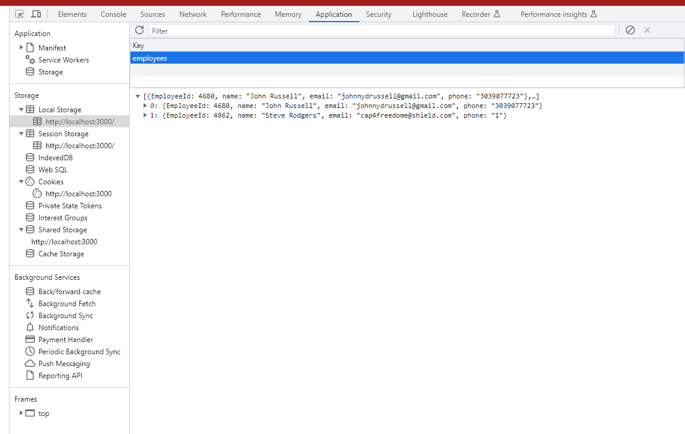
Alt Text: Screenshot of the Employee Data on the Local Storage page.
- Add it to your paper in an appendix, formatted according to APA Style. Refer to the Tables, Images, and Appendices resource for assistance in adding the appendix.
- Write about 100 words describing your experience while completing the first part of your assignment. Share your perspective on the following:
  - The steps you took to achieve your weekly assignment’s goal.
  - Whether you think there were easier, simpler ways of achieving the assignment goal.
  - Anything else that stood out as a question, hurdle, or insight.

______END OF DOCUMENT_______

