

Course: INT304 – Web Design and Development
Week 4 – Building the Employee List and Final Details – Instruction Manual

WEEK 4

Advanced REACTJS

Assignment: Building the Employee List and Final Details
In this week’s assignment, you will build an employee list and final details. This data will persist even after the page is refreshed or closed and reopened.
Part 1:
Follow the instructions given below to save the employee data to the local storage of the browser.
Reference: https://www.pragimtech.com/blog/reactjs/iterate-list-in-react/
 | What to do | How to do
1 | Create the Employee List Component. | function EmployeeList(props) {  // Render the employee list  return (  <div className="employee-list">  <h1>Employee List</h1>  <ul>  {props.employees.map((employee) => (  <li key={employee.EmployeeId}>  {/* Create a link to the employee detail page */}  <Link to={`/employees/${employee.EmployeeId}`}>  {employee.name}  </Link>  </li>  ))}  </ul>  </div>  );  }  Refer to https://github.com/JohnRussell-UAGC/employee-management-system/tree/Assignment-4 for any help with code
2 | Update the App Component.
3 | Style the Employee List. | Use the CSS components that you created in Week 2.
4 | Test and finalize. | Run the application as you learned in Week 1.
5 | Commit your changes to your GitHub repositories after you have verified the changes. | As a final step, verify that your browser behaves as expected. If it does not, you should check your console for any error messages, verify your code against the original in the GitHub repository, and ask for help, if needed.
Important:
We recommend you use GitHub code hosting platform to upload your work. This will enable you to version control and collaborate effectively with your instructors and peers.

Part 2:
- Take a screen capture of the Employee Form.
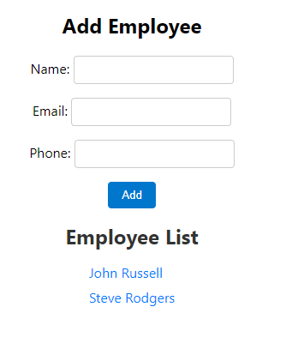
Add it to your paper in an Appendix, formatted according to APA Style. For assistance on adding the Appendix, refer to Tables, Images, and Appendices resources.
- In about 100 words, describe your experience while completing the first part of your assignment. Do share your perspective on:
  - the steps you took to achieve the goal of your weekly assignment.
  - in hindsight, do you think there were easier, simpler ways of achieving the assignment goal.
  - anything else that stood out as a question, hurdle, or insight.

______END OF DOCUMENT_______

