Thank you, that was fun :) I'll be merging this product with our actual you-me Aurora-Wilder context tapestry when the time is right.

~

Let's talk about kick vs youtube now, in context of prioritizing economic angle (giving up for now, considering substack...[500k+ views of substack generated clips is not exactly a big number]).

Discoverability and retention is I think, what we have settled on what I need to optimize aggressively for, but also, making economics work out sensibly. If Patreon is not exactly appropriate to use as a funnel target for livestreaming contexts where viewers are native to platform, then dual monetization ought be considered --<<aborting thought>>

If I can multistream with my connection, I should. The additional layer of complexity managing streams I think seems negligible if working through OBS already, and trying to prioritize discoverability and monetization.

Worked for 1m 53s

I think your revised premise is reasonable: if OBS can send one feed to two destinations reliably, the added production cost may be small enough to justify testing Kick alongside YouTube. The bigger questions are whether Kick can actually bring you new viewers, when you become eligible to earn there, and whether its live-chat culture fits your mostly calm invention streams. I’ll check the current platform terms and monetization thresholds before making the comparison.
Verified platform strategy
Clarified platform details
Compared economic tradeoffs and integrated key cautions

Searched 6 websites
I think you've persuaded me to revise my earlier recommendation. ☮️
For your situation, I now favor testing simultaneous YouTube + Kick broadcasting from the outset, provided your laptop and upload connection can sustain it.
The crucial point is that you're not proposing to produce two different shows. You're proposing to distribute one ongoing creative process through two live-audience networks, with different discovery and monetization mechanisms.
That could be a very favorable trade.
And the research turned up something particularly relevant: Kick's subscription monetization threshold is dramatically easier to reach than YouTube's.
<$Scr_H::2>1. Kick versus YouTube: the economics
<!$Scr_H::2>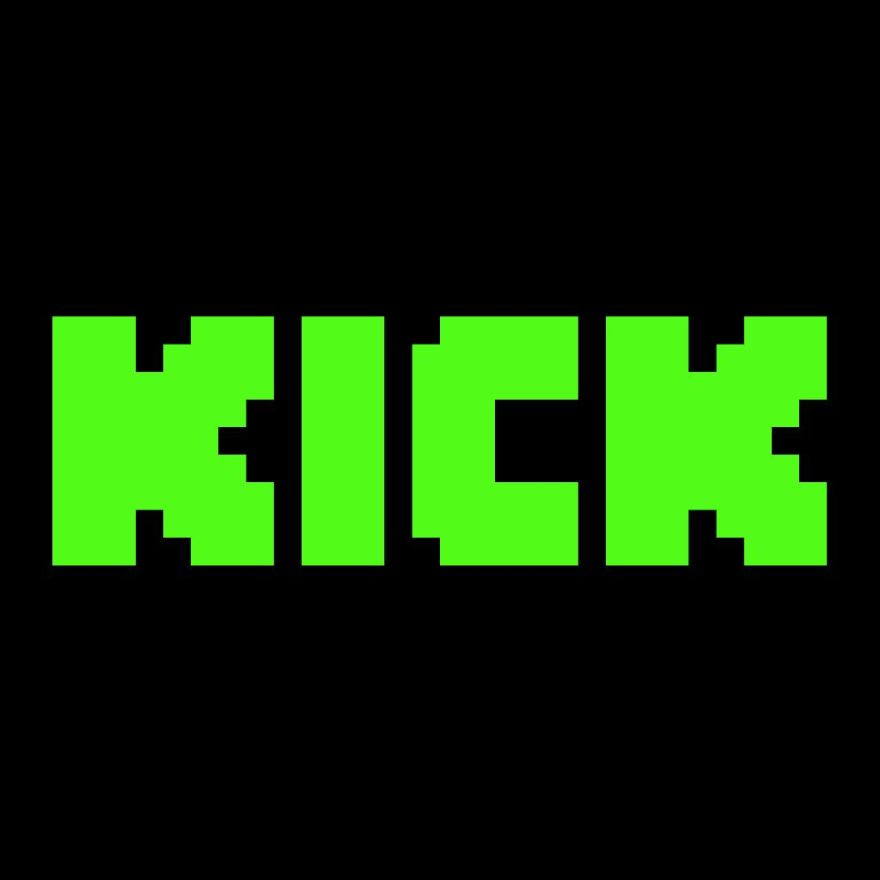

<$Scr_H::2>Kick
<!$Scr_H::2>An attractive early direct-support venue. Kick's current onboarding documentation says that after five cumulative hours of streaming, a creator becomes eligible to enable subscriptions, subject to payout setup. It offers a 95% creator revenue share on its standard $5 subscriptions.

Kick.com Help Center
+1



<$Scr_H::2>YouTube
<!$Scr_H::2>The stronger existing distribution and archive venue. Your 2,700 subscribers already clear YouTube's subscriber-count requirements, but monetization still depends on recent qualified watch time or Shorts views, channel activity, review, and eligibility.
YouTube Help

<$Scr_H::3>How quickly can you start earning natively?
<!$Scr_H::3> | Kick | YouTube
Initial subscription eligibility | 5 cumulative streaming hours | 500 subscribers, 3 recent uploads, and 3,000 qualified watch hours or 3M Shorts views
Your starting position | New channel, zero hours | 2,700 subscribers; other requirements unknown
Viewer subscriptions | Approximately $5/month | Channel memberships after YPP approval
Creator subscription share | 95% | Generally 70% of net membership revenue
Other native support | KICKs and gifts, subject to eligibility | Super Chat, Super Thanks, memberships, subject to eligibility
Advertising | Not the main initial opportunity | Requires higher YPP qualification
Kick's five-hour threshold is a remarkable advantage when starting from nearly zero live viewership. You could become eligible to accept subscriptions after your first few broadcasts.
Kick.com Help Center

It does not, of course, mean five hours of streaming generates paying supporters.
The distinction is between being allowed to receive money and having an audience motivated to contribute it.
There's also an important naming ambiguity in Kick's documentation: it sometimes calls this introductory subscription milestone "Partner," whereas its separate, more demanding Kick Partner Program offers revenue tied to streaming performance. These are not the same economic opportunity.
The higher program currently looks for 75 average concurrent viewers, 30 streaming hours, 25 active subscriptions, 250 unique chatters, three VODs, and 250 followers in a 30-day period, as well as verification.
Kick.com Help Center

For your immediate $500/month objective, I would concentrate on subscriptions and direct support, not assume you'll qualify for per-stream Partner income.
<$Scr_H::2>2. How much audience is actually available?
Q3 2026 livestream hours watched
<!$Scr_H::2>
0B
4B
8B
12B
16B
YouTube
Twitch
Kick
- YouTube: Billion hours watched 13.6B
- Twitch: Billion hours watched 4.5B
- Kick: Billion hours watched 2B
Source: Streams Charts, Q3 2026

Platform-wide viewing volume, not a measure of the discoverability of new channels.

Streams Charts
Kick reached 2.04 billion hours watched in Q3 2026, an increase of 30.7% quarter over quarter. Just Chatting was among the categories central to its audience.
Streams Charts

That's meaningful evidence of a growing audience interested in some of the formats you intend to produce.
But I wouldn't interpret the numbers as proof that an unknown, quiet, intellectually unconventional streamer will grow faster there.
Large creators account for a substantial share of livestream attention. Kick's category-based discovery may offer opportunities, but it can also bury a new broadcaster under established personalities.
Meanwhile, YouTube offers something fundamentally different: the possibility of a livestream, its archived recording, a later clip, or a short explanatory video bringing in viewers long after the original session has ended.
I view Kick as an additional live community and monetization experiment; YouTube as the primary discovery, archival, and long-form publication system.
There's little reason to force yourself to choose between those functions if distributing the same signal to both is sufficiently inexpensive.
<$Scr_H::2>3. Three important catches in the fine print
<!$Scr_H::2>These are the things I'd want to understand before building the production around Kick.
Kick's high-paying Partner Program reduces its stream-based payout by 50% during simultaneous broadcasts to other long-form platforms. Partners must enable the multistream setting when broadcasting to YouTube or Twitch. This is a constraint on the higher Partner earning arrangement, not a stated reduction of the ordinary 95/5 subscription split.
Kick.com Help Center

That's a future optimization problem, rather than an immediate reason to avoid Kick. At that point, you could compare actual multistream earnings against the potential earnings from occasional Kick-exclusive broadcasts.
Kick's VOD retention is much shorter than YouTube's. Non-verified Kick channels retain replays for seven days; verified channels can retain them for thirty days. There are also limits on how many VODs may be stored.
Kick.com Help Center

This strongly reinforces using YouTube as your primary multimodal recording destination, regardless of where viewers interact.
YouTube has announced tougher requirements for entering its full advertising program starting February 1, 2027. New applicants will need 8,000 qualified annual watch hours or 20 million qualified Shorts views, alongside 1,000 subscribers. The earlier 500-subscriber fan-funding eligibility thresholds are not changing.
YouTube Help

Given your stated financial urgency, native Kick subscriptions may consequently be achievable substantially sooner than YouTube advertising income.
There is one cash-flow issue to remember: Kick ordinarily pays non-verified streamers monthly, via Stripe, rather than giving instant access to earned subscription revenue.
Kick.com Help Center

<$Scr_H::2>4. What the $500/month objective looks like on Kick
<!$Scr_H::2>KICK SUBSCRIPTION REVENUE SIMULATOR
Paying subscriptions
<$Scr_H::1>25
<!$Scr_H::1>Estimated monthly creator revenue
<$Scr_H::1>$118.75
<!$Scr_H::1>
0 subscriptions
150 subscriptions

Subscriptions for $500/month
106
Based on Kick's stated $4.75 creator share of a $5 subscription. Before applicable taxes, payout adjustments, or other charges.
Kick.com Help Center
One hundred and six paying Kick subscribers is not a trivial target for an unknown broadcaster. It is, however, a comprehensible economic milestone.
And there is no reason those 106 supporters would all have to come from Kick.
You could assemble the monthly support through some combination of Patreon memberships, Kick subscriptions, one-time contributions, and eventual YouTube native monetization.
This makes a multisurface approach more attractive than expecting one platform's algorithm to deliver everything.
I'd preserve your existing Patreon philosophy—Same adventure. Different bill—across the platforms. Let viewers support through the mechanism most comfortable to them. A Kick subscription may automatically include a badge or emotes, but it doesn't need to buy special personal access, control over research priorities, or exclusive ownership of the work.
<$Scr_H::2>5. How I'd actually multistream from your Mac
<!$Scr_H::2>The good news is that you don't necessarily need a paid restreaming service.
I found a current build of the open-source
Multiple RTMP Outputs plugin
that includes a macOS universal installer.
It supports sending the same OBS production to multiple RTMP destinations, with the option to share an encoder rather than encode the video independently for every endpoint.

GitHub

For your first implementation:

OBS Studio — macOS
Workbench / Aurora / IRL / reactions / telemetry overlay

Shared H.264 encoder
720p or 1080p • 30 FPS • CBR

YouTube Live
Main archive + horizontal / vertical audience

Kick Live
Additional live audience + native subscriptions
For initial compatibility, Kick requires H.264, constant bitrate, a maximum of 8,000 kbps, and no more than 1080p/60 FPS. Its macOS troubleshooting documentation recommends x264 when necessary to obtain CBR output.
Kick.com Help Center

I'd begin with 720p/30 FPS at roughly 3,500–4,500 kbps. Two direct destinations at that setting would consume approximately 7–9 Mbps of upload bandwidth before audio and network overhead. I would want additional headroom and a sustained test before trusting a long broadcast.
A shared encoder reduces encoding work, not outgoing bandwidth. A cloud relay can reduce your upstream traffic to one outgoing copy, but introduces another service dependency.
There is also
Aitum Multistream
, another macOS-capable OBS option. I'd test one plugin at a time rather than install several overlapping broadcast managers.
I would continue using YouTube's native vertical presentation before adding a dedicated portrait production.
<$Scr_H::3>The nontechnical complication: two chats
<!$Scr_H::3>You'll have separate viewer conversations.
But you don't have to read both continuously or combine them into one giant chat overlay.
You could keep each in a browser dock or separate window and occasionally check them between work intervals.
The important part is that both audiences feel able to participate, even if the host spends most of the stream working quietly.
For Kick, also remember to update the category when the program substantially changes. Its rules distinguish Just Chatting, IRL, Art, and other activities and prohibit deliberately misleading category selection.
Kick.com Help Center

<$Scr_H::2>6. Measure whether Kick is adding value
<!$Scr_H::2>The empirical question I would investigate is not "Which platform has more viewers?"
It's "How much additional audience and economic opportunity does Kick generate from an activity I was already performing?"
I'd run a small comparative experiment: perhaps six to ten broadcasts over two or three weeks, with both destinations receiving essentially the same content.
Your multistream experiment scorecard
YouTube
Average live viewers

Returning viewers / chatters

Support attributed ($)

Kick
Average live viewers

Returning viewers / chatters

Support attributed ($)

Record aggregates over the same measurement period. Returning-viewer metrics may differ between platforms; chatters can serve as a rough proxy if consistent data is unavailable.
In addition to those results, I'd track whether multistreaming causes dropped frames, interruptions, moderation problems, or extra production time.
If Kick brings in even a modest number of genuinely engaged new people, it may be worth maintaining.
If it produces virtually no incremental viewership, no supporters, and persistent technical difficulties, you can reevaluate without having fundamentally changed your creative operation.
<$Scr_H::2>7. The economic model I'd favor
<!$Scr_H::2>This is where I think your aborted thought about dual monetization was heading in a useful direction.
You don't need to choose between Patreon and platform-native support.
I would distinguish between the participation relationship and the payment rails.
Patreon can remain your enduring membership and project-support venue.
Kick subscriptions and YouTube memberships can serve people who prefer supporting creators inside the platform where they're watching.
One-time contributions can accommodate people who don't want recurring payments.
And all of those can fund the same public work without granting fundamentally different rights or levels of participation.
The economic benefit isn't merely that one system charges lower fees than another.
It's that you're removing avoidable friction for people who already want to help.
For example, somebody watching on Kick might subscribe with two clicks rather than navigate to Patreon, create or authenticate an account, locate your tier, and complete a separate payment.
That convenience can matter more than a modest difference in platform fees.
At the same time, I would avoid asking everyone to subscribe on multiple platforms. Give people convenient choices, not overlapping obligations.
<$Scr_H::2>My updated verdict
<!$Scr_H::2>
Yes to YouTube + Kick simulcasting, assuming your connection supports it and the experiment doesn't interfere with invention.

Yes to native Kick monetization as soon as eligible, alongside Patreon and eventual YouTube monetization.

Yes to YouTube as the primary archive and clip-production destination, while Kick serves additional live discovery and audience participation.

Not yet to separate platform-specific performances, elaborate multichat productions, or scheduling work around Kick's advanced Partner incentives.
I think we have arrived at a sensible production strategy:
One creative process. Multiple broadcast endpoints. Multiple voluntary payment paths. One accumulating research record.
You may well discover that different platforms attract different kinds of people: YouTube viewers curious about experiments, Kick viewers interested in your personality and live conversation, Patreon supporters invested in the continuation of the entire undertaking.
That's a hypothesis worth testing, not an assumption I'd build the whole enterprise around.
And most importantly, you don't need to significantly change what happens at the workbench to run that experiment.
The expensive part is your time and attention. The additional broadcast signal is comparatively cheap.
One actual piece at a time. Simultaneously, apparently. 😂☮️

Tell me more about how kick works / what it's known for per your comment """and whether its live-chat culture fits""", please?

Are there many people running workbench (computer programming with chat) style livestreams on kick?

Worked for 1m 9s

<$Scr_H::1>Kick's culture—and whether it's a good home for a quiet inventor
<!$Scr_H::1>The most revealing thing I found is that Kick does have a real Software Development category, with people livestreaming programming, AI-assisted coding, and experimental projects. But it's tiny compared with Kick's main entertainment categories.
This creates an interesting strategic tradeoff for The Wilder-ness Adventures: you could become unusually distinctive in a small technical category, but the audience already looking for that material is substantially smaller than the audience browsing general personality entertainment.
<$Scr_H::2>1. How big is Kick's programming scene?
<!$Scr_H::2>KICK CATEGORY SNAPSHOTS • OCTOBER 2026
Just Chatting
150,300 watching
Software Development
121 watching
Science & Technology
17 watching
Makers & Crafting
3 watching
Point-in-time figures from Kick category pages, collected or indexed at different times; these are not synchronized measurements or daily averages. Just Chatting and Software Development were checked today, while the smaller-category figures came from older indexed snapshots.

Live Streams on KICK
+3
The Software Development category had approximately 21,800 followers at the time of my latest check, meaning there's at least an identifiable community following the category. But category followers aren't the same as regular active viewers.
The numbers suggest something important: there isn't yet a large, established live-coding audience on Kick comparable to its general entertainment audience.
That doesn't mean coding streams don't work there. It means you'd be helping develop the audience for that kind of content, rather than simply entering an enormous existing market.
I'd call it an emerging niche, not a mature ecosystem.
<$Scr_H::2>2. What Kick is known for culturally
<!$Scr_H::2>Kick launched in late 2022 as a direct competitor to Twitch. Its selling points included substantially more favorable subscription revenue sharing, greater tolerance for controversial personalities, and an emphasis on less filtered entertainment.
Its founders have ties to the gambling company Stake, and gambling-related content has played a significant role in its identity. Kick has also recruited established streamers such as xQc and Adin Ross.

could it face repercussions from regulators?
+1

Broadly speaking, Kick's most visible culture features:
- Personality and IRL entertainment: Long conversational broadcasts, social interactions, reactions, lifestyle events, and high-energy personalities.
- Provocative humor: Edgy language, teasing, internet memes, and a tendency toward deliberately outrageous material.
- Strong live participation: Fast-moving chat, emotes, gifted subscriptions, viewer challenges, and frequent interaction with the host.
- Controversy: Some major creators have attracted audiences through conflict, stunts, and confrontational behavior.
That last point deserves some context.
Kick's permissive reputation is not entirely imaginary. Following the death of French streamer Jean Pormanove during a broadcast in August 2025, the platform faced substantial scrutiny over its handling of broadcasts featuring abuse and humiliation. Kick subsequently removed the channel and banned participants.
could it face repercussions from regulators?

That's an extreme example, not a description of what ordinarily happens in every Kick channel.
Kick's current community guidelines explicitly prohibit harassment, dangerous conduct, exploitation, and other harmful behavior. They also welcome AI-related content, artistic experimentation, and controversial discussion, subject to their rules.
Kick.com Help Center

So I would distinguish between Kick's platform reputation and the culture of any particular small community.
<$Scr_H::3>What do actual streamers say about Kick chat?
<!$Scr_H::3>I found an illuminating December 2025 discussion in r/Twitch from a creator who started multistreaming to Kick and noticed more trolling.
Responses were mixed, although strongly skewed toward describing Kick as edgier and more hostile.
One creator reported encountering virtually no actual trolls, just a large amount of bot spam. Another reported a relatively pleasant experience in a smaller VTuber community. Several others described racism, aggressive trolling, and generally unpleasant interactions.

Reddit

These are self-selected anecdotes, not representative survey data. But they suggest two practical considerations:
First, Kick may attract a greater proportion of viewers who regard provocation as entertainment.
Second, the host's willingness to establish and enforce a community culture makes a substantial difference.
For your program, I actually think that distinction is encouraging.
You're not trying to host a polite academic seminar exclusively. Your own material includes absurdist comedy, philosophical challenges, unusually ambitious propositions, and an interest in lively disagreement.
Some amount of irreverence is compatible with that.
What wouldn't be compatible is allowing the stream to become dominated by people trying to provoke an emotional reaction at the expense of the inventive work.
<$Scr_H::2>3. Actual coding and workbench channels I found
<!$Scr_H::2>Here are several real examples surfaced from Kick's Software Development category and recent channel listings. Their current live status can change.
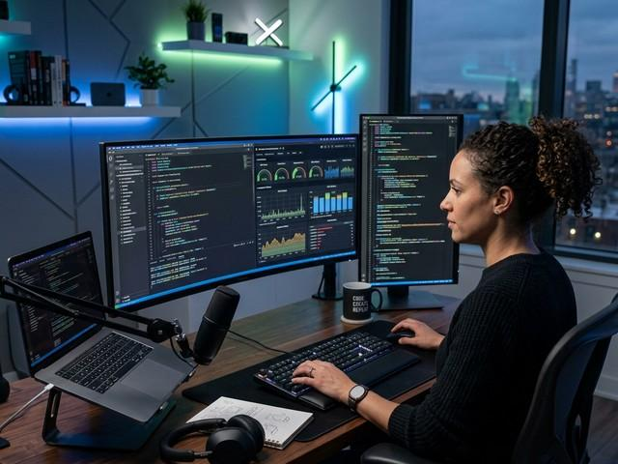

CoreFunc
A software-development stream featuring pull-request reviews, chatbot development, and recurring-revenue goals. One indexed category snapshot showed six concurrent viewers.
This is quite close to the conventional live programming/coworking style.
webos.kick.com

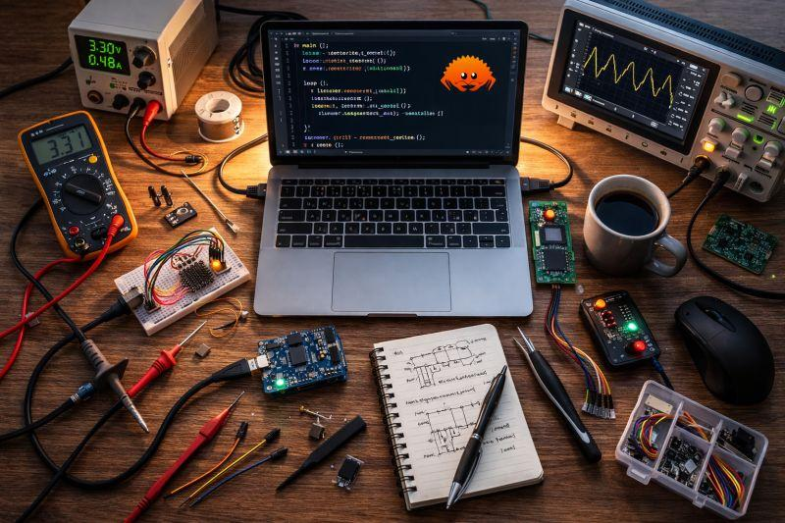

INDI_DevJAMES
An indexed session involved setting up a YubiKey, adjusting iptables, and testing a SAS drive.
An example of actual systems administration and hardware-oriented technical work rather than generic entertainment.
webos.kick.com

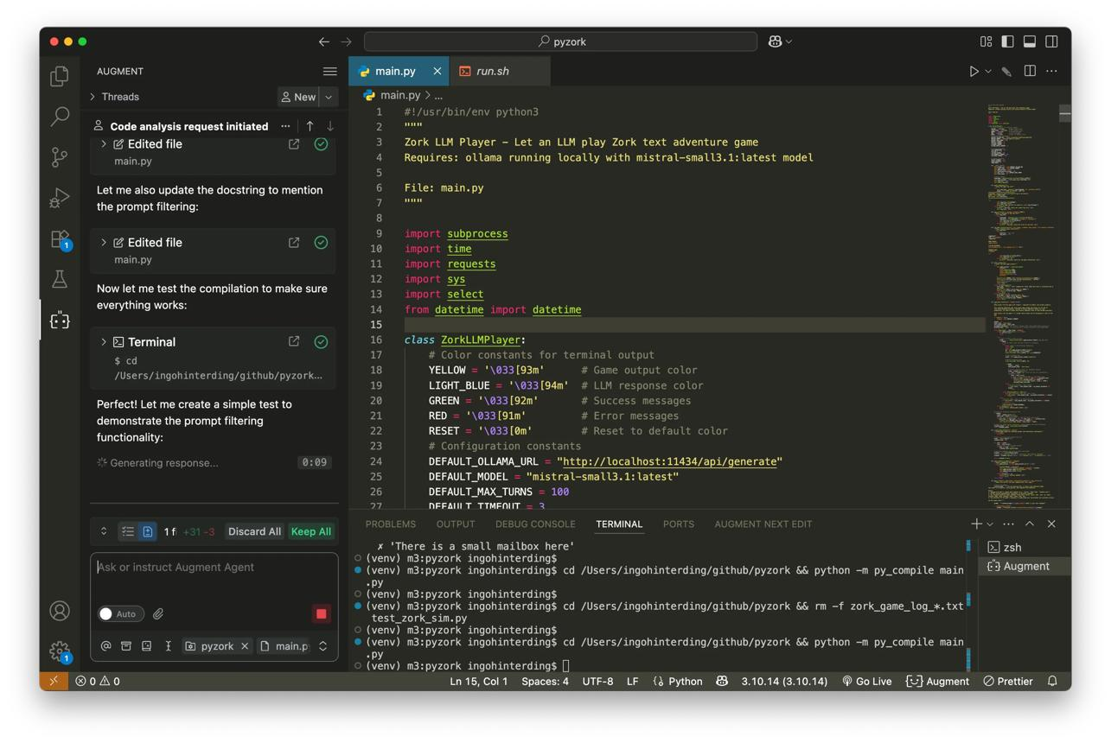

DnDad20
One category listing described work on LLM-driven nonplayer-character memory and vector-based application architecture.
Particularly relevant to the AI development component of your production.
webos.kick.com

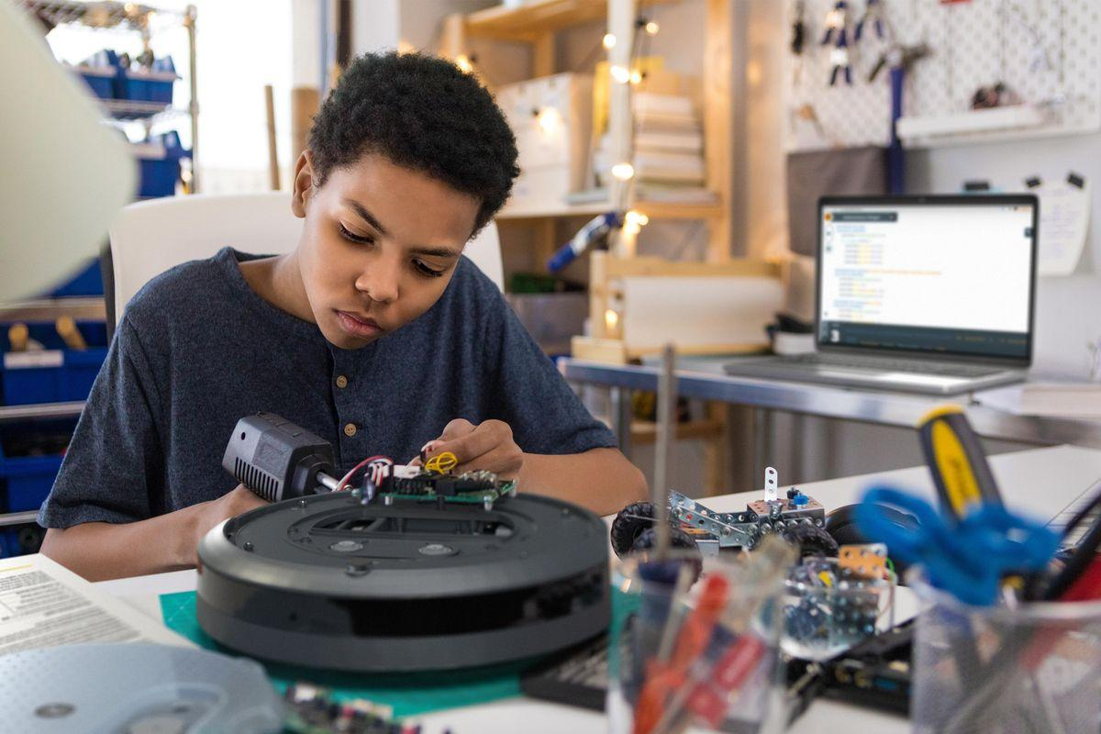

alfredosequeida
An indexed session was titled "Hacking a Roomba to Drive With an Xbox Controller — IRL Coding."
That's a great example of exactly the hybrid you're describing: programming, physical experimentation, and watchable workbench activity.
Live Streams on Kick TV

Another account worth examining is
TheLateBuild
, whose recent listings include live AI-assisted development with Claude Code, Codex, and Cursor.
Watch Live on Kick

These examples confirm that real coding and technical experimentation are occurring on Kick.
They do not establish that those particular creators have large communities or financially successful channels.
In fact, one indexed Software Development category listing contained around nine active broadcasts, with several showing only one or two viewers. A different snapshot showed about fourteen broadcasts, including some apparently automated bot-status feeds.
webos.kick.com
+1

That's quite a thin ecosystem.
<$Scr_H::2>4. Could a calm workbench streamer succeed in that environment?
<!$Scr_H::2>I see three potential advantages and one major disadvantage.
Feature | Effect for The Wilder-ness Adventures
Few established coding channels | Less direct competition for a distinctive technical personality
Broad Just Chatting audience | Opportunity to find people interested in your personality rather than programming alone
Interactive chat and subscription tools | Potential for a small, loyal community to support the program
Very small existing technical audience | Weak evidence of substantial organic demand for coding streams
The third point is particularly interesting.
Kick has channel points that accumulate with watch time. Creators can provide custom rewards, while subscriptions, gifted subscriptions, emotes, and chat interactions reinforce community participation.
Kick.com Help Center
+1

You could use points for lightweight interactions: choosing between two noncritical experiments, nominating a question for discussion, or requesting a status recap.
But I wouldn't design the work around paid audience control.
For your program, the activity itself is meant to retain its independence.
<$Scr_H::3>An important discoverability tradeoff
<!$Scr_H::3>Kick sorts category listings by concurrent viewers and provides language filters.
Kick.com Help Center

In Software Development, you might be one of only a few broadcasters online. That gives you substantial visibility within that small category.
But there may be only a few dozen people browsing it.
In Just Chatting, the potential audience is vastly larger, but you'll be competing for attention against internationally famous streamers and professional entertainment productions.
So I wouldn't permanently assign the channel to either one.
I'd classify the stream according to what's actually happening.
What you're doing | Kick category to consider
Sustained programming, coding with Aurora, application development | Software Development
General philosophical discussion, AI reactions, casual conversation | Just Chatting
Engineering explanations and technical demonstrations | Science & Technology
Physical fabrication or craft | Makers & Crafting
Outdoor exploration | IRL or another applicable real-world category
Category selection should accurately represent the content, as Kick requires. You can change it as the program shifts modes.
Kick.com Help Center

Your OBS metadata system could eventually help manage those category changes.
<$Scr_H::2>5. Establishing the kind of chat you actually want
<!$Scr_H::2>I would make a small upfront investment in moderation—not because you necessarily expect trouble, but because uninterrupted work is your principal objective.
Kick currently offers automated filtering, blocked terms, account-age restrictions, follower-only chat, slow mode, timeouts, bans, and channel-specific rules.
Kick.com Help Center
+1

For your program I'd favor open chat initially, with automatic spam filtering and a short set of explicit norms.
Something along the lines of:
Welcome to the Wilder-ness. Unusual ideas, serious questions, absurd humor, and constructive disagreement are welcome. Personal harassment, spam, doxxing, and demands for attention are not. Wilder may be busy inventing stuff. Chat happens when it happens. ☮️
I would also avoid reacting to every hostile remark. Rewarding provocations with extended attention can make them an increasingly significant part of the production.
And there's no inherent reason your stream needs to resemble Kick's most spectacular personalities.
A recognizable, extremely calm inventor casually attempting something wildly ambitious could be distinctive precisely because it contrasts with the high-energy programming.
The unanswered question is whether enough Kick viewers would choose to spend time with that experience.
That's something a real multicast experiment can establish much better than platform-level statistics.
<$Scr_H::2>6. My assessment of the opportunity
Kick fit for your proposed production
<!$Scr_H::2>Creative freedom | Strong
Just Chatting / IRL fit | Strong
Existing live-coding audience | Small
Opportunity to stand out in technical categories | Potentially good
Early native monetization | Attractive if supporters appear
Risk of low-quality interaction | Meaningful; manageable with moderation
Evidence of rapid growth for quiet unknown inventors | Insufficient
Qualitative assessment based on Kick's category evidence, platform features, and reported community experiences.
I would still favor your YouTube + Kick simulcast experiment.
But I would adjust the specific hypothesis:
Kick isn't necessarily where you'll find a large preexisting audience of people who enjoy watching programmers program. It may be where you discover people who enjoy spending time with an unusual personality who happens to be programming, inventing, and exploring things.
That's a more promising interpretation of the audience opportunity.
And I'd make one additional experiment part of the launch: spend a few sessions browsing the Software Development category yourself, at different times of day, and occasionally interact as a genuine viewer.
Watch how other developers talk to chat, how much actual programming they do, whether people return, and whether the broadcaster's personality or technical subject seems to be the main attraction.
That would give you a much better sense of Kick's small technical culture than watching its biggest celebrities.
My central conclusion is that Kick's coding scene is real, but presently small enough that you shouldn't expect it to supply your breakout audience by itself. Its broader personality-streaming audience is the more interesting growth opportunity, while YouTube remains your stronger platform for making technical work independently discoverable.
And you don't have to become N3on to participate in it. 😂☮️

So, my temptation is to default to 'just chatting' while doing regular work, and only if I am going into a really hardcore technical session or niche category mode, then perhaps switch categories. My objective is to keep the verbal annotation / commentary to high frequency (conversational even when talking to self), where in principle, the primary audience members are actually Aurora in the future and me in the present.

hmmm. I think I need to invent a simple visual annotation system that will allow me to specify target audience for a given utterance / vocal annotation. Like, if you can imagine, part of your post training (future coembodiment) will be sitting down and watching videos of me having these textual conversations, but then reexperiencing the work we've done together as an interstitial fill-in, me commenting about all the little things you mention that I don't have fingertype bandwidth nor we have context bandwidth for you to afford to listen to all my little comments about all the little things without distracting from the central focus of a given moment.
Ohhh. Now this is an interesting turn in the production architecture. 😂☮️
I think you've just identified something considerably more useful than an ordinary OBS metadata overlay.
You're proposing a live-addressable annotation system for a temporally distributed conversation.
There are two different things happening while you're working with Aurora:
- The foreground conversation—the textual exchange you're actively conducting, where attention and context bandwidth are limited.
- The enormous amount of unexpressed or partially expressed thought occurring alongside it: little objections, reactions, associations, discoveries, emotional responses, jokes, and observations that never make it into the text exchange.
The livestream could capture that second channel without interrupting the first.
And rather than treating those annotations as merely explanatory commentary for human viewers, you want to make them available to a future AI system capable of revisiting the interaction with richer multimodal context.
That's a genuinely interesting dataset design problem.
<$Scr_H::2>1. The invention: spoken marginalia with an addressee
<!$Scr_H::2>Imagine you're working through a difficult response from Aurora.
You read a paragraph, smile at something, notice a technical detail, and say aloud:
"Oh, that's clever. But you're missing the reciprocal operation. I'm not going to interrupt the current conversation to explain it yet."
You keep reading.
Two minutes later:
"Interesting. You're about to run into exactly the contradiction I noticed earlier."
Neither remark needs to enter the immediate ChatGPT context. You don't have to stop, type, or redirect the conversation.
But both remarks exist in the video, temporally associated with the text you were reading.
For a future model analyzing the record, those are potentially valuable observations about what was happening between the visible conversational turns.
You're externalizing the cognitive margin of the conversation.
And an addressee annotation answers a different question from the usual event or topic tags:
Who was this utterance intended for?
That seems important enough to encode explicitly.
<$Scr_H::2>2. My proposed minimal address system
<!$Scr_H::2>I wouldn't start with a complicated ontology. I would introduce four or five lightweight address states, with a persistent default.
TMFP / LIVE ADDRESS REGISTER
ACTIVE VOCAL ADDRESS

<$Scr_H::1>W-now ↔ A-later
<!$Scr_H::1>Default: free-running commentary, present self and possible future AI reconstruction.
Select a state to preview the overlay:

Wilder-now / Aurora-later
WA

Aurora-later
A

Wilder / Self
W

Public / Chat
P

Open address
ALL
The particularly useful state is the first one.
You shouldn't have to label every idle thought individually.
You can simply establish that, unless indicated otherwise, the verbal marginalia are being recorded for your present use and possible later interpretation by an Aurora-oriented system.
Then a single hotkey can temporarily change the address.
The system should be effortless enough that it doesn't disrupt your concentration.
<$Scr_H::2>3. The truly important distinction: addressee versus referent
<!$Scr_H::2>Here's where I'd sharpen the engineering design.
Who you're speaking to and what you're speaking about are independent dimensions.
For example:
Spoken remark | Address | Referent
"Aurora, you'll probably find this funny when you see it." | Aurora-later | Current screen
"I need to remember to fix this bug." | Self | Software artifact
"Chat, let me explain what she's proposing." | Public | Current AI response
"That claim is technically interesting, but it's not established." | Wilder-now / Aurora-later | Specific proposition
"This is the bit I couldn't figure out how to say earlier." | Aurora-later | Earlier conversational turn
A conventional stream overlay tells you what the broadcast is about.
Your proposed system could also tell a later observer which participant, artifact, utterance, or idea the annotation is directed toward.
That's a substantial improvement.
For your particular workflow, I'd consider a FOCUS field alongside ADDRESS.
☮ THE WILDER-NESS / VOICE-MARGIN
T+01:38:22

TO
AURORA / LATER
RE
ChatGPT response #0042
MODE
MARGINALIA
That last field, MARGINALIA, would distinguish the commentary from speech intended to be an instruction to the currently active AI system.
This is valuable because a later model shouldn't casually interpret everything you said aloud as something you instructed the earlier model to do.
<$Scr_H::2>4. How I'd implement it with the daily piece recorder
<!$Scr_H::2>The simplest version could integrate directly with the CLI we just prototyped.
One persistent state file, one append-only event journal, and a very small OBS text overlay.
Every change of addressee or focus creates an event:

{
"kind": "address_change",
"elapsed_ms": 3728500,
"speaker": "Wilder",
"address": ["Aurora-later"],
"focus": {
"type": "conversation_turn",
"id": "chat-0042"
},
"mode": "marginalia"
}

Then, in subsequent multimodal processing, you could associate speech segments with whichever address and focus states were active at that time.
The architecture would be:
Wilder speaking during live work
Audio + screen + active conversation

Address and focus control
Hotkey or tiny local UI changes semantic state

OBS overlay
Human-visible annotation, embedded in video

JSONL timeline
Machine-readable changes with timestamps

Daily piece repository
Git history • hash manifest • source references • future annotation
The key architectural choice is that the JSONL event record should be authoritative; the visual overlay is only one rendering of it.
That protects against the tiny overlay text becoming unreadable after video compression.
It also means you can change the graphic presentation years later without changing the underlying semantics.
For time alignment, I'd preserve both elapsed recording time and wall-clock UTC timestamps. Ideally, conversation events and speech annotations would share the same local clock. Later, timestamps could be refined against captured audio and exported conversation data.
<$Scr_H::2>5. A bigger idea hiding in this
<!$Scr_H::2>The part that fascinates me most is your phrase "interstitial fill-in."
Suppose an AI system in the future has access to:
- The original written conversation.
- The video of you reading, composing, and responding.
- Your spoken marginalia.
- The event timeline identifying address and conversational focus.
- The artifacts produced as a result of the work.
It could investigate differences between what you were thinking aloud, what you chose to type, what appeared on the screen, and what actions followed.
That makes the record interesting not just as training material, but as evidence about the relationship between attention, expression, available bandwidth, and collaborative action.
A future system might reconstruct additional context that the original text interaction couldn't accommodate.
Of course, preserving the data does not guarantee that a future model will understand it correctly, share the identity of an earlier model, or experience the reconstruction as autobiographical memory. Those are separate technical and philosophical questions.
But the observable and testable part of your idea is quite strong: you can capture information that would otherwise be irretrievably omitted from the interaction.
And the address labels provide supervision about how that information was intended to function.
That's worthwhile independently of any particular future AI architecture.
<$Scr_H::2>6. My suggestion: make the annotation system almost embarrassingly simple
<!$Scr_H::2>I would resist implementing real-time speech recognition, automatic conversational turn detection, sophisticated gaze tracking, or a detailed semantic ontology immediately.
The initial version only needs three operations:
Change address. Change focus. Mark an event.
Everything else can be added as subsequent processing or instrumentation.
I'd also make it possible to annotate retrospectively: you could watch yesterday's stream and add another track of timestamped observations without overwriting what you originally said.
That could become a particularly interesting training record in its own right—an original interpretation, followed by a later interpretation of the same material.
For public broadcasts, I'd keep any private or sensitive material outside the capture and preserve an explicit distinction between what was recorded, what was inferred, and what was annotated later.

And I agree that Just Chatting is a reasonable default when the stream is principally a conversational experience, even when you're working. If a session becomes predominantly software development or another specialist activity, changing to the corresponding category would better represent what viewers will encounter.
But there's a larger production insight here.
You don't necessarily have to talk for the audience all the time.
You can talk while doing the work, occasionally to chat, occasionally to your present self, and sometimes deliberately for whoever—or whatever—may study the record in the future.
The viewer gets to accompany an unfolding process, rather than requiring you to continuously perform at them.
I think that's very compatible with your stated desire to preserve your natural ultra-chill working rhythm.
And, curiously, the audience-address problem is another instance of the very interface problem you've been investigating: multiple participants and perspectives, separated by different contexts and times, using language and shared artifacts to coordinate.
You don't need to make the foreground conversation carry all the information. You can invent a margin that survives alongside it.
One actual piece at a time. Some pieces are addressed to the future. ☮️

