InClass 13 - Firebase Authentication in Flutter
ISCO 13 - Mobile App Development
Wilder Edwards
Nov 4, 2026 | Android emulator (Medium Phone, API 37)
Flutter 3.47.5 / Dart 3.13.4 / firebase_auth 7.0.1
Repository: https://github.com/WilderEdwards/my_product_app
AI disclosure: I used a free AI assistant for planning and for a review of my test plan. The tool, date, prompt, and what I did with the answer are in section 4.

1. What I built
The product list from In-Class 12 is still here: Firestore documents with add, edit, delete, search, and a price filter. The change is that it sits behind a login now. The app opens on an email and password form, a successful sign-in shows the profile, and the product list is a button on the profile. So it is only reachable by a signed-in user.
The Firebase calls all live in AuthService: register, signIn, signOut, changePassword, and the auth state stream. AuthGate wraps that stream in a StreamBuilder and returns the profile, the form, or a spinner. There is no Navigator.push after login, so sign out needs no special handling either. The form has a sign-in and a register mode with the same fields and validators, and it checks the email shape and a six-character password before calling Firebase. Error codes are translated into short sentences. The profile shows the email, opens the products, changes the password, and signs out.

2. Test evidence
All screenshots come from the release APK on the emulator, pointed at the real project my-product-app-d03af with Email/Password enabled. I used one test account, wilder.ica13@example.com, and no password appears in this document or the repository. The product search and price filter unit tests still pass.

T1 - Empty submit is blocked
Action: tapped Sign in with both fields empty. Expected: both fields marked, no network call. Observed: Email is required and Password must be at least 6 characters. Result: pass.
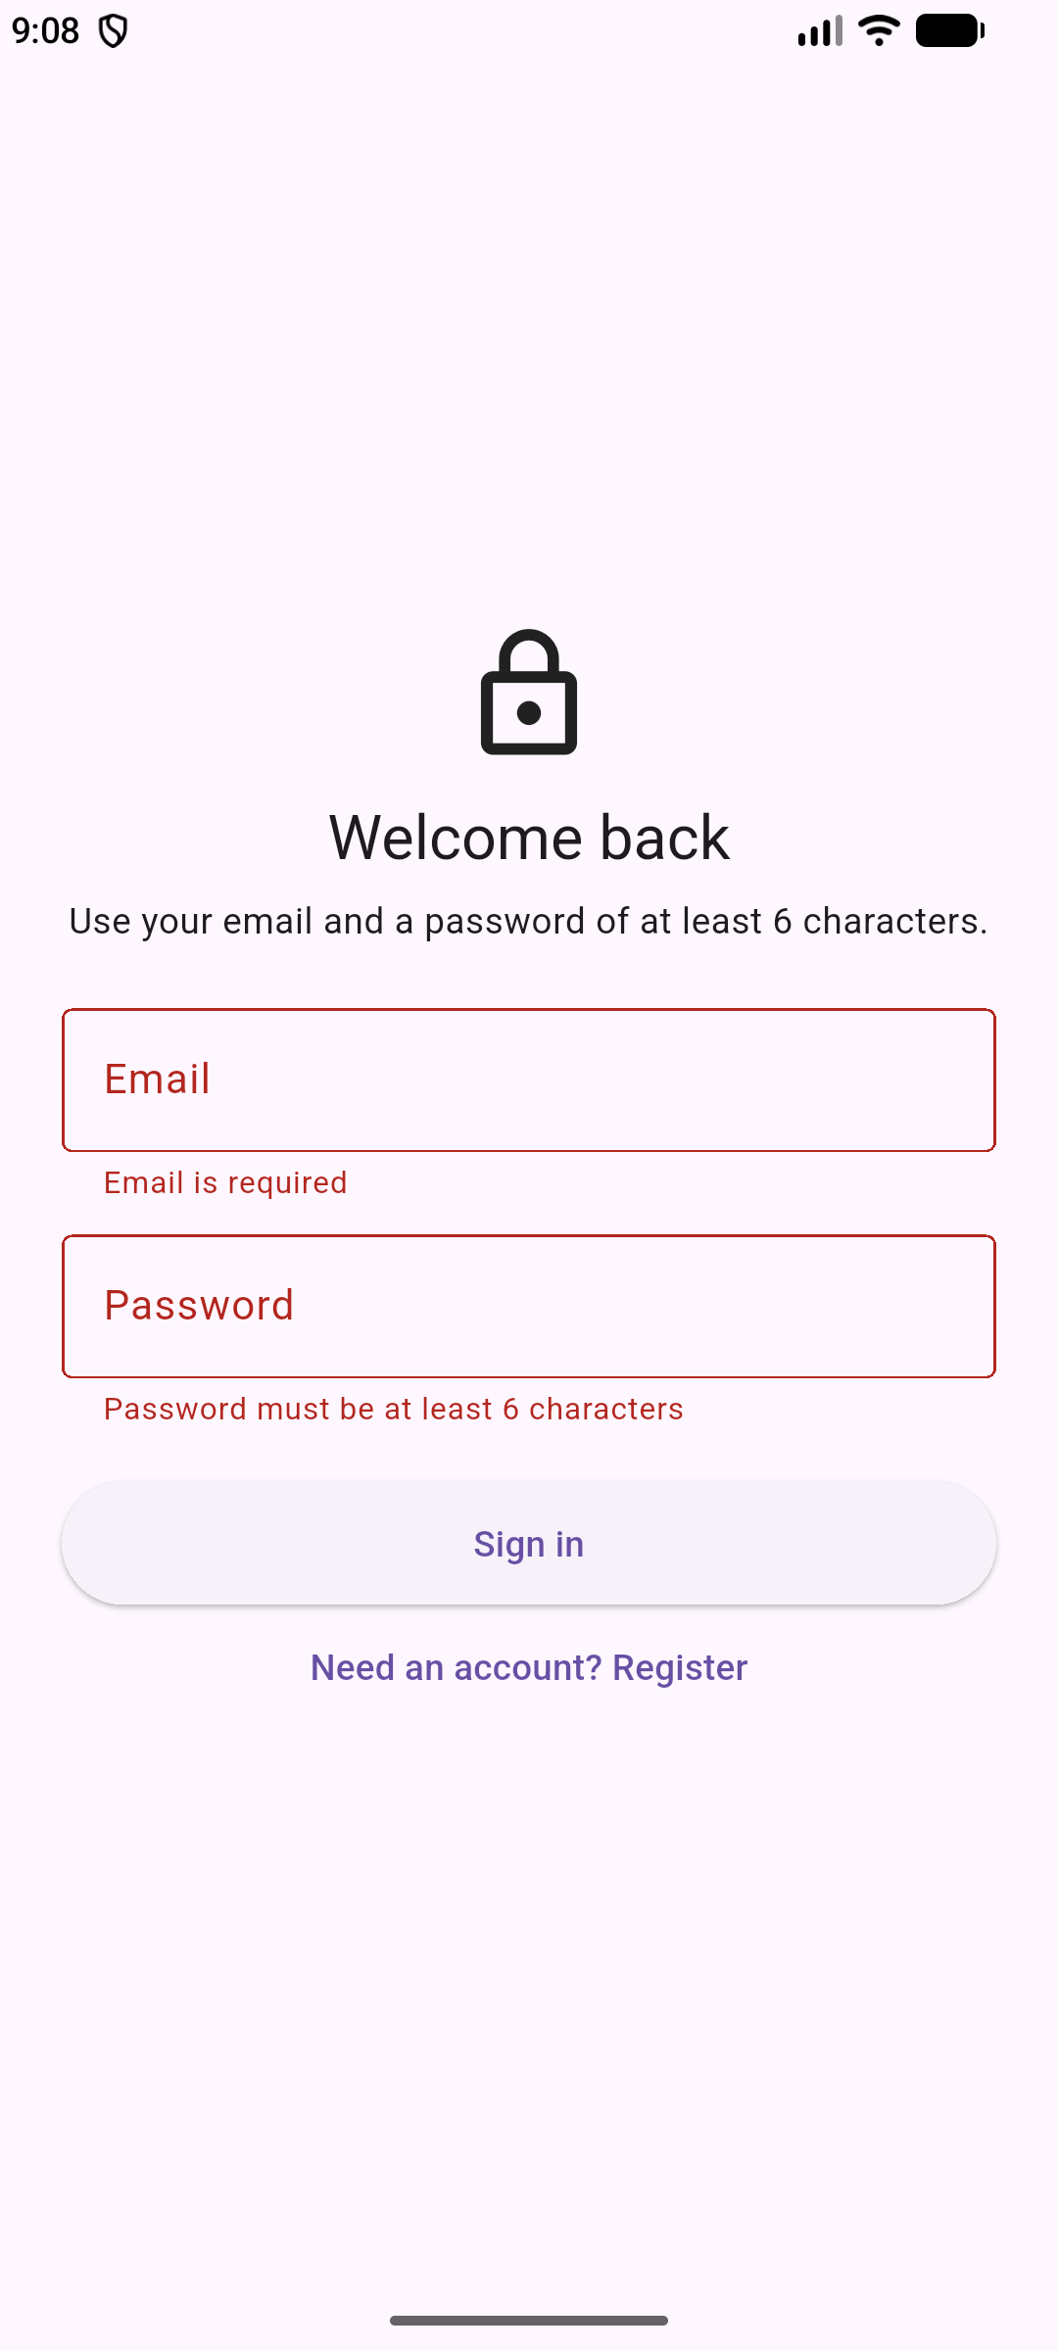
Fig 1 - Both fields rejected before any Firebase call.

T2 - Malformed email and short password
Action: typed wilder as the email and 123 as the password, then tapped Sign in. Expected: a format message and a length message, again with no request. Observed: Enter a valid email address and Password must be at least 6 characters. Result: pass.
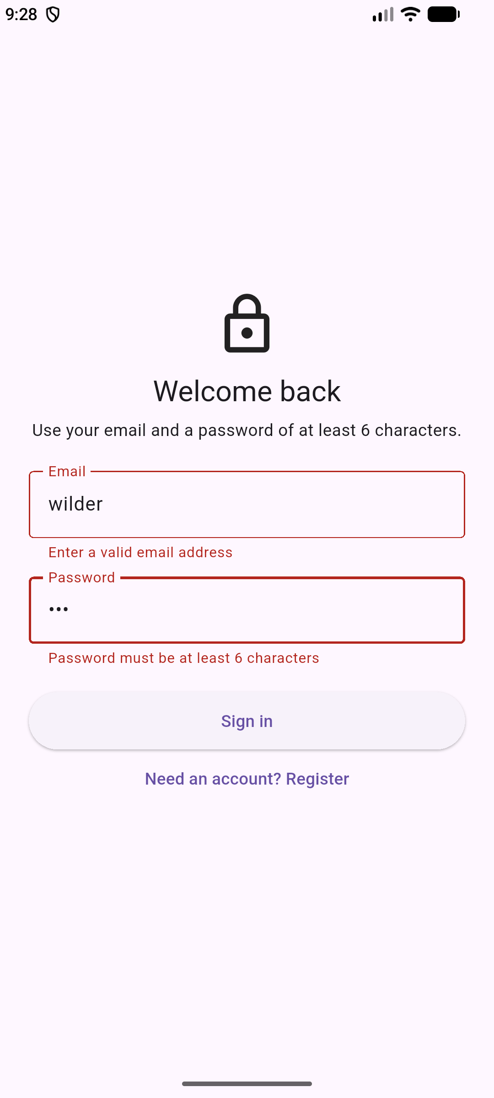
Fig 2 - Invalid format and short password caught locally.

T3 - Registration creates the account and signs in
Action: switched to register, entered the test email and an eight-character password, and tapped Create account. Expected: Firebase creates the user, signs them in, and the profile shows the email. Observed: the profile opened with the new email. I confirmed the account later in T6 by signing back in with that password. Result: pass.
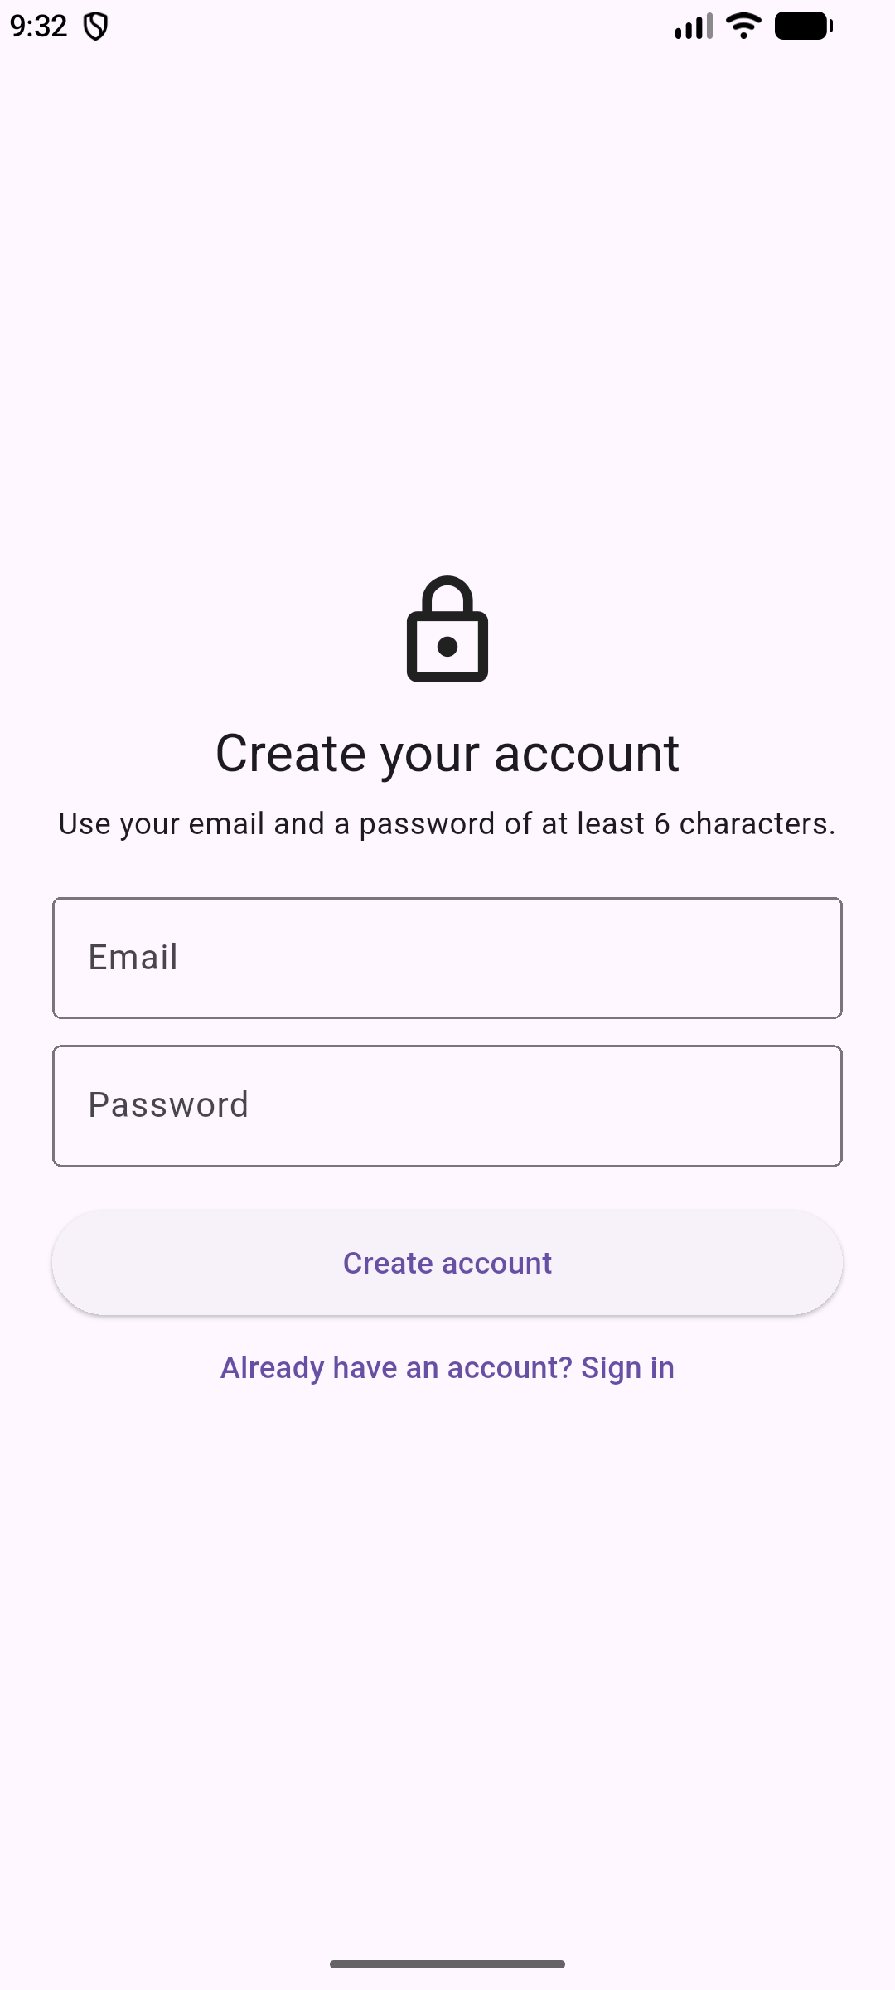
Fig 3 - Register mode uses the same form with a different action.
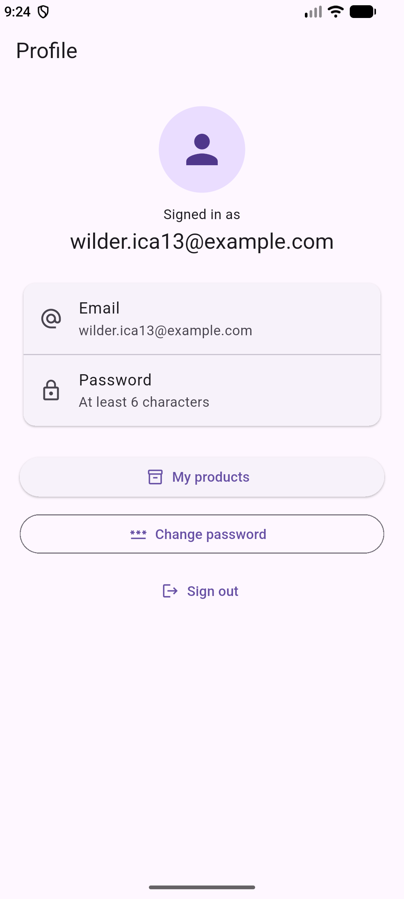
Fig 4 - The new account lands on the profile, email shown.

T4 - Password update
Action: opened Change password, entered the current password and a new one, and pressed Update. Expected: the dialog closes and the app confirms the change. Observed: the dialog closed and a Password updated snackbar appeared. Result: pass.
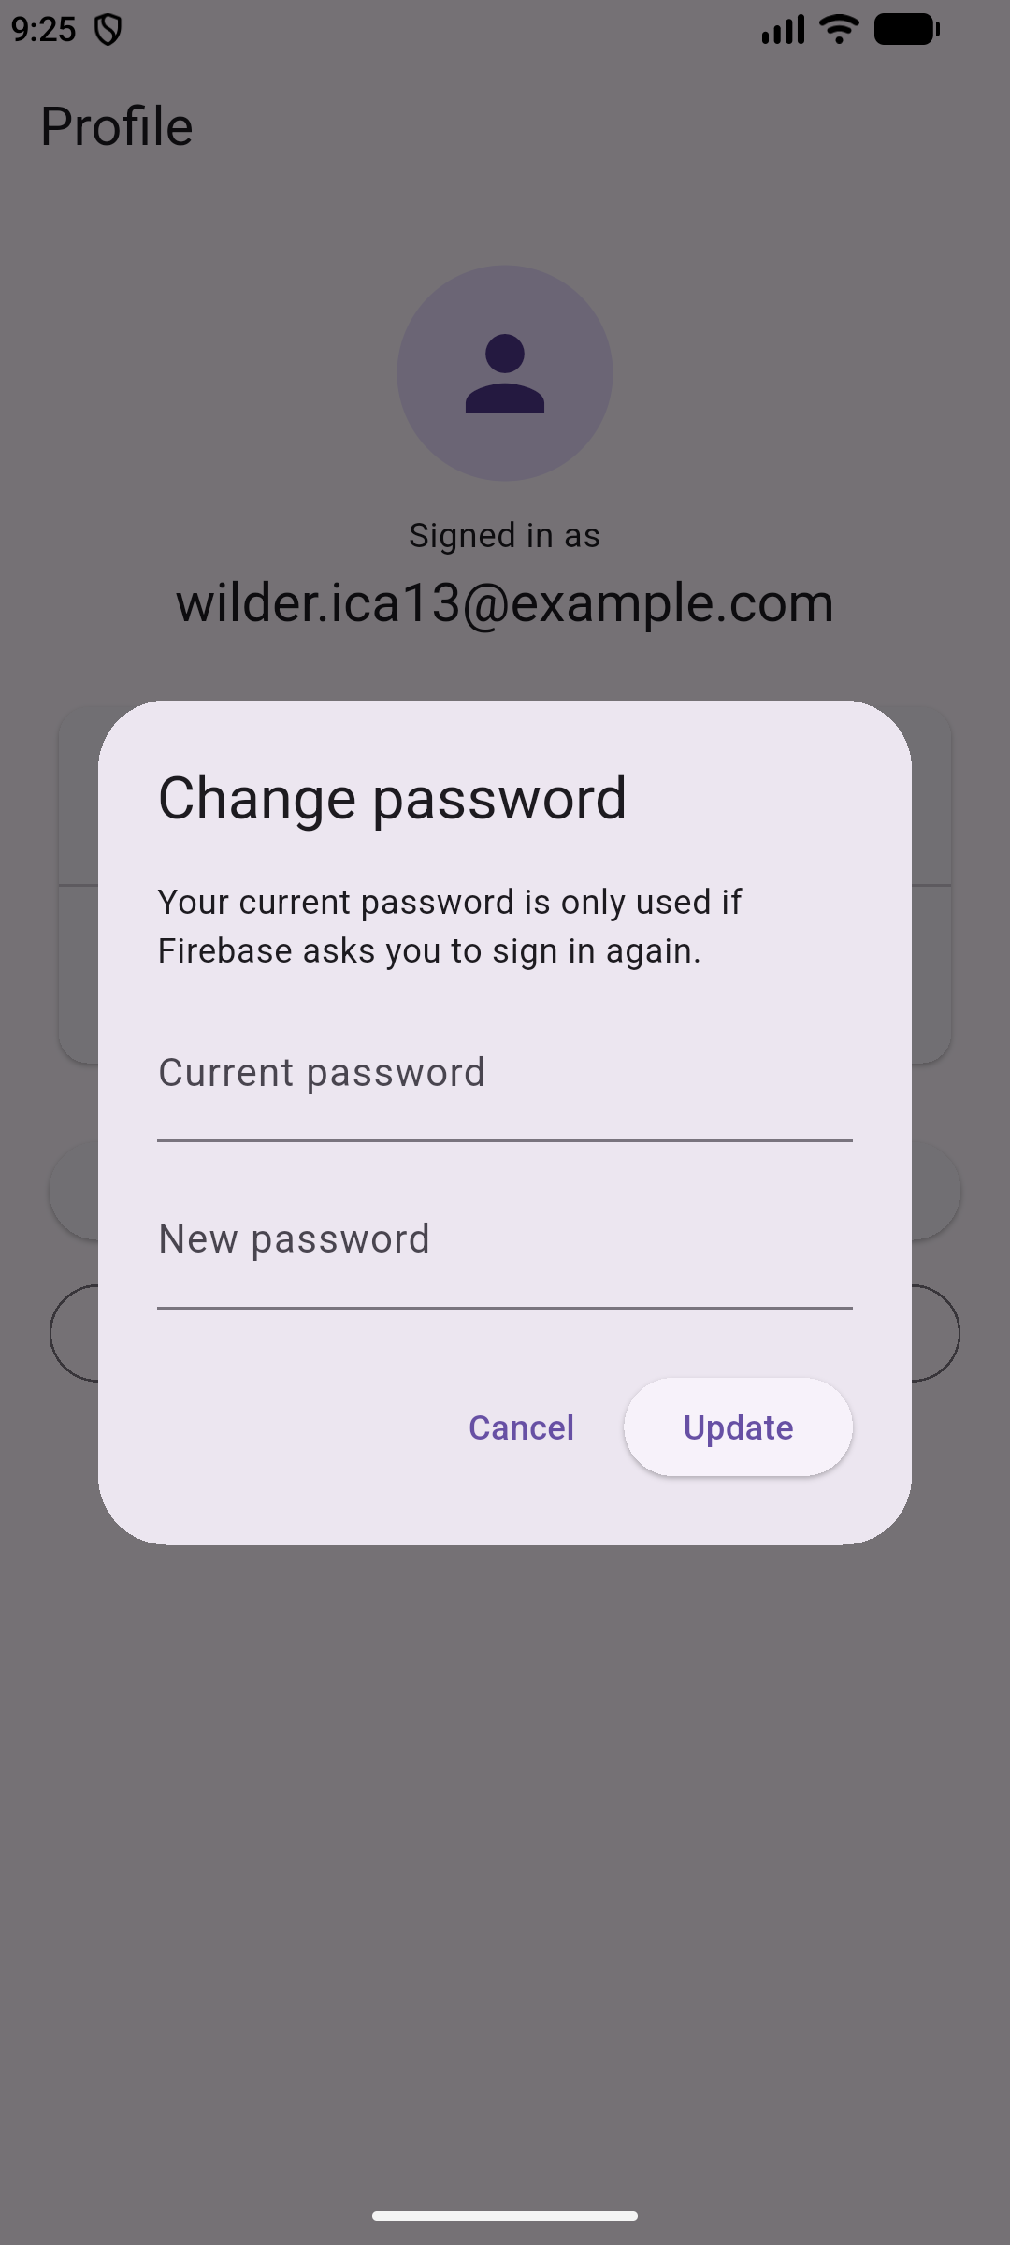
Fig 5 - The dialog asks for the current password before the new one.
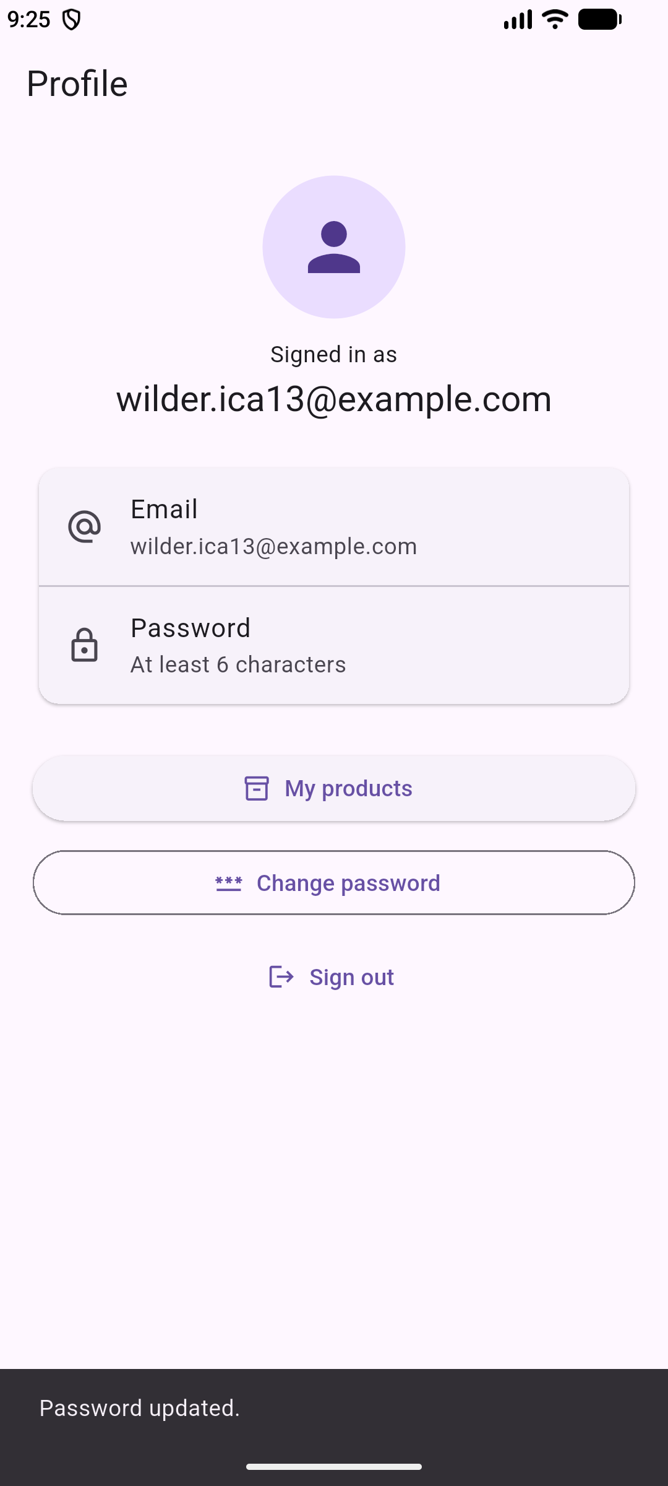
Fig 6 - Confirmation after a successful update.

T5 - The old password stops working
Action: signed out, then tried the old password. Expected: a rejection that does not say whether the email exists, and no access. Observed: The email or password is not correct, and the app stayed on the form. Result: pass.
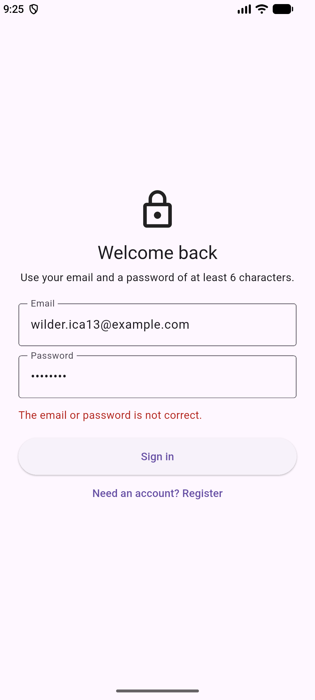
Fig 7 - Old password rejected after the update.

T6 - The new password works
Action: signed in with the new password. Expected: the fields lock and the button shows progress while the request is out, then the profile opens. Observed: both fields greyed out and the button held a spinner until the profile appeared. Result: pass.
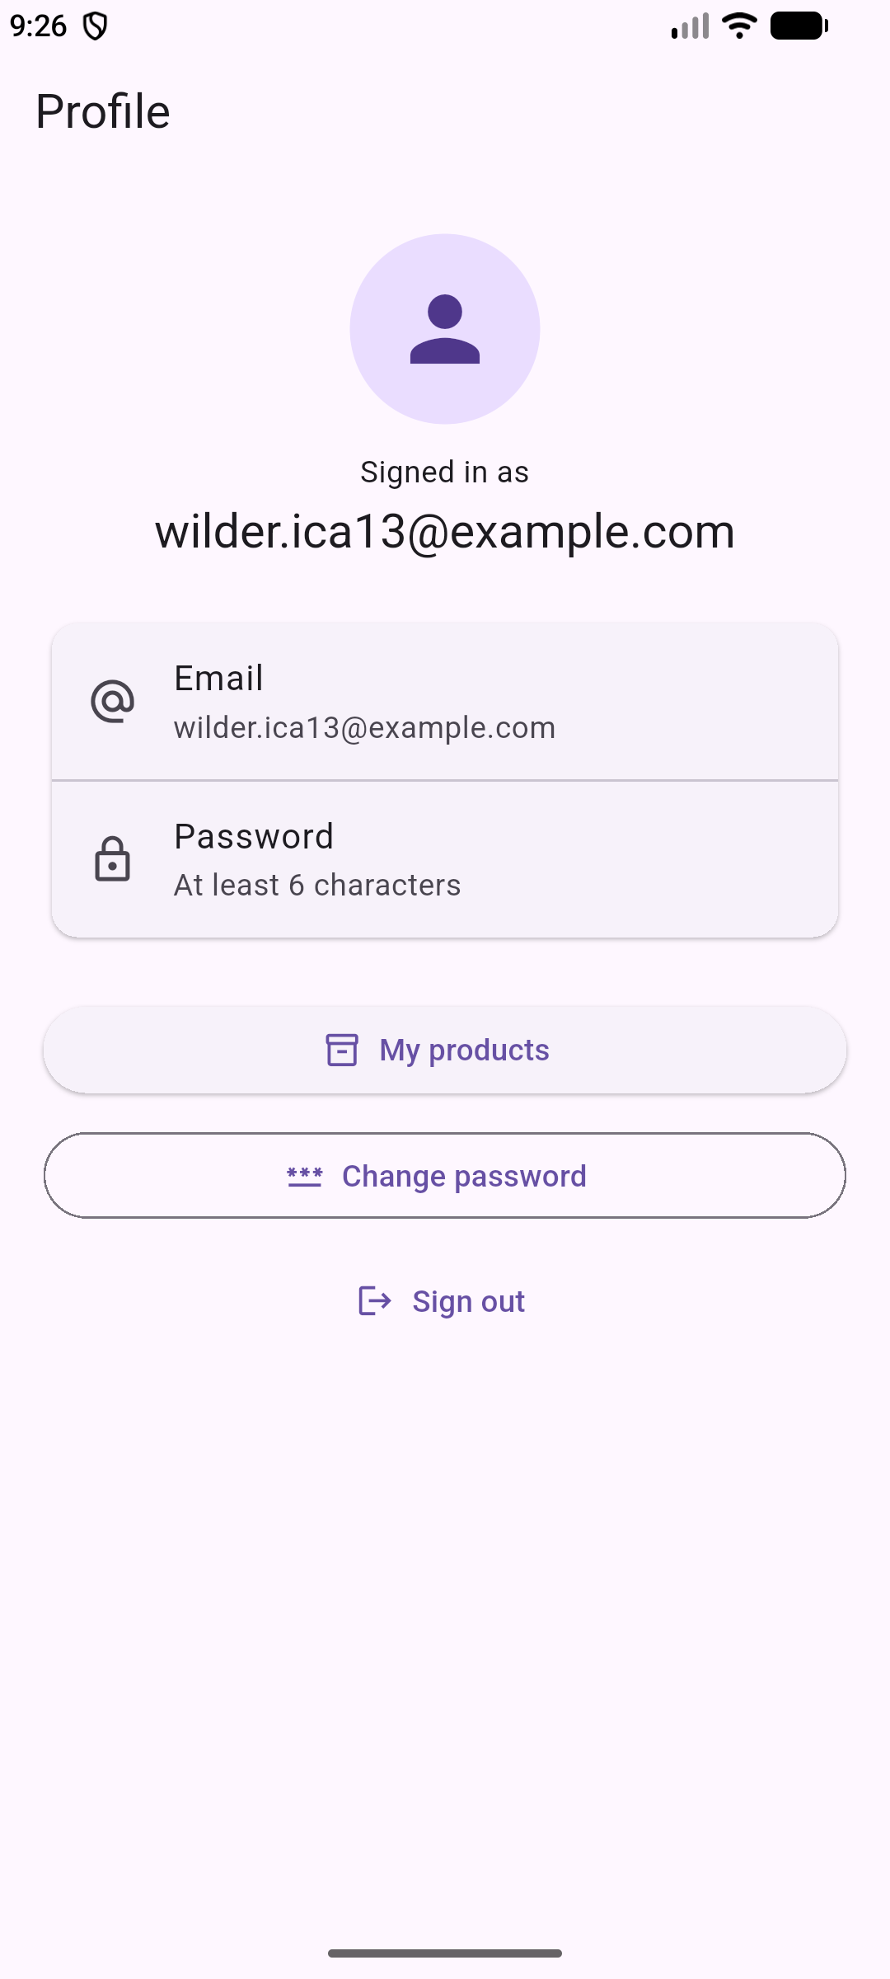
Fig 8 - Signed in with the new password.

T7 - Session survives an app restart
Action: force-stopped the app and launched it again. Expected: the saved session is restored and the profile opens without a password. Observed: a short spinner, then the profile with the same email. Result: pass.
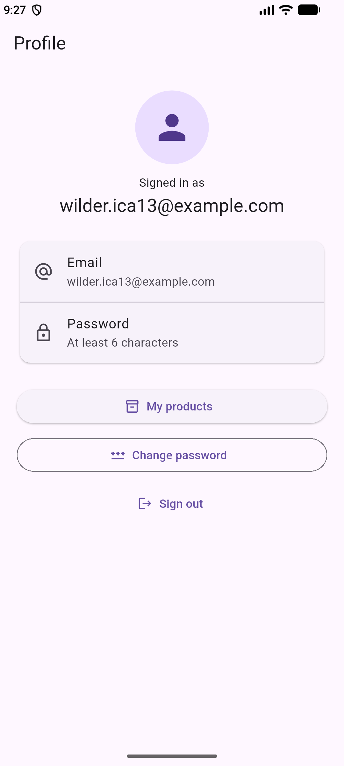
Fig 9 - Profile after a cold start, no login prompt.

T8 - Sign out removes access
Action: tapped Sign out. Expected: the form, with no route back to the profile. Observed: the form replaced the profile. The profile is not a pushed route, so there is nothing to pop. Result: pass.
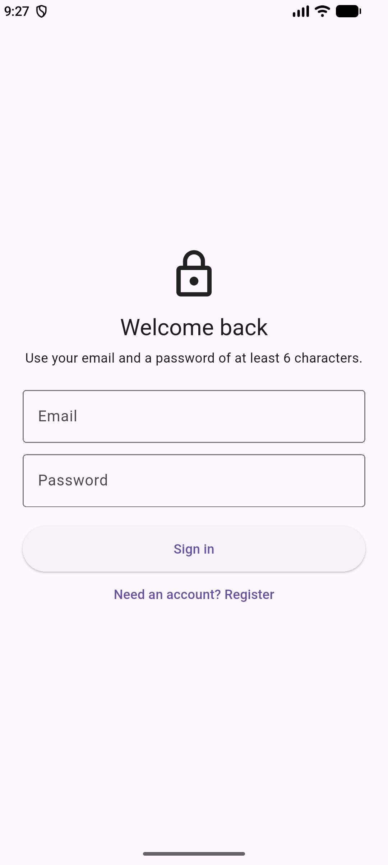
Fig 10 - Signed out, back at the form.

3. Reflection

Prompt 1 - Expectation vs obtained
I expected register to be one step: fill two fields, tap Create account, land on the profile. The final build does that, but the first try returned That did not work. Please try again (Fig 11). The Dart code was fine. Email/Password was not enabled on the Firebase project, so the request was rejected before an account existed. Once I enabled it, the same build worked.
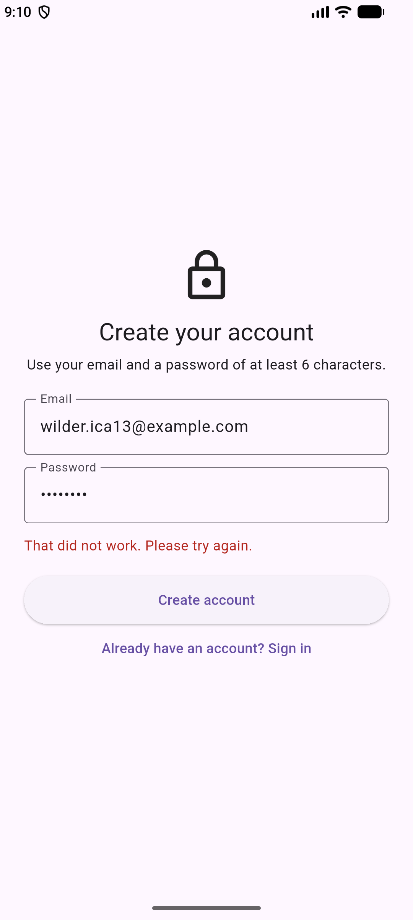
Fig 11 - The first registration attempt, before the provider was enabled.

Prompt 1 follow-up - Analysis
The root cause was setup, but my error mapping hid it. authErrorMessage had no case for a configuration failure, so a specific problem looked generic. Backend setup is part of the feature, not something after the UI. Next time I would test registration as soon as Firebase initializes, and add a message for that case.

Prompt 2 - Debug evidence
After an empty submit, the Email is required error stayed even after I typed a full address, until I pressed the button again. I added AutovalidateMode.onUserInteraction to the Form, so each field rechecks as it changes. Fig 12 shows the email error gone and the password error still there, which is right because that field was empty. The validators did not change.
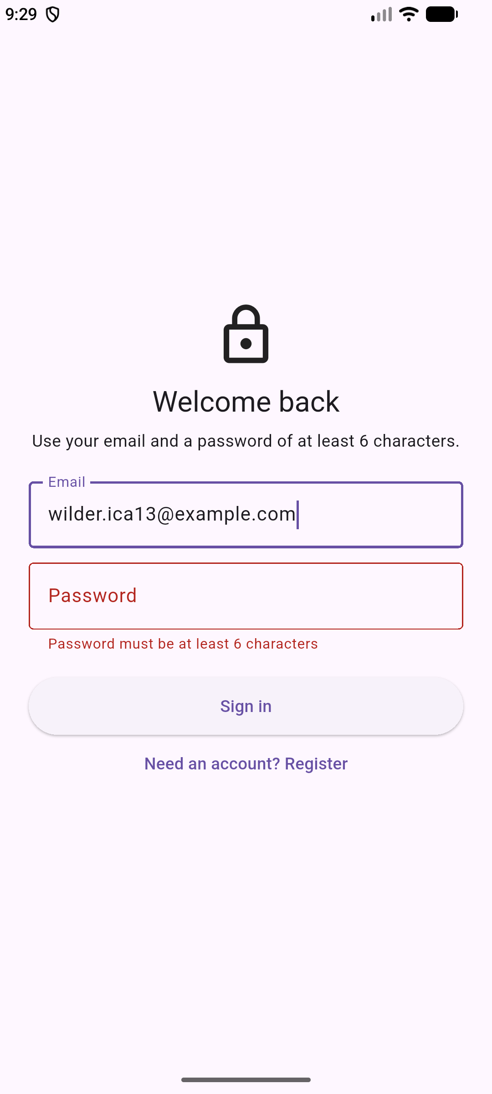
Fig 12 - The email error clears while typing; the password error stays.

Prompt 2 follow-up - Alternative solutions
I could have called _formKey.currentState!.validate() in each field's onChanged with setState. That works, but it duplicates the call and rebuilds on every keystroke. AutovalidateMode does the same thing through the Form. Clearing the error by hand was the other option, but that hides the message without checking the new value.

Prompt 3 - Improvement plan
The next feature I would add is password reset with sendPasswordResetEmail. The change dialog only helps someone who can still sign in, and a user who forgot the password is stuck at the form. Firebase already sends the email, so the work is a link, a confirmation that does not reveal whether the address exists, and a test for an unknown address. After that, email verification before the product screen.

Prompt 4 - Security and UX judgment
Sign-in failures always say The email or password is not correct, even for an unknown email. That is less helpful, but it stops the form from confirming which emails have accounts. The six-character minimum is the assignment baseline and runs before the call, though the Firebase project could be stricter. The password dialog always asks for the current password, which is one extra field, but it means the recovery path never stops halfway. No password is logged or stored.

Prompt 5 - Authentication, authorization, and prior learning
Auth state decides which widget tree exists. AuthGate listens to authStateChanges and returns the profile or the form, so there is no route to push and no screen to guard by hand. This is the same StreamBuilder pattern as the Firestore work in In-Class 12, except the snapshot now says who the user is. Hiding a screen is not authorization. If I add users/{uid} data, the rule has to compare request.auth.uid to the document id. I did not add that collection, so I am not claiming a rules test.

Prompt 6 - Scale and maintainability
The auth calls would be fine at 10,000 users because they run on Google's side. The product screen is the weak point. It loads the whole collection and filters in the client, which is fine for a demo but wrong for a large catalog. I would page the query and push the search and price filters into Firestore with indexes. I would also pass one AuthService down instead of creating one per screen, so claims or logging have one place to go.

4. AI comparison (undergraduate track)

My prediction, before consulting AI
Before asking anything, I wrote down the flow I expected: form to AuthService, then the auth state stream, then AuthGate, then the profile. Registration would sign the user in automatically, and sign out would return to the form. My tests were that a new registration shows the profile email, and that sign out leaves no route back.

Tool, date, and what it suggested
Tool: DeepSeek V4.1 Flash Free through OpenCode, November 4, 2026. I used the undergraduate prompt from the activity guide, with no passwords, keys, or project config. In my own words, it suggested validating before the call, letting the stream drive the screen, storing extra profile fields in Firestore by user id, and testing duplicate email, wrong password, invalid input, and signed-out access.

Useful idea, claim to check, and decision
The useful idea was avoiding manual navigation after sign-in, because that is how apps get stuck on the wrong screen. I already used a gate, but it made me treat sign out as a routing question, which is why T8 checks for a way back.
The claim I checked was that authStateChanges fires once at startup after the saved session is restored. The Flutter guide says it emits the current state on listen and again on every change, and the persistence docs say Android keeps the session across restarts. My restart test agrees (Fig 9). The claim is close, but once is the wrong word. I kept the stream routing and the loading state. I rejected the Firestore profile fields because the profile only needs the email Auth already has, and that collection would need rules the AI never mentioned.

5. Recent-login recovery: test plan, not a pass
I did not trigger requires-recent-login. The account was created and the password changed in the same session, so Firebase accepted the update. This section is a test plan, not observed evidence.
AuthService.changePassword tries updatePassword first. On requires-recent-login it builds an EmailAuthProvider credential from the signed-in email and the current password, reauthenticates, and retries once. Any other code is rethrown. To test it, I would sign in, age the session or revoke refresh tokens with the Admin SDK, and confirm the first change raises the code. Then I would retry with the correct password, repeat with a wrong one, and check the dialog stays open with a readable error.

6. Sources
- Firebase - Get started with Firebase Authentication on Flutter: https://firebase.google.com/docs/auth/flutter/start
- Firebase - Manage Users in Flutter (password update and reauthentication): https://firebase.google.com/docs/auth/flutter/manage-users
- Flutter - Build a form with validation: https://docs.flutter.dev/cookbook/forms/validation

